Lesson !!!: The Circle of Fifths
Introduction:

Closely-related keys share six of their seven pitch classes. In Lesson VVV, we saw that if we started with C major we could build another major scale (G major) on scale degree 5 which would have one sharp in the key signature. If we built a major scale on 5 of G major, we would arrive at D major which requires two sharps. The pattern could continue indefinitely.

In this lesson we will discuss the various types of relationships that occur between keys. We will introduce a widely-used diagram known as the circle of fifths to provide a visual representation of these relationships.

The circle of fifths:

The following diagram arranges the sharp keys around the edge of a circle:

Example 1 (the circle of fifths, sharp keys only):
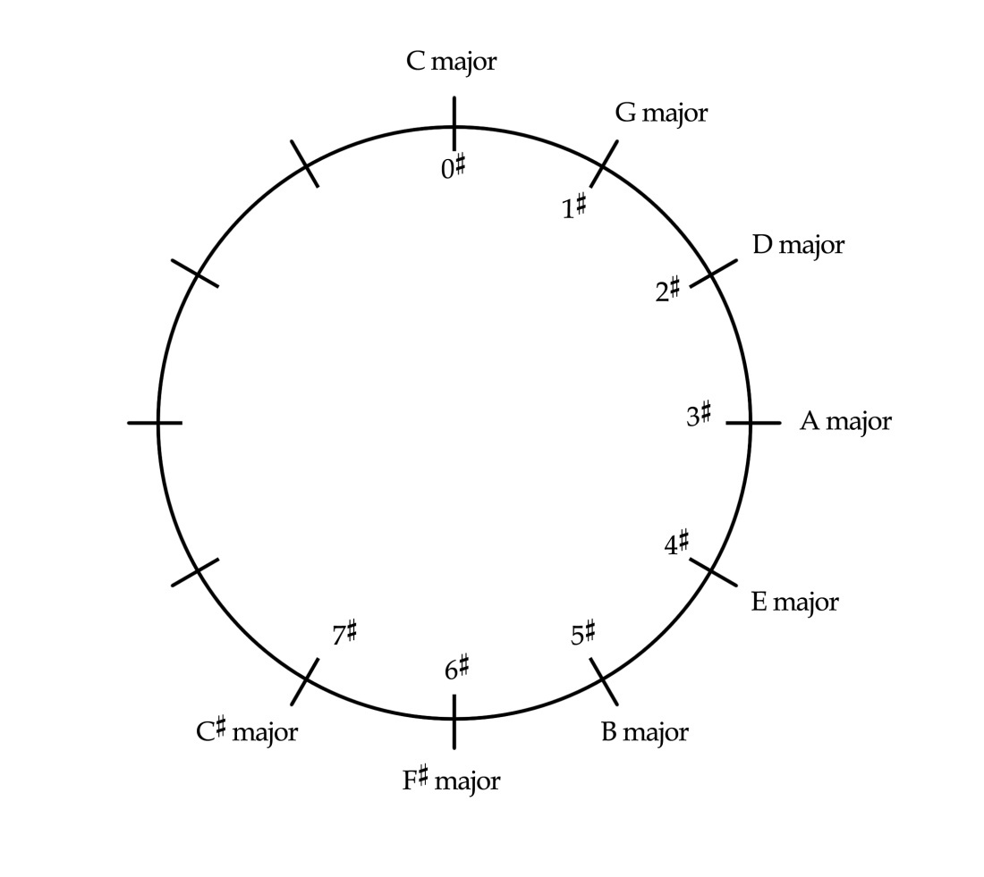

This diagram, commonly referred to as the circle of fifths, is a useful way of visualizing key relationships. The diagram gets its name from the fact that as we move clockwise around the circle, each new key is built on the fifth scale degree of the one that came before it. (The accidentals for each corresponding key signature are indicated on the inner circle.) C major is placed at the top of the diagram because it requires no accidentals. Each clockwise step also adds one more sharp to the key signatures. Moving from D major to A major, for example, requires the addition of one more sharp:

Example 2:
a. D major: b. A major:

We can add flat keys to the circle as well. Increasingly flat keys will move counterclockwise around the circle:

Example 3 (the circle of fifths, all major keys):
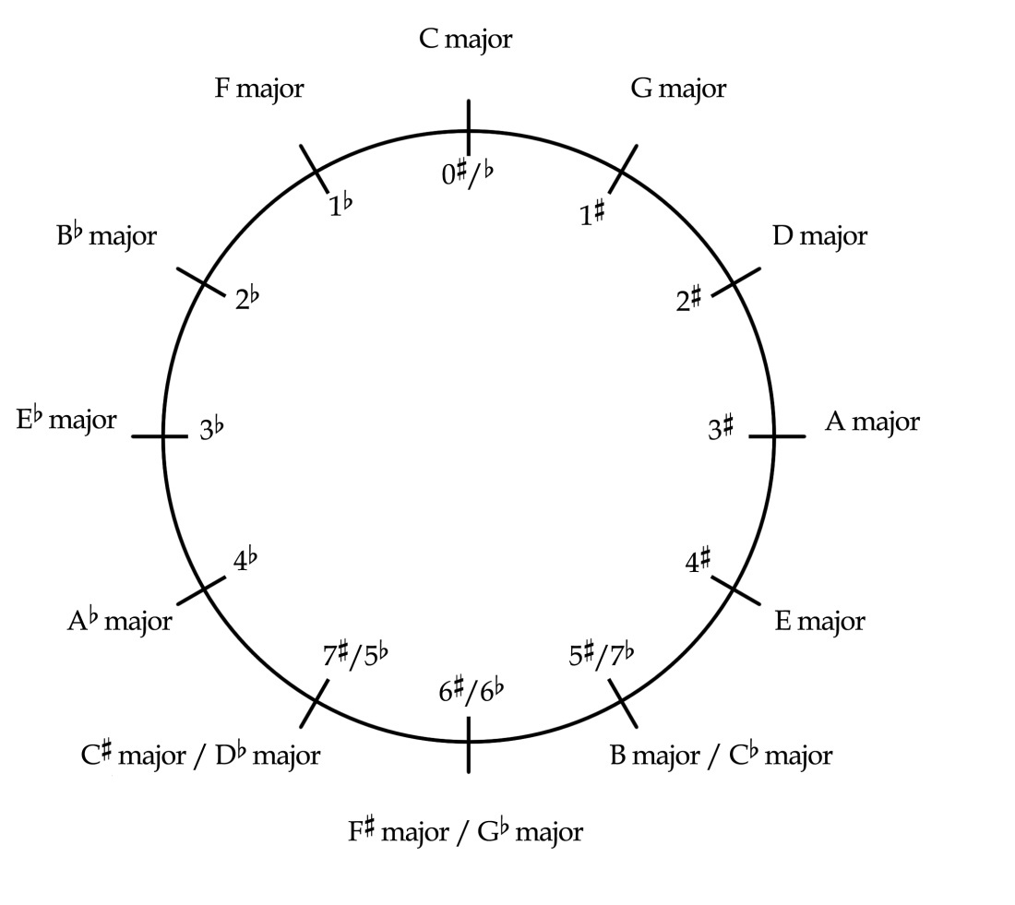

Moving counterclockwise, each subsequent key is built on scale degree 4 of the one before it and has one additional flat in its key signature. Moving from Eb major to Ab major, for example, requires one additional flat in the key signature:

Example 4:
a. Eb major: b. Ab major:

If we consider the entire circle, we can make several interesting observations. A clockwise move results in one of the pitches of the scale—scale degree 4—being raised. This raised pitch becomes scale degree 7 in the new key. For example, in moving from D major to A major, G is raised to G#, as in Example 2. Likewise, moving counterclockwise around the circle will result in one pitch, scale degree 7, being lowered. This lowered pitch becomes scale degree 4 in the new key. So moving from Eb major to Ab major requires that D be lowered to Db, as in Example 4.

Notice as well that there is some overlap at the bottom of the circle. These keys—which tend to be used less frequently than those with fewer accidentals—are enharmonically equivalent. C# major and Db major, for example, both begin on the same pitch class, but are spelled differently.

You should be familiar enough with the relationships between major keys and their key signatures to be able to reproduce the circle of fifths from memory.

Activity !!!.1:
Answer the following questions using the circle of fifths,
Exercise !!!.1a
How many pitch classes do A major and E major have in common?
[Answer: 6. Response if correct: “Correct! A major and E major share six of their seven pitch classes.” Response if incorrect: “Incorrect. (Hint: How many steps are there between these two keys? Each step represents one different pitch.)”]

Exercise !!!.1b
How many pitch classes do F major and G major have in common?
[Answer: 5. Response if correct: “Correct! F major and G major share five of their seven pitch classes.” Response if incorrect: “Incorrect. (Hint: How many steps are there between these two keys? Each step represents one different pitch.)”]

Exercise !!!.1c
How many pitch classes do Eb major and A major have in common?
[Answer: 1. Response if correct: “Correct! Eb major and A major share only one of their seven pitch classes.” Response if incorrect: “Incorrect. (Hint: How many steps are there between these two keys? Each step represents one different pitch.)”]

Exercise !!!.1d
How many pitch classes do Bb major and D major have in common?
[Answer: 3. Response if correct: “Correct! Bb major and D major share three of their seven pitch classes.” Response if incorrect: “Incorrect. (Hint: How many steps are there between these two keys? Each step represents one different pitch.)”]

Minor keys and the circle of fifths:

Minor keys can be added to the circle as well. Each minor key is paired with its relative major (the key with which it shares a key signature). A minor, therefore, is placed at the top of the circle, paired with C major:

Example 5 (the complete circle of fifths):
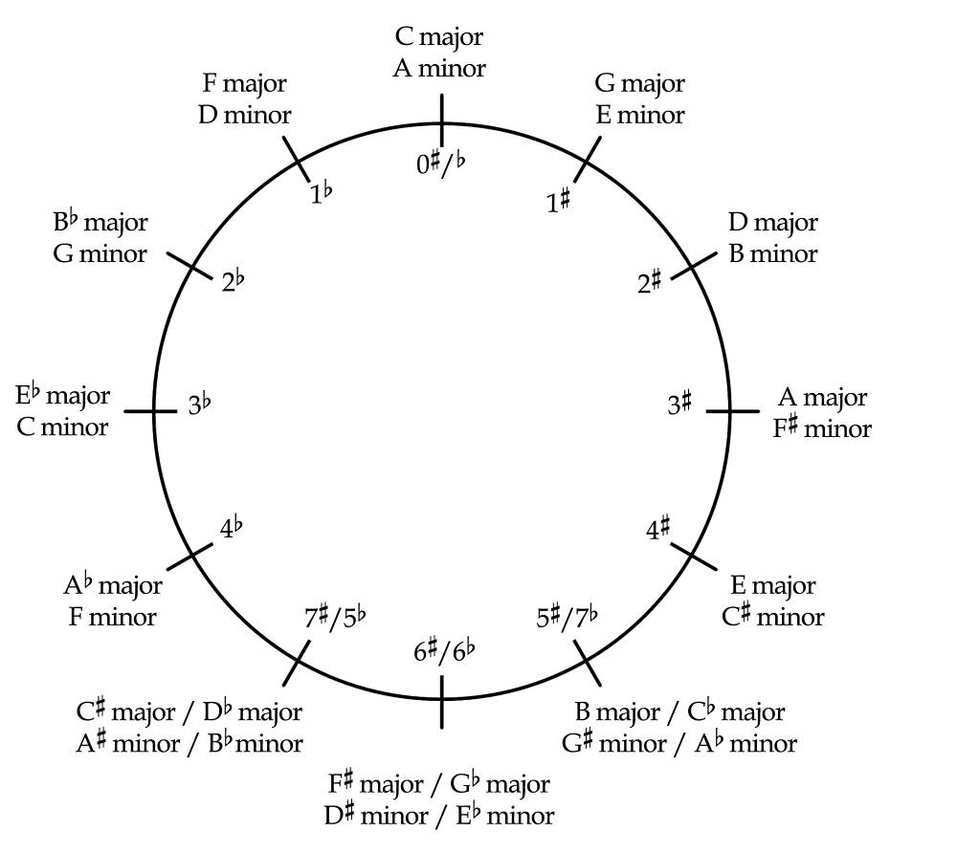

Earlier, we saw that as we move clockwise around the circle, each new key begins on scale degree 5 of the key that came before it. This is true for major keys and minor keys. Continuing to step up to scale degree 5 of each new key will eventually bring us back to the beginning: A, E, B, F#, C#, G#, D# = Eb, Bb, F, C, G, D, A.

Note that while the circle of fifths is particularly useful for showing the closeness of keys that differ by only one pitch class, parallel keys are not as clearly demonstrated. E minor and E major, for example, are three steps away from each other on the circle. Keep in mind, however, that, despite this distance, parallel keys sound quite similar. Because they share the same tonic (and scale degrees, 2, 4 and 5), it is easy to hear the relationship between parallel keys.

Conclusion:

All keys, major and minor, can be arranged on a circle of fifths to show the relationships between them. Relative keys are paired together because they share the same key signature. C major and A minor, for example, appear at the top of the circle and have no accidentals in their key signatures.

A clockwise move around the circle results in a new scale with one additional sharp (or one less flat) built on scale-degree 5 of the one that came before it. Likewise, a counterclockwise move around the circle results in a new scale with one additional flat (or one less sharp) built on scale-degree 4 of the one that came before it. The keys are arranged in a circle, because continually stepping around the circle will eventually return to the beginning.

The circle of fifths is particularly useful in showing the closeness of various keys with regards to their key signatures. C major and G major are closely related, differing by only one pitch class. C major and F# major, on the other hand, are not closely related and differ by six pitch classes. It is important to keep in mind that parallel keys, while not adjacent on the circle of fifths, are heard as closely related because they share the same tonic.

