Lesson SSS: Diatonic Sequences

Introduction:

Very frequently in tonal music, we encounter passages such as the following, where a harmonic pattern coupled with a melodic one repeats at different pitch levels. An example of this appears in the following Mozart sonata, beginning in m. 63:

Example 1 (W.A. Mozart, Piano Sonata in C major, K. 545, Mvt. I, mm. 61-71):
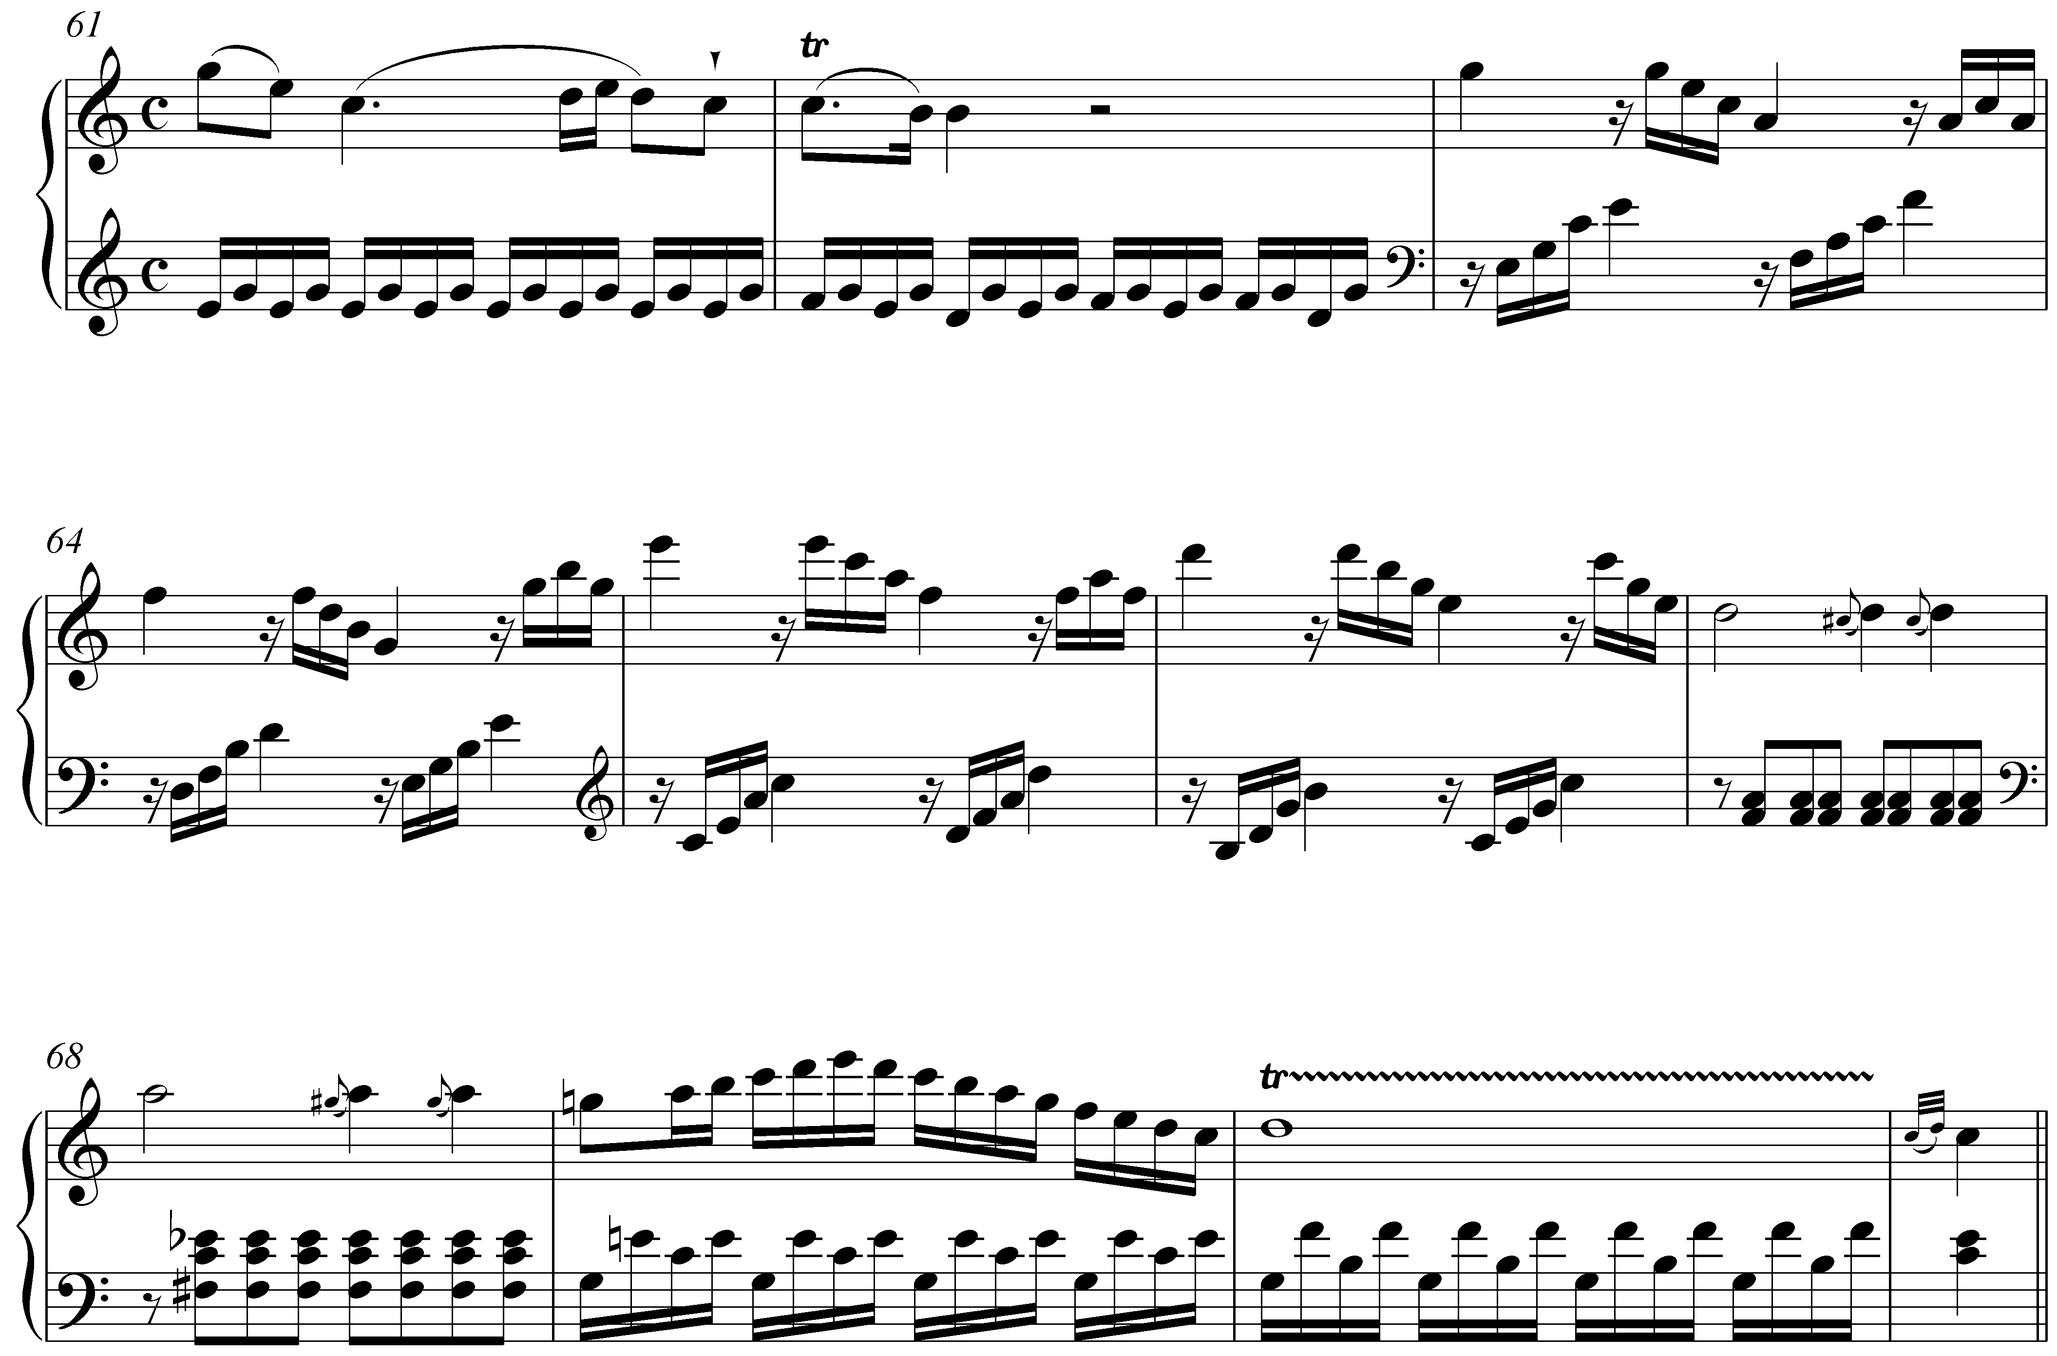

Following a half cadence in m. 62, we find a series of arpeggiated triads. Comparing m. 63 with mm. 64, 65, and 66, we find that the pattern repeats in each measure, the only differences being the pitch level of each repetition. In the right hand, the pattern begins on G in m. 63, then repeats on F in m. 64, then another step down on E in m. 65 (transferred up an octave), and finally on D in m. 66. In the left hand, the repeated pattern begins with upward arpeggiated chords on E and F in m. 63, then a step down, on D and E in m. 64, then C-D and B-C in mm. 65-66. Harmonically, the pattern ends right where it began: with a I chord. With that in mind, we can consider the entire passage from mm. 63-66 to expand tonic harmony, bringing dramatic weight to the authentic cadence that follows in m. 71.

When successive repetitions occur at different but predictable pitch levels, as in Example 1, the patterning is called a sequence. Sequences appear with greatest frequency in music from the Baroque, but appear in every era of the common practice period. As we will discuss in this lesson, sequences function in a number of ways, but always derive from a handful of basic interval progressions. (See Lesson 1 for review of basic interval progressions.)

We will begin with a brief discussion of the general nature of sequences and will then proceed with an examination of some common variations on the basic principles.

The nature of sequences:

Composers generally employ sequences to either expand a single harmony—as we saw in Example 1—or as a transitional device from one harmony to another, sometimes from one key to another. In all cases, identifying the function of a sequence depends on a listener’s ability to recognize the repeated pattern in context. Generally, we first hear the repetition in the contour of the leading melodic voice. But these repeated lines or motives are always linked to strong harmonic progressions, which in turn derive from basic interval progressions.

Sequences are based on the same harmonic progressions that appear everywhere in tonal music. Progressions in which the chord roots descend by fifth are by far the strongest and most frequent, but ascending-fifth and descending- and ascending-third progressions are also quite common. In this sense, sequences are an extension of basic tonal practices expressed in a unique way.

Look again at the harmonic progression of the sequence in Mozart’s Piano Sonata, K. 545:

Example 2 (W.A. Mozart, Piano Sonata in C major, K. 545, Mvt. I, mm. 61-71):
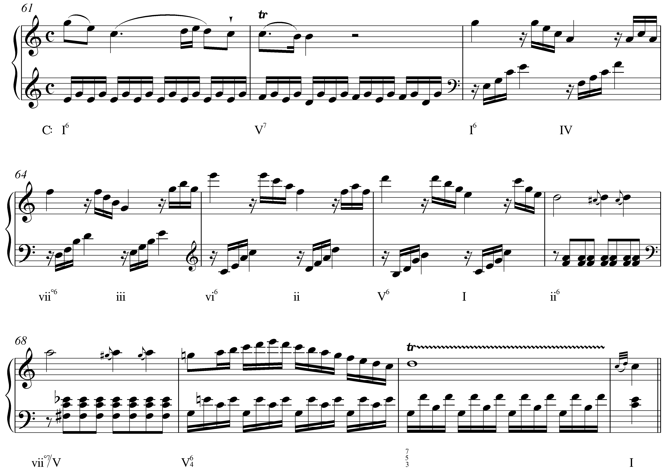

The root of each successive triad, starting with the tonic chord in m. 63, is a fifth lower than the previous one: I – IV – viiº – iii – vi – ii – V – I. (Note that some of these descending fifths are expressed as ascending fourths. This is done to avoid too low of a register.) Here, the sequence traverses an entire cycle of descending fifths, from tonic back to tonic. This is common—particularly with descending-fifth sequences—but most sequences consist of only three to five repetitions since completing an entire cycle can become tedious..

Note: This sequence and the others considered in this lesson are diatonic: all of the chords are native to a single key. Because the repetitions are not literal, you will find some variation in quality. The triads in m. 63 of Example 2 are both major, while those in m. 64 are diminished and minor. Regardless of the changes in quality, the similarity of the melodic contour is explicit enough for the listener to recognize the repeated pattern.

Another consequence of using only diatonic chords is the inevitable inclusion of diminished and augmented intervals. Composers negotiate these dissonant sonorities in several ways, as you’ll see from the various examples in this lesson. In Example 2, Mozart conceals the diminished-fifth root motion from F down to B as IV moves to viiº by alternating between root position and first inversion chords.

In addition to considering the repeated material—melodic and harmonic—it is essential that you be able to recognize the underlying outer-voice interval patterns that form the basic structure of sequences. In multi-voiced settings, look to the outer voices for these governing progressions. The following example provides a reduction of the sequence in Example 2, showing the successive intervals formed by the highest and lowest voices:

Example 3 (reduction of W.A. Mozart, Piano Sonata in C major, K. 545, Mvt. I, mm. 63-66):
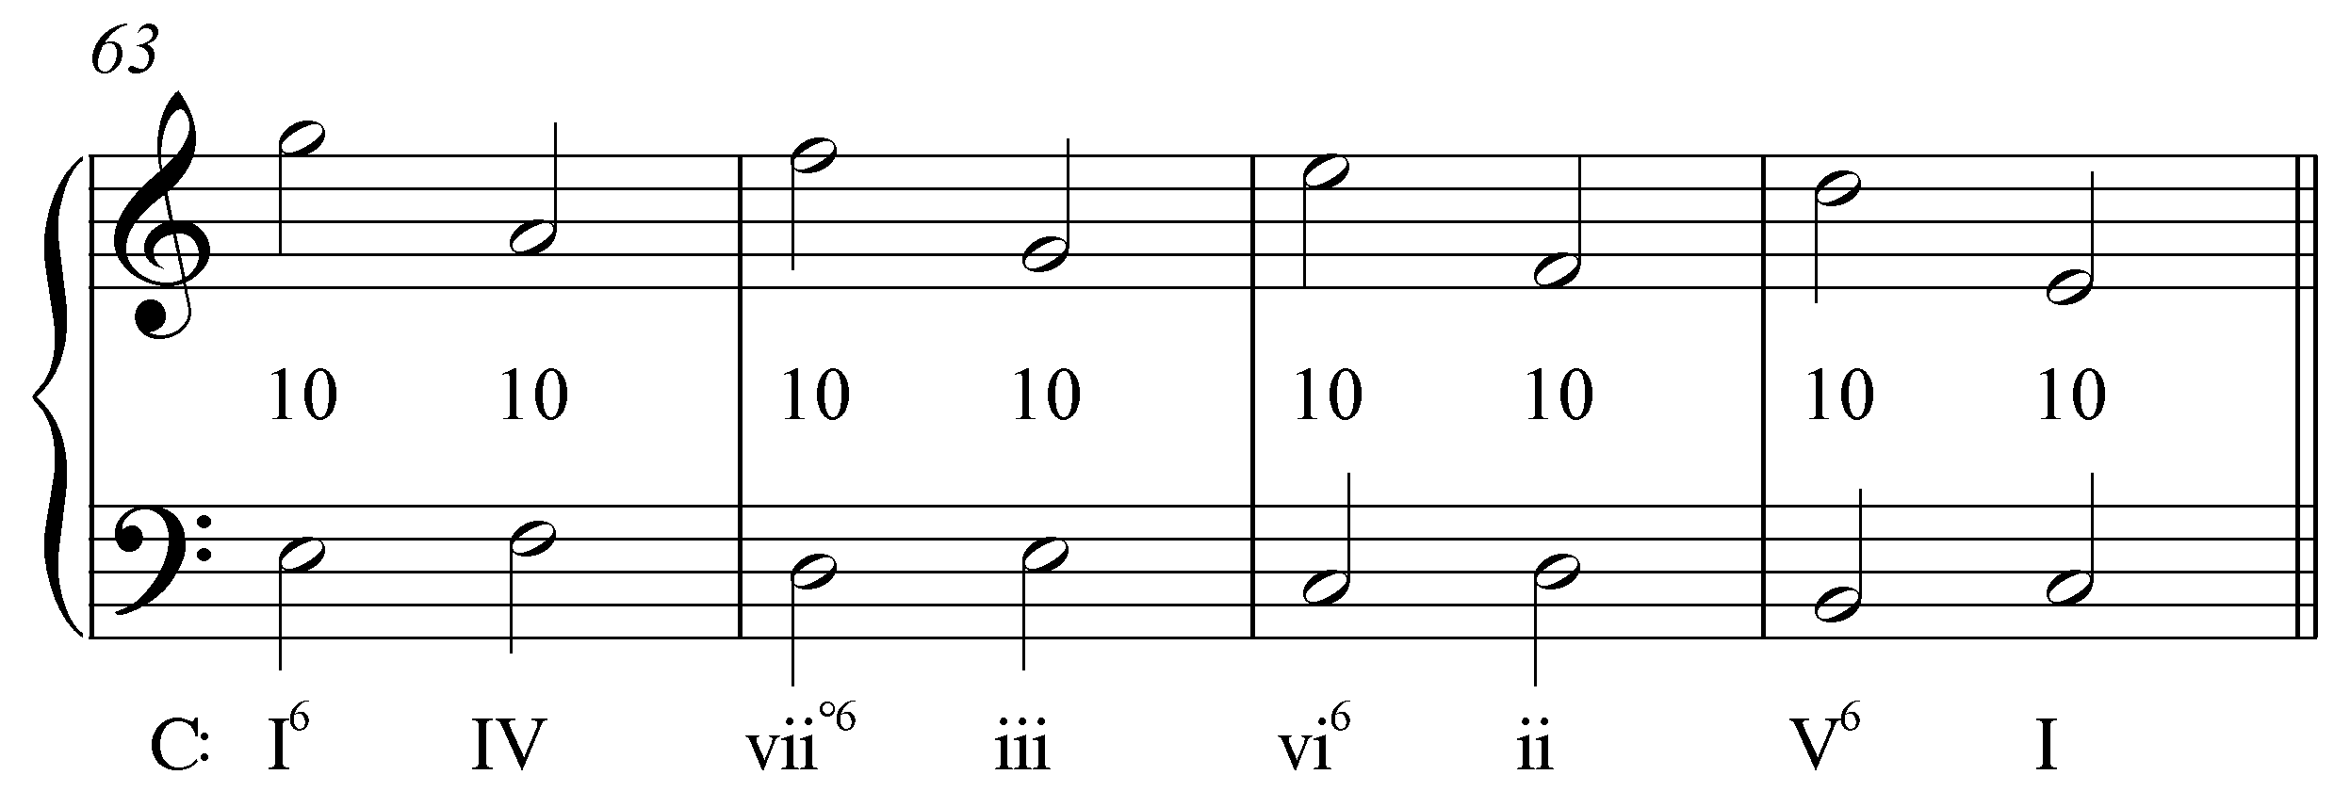

With each change in harmony, the outer voices form a series of tenths. Mozart enhances the pattern of tenths by leaping down by seventh to the second tenth of each measure, and also by transferring the pattern to a higher register in m. 65. However, the underlying principle is common. (These patterns are sometimes referred to as linear intervallic patterns, or, LIPs for short.) Each of the sequences discussed in this lesson can be similarly analyzed as LIPs.

Descending-fifth sequences:

Sequences in which the chord roots descend by fifth are common enough that they should be instantly recognizable by ear. Compare the following excerpt with the Mozart from above:

Example 4 (J. Brahms, Clarinet Sonata in E-flat Major, Op. 120, no. 2, Mvt. I, mm. 160-169):
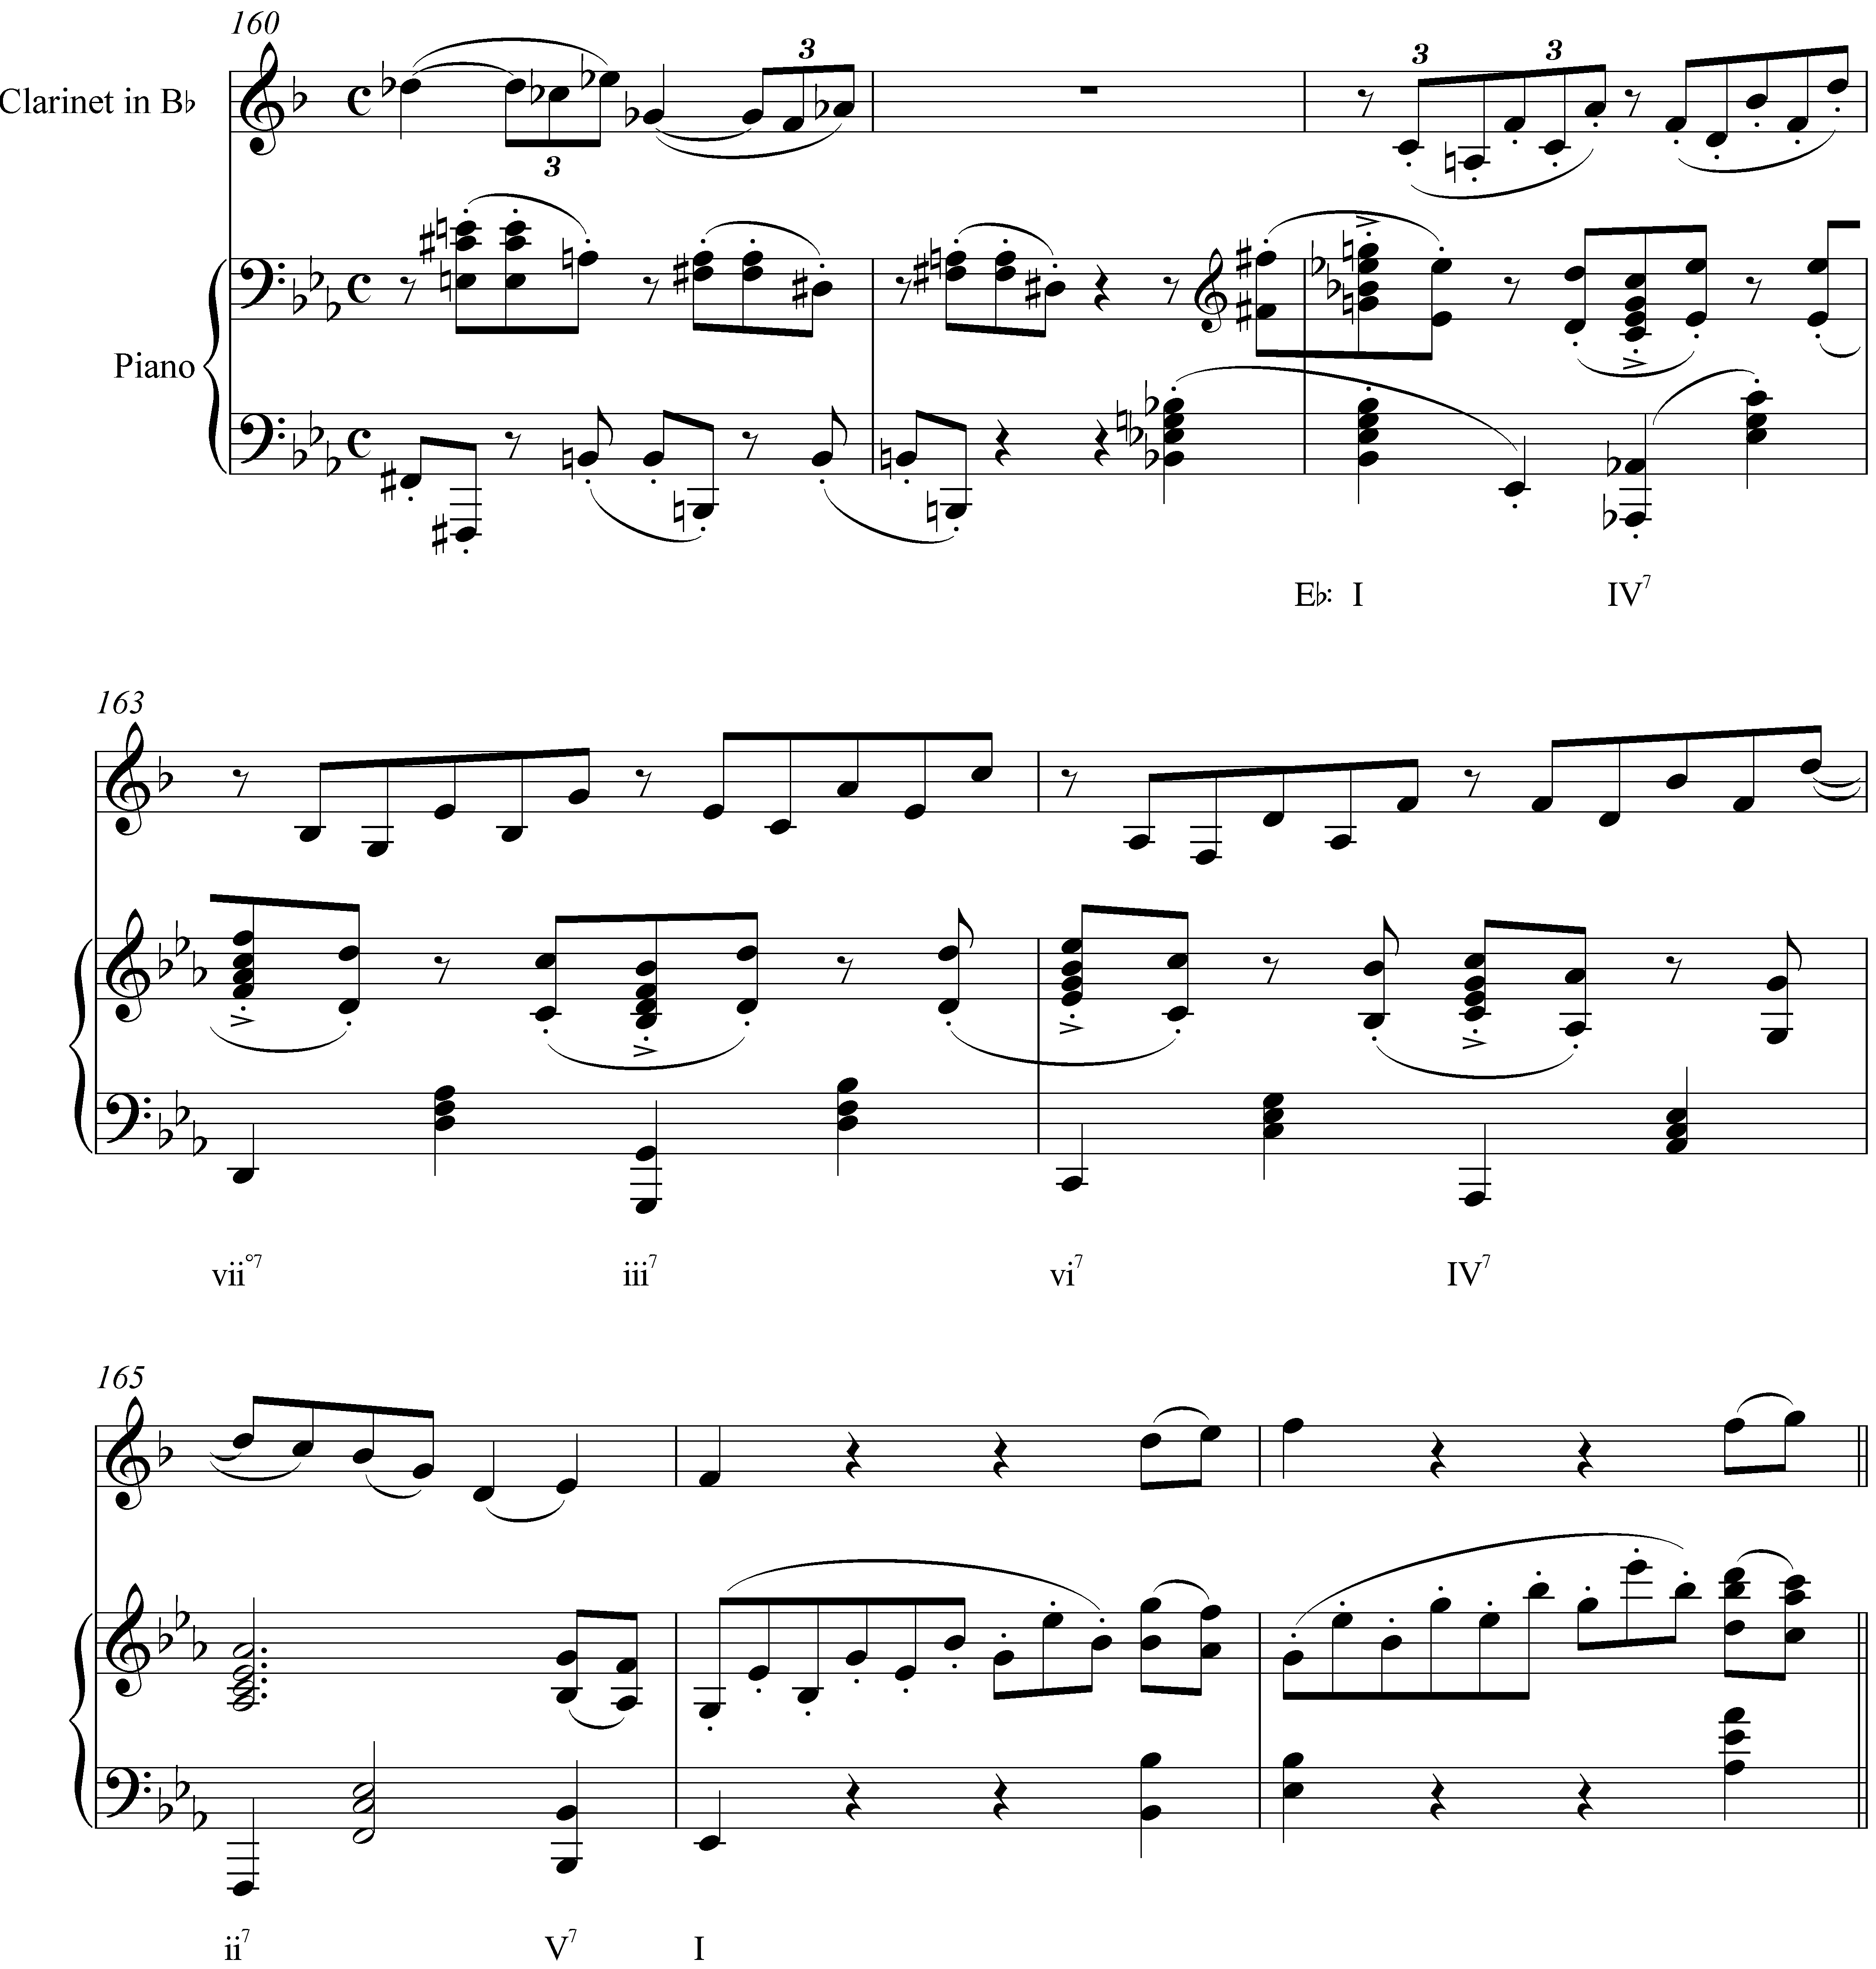

Despite some superficial differences, these two passages have a very similar sound. In this case, however, the sequence extends only from the initial tonic to the vi chord in m. 164. The pattern is then broken when the harmony moves to a IV⁷ chord (part of the pre-dominant area leading to an authentic cadence). Additionally, starting with the IV⁷ in m. 162, each harmony is adorned with a seventh above the root. Whereas sevenths appearing above iii and vi chords would not typically be considered chord tones, in this case they are included by virtue of the sequence’s repetition.

Now consider the interval progression formed by the outer voices. Example 5 provides a reduction:

Example 5 (reduction of J. Brahms, Clarinet Sonata in E-flat Major, Op. 120, no. 2, Mvt. I, mm. 162-164):
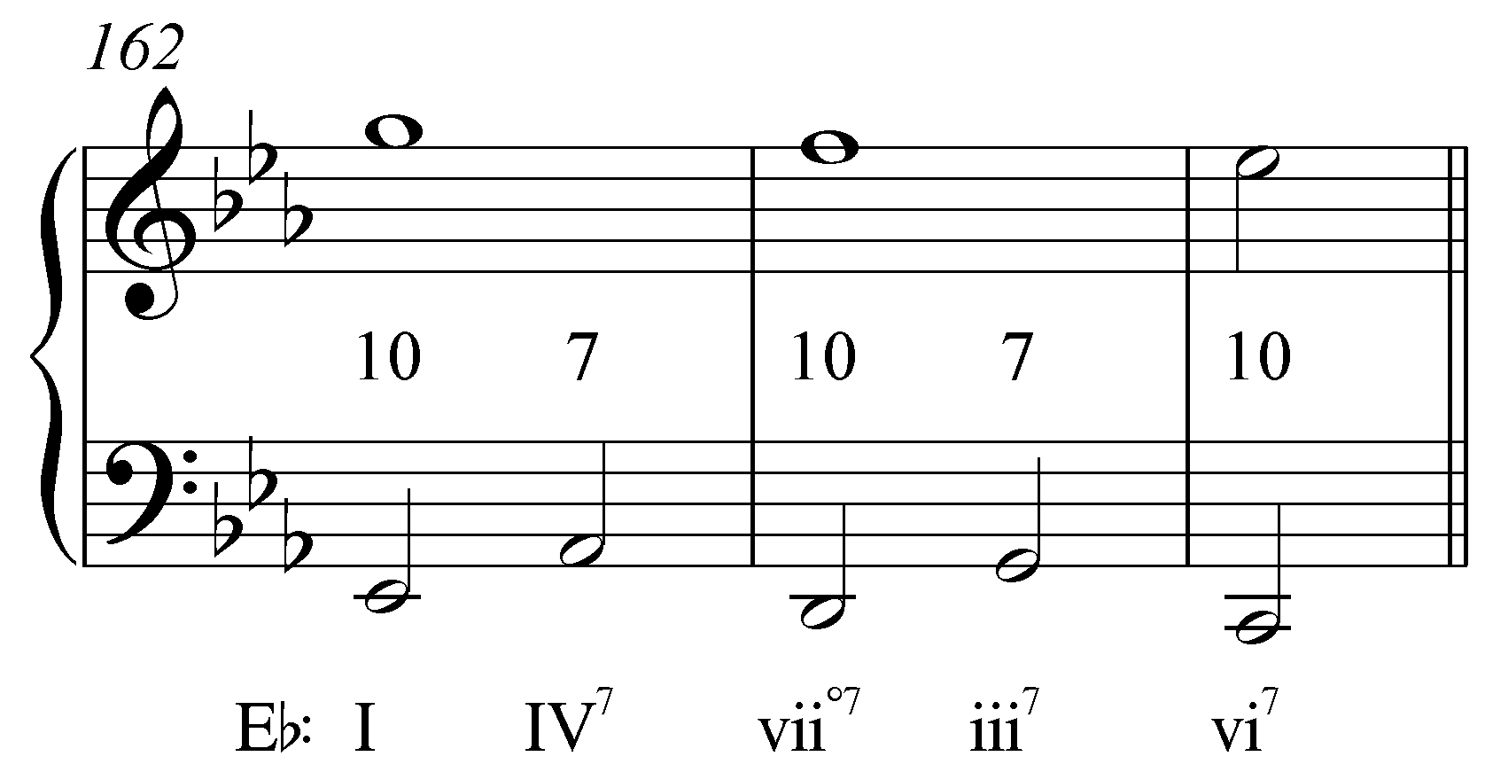
[or this:
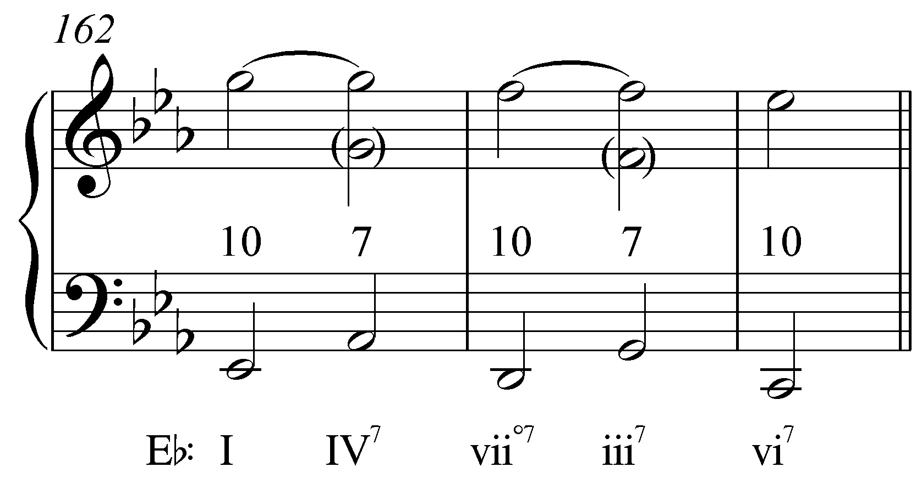
or perhaps this:
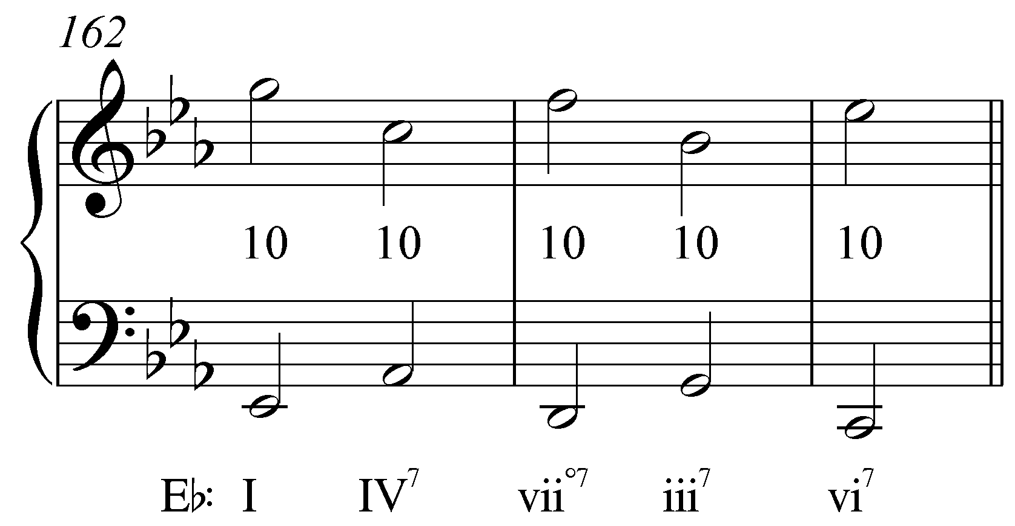?]

Similar to the sequence in Example 2, this passage proceeds through a series of parallel tenths. On the downbeat of m. 162, the highest voice in the piano (G) sounds a tenth above the bass (Eb). That G is suspended through the measure (moving to an inner voice on the third beat) and becomes a seventh as the bass leaps up to Ab. The alternating tenths and suspended sevenths continue until m. 164 where the IV⁷ chord breaks the pattern. At that point, the expected bass note F—the note that would appear were the sequence to have continued—is delayed until m. 165, where the seventh (Eb) finally resolves to D on beat four in the clarinet.

Note as well that even though each chord in this sequence appears in root position on a strong beat, the tritone between Ab and D that arises between the roots of the IV and viiº chords is obscured by the intervening inversions that appear on the second and fourth beats of every measure.

Descending-fifth sequences are particularly prevalent in music of the Baroque era. The following excerpt from a harpsichord suite by Handel makes great use of this device:

Example 6 (G.F. Handel, Harpsichord Suite no. 12, Gigue, mm. 13-16):
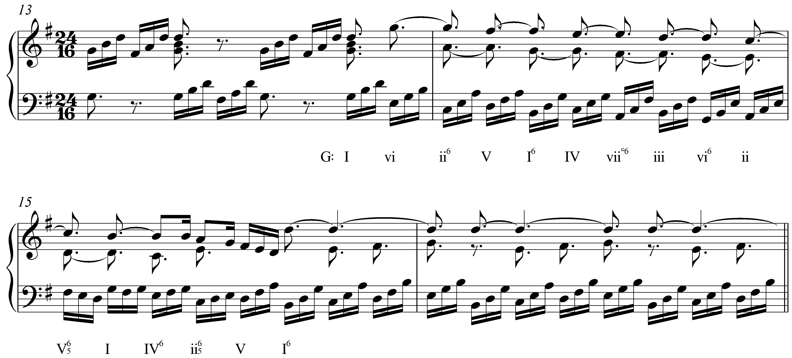

Beginning with the vi chord on the anacrusis to m. 14, a series of arpeggios in the left hand outline a descending fifth sequence through the remainder of that measure. In m. 15, the descending-fifth harmonic pattern set into motion by the sequence continues through V, I, and IV, despite the altered melodic pattern in the bass. At this point, the sequence is broken off, leading to an authentic cadence. Sequences such as this—which complete an entire lap around the circle of fifths and then some—are commonplace in Baroque music but were generally considered monotonous by later composers.

The outer-voice interval progression is particularly clear in this example. A series of suspensions in the upper voice create a pattern of alternating thirds and fifths with the bass:

Example 7 (reduction of G.F. Handel, Harpsichord Suite no. 12, Gigue, mm. 14-15):
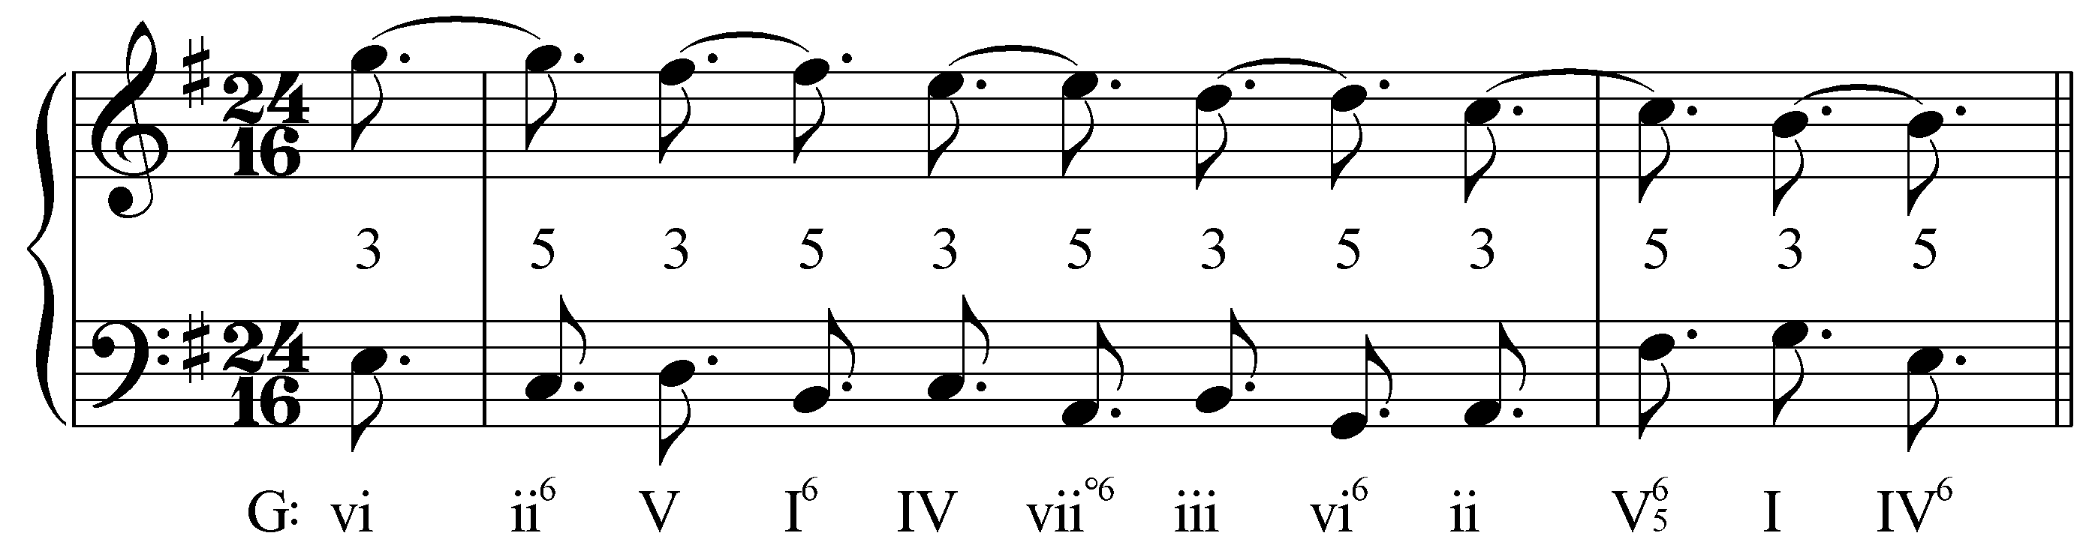

The following excerpt from a Schubert impromptu also includes a complete cycle of descending fifths, this time in a minor key:

Example 8 (F. Schubert, Impromptu in E-flat, D. 899, No. 2, mm. 23-35):
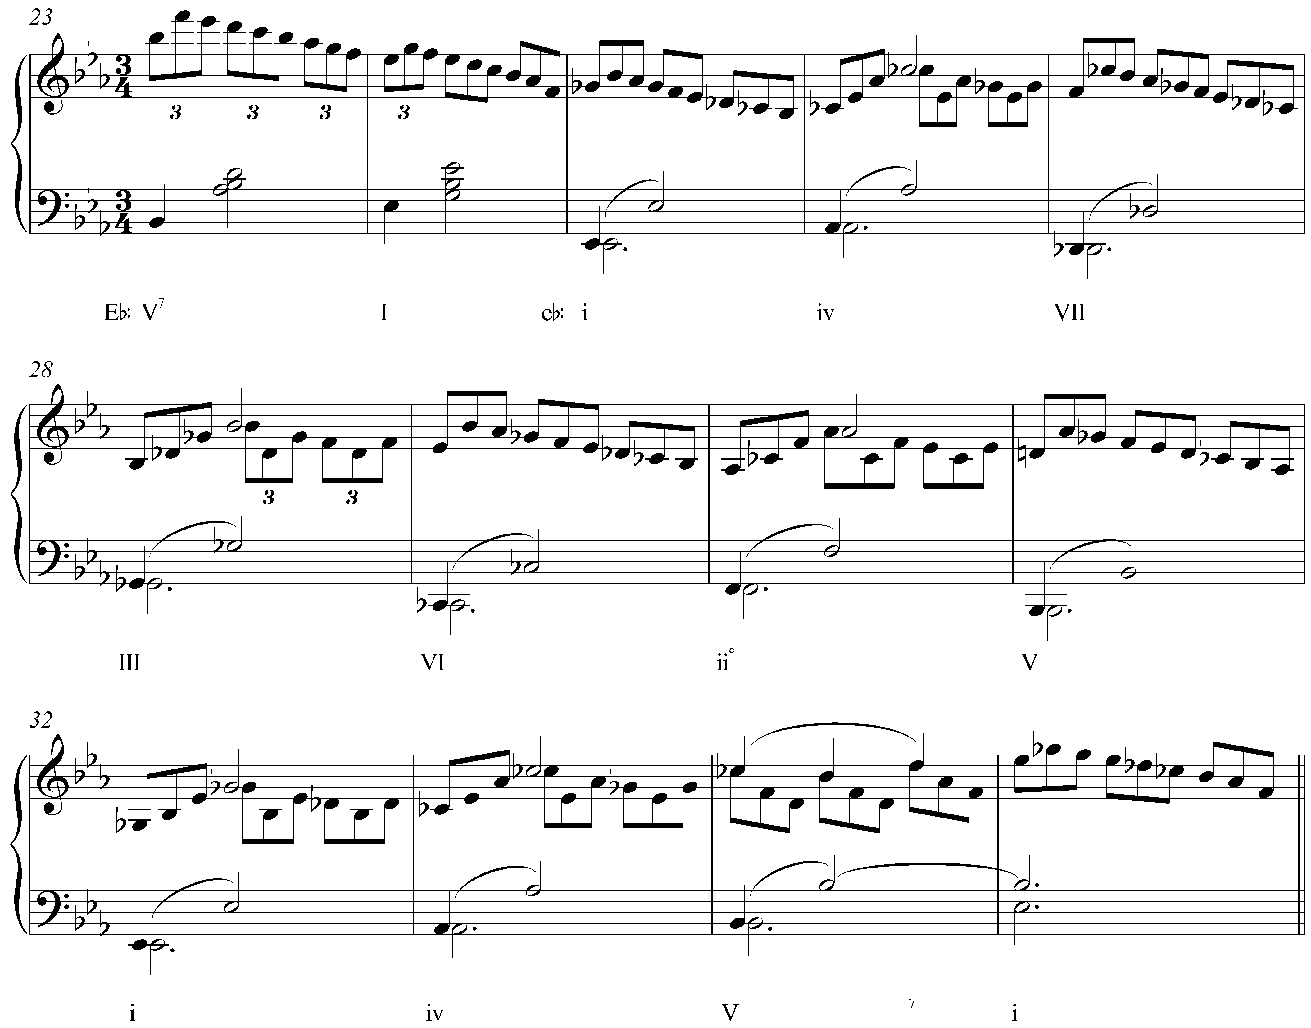

Following a cadence in m. 24, Eb major becomes Eb minor with the addition of Gb (and, subsequently, Db and Cb). The descending-fifth sequence that follows, beginning with iv in m. 26, completes the cycle from the initial i chord to the tonic in m. 32. Harmonically, the iv chord in m. 33 continues the descending-fifth series, but by then, the melodic pattern in the upper voice is broken.

Sequences in minor keys, in addition to the extra tritone between scale degrees 2 and 6, bear the added complication of the harmonic and melodic composites of the scale. (See Lesson 3 for more information on the harmonic and melodic minor composites.) Typically, in a minor-key sequence, scale degrees 6 and 7 are left in their diatonic form, appearing in their raised form only at sequence-ending cadences. Notice that in mm. 25-30, every instance of scale degrees 6 and 7 is diatonic (Cb and Db, respectively). Using diatonic 7 avoids the diminished triad built on the leading tone. It is only with the V chord towards the end of the sequence (m. 31) that we find the raised leading tone, effectively signaling the end of the sequence.

Now, let’s look at the outer-voice interval progression:

Example 9 (reduction of F. Schubert, Impromptu in E-flat, D. 899, No. 2, mm. 25-32):
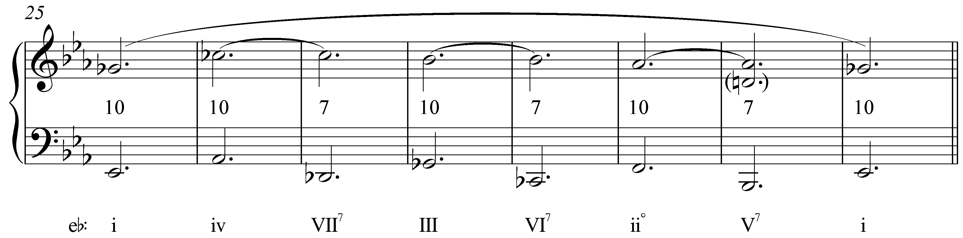

As Example 9 shows, this excerpt is based on the type of interval progression already familiar from Example 5: tenths becoming suspended sevenths. [Note to self: Change the wording of the previous sentence if we go with “10-10” for Example 5.] After the initial Gb is heard in m. 25 as the third of the now minor tonic, the upper voice leaps up to Cb in m. 26. That Cb is heard again in m. 27, though there it appears as a seventh above the new bass (Db). (This suspension is indicated with a tie in the reduction.) The pattern is then repeated in mm. 28-29, and again 30-31, leading back to Gb and the minor tonic in m. 32. The entire sequence prolongs the initial Gb of m.25 all the way through to m. 32 (indicated by the large tie over the entire passage).

Other outer-voice interval progressions are possible as well. The progression that defines a sequence depends, in large part, on which of the upper voices appears on top. Below is one example of a four-voice, descending-fifth sequence. Consider the interval progressions formed by each of the upper voices with the bass:

Example 10:
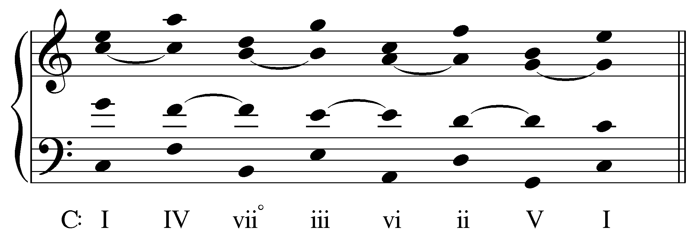

[Potential activity?] [NOTE: Yes, good idea.] [OK! Next time around…]

Here the bass and soprano form a chain of parallel tenths. Between the bass and alto we find a series of upper-voice suspensions leading to alternating octaves and fifths. The tenor and bass also alternate between fifths and octaves, but begin with the fifth between 1 and 5. Any of these interval progressions could appear between the outer voices depending on the arrangement of the voices.

Alternating between root-position and first inversion chords in a descending-fifth sequence will create a different set of potential interval progressions:

Example 11:
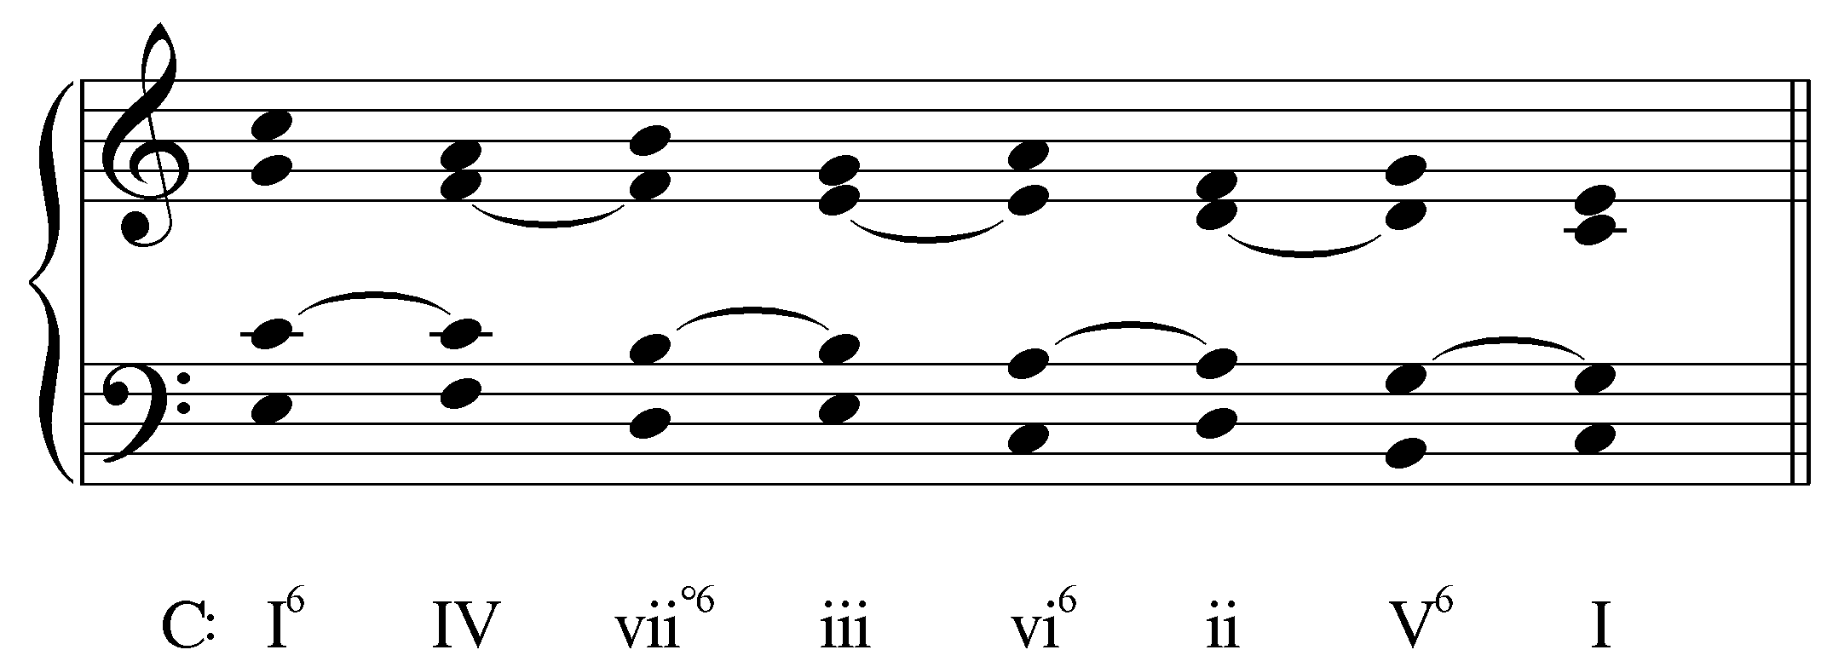

In Example 11, the soprano voice yields a “6 – 10” pattern with the bass, while the alto and tenor yield “10 – 8” and “6 – 5” patterns respectively. Again, the LIP will vary depending on which chord member the composer places in the soprano. The sequence could, of course, also begin with a root-position chord: I – IV⁶ – viiº – iii⁶ – etc., which would likewise affect the outer-voice intervals of the LIP.

Adding sevenths to the chords in either of the two examples above would lead to other possible outer-voice interval progressions.

Ascending-fifth sequences:

Ascending-fifth sequences are far less common than their descending root-motion counterparts. Nonetheless, they do appear with some frequency and have a decidedly different effect. Consider the following example:

Example 12 (A. Corelli, Sonata no. 11 from Sonate da Camera a Tre, Op. 4, Corrente, mm. 18-27):
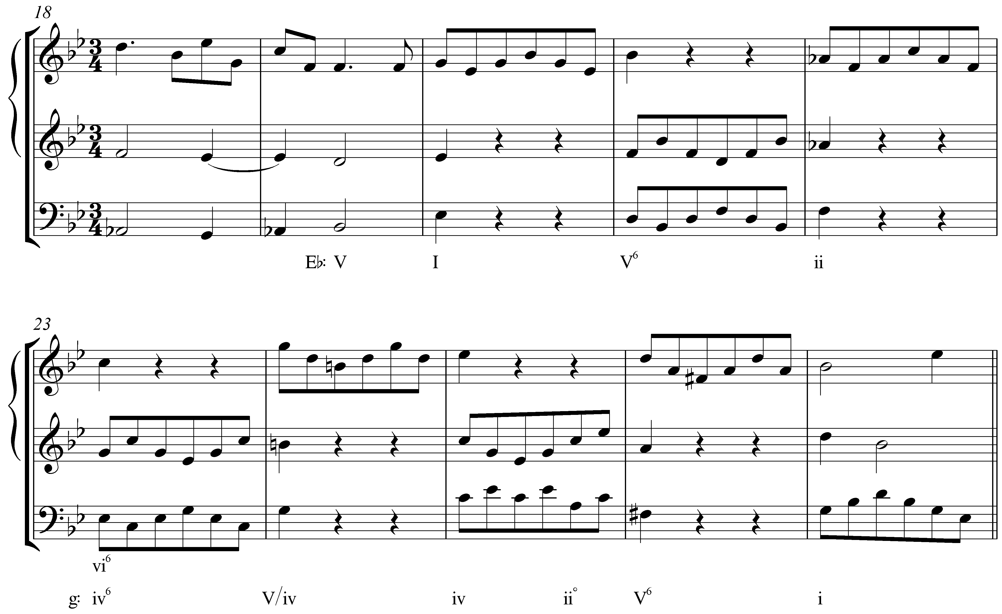

The melodic figure in m. 20 is passed back and forth between the bass and uppermost voice with every change in harmony. Starting with the tonic chord in m. 20, the harmonic progression ascends by fifth in each subsequent measure: I – V – ii – vi. In m. 24, the root of the chord is again a fifth higher, but the pattern is broken by the altered melodic line in the upper voice.

Note as well that m. 24 introduces B natural. That chord, initially heard as V/vi in Eb major, turns out to be an auxiliary sonority prolonging the C-minor chord of m. 23, which in light of the ensuing cadence in G minor is retroactively interpreted as iv in that key.

Looking at the outer-voiceleading reduction, we again see a familiar interval progression:

Example 13 (reduction of A. Corelli, Sonata no. 11 from Sonate da Camera a Tre, Op. 4, Corrente, mm. 20-23):
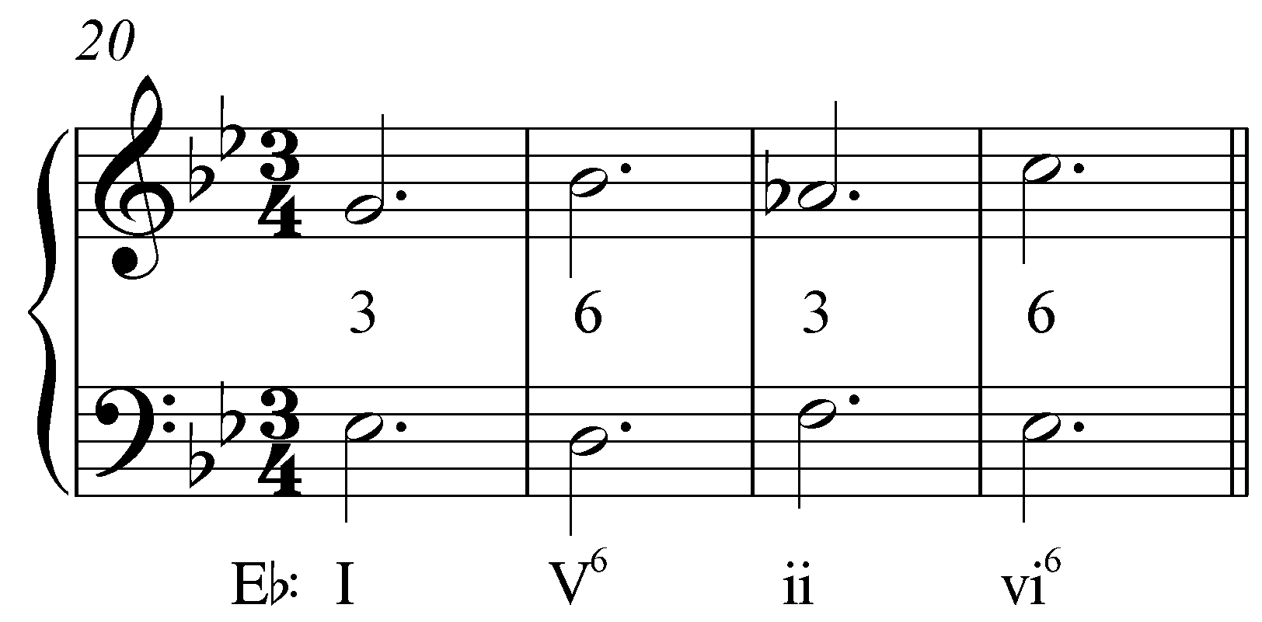

Here, the root-position chords have a third above the bass while the first-inversion chords have a sixth. “3 – 6” interval progressions are also very common. Note that in contrast to descending-fifth sequences, in which the overall motion descends, here the overall motion ascends.

The beginning of Bach’s Little Prelude in C Major, BWV 924, begins with an ascending-fifth sequence (Example 15 provides a reduction):

Example 14 (J.S. Bach, Little Prelude in C Major, BWV 924, mm. 1-3):
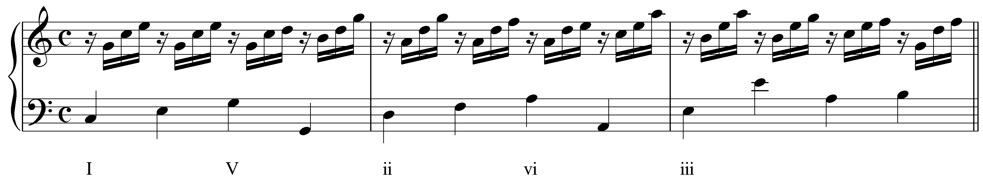

Example 15 (reduction of J.S. Bach, Little Prelude in C Major, BWV 924, mm. 1-3):
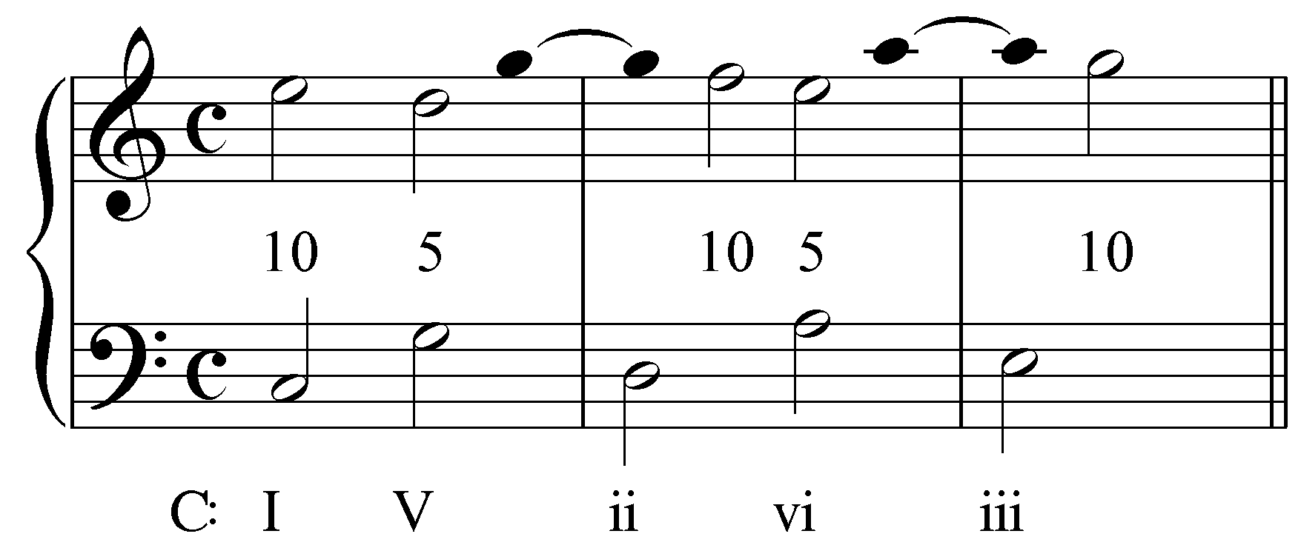

Throughout the passage, Bach uses suspensions and other techniques to smooth out the ascending-fifth progressions. In m. 1, the V chord is introduced as the continuation of a bass arpeggiation of I. The suspended fourth (C on beat 3) resolves on the fourth beat as the upper voice makes a consonant skip up to the root of the triad. That voice is then suspended as a dissonant fourth into the next measure before resolving to the tenth above the bass and repeating the pattern. The basic framework of this sequence, then, is a series of alternating tenths and fifths.

Again, other interval patterns are possible (e.g. “10 – 8” and “10 – 10”) with ascending-fifth sequences, depending on whether chords are inverted, and on what chord member appears in the uppermost voice.

Descending- and ascending-“5 – 6” sequences (sequences based on thirds and seconds):

Sequences in which the harmonic units move by seconds or thirds run a greater risk of creating parallel fifths and octaves than those that move by fifths. For this reason, composers often include intervening chords to break up the parallel motion.

The following excerpt from Beethoven sonata shows a descending-third sequence in which intervening chords appear in first inversion:

Example 16 (L. Beethoven, Piano Sonata in E Major, Op. 109, Mvt. I, mm. 1-3):
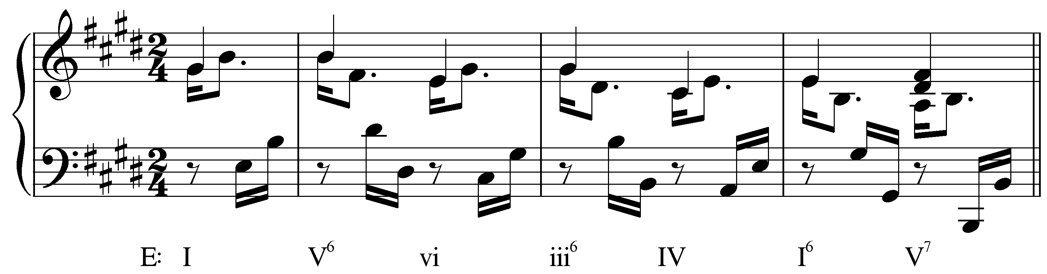

Each step in the chain of descending thirds appears on the second beat of its measure: I – vi – IV. Between each step, however, the chord roots move down by fifth: V⁶ is inserted between I and vi, iii⁶ between vi and IV. These secondary chords—along with the weak metric placement and melodic figuration—obscure the parallel fifths between each step in the sequence. The following reduction clarifies:

Example 17 (reduction of L. Beethoven, Piano Sonata in E Major, Op. 109, Mvt. I, mm. 1-3):
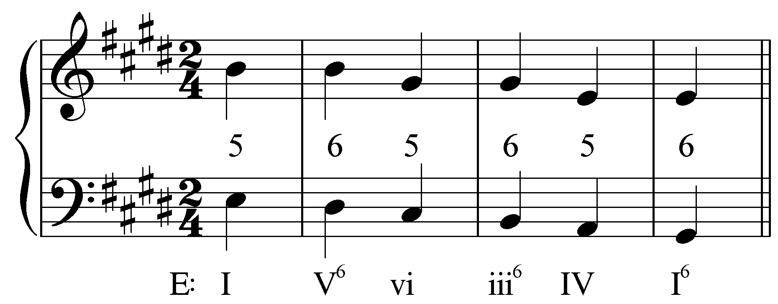

As this reduction shows, alternating between root position and first inversion produces a desirable effect: a stepwise descending bassline. The intervening chords (V⁶ and iii⁶) break up the parallel fifths that would normally result from successive descending third root motions. The result is a series of fifths suspended to become sixths as the bass steps down on the downbeat of each measure. The descending “5 – 6” technique was a popular contrapuntal strategy in the Renaissance and was continually used in later music.

In the following excerpt, the order of harmonies (i - V – VI – III – iv – i) is virtually identical to Example 16, though here they all appear in root position:

Example 18 (J.S. Bach, Fugue No. 16 in G minor, BWV 861, mm. 24-28):
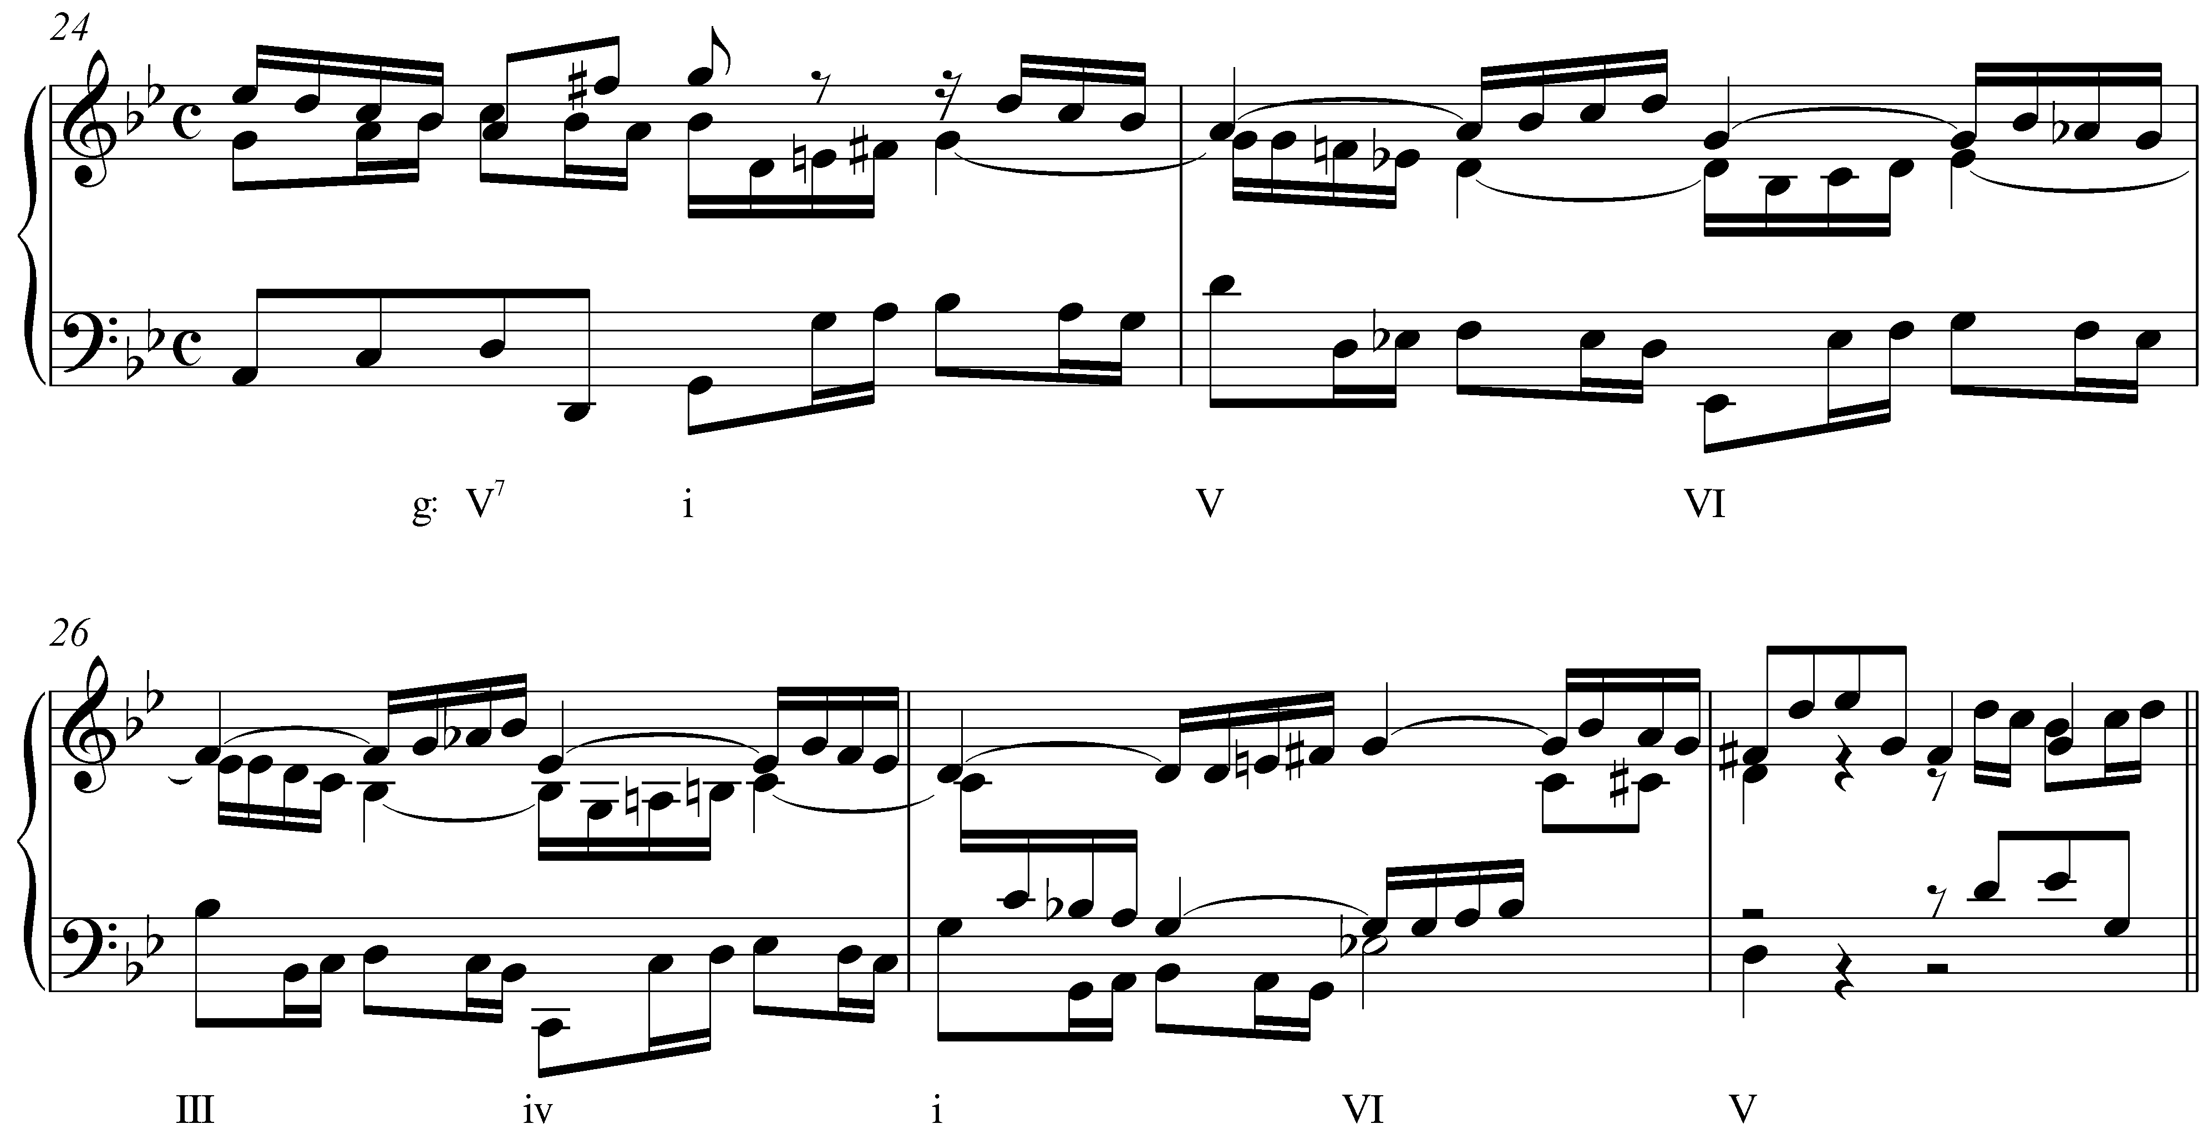

An authentic cadence in G minor initiates a descending-third sequence in m. 24 of this fugue by Bach. Again, each step in the chain of descending thirds appears on the second beat of its measure (i – VI – iv) with intervening chords on the downbeats. These secondary chords—along with the weak metric placement and melodic figuration—obscure the parallel octaves between each step in the sequence. (The parallel octaves appear on beat four of each measure between the bass and the inner voice.)

The following reduction removes some of the melodic figuration to clarify the voiceleading:

Example 19 (reduction of J.S. Bach, Fugue No. 16 in G minor, BWV 861, mm. 25-27):
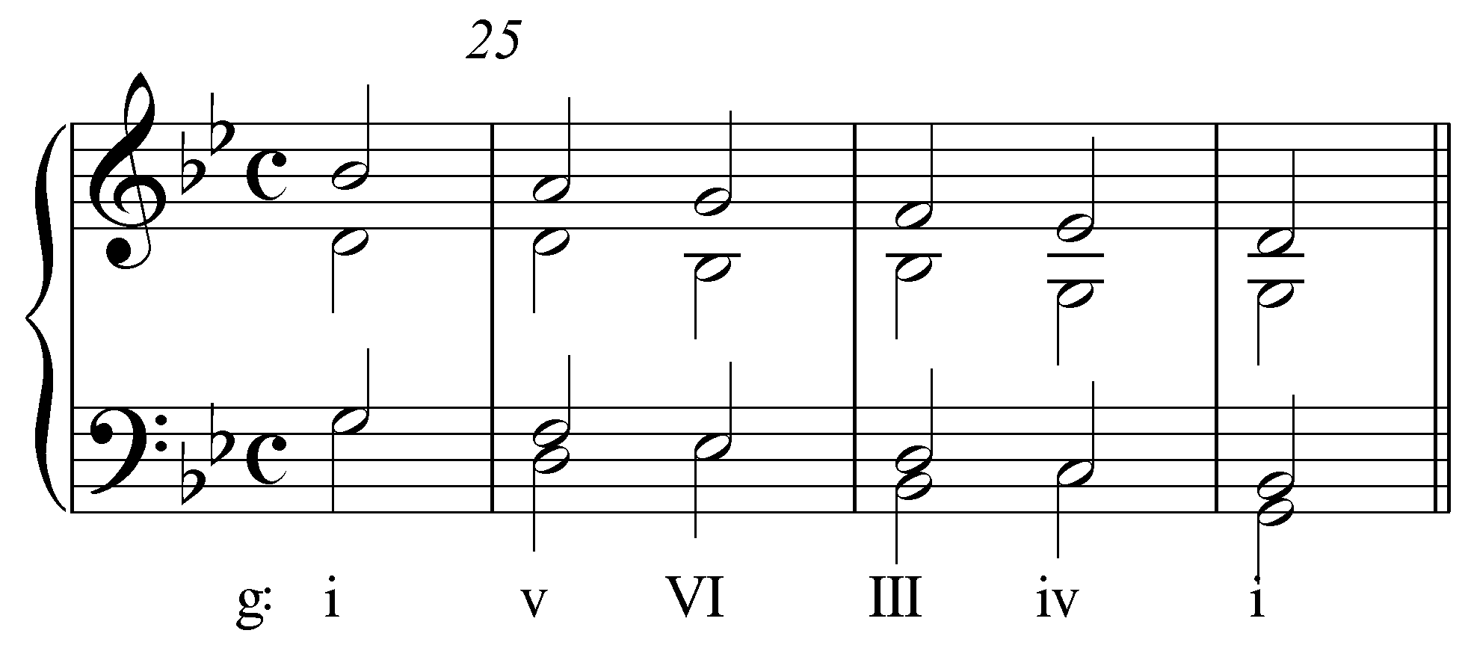

As Example 19 shows, there are four voices present throughout this sequence. Between the outer voices—the “bass” and “soprano” of the reduction—we find tenths on the upbeats alternating with fifths on the downbeats. Because tenths correspond with the main harmonies, we can think of this as a “10 – 10” sequence with intervening fifths.

But take note of the LIP appearing between the “tenor” and “alto.” On the upbeat to m. 25, the alto (D) forms a fifth above the tenor (G). The D is held as the tenor steps down to F forming an oblique “5 – 6” interval progression. This pattern then repeats twice more. This inner-voice interval progression is the same one we saw in Example 17: a descending “5 -6” pattern. Because this pattern is so recognizable, sequences such as the one found in Example 18 are often referred to as root-position variants of the descending “5 – 6” technique.

Note: Reductions like the one found in Example 19 may at first seem very unrelated to the original passage. Likewise, reducing such passages can seem a daunting task. Don’t be discouraged by the apparent complexity of multi-voice sequences. Your ability to identify voiceleading structures will improve with practice and your familiarity with common patterns, like those discussed in this lesson, will be of great help.

In the following excerpt from the fourth of Vivaldi’s Four Seasons concertos, first-inversion chords mediate between each step of an ascending-second sequence:

Example 20 (A. Vivaldi, Violin Concerto in F Minor, Op. 8, no. 4 (“Winter”), Mvt. II, mm 11-13):
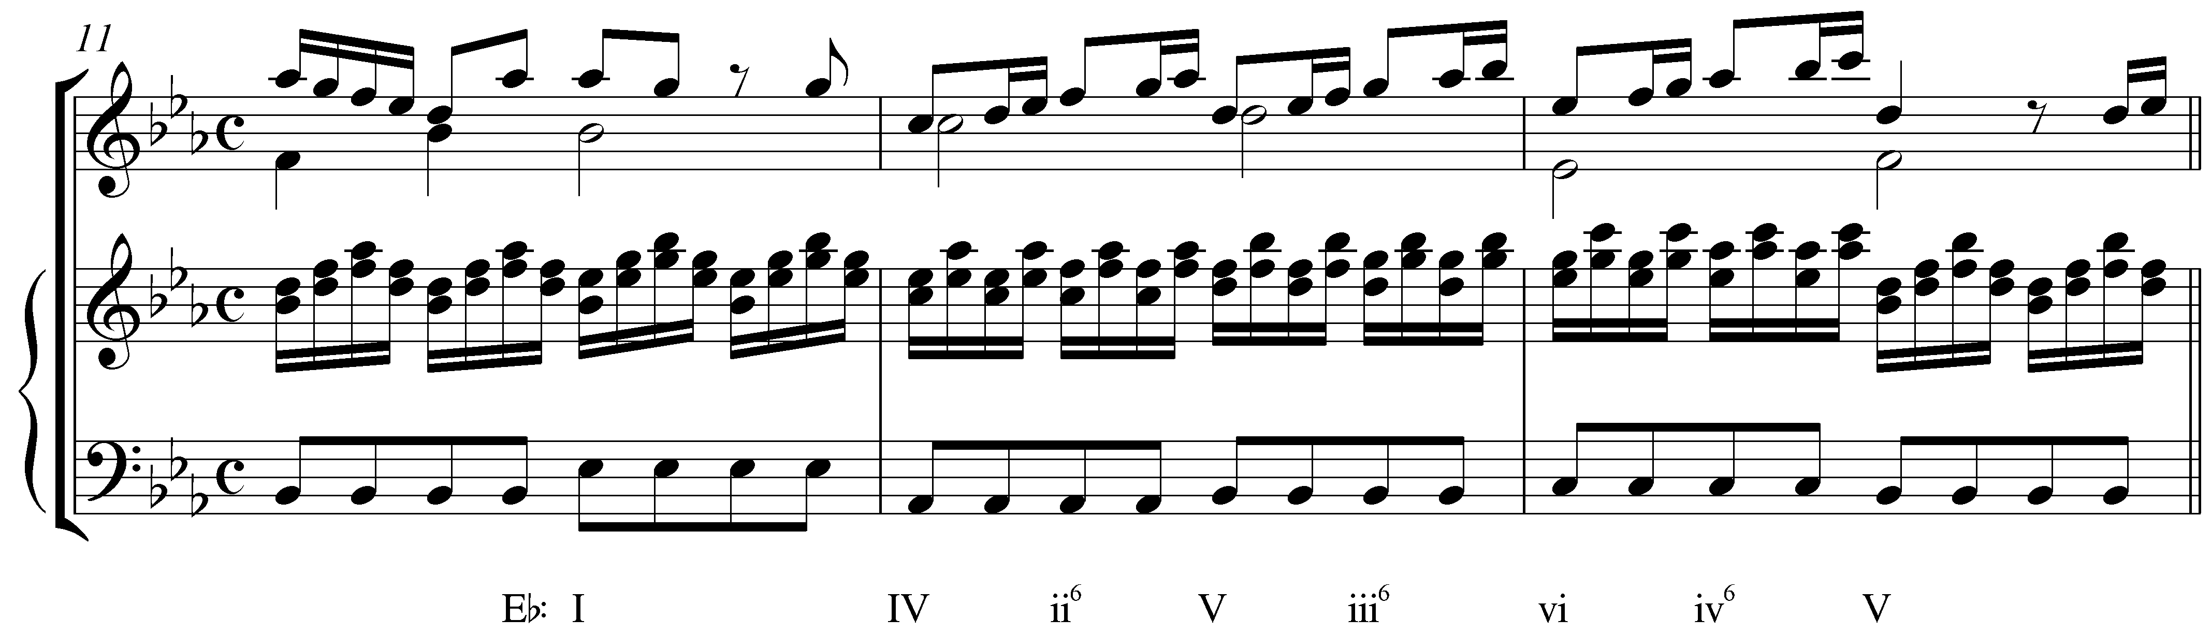

Like sequences based on thirds, ascending-second sequences often make use of intervening chords to break up parallel fifths and octaves. The IV chord on the downbeat of m. 12 initiates the sequence (IV – V – vi) with intervening chords on the weak beats. The intervening chords appear in first inversion, preserving the stepwise motion of the bass. The following reduction reveals the outer-voice interval progression and how the intervening chords obscure the parallel fifths:

Example 21 (reduction of A. Vivaldi, Violin Concerto in F Minor, Op. 8, no. 4 (“Winter”), Mvt. II, mm 11-13):
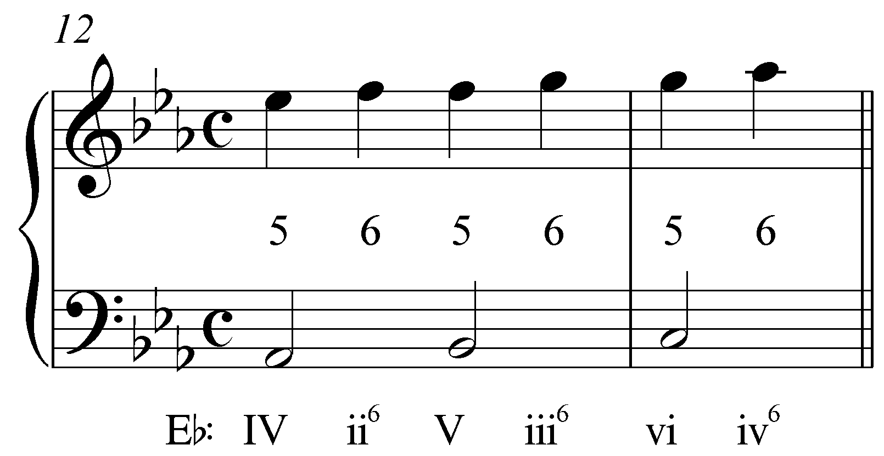

The ascending “5 – 6” motion seen in this reduction is remarkably similar to what we saw in Example 17. The only difference is that here the voices ascend instead of descend. The resultant sixths approach each subsequent fifth with oblique motion. Such interval progressions are often referred to as ascending “5 – 6” LIPs.

In the following excerpt begins with an ascending-third sequence starting with the V⁷ chord in the first measure:

Example 22 (A. Corelli, Sonata no. 11 from Sonate da Camera a Tre, Op. 4, Allemanda, mm. 1-5):
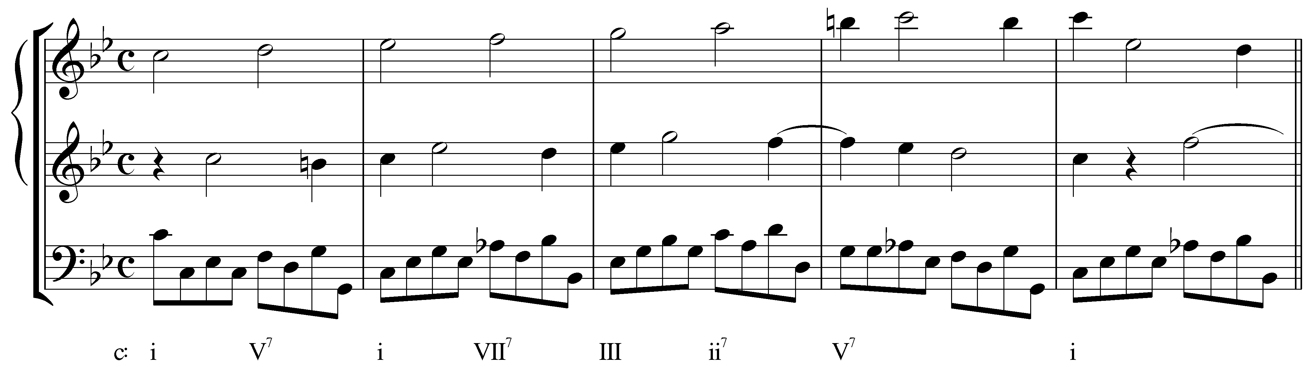

This ascending-third sequence features an ascending stepwise line in the uppermost voice. Again, intervening chords break up the inevitable parallel fifths. Note that while parallel octaves do appear on the downbeats between the bass and the middle voice, they quickly skip up to tenths on the second beat of each measure.

Looking at the reduction, we can see how the mediating chords break up the parallel fifths:

Example 23 (reduction of A. Corelli, Sonata no. 11 from Sonate da Camera a Tre, Op. 4, Allemanda, mm. 2-4):
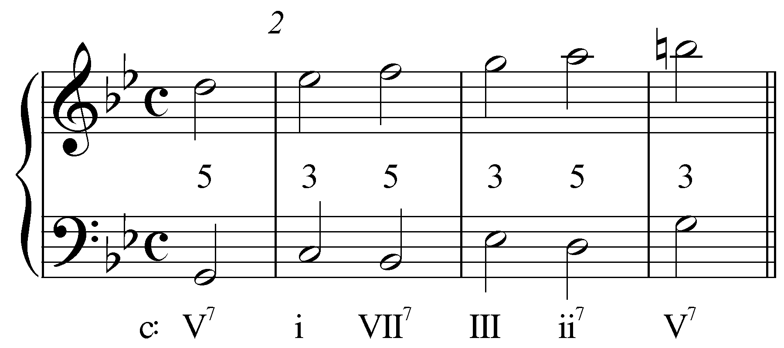

Instead of moving directly from one fifth to the next on the second beat of each measure, thirds intervene on the downbeats, changing the parallel motion to contrary motion. This results in the ascending stepwise motion of the entire upper line. If we consider the partially concealed inner voice, however, we find a familiar pattern:

Example 24 (reduction of A. Corelli, Sonata no. 11 from Sonate da Camera a Tre, Op. 4, Allemanda, mm. 2-4):
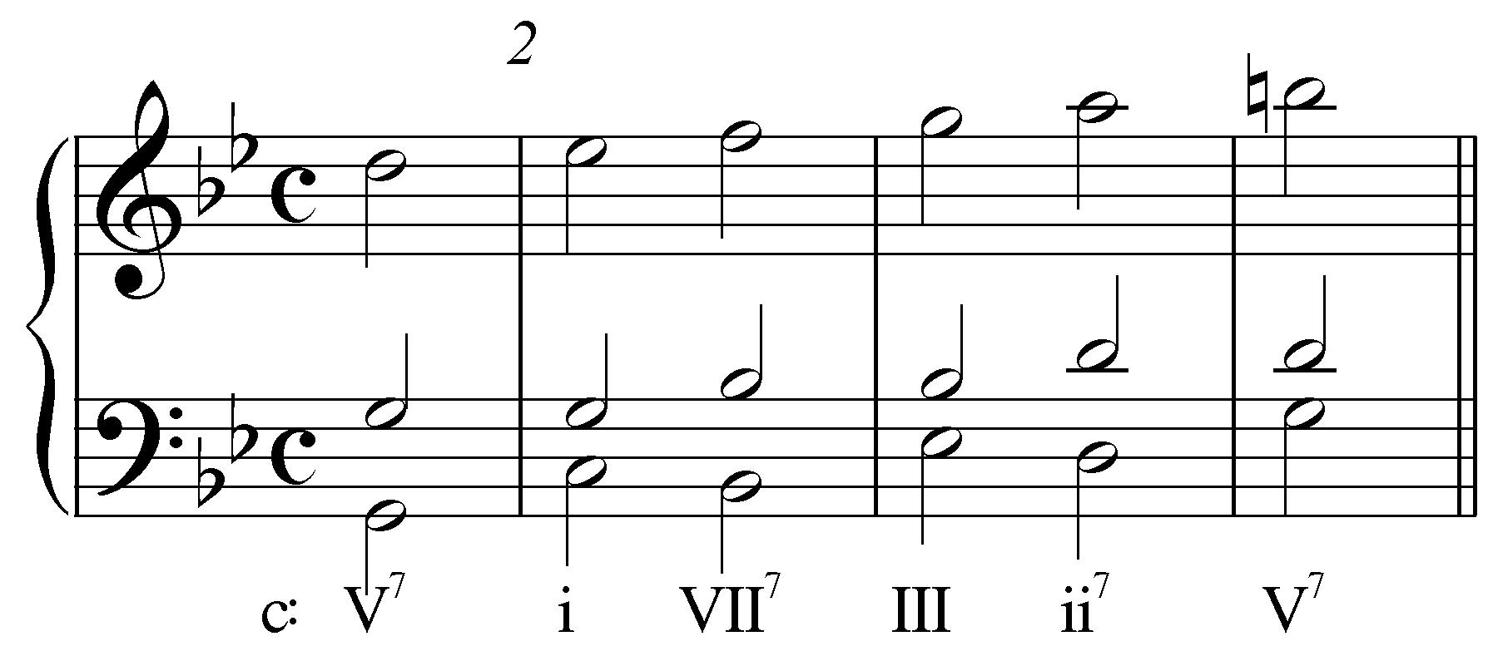

Consider the interval progression formed by the inner voice and the upper voice. On the anacrusis to m. 2, we find the upper voice (D) a fifth above the inner voice (G). The G is held into m. 2 while the upper voice steps up to Eb forming a sixth with the inner voice. The pattern then repeats. This is the same LIP we saw in Example 21! In this case, however, each of the harmonies appears in root position. You can think of this pattern as a root-position variant of the ascending “5 – 6” technique.

Conclusion:

Sequences consist of melodic and harmonic patterns repeated at different pitch levels, which, after a few repetitions, become predictable. Diatonic sequences rely on the listener’s ability to recognize the basic design of the patterns, since the qualities may change from step to step in conforming to the key. Composers use sequences in a number of ways, primarily to prolong a specific harmony or to move from one harmony to another. This lesson focused on non-modulatory sequences, but sequences can also be designed for modulating.

Each step of a sequence—that is, each cycle of the pattern—is successively transposed at a specific interval until the harmonic goal (or key) is reached. The root movement in a majority of sequences is by descending fifths (or ascending fourths), which reflects the general prominence of descending-fifth root motion in tonal music. Some sequences proceed by ascending fifths, others by ascending or descending thirds or seconds.

Significantly, the voiceleading of sequences follows the same basic interval progressions that govern all tonal music. Being able to recognize these patterns in a sequence is an important part of understanding how they work. (It is not important to memorize all of the possible interval patterns that form the skeleton of the various sequence types.) These outer-voice intervallic patterns (LIPs) are determined partly by which chord member appears on top, and partly by whether all chords appear in root position or alternate between root-position and first-inversion.

Alternate examples:

Example 25 (W.A. Mozart, Piano Sonata in Bb major, K. 333, Mvt. III, mm. 188-193):
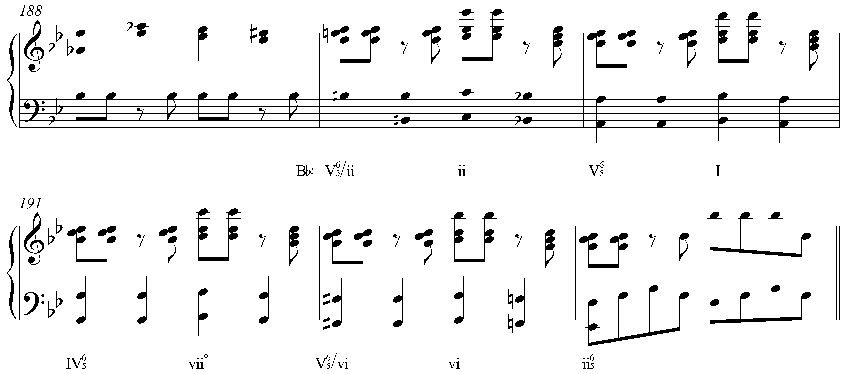
Example 26 (reduction of W.A. Mozart, Piano Sonata in Bb major, K. 333, Mvt. III, mm. 189-192):
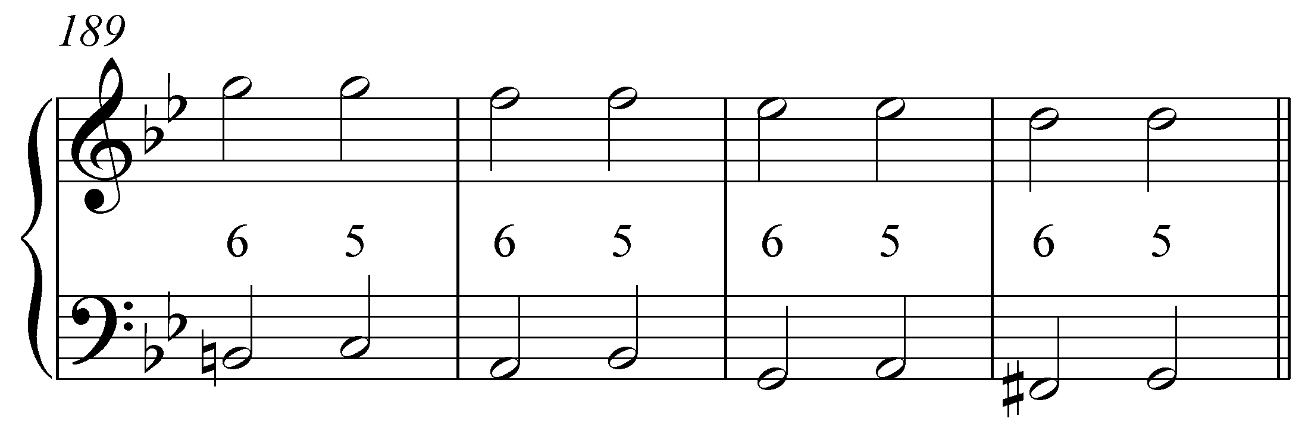

Example 27 (W.A. Mozart, Piano Sonata in D major, K. 284, Mvt. III, mm. 9-10):
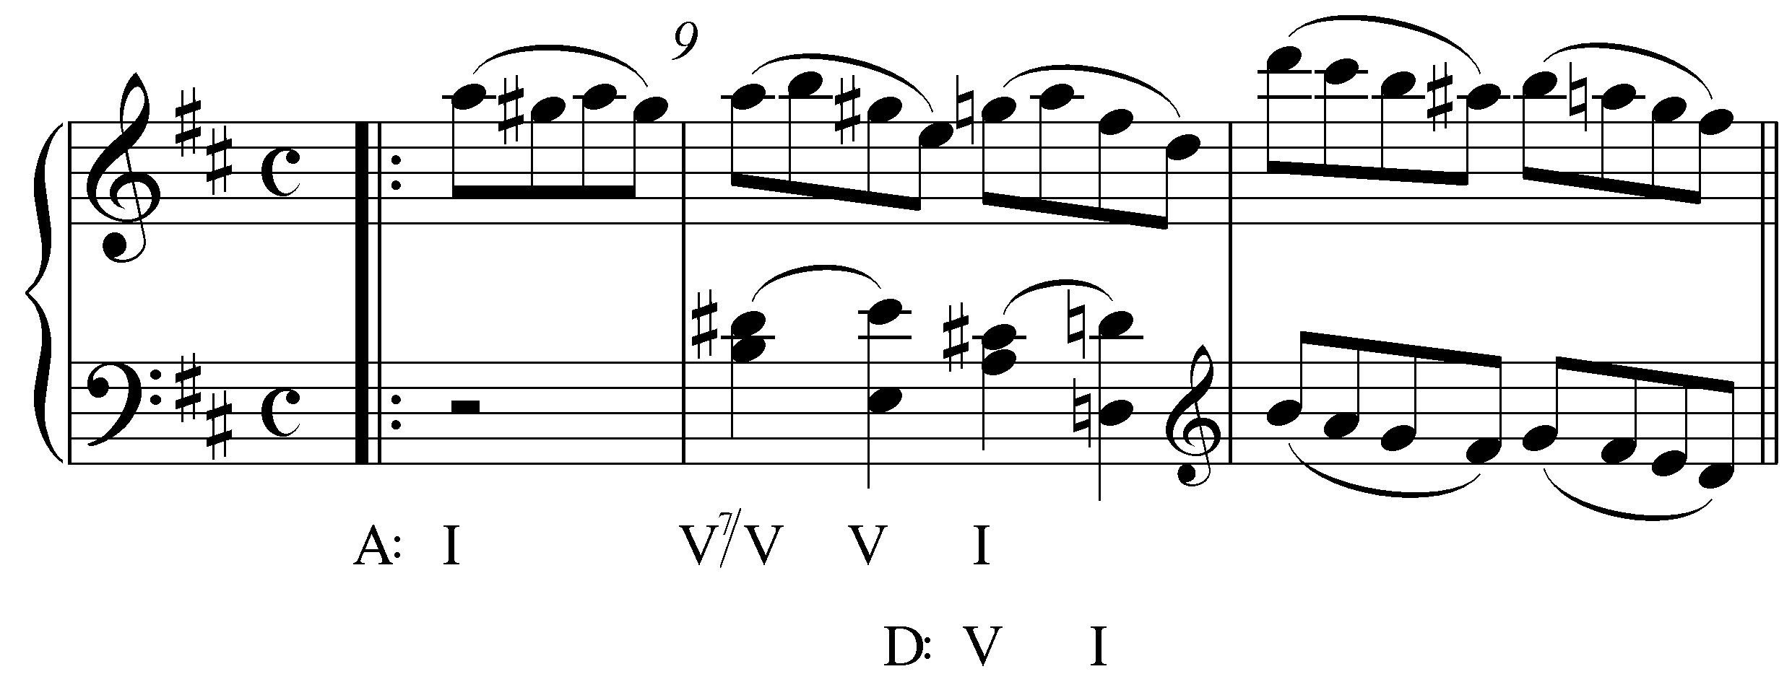
Example 28 (reduction of W.A. Mozart, Piano Sonata in D major, K. 284, Mvt. III, m. 9):
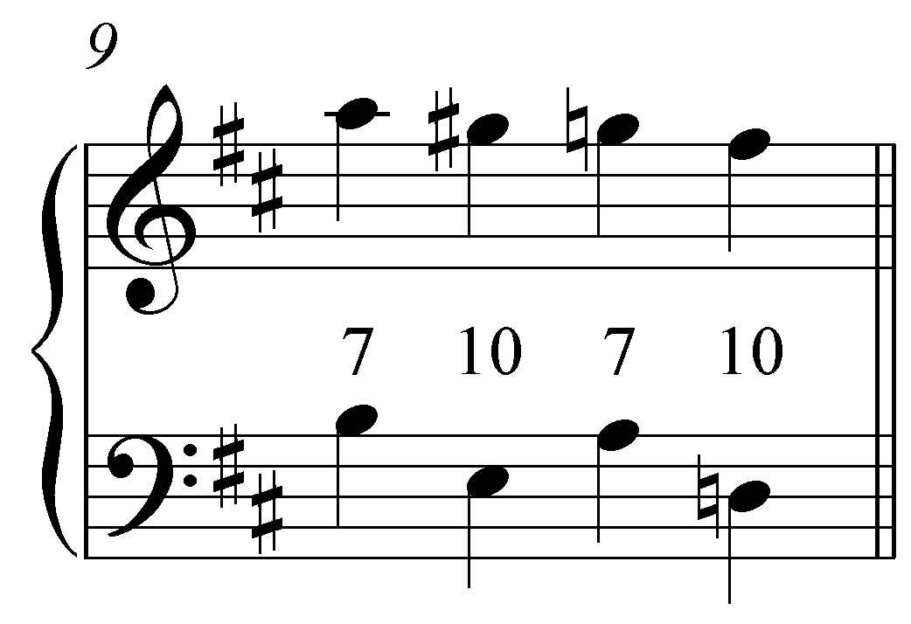

Example 29 (J.S. Bach, Sonata No. 1 in G Minor for Solo Violin, BWV 1001, Mvt. 4, mm. 11-17):
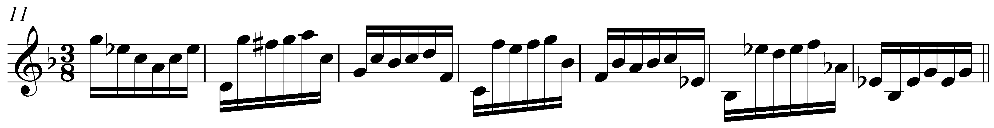

Example 30 (Bach Sinfonia No 8 mm 18-22):
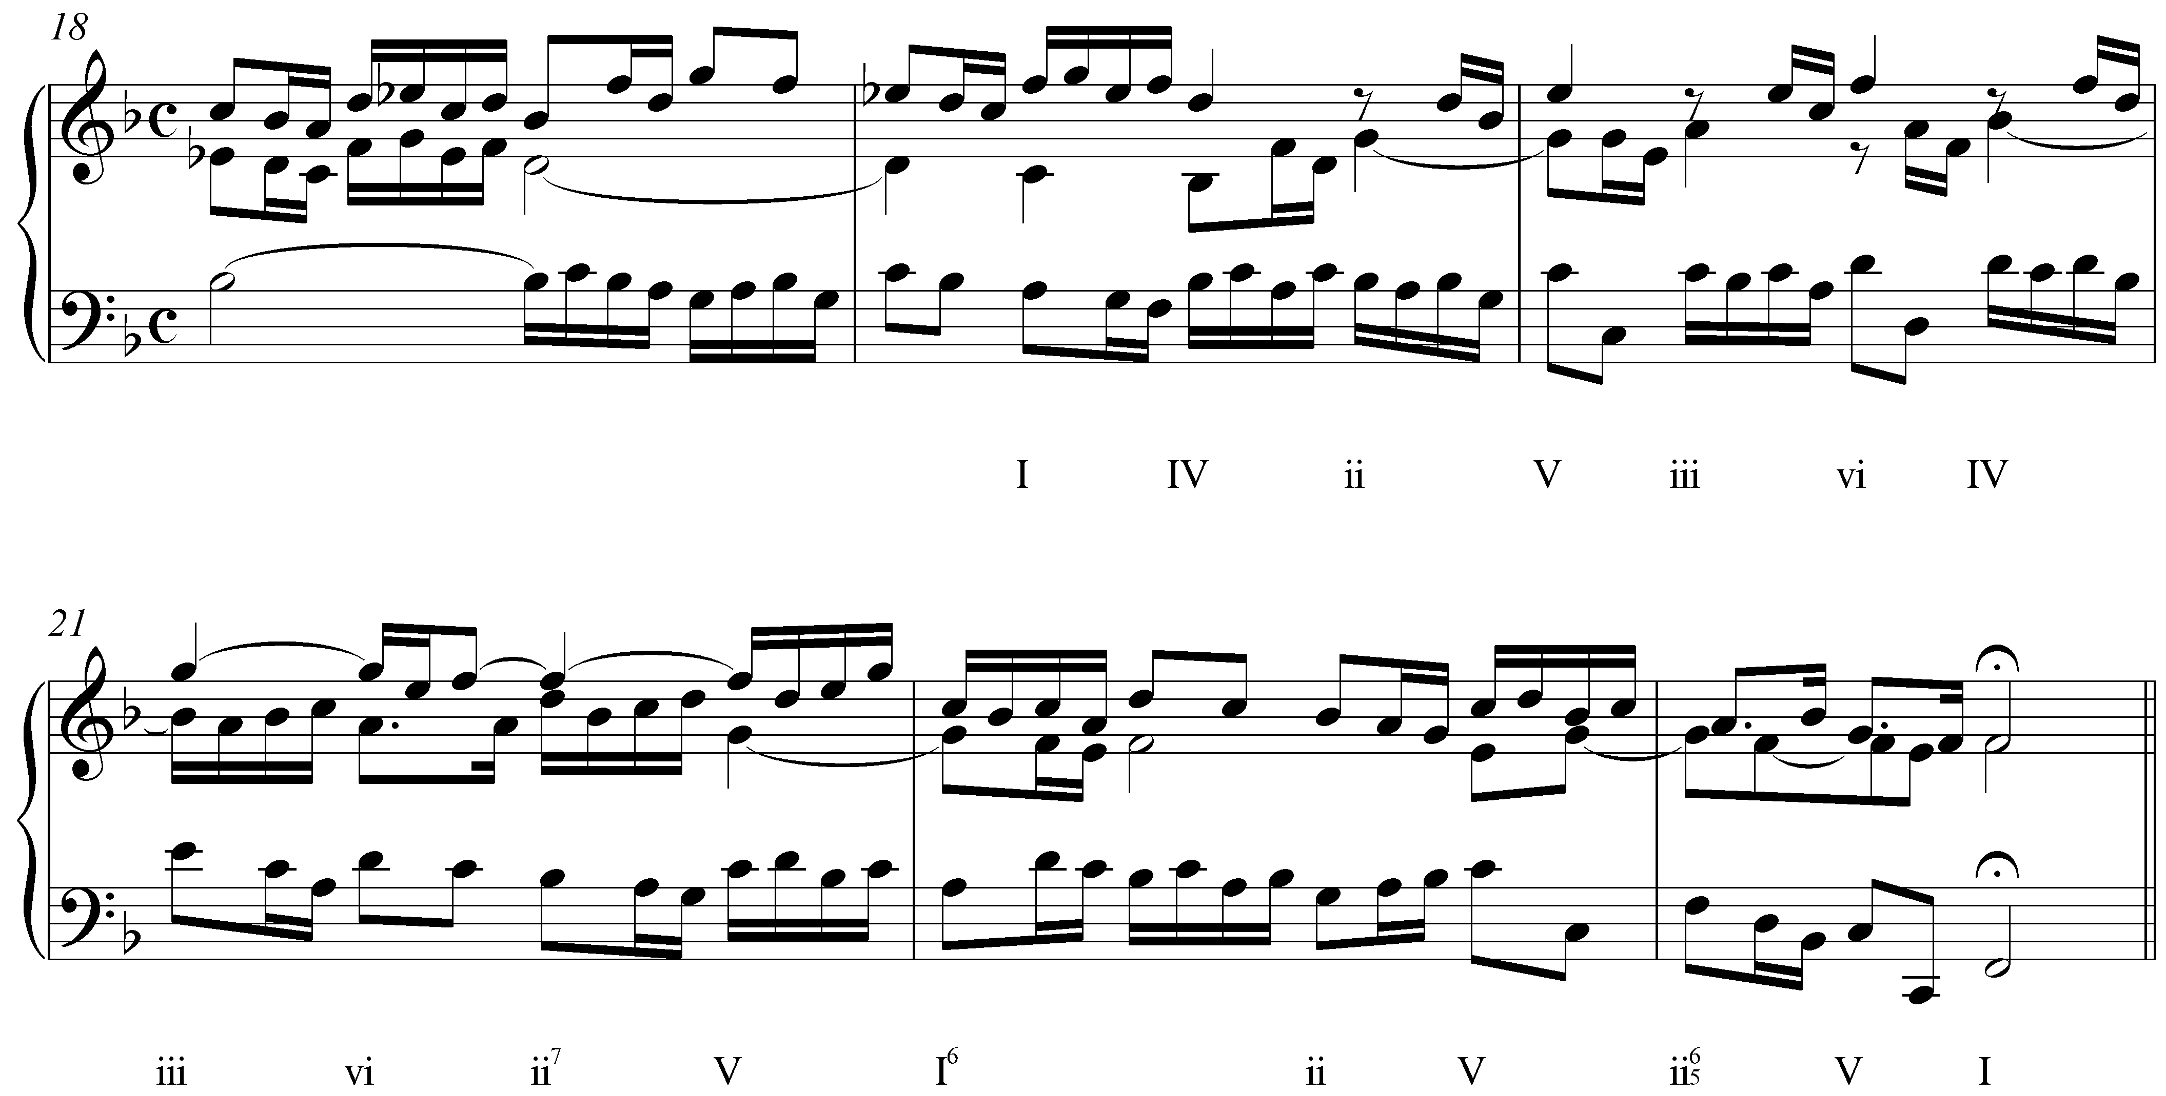

Example 31 (Bach Sinfonia No 12 mm 10-13):
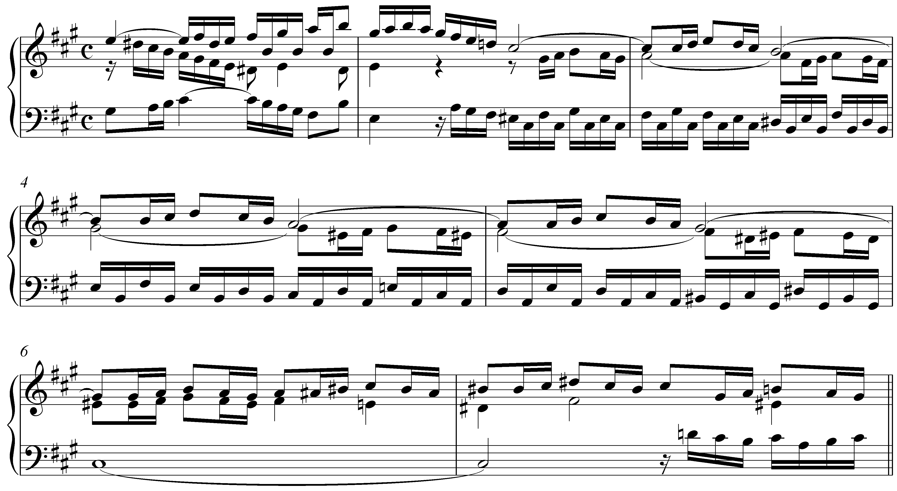

Example 32 (Mozart k 279 i mm 39-47)


