Lesson VVV: Major Keys and Key Signatures
Introduction:

In tonal music, when a piece tends to use primarily the pitches of a single major or minor scale, it is said to be in that major or minor key. Such pieces typically have groups of accidentals called key signatures. The following excerpt from a Mozart sonata has a Bb-major key signature. It appears just after the clef at the beginning of each line:

Example 1 (W.A. Mozart, Sonata in Bb major, K. 281, mm. 1-8):
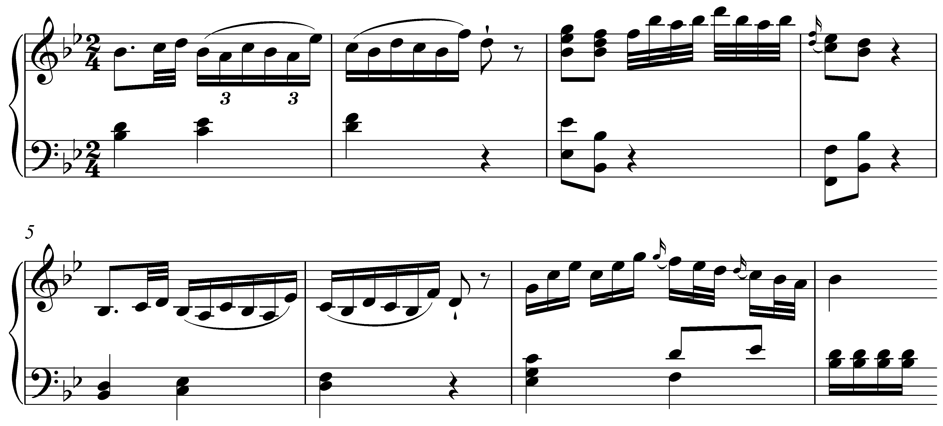

These key signatures provide a convenient way of saving time instead of writing out all of the necessary accidentals for a given key. Instead of writing a “b” before every B and E (as necessitated by the Bb-major scale), the key signature instructs the performer that every B and E are to be played as Bb and Eb respectively unless otherwise noted. Compare Example 1 with the following, which writes out the required accidentals instead of using a key signature. Note how cluttered the score appears compared to Example 1:

Example 2 (no key signature):
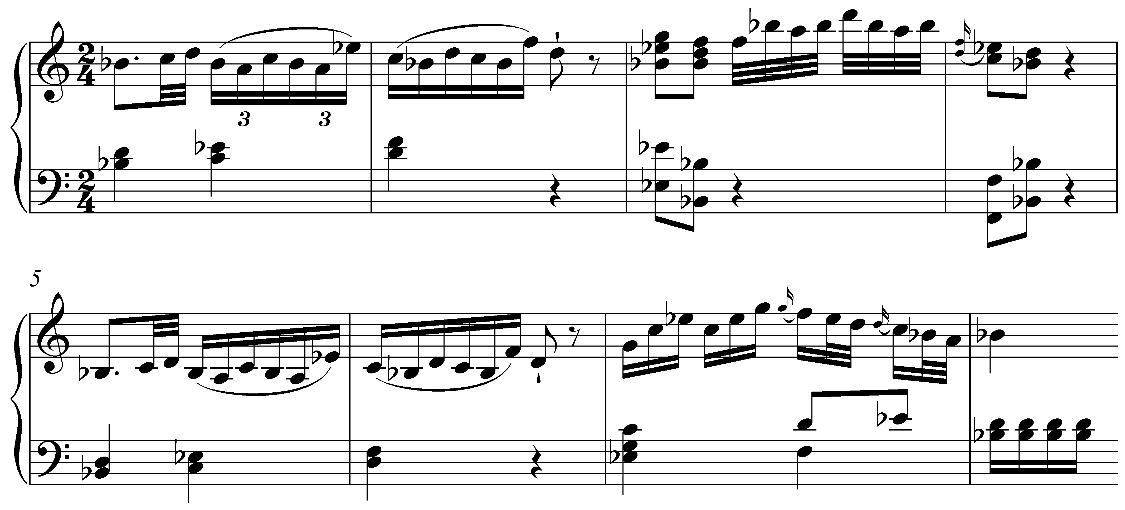

In this lesson, we will discuss how a key is established using the pitches of a major scale, how to determine a major key from a given key signature, and how to write key signatures on bass and treble clefs. We will also look at relationships between major scales and how to organize them with regards to one another.

Major keys:

Lesson UUU discusses the role of the tonic (the keynote) as the most prominent note of a major scale. When a piece is in a major key it takes the pitches from that major scale and gives the tonic a position of primary importance. The remaining scale degrees are treated according to a hierarchy relative to the tonic.

Consider the following familiar melody:

Example 3:

As you can see, this melody uses the pitches C, D, E, F, G, and A. All of these pitches belong to the C major scale (C, D, E, F, G, A, and B). This is a very good indication that this melody is in the key of C major. But all of these pitches also belong to the F major scale (F, G, A , Bb, C, D, and E). To determine the key of this melody—C major or F major—we need to decide which note sounds most like the tonic. Listen to the melody again and consider which pitch, C or F, sounds more stable to your ear.

It is likely that you heard the pitch C as having greater stability. Simply looking at the melody, we can see that C occupies a more stable position than the pitch-class F. The excerpt begins and ends on C, and C holds a prominent position at the end of m. 2 and the beginning of m. 5. Whenever F appears, on the other hand, it is given a shorter note-value, and is always within a descending stepwise passage toward C. Since the pitch class C is the most stable-sounding pitch in the melody, Example 3 is in the key of C major.

The melody from Example 3 can be written in any major key. The following example transposes it (rewrites it at a different pitch level) to E major by raising each note up two whole steps, putting E in the most stable position. The melody sounds the same, only higher:

Example 4:

Activity VVV.1:
Identify the key of each of the following melodies by considering which scale is represented by the present pitches and by looking for points of stability that might be the tonic note.

Exercise: VVV.1a
In what key is the following melody (“Ah! Vous dirai-je, Maman?” better known as “Twinkle, Twinkle, Little Star.”)?
[Answer: “Bb” or “Bb major.” Response if correct: “Correct!” Response if incorrect: “Incorrect. Try again. (Hint: Look for stable pitches that might be the tonic.)”]

Activity VVV.2:
In what key is the following melody (J.S. Bach, “Aus meines Herzens Grunde,” BWV 269, mm. 1-7)?
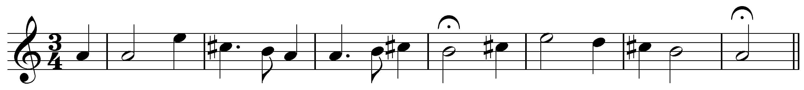
[Answer: “A” or “A major.” Response if correct: “Correct!” Response if incorrect: “Incorrect. Try again. (Hint: Look for stable pitches that might be the tonic.)”]

Key signatures:

Each major scale contains a distinct set of seven pitch classes. (Again, see Lesson UUU for a lengthier discussion of the major scale.) One major scale may share as many as six pitches with another, as we saw in Example 3, but not all. (Two major scales that share seven pitch classes in common are considered to be the same scale.) Since each major scale is unique in this way, a piece in a major key will draw from the same pitches as its corresponding major scale. These sharps and flats used in the corresponding major scale are usually written at the beginning of each line in a key signature.

The key signature is a collection of sharps or flats that indicates which notes should be raised or lowered so that they belong to the key. In C major, there are no sharps or flats in the key signature, just as there are no sharps or flats in the C major scale. In keys other than C major, the key signature is written to the right of the clef, just before the time signature, at the beginning of each line of music. In Example 4 we transposed “Twinkle, Twinkle, Little Star” to the key of E major. The following example shows the same melody in E major but here makes use of a key signature instead of writing out all the accidentals:

Example 5:
a. (without key signature):

b. (with key signature)

E major has four sharps (F#, C#, G#, and D#), all of which appear in the key signature. Sharps or flats in the key signature apply to every octave. In other words, the F# in the key signature indicates that every F should be made sharp—the F on beat three of the second measure, for example, even though it’s not on the same line. (Even though D# is not used in this melody, the accidental is left in the key signature. Doing so makes it clear that this excerpt is in E major.)

Activity VVV.2:
Identify the major key represented by each of the following key signatures:

Exercise VVV.2a
Which major key does the following key signature represent?
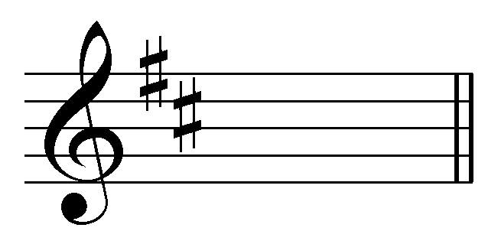
[Answer: “D” or “D major.” Response if correct: “Correct!” Response if incorrect: “Incorrect. Try again. (Hint: Which major scale has two sharps?)”]

Exercise VVV.2b
Which major key does the following key signature represent?
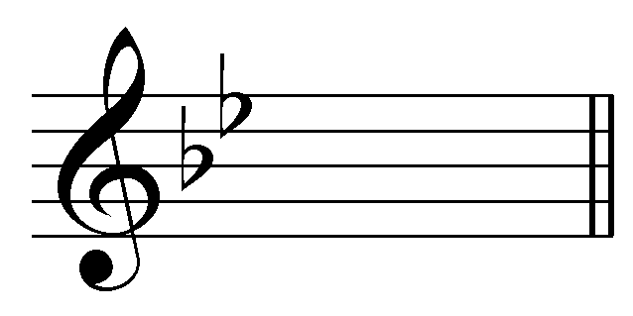
[Answer: “Bb” or “Bb major.” Response if correct: “Correct!” Response if incorrect: “Incorrect. Try again. (Hint: Which major scale has two flats?)”]

Exercise VVV.2c
Which major key does the following key signature represent?
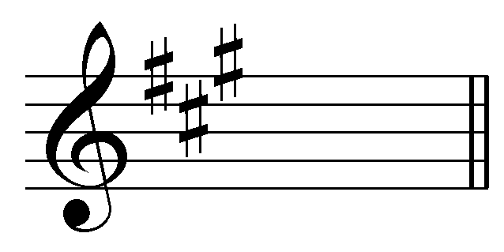
[Answer: “A” or “A major.” Response if correct: “Correct!” Response if incorrect: “Incorrect. Try again. (Hint: Which major scale has three sharps?)”]

Exercise VVV.2d
Which major key does the following key signature represent?
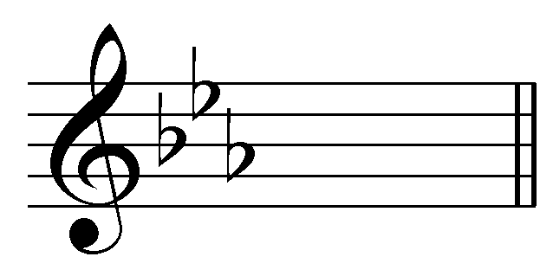
[Answer: “Eb” or “Eb major.” Response if correct: “Correct!” Response if incorrect: “Incorrect. Try again. (Hint: Which major scale has three flats?)”]

Pitches specified by the key signature can be canceled out by an accidental next to a note, as in the following example:

Example 6 (W.A. Mozart, Piano Sonata in Eb major, K. 282, mm. 1-4):
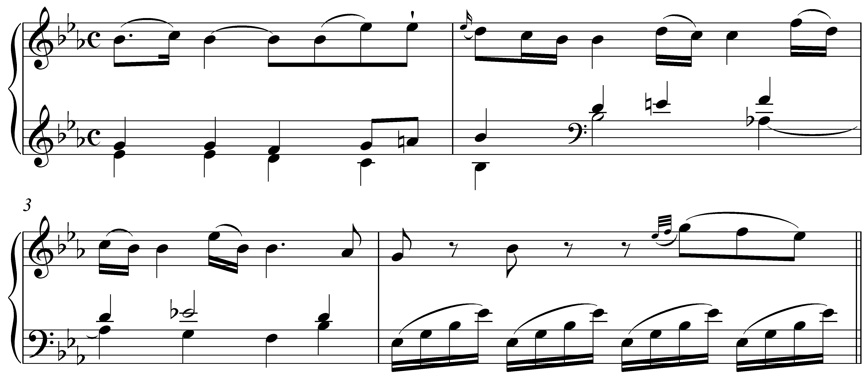

This piece is in Eb major, which has three flats (Bb, Eb, and Ab) as specified by the key signature. The natural sign (ª) next to the A on the last eighth note of the first measure cancels out the Ab of the key signature. This cancelling out of Ab lasts only as long as the measure the accidental appears in. By the second measure, all As should again be flatted according to the key signature.

Note: You will frequently come across accidentals that may seem unnecessary. The flat next to the A on the fourth beat of m. 2, for instance seems superfluous, given the Ab in the key signature. Such accidentals are referred to as “courtesy accidentals.” They occur after a previous accidental altered a given pitch (in this case, the A natural at the end of the first measure) to remind the performer that a scale degree has gone back to normal as specified by the key signature.

Writing key signatures:

In Lesson UUU we discussed how one octave of a major scale can be divided into two tetrachords, an upper and a lower, each of which follows the same a W-W-H step pattern. In C major, for example, the lower tetrachord would be (C, D, E, F) and the upper (G, A, B, C). Since the pattern of whole steps and half steps is identical in each major tetrachord, they can both be used interchangeably as either the upper or lower tetrachord of a major scale. The upper tetrachord of a C-major scale (G, A, B, C) could, for example, also serve as the lower tetrachord of a G-major scale:

Example 7:
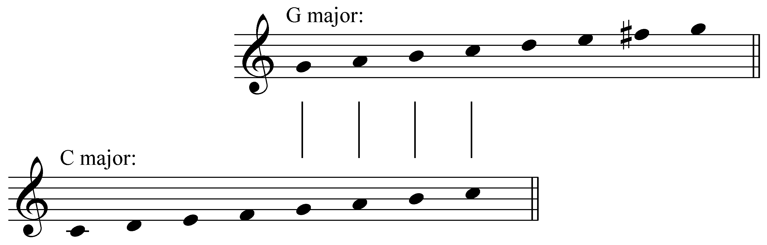

Notice how similar these two scales are. They have six pitch classes in common (G, A, B, C, D, and E), differing in only one note: C major has F, while G major has F#. Scales like these that share six out of their seven pitch classes are referred to as closely related. Their key signatures, therefore, will differ by only one accidental. (C major has no sharps, G major has one sharp.)

The following example shows the key signatures for C and G major, and takes the process one step further, using the upper tetrachord of G major (D, E, F#, G) as the lower tetrachord of D-major. Each subsequent scale, in other words, begins on the fifth degree of the scale before it (as shown by the arrows):

Example 8 (sharp keys):

a. key signatures: b. scales:
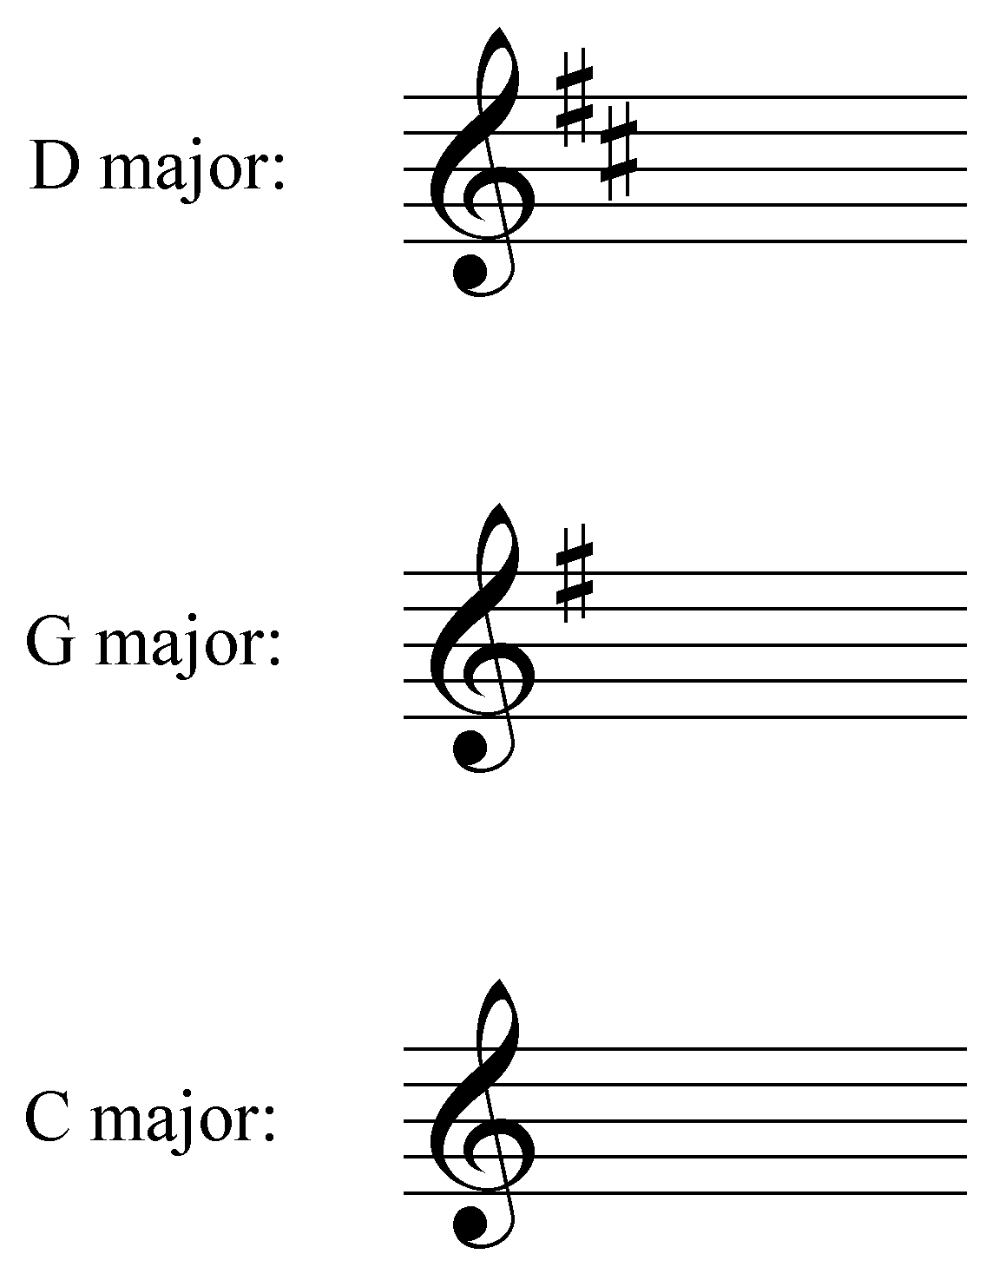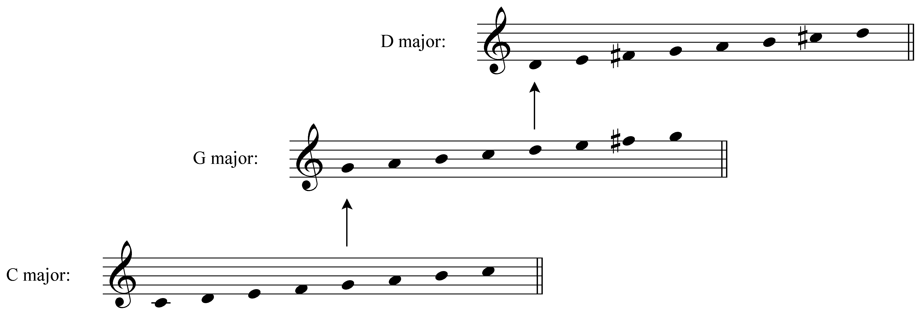

We can see a pattern beginning to emerge. G major is built on scale degree 5 of C major and has one sharp (F#). D major is built on scale degree 5 of G major and has two sharps (F# and C#). We could continue the pattern by building a major scale on scale degree 5 of D major (A) and would arrive at A major, which has three sharps (F#, C#, and G#). And so on…

The following example shows all of the sharp key signatures up through seven sharps—from C major, in which none of the notes require an accidental, to C# major, in which every note is sharped:

Example 9 (sharp key signatures):
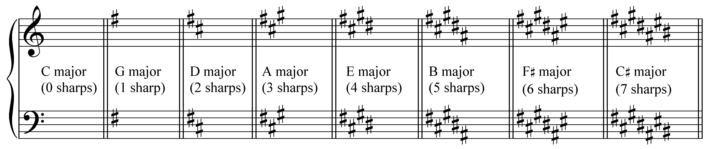

The sharps or flats in a key signature must be written in a particular order and position on the staff. Notice how none of the sharps are written on ledger lines and that the key signatures are adjusted depending on which clef is assigned to the staff. It is important that you memorize not only the order in which particular sharps are added to the key signature (F#, C#, G#, D#, A#, E#, B#), but also the pattern in which they are added on the staff.

Note: You may find it helpful to come up with mnemonic devices to help remember these patterns. The order of sharps as they are added to a key signature, for example, can be remembered by the sentence: “Father Charles Goes Down And Ends Battle.”

There is also a useful, quite easy trick for determining the tonic of a sharp key. In every sharp key, the right-most accidental of the key signature is the leading tone of the key. Say the key signature has five sharps: F#, C#, G#, D#, A#. A# is the leading tone for the B major scale. Therefore, the key is B major.

Activity VVV.3:
Write out each of the following sharp key signatures. Be sure to write each sharp on the appropriate line and in the correct order.

Exercise VVV.3a
Write out a G-major key signature on the staff provided:
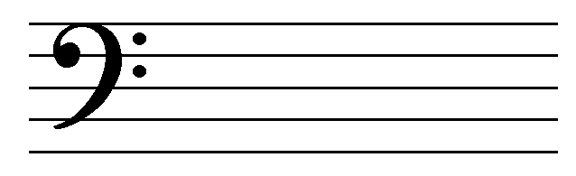
[Answer: 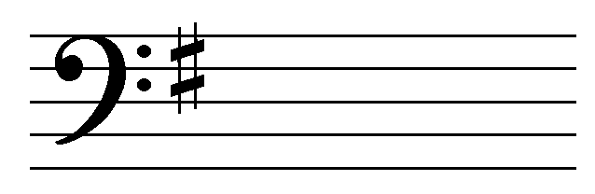. Response if correct: “Correct! G major has one sharp.” Response if incorrect: “Incorrect. Try again.”]

Exercise VVV.3b
Write out an F#-major key signature on the staff provided:
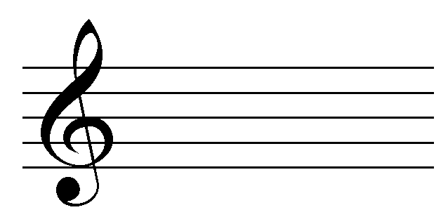
[Answer: 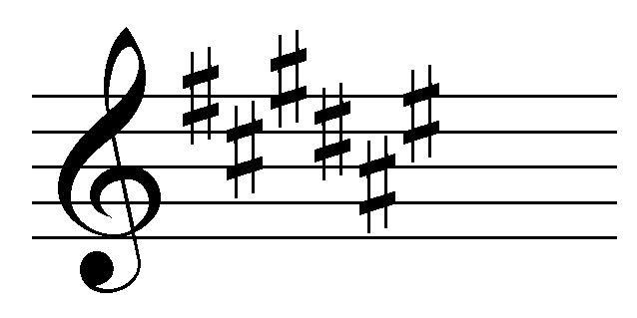. Response if correct: “Correct! F# major has six sharps.” Response if incorrect: “Incorrect. Try again.”]

Exercise VVV.3c
Write out an D-major key signature on the staff provided:
[Answer: 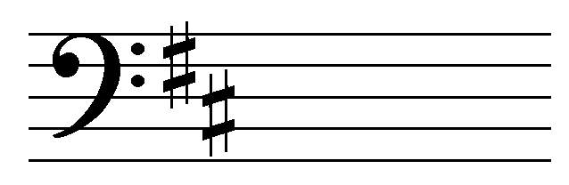. Response if correct: “Correct! D major has two sharps.” Response if incorrect: “Incorrect. Try again.”]

Exercise VVV.3d
Write out an E-major key signature on the staff provided:
[Answer: 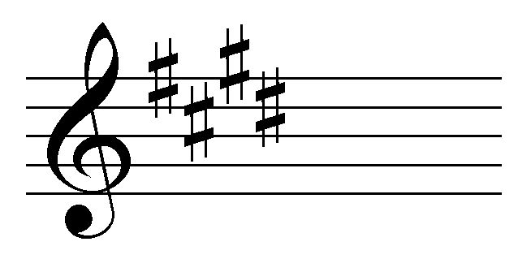. Response if correct: “Correct! E major has four sharps.” Response if incorrect: “Incorrect. Try again.”]

Flat key signatures can be determined similarly, though here, the lower tetrachord of each scale becomes the upper tetrachord of the next closely-related key. Instead of going up four steps from the tonic to begin each subsequent key on scale degree 5, we must go down four steps from the tonic and start on scale degree 4. F major, for example, begins on scale degree 4 of C major and has one flat (Bb):

Example 10 (flat keys):

a. key signatures: b. scales:
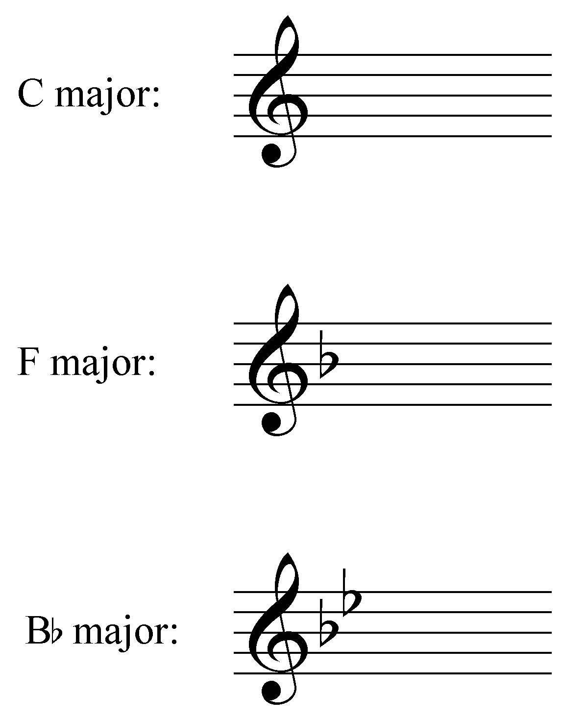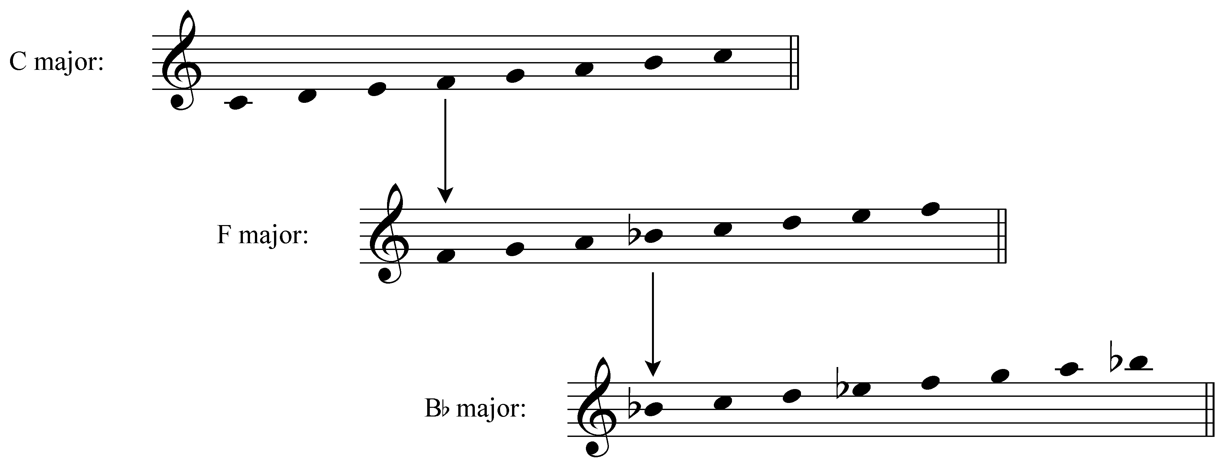

Bb major begins on scale degree 4 of F major and has two flats (Bb and Eb). If we were to continue, the next key would be Eb major which would have three flats (Bb, Eb, and Ab). And so on…

The following example shows all of the flat key signatures up to seven flats:

Example 11 (flat key signatures):
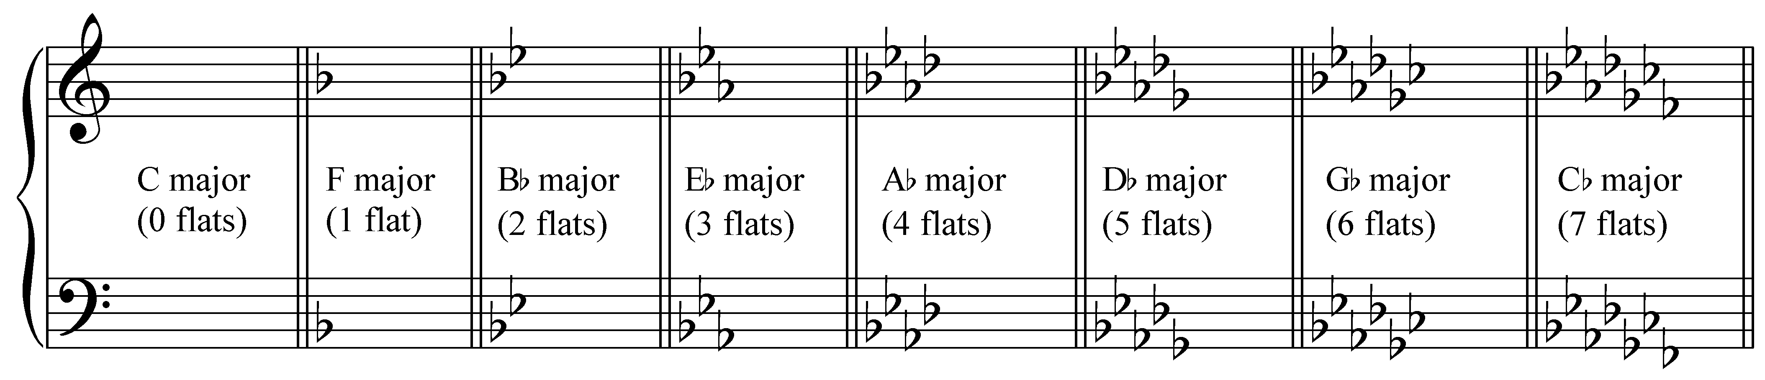

Again, it is essential that you remember the order in which flats are added to key signatures and the pattern in which they are notated on the staff.

Note: The order of flats as they are added to a key signature can be reversing the mnemonic for sharp keys: “Battle Ends And Down Goes Charles' Father.”

The second to last accidental in a flat key signature will tell you the key. Eb major, for example, has three flats: Bb, Eb, and Ab. The second to last (Eb) is the tonic of the key!

Activity VVV.4:
Write out each of the following flat key signatures. Be sure to write each flat on the appropriate line and in the correct order.

Exercise VVV.4a
Write out an Ab-major key signature on the staff provided:
[Answer: 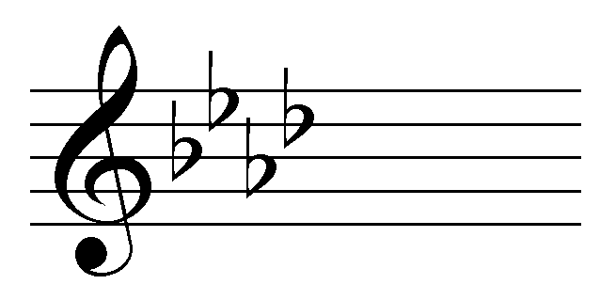. Response if correct: “Correct! Ab major has four flats.” Response if incorrect: “Incorrect. Try again.”]

Exercise VVV.4b
Write out an F-major key signature on the staff provided:
[Answer: 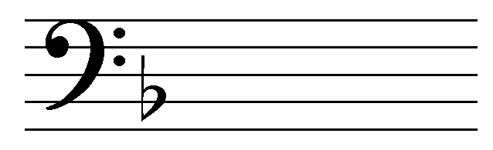. Response if correct: “Correct! F major has one flat.” Response if incorrect: “Incorrect. Try again.”]

Exercise VVV.4c
Write out an Db-major key signature on the staff provided:
[Answer: 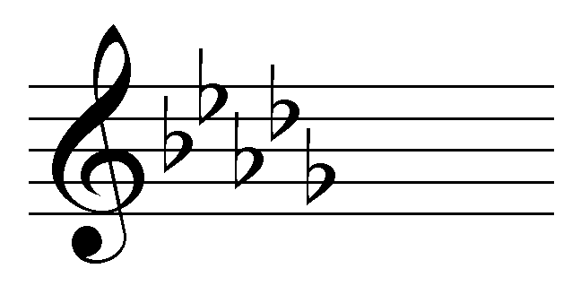. Response if correct: “Correct! Db major has five flats.” Response if incorrect: “Incorrect. Try again.”]

Exercise VVV.4d
Write out an Eb-major key signature on the staff provided:
[Answer: 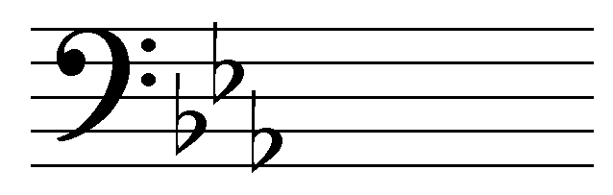. Response if correct: “Correct! Eb major has three flats.” Response if incorrect: “Incorrect. Try again.”]

As you can see from Examples Example 9 and Example 11, we typically divide keys into two categories: “sharp keys” (those whose key signatures consist of sharps) and “flat keys” (those whose key signatures consist of flats). In tonal music, you will never see a key signature with a mixture of sharps and flats. You may, however, encounter natural signs in a key signature when the accidentals of a previous key signature must be canceled out as in the following excerpt where the key changes to E major in m. 17:

Example 12 (F. Chopin, Etude No. 10, Op. 10, mm. 16-17):
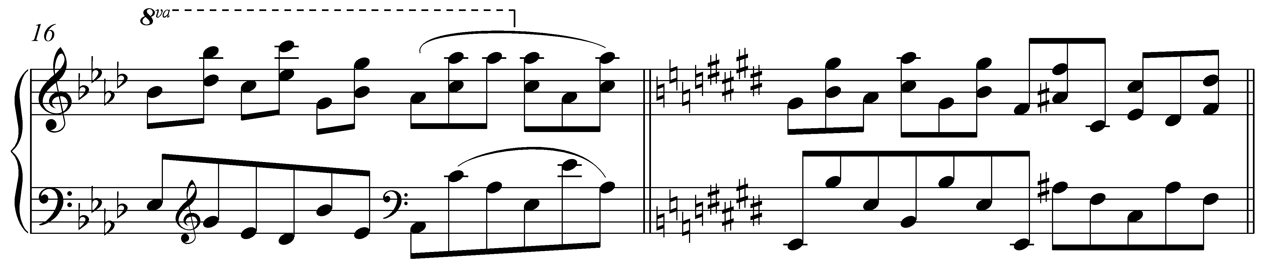

The circle of fifths:

In the previous section, we discussed the relationships between closely-related major scales. With regards to sharp keys, we saw that if we started with C major we could build another major scale (G major) on scale degree 5 which would have one sharp in the key signature. If we built a major scale on 5 of G major, we would arrive at D major which requires two sharps.

A useful way to visualize these key relationships is with a diagram commonly referred to as the circle of fifths. C major is placed at the top of the diagram because it requires no accidentals. The number of sharps for each corresponding key signature is indicated on the inner circle:

Example 13 (the circle of fifths—sharp keys only):
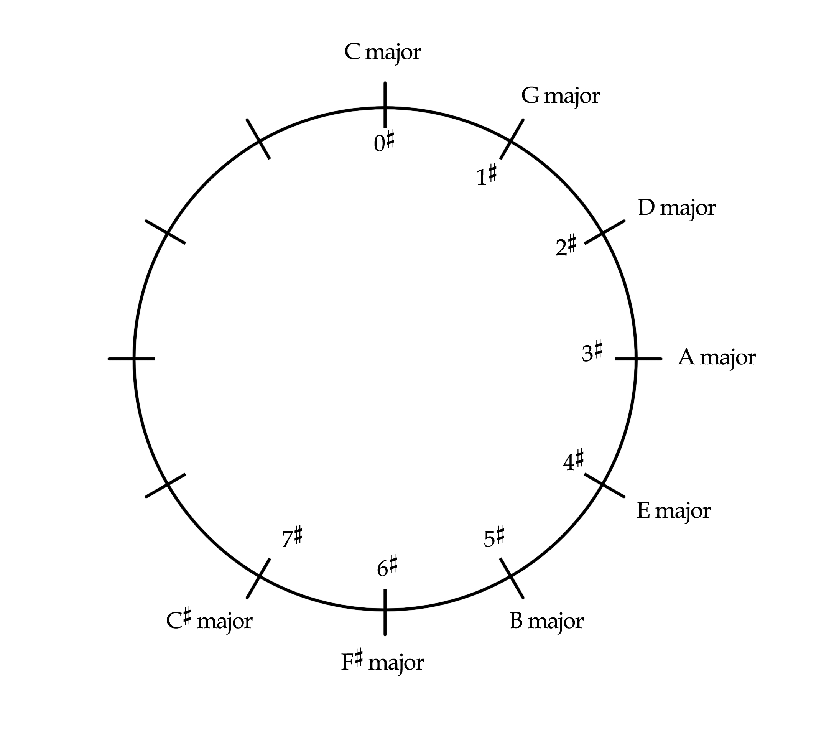

The circle of fifths gets its name from the fact that as we move clockwise around the circle, each new key is built on the fifth scale degree of the one that comes before it. Each clockwise step also adds one more sharp to the key signatures. Moving from D major to A major, for example, requires the addition of one more sharp:

Example 14:
a. D major: b. A major:
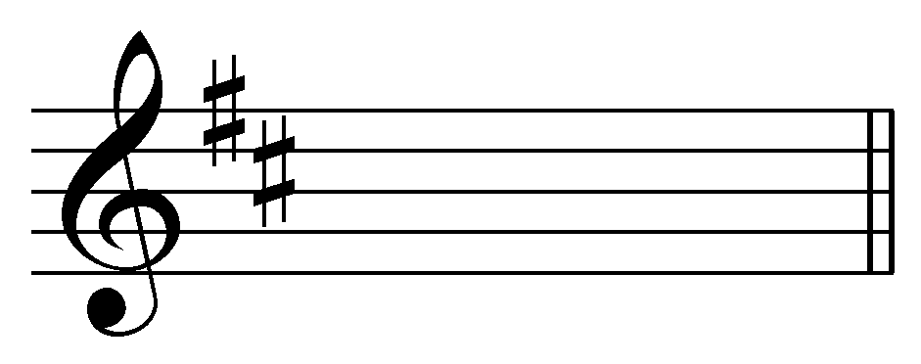 → 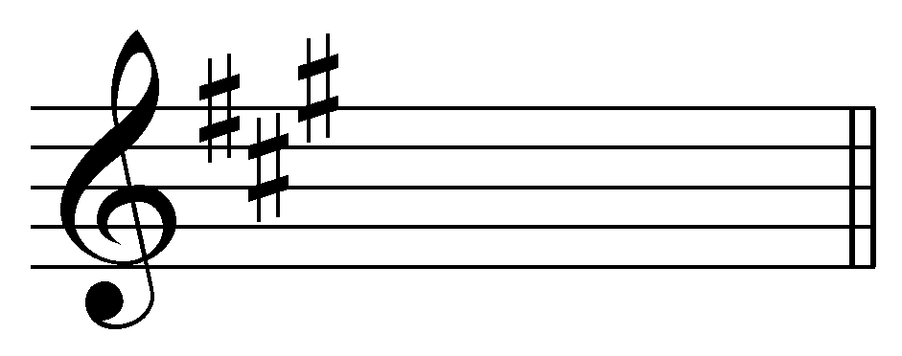

We can add flat keys to the circle as well. Increasingly flat keys will move counterclockwise around the circle:

Example 15 (the circle of fifths—all major keys):
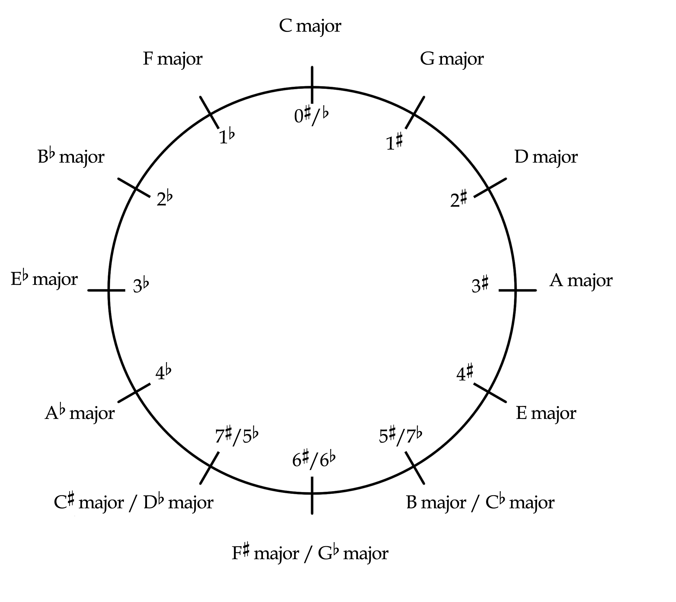

Moving counterclockwise from C major, each subsequent key is built on scale degree 4 and has one more flat than the one before it. Moving from Eb major to Ab major, for example, requires one additional flat in the key signature:

Example 16:
a. Eb major: b. Ab major:
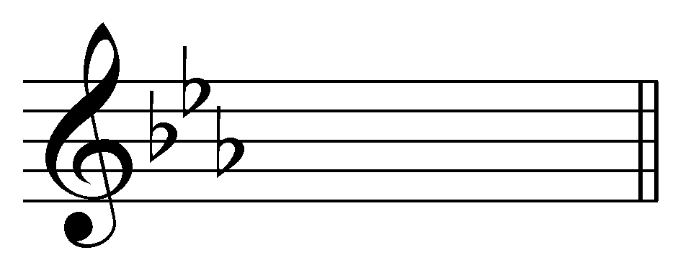 → 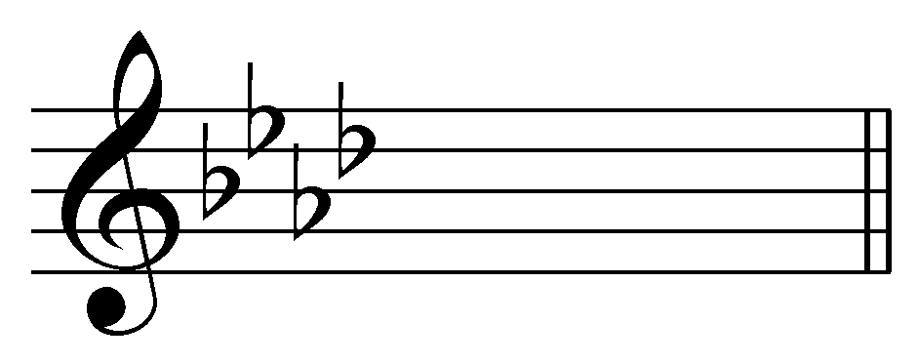

If we consider the entire circle, we can make an interesting observation. A clockwise move results in one of the pitches of the scale, scale degree 4, being raised. This raised pitch becomes scale degree 7 in the new key. For example, in moving from D major to A major, G is raised to G#, as in Example 14. Likewise, moving counterclockwise around the circle will result in one pitch, scale degree 7, being lowered. This lowered pitch becomes scale degree 4 in the new key. Soomoving from Eb major to Ab major requires that D be lowered to Db, as in .)

Notice as well that there is some overlap at the bottom of the circle. These keys—which tend to be used less frequently than those with fewer accidentals—are enharmonically equivalent. C# major and Db major, for example, both begin on the same pitch class, but are spelled differently.

You should be familiar enough with the relationships between major keys and their key signatures to be able to reproduce the circle of fifths from memory.

Conclusion:

A piece that draws primarily from the pitches of a single major scale is said to be in that major key. Within a key, pitch classes are organized hierarchically—primarily around the tonic which is heard as the most stable and grounding degree of the scale. A piece in G major, for example, will use pitch classes from the G major scale and will treat the pitch class G as the most important. Other scale degrees will be treated accordingly, relative to the tonic.

A key signature is a symbol—a collection of sharps or flats—that indicates the key of a particular piece or passage. Key signatures are written just to the right of the clef and appear at the beginning of each line of music. The sharps or flats indicated by the key signature apply to every instance of a given pitch class, not just those on the line or space on which they are written. They remain in effect throughout the entire piece unless they are cancelled out by another accidental or a new key signature. Key signatures are always written in a particular pattern on the staff and must be adjusted to match the clef.

Certain major keys are said to be closely related if they differ by only one pitch. These key relations can be visualized using the circle of fifths. Adjacent keys on the circle of fifths are closely related. Moving around the circle clockwise requires that one of the pitches be raised. Likewise, a counterclockwise move around the circle will require one of the pitches to be lowered. All of the major keys can be arranged on the circle of fifths.
[Claire’s original draft begins here:]

Lesson XXX: Major Keys and Key Signatures

Introduction:
In tonal music, a piece will primarily use pitches from a major or minor scale, and it is therefore in a major or minor key. Suppose you are looking at a piece of music that is written in a major key. Instead of writing out every sharp or flat next to the relevant notes from the corresponding major scale, they are written at the beginning of every line of music, and are called a key signature. In this lesson, we will review how to determine the major key of a melody, how to determine a major key from a given key signature, and how to write key signatures on bass and treble cleff.

Major Keys:
A piece is in a major key if it takes pitches from a major scale, the tonic (key note) has a position of primary importance and the remaining scale degrees are treated according to a hierarchy of pitches relating to tonic. Each major scale contains a distinct set of seven pitch classes: two major scales may share as many as six pitch classes, but not all seven. Since each major scale is unique in this way, a piece in a major key will have the same sharps or flats as its corresponding major scale. When these sharps or flats are written at the beginning of each line of music, to the right of the clef, they are called a key signature.

Example XXX.1
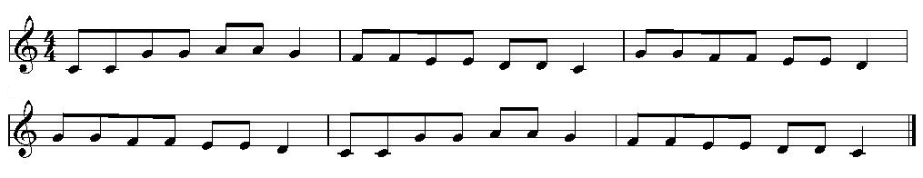
The excerpt in Example XXX.1 contains the pitches of the C major scale (there are no sharps or flats), but also contains pitches from the F major scale. Upon further examination, however, we can see that the pitch-class C is in a more stable position than the pitch-class F. The excerpt begins and ends on C, measure two ends on C, and measure five begins on C. Whenever an F appears, it is given a shorter note-value, and is within a descending stepwise passage toward C. Since the pitch class C is the most stable-sounding pitch in the melody, Example XXX.1 is in the key of C major. We could also say that Example XXX.1 is in the key of C major because the pitch-class C occupies a position of primary importance, whereas the pitch-class F occupies a position of secondary importance.

Exercise XXX.1:
In what key is Twinkle twinkle notated below?
(graphic of twinkle twinkle in G major without the key signature)
[drop down menu with possible major keys]

Exercise XXX.2:
In what key is the following melody notated:
(graphic of another melody in Bb major)
[drop down menu with possible major keys]

Key Signatures:
The key signature is a collection of sharps or flats that indicates which notes should be raised or lowered so that they belong to the key. In C major, there are no sharps or flats in the key signature, just as there are no sharps or flats in the C major scale. In keys other than C major, the key signature is written to the left of the time signature, and to the right of the clef on each line of music. Example XXX.1 can be transposed to F major, and is shown in Example XXX.2:

Example XXX.2: Twinkle Twinkle Little Star in F major
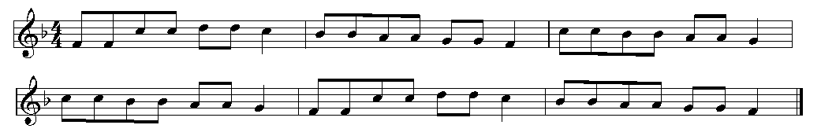

Notice in Example XXX.2 that the Bb from the F major scale is written on each line of music, to the left of the time signature on the first line, and to the right of the clef on both lines. Sharps or flats in the key signature apply to every octave, and remain in effect throughout the piece unless canceled by an accidental. The sharps and flats in a key signature must be placed in a particular order on the staff.

Exercise XXX.3:
What major key is given the following key signature?
(graphic of the key signature for D major in treble clef]
[text in a pop-up box with hyperlink title 'hint': “What major scale has the same sharps or flats as are notated in the key signature?]
[drop down menu with possible major keys]

Exercise XXX.4:
What major key is given in the following key signature?
(graphic of the key Bb major in bass clef)
[text in a pop-up box with hyperlink title 'hint': “What major scale has the same sharps or flats as are notated in the key signature?]
[drop down menu with possible major keys]

Writing Key Signatures:
The sharps or flats in a key signature must be written in a particular order and position on the staff. We will determine this order by examining scales that are closely related, or share six out of their seven pitch classes. From the major scale lesson, we saw that two closely related keys share a tetrachord. The lower tetrachord in C major, for example, is the upper tetrachord in F major. Notice that in Example XXX.3, C major and F major differ by just one note (B in C major, Bb in F major). Similarly, Bb major and F major differ by just one note (E in F major, Eb in Bb major).

Example XXX.3:
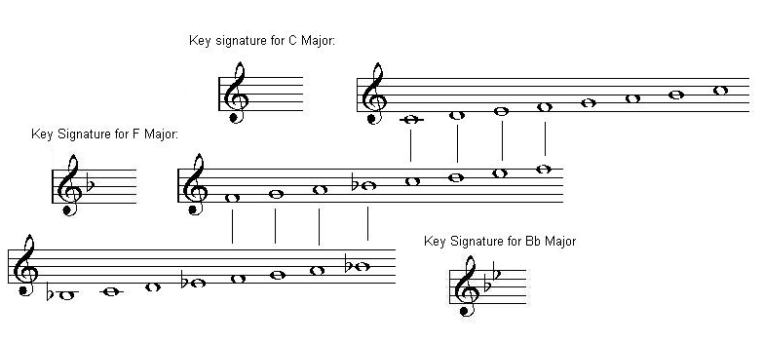

We can continue adding flats by adding more closely related major scales to the chain in Example XXX.3. For each major key in this chain, the last flat in the key signature is ^4. For example, the key signature for F major is {Bb}, and ^4 is a Bb in the F major scale. The key signature for Bb major is {Bb, Eb} and Eb is ^4 in the Bb major scale. If we continue down the chain of major scales that are closely related as in Example XXX.3, we will eventually arrive at seven flats. The order of the flats is shown in Example XXX.4:

Example XXX.4: seven flats in treble and in bass clef
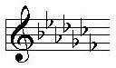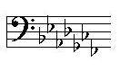

Exercise XXX.5a:
Notate the following flat key signature on the staff: (can randomly generate a flat key?)
[GUI of a treble clef where user can click on any line or space to add a flat. Have the user press a button titled 'submit' to give either the output “correct” if the order and placement of the flats is correct, or “incorrect, try again” if the order or placement of the flats is incorrect]

Exercise XXX.5b:
Notate the following flat key signature on the staff:
[GUI of a bass clef where user can click on any line or space to add a flat. Have the user press a button titled 'submit' to give either the output “correct” if the order and placement of the flats is correct, or “incorrect, try again” if the order or placement of the flats is incorrect]

The order of the sharps can be determined similarly. The upper tetrachord in the C major scale is the same as the lower tetrachord in the G major scale. Similarly, the upper tetrachord in the G major scale is the same as the lower tetrachord in the D major scale. The C major and G major scales share six out of seven notes, and the G major and D major scales share six out of seven notes.

Example XXX.4:
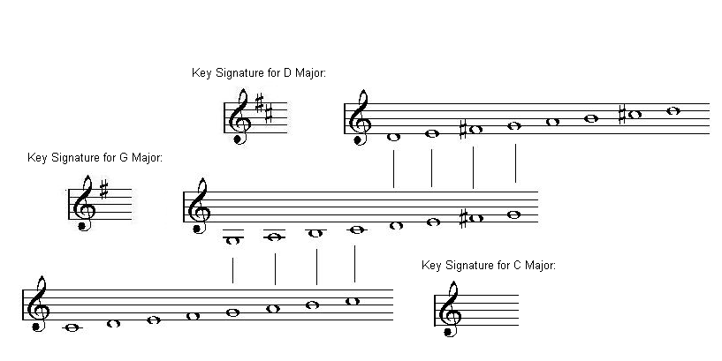
We can continue adding sharps by adding more closely related major scales to the chain in Example XXX.4. For each major key in this chain, the last sharp in the key signature is ^7. For example, the key signature for G major is {F#}, and ^7 is an F# in the G major scale. The key signature for D major is {F#, C#} and C# is ^7 in the D major scale. If we continue up the chain of closely related keys as in Example XXX.4, we will eventually arrive at seven sharps. The order of the sharps is shown in Example G:

Example G: seven sharps in treble and bass clef
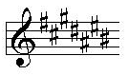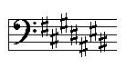

Exercise XXX.6a:
Notate the following sharp key signature on the staff:
[GUI of a treble clef where user can click on any line or space to add a sharp. Have the user press a button titled 'submit' to give either the output “correct” if the order and placement of the sharps is correct, or “incorrect, try again” if the order or placement of the sharps is incorrect]

Exercise XXX.6b:
Notate the following sharp key signature on the staff:
[GUI of a bass clef where user can click on any line or space to add a sharp. Have the user press a button titled 'submit' to give either the output “correct” if the order and placement of the sharps is correct, or “incorrect, try again” if the order or placement of the sharps is incorrect]

Conclusion:
A major key named after the major scale that shares its pitches and determines the hierarchy of pitch classes. A piece in G major, for example, will use pitch classes from the G major scale, and will treat each pitch class as a particular scale degree from the G major scale (for example, the pitch-class G will be given a position of primary importance in the piece). A key signature is a collection of sharps or flats that is written to the right of the clef on each line of music. The sharps or flats in the key signature remain in effect throughout the piece unless cancelled by an accidental, and they apply to every octave (not just the one they are written in). Sharps or flats in a key signature must be written in a particular order and octave on the staff, and that order can be determined by creating a chain of closely related major scales.

