Lesson AAA: Basic Interval Progressions

Exam:

Question 1a:
[Multiple choice question:] Identify the following interval:
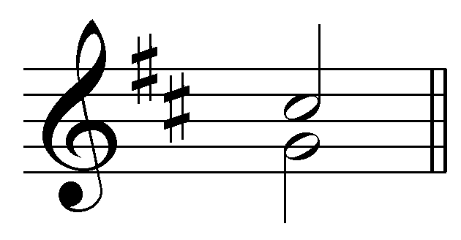
[Possible answers: m2, M2, m3, M3, P4, A4, d5, P5, m6, M6, m7, M7, P8]
[Answer: A4. Feedback for correct answer: “Correct! G and C# form an augmented fourth.” Feedback for incorrect answer: “Incorrect. G and C# form an augmented fourth (A4).”]
[Follow-up question:] Is this interval consonant or dissonant in two-voice textures?
[Answer: dissonant. Feedback for correct answer: “Correct! An augmented fourth is dissonant.” Feedback for incorrect answer: “Incorrect. An augmented fourth is dissonant.”]

Question 1b:
[Multiple choice question:] Identify the following interval:
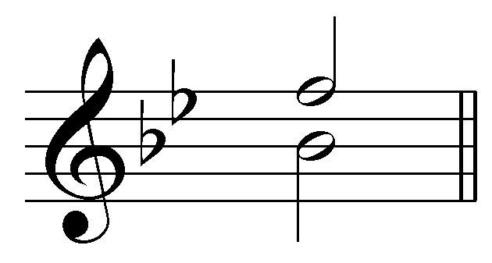
[Possible answers: m2, M2, m3, M3, P4, A4, d5, P5, m6, M6, m7, M7, P8]
[Answer: P5. Feedback for correct answer: “Correct! B^{b} and F form a perfect fifth.” Feedback for incorrect answer: “Incorrect. B^{b} and F form a perfect fifth (P5).”]
[Follow-up question:] Is this interval consonant or dissonant in two-voice textures?
[Answer: consonant. Feedback for correct answer: “Correct! A perfect fifth is consonant.” Feedback for incorrect answer: “Incorrect. A perfect fifth is consonant.”]

Question 2a:
[Multiple choice question:] Is the following parallel interval progression permissible or forbidden in two-voice textures?
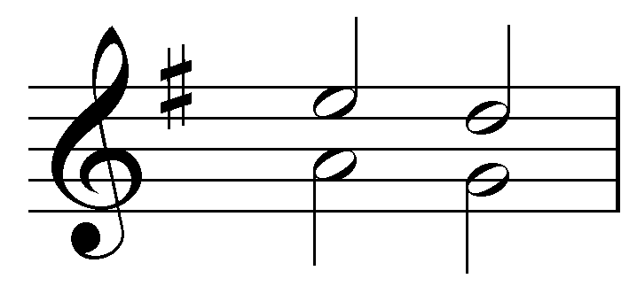
[Possible answers: permissible, forbidden.]
[Answer: forbidden. Feedback for correct answer: “Correct! Parallel fifths are not allowed.” Feedback for incorrect answer: “Incorrect. Parallel fifths are not allowed.”]

Question 2b:
[Multiple choice question:] Is the following parallel interval progression permissible or forbidden in two-voice textures?
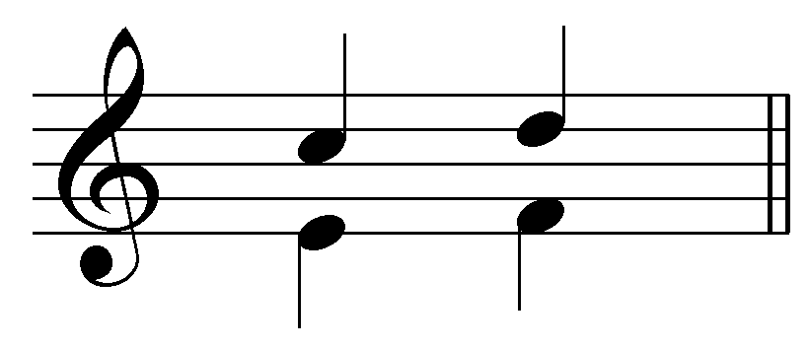
[Possible answers: permissible, forbidden.]
[Answer: permissible. Feedback for correct answer: “Correct! Parallel sixths are allowed.” Feedback for incorrect answer: “Incorrect. Parallel sixths are allowed.”]

Question 3a:
Continue the following interval progression using stepwise, contrary motion:
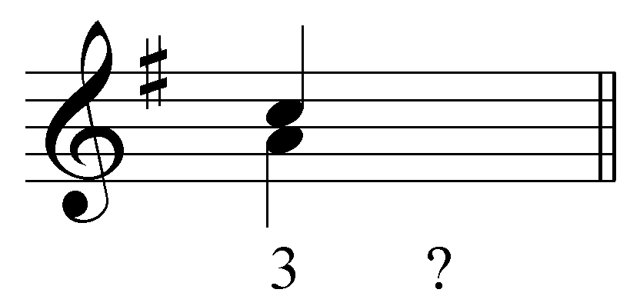
[Answers: upper voice to D and lower voice to G OR both voices to B. Feedback for D/G correct answer: “Correct! A minor third can move by stepwise contrary motion to a perfect fifth.” Feedback for B/B correct answer: “Correct! A minor third can move inwards to form a unison.” Feedback for all other incorrect answers: “Incorrect. That is not a valid interval progression. In this case, the voices could either move inwards to form a unison B, or outwards to form a perfect fifth.”]

Question 3b:
Continue the following interval progression using stepwise, contrary motion:
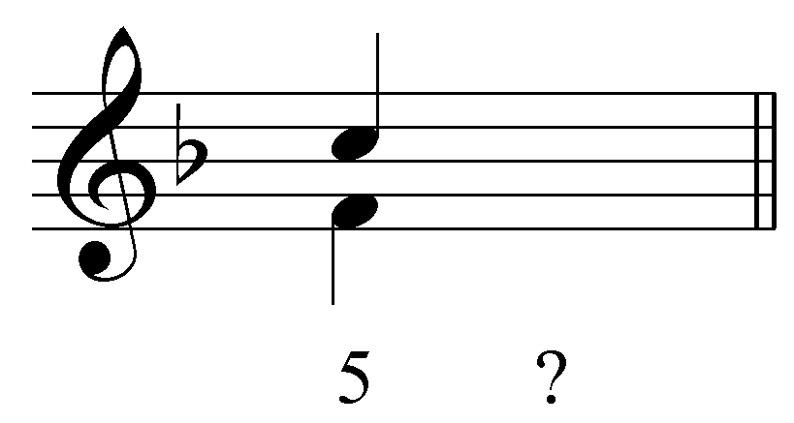
[Answers: upper voice to B^{b} and lower voice to G. Feedback for correct answer: “Correct! A perfect fifth can move by stepwise contrary motion to a minor third.” Feedback if student has upper voice moving to D and lower voice moving to E: “Incorrect. This progression does exhibit stepwise, contrary motion, but a perfect fifth cannot move to a minor seventh in a two-voice texture because sevenths are dissonant. The voices should have moved inward to form a minor third.” Feedback for all other incorrect answers: “Incorrect. The voices should move inward to form a minor third.”]

Question 4:
Complete the following interval progression in two unique and valid ways by providing voices for the second beat moving in either parallel or contrary motion.
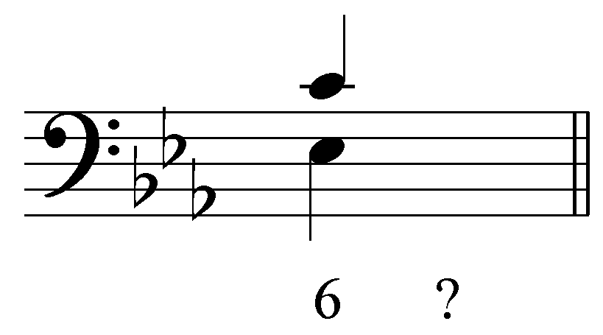
[Answers:
- Upper voice to D / lower voice to F
- Upper voice to B^{b} / lower voice to D
- Upper voice to B^{b} / lower voice to G
- Upper voice to A^{b} / lower voice to F
- Upper voice to D / lower voice to D
- Upper voice to E^{b} / lower voice to C
Feedback for correct answer: “Correct!” Feedback for incorrect answer: “Incorrect. Those voices don’t create a valid parallel- or contrary-motion interval progression.”]

Question 5:
Complete the following interval progression in two unique and valid ways by providing voices for the second beat moving using similar motion only.
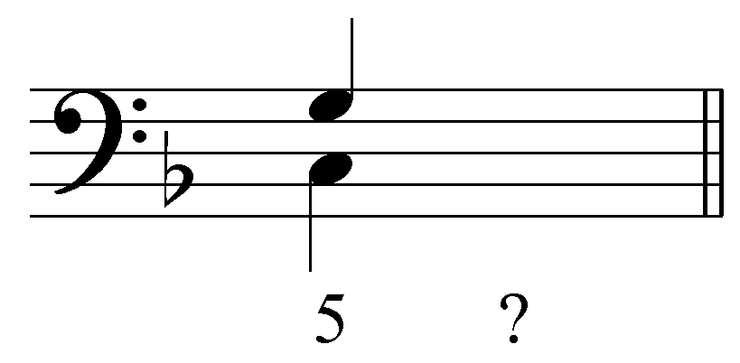
[Answers:
- Upper voice to F / lower voice to F
- Upper voice to F / lower voice to A
- Upper voice to B^{b} / lower voice to D
- Upper voice to A / lower voice to F
- Upper voice to D / lower voice to B^{b}
Feedback for correct answer: “Correct!” Feedback for incorrect answer: “Incorrect. Those voices don’t create a valid similar-motion interval progression.”]

Question 6a:
Identify all of the intervals in the following two-voice progression:
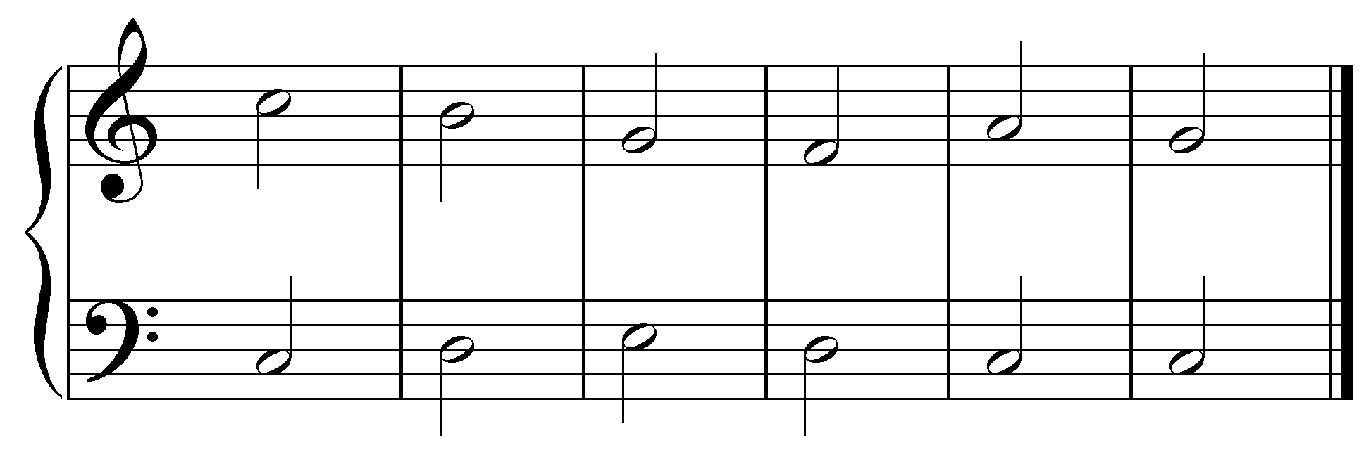
[Answer:
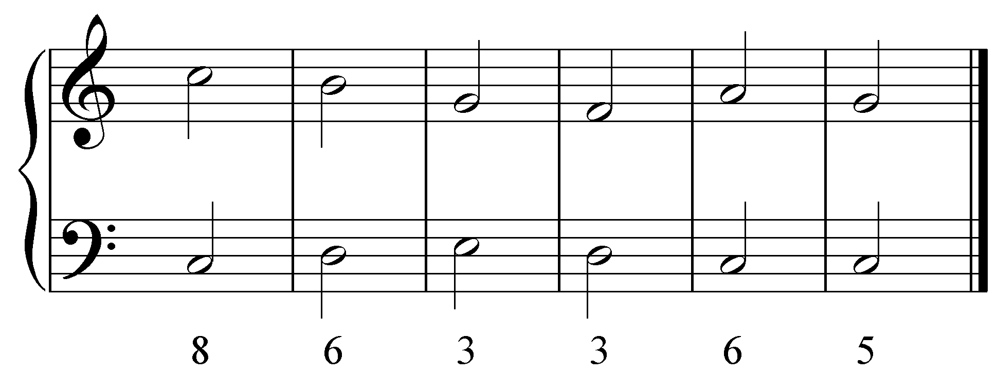. Feedback for each correct answer: “Correct!” For each incorrect answer: “Incorrect. That is a [X].”]

Question 6b:
Now label each pair of intervals as having parallel, contrary, similar, or oblique motion.
[Answer:
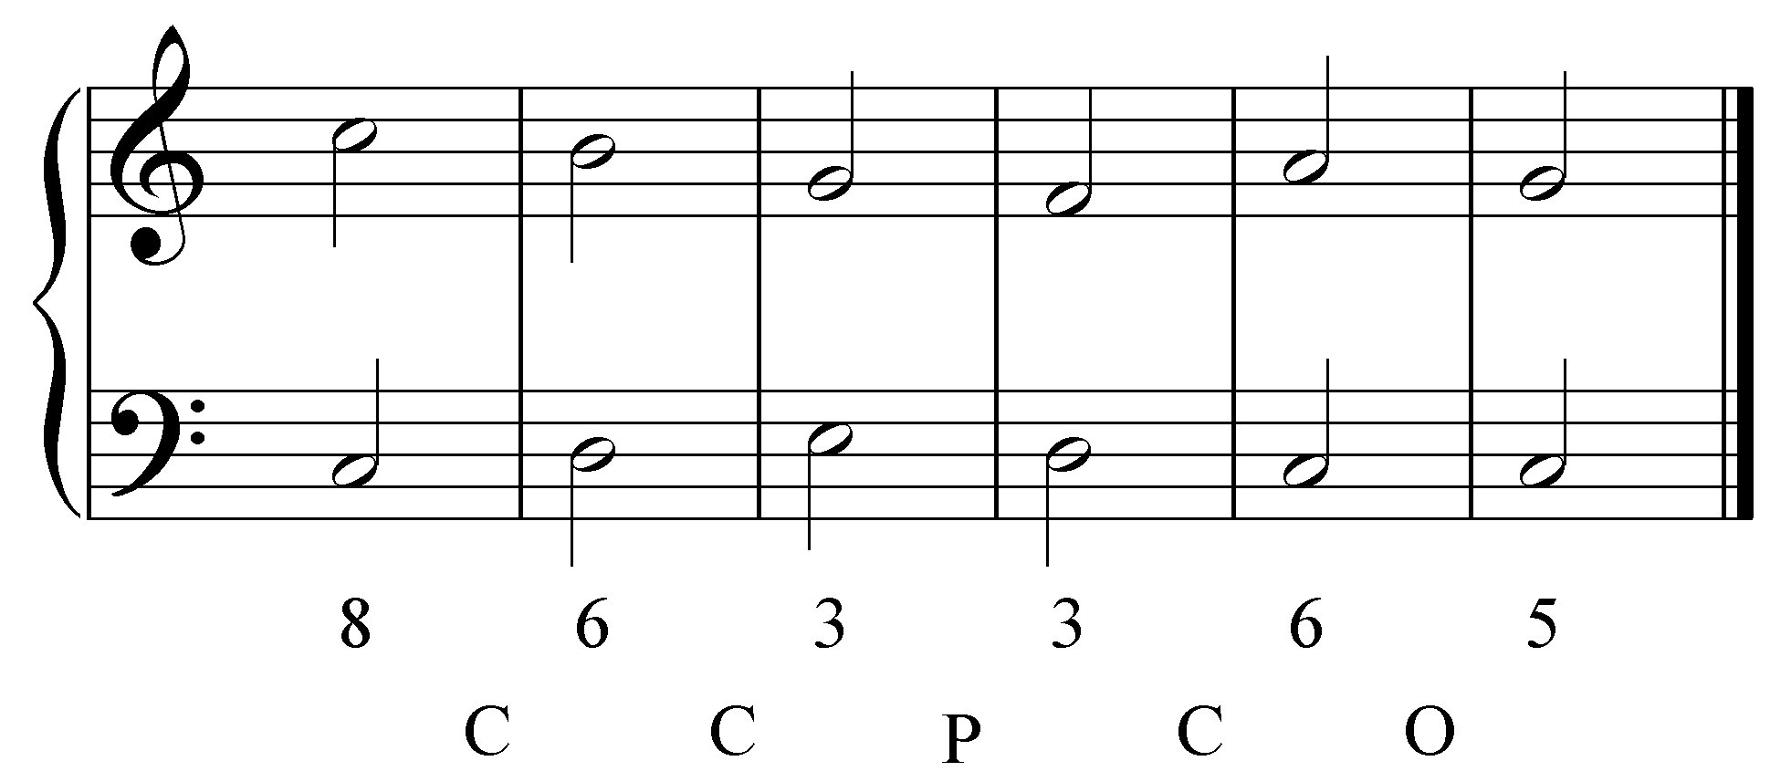. Feedback for each correct answer: “Correct!” For each incorrect answer: “Incorrect. Those two intervals exhibit [X] motion.”]

Question 7a:
Identify the basic interval progression being followed by the red notes in the following excerpt (J.S. Bach, BWV 269, “Aus meines Herzens Grunde,” mm. 1-7):
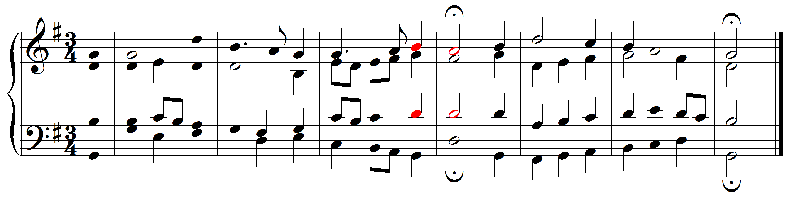
[Answer: oblique motion (6-5). Feedback for correct answer: “Correct! The tenor and the soprano are moving in oblique motion from a major sixth to a perfect fifth (“6 - 5”).” Feedback for incorrect answer: “Incorrect. The tenor and the soprano are moving in oblique motion from a major sixth to a perfect fifth (“6 - 5”).”]

Question 7b:
Identify the basic interval progression being followed by the red notes in the following excerpt (J.S. Bach, BWV 269, “Aus meines Herzens Grunde,” mm. 1-7):
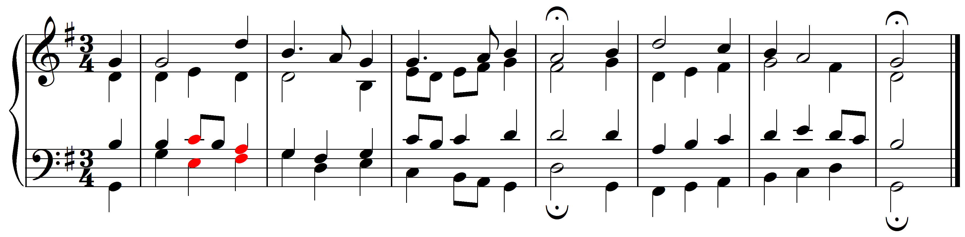
[Answer: oblique motion (6-3). Feedback for correct answer: “Correct! The tenor and the bass are moving in contrary motion from a minor sixth to a minor third (“6 - 3”).” Feedback for incorrect answer: “Incorrect. The tenor and the bass are moving in contrary motion from a minor sixth to a minor third (“6 - 3”).”]

