Lesson AAA – Basic Interval Progressions

Introduction:

Consider the following exercise, where you might be asked to provide a four-part texture for a given bass line:

Example 1:
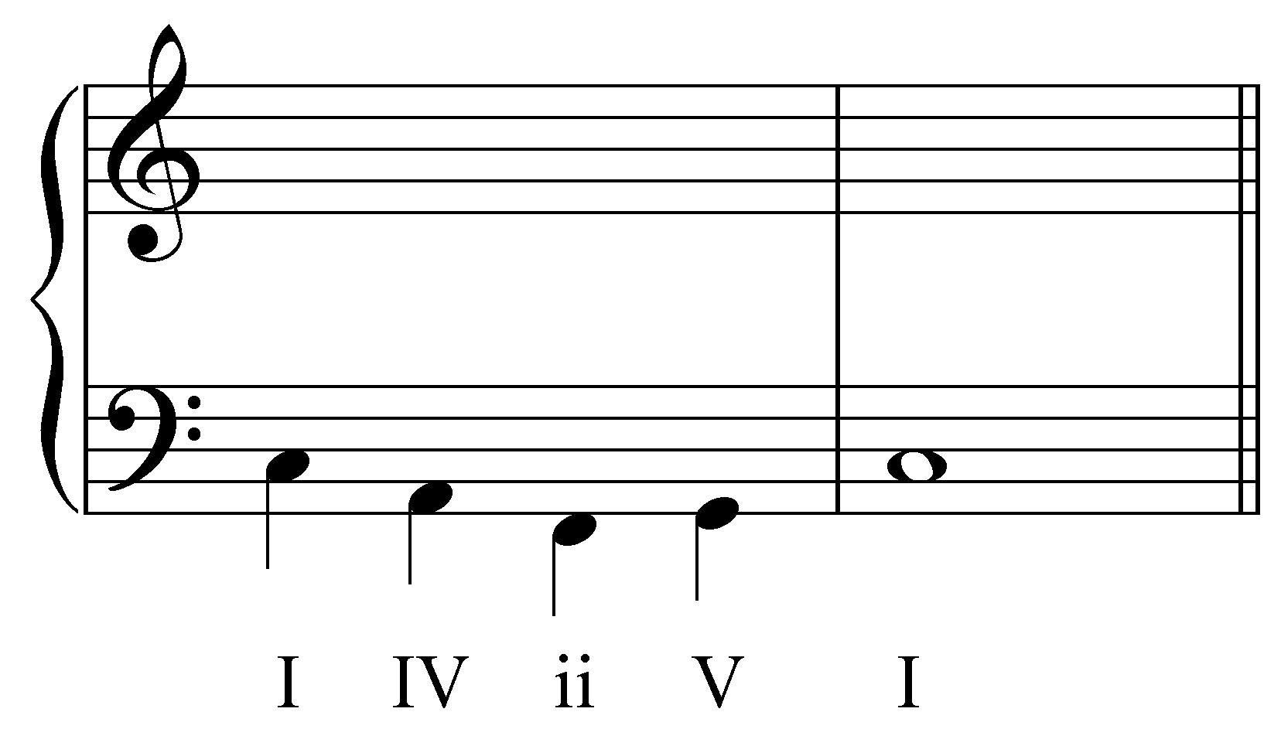

One approach to this exercise would be to simply “fill out” each Roman numeral. In other words, you might create upper voices by making sure each Roman numeral had all of its members present (C, E, and G for I; F, A, and C for IV; and so on). Although that method will produce correct harmonies, it does not take into account the melodic path of each part, nor the relationships among the parts. This melodic aspect of tonal music is crucial, particularly in four-part vocal settings (SATB) such as the one shown above. This lesson will introduce you to a set of tools for creating such multi-voiced textures that address both harmonic and melodic considerations.

Interval progression, as the phrase implies, is simply a series of two or more intervals. Interval progressions form the backbone of counterpoint, and counterpoint is the foundation of tonal music. The purpose of this lesson is to familiarize you with the concept and handling of basic interval progressions. A firm understanding of interval progressions will guarantee proper and problem-free part-writing.

This lesson will begin by presenting you with a catalog of standard interval progressions. In subsequent lessons you will be given an opportunity to expand these progressions by adding a third and fourth voice (see Lesson BBB).

Background principles:

By the time of J.S. Bach, a number of interval progressions had become standard. This lesson will not delve too deeply into the history of why certain progressions became standard, but several guiding principles are worth mentioning.

Contrary Motion. In early multi-voice (polyphonic) music, composers began to prefer contrary motion between voices, giving each part melodic independence. If one voice descended, the other voice would typically ascend, and vice versa, as illustrated here:

Example 2:
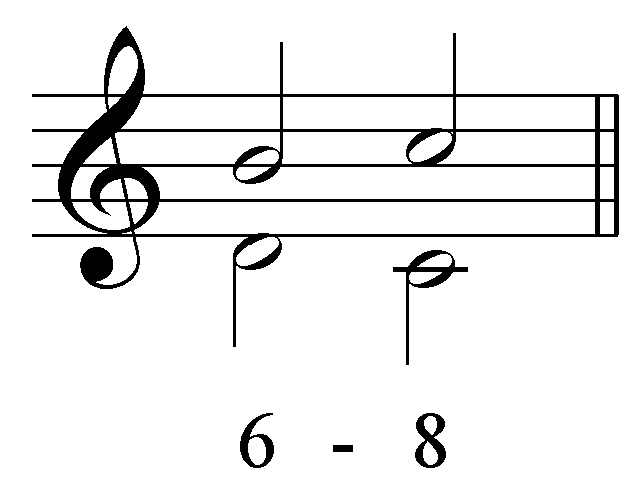

The voices, though singing together, maintained their own identity, leading to a richer, more interesting texture.

Parallel Motion. Parallel motion, where two voices move simultaneously in the same direction keeping the same intervallic distance between them, was also permissible in this style, though with some regulations. Because parallel motion diminishes the independence of the voices, it could be used only with certain intervals. Voices forming perfect intervals (unison, fifth, octave) blended together so well that it seemed as though they were undifferentiated. If voices maintained perfect intervals as they moved up or down, as here:

Example 3:
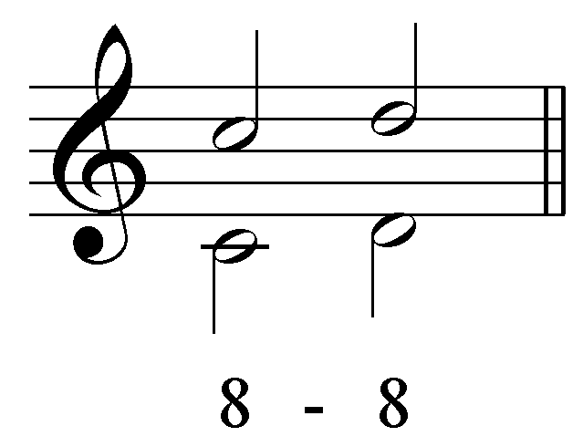

they would lose their independence altogether. Parallel motion is therefore permitted only with imperfect intervals (minor/major thirds and minor/major sixths). We will return to this concept shortly.

Consonant Intervals Only. For now, we will consider only consonant intervals: The perfect consonances (unison, perfect fifth, and perfect octave), and imperfect consonances (minor/major thirds and minor/major sixths).

Example 4:
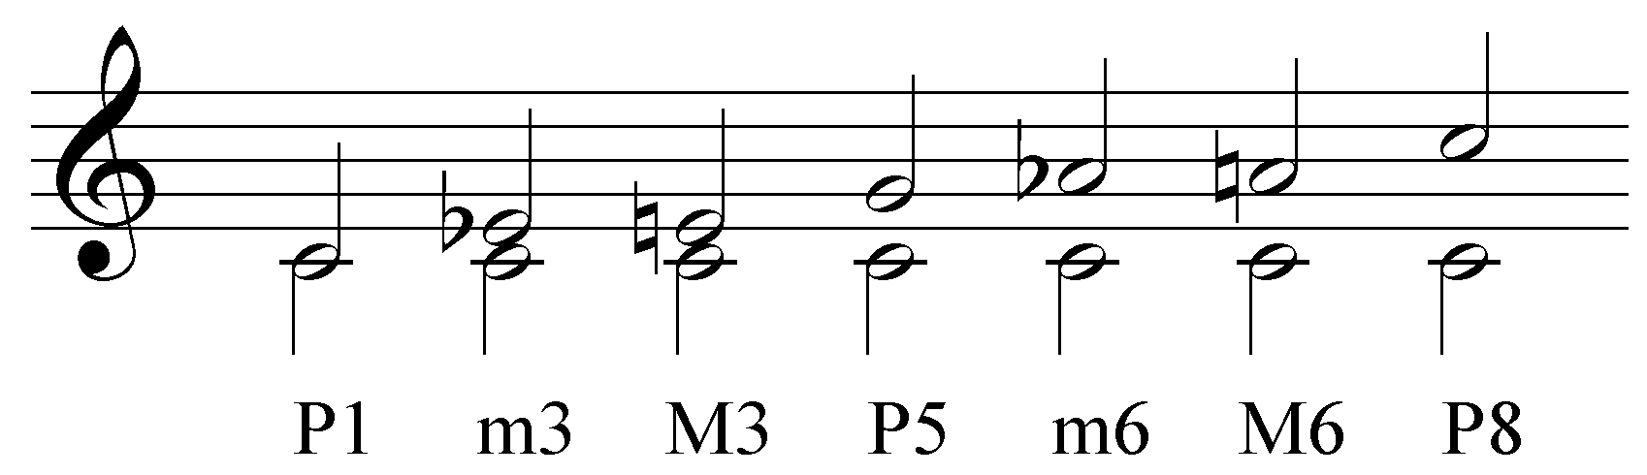

The following intervals are excluded for now:

Example 5:
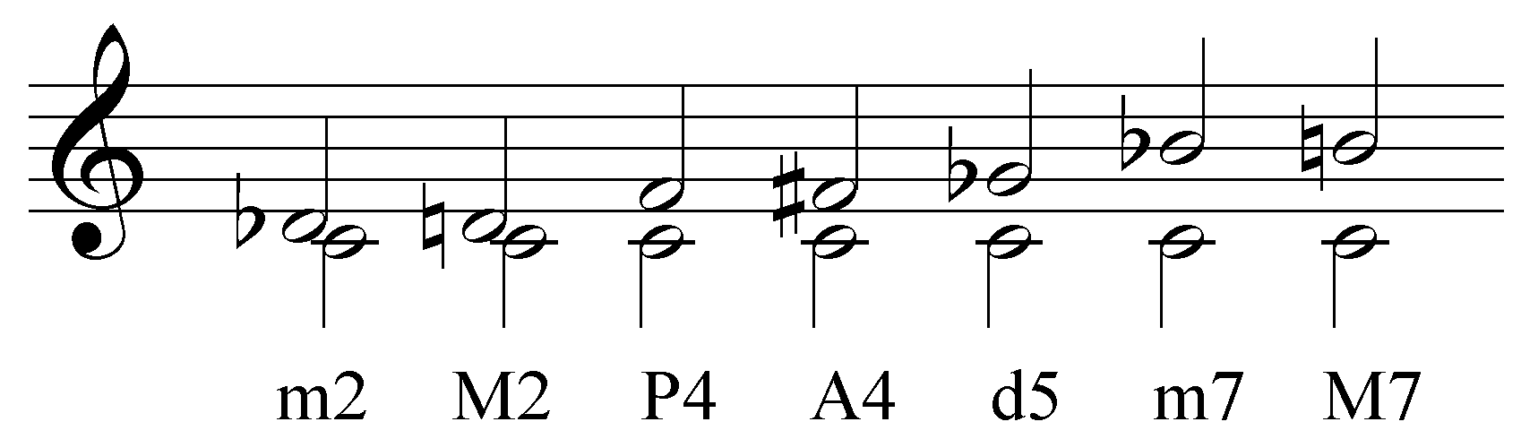

We will not yet consider dissonant intervals (minor/major seconds, minor/major sevenths, augmented or diminished intervals). The perfect fourth, however, is a special case. Although considered consonant by some definitions, it is treated as a dissonance in two-voice textures. When only two voices are present, they are not permitted to form a perfect fourth or any other dissonance.

Activity 1.1:
In order to fully understand basic interval progressions, it is essential that you first have a firm understanding of the intervals themselves. In this activity you will identify a series of intervals and specify whether they are consonant or dissonant.

Exercise 1.1a:
[Multiple choice question:] Identify the following interval:
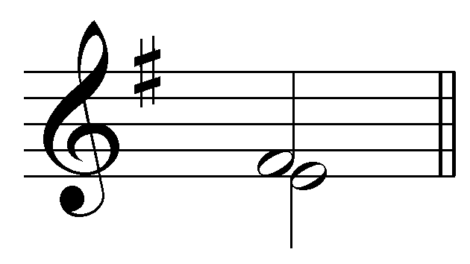
[Possible answers: m2, M2, m3, M3, P4, A4, d5, P5, m6, M6, m7, M7, P8]
[Answer: M2. Response if correct: “Correct!” Response if incorrect: “Incorrect. Try again…”]
[Follow-up question:] Is this interval consonant or dissonant in two-voice textures?
[Answer: dissonant. Response if correct: “Correct! A major second is dissonant.” Response if incorrect: “Incorrect. Try again…”]

Exercise 1.1b:
[Multiple choice question:] Identify the following interval:
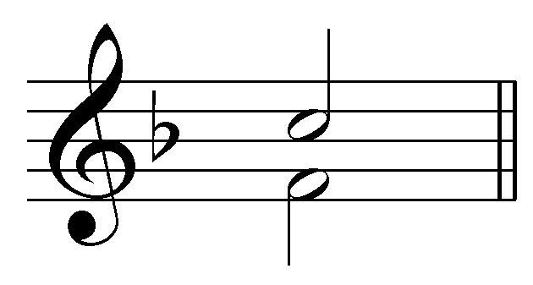

[Possible answers: m2, M2, m3, M3, P4, A4, d5, P5, m6, M6, m7, M7, P8]
[Answer: P5. Response if correct: “Correct!” Response if incorrect: “Incorrect. Try again…”]
[Follow-up question:] Is this interval consonant or dissonant in two-voice textures?
[Answer: consonant. Response if correct: “Correct! A perfect fifth is consonant.” Response if incorrect: “Incorrect. Try again…”]

Exercise 1.1c:
[Multiple choice question:] Identify the following interval:
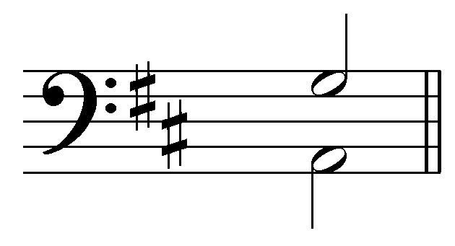
[Possible answers: m2, M2, m3, M3, P4, A4, d5, P5, m6, M6, m7, M7, P8]
[Answer: m7. Response if correct: “Correct!” Response if incorrect: “Incorrect. Try again…”]
[Follow-up question:] Is this interval consonant or dissonant in two-voice textures?
[Answer: dissonant. Response if correct: “Correct! A minor seventh is dissonant.” Response if incorrect: “Incorrect. Try again…”]

Exercise 1.1d:
[Multiple choice question:] Identify the following interval:
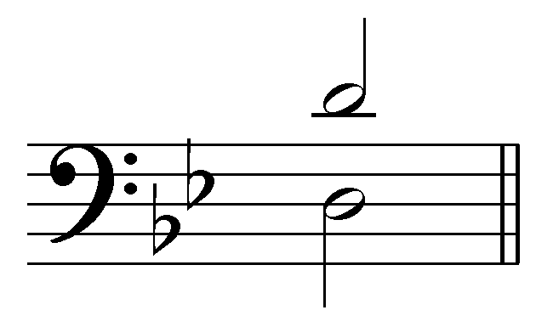
[Possible answers: m2, M2, m3, M3, P4, A4, d5, P5, m6, M6, m7, M7, P8]
[Answer: P8. Response if correct: “Correct!” Response if incorrect: “Incorrect. Try again…”]
[Follow-up question:] Is this interval consonant or dissonant in two-voice textures?
[Answer: consonant. Response if correct: “Correct! A perfect octave is consonant.” Response if incorrect: “Incorrect. Try again…”]

Exercise 1.1e:
[Multiple choice question:] Identify the following interval:
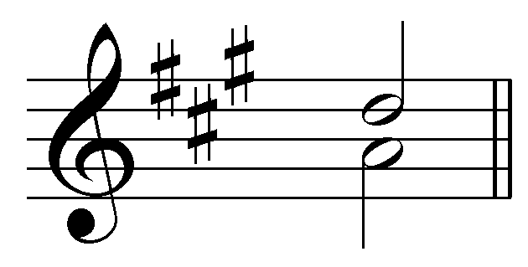
[Possible answers: m2, M2, m3, M3, P4, A4, d5, P5, m6, M6, m7, M7, P8]
[Answer: P4. Response if correct: “Correct!” Response if incorrect: “Incorrect. Try again…”]
[Follow-up question:] Is this interval consonant or dissonant in two-voice textures?
[Answer: dissonant. Response if correct: “Correct! Perfect fourths are considered dissonant in two-voice textures.” Response if incorrect: “Incorrect. Try again…”]

Exercise 1.1f:
[Multiple choice question:] Identify the following interval:
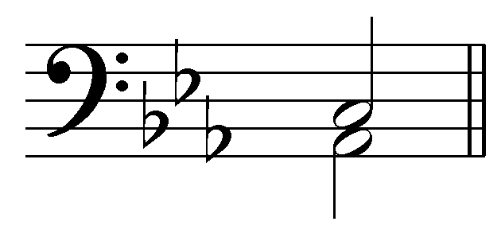
[Possible answers: m2, M2, m3, M3, P4, A4, d5, P5, m6, M6, m7, M7, P8]
[Answer: M3. Response if correct: “Correct!” Response if incorrect: “Incorrect. Try again…”]
[Follow-up question:] Is this interval consonant or dissonant in two-voice textures?
[Answer: dissonant. Response if correct: “Correct! A major third is consonant.” Response if incorrect: “Incorrect. Try again…”]

Standard interval progressions:

Parallel motion:

As mentioned above, parallel motion is permitted with imperfect consonances, as shown here:

Examples 6-7:
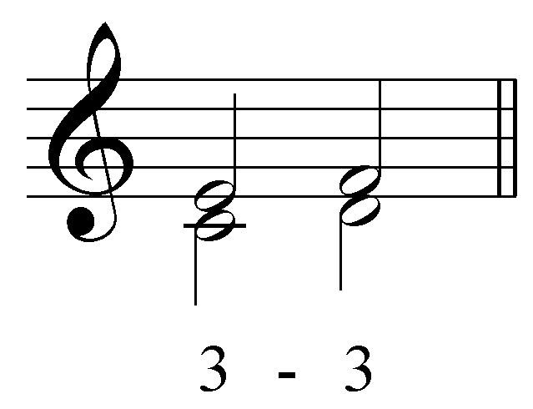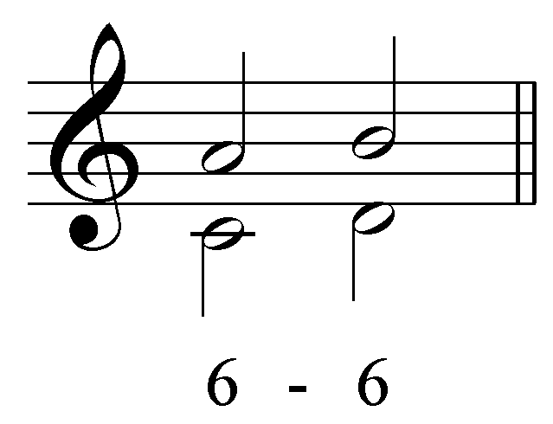

Note that each of the progressions is also valid in reverse. That principle holds for every interval progression outlined in this lesson. The following examples show the permissible parallel interval progressions in descending motion:

Examples 8-9:
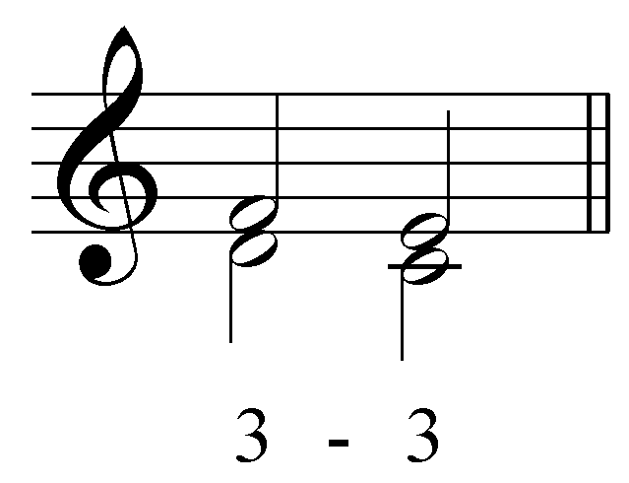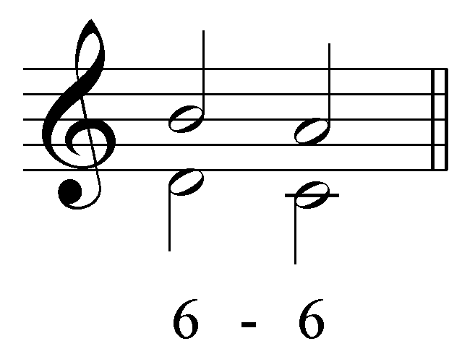

(From this point on, each progression will be given with its reverse.)

Forbidden interval progressions:

Voices that form perfect consonances may not progress in parallel motion. That restriction holds for voices forming a unison. The following interval progressions are not allowed:

Examples 10-15:
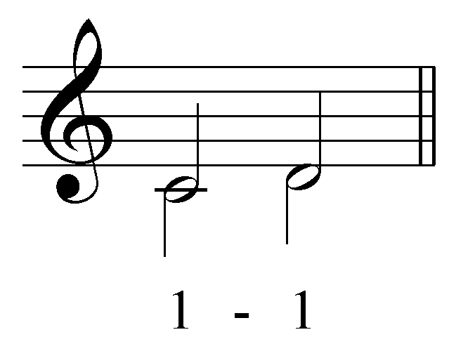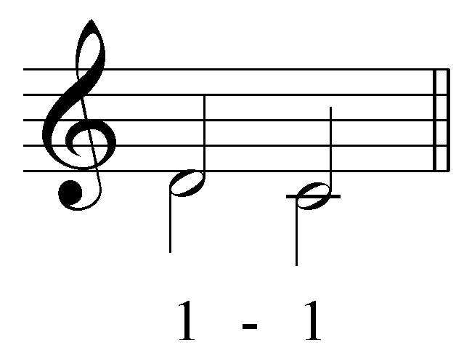

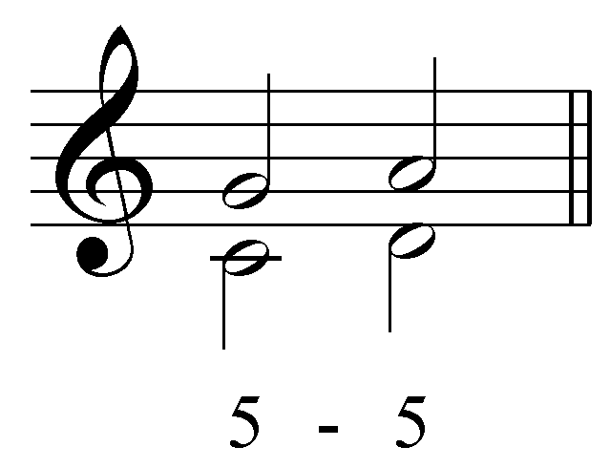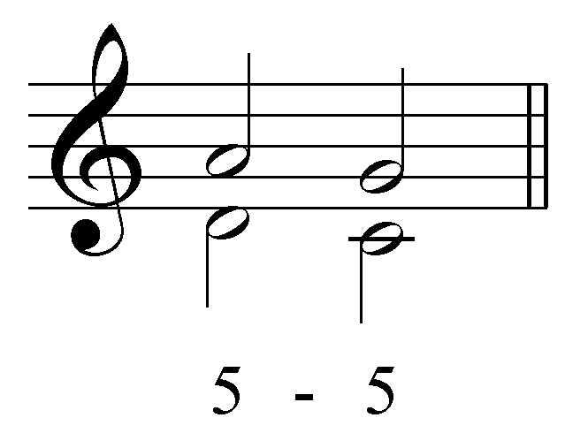

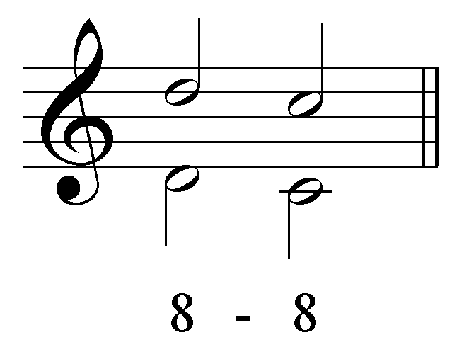

Activity 1.2:
Certain types of parallel interval progressions are allowed in two-voice textures while others are forbidden. In this activity you will be presented with various types of parallel interval progressions. It is up to you to determine which are permissible and which are not allowed.

Exercise 1.2a:
Is the following parallel interval progression permissible or forbidden?
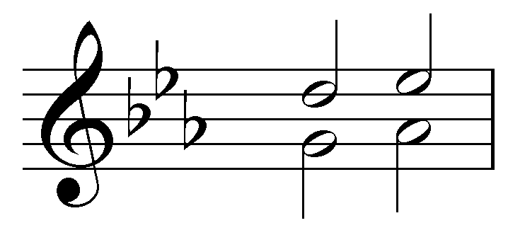
[Answer: forbidden. Response if correct: “Correct! Parallel fifths are not allowed.” Response if incorrect: “Incorrect. Try again.”]

Exercise 1.2b:
Is the following parallel interval progression permissible or forbidden?
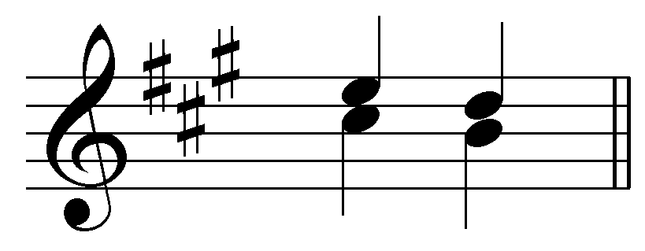
[Answer: permissible. Response if correct: “Correct! Parallel thirds are allowed.” Response if incorrect: “Incorrect. Try again.”]

Exercise 1.2c:
Is the following parallel interval progression permissible or forbidden?
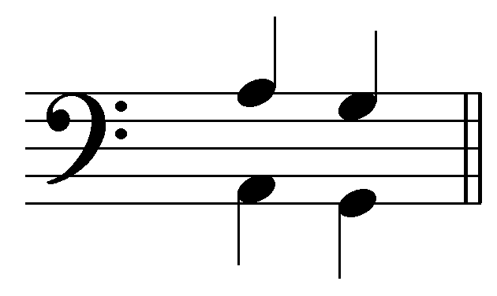
[Answer: forbidden. Response if correct: “Correct! Parallel octaves are not allowed.” Response if incorrect: “Incorrect. Try again.”]

Exercise 1.2d:
Is the following parallel interval progression permissible or forbidden?
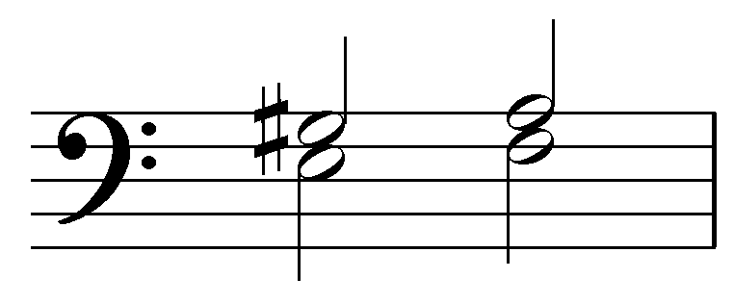
[Answer: permissible. Response if correct: “Correct! Parallel thirds are allowed, even with chromatic alterations.” Response if incorrect: “Incorrect. Try again.”]

Exercise 1.2e:
Is the following parallel interval progression permissible or forbidden?
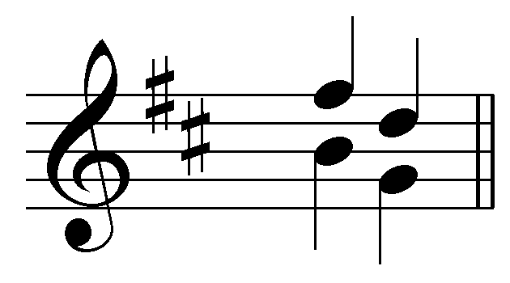
[Answer: forbidden. Response if correct: “Correct! Parallel fifths are not allowed.” Response if incorrect: “Incorrect. Try again.”]

Exercise 1.2f:
Is the following parallel interval progression permissible or forbidden?
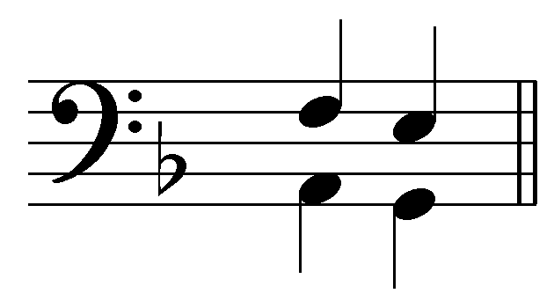
[Answer: permissible. Response if correct: “Correct! Parallel sixths are allowed.” Response if incorrect: “Incorrect. Try again.”]

Contrary Motion:

Because of special acoustic properties, the group of permitted parallel interval progressions is relatively small. By contrast, the group of interval progressions where voices move in contrary motion is much larger. We can divide this group into three categories:

Both voices move by step
One voice moves by step, the other by skip
Both voices move by skip

Contrary motion – Both voices move by step:

We will begin by looking at interval progressions where each voice moves by step in contrary motion. These progressions may start from a unison, a third or a sixth. In each case, the two voices begin with a consonant interval and move in opposite directions (contrary motion). A unison expands to a third, a third to a perfect fifth, and a sixth to an octave, as shown here.

Examples 16-21:
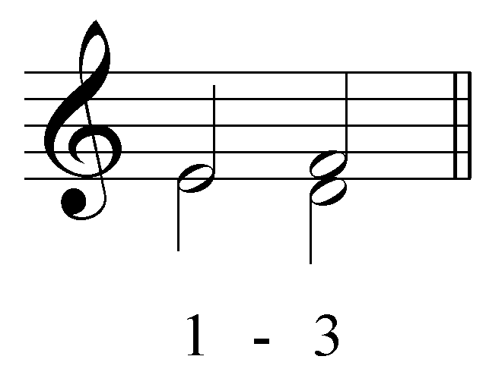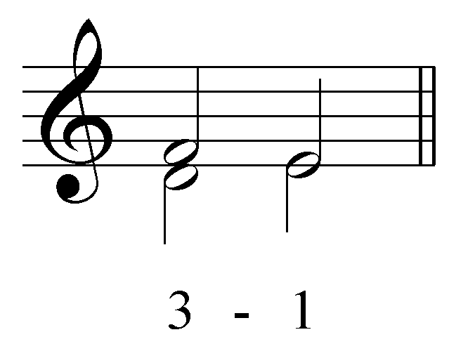
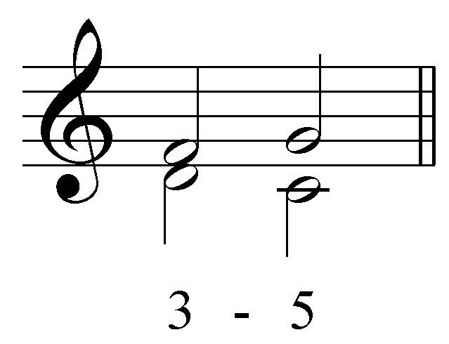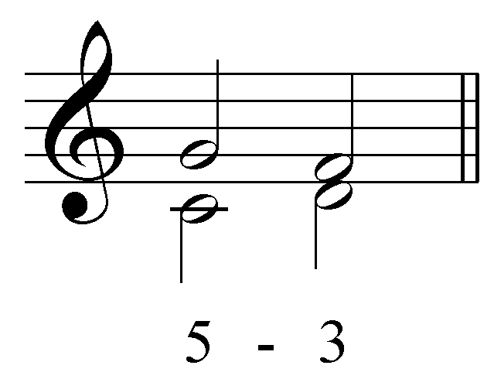
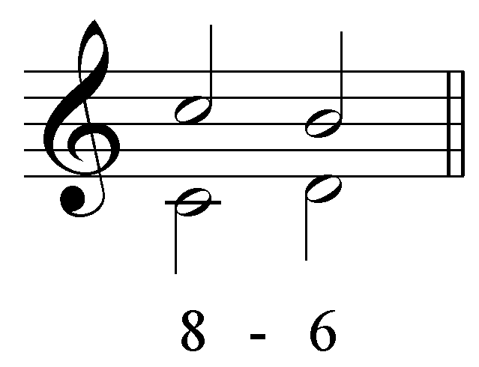

(Notice that there is no standard interval progression in which the voices expand outwards by step from a perfect fifth. If two voices forming a fifth were to move away from each other by step, the result would be a seventh, which is a dissonance and is not allowed here.)

These interval progressions can also appear as compound intervals. In other words, the “1 - 3” interval progression can be written as an octave followed by a tenth:

Example 22:
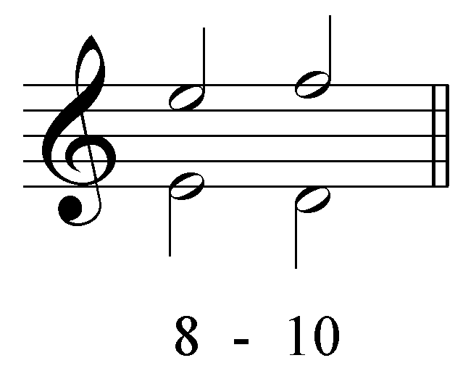

becomes…

All of the interval progressions given in lesson are also valid in their compound forms. For the sake of clarity, however, interval progressions will only be listed in their simple forms. Compound intervals will only be used for naming progressions when the intervals expand from smaller than an octave to greater than an octave or vice versa.

Activity 1.3:
This activity will give you the opportunity to complete a short interval progression. For each exercise, provide a second interval so that both voices move by step in contrary motion. For example, the following minor third:

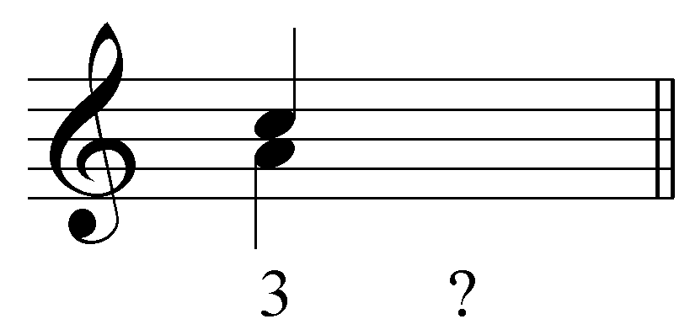

could move in stepwise, contrary motion to either a unison or a perfect fifth:

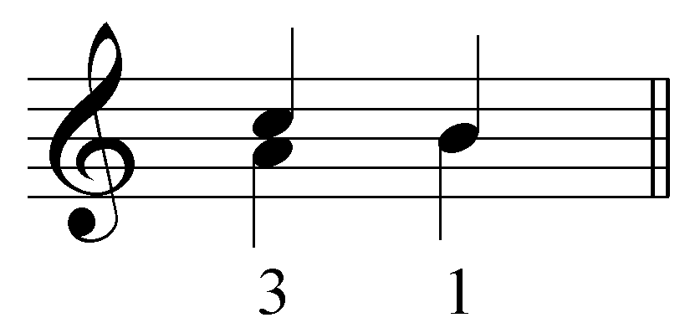 or 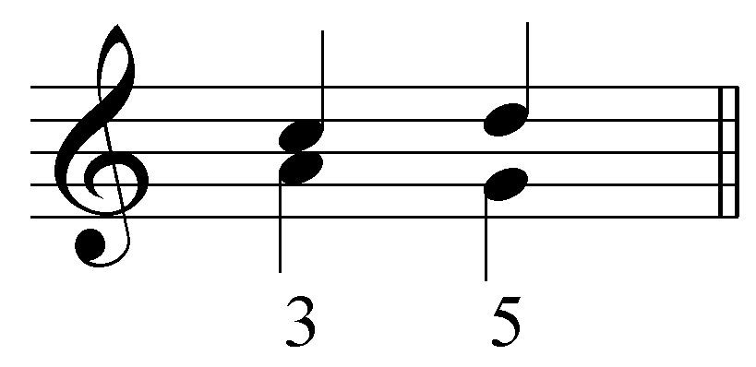

Exercise 1.3a:
Continue the following interval progression with stepwise, contrary motion:
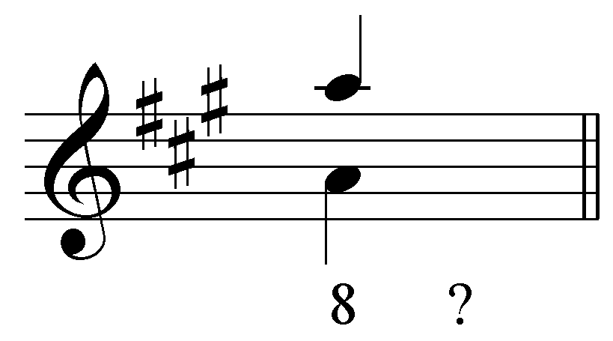
[Answers: upper voice to G# and lower voice to B or upper voice B and lower voice to G#. Response if correct: “Correct!” Response if incorrect: “Incorrect. Remember, for this exercise both voices must move by step in opposite directions. Try again.”]

Exercise 1.3b:
Continue the following interval progression with stepwise, contrary motion:
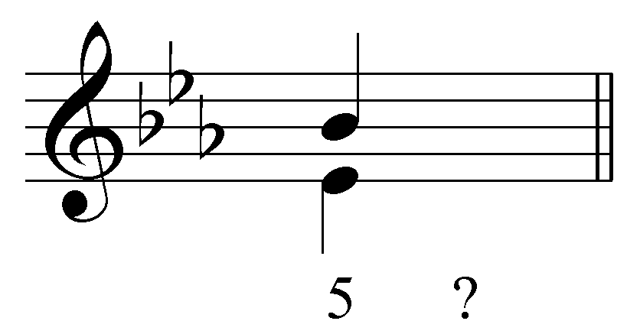

[Answers: upper voice to A^{b} and lower voice to F. Response if correct: “Correct!” Response if upper voice to C and lower voice to D: “Incorrect. Your answer does move in contrary motion, but the C and D form a minor seventh, which is a dissonance. Try again.” All other answers: “Incorrect. Remember, for this exercise both voices must move by step in opposite directions. Try again.”]

Exercise 1.3c:
Continue the following interval progression with stepwise, contrary motion:
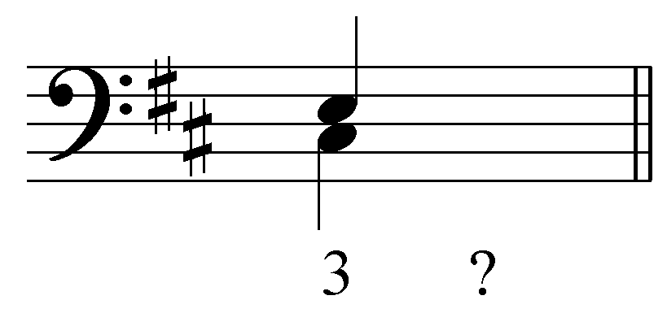
[Answers: upper voice to F# and lower voice to B or both voices to D. Response if correct: “Correct!” Response if incorrect: “Incorrect. Remember, for this exercise both voices must move by step in opposite directions. Try again.”]

Exercise 1.3d:
Continue the following interval progression with stepwise, contrary motion:
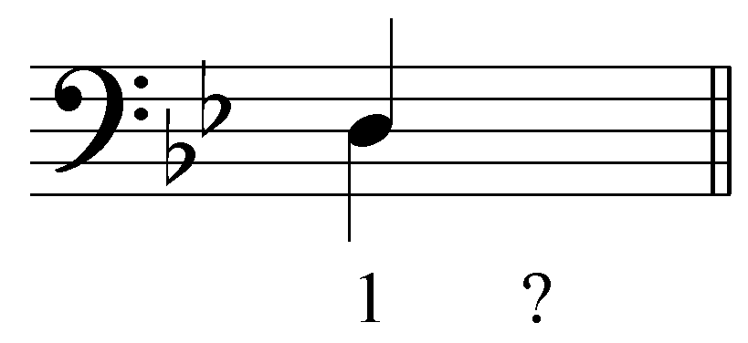
[Answers: upper voice to E^{b} and lower voice to C. Response if correct: “Correct!” Response if upper voice to C and lower voice to E^{b}: “Incorrect. Your answer does move in contrary motion, but by having the upper voice move down and the lower voice move up, you create a voice crossing. Try again.” All other answers: “Incorrect. Remember, for this exercise both voices must move by step in opposite directions. Try again.”]

Contrary motion – One voice moves by step, the other by skip:

The second category of interval progressions includes those in which one voice moves by step and the other by skip, again in contrary motion. One example is a perfect fifth expanding to a perfect octave:

Examples 23-24:
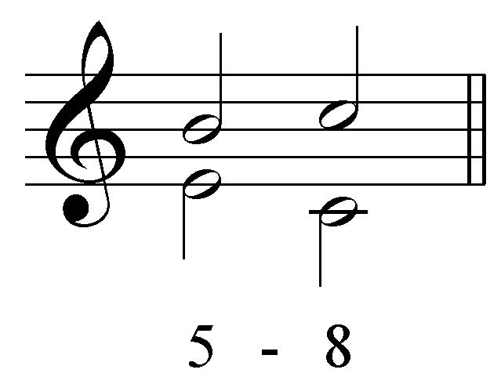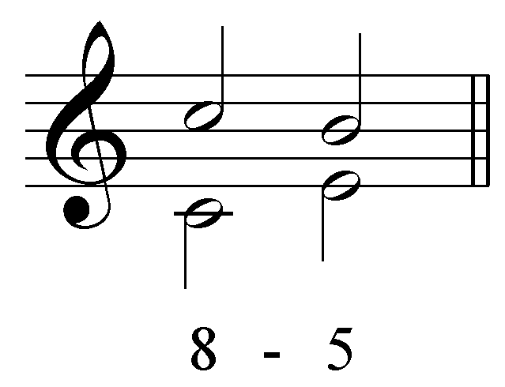

In this example, the upper voice ascends by step from B to C which the lower voice skips from E down to C. These roles could be reversed as well. In the following example, the upper voice skips, while the lower voice descends by step:

Examples 25-26:
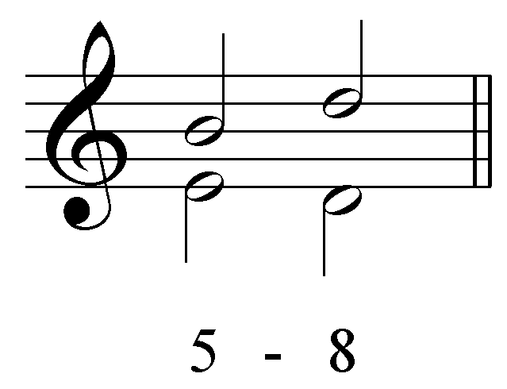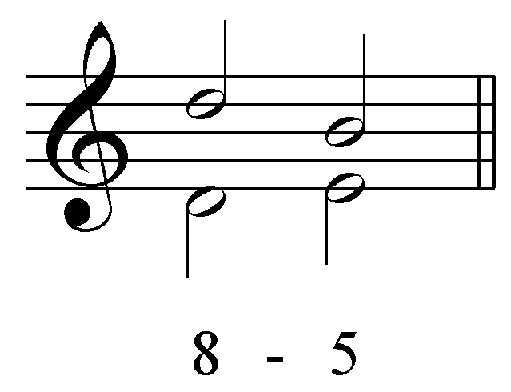

A third expands to a sixth in the same way, a step in one voice, a skip in the other:

Examples 27-30:
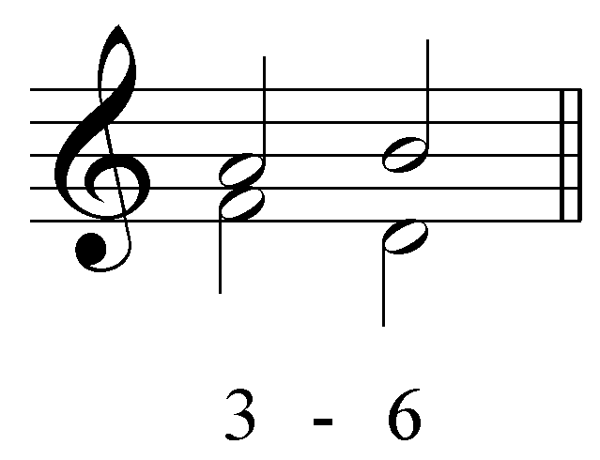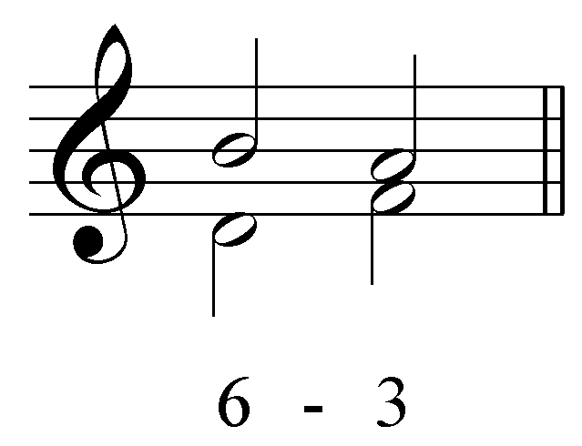

and

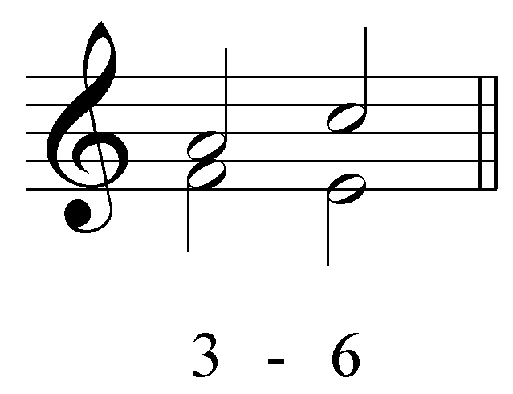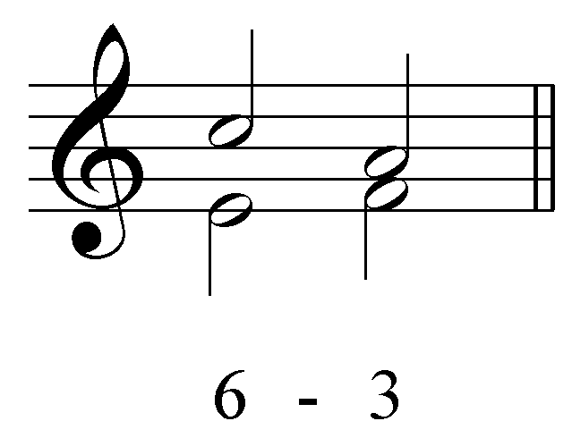

Contrary motion – Both voices move by skip:

Finally, there is the third category of contrary motion in which both voices move by skip. The only permitted progression in this category is the “6 - 10” progression:

Examples 31-32:
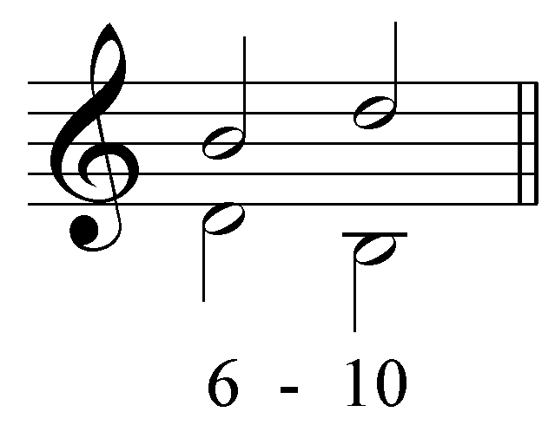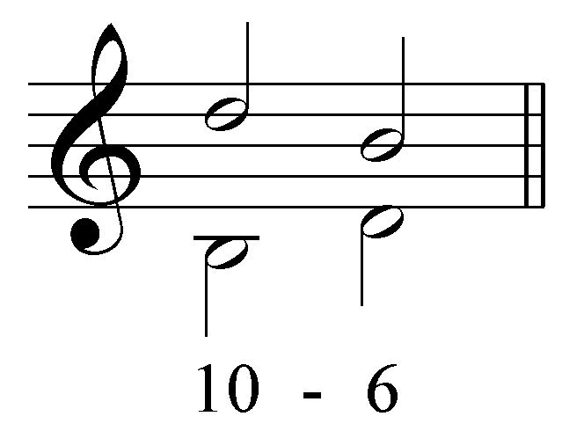

This progression contains a voice exchange. Notice that the while the soprano moves from B to D, the bass does just the opposite: D to B. Voice exchanges are a common contrapuntal procedure.

Activity 1.4:
There are usually several different possibilities for following a given interval in a basic interval progression. In this activity, you will become more familiar with this multiplicity of successions by completing an interval progression in four different ways.

Exercises 1.4a-d:
Complete the following interval progression in four unique and valid ways by providing voices for the second beat moving in either parallel or contrary motion.
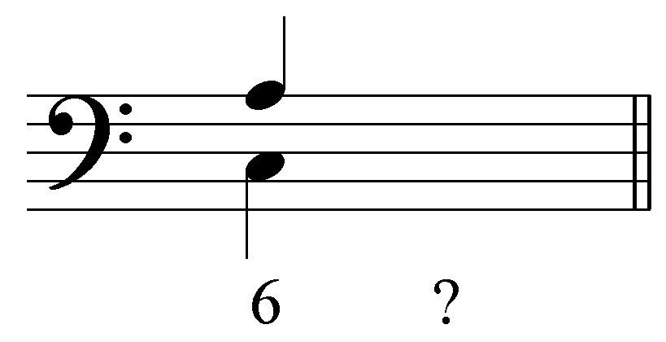
[Answers:
Upper voice to B / lower voice to D
Upper voice to G / lower voice to B
Upper voice to G / lower voice to E
Upper voice to F / lower voice to D
Upper voice to B / lower voice to B
Upper voice to C / lower voice to A
Response if correct: “Correct!” Response if incorrect: “Incorrect. Those voices don’t create a valid parallel- or contrary-motion interval progression. Try again.”]

Similar motion:

A second large category of interval progressions includes those where voices move in similar motion. In each of these progressions, one voice moves by step, the other by skip (or leap) in the same direction. In the following example, we see two voices forming a third expanding to a fifth with both moving in the same direction.

Examples 33-34:
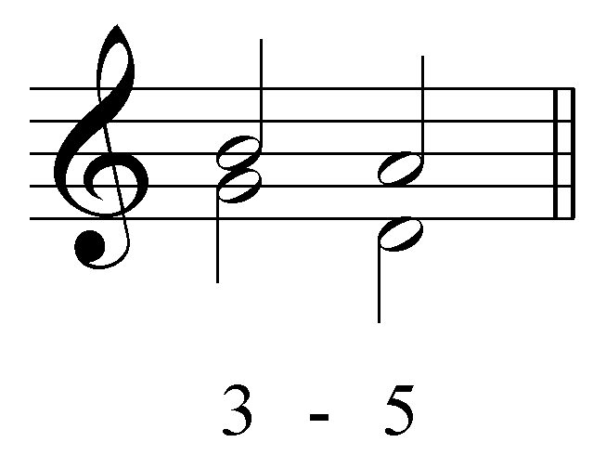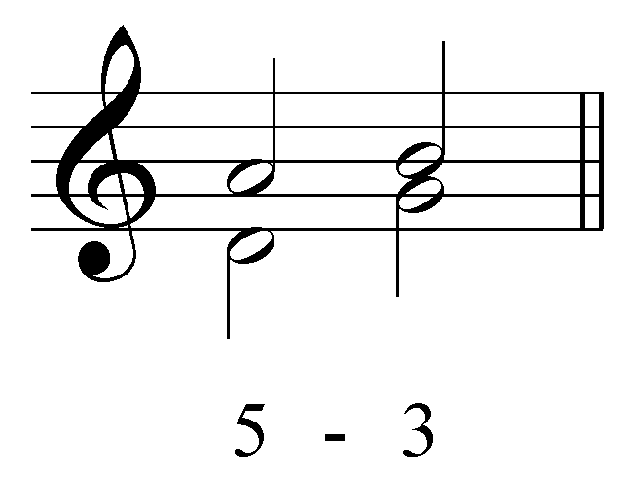

Like the second category of contrary-motion progressions, the roles of the two voices may be reversed. In the previous example, the upper voice moved by step while the lower voice moved by skip. In the following example, it is the lower voice that moves by step and the upper by skip:

Examples 35-36:
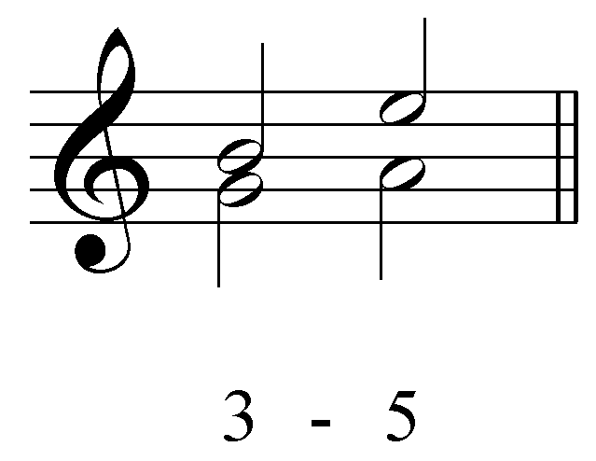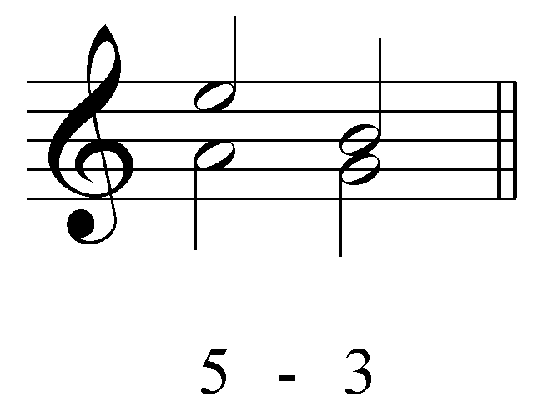

There are two other such similar-motion interval progressions, “5 - 6” (and its reverses):

Examples 37-40:
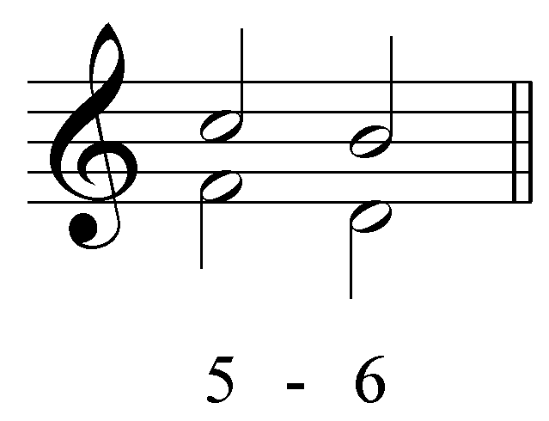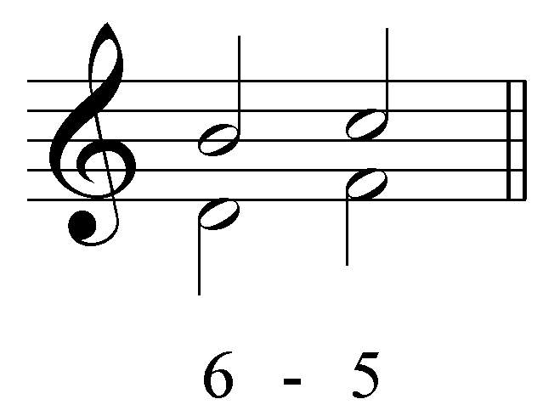

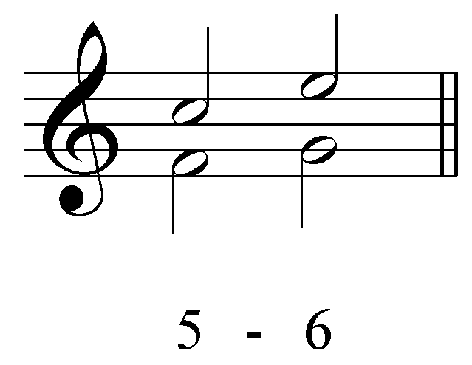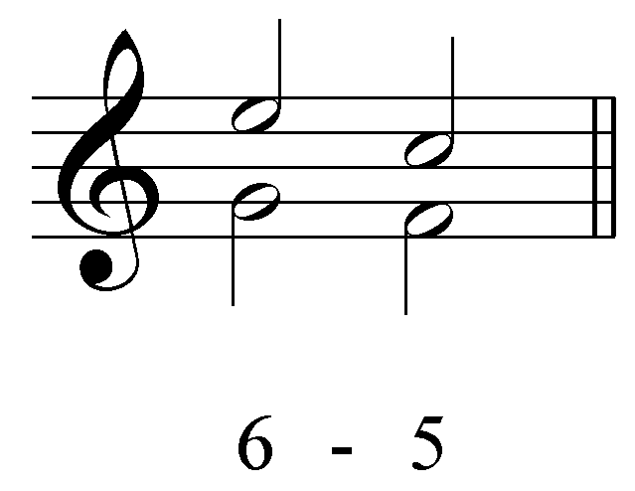

and “6 - 8” (and its reverses):

Examples 41-44:
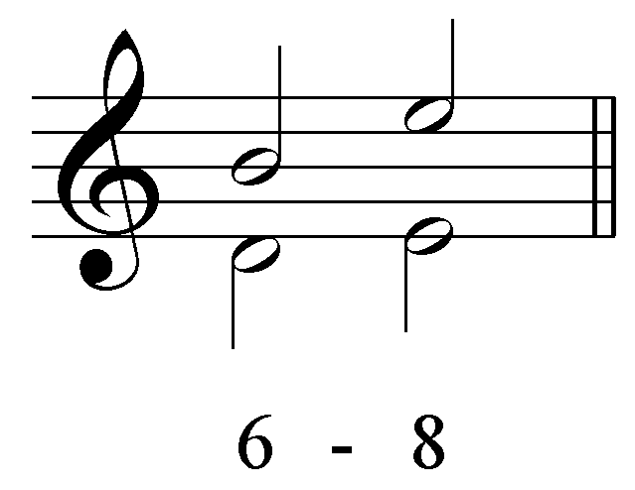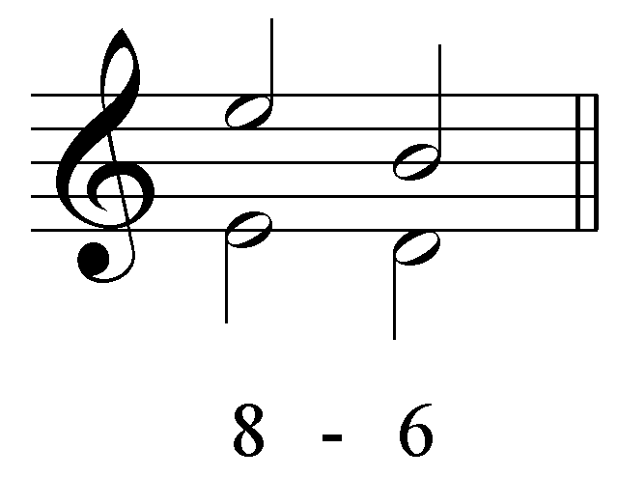

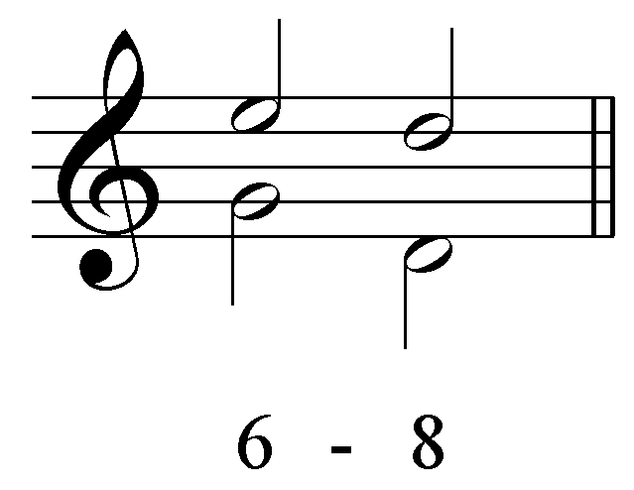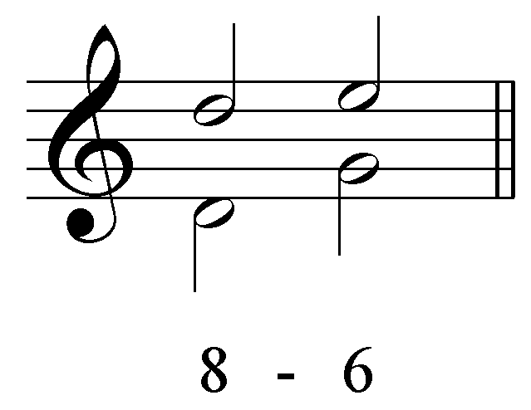

There is one special type of similar-motion interval progressions which occurs mainly between the bass and one upper voice. As we will see later, this progression is typical for falling-fifth chord progressions. In this progression, the upper voice moves by step while the bass leaps by fifth in the same direction:

Examples 45-46:
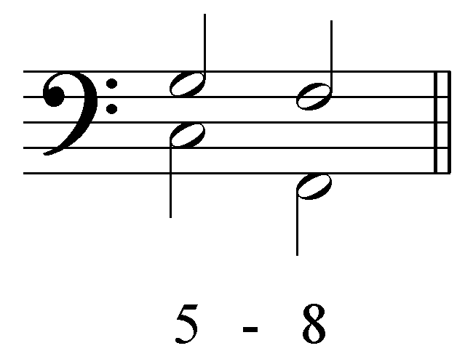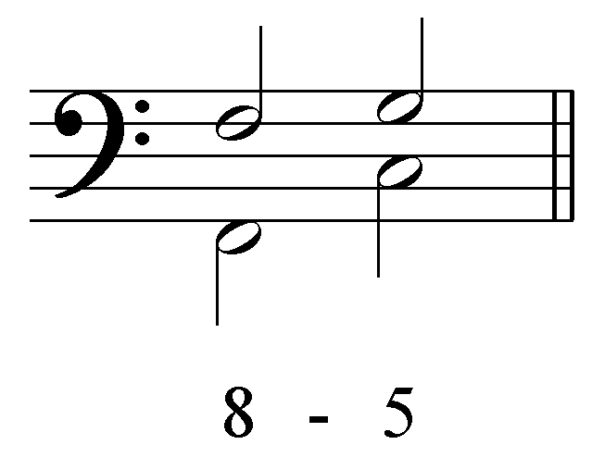

Activity 1.5:
As you saw in the previous activity, there are often several possibilities for following an interval. In this activity, you will complete an interval progression in four different ways using similar motion.

Exercises 1.5a-d:
Complete the following interval progression in four unique and valid ways by providing voices for the second beat moving using similar motion only.
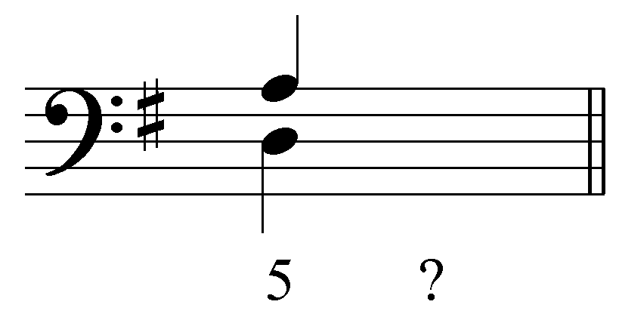
[Answers:
Upper voice to G / lower voice to G
Upper voice to G / lower voice to B
Upper voice to C / lower voice to E
Upper voice to B / lower voice to G
Upper voice to E / lower voice to C
Response if correct: “Correct!” Response if incorrect: “Incorrect. Those voices don’t create a valid similar-motion interval progression. Try again.”]

Oblique motion:

The last type of motion for interval progressions is oblique motion, where one voice remains stationary while the other moves against it by step (or skip). The “5 - 6” progression is typical, as shown here.

Examples 47-48:
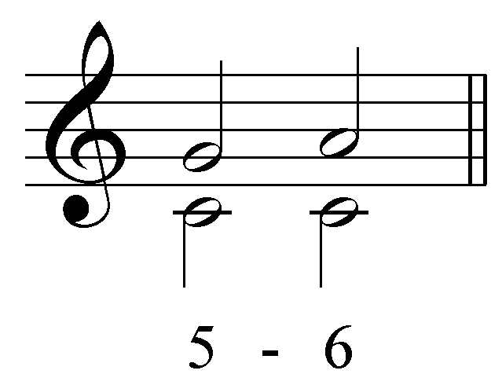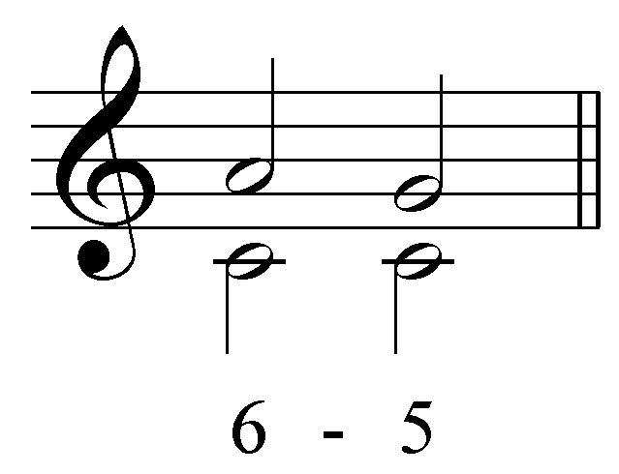

Activity 1.6:
Being able to recognize the various basic interval progressions will help you immeasurably in your study of tonal music. In this activity you will identify various basic interval progressions and classify them as having parallel, contrary, similar, or oblique motion.

Exercise 1.6a:
Identify all of the intervals in the following two-voice progression:
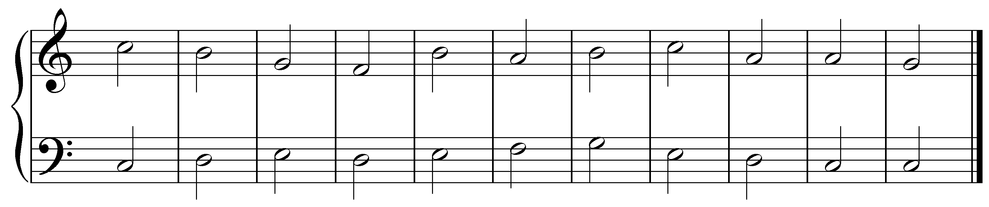
[Answer:
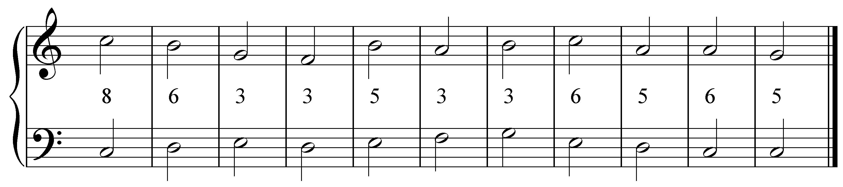]

Exercise 1.6b:
Now label each pair of intervals as having parallel, contrary, similar, or oblique motion.
[Answer:
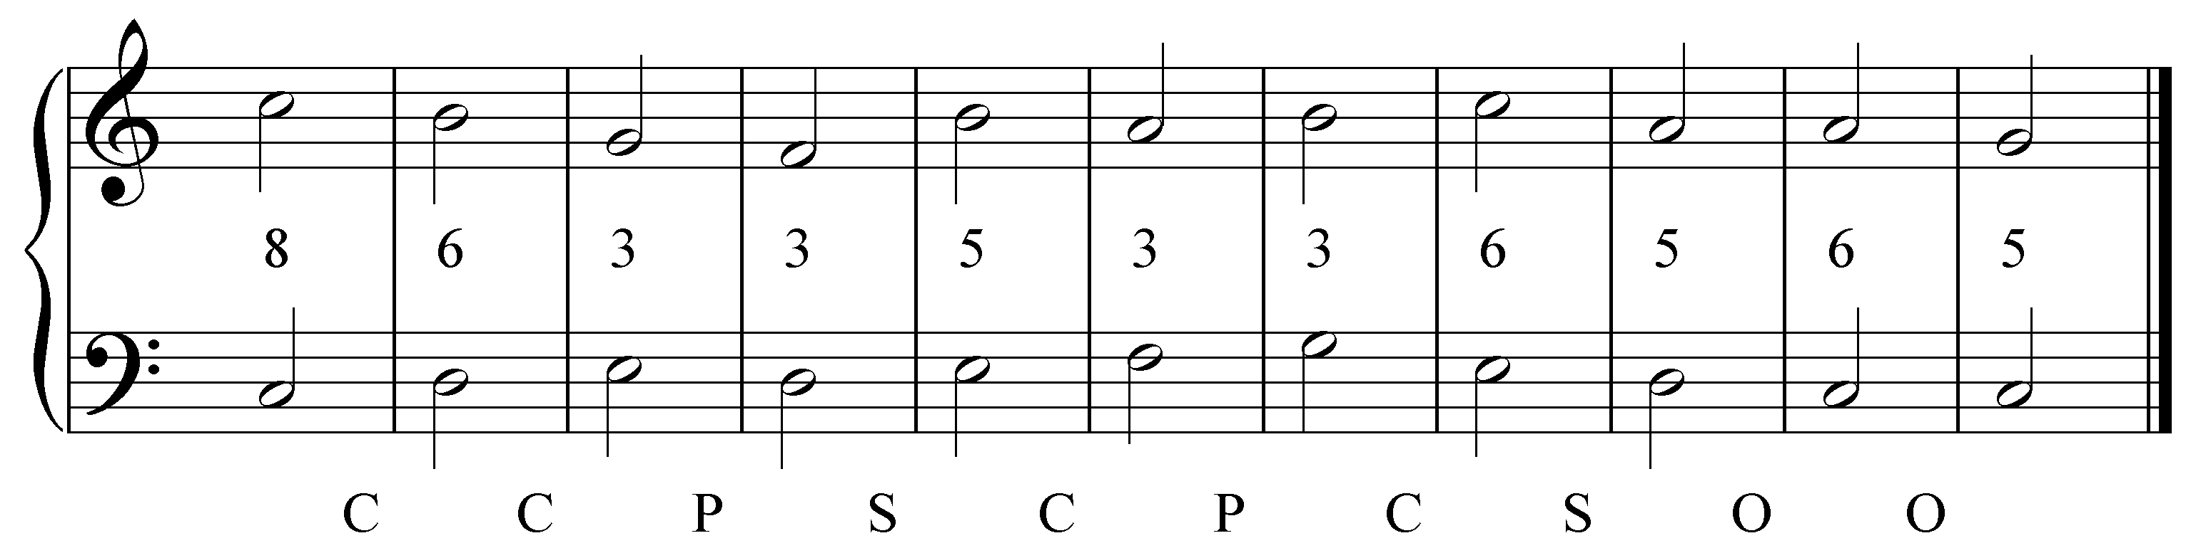]

Activity 1.7:
Basic interval progressions form the basis of tonal music. In this exercise you will identify basic interval progressions in an excerpt from a chorale by J.S. Bach (BWV 269, “Aus meines Herzens Grunde,” mm. 1-7). You may notice that not all of the voices seem to follow basic interval progressions exactly. This will be clarified in later lessons.

Exercise 1.7a:
Identify the basic interval progression being followed by the red notes:
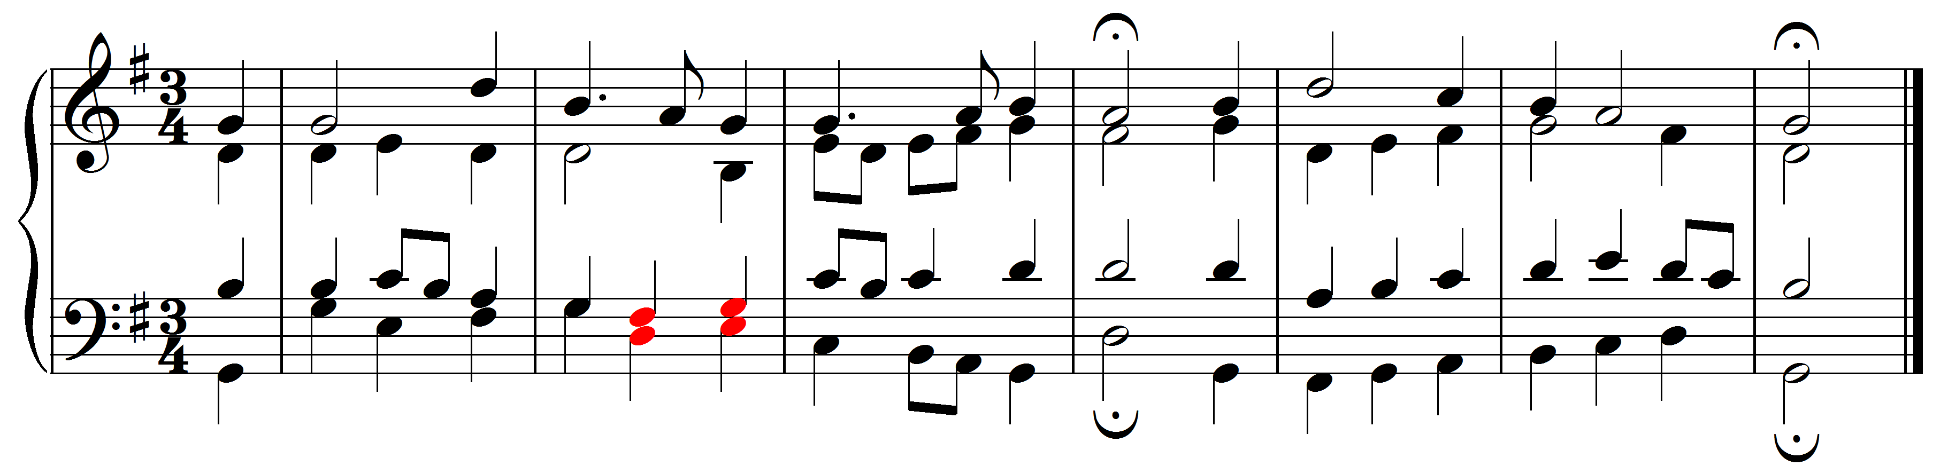
[Answer: “parallel thirds (3-3)”. Response if correct: “Correct! The tenor and the bass are moving in parallel thirds.” Response if incorrect: “Incorrect. Try again.”]

Exercise 1.7b:
Identify the basic interval progression being followed by the red notes:
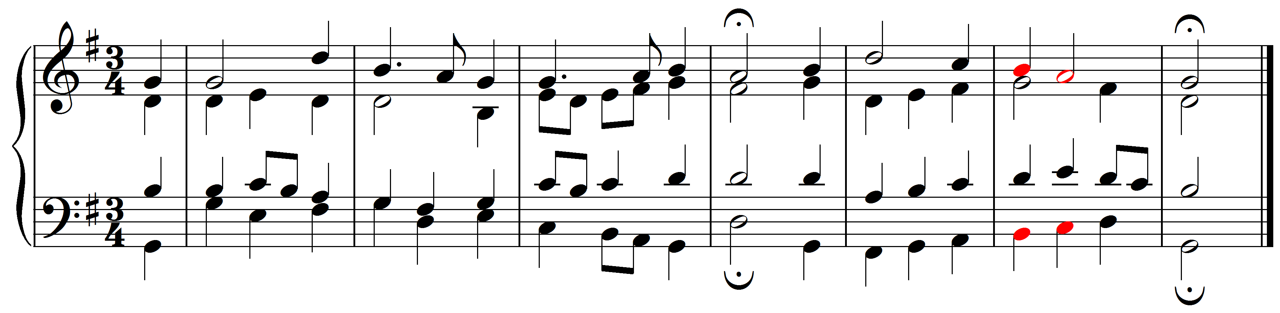

[Answer: “8-6”. Response if correct: “Correct! The soprano and the bass are moving in contrary motion from an octave to a sixth.” Response if incorrect: “Incorrect. Try again.”]

Exercise 1.7c:
Identify the basic interval progression being followed by the red notes:
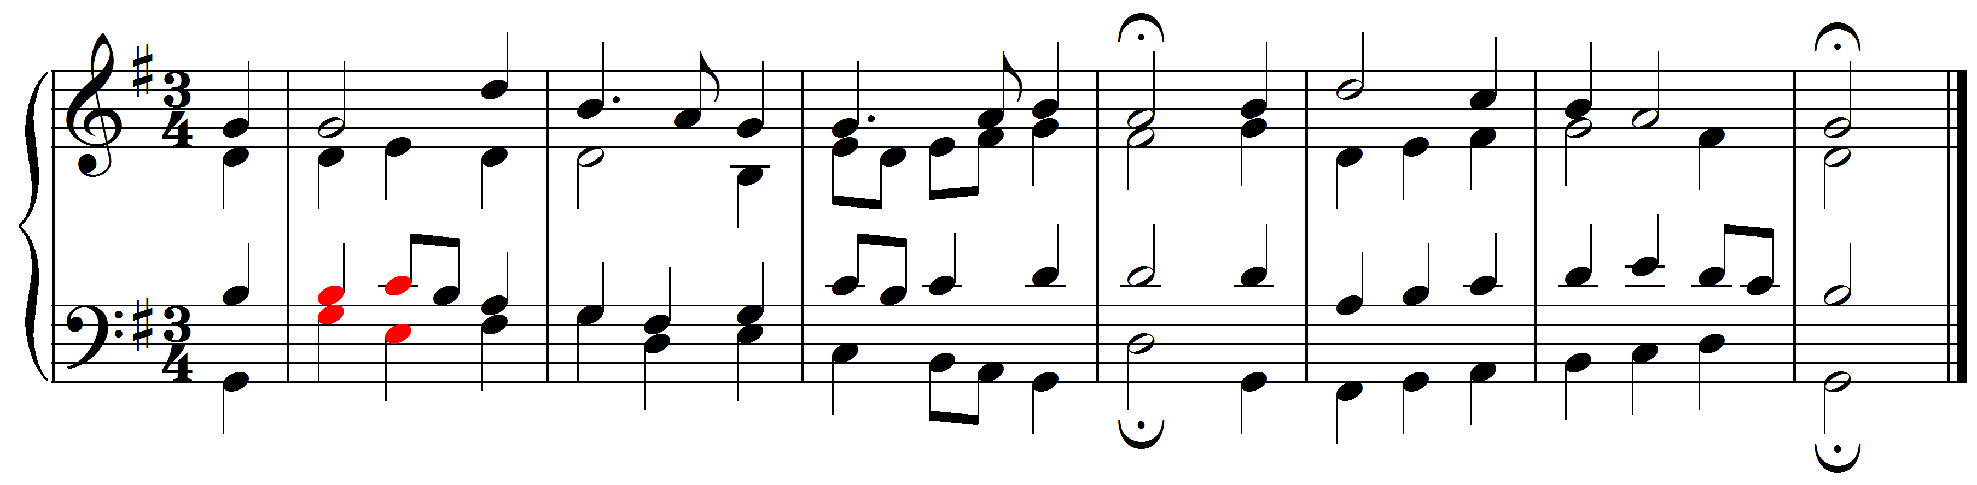
[Answer: “3-6”. Response if correct: “Correct! The tenor and the bass are moving in contrary motion from a third to a sixth.” Response if incorrect: “Incorrect. Try again.”]

Exercise 1.7d:
Identify the basic interval progression being followed by the red notes:
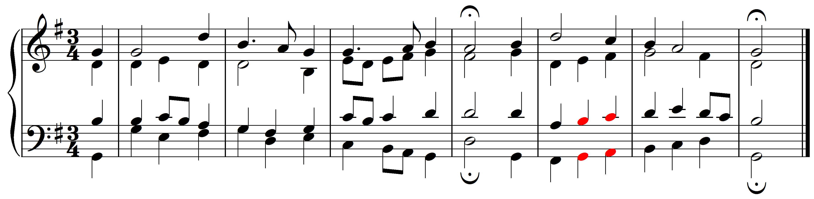
[Answer: “3-3”. Response if correct: “Correct! The tenor and the bass are moving in parallel thirds.” Response if incorrect: “Incorrect. Try again.”]

Exercise 1.7e:
Identify the basic interval progression being followed by the red notes:
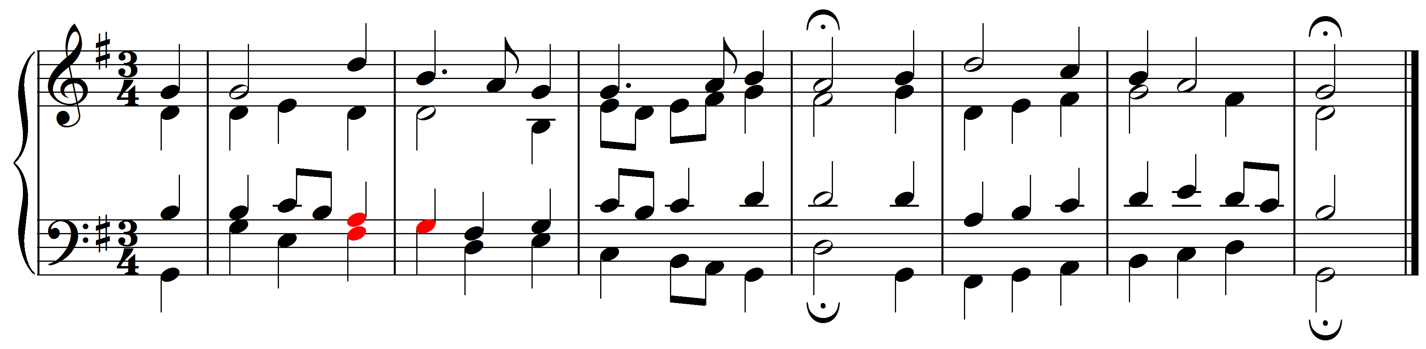
[Answer: “3-1”. Response if correct: “Correct! The tenor and the bass move by contrary motion from a third to a unison.” Response if incorrect: “Incorrect. Try again.”]

Exercise 1.7f:
Identify the basic interval progression being followed by the red notes:
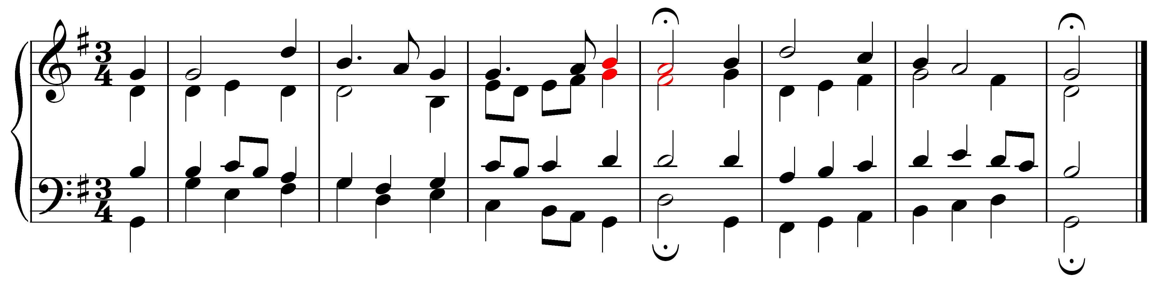

[Answer: “3-3”. Response if correct: “Correct! The soprano and the alto are moving in parallel thirds.” Response if incorrect: “Incorrect. Try again.”]

Conclusion:

These standard interval progressions form the backbone of counterpoint in tonal music. In the following lesson (Lesson BBB), you will be given opportunities to use them in constructing a multi-voiced texture and to see them at work in a chorale by J.S. Bach. The list of progressions may seem daunting at first and for that reason we have included a printable overview summarizing them all by category. With time and some practice, you will easily become familiar with all of them.

[Click here for a printable table of the standard interval progressions.]

