Lesson DDD: Figured Bass

Exam:

Question 1a: According to the figured bass signature, what pitches must appear above this bass note?
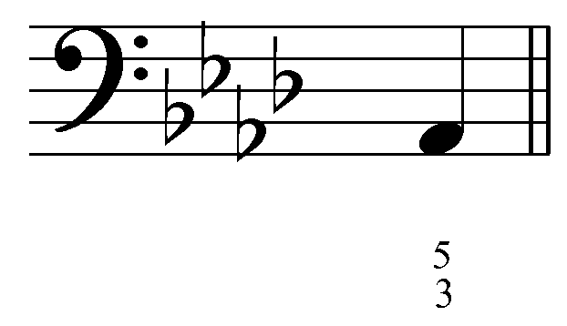
[Answer: C and E^{b}. Feedback if correct: “Correct!” Feedback if incorrect: “Incorrect. This figured bass signature implies that a C and an E^{b} must appear above the bass.”]

Question 1b: According to the figured bass signature, what pitches must appear above this bass note?
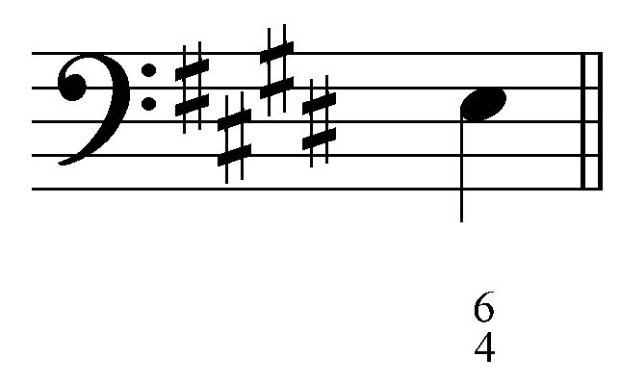
[Answer: A and C#. Feedback if correct: “Correct!” Feedback if incorrect: “Incorrect. This figured bass signature implies that an A and a C# must appear above the bass.”]

Question 1c: According to the figured bass signature, what pitches must appear above this bass note?
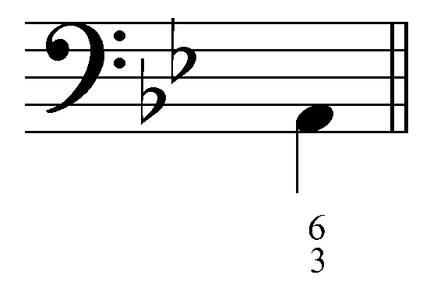
[Answer: C and F. Feedback if correct: “Correct!” Feedback if incorrect: “Incorrect. This figured bass signature implies that a C and an F must appear above the bass.”]

Question 2a: In which voice will the “6 - 5” motion indicated by the figured bass occur? And to which pitch should that voice move?
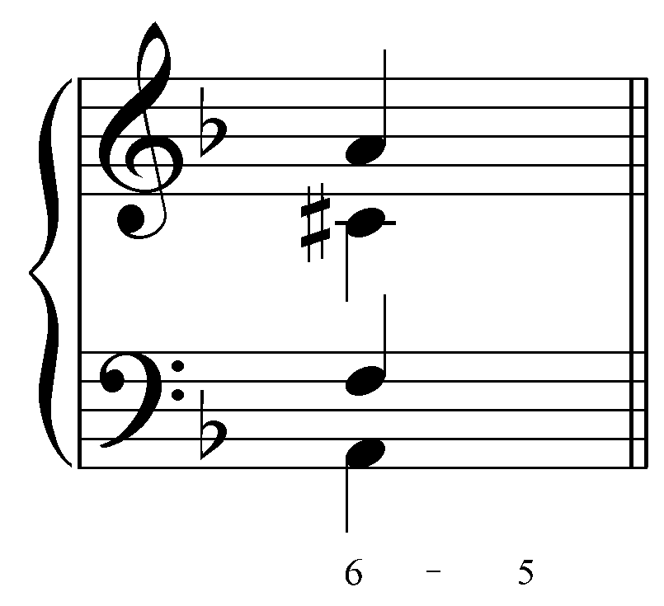
[(Students must enter two answers.) Answer: Tenor and E. Feedback if correct: “Correct! The “6 - 5” figure indicates that the tenor must step down to E.” Feedback if incorrect: “Incorrect. The “6 - 5” figure indicates that the tenor must step down to E.”]

Question 2b: In which voice will the “8 - 7” motion indicated by the figured bass occur? And to which pitch should that voice move?
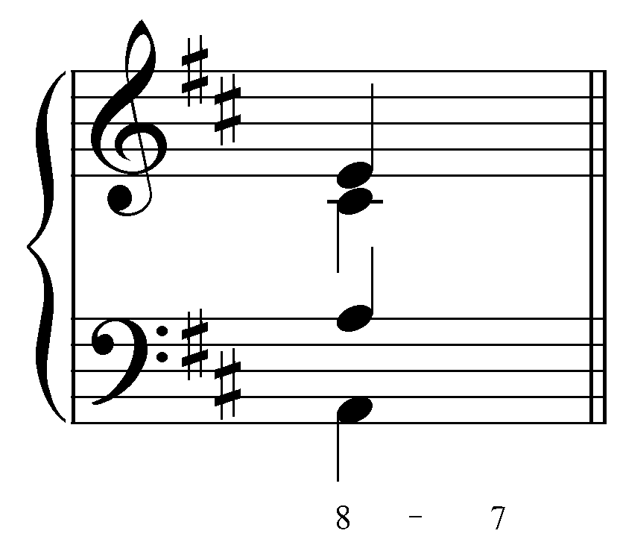
[(Students must enter two answers.) Answer: Tenor and G. Feedback if correct: “Correct! The “8 - 7” figure indicates that the tenor must step down to G.” Feedback if incorrect: “Incorrect. The “8 - 7” figure indicates that the tenor must step down to G.”]

Question 3a: [Multiple choice.] Which figured bass signature would be used to represent this chord?
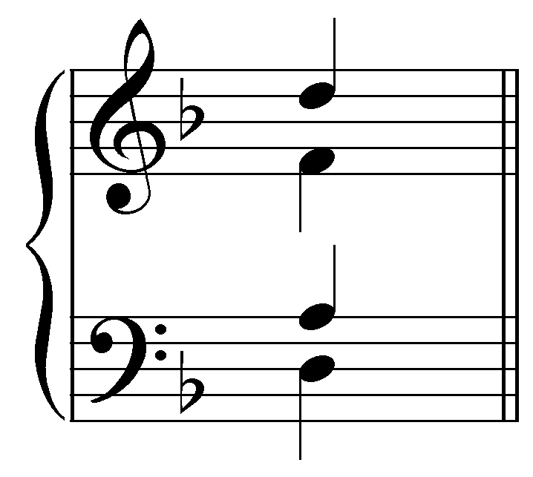
[Options: “${}_{3}^{5}$,” “${}_{3}^{6}$,” and “${}_{4}^{6}$.” Answer: “${}_{3}^{5}$.” Feedback if correct: “Correct! This is a root position triad.” Feedback if incorrect: “Incorrect. This is a root position triad (represented by ${}_{3}^{5}$).”]

Question 3b: [Multiple choice.] Which figured bass signature would be used to represent this chord?
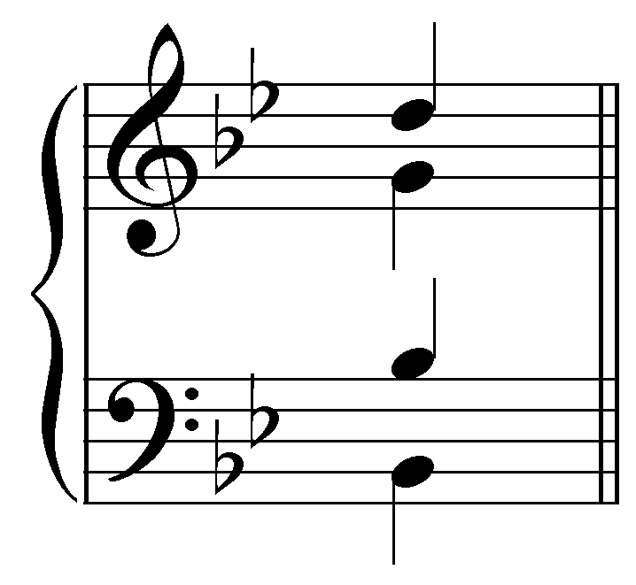
[Options: “${}_{3}^{5}$,” “${}_{3}^{6}$,” and “${}_{4}^{6}$.” Answer: “${}_{3}^{6}$.” Feedback if correct: “Correct! This is a first-inversion triad.” Feedback if incorrect: “Incorrect. This is a first-inversion triad (represented by ${}_{3}^{6}$).”]

Question 3c: [Multiple choice.] Which figured bass signature would be used to represent this chord?
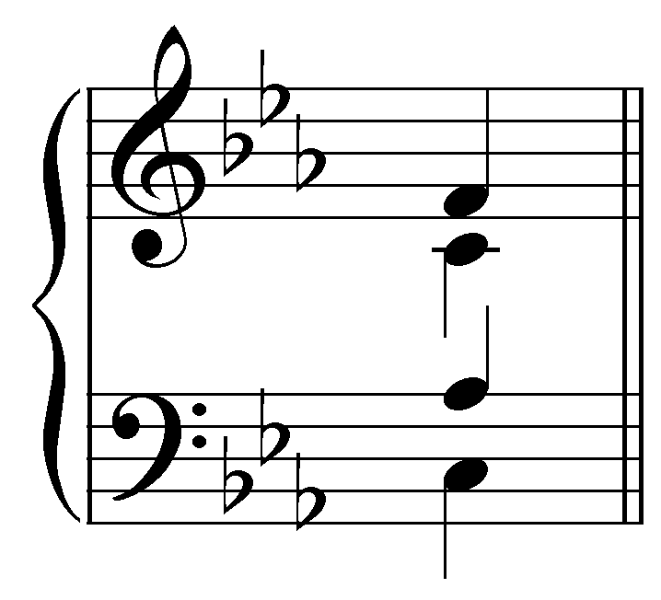
[Options: “${}_{3}^{5}$,” “${}_{3}^{6}$,” and “${}_{4}^{6}$.” Answer: “${}_{4}^{6}$.” Feedback if correct: “Correct! This is a second-inversion triad.” Feedback if incorrect: “Incorrect. This is a second-inversion triad (represented by ${}_{4}^{6}$).”]

Question 4a: According to the figured bass signature, what pitches must appear above this bass note?
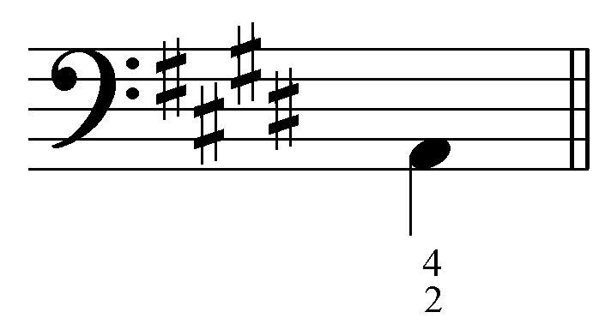
[Answers: B, D#, and F#. Feedback if correct: “Correct!” Feedback if incorrect: “Incorrect. This figured bass signature implies that B, D#, and F# must appear above the bass.”]

Question 4b: According to the figured bass signature, what pitches must appear above this bass note?
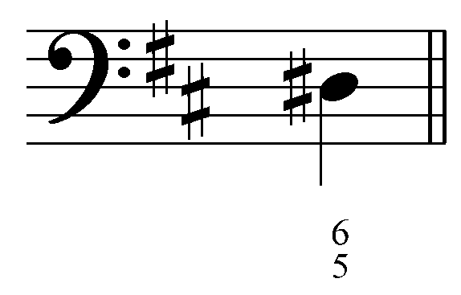
[Answers: F#, A, and B. Feedback if correct: “Correct!” Feedback if incorrect: “Incorrect. This figured bass signature implies that F#, A, and B must appear above the bass.”]

Question 4c: According to the figured bass signature, what pitches must appear above this bass note?
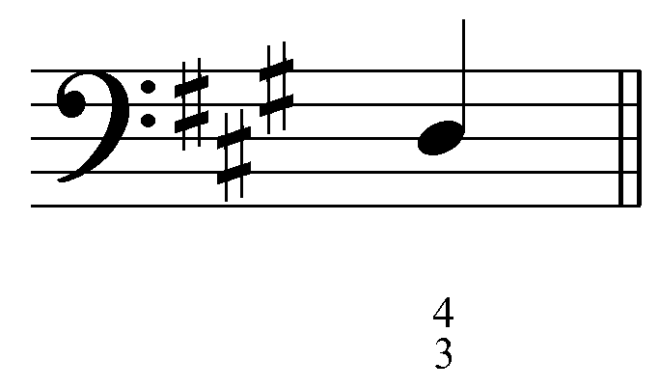
[Answers: F#, G#, and B. Feedback if correct: “Correct!” Feedback if incorrect: “Incorrect. This figured bass signature implies that F#, G#, and B must appear above the bass.”]

Question 4d: According to the figured bass signature, what pitches must appear above this bass note?
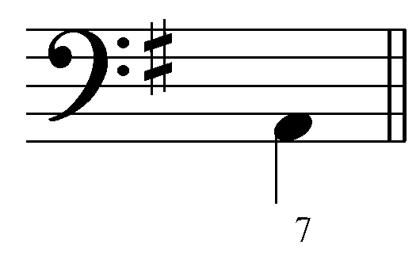
[Answers: C, E, and G. Feedback if correct: “Correct!” Feedback if incorrect: “Incorrect. This figured bass signature implies that C, E, and G must appear above the bass.”]

Question 5a: [Multiple choice.] Which figured bass signature would be used to represent this chord?
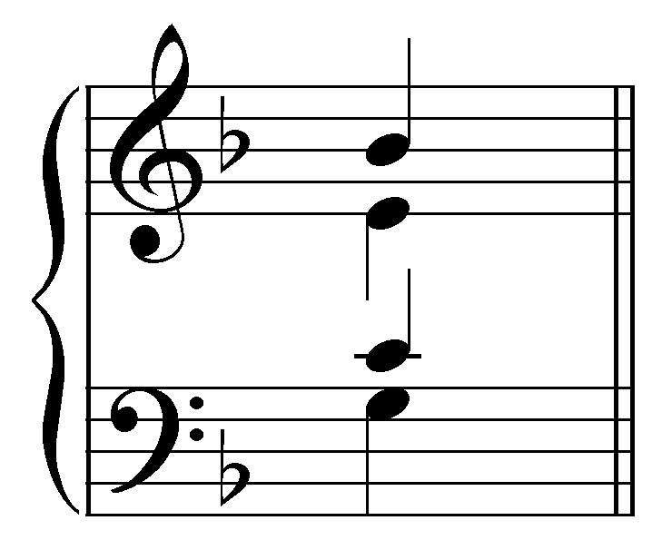
[Options: “${}^{7}$,” “${}_{5}^{6}$,” “${}_{3}^{4}$,” and “${}_{2}^{4}$.” Correct answer: “${}_{3}^{4}$.”Feedback if correct: “Correct! This is a second-inversion seventh chord.” Feedback if incorrect: “Incorrect. This is a second-inversion seventh chord (represented by ${}_{3}^{4}$).”]

Question 5b: [Multiple choice.] Which figured bass signature would be used to represent this chord?
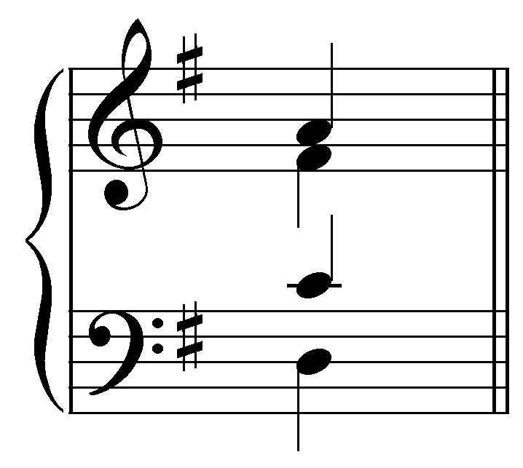
[Options: “${}^{7}$,” “${}_{5}^{6}$,” “${}_{3}^{4}$,” and “${}_{2}^{4}$.” Correct answer: “${}^{7}$.”Feedback if correct: “Correct! This is a root position seventh chord.” Feedback if incorrect: “Incorrect. This is a root position seventh chord (represented by ${}^{7}$).”]

Question 5c: [Multiple choice.] Which figured bass signature would be used to represent this chord?
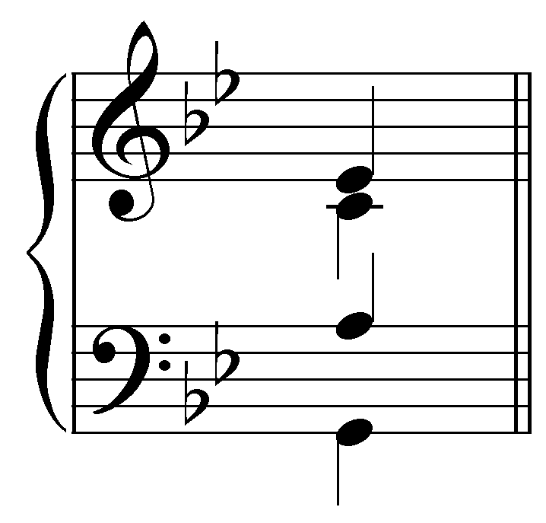
[Options: “${}^{7}$,” “${}_{5}^{6}$,” “${}_{3}^{4}$,” and “${}_{2}^{4}$.” Correct answer: “${}_{2}^{4}$.”Feedback if correct: “Correct! This is a third-inversion seventh chord.” Feedback if incorrect: “Incorrect. This is a third-inversion seventh chord (represented by ${}_{2}^{4}$).”]

Question 5d: [Multiple choice.] Which figured bass signature would be used to represent this chord?
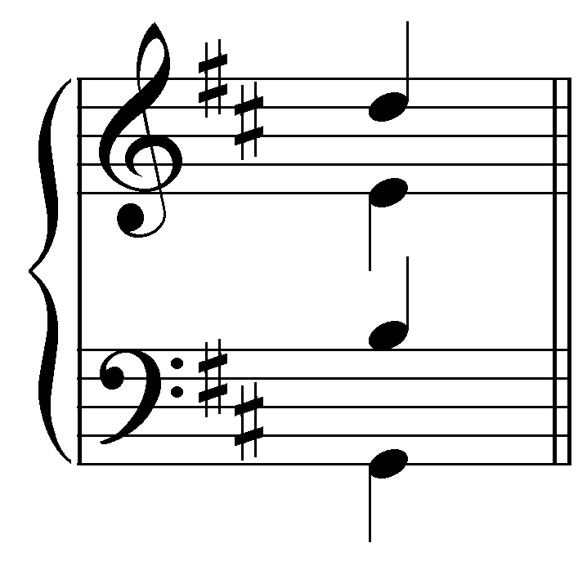
[Options: “${}^{7}$,” “${}_{5}^{6}$,” “${}_{3}^{4}$,” and “${}_{2}^{4}$.” Correct answer: “${}_{5}^{6}$.”Feedback if correct: “Correct! This is a first-inversion seventh chord.” Feedback if incorrect: “Incorrect. This is a first-inversion seventh chord (represented by ${}_{5}^{6}$).”]

Question 6a: According to the figured bass signature, what pitches must appear above this bass note? (Remember to apply the chromatic alterations to the correct voice.)
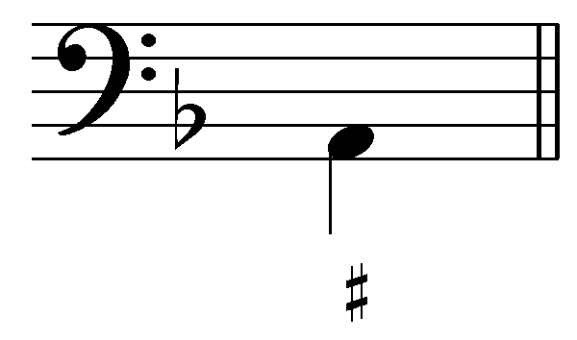
[Answers: C# and E. Feedback if correct: “Correct!” Feedback if incorrect: “Incorrect. This figured bass signature implies that C# and E must appear above the bass.”]

Question 6b: According to the figured bass signature, what pitches must appear above this bass note? (Remember to apply the chromatic alterations to the correct voice.)
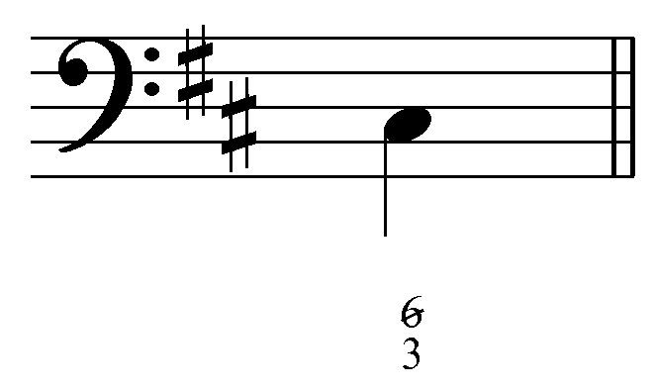
[Answers: E and A#. Feedback if correct: “Correct!” Feedback if incorrect: “Incorrect. This figured bass signature implies that E and A# must appear above the bass.”]

Question 6c: According to the figured bass signature, what pitches must appear above this bass note? (Remember to apply the chromatic alterations to the correct voice.)
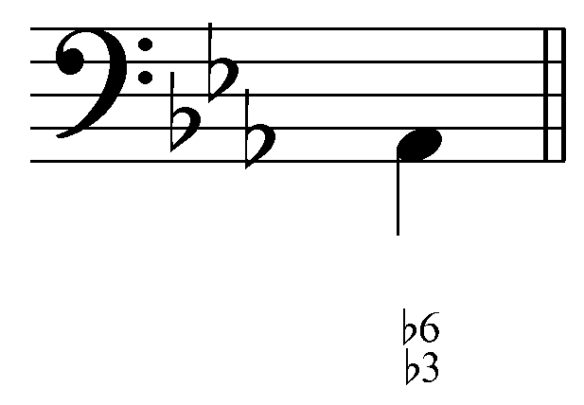
[Answers: C^{b} and F^{b}. Feedback if correct: “Correct!” Feedback if incorrect: “Incorrect. This figured bass signature implies that C^{b} and F^{b} must appear above the bass.”]

Question 7a: What roman numeral and figured bass signature should appear under the chord indicated by the arrow? (J.S. Bach, “Aus meines Herzens Grunde,” BWV 269, mm. 5-7.)
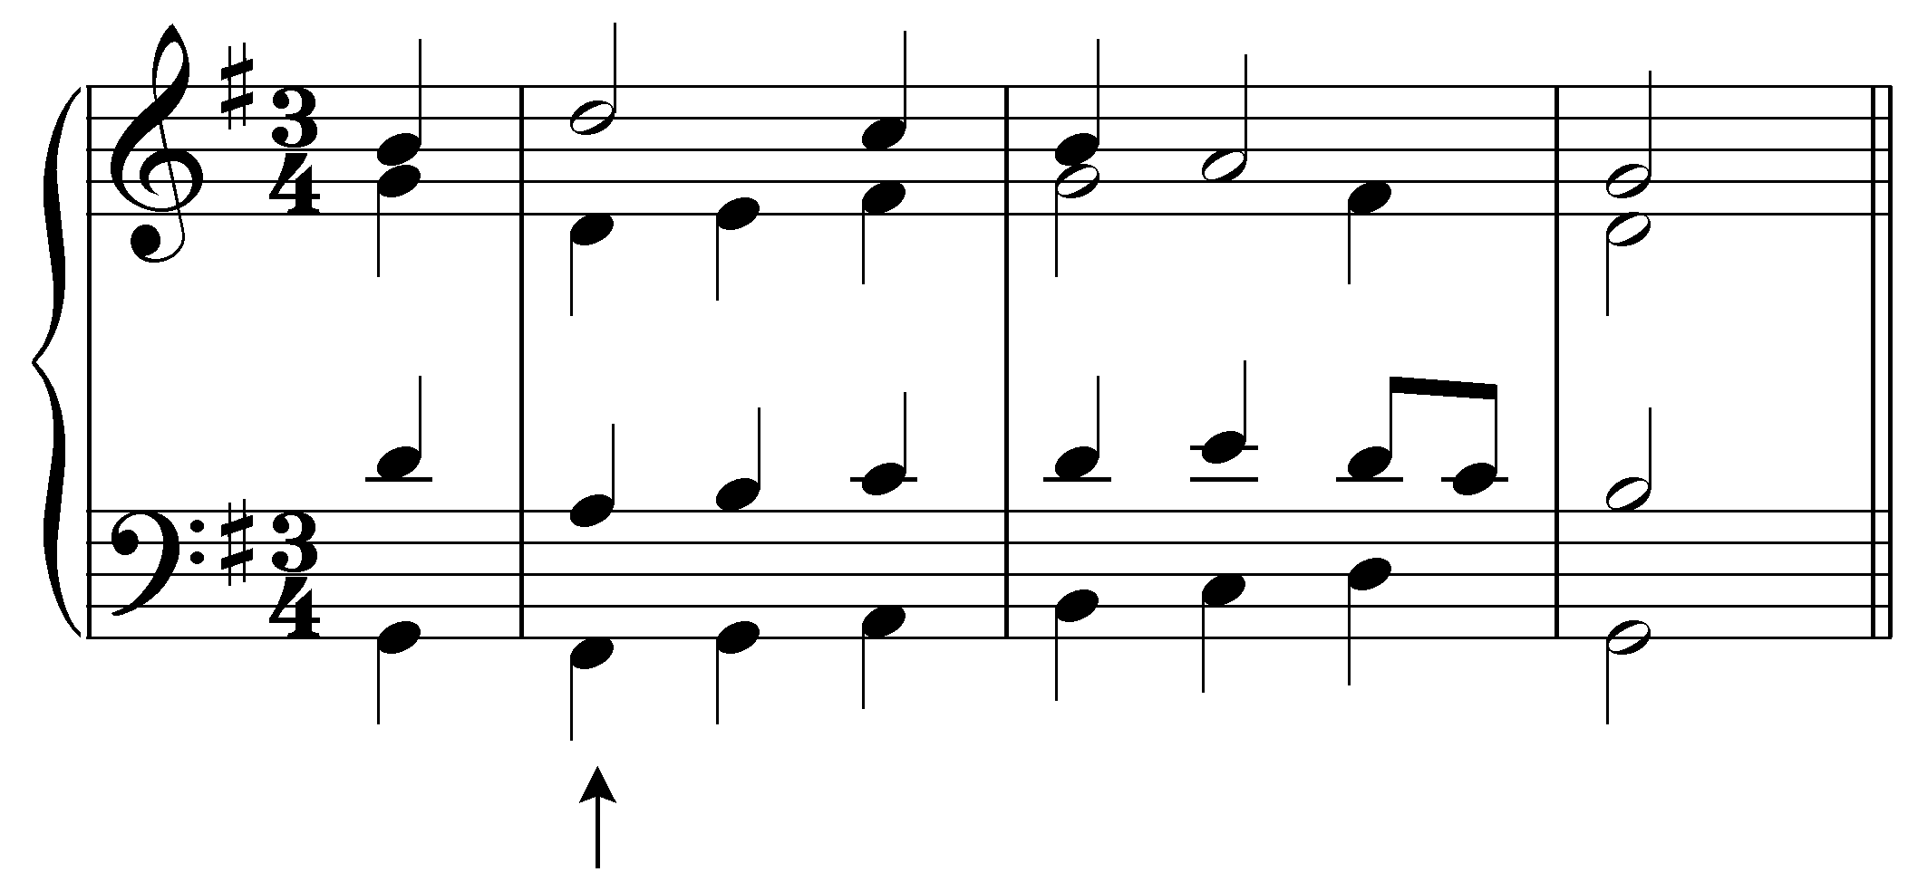
[Answer: V⁶ or V${}_{3}^{6}$. Feedback if correct: “Correct!” Feedback if incorrect: “Incorrect. This chord should be represented with “V⁶.”]

Question 7b: What roman numeral and figured bass signature should appear under the chord indicated by the arrow? (J.S. Bach, “Aus meines Herzens Grunde,” BWV 269, mm. 5-7.)
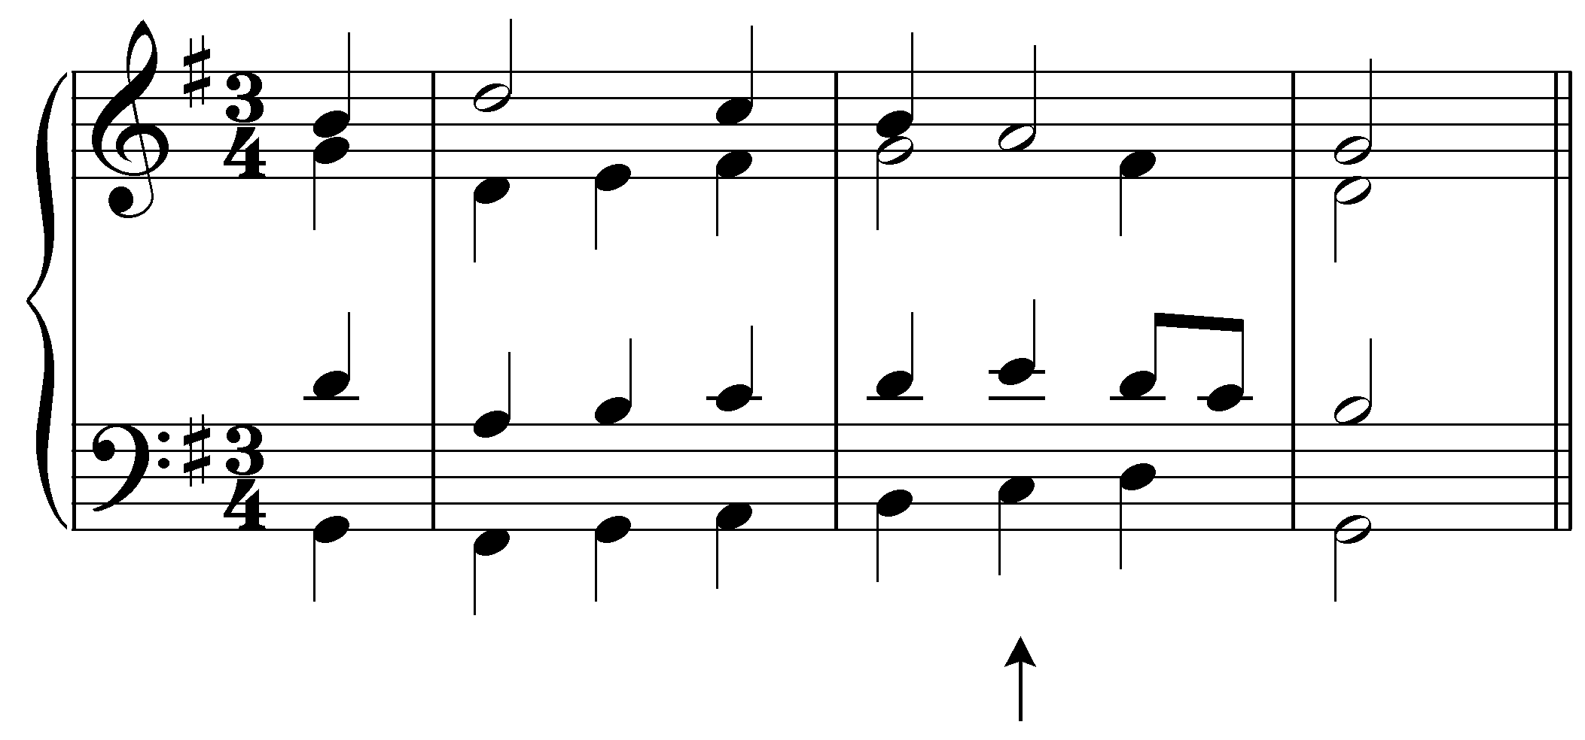
[Answer: ii${}_{5}^{6}$ or ii${{\begin{aligned}5\end{aligned}}^{3}}_{6}$. Feedback if correct: “Correct!” Feedback if incorrect: “Incorrect. This chord should be represented with “ii${}_{5}^{6}$.”]

