Lesson DDD: Figured Bass

Introduction:

In this lesson you will learn about the various uses of figured bass. Figured bass comes from a Baroque compositional practice in which composers used a numerical shorthand to provide an accompanist with a harmonic blueprint. The blueprint consisted of a bass line above a series of symbols and arabic numerals. The numerals indicated intervals to be played above the bass. Unless otherwise specified, the notes that form the intervals specified by the figured-bass signatures are understood to be diatonic—that is, in accordance with the key signature. The actual voicing of the intervals (register, doublings, etc.) was left to the accompanist. In this way, the composer would be able to quickly specify harmonic progressions, though not the chord voicings or, for the most part, voice leading among chords.

For music analysts today, figured bass is useful in two ways: for representing intervals and melodic motion above a bass line, and for indicating chord inversions. In this lesson, we will discuss both of those applications and how they interact. Because figured bass developed as a type of shorthand, numerous abbreviations are used; our discussion will cover the most common ones.

Intervals above the bass:

Example 1 shows a bass note with figures:

Example 1:
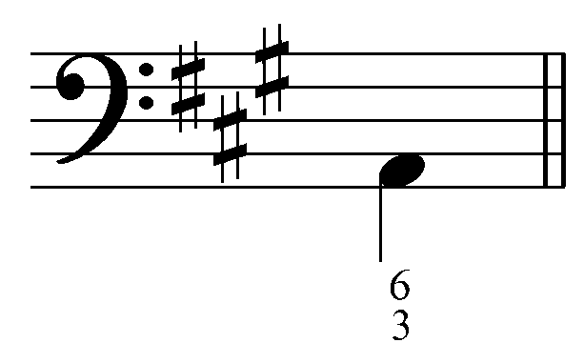

As explained, the arabic numerals indicate intervals above the bass. In other words, the 6 and the 3 specify that a sixth and a third must occur over the A. The quality of each interval (major, minor, etc.) is determined by the key signature unless otherwise specified (more on this below). In this case, a third above the bass A would be C# and a sixth above the bass would be an F#, as dictated by the A-major key signature. The following example shows the complete chord:

Example 2:
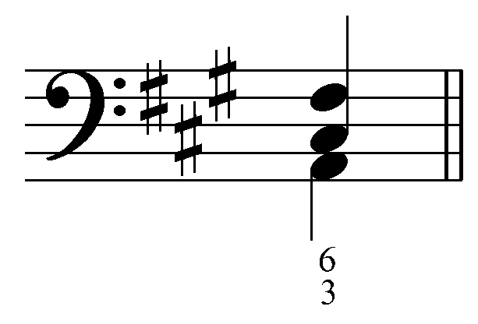

You may have noticed that the sonority shown in this example is an F#-minor chord in first inversion. The use of figured bass to indicate inversions will be discussed in greater detail below.

The figures specify the intervals to be played above the bass, but they do not specify the register of pitches forming those intervals, nor anything about doublings. Both of the following examples show valid SATB voicings of the figured bass from Example 1:

Example 3:
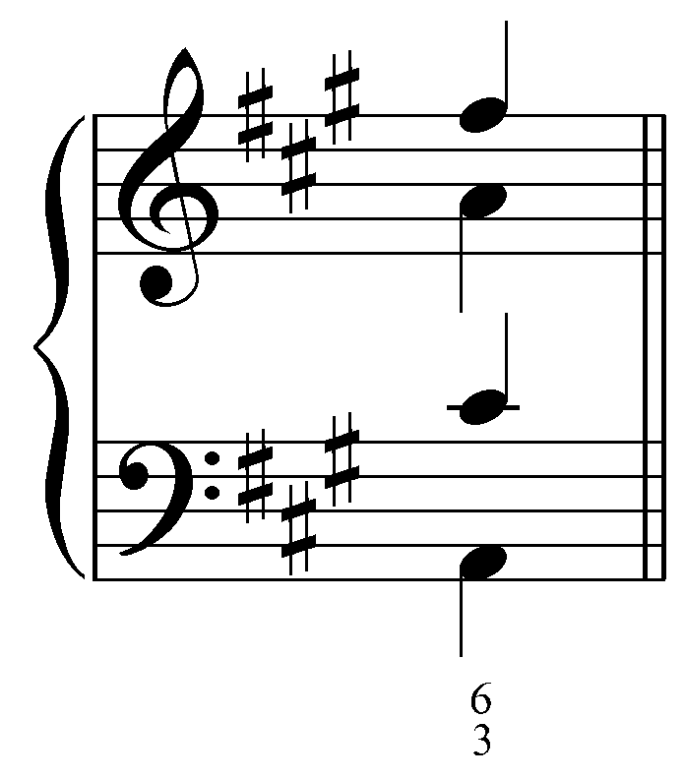

Example 4:
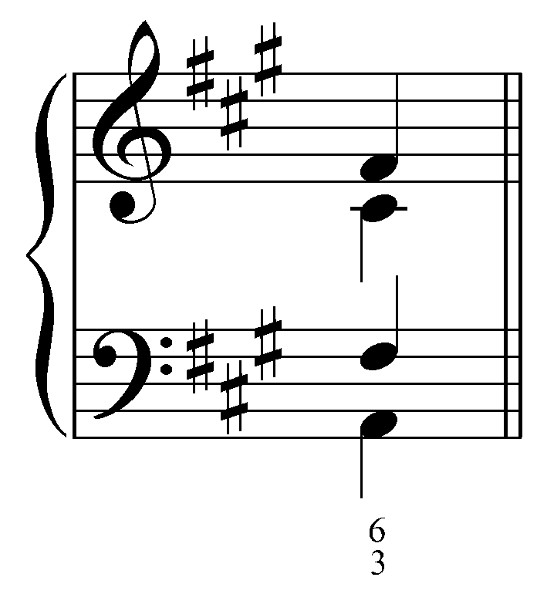

Example 3 has wider spacing and doubles the bass two octaves above in the alto. Example 4 doubles the sixth and has the voices more tightly arranged.

Activity 4.1:
“In this activity you will be presented with a series single-note of figured bass examples. For each exercise, indicate the pitches that must appear above the bass according to the figures. (Remember, unless otherwise specified, the quality of the interval is determined by the key signature.)”

Exercise 4.1a:
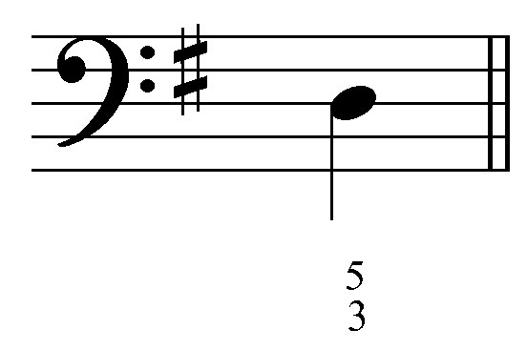
Question: “According to the figured bass signature, what pitches must appear above this bass note?” [Answers: “A” and “F#.” Incorrect answer response: “Incorrect. Remember, the arabic numerals indicate the intervals above the bass. The quality is determined by the key signature. Try again.”]

Exercise 4.1b:
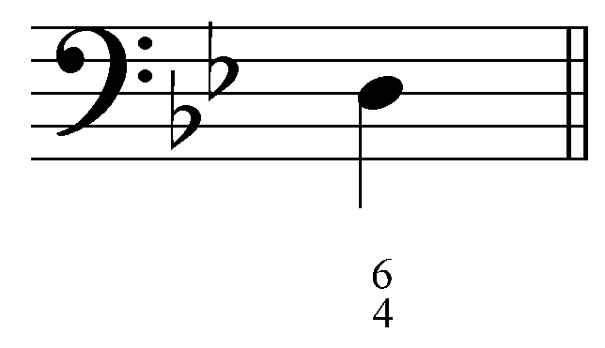
Question: “According to the figured bass signature, what pitches must appear above this bass note?” [Answers: “B^{b}” and “G.” Incorrect answer response: “Incorrect. Remember, the arabic numerals indicate the intervals above the bass. The quality is determined by the key signature. Try again.”]

Exercise 4.1c:
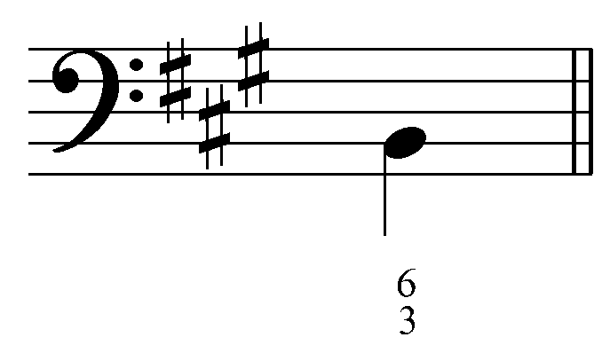
Question: “According to the figured bass signature, what pitches must appear above this bass note?” [Answers: “G#” and “D.” Incorrect answer response: “Incorrect. Remember, the arabic numerals indicate the intervals above the bass. The quality is determined by the key signature. Try again.”]

Exercise 4.1d:
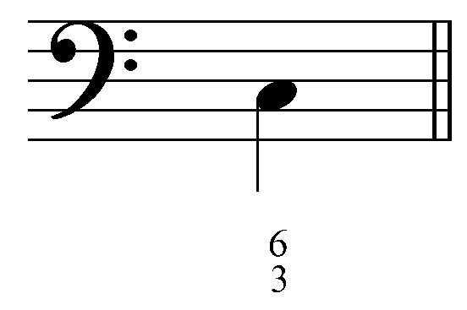
Question: “According to the figured bass signature, what pitches must appear above this bass note?” [Answers: “A” and “E.” Incorrect answer response: “Incorrect. Remember, the arabic numerals indicate the intervals above the bass. The quality is determined by the key signature. Try again.”]

Figures under a bass line can also indicate melodic motion in the upper voices:

Example 5:
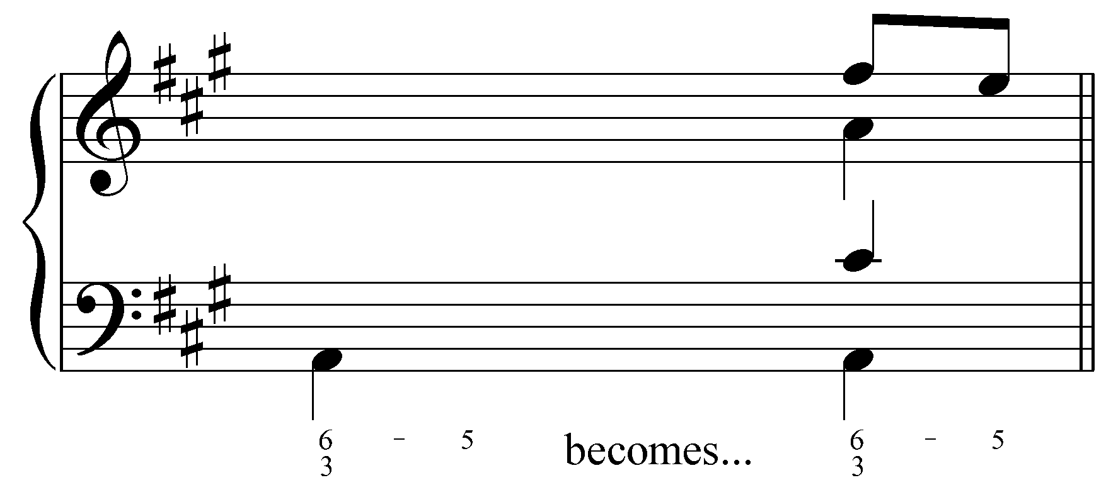

In Example 5, the figures indicate that the sixth above the bass will step down to the fifth, from F# to E. This is indicated specifically by the “6 - 5” figure. (The “- 5” applies only to the 6, because they are found next to one another on the same line.) Simultaneous motion in several voices can also be indicated in this manner:

Example 6:
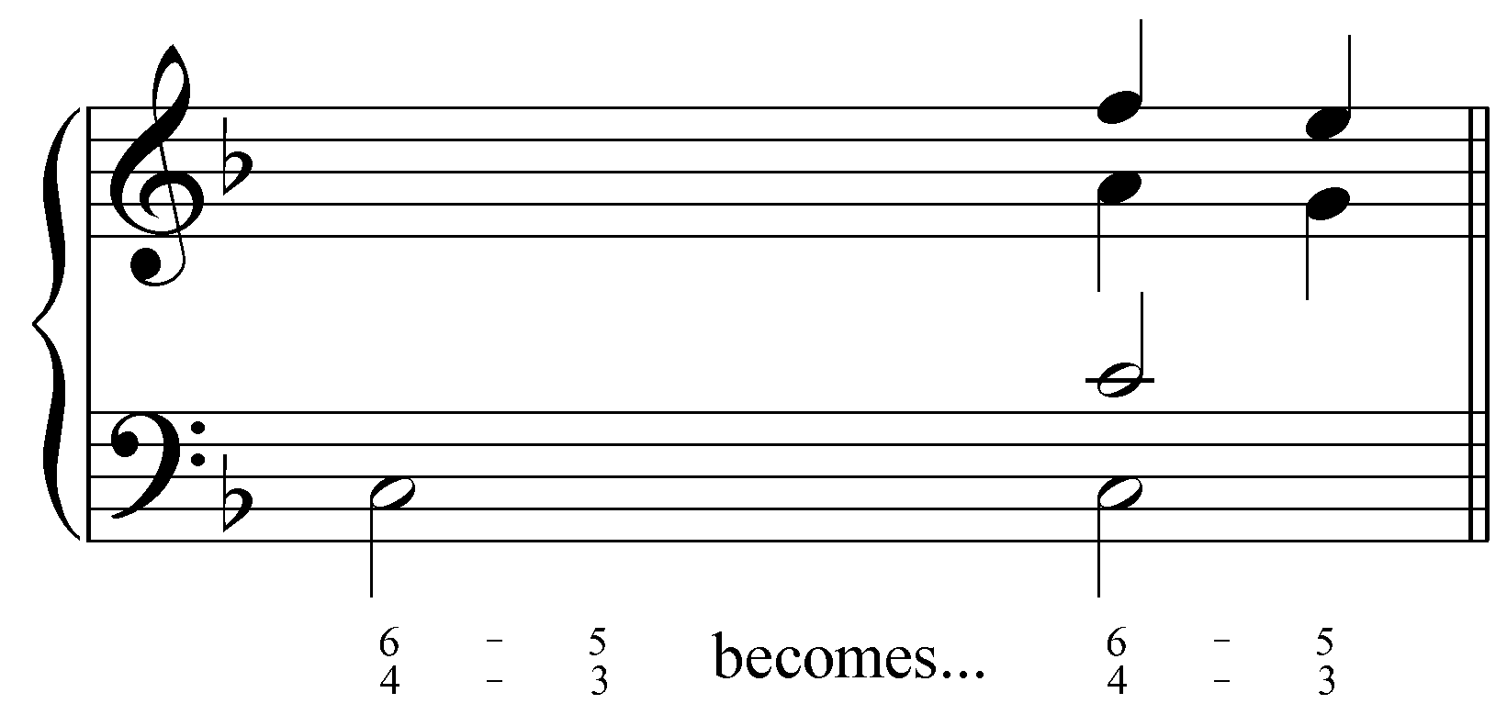

Activity 4.2:
“The figured bass signatures in each of the following exercises indicate the presence of melodic motion in one or more of the upper voices. For each exercise, identify the voice or voices where the melodic motion should occur. Then, indicate the pitch to which that voice should move.”

Activity 4.2a:
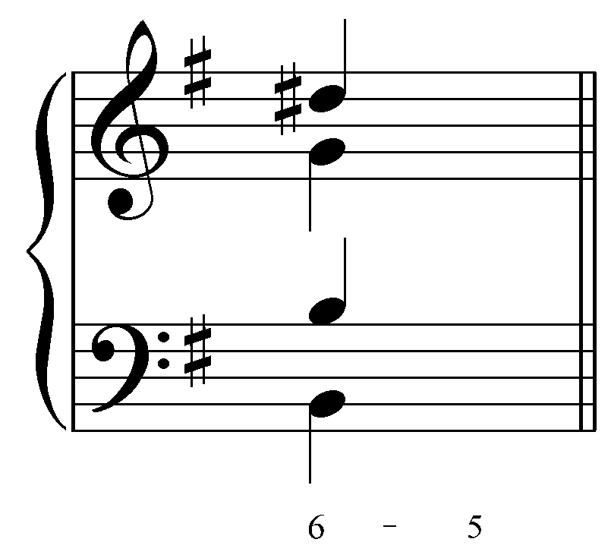
Question: “In which voice will the “6 - 5” motion indicated by the figured bass occur?” [Options: “Soprano,” “Alto,” and “Tenor.” Correct answer: “Alto.” Incorrect answer response: “That voice does not form a sixth (or compound sixth) with the bass. Try again.”]

Followup question: “Which pitch should the alto voice move to?” [Correct answer: “F#.” Incorrect answer response: “Incorrect. Remember to make sure that your answer forms a fifth with the bass and corresponds with the key signature. Try again.”]

Activity 4.2b:
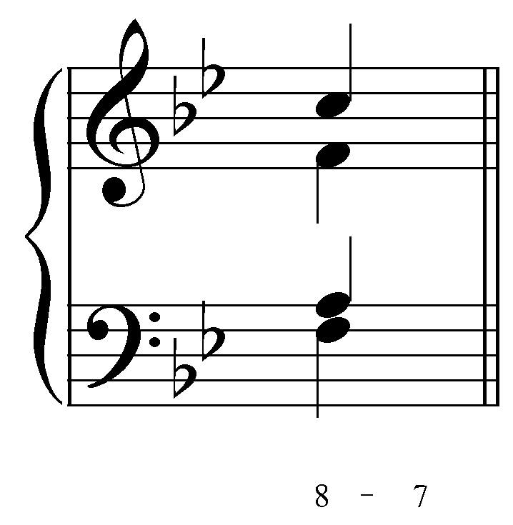
Question: “In which voice will the “8 - 7” motion indicated by the figured bass occur?” [Options: “Soprano,” “Alto,” and “Tenor.” Correct answer: “Alto.” Incorrect answer response: “That voice does not form an octave with the bass. Try again.”]

Followup question: “Which pitch should the alto voice move to?” [Correct answer: “E^{b}.” Incorrect answer response: “Incorrect. Remember to make sure that your answer forms a fifth with the bass and corresponds with the key signature. Try again.”]

Activity 4.2c:
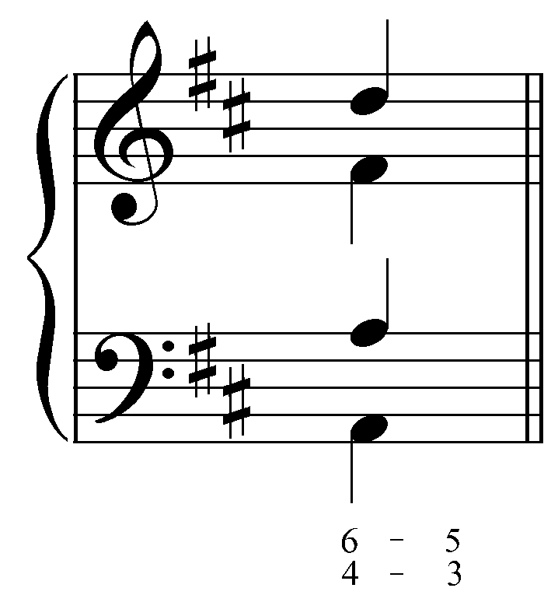
Question 1: “In this example there is melodic motion in two voices. In which voice will the “6 - 5” motion indicated by the figured bass occur?” [Options: “Soprano,” “Alto,” and “Tenor.” Correct answers: “Alto.” Incorrect answer response: “That voice does not form a sixth (or compound sixth) with the bass. Try again.”]

Question 2: “In which two voices will the “4 - 3” motion indicated by the figured bass occur?” [Options: “Soprano,” “Alto,” and “Tenor.” Correct answers: “Soprano.” Incorrect answer response: “That voice does not form a fourth (or compound fourth) with the bass. Try again.”]

Followup question 1: “Which pitch should the alto voice move to?” [Correct answer: “E.” Incorrect answer response: “Incorrect. Remember to make sure that your answer forms a fifth with the bass and corresponds with the key signature. Try again.”]

Followup question 2: “Which pitch should the soprano voice move to?” [Correct answer: “C#.” Incorrect answer response: “Incorrect. Remember to make sure that your answer forms a third with the bass and corresponds with the key signature. Try again.”]

Activity 4.2d:
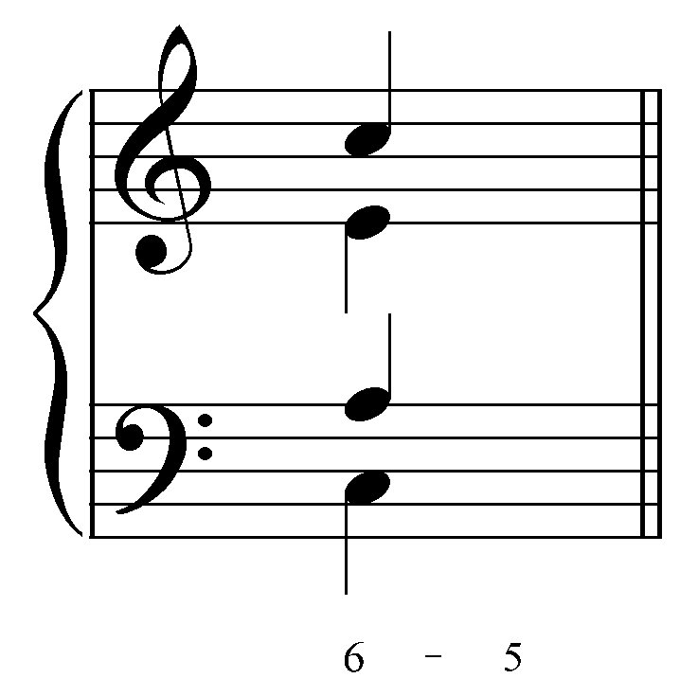
Question: “In which voice will the “6 - 5” motion indicated by the figured bass occur?” [Options: “Soprano,” “Alto,” and “Tenor.” Correct answer: “Tenor.” Incorrect answer response: “That voice does not form a sixth (or compound sixth) with the bass. Try again.”]

Followup question: “Which pitch should the tenor voice move to?” [Correct answer: “G.” Incorrect answer response: “Incorrect. Remember to make sure that your answer forms a fifth with the bass and corresponds with the key signature. Try again.”]

Figured bass and inversions:

In Examples 2-4, the completed harmony is an F#-minor triad in first inversion. By using figured bass, composers can specify any inversion of a given harmony. The inversion of a chord is determined by the lowest note (the bass). The upper voices can be in any position. Consider the three positions of a triad. A root position triad has the root in the bass while the first and second inversions have the third and fifth in the bass respectively. The following example shows the three positions of a C-major triad using figured bass to indicate the intervallic content:

Example 7:
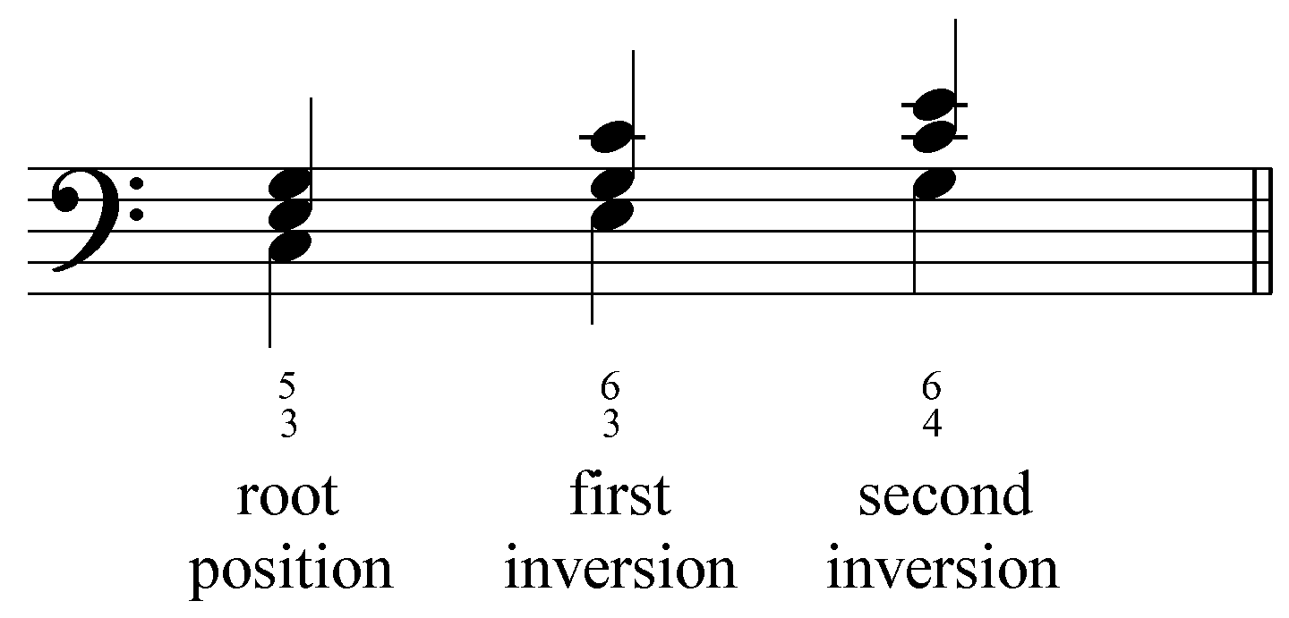

A root position triad has the root in the bass, with the other notes of the triad forming a third and fifth above the bass. The complete figured-bass signature is thus ${}_{3}^{5}$. A first inversion triad inverts the interval between the root and third of the chord (C and E in this case) to a sixth and retains the third between the third and the fifth (E and G), hence the figured-bass signature ${}_{3}^{6}$. A second inversion triad inverts both of the original intervals and therefore contains a fourth and a sixth above the bass, thus the figured-bass signature ${}_{4}^{6}$. You will frequently encounter triads referred to by their interval content (“six-three triad” instead of “first-inversion triad”).

Activity 4.3:
“In this activity you will be presented with a series of triads in SATB setting. For each exercise, choose the appropriate figured bass signature (${}_{3}^{5}$, ${}_{3}^{6}$, or ${}_{4}^{6}$) to represent the inversion of the triad.”

Exercise 4.3a:
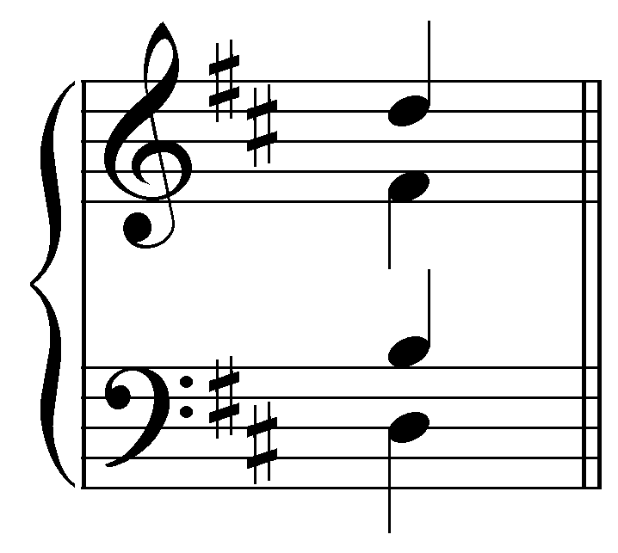

Question: “Which figured bass signature would be used to represent this chord?” [Options: “${}_{3}^{5}$,” “${}_{3}^{6}$,” and “${}_{4}^{6}$.” Correct answer: “${}_{3}^{6}$.” Incorrect answer response: “Incorrect. Remember, the figured bass signature represents the intervals that appear above the bass. Disregarding octave doublings, make sure your answer accounts for all the intervals formed with the bass.”]

Exercise 4.3b:
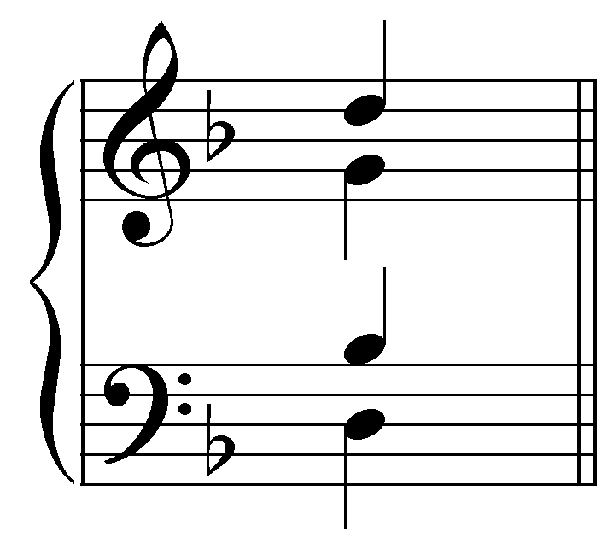

Question: “Which figured bass signature would be used to represent this chord?” [Options: “${}_{3}^{5}$,” “${}_{3}^{6}$,” and “${}_{4}^{6}$.” Correct answer: “${}_{4}^{6}$.” Incorrect answer response: “Incorrect. Remember, the figured bass signature represents the intervals that appear above the bass. Disregarding octave doublings, make sure your answer accounts for all the intervals formed with the bass.”]

Exercise 4.3c:
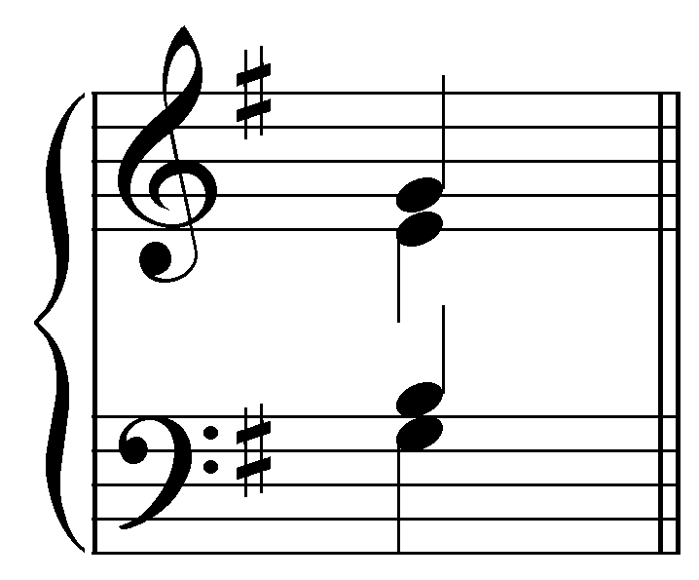

Question: “Which figured bass signature would be used to represent this chord?” [Options: “${}_{3}^{5}$,” “${}_{3}^{6}$,” and “${}_{4}^{6}$.” Correct answer: “${}_{3}^{6}$.” Incorrect answer response: “Incorrect. Remember, the figured bass signature represents the intervals that appear above the bass. Disregarding octave doublings, make sure your answer accounts for all the intervals formed with the bass.”]

Exercise 4.3d:
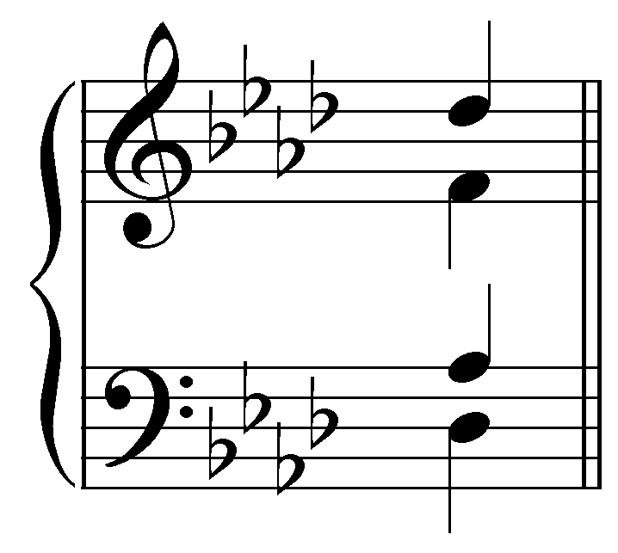

Question: “Which figured bass signature would be used to represent this chord?” [Options: “${}_{3}^{5}$,” “${}_{3}^{6}$,” and “${}_{4}^{6}$.” Correct answer: “${}_{3}^{5}$.” Incorrect answer response: “Incorrect. Remember, the figured bass signature represents the intervals that appear above the bass. Disregarding octave doublings, make sure your answer accounts for all the intervals formed with the bass.”]

Because figured bass originated as a shorthand technique, the figures used to indicate chord inversions are often abbreviated. Root-position triads are so common that they are generally represented by a bass note with no figure at all. They are also occasionally indicated with only “⁵” (the third above the bass is assumed). The following example shows three ways of representing a C-major triad in root position:

Example 8:
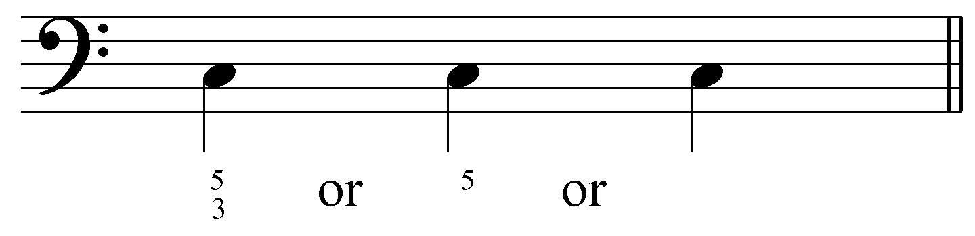

First-inversion triads also appear so frequently that the ${}_{3}^{6}$ figure is often abbreviated to just “⁶”, with the third taken for granted. Both of the figures in Example 9 can be used to indicate a C-major triad in first inversion:

Example 9:
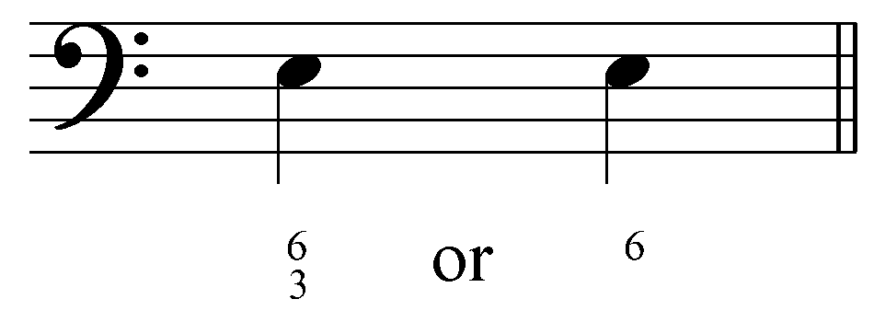

Second inversion triads are always represented with ${}_{4}^{6}$.

The following excerpt from a chorale by J.S. Bach shows how figured bass can be used to indicate inversions:

Example 10 (reduction of J.S. Bach, BWV 386, “Nun danket alle Gott,” mm. 1-2):
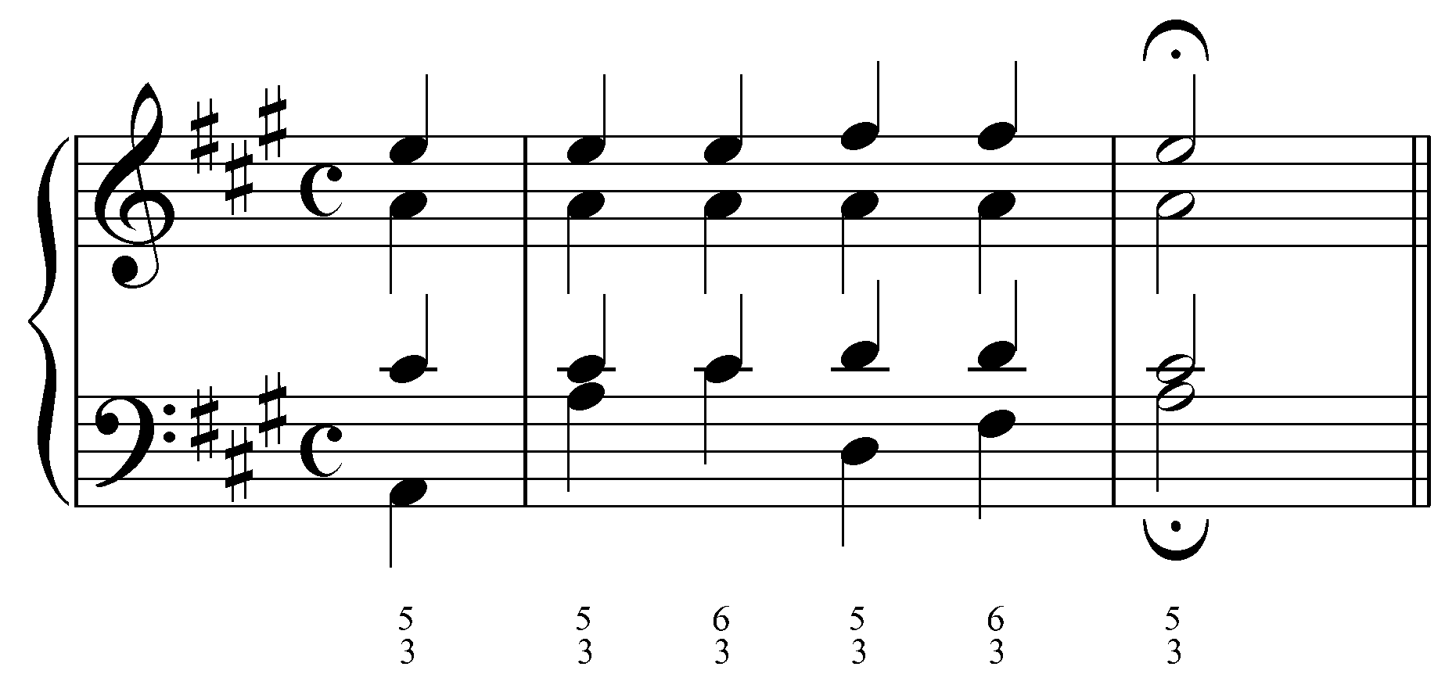

The first three chords are all A-major triads. As the bass skips up from A to C# in the first full measure, the figures change from ${}_{3}^{5}$ to ${}_{3}^{6}$ indicating the progression from a root position A-major triad to a first inversion A-major triad. A similar situation happens with the two D-major triads on beats three and four of that same measure.

The following table summarizes the various figures for triads and lists the common abbreviations:

Table 1:
Position: | Figured Bass: | Common  Abbreviations:
root position | $${}_{3}^{5}$$ | ${}^{5}$ or no figure
first inversion | $${}_{3}^{6}$$ | $${}^{6}$$
second inversion | $${}_{4}^{6}$$

The various positions of seventh chords also have standard figured-bass signatures. The following example shows the four positions of a dominant-seventh chord on G (see Lesson EEE for more on the dominant seventh chord):

Example 11:
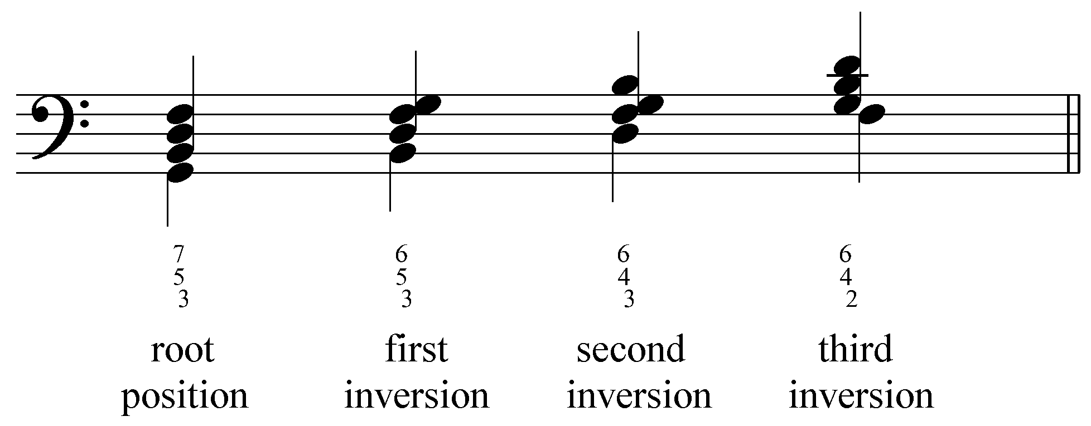

The figures indicate the various intervals above the bass. As with triads, the figures for seventh chords are often abbreviated. The following table summarizes the various figures for seventh chords and lists the common abbreviations:

Table 2:
Position: | Figured Bass: | Common  Abbreviations:
root position | $${{\begin{aligned}5\end{aligned}}^{3}}_{7}$$ | $${}^{7}$$
first inversion | $${{\begin{aligned}5\end{aligned}}^{3}}_{6}$$ | $${}_{5}^{6}$$
second inversion | $${{\begin{aligned}4\end{aligned}}^{3}}_{6}$$ | $${}_{3}^{4}$$
third inversion | $${{\begin{aligned}4\end{aligned}}^{2}}_{6}$$ | ${}_{2}^{4}$ or ${}^{2}$

Activity 4.4:
“In this activity you will be presented with a series of seventh chrods in SATB setting. For each exercise, choose the appropriate figured bass signature (${}^{7}$, ${}_{5}^{6}$, ${}_{3}^{4}$, or ${}_{2}^{4}$) to represent the inversion of the chord.”

Exercise 4.4a:
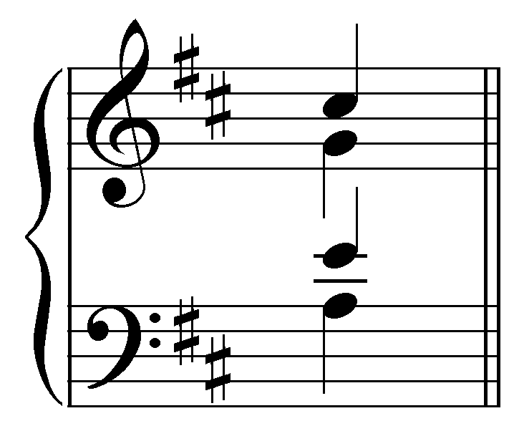
Question: “Which figured bass signature would be used to represent this chord?” [Options: “${}^{7}$,” “${}_{5}^{6}$,” “${}_{3}^{4}$,” and “${}_{2}^{4}$.” Correct answer: “${}^{7}$.” Incorrect answer response: “Incorrect. Remember the common abbreviations for figured bass signatures. Only one of the four options makes sense with the given intervals above the bass. Try again.”]

Exercise 4.4b:
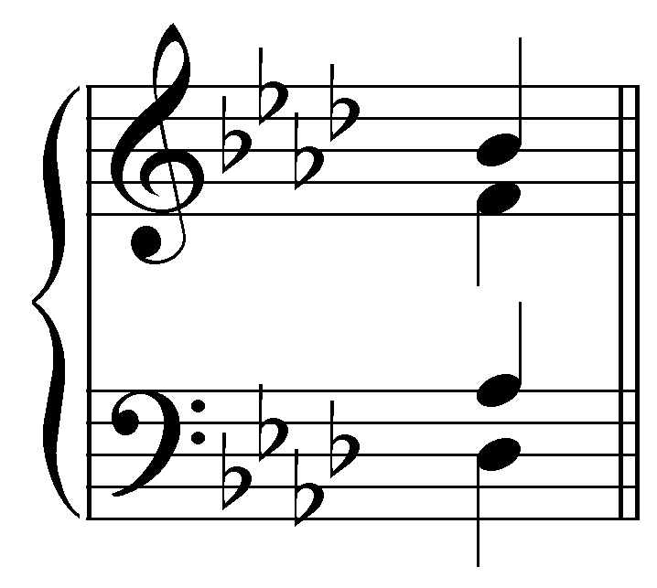
Question: “Which figured bass signature would be used to represent this chord?” [Options: “${}^{7}$,” “${}_{5}^{6}$,” “${}_{3}^{4}$,” and “${}_{2}^{4}$.” Correct answer: “${}_{5}^{6}$.” Incorrect answer response: “Incorrect. Remember the common abbreviations for figured bass signatures. Only one of the four options makes sense with the given intervals above the bass. Try again.”]

Exercise 4.4c:
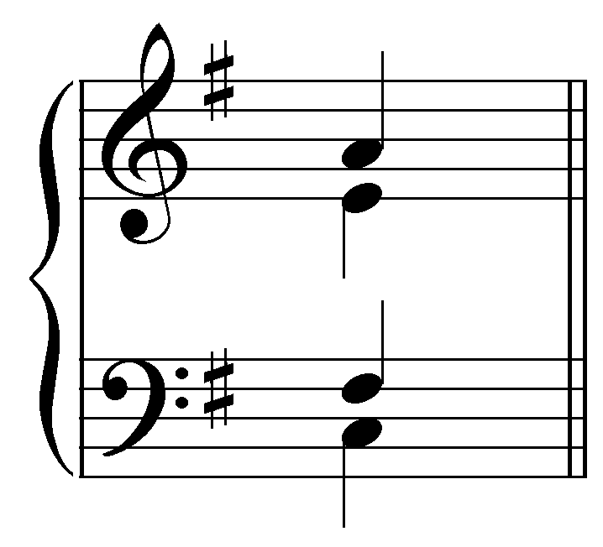
Question: “Which figured bass signature would be used to represent this chord?” [Options: “${}^{7}$,” “${}_{5}^{6}$,” “${}_{3}^{4}$,” and “${}_{2}^{4}$.” Correct answer: “${}_{3}^{4}$.” Incorrect answer response: “Incorrect. Remember the common abbreviations for figured bass signatures. Only one of the four options makes sense with the given intervals above the bass. Try again.”]

Exercise 4.4d:
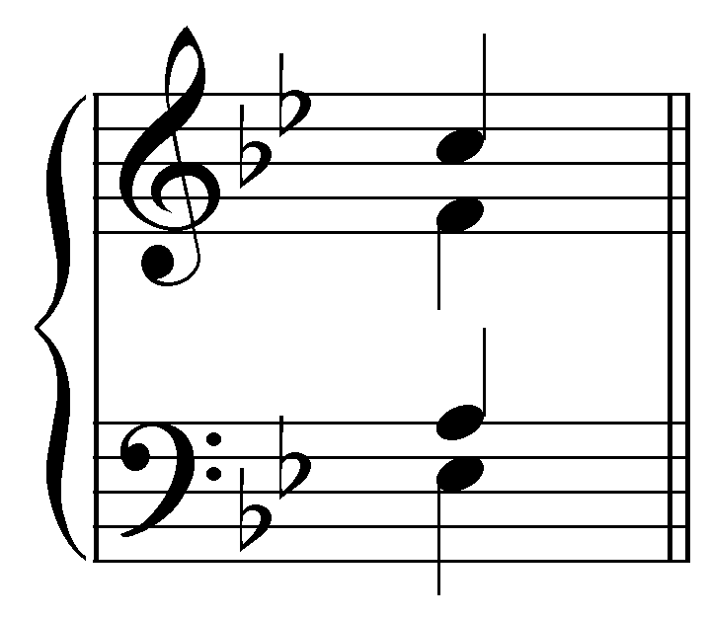
Question: “Which figured bass signature would be used to represent this chord?” [Options: “${}^{7}$,” “${}_{5}^{6}$,” “${}_{3}^{4}$,” and “${}_{2}^{4}$.” Correct answer: “${}_{2}^{4}$.” Incorrect answer response: “Incorrect. Remember the common abbreviations for figured bass signatures. Only one of the four options makes sense with the given intervals above the bass. Try again.”]

Activity 4.5:
“In this activity you will be presented with a series single-note of figured bass examples. For each exercise, indicate the pitches that must appear above the bass according to the figures. The exercises will consist of both triads and seventh chords, and the figured bass signatures may be abbreviated. (Remember, unless otherwise specified, the quality of the interval is determined by the key signature.)”

Exercise 4.5a:
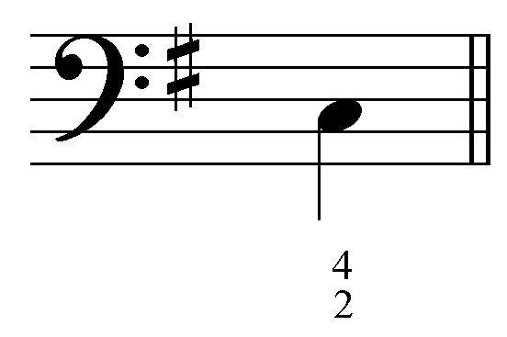
Question: “According to the figured bass signature, what pitches must appear above this bass note?” [Answers: “D,” “F#,” and “A.” Incorrect answer response: “Incorrect. Remember, the arabic numerals indicate the intervals above the bass. The quality is determined by the key signature. Try again.”]

Exercise 4.5b:
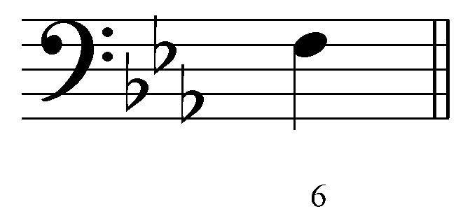
Question: “According to the figured bass signature, what pitches must appear above this bass note?” [Answers: “D,” and “A^{b}.” Incorrect answer response: “Incorrect. Remember, the arabic numerals indicate the intervals above the bass. The quality is determined by the key signature. Try again.”]

Exercise 4.5c:
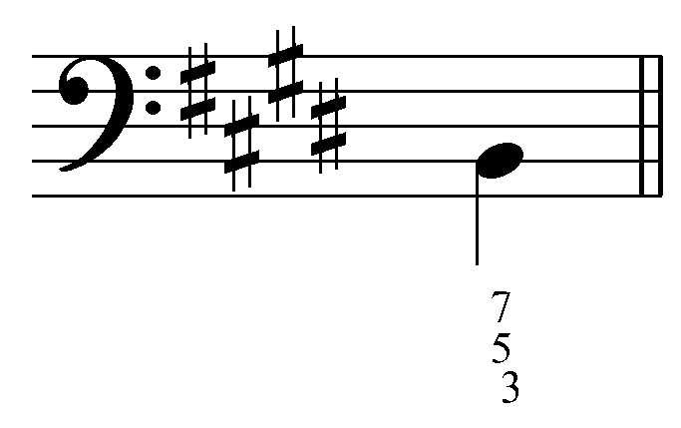
Question: “According to the figured bass signature, what pitches must appear above this bass note?” [Answers: “D#,” “F#,” and “A.” Incorrect answer response: “Incorrect. Remember, the arabic numerals indicate the intervals above the bass. The quality is determined by the key signature. Try again.”]

Exercise 4.5d:
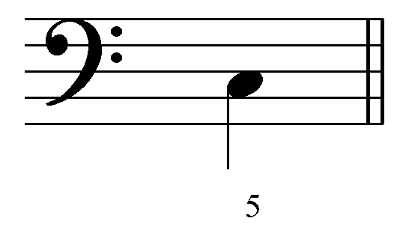
Question: “According to the figured bass signature, what pitches must appear above this bass note?” [Answers: “E” and “G.” Incorrect answer response: “Incorrect. Remember, the arabic numerals indicate the intervals above the bass. The quality is determined by the key signature. Try again.”]

Chromatic alterations:

As explained above, figured-bass signatures assume diatonic intervals above bass notes, i.e. the key signature determines the quality of the intervals. If a non-diatonic pitch is necessary in a chord, accidentals (^{b}, #, etc.) appear next to the figured-bass signatures.

Example 12:
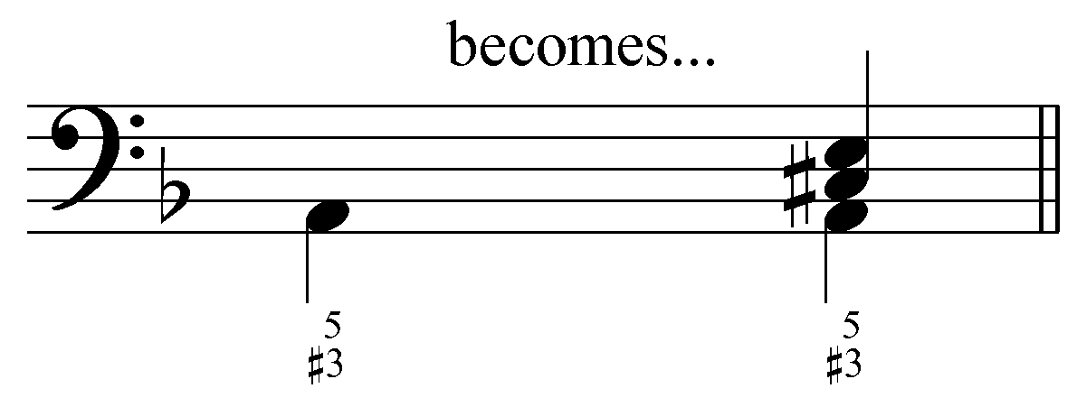

Example 12 shows a bass A with the figure ${}_{3}^{5}$. The accidental next to the 3 specifies that a C# is required instead of a C. An accidental that occurs by itself is assumed to affect the third above the bass (the most frequently altered chord member). Multiple chromatic alterations may occur simultaneously as well:

Example 13:
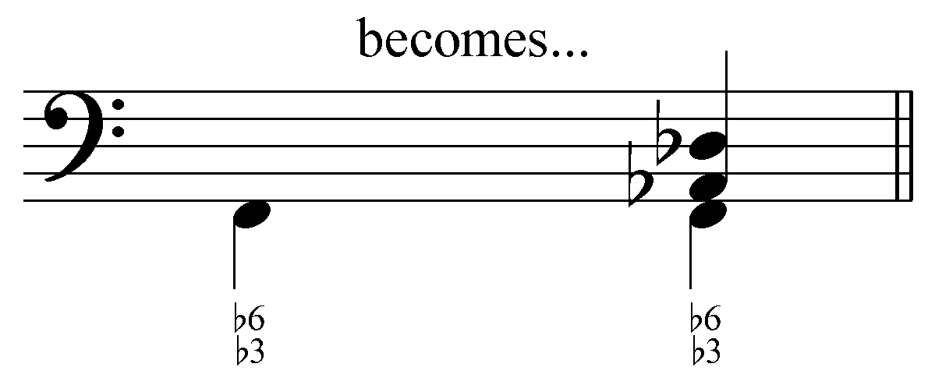

Another common convention is to indicate a raised pitch by drawing a slash or a small vertical line through the appropriate figure. The A-major triad of Example 12 could also be indicated by the following figured bass:

Example 14:
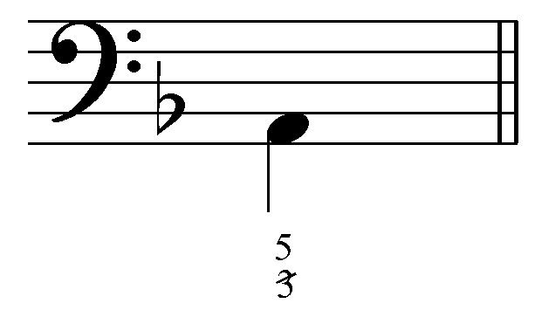

The slash through the 3 indicates that the third above the bass must be raised by a semitone (C# instead of C).

Activity 4.6:
“Each of the figured bass signatures in the following exercises require at least one chromatic alteration. For each exercise, indicate the pitches that must appear above the bass according to the figures. The exercises will consist of both triads and seventh chords, and the figured bass signatures may be abbreviated.”

Exercise 4.6a:
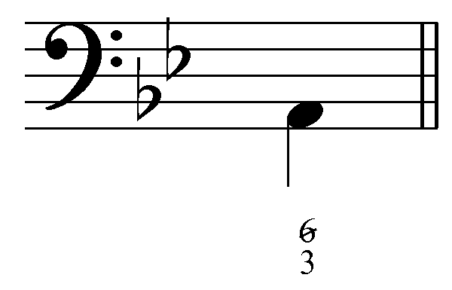
Question: “According to the figured bass signature, what pitches must appear above this bass note?” [Answers: “F#” and “A.” Incorrect answer response: “Incorrect. Remember, a slash through a numeral indicates a pitch a half step above the diatonic pitch. Try again.”]

Exercise 4.6b:
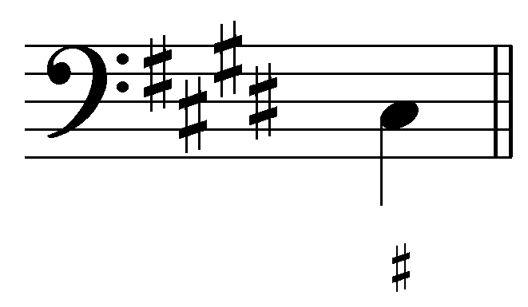
Question: “According to the figured bass signature, what pitches must appear above this bass note?” [Answers: “E#” and “G#.” Incorrect answer response: “Incorrect. Remember, an accidental by itself is applied to the third above the bass. Try again.”]

Exercise 4.6c:
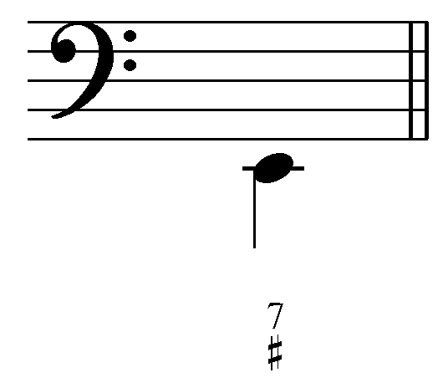
Question: “According to the figured bass signature, what pitches must appear above this bass note?” [Answers: “G#,” “B,” and “D.” Incorrect answer response: “Incorrect. Remember, an accidental by itself is applied to the third above the bass. Try again.”]

Exercise 4.6d:
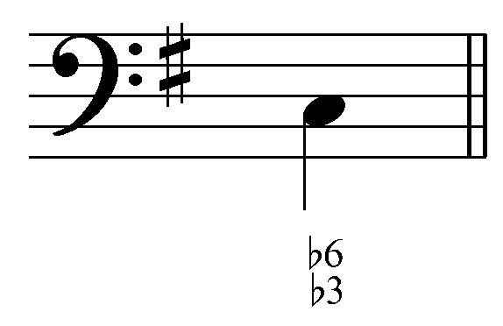
Question: “According to the figured bass signature, what pitches must appear above this bass note?” [Answers: “A^{b}” and “E^{b}.” Incorrect answer response: “Incorrect. Remember, accidentals in the figured bass signature must be applied to the appropriate intervals. Try again.”]

Figured bass with roman numerals:

Because figured bass signatures can be used to indicate inversions of triads and seventh chords, they may also be combined with roman numerals to indicate roots and positions of triads. Roman numerals indicate the scale degree of each chord’s root. Figured-bass symbols, on the other hand, are determined by the intervals above the bass, irrespective of roots. Consider the following excerpt from a Bach chorale:

Example 15 (J.S. Bach, BWV 256, “Wo Gott der Herr nicht bei uns halt,” mm. 1-2):
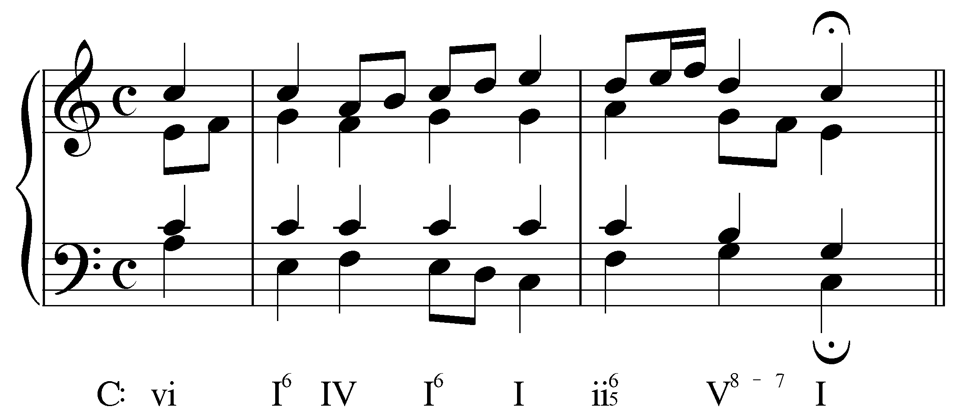

In Example 15, a roman numeral appears under every beat. These roman numerals indicate the root of each harmony: the anacrusis is labeled “vi” because the root of that chord is A (scale degree 6 in C major), the downbeat of the first measure is labeled “I” because the root of that chord is C (scale degree 1 in C major), and so on. Some of the roman numerals are accompanied by figured-bass signatures, which indicate chord inversions. The C-major chords on beats one and three of the first measure are labeled “I⁶” because they are in first inversion. Likewise, the chord on the downbeat of measure two is a first inversion seventh chord whose root is D (hence “ii${}_{5}^{6}$”).

As mentioned earlier, figured-bass signatures may also indicate melodic motion above the bass, as in the passing seventh in the second measure. The figures “⁸ ⁻ ⁷” indicate that one of the upper voices first forms an octave above the bass, and then steps down to form a seventh with the bass before the next beat.

It is crucial to remember that figured-bass signatures do not always indicate chord inversions. As with the V⁸⁻⁷ in Example 15, they may instead indicate movement over a stationary bass. Consider the following excerpt from a Bach chorale:

Example 16 (J.S. Bach, BWV 290, “Das walt’ Gott Vater und Gott Sohn,” mm. 7-8):
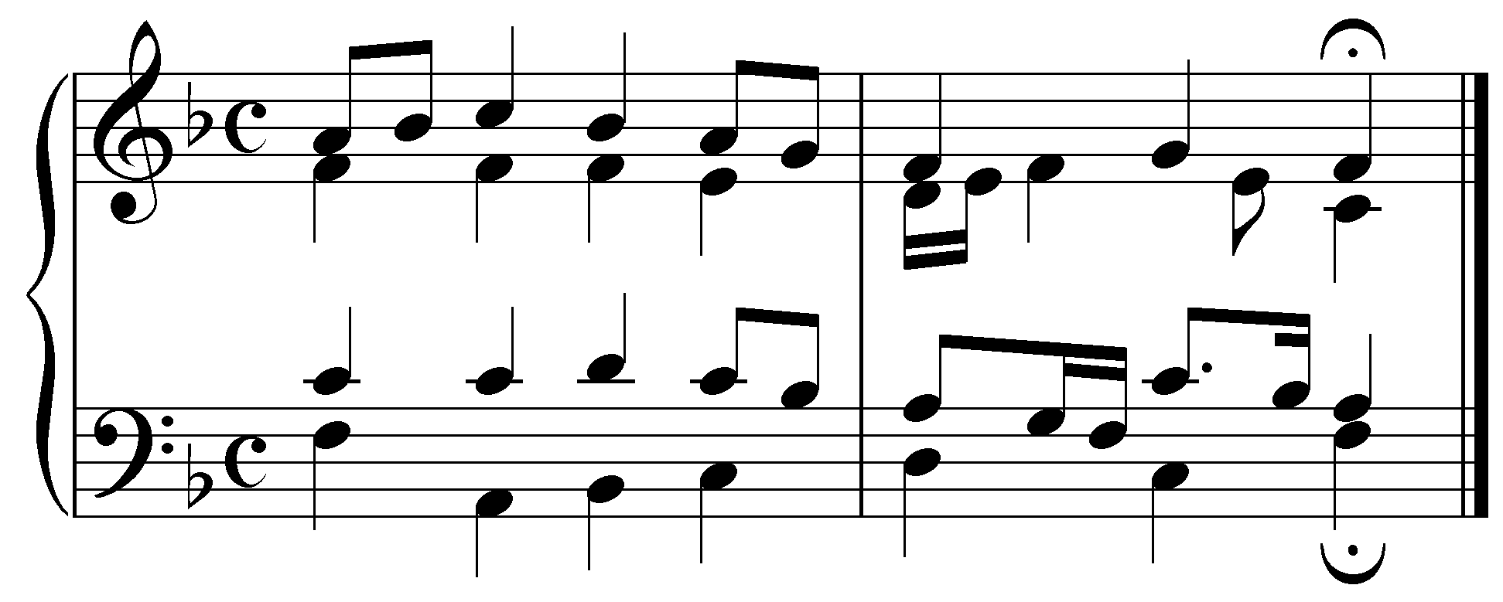

On the fourth beat of m. 7 we find what appears to be iii⁶ chord in F major. The bass C is doubled at the octave in the tenor while the alto and soprano have E and A respectively. Although this sonority contains all the pitches of a iii⁶ chord, it would be incorrect to label it as such. The soprano and tenor voices contain accented passing tones (A and C, respectively). These passing tones resolve to G and B^{b} on the second eighth note, creating a root-position V⁷ chord. The passage should therefore be analyzed like this:

Example 17:
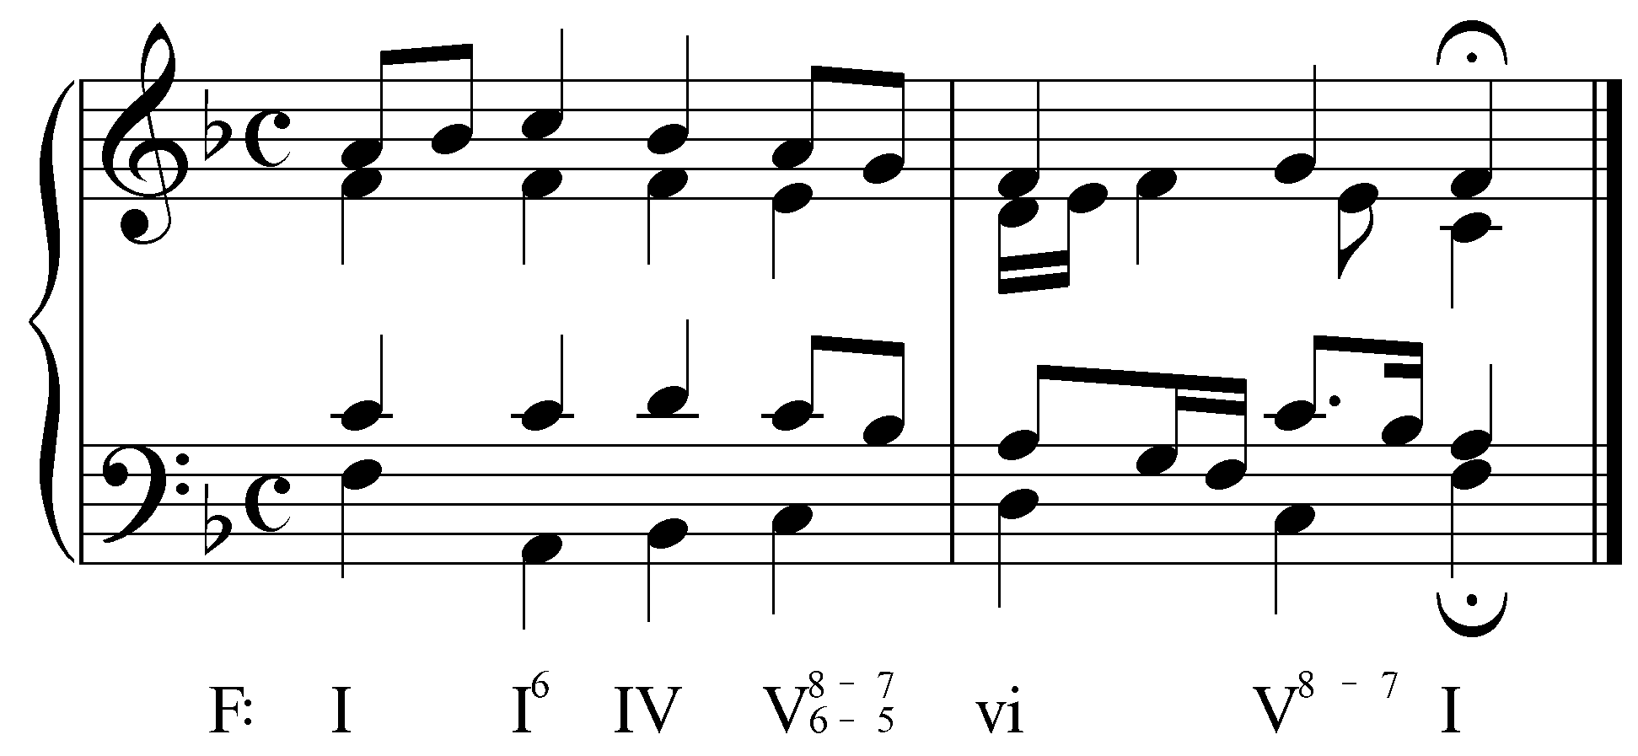

To label beat four as anything other than a V chord would undermine its important role in the underlying “IV - V - vi” progression. What appears to be an A-minor chord on beat four is a byproduct of voice leading. Such byproducts are quite common and it is important that you learn to identify them. Consider the following example:

Example 18:
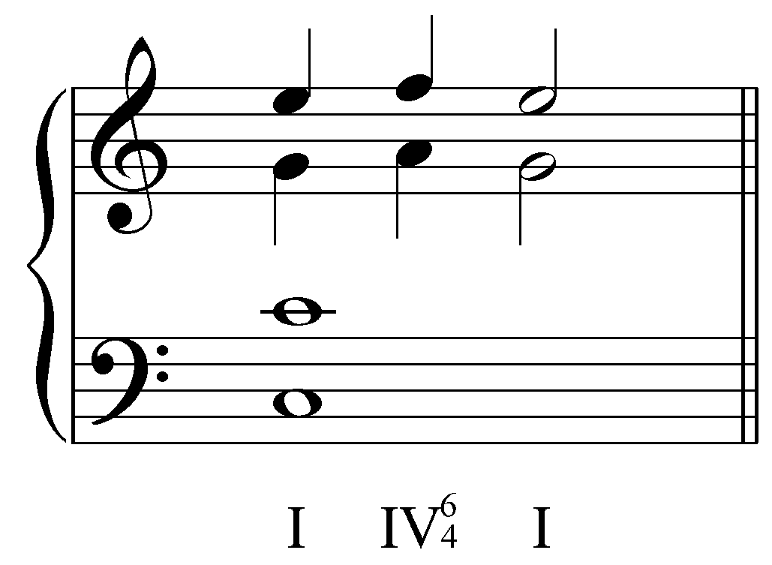

In Example 18, the entire measure consists of a C-major chord. Melodic motion above a stationary bass appears in two of the upper voices: the soprano and alto voices are each decorated with upper neighbor tones. Because the two neighbor notes together with the stationary bass coincidentally produce the pitches of an F-major chord, it is tempting to analyze passage like this:

Example 19:

However, that analysis is inaccurate because the chord does not function as a subdominant. We refer to such coincidentally formed chords as auxiliary sonorities. (See Lesson III for more information on auxiliary sonorities.) A correct analysis will demonstrate that the I chord is being prolonged throughout the measure, using figured-bass signatures to indicate the melodic motion:

Example 20:
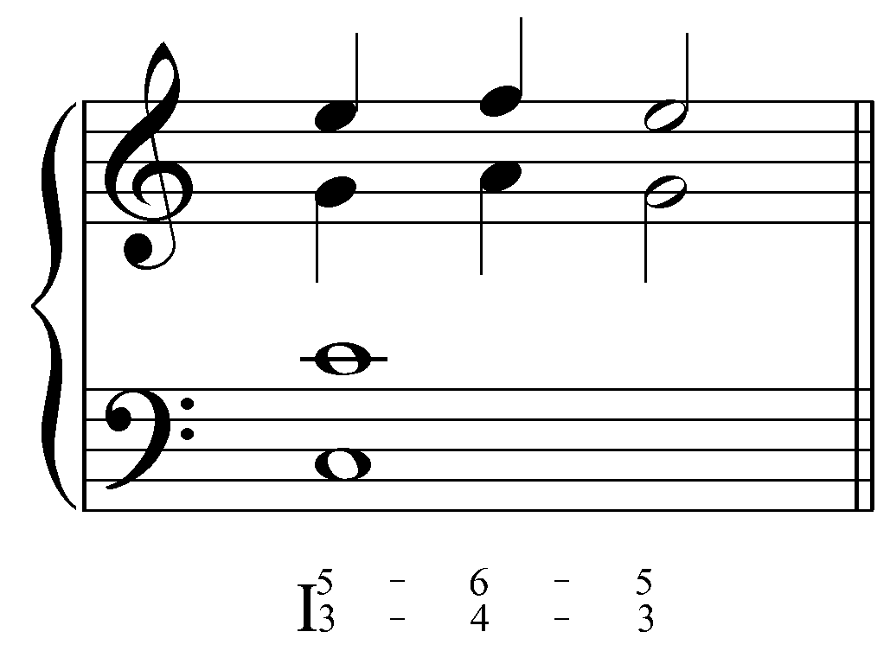

If we compare the figures in this example with the figures in Example 10, we can see the different roles of figured bass. In Example 10, the figures indicate chord inversion. In Example 18, the figures indicate part movement above a stationary bass. Many sonorities—like the A-minor chord in Example 16 or the F-major chord in Examples18-20—arise from melodic motion in one or more of the upper voices. It is crucial that you learn to distinguish these voice-leading byproducts from the fundamental chords.

Activity 4.7:
In this activity, you will be presented with a short passage from a Bach chorale (the second phrase of BWV 279, “Christ lag in Todesbanden,” mm. 3-4). Each exercise will have you analyze a single chord from the excerpt by providing a roman numeral with figures.

Exercise 4.7a:
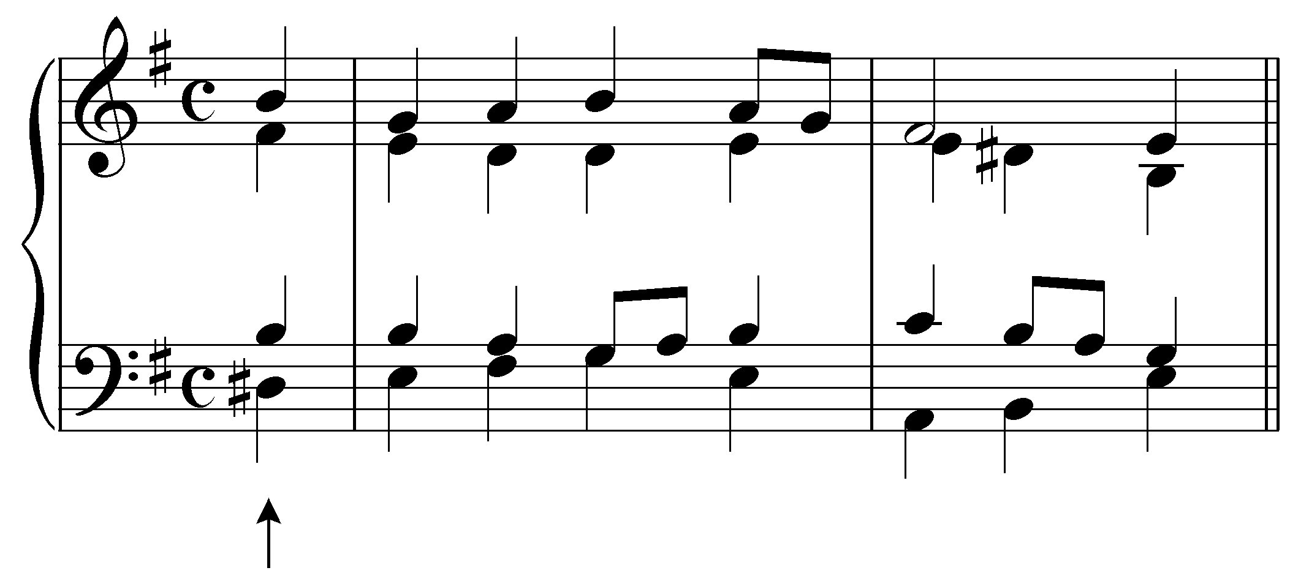
Question: “What roman numeral should appear under the chord indicated by the arrow?” [Answer: “V.” Incorrect answer response: “Incorrect. Remember, the roman numeral should be determined by the root of the chord (which may be in inversion). Try again.”]

Followup question: “What figures, if any, should accompany the roman numeral?” [Answer: “${}^{6}$,”“${}_{}^{6}$,” or “${}_{3}^{6}$.” Incorrect answer response: “Incorrect. Try again.”]

Exercise 4.7b:
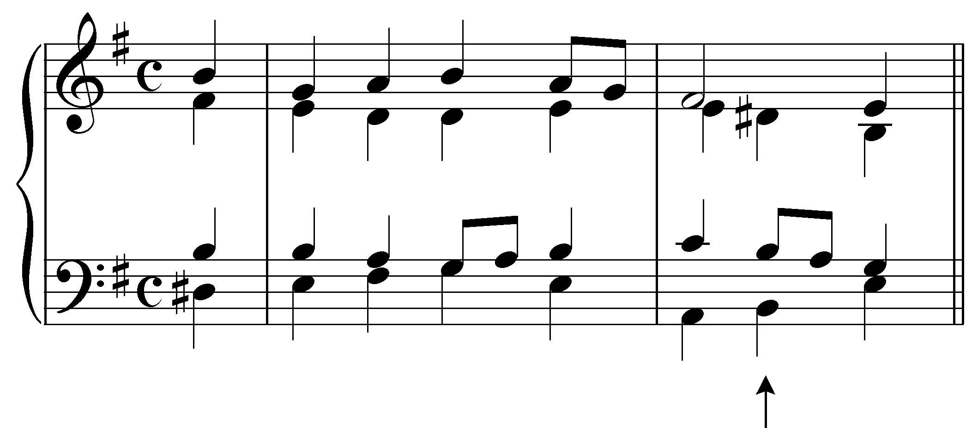
Question: “What roman numeral should appear under the chord indicated by the arrow?” [Answer: “V.” Incorrect answer response: “Incorrect. Remember, the roman numeral should be determined by the root of the chord (which may be in inversion). Try again.”]

Followup question: “What figures, if any, should accompany the roman numeral?” [Answer: “⁸⁻⁷,” “${}_{3}^{8−7}$,” “${}_{3}^{8−7}$,” “${}_{}^{8−7}$,” “${{\begin{aligned}5\end{aligned}}^{3}}_{8−7}$,” “${{\begin{aligned}5\end{aligned}}^{3}}_{8−7}$,” or “${{\begin{aligned}5\end{aligned}}^{}}_{8−7}$.” Incorrect answer response: “Incorrect. Try again.”]

Exercise 4.7c:
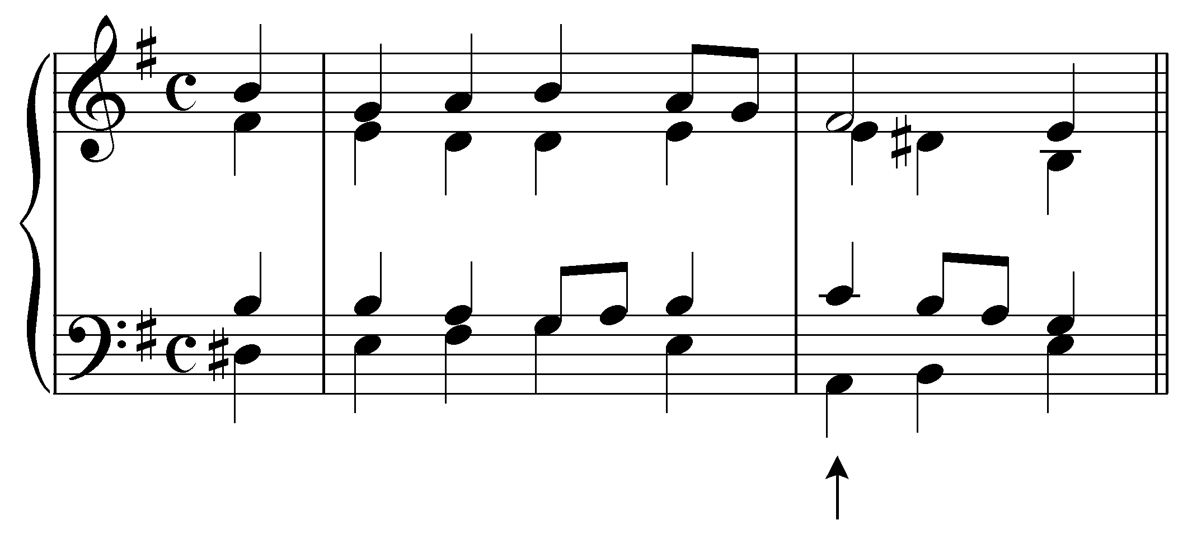
Question: “What roman numeral should appear under the chord indicated by the arrow?” [Answer: “ii.” Incorrect answer response: “Incorrect. Remember, the roman numeral should be determined by the root of the chord (which may be in inversion). Try again.”]

Followup question: “What figures, if any, should accompany the roman numeral?” [Answer: “${}_{5}^{6}$” or “${{\begin{aligned}5\end{aligned}}^{3}}_{6}$.” Incorrect answer response: “Incorrect. Try again.”]

Exercise 4.7d:
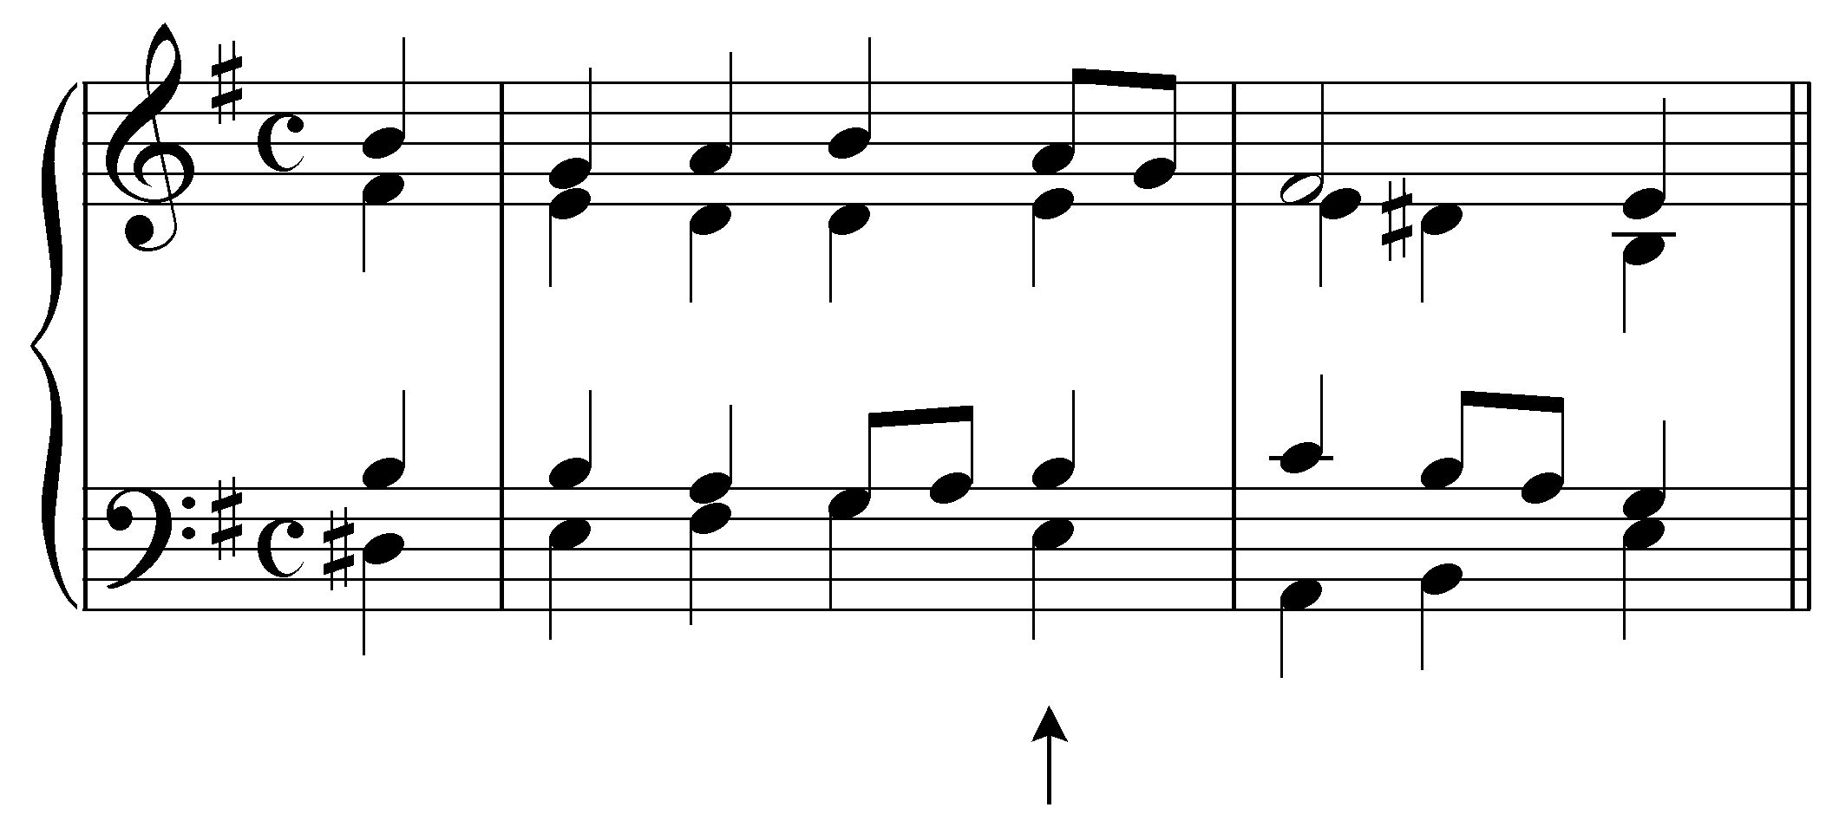
Question: “What roman numeral should appear under the chord indicated by the arrow?” [Answer: “i.” Incorrect answer response: “Incorrect. Remember, the roman numeral should be determined by the root of the chord (which may be in inversion). Try again.”]

Followup question: “What figures, if any, should accompany the roman numeral?” [Answer: “⁵,”“${}_{3}^{5}$,” or no figure. Incorrect answer response: “Incorrect. Try again.”]

Conclusion:

Figured bass originated as a compositional shorthand. It consists of a bass line accompanied by a series of arabic numerals. These numerals—figured-bass signatures—indicate intervals to be played above the bass. The intervals are assumed to be diatonic (in accordance with the prevailing key signature) unless the figured-bass signatures are modified by accidentals or slashes. Melodic motion in the upper voices are indicated by figured-bass signatures printed horizontally.

Figured-bass signatures can also be used to indicate inversions of triads and seventh chords. The figure ${}_{3}^{5}$ (or ${}^{5}$ or no figure at all) is used to indicate a triad in root position, and ${}_{3}^{6}$ (or ${}^{6}$) and ${}_{4}^{6}$ are used to represent triads in, respectively, first and second inversions. Similarly, ${{\begin{aligned}5\end{aligned}}^{3}}_{7}$ (${}^{7}$) is used to indicate a seventh chord in root position while ${{\begin{aligned}5\end{aligned}}^{3}}_{6}$ (or ${}_{5}^{6}$), ${{\begin{aligned}4\end{aligned}}^{3}}_{6}$ (${}_{3}^{4}$), and ${{\begin{aligned}4\end{aligned}}^{2}}_{6}$ (${}_{2}^{4}$ or ${}^{2}$) are used to represent seventh chords in first, second, and third inversions respectively. These figures can be combined with roman numerals to show the root progression and inversion simultaneously, but care must be taken to distinguish between functional harmonies and sonorities that arise coincidentally as the result of melodic motion in one or more upper voices.

