Lesson GGG: Seventh Chords

Exam:

Question 1a: Move one of the upper voices to create a V⁷ chord:
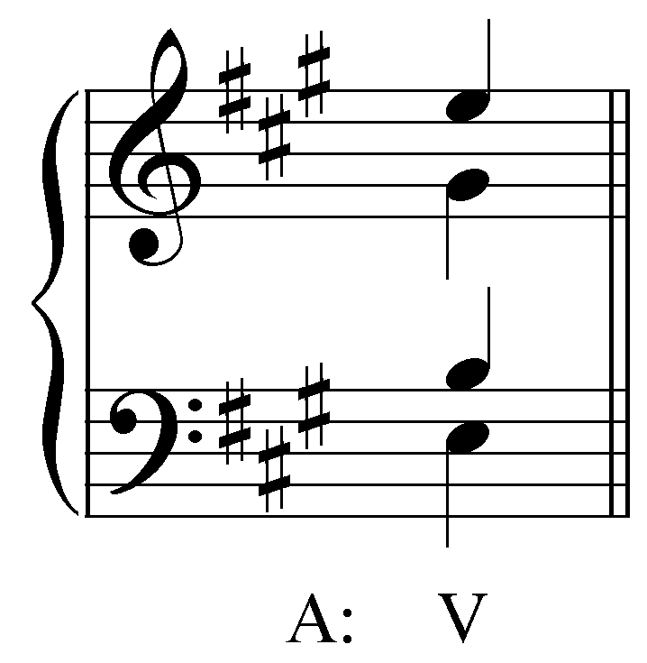
[Answer: soprano should be changed from E to D. Feedback if correct: “Correct!” Feedback if incorrect: “Incorrect. A V⁷ chord in A major contains the pitches E, G#, B, and D. You should have moved the soprano from E to D.”]

Question 1b: Move one of the upper voices to create a ii^{ø7} chord:
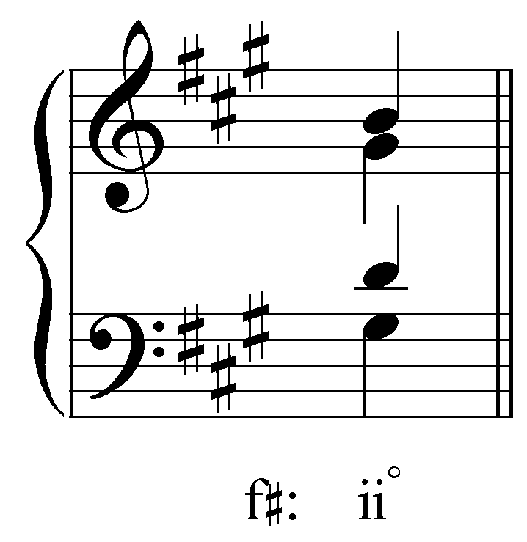
[Answer: alto should be changed from G# to F#. Feedback if correct: “Correct!” Feedback if incorrect: “Incorrect. A ii^{ø7} chord in F# minor contains the pitches G#, B, D, and F#. You should have moved the alto from G# to F#.”]

Question 2a: Describe the intervallic content of this seventh chord by identifying the quality of the triad and the quality of the seventh.
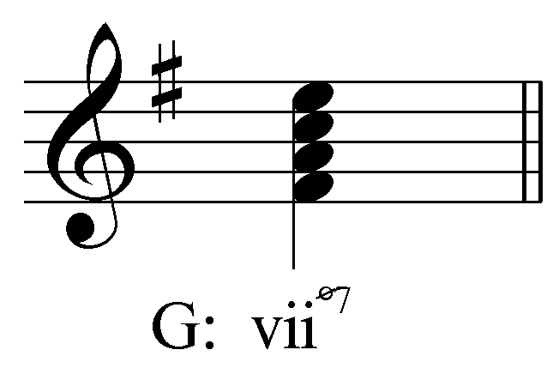
[Multiple choice question] The quality of the triad is _______.
[Options: “major,” “minor,” and “diminished.” Answer: “diminished.” Feedback if correct: “Correct!” Feedback if incorrect: “Incorrect. This triad is diminished.”]

[Multiple choice question] The quality of the seventh is _______.
[Options: “major,” “minor,” and “diminished.” Answer: “minor.” Feedback if correct: “Correct!” Feedback if incorrect: “Incorrect. This seventh is minor.”]

Question 2b: Describe the intervallic content of this seventh chord by identifying the quality of the triad and the quality of the seventh.
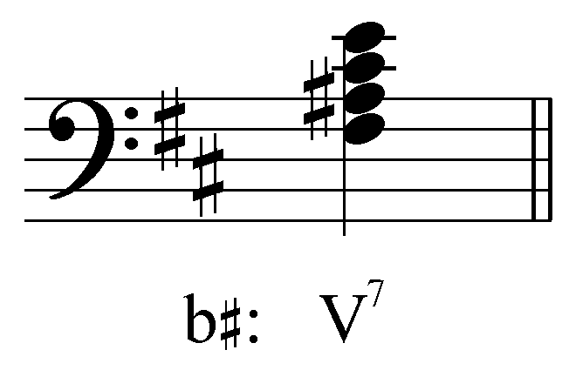
[Multiple choice question] The quality of the triad is _______.
[Options: “major,” “minor,” and “diminished.” Answer: “major.” Feedback if correct: “Correct!” Feedback if incorrect: “Incorrect. This triad is major.”]

[Multiple choice question] The quality of the seventh is _______.
[Options: “major,” “minor,” and “diminished.” Answer: “minor.” Feedback if correct: “Correct!” Feedback if incorrect: “Incorrect. This seventh is minor.”]

Question 3a: What roman numeral should appear in place of the question mark? Be sure to indicate the inversion in your answer.
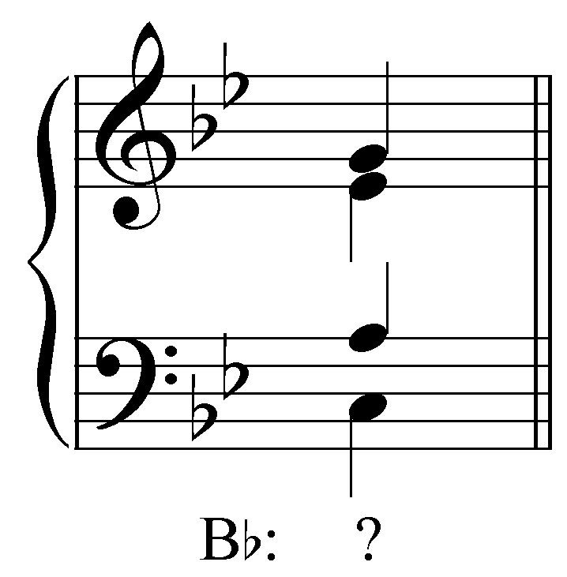
[Answer: vii^{ø}${}_{5}^{6}$. Feedback if correct: “Correct!” Feedback for correct roman numeral but wrong inversion: “That is the correct roman numeral, but the wrong inversion. This is a vii^{ø}${}_{5}^{6}$ in B^{b} major.” Feedback for correct inversion but wrong roman numeral: “That is the correct inversion, but the wrong roman numeral. This is a vii^{ø}${}_{5}^{6}$ in B^{b} major.” Feedback if entirely incorrect: “Incorrect. This is a vii^{ø}${}_{5}^{6}$ in B^{b} major.”]

Question 3b: What roman numeral should appear in place of the question mark? Be sure to indicate the inversion in your answer.
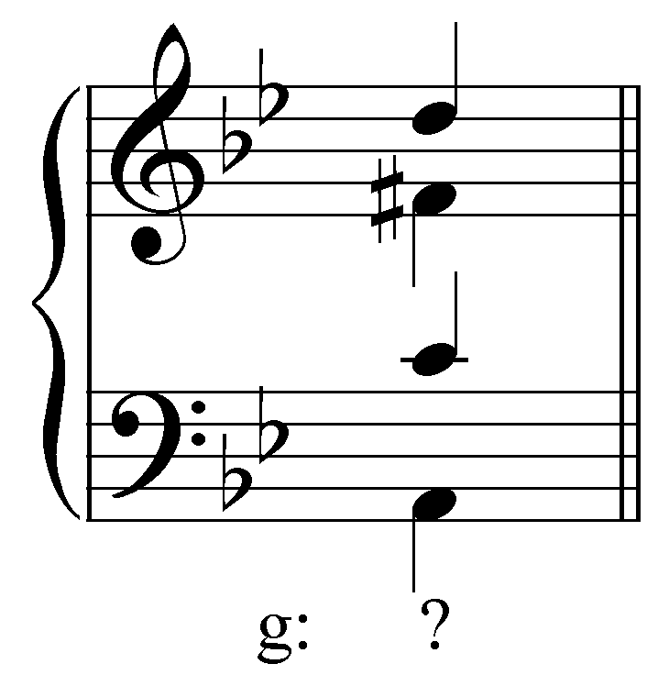
[Answer: V${}_{3}^{4}$. Feedback if correct: “Correct!” Feedback for correct roman numeral but wrong inversion: “That is the correct roman numeral, but the wrong inversion. This is a V${}_{3}^{4}$ in G minor.” Feedback for correct inversion but wrong roman numeral: “That is the correct inversion, but the wrong roman numeral. This is a V${}_{3}^{4}$ in G minor.” Feedback if entirely incorrect: “Incorrect. This is a V${}_{3}^{4}$ in G minor.”]

Question 4a: Write a V${}_{5}^{6}$ in D minor in four-part SATB voicing.
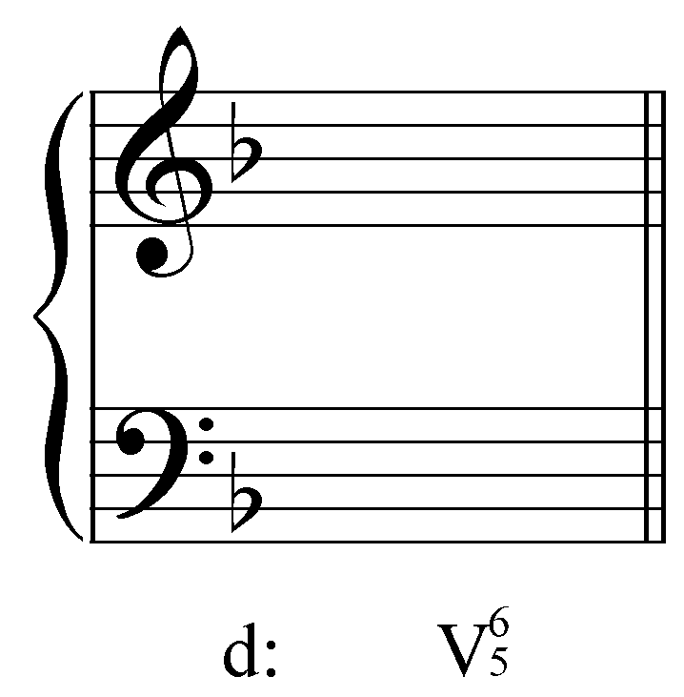
[Answer: C# in the bass with A, E, and G in the upper voices in any arrangement. Feedback if correct: “Correct!” Feedback if incorrect: “Incorrect. A V${}_{5}^{6}$ in D minor will have C# in the bass with A, E, and G in the upper voices.”]

Question 4b: Write a ii${}_{5}^{6}$ in F major in four-part SATB voicing.
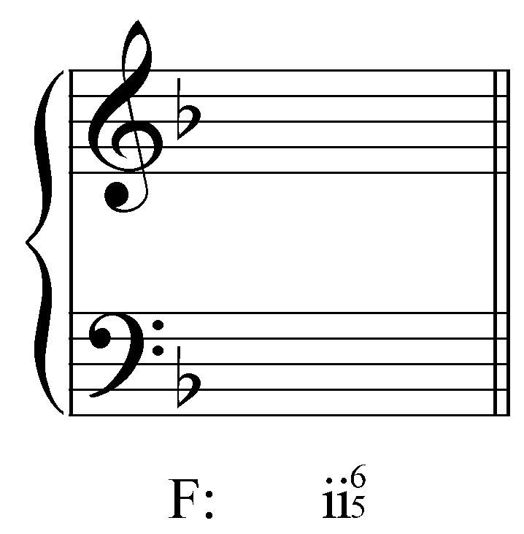
[Answer: B^{b} in the bass with G, D, and F in the upper voices in any arrangement. Feedback if correct: “Correct!” Feedback if incorrect: “Incorrect. A ii${}_{5}^{6}$ in D minor will have B^{b} in the bass with G, D, and F in the upper voices.”]

Question 5: Complete the following progression from I to ii${}_{5}^{6}$. Remember to prepare the seventh of the ii${}_{5}^{6}$ as a common tone from the I chord. (The bass has been provided for you.)

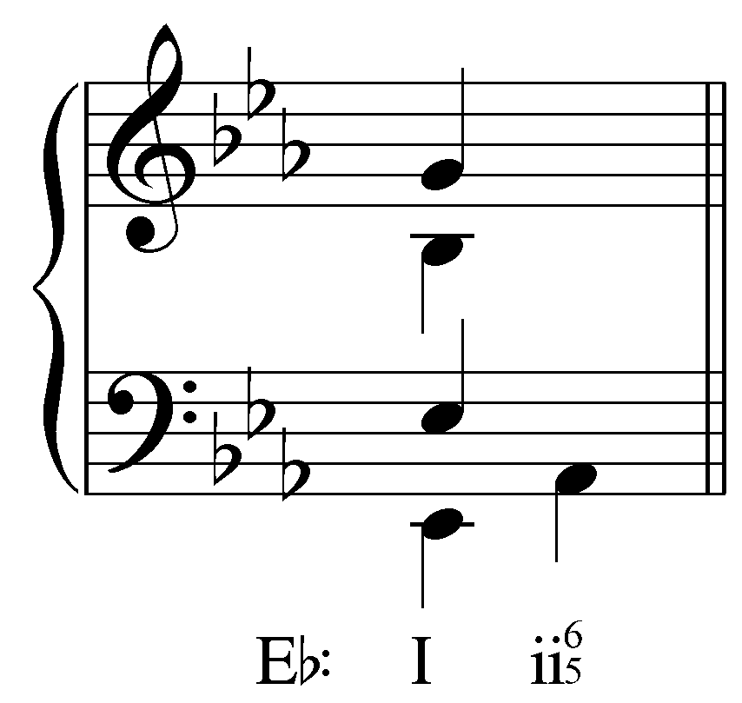
[Answer: 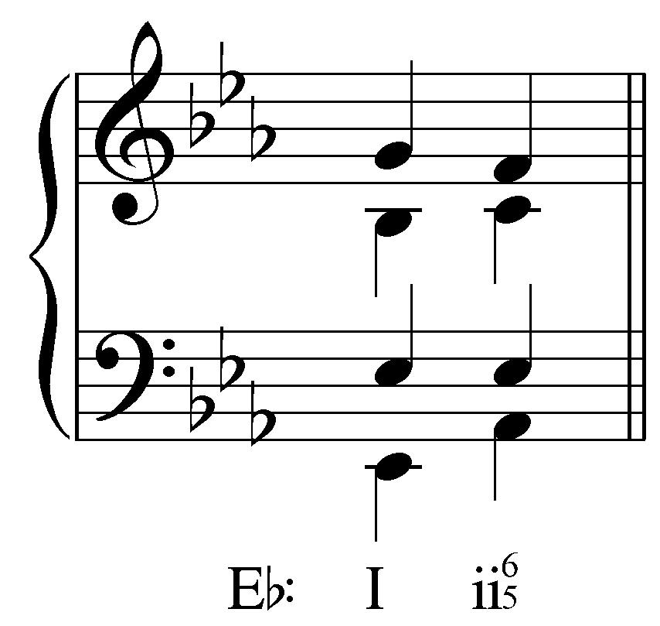. Feedback if correct: “Correct!” Feedback if incorrect: “Incorrect. The seventh of the ii${}_{5}^{6}$ chord should be introduced as a common tone E^{b} in the tenor. The soprano should step down to F and the alto up to C.”]

Question 6: Continue the following progression from ii${}_{5}^{6}$ V. Remember to resolve the seventh of the ii${}_{5}^{6}$ properly. (The bass has been provided for you.)

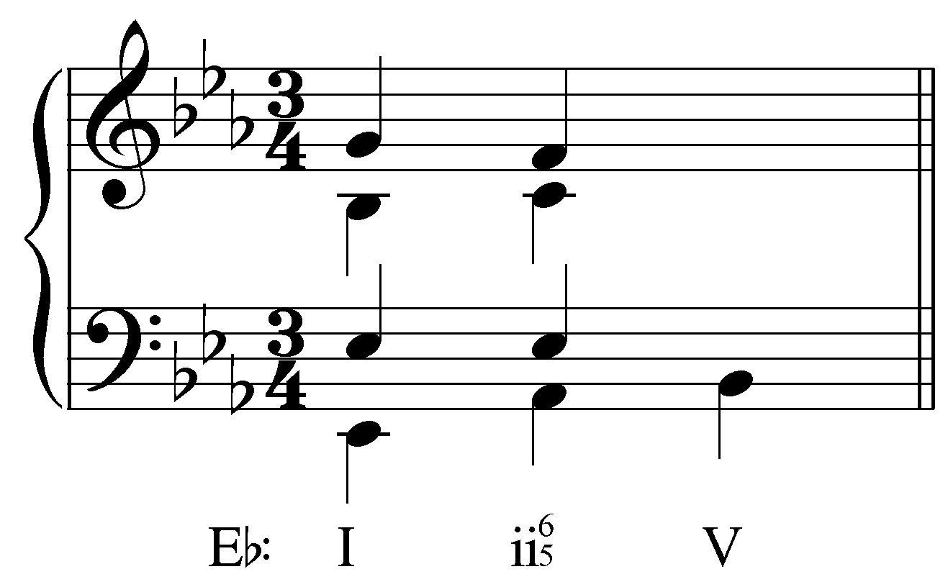
[Answer: 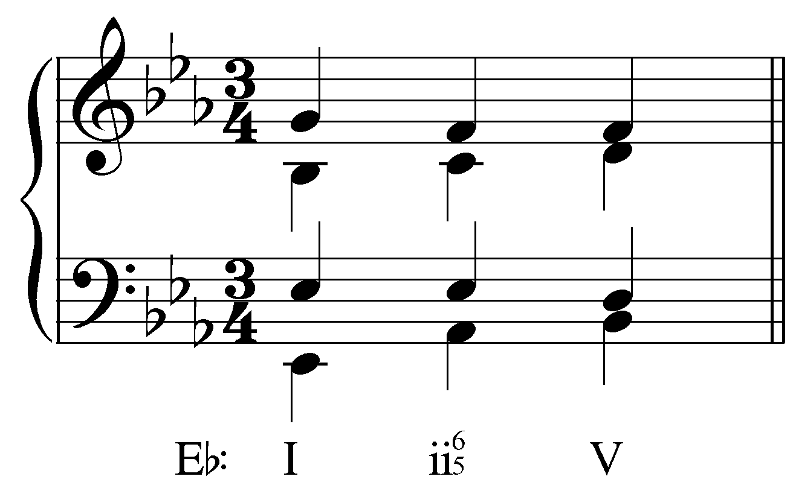 or 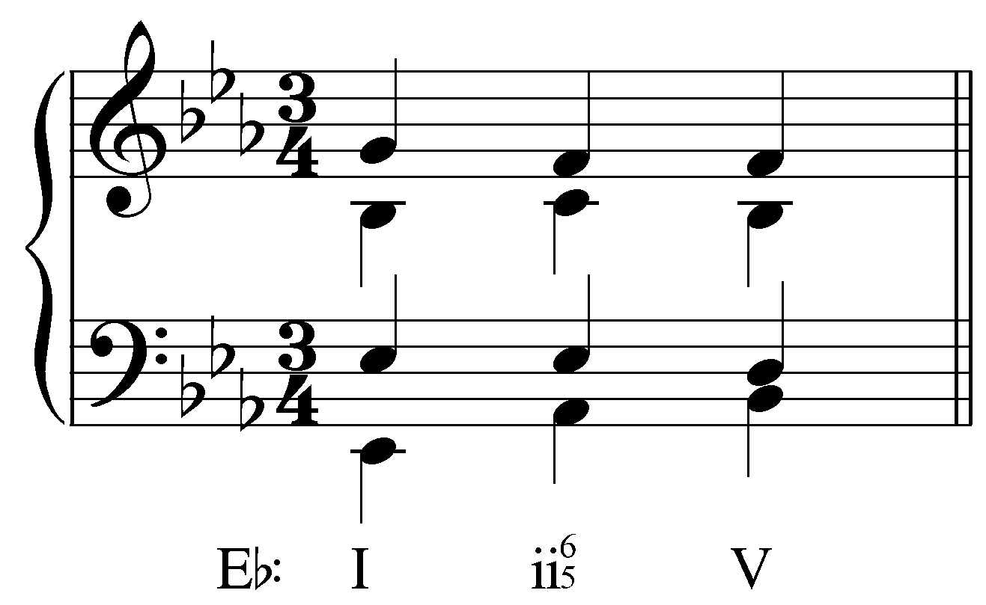. Feedback if correct: “Correct!” Feedback if incorrect: “Incorrect. The seventh of the ii${}_{5}^{6}$ chord should resolve down to D in the tenor. The soprano should remain on F and the alto should step up to D or down to B^{b}.”]

Question 7: Complete this “I - IV⁷ - V” progression in four voices. The voicing of the I chord and the bass line have been provided. (Remember, the seventh of the IV⁷ chord must be prepared as a common tone and must resolve downwards by step. Also, be sure to avoid parallel fifths in the move from IV⁷ to V.)
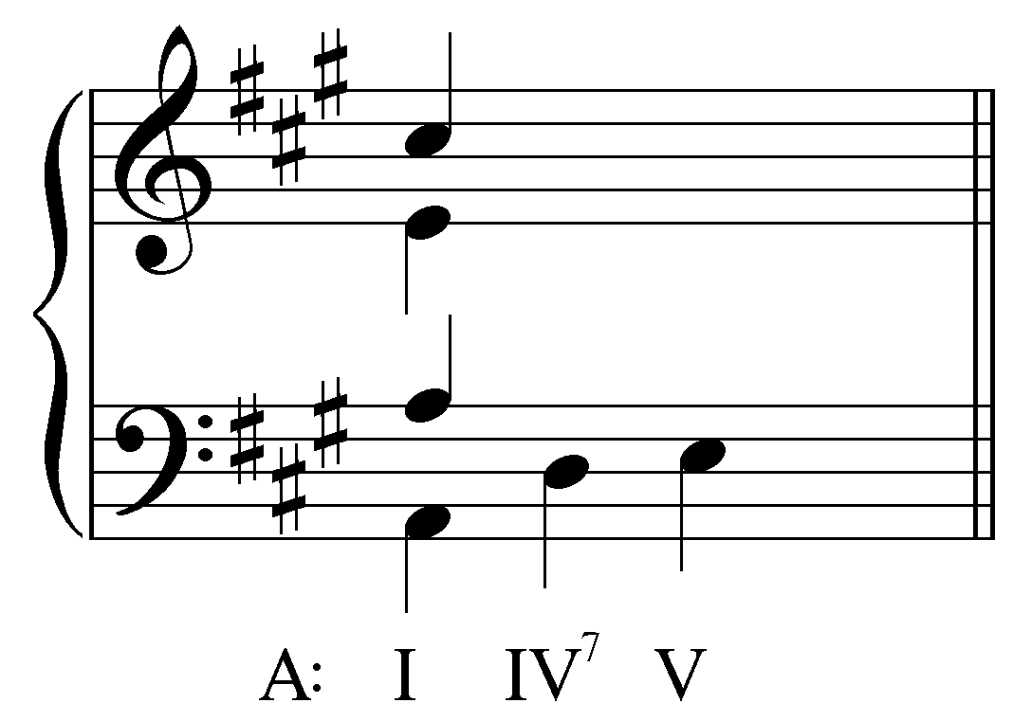
[Answer: 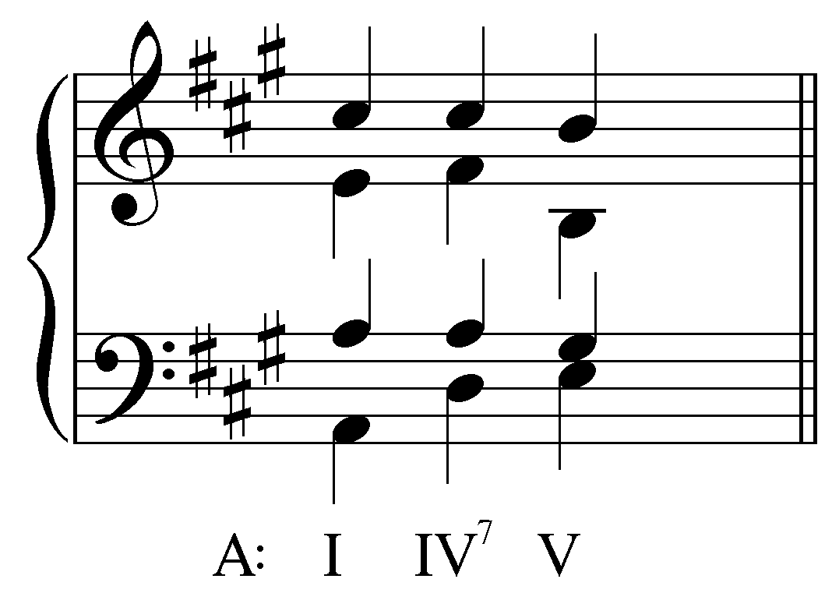. Feedback if correct: “Correct!” Feedback if incorrect: “Incorrect. This progression should be voiced as follows:
.”]

Question 8: Identify the tritones in this vii^{o7} chord:
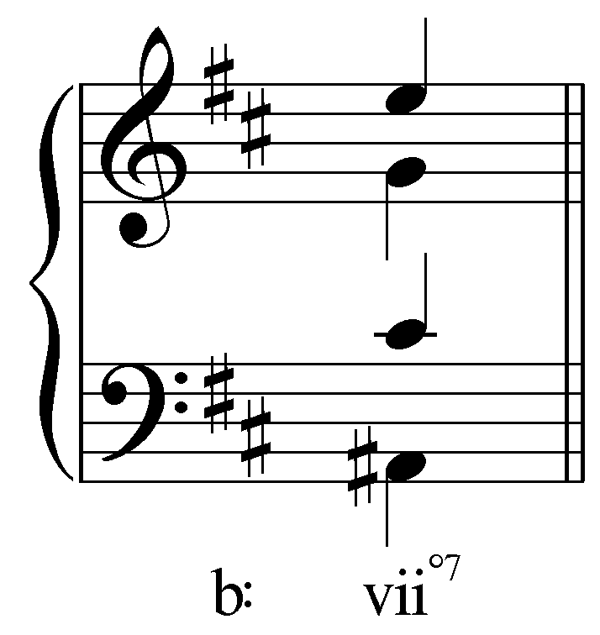
[Answer: A#/E and C#/G. Feedback if correct: “Correct! A# and E form a diminished fifth while C# and G also form a diminished fifth.” Feedback if incorrect: “Incorrect. The two tritones are formed by A# and E (diminished fifth) and C# and G (another diminished fifth).”]

Question 9: Complete the resolution of vii^{o7} to i keeping the proper resolutions of the tritones in mind:
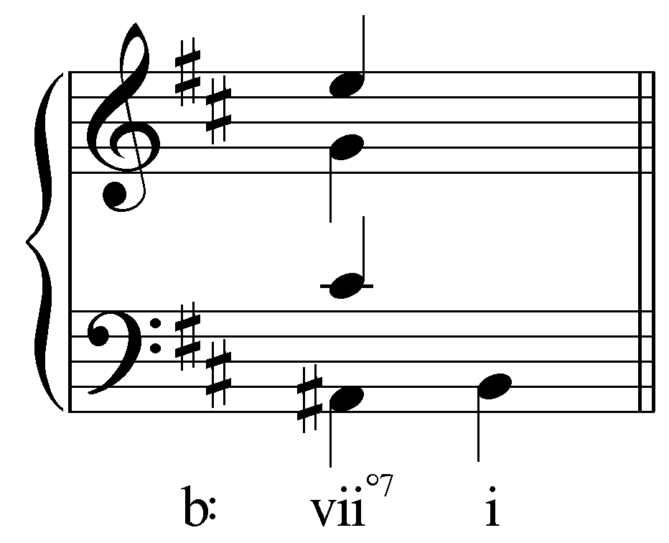
[Answer: 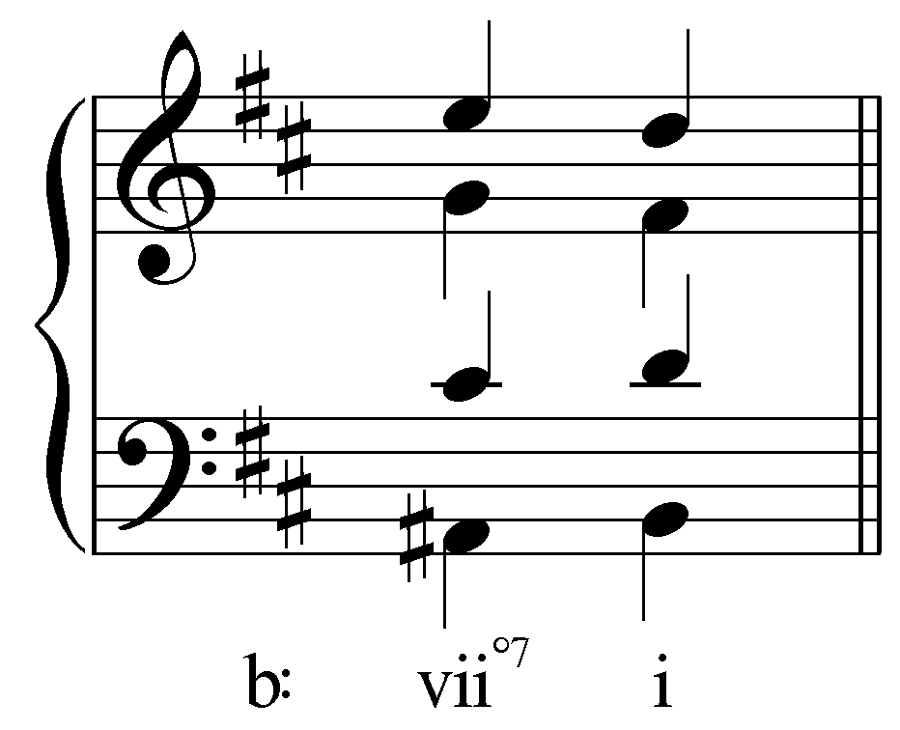. Feedback if correct: “Correct!” Feedback if incorrect: “Incorrect. Both tritones should resolve inwards by step, like so:
.”]

