Lesson GGG – Seventh Chords

Introduction:

Seventh chords provide an additional range of sonorities to the harmonic landscape. Because they contain four distinct pitches and include a dissonance by definition, they offer richer harmonies than their triadic counterparts. It is this very dissonance, however, that makes the voice leading of seventh chords a matter requiring special attention.

This lesson will present the various categories of seventh chords and familiarize you with their construction. A more specific discussion follows, touching on the commonly used seventh chords and the reasons why other seventh chords are not used. (Seventh chords are also frequently used as auxiliary sonorities. For more information on auxiliary sonorities, refer to Lesson III.)

Construction and types of seventh chords:

Seventh chords are built by extending triadic construction to include a fourth voice. A triad consists of two stacked thirds; a seventh chord simply adds a diatonic third above the fifth of the triad. In the following example, a D-minor triad becomes a seventh chord with the addition of the pitch C:

Example 1:
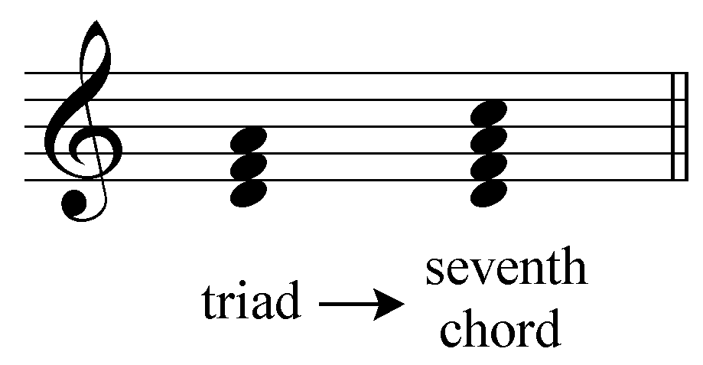

A triad is a consonant harmony. The seventh chord, containing a seventh, is naturally dissonant. The added pitch forms a dissonant seventh with the root of the chord and must be treated carefully. We will return to this matter shortly.

The following examples show the diatonic seventh chords of C major and C minor respectively. Like triads, the quality of a seventh chord built on any particular scale degree depends on whether the key is major or minor.

Example 2:
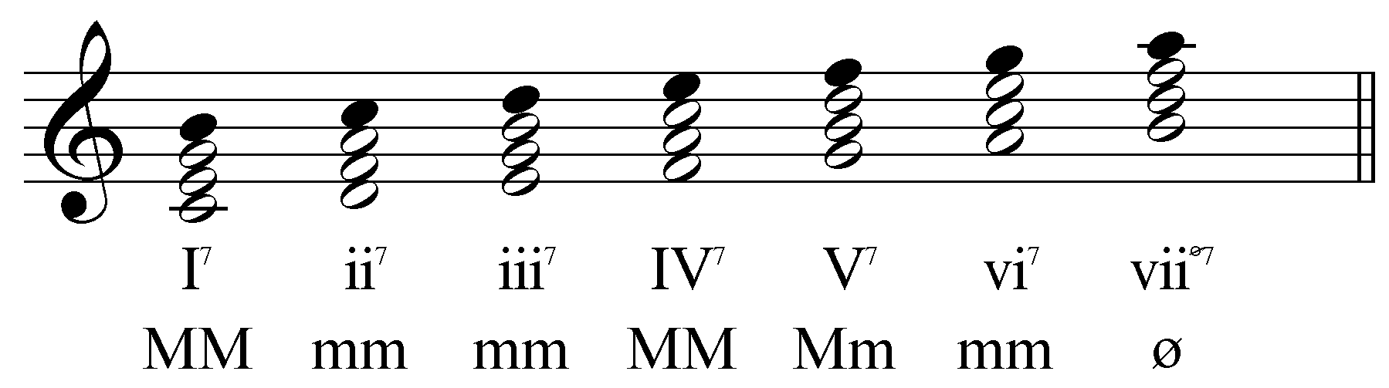

Example 3:
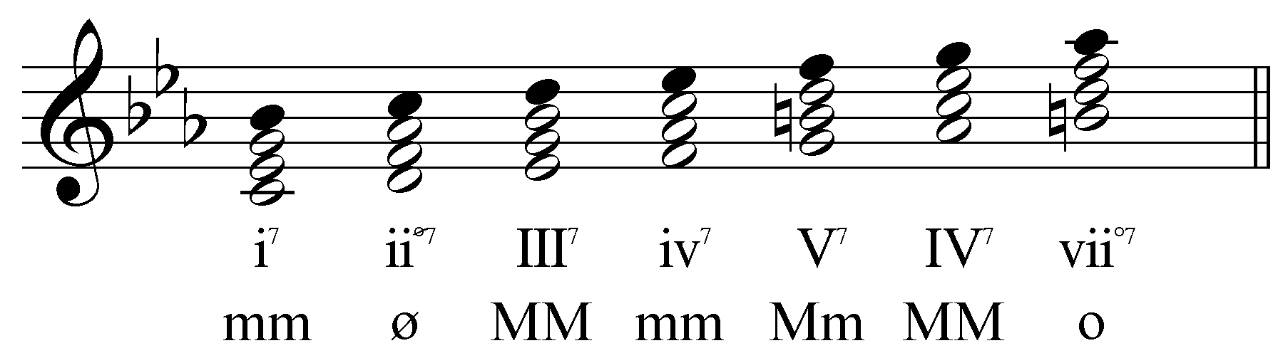

As you can see from Examples 2 and 3, seventh chords are labeled with the Roman numeral of their defining triads (look at the open noteheads of each chord) with a superscript “7” to the right. “I⁷” refers to the diatonic seventh chord built on scale degree 1, “ii⁷” to the chord built on 2, and so on.

Activity 7.1:
In this activity you will be presented with a triad in SATB setting. Change one of the pitches in the upper voices to transform the triad into a seventh chord. Then, identify the seventh chord with roman numerals.

Exercise 7.1a:
Move one of the upper voices to change the triad into a seventh chord:
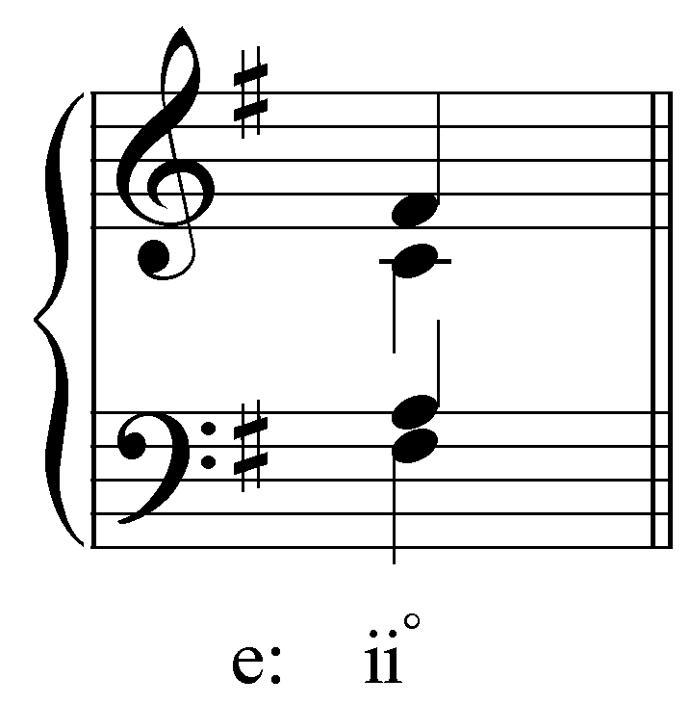
[Answer: soprano should be changed from F# to E.]
[Follow-up question:] Give this new chord a roman numeral.
[Answer: ii ^{ø 7}]

Exercise 7.1b:
Move one of the upper voices to change the triad into a seventh chord:
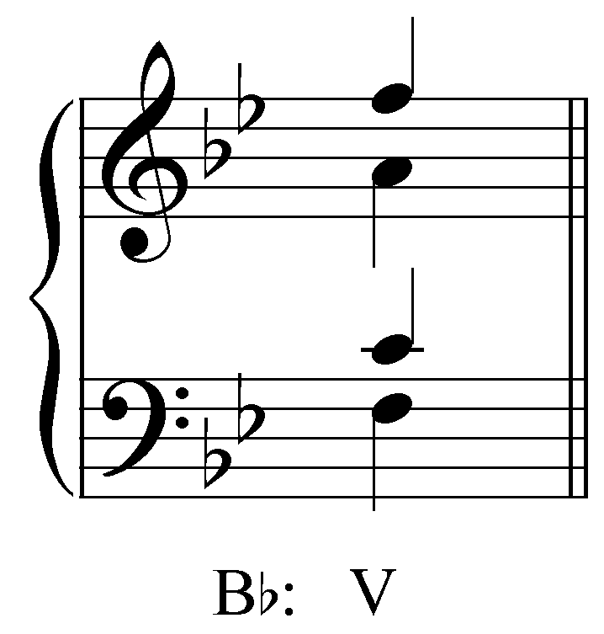
[Answer: soprano should be changed from F to E^{b}.]
[Follow-up question:] Give this new chord a roman numeral.
[Answer: V⁷]

Exercise 7.1c:
Move one of the upper voices to change the triad into a seventh chord:
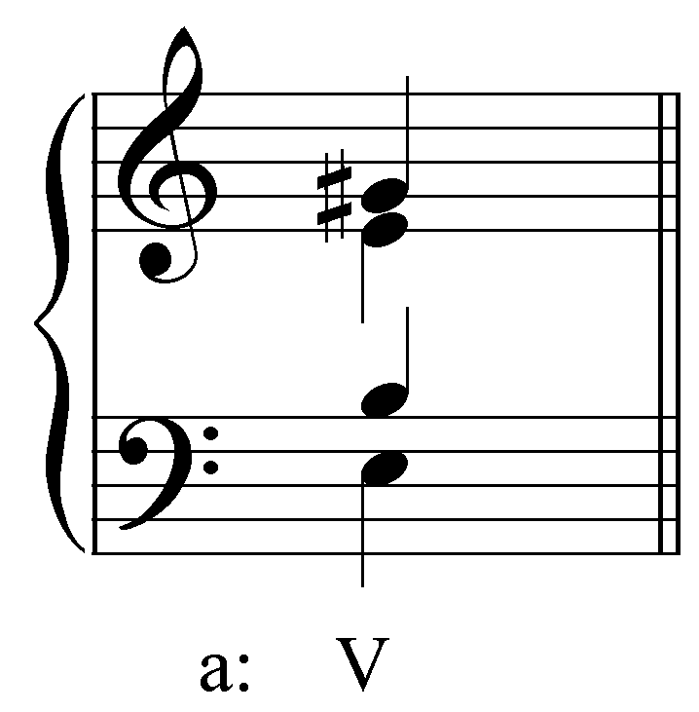
[Answer: alto should be changed from E to D.]
[Follow-up question:] Give this new chord a roman numeral.
[Answer: V⁷]

Exercise 7.1d:
Move one of the upper voices to change the triad into a seventh chord:
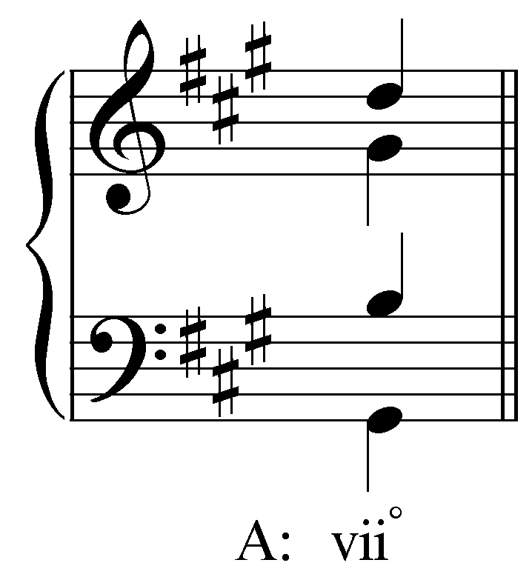
[Answer: soprano should be changed from G# to F#.]
[Follow-up question:] Give this new chord a roman numeral.
[Answer: vii^{o7}]

Below each line of Roman numerals in Examples 2 and 3 is another line of letters and symbols. These markings indicate the intervallic content of the chord and in doing so describe the sonority. For the chords labeled with letters, the first M describes the quality of the triad (“M” for a major triad; “m” for a minor triad) and the second M indicates the quality of the seventh (again, “M” for a major seventh; “m” for a minor seventh). You will find two other symbols as well. These symbols are used for seventh chords built on diminished triads: “^{ø}” indicates a half-diminished seventh chord (a diminished triad with a major seventh) and “º” indicates a fully-diminished seventh chord (a diminished triad with a minor seventh). The following table summarizes the various types of commonly encountered seventh chords:

Quality of Triad | Quality of Seventh | Symbol | Name
major | major | MM | major-major seventh chord
major | minor | Mm | dominant seventh chord  or major-minor seventh chord
minor | minor | Mm | minor-minor seventh chord
diminished | minor | ^{ø7} | half-diminished seventh chord
diminished | diminished | ^{o7} | fully-diminished seventh chord

The dominant seventh chord is unique to each collection of diatonic seventh chords. It is the most important seventh chord in tonal music and as such has its own lesson (see Lesson EEE).

Activity 7.2:
In this activity you will examine the intervallic content of various seventh chords by identifying the quality of the triad and the quality of the seventh.

[For each question, the options for triad quality are “major,” “minor,” and “diminished.” The options for seventh quality are “major,” “minor,” and “diminished.”]

Exercise 7.2a:
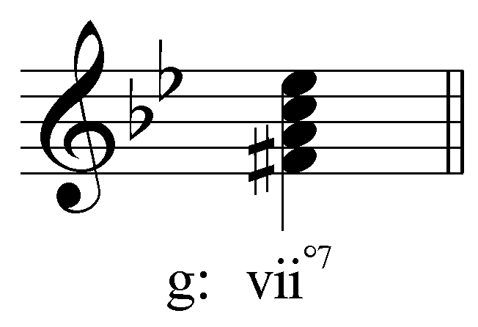
[Fill in the blank:]
The quality of the triad is _______.
The quality of the seventh is _______.
[Answers: “diminished” and “diminished.” Response for correct answer: “Correct! The vii^{o7} chord in G minor is a fully-diminished seventh chord.” Response for incorrect answer: “Incorrect. Check your intervals and try again.”]

Exercise 7.2b:
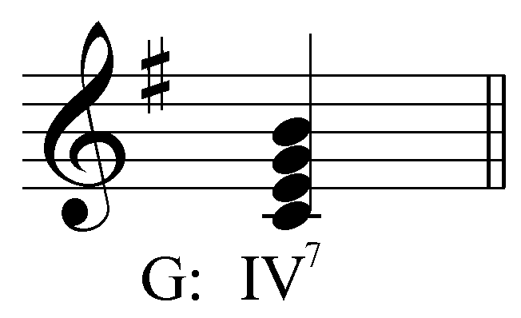
[Fill in the blank:]
The quality of the triad is _______.
The quality of the seventh is _______.
[Answers: “major” and “major.” Response for correct answer: “Correct! The IV⁷ chord in G major is a major-major seventh chord.” Response for incorrect answer: “Incorrect. Check your intervals and try again.”]

Exercise 7.2c:
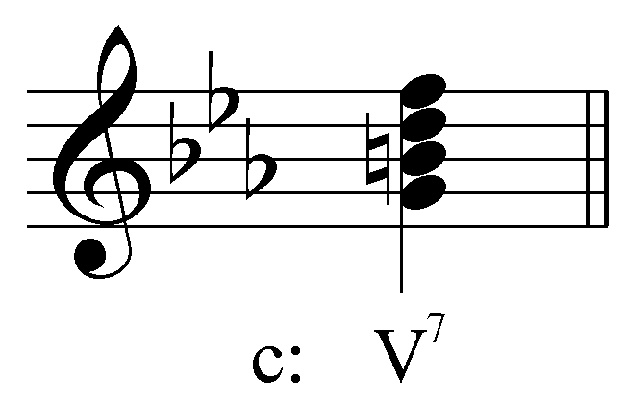
[Fill in the blank:]
The quality of the triad is _______.
The quality of the seventh is _______.
[Answers: “major” and “minor.” Response for correct answer: “Correct! The V⁷ chord in C minor is a major-minor seventh chord.” Response for incorrect answer: “Incorrect. Check your intervals and try again.”]

Exercise 7.2d:
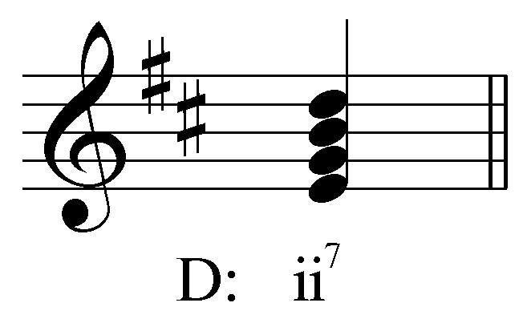
[Fill in the blank:]
The quality of the triad is _______.
The quality of the seventh is _______.
[Answers: “minor” and “minor.” Response for correct answer: “Correct! The ii⁷ chord in D minor is a minor-minor seventh chord.” Response for incorrect answer: “Incorrect. Check your intervals and try again.”]

Inversions of seventh chords:

As with triads, seventh chords may also be written in inversion. Because there are four distinct pitches in a seventh chord, there are, accordingly, four possible positions (determined by the lowest pitch). The following example shows the four positions of a ii⁷ chord in C major:

Example 4:
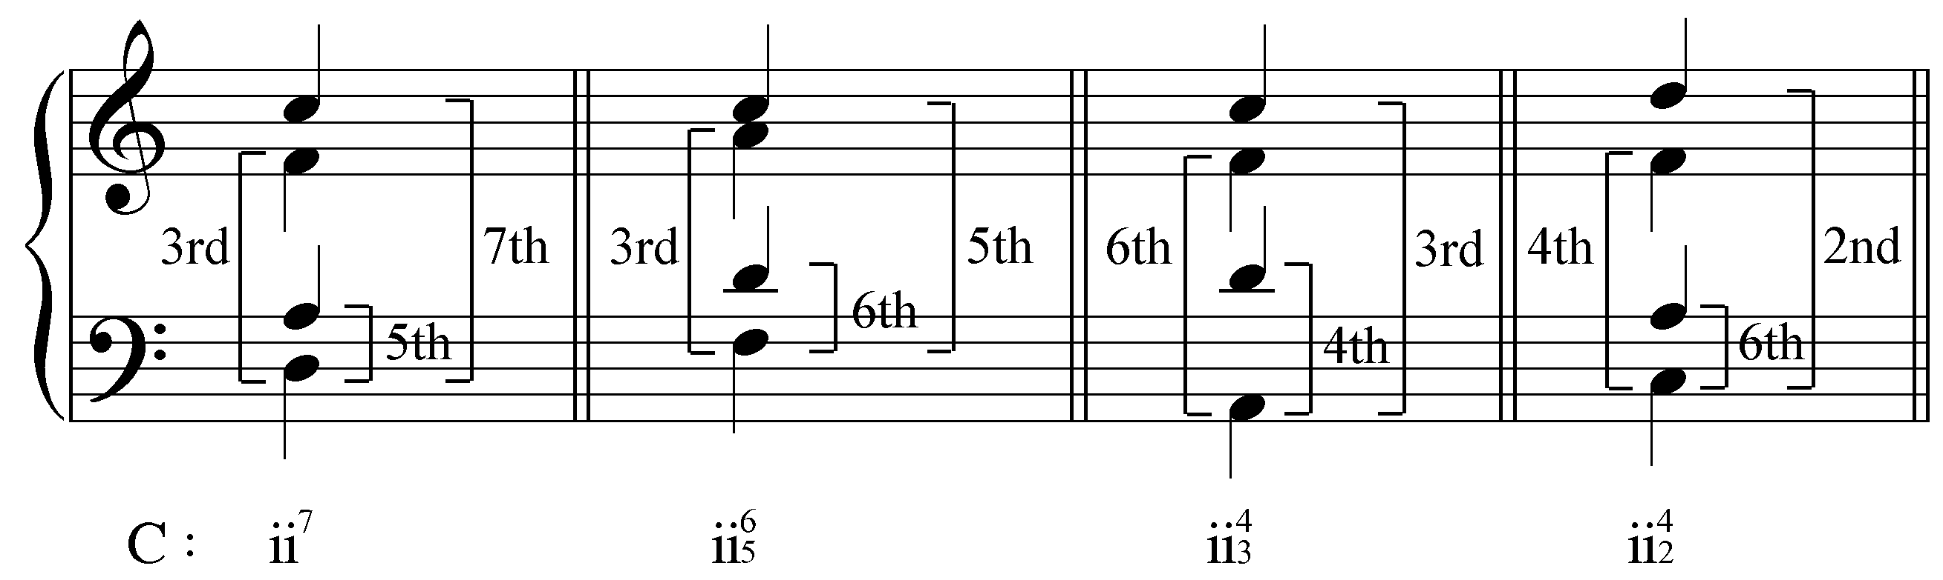

Like triads, inverting a seventh chord alters the intervallic relationships between the upper voices and the bass. The notation for labeling seventh chords indicates the intervals formed with the bass, although abbreviated notation is often used. For example, a seventh chord in first inversion contains the intervals of a 6th, a 5th, and a 3rd above the bass. Rather than write three numerals every time (${}_{3}{\begin{aligned}6\end{aligned}}^{5}$), the convention is to assume the 3rd and simply write: ${}_{5}^{6}$. The following table summarizes the figured-bass signatures of the inversions of seventh chords, and gives the notational short hand in the rightmost column:

Position | Chord Member  in the Bass | Intervallic  Content | Figured Bass  Short Hand
root position | root | 7  5  3 | 7
first inversion | third | 6  5  3 | 6  5
second inversion | fifth | 6  4  3 | 4  3
third inversion | Seventh | 6  4  2 | 4  2 | or | 2

Activity 7.3:
In this activity you will be asked to identify various seventh chords and their inversions.

Exercise 7.3a:
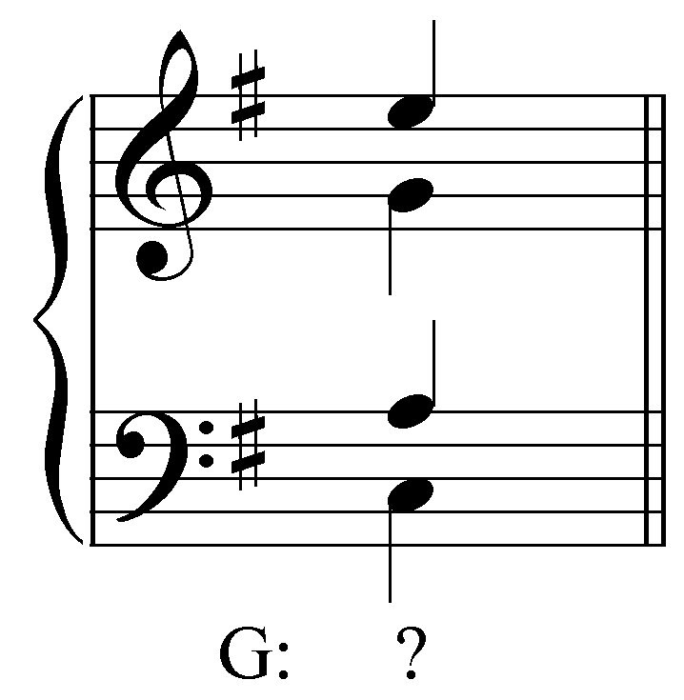
What roman numeral should appear in place of the question mark? Be sure to indicate the inversion in your answer.
[Answer: ii ^{ø}${}_{5}^{6}$. Response for correct roman numeral but wrong inversion: “That is the correct roman numeral, but the wrong inversion. Try again. (Hint: Which member of the chord is in the bass?)” Response for correct inversion but wrong roman numeral: “That is the correct inversion, but the wrong roman numeral. Try again. (Hint: The root of the chord is which scale degree in G major?)”]

Exercise 7.3b:
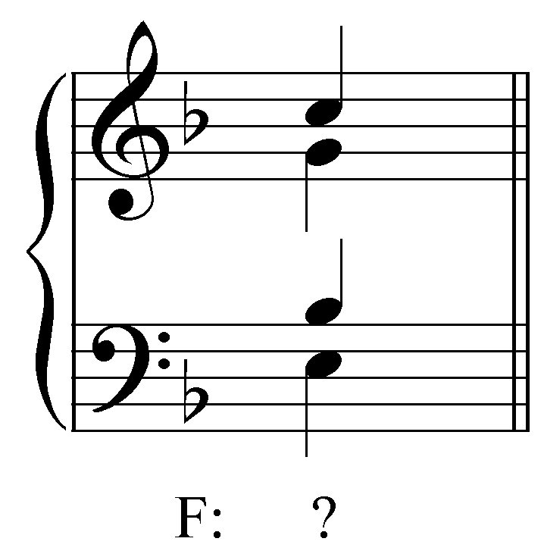
What roman numeral should appear in place of the question mark? Be sure to indicate the inversion in your answer.
[Answer: V${}_{5}^{6}$. Response for correct roman numeral but wrong inversion: “That is the correct roman numeral, but the wrong inversion. Try again. (Hint: Which member of the chord is in the bass?)” Response for correct inversion but wrong roman numeral: “That is the correct inversion, but the wrong roman numeral. Try again. (Hint: The root of the chord is which scale degree in F major?)”]

Exercise 7.3c:
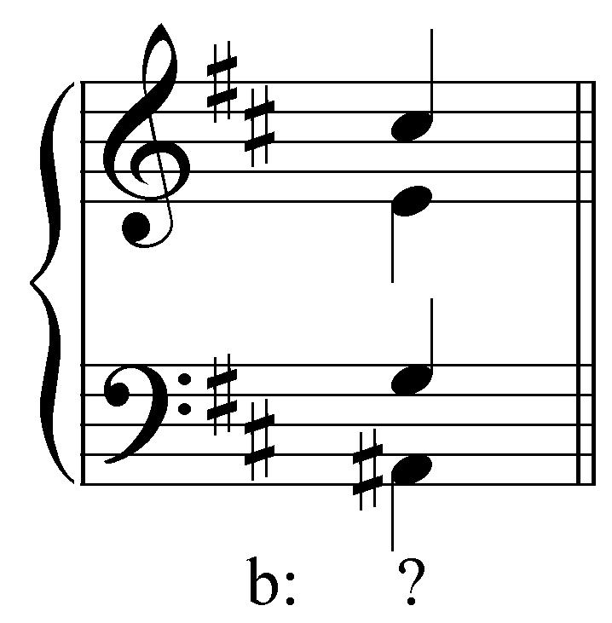
What roman numeral should appear in place of the question mark? Be sure to indicate the inversion in your answer.
[Answer: vii^{o7}. Response for correct roman numeral but wrong inversion: “That is the correct roman numeral, but the wrong inversion. Try again. (Hint: Which member of the chord is in the bass?)” Response for correct inversion but wrong roman numeral: “That is the correct inversion, but the wrong roman numeral. Try again. (Hint: The root of the chord is which scale degree in B minor?)”]

Exercise 7.3d:
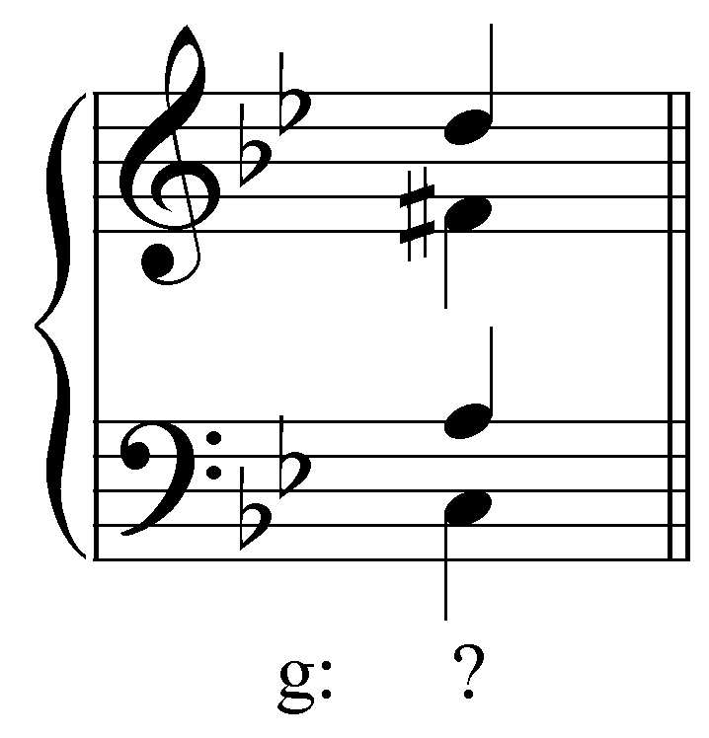
What roman numeral should appear in place of the question mark? Be sure to indicate the inversion in your answer.
[Answer: V${}_{2}^{4}$. Response for correct roman numeral but wrong inversion: “That is the correct roman numeral, but the wrong inversion. Try again. (Hint: Which member of the chord is in the bass?)” Response for correct inversion but wrong roman numeral: “That is the correct inversion, but the wrong roman numeral. Try again. (Hint: The root of the chord is which scale degree in G minor?)”]

Activity 7.4:
In this activity you will build various types of seventh chords in different keys.

Exercise 7.4a:
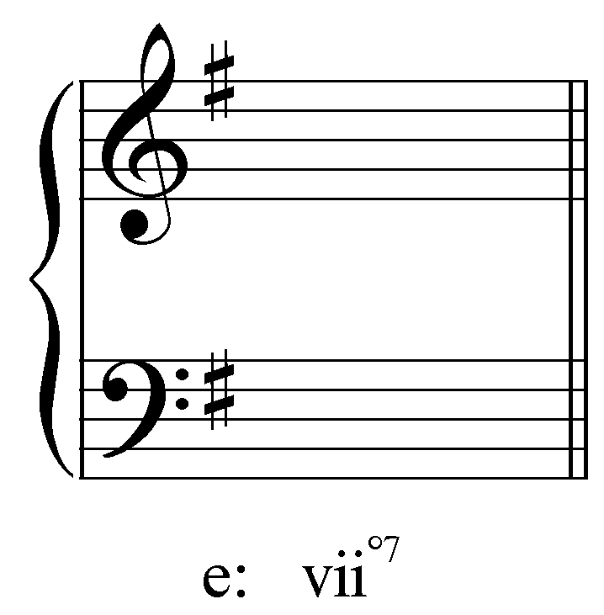
Write a vii^{o7} chord in E minor in four-part SATB voicing.
[Answer: D# in the bass, F#/A/C in the upper voices in any arrangement.]

Exercise 7.4b:
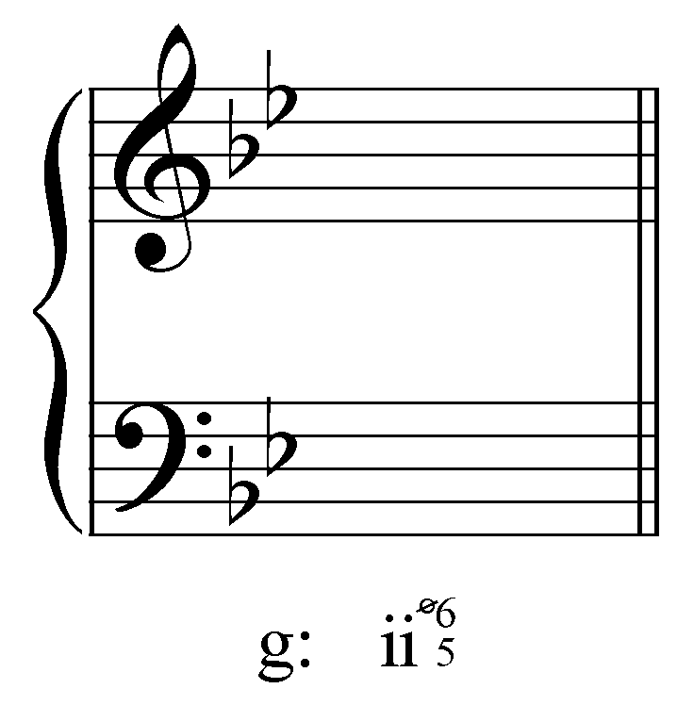
Write a ii ^{ø}${}_{5}^{6}$ chord in G minor in four-part SATB voicing.
[Answer: C in the bass, A/E^{b}/G in the upper voices in any arrangement.]

Exercise 7.4c:
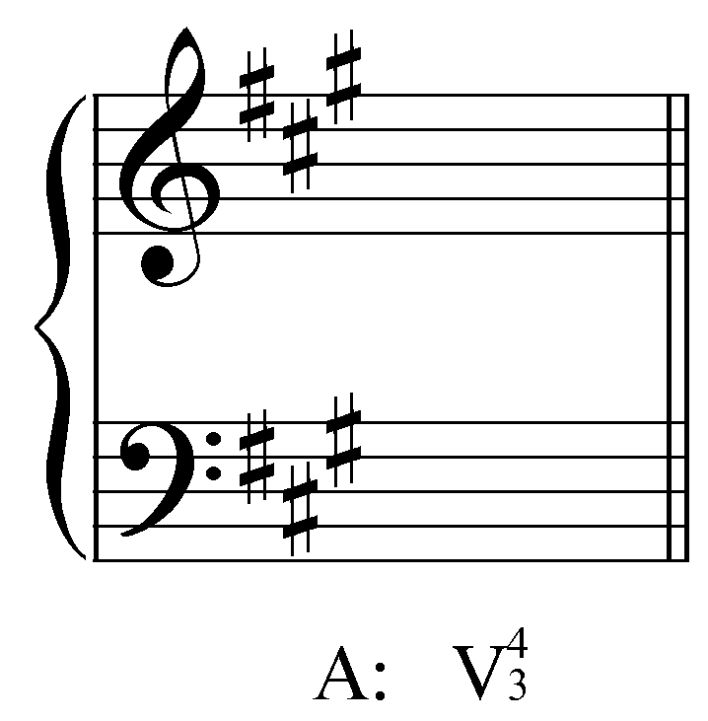
Write a V${}_{3}^{4}$ chord in A major in four-part SATB voicing.
[Answer: B in the bass, E/G#/D in the upper voices in any arrangement.]

Exercise 7.4d:
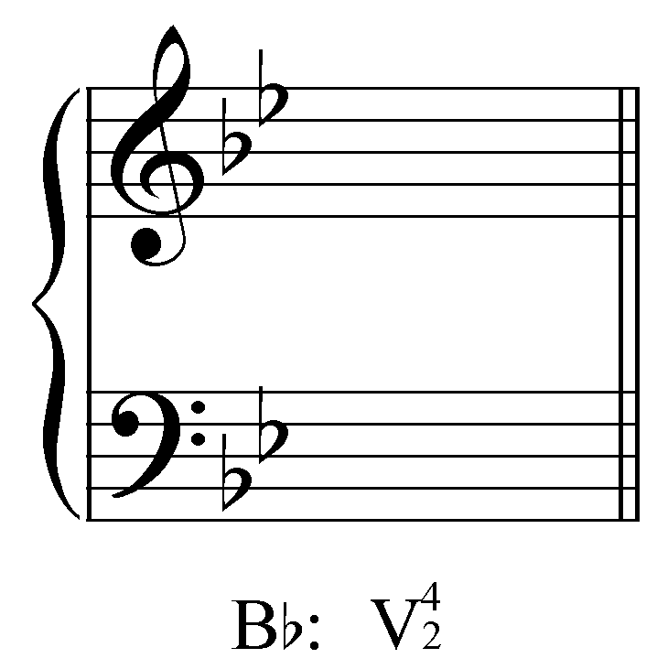
Write a V${}_{2}^{4}$ chord in Bb major in four-part SATB voicing.
[Answer: E^{b} in the bass, F/A/C in the upper voices in any arrangement.]

Preparing and resolving seventh chords:

As mentioned earlier, the characteristic feature of a seventh chord is the dissonant seventh formed with the root. This dissonance is unstable and must resolve. Chordal sevenths always resolve downward by step. This can be explained by considering the origin of the seventh chord. Example 5 shows a common cadential pattern where the octave above the bass in the V chord (scale degree 5) steps down through a passing tone to scale degree 3. Over time, this passing tone became incorporated into the chord (as shown by the arrow).

Example 5:
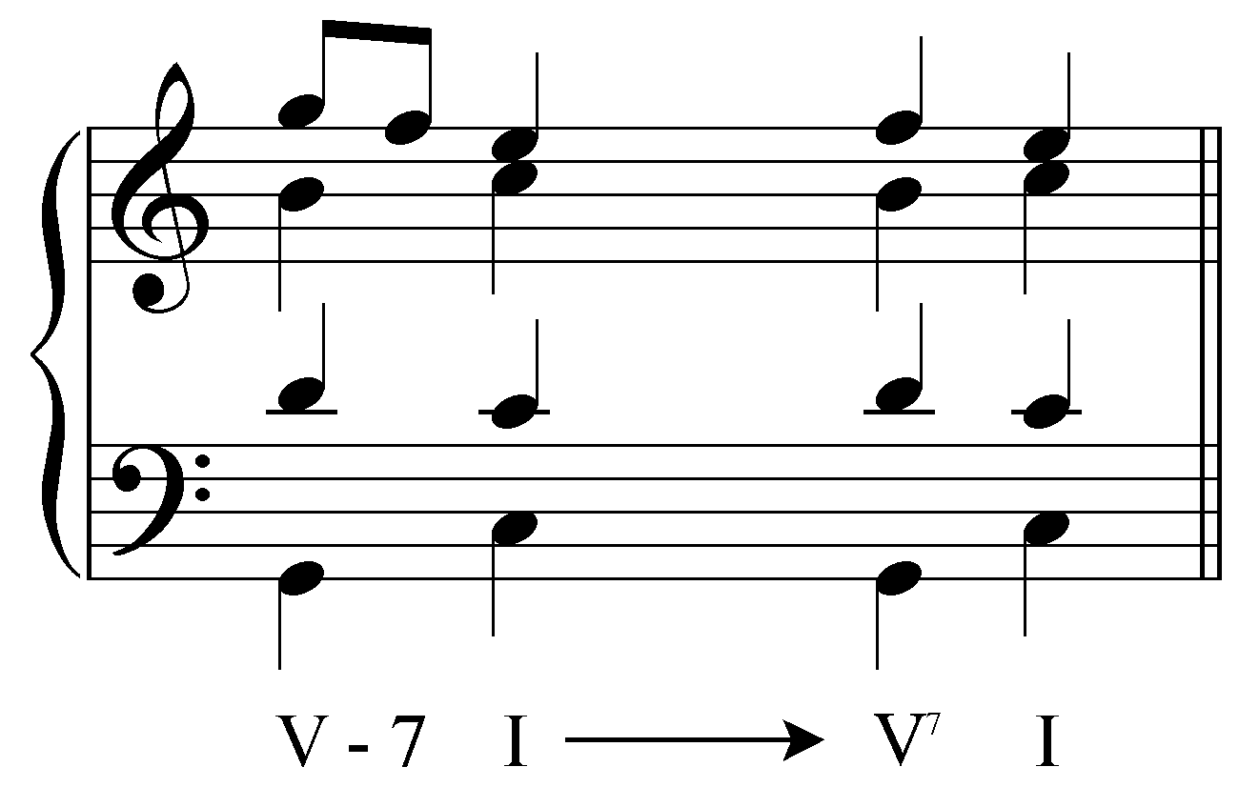

In the previous section we saw that seventh chords can be categorized according to their intervallic content and their sonority. However, not all seventh chords are treated equally. A seventh chord built on scale degree 1, for example, is always the result of a melodic phenomenon and should be analyzed as a triad (to do otherwise would undermine its primacy in defining tonality). Seventh chords built on scale degrees 2, 3, 4, 5, 6, and 7, however, occur frequently in tonal music and the rules for approaching and resolving them are similar. (The V⁷ chord, as mentioned above, is a special case and has its own lesson: Lesson FFF.)

The following example shows a typical progression involving a seventh chord—in this case, a ii${}_{5}^{6}$ chord:

Example 6:
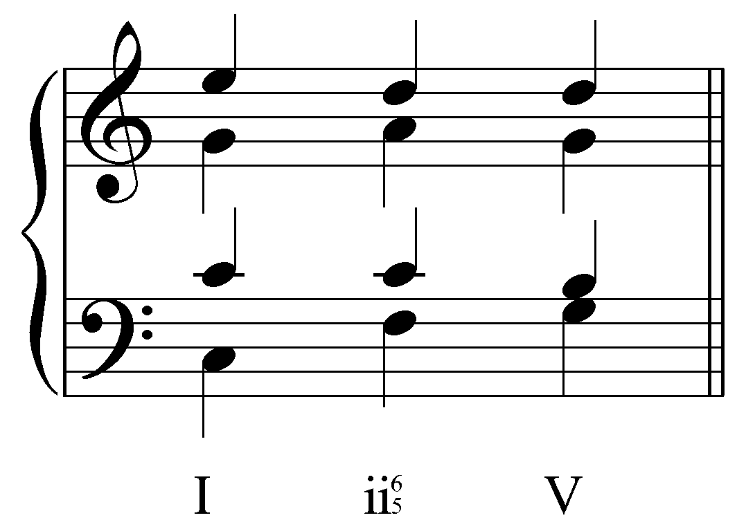

Note that the seventh of the ii${}_{5}^{6}$ chord (C in the tenor voice) is prepared as a common tone by the preceding I chord. As mentioned above, the seventh of a seventh chord is a dissonance and originated as a melodic event. The preparation of a chordal seventh as a common tone with the preceding harmony is the ideal voice leading into a seventh chord. Stepwise motion to the chordal seventh would be the next best alternative, should common-tone preparation be impossible. Chordal sevenths are seldom approached by leap as this would overemphasize the dissonance.

Activity 7.5:
In this activity you will be asked to complete a progression from I to ii${}_{5}^{6}$.

Exercise 7.5a:
In the following example, which voice will contain the seventh of the ii${}_{5}^{6}$ chord?
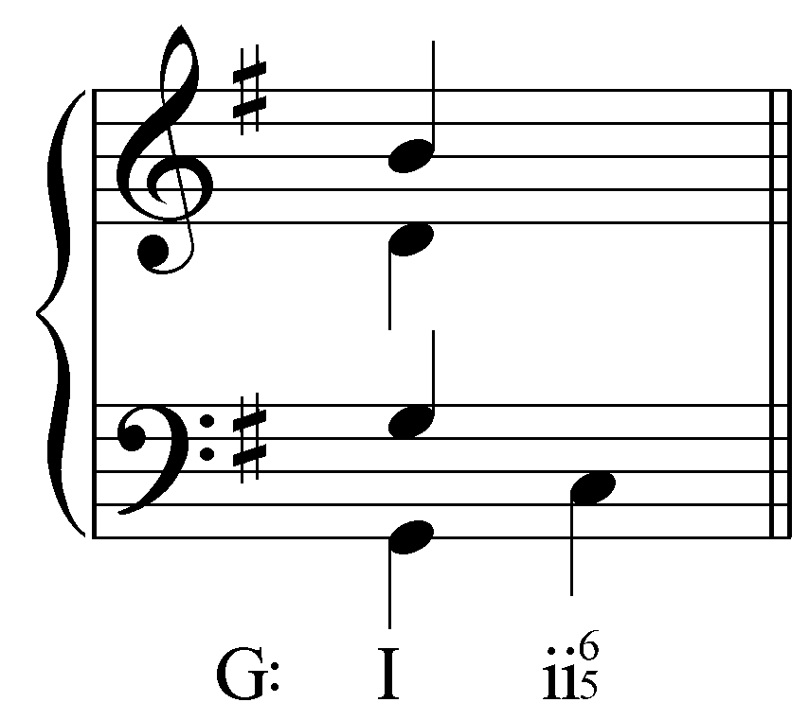
[Answer: tenor. Response if correct. “Correct! The tenor will prepare the seventh of the ii${}_{5}^{6}$ as a common tone G from the I chord.” Response if incorrect: “Incorrect. Remember, the seventh of the ii${}_{5}^{6}$ chord should be prepared as a common tone. Try again.”]
[Follow-up activity:] Complete the ii${}_{5}^{6}$ by adding the two remaining voices.
[Answer:
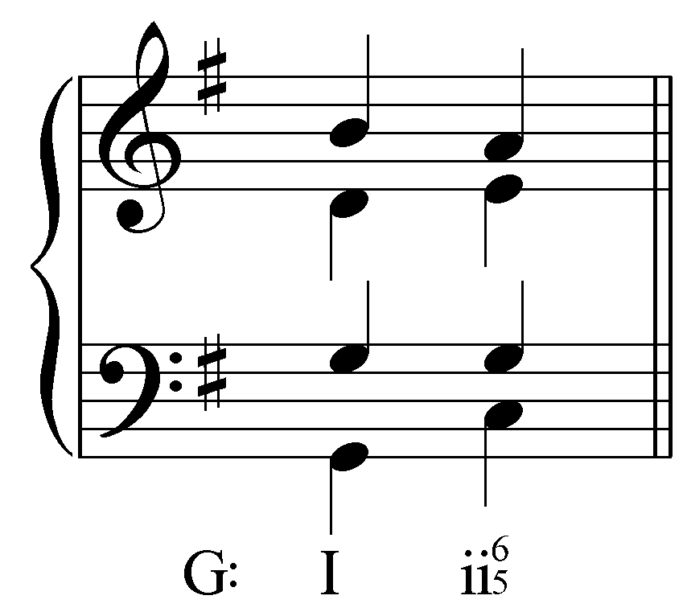]

Exercise 7.5b:
In the following example, which voice will contain the seventh of the ii${}_{5}^{6}$ chord?
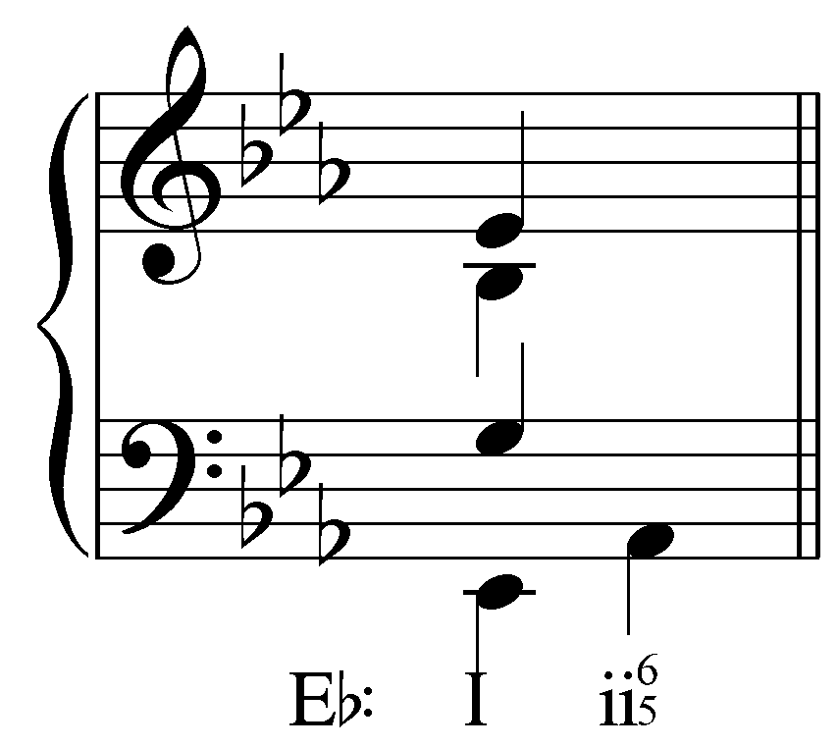
[Answer: soprano. Response if correct. “Correct! The soprano will prepare the seventh of the ii${}_{5}^{6}$ as a common tone E^{b} from the I chord.” Response if incorrect: “Incorrect. Remember, the seventh of the ii${}_{5}^{6}$ chord should be prepared as a common tone. Try again.”]
[Follow-up activity:] Complete the ii${}_{5}^{6}$ by adding the two remaining voices.
[Answer:
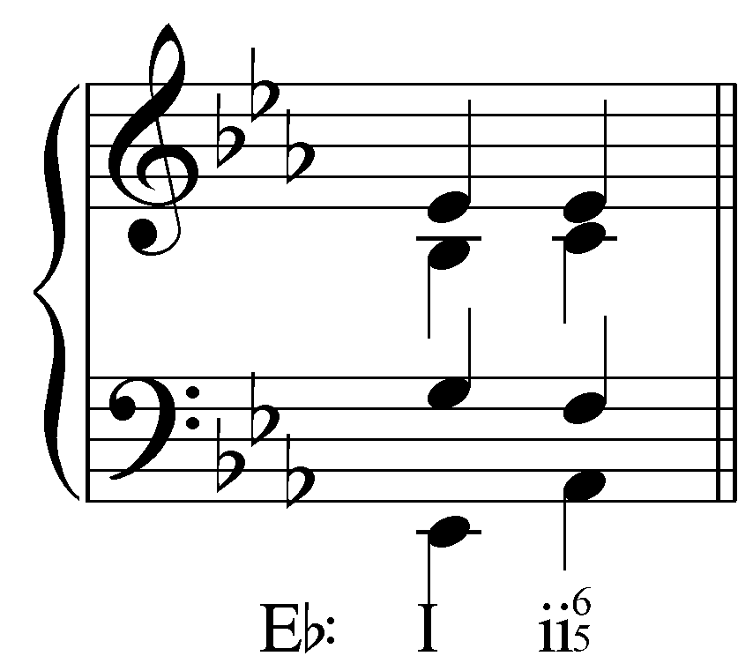]

Exercise 7.5c:
In the following example, which voice will contain the seventh of the ii${}_{5}^{6}$ chord?
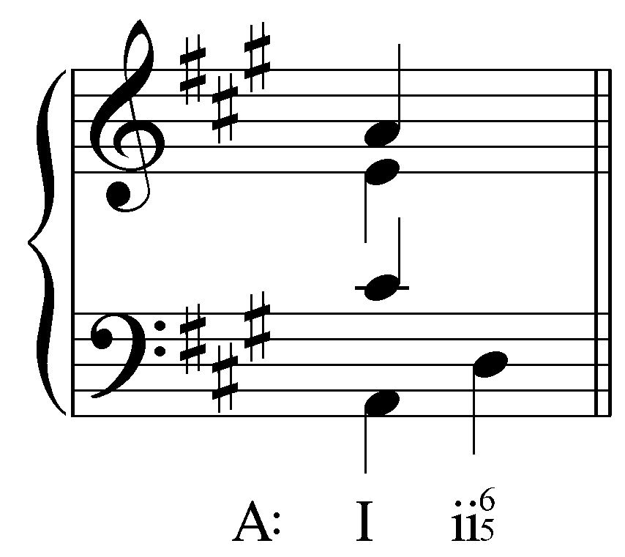
[Answer: soprano. Response if correct. “Correct! The soprano will prepare the seventh of the ii${}_{5}^{6}$ as a common tone A from the I chord.” Response if incorrect: “Incorrect. Remember, the seventh of the ii${}_{5}^{6}$ chord should be prepared as a common tone. Try again.”]
[Follow-up activity:] Complete the ii${}_{5}^{6}$ by adding the two remaining voices.
[Answer:
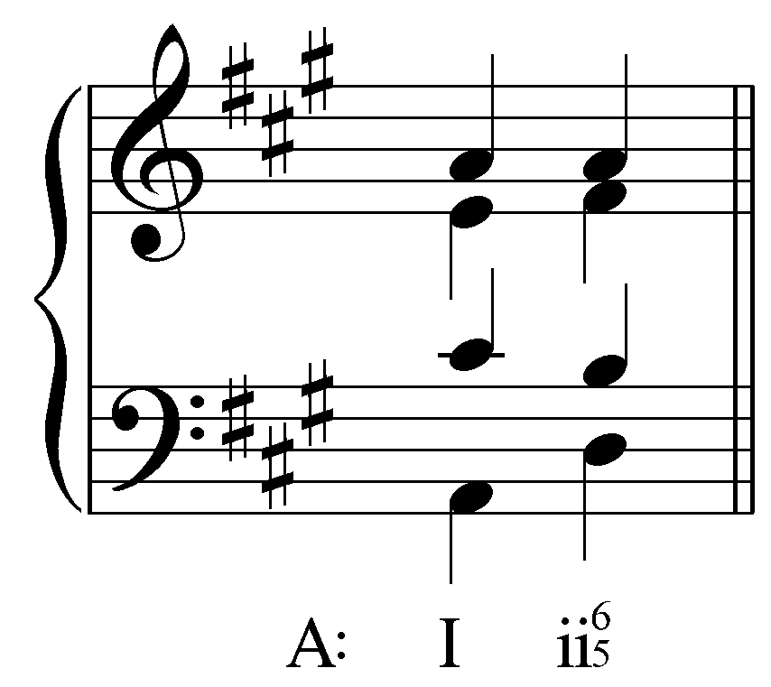]

Exercise 7.5d:
In the following example, which voice will contain the seventh of the ii${}_{5}^{6}$ chord?
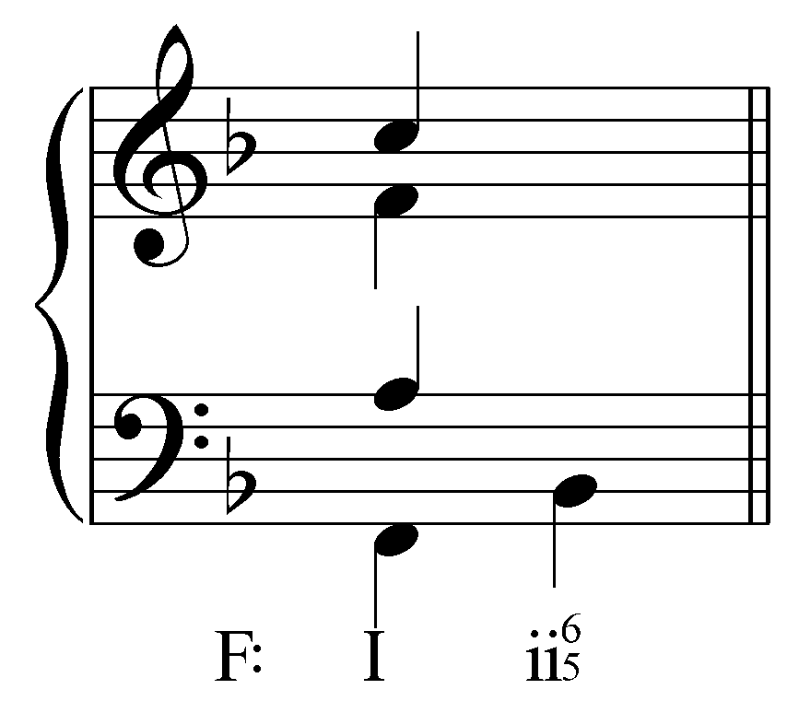
[Answer: alto. Response if correct. “Correct! The alto will prepare the seventh of the ii${}_{5}^{6}$ as a common tone F from the I chord.” Response if incorrect: “Incorrect. Remember, the seventh of the ii${}_{5}^{6}$ chord should be prepared as a common tone. Try again.”]
[Follow-up activity:] Complete the ii${}_{5}^{6}$ by adding the two remaining voices.
[Answer:
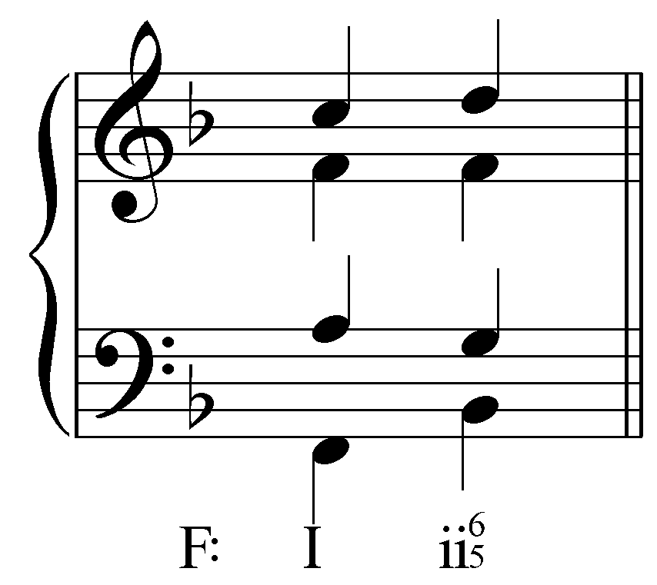]

Seventh chords typically resolve by falling-fifth root motion. In other words, a seventh chord will normatively resolve to the sonority whose root is a fifth below (or a fourth above) its own root. In Example 6, the ii${}_{5}^{6}$ chord (whose root is D) resolves to V (whose root, A, is a fifth below). Note that the falling-fifth root motion is not affected by the fact that the ii${}_{5}^{6}$ chord appears in inversion.

As a dissonance, the seventh of any seventh chord requires resolution. Because of its descending passing-tone origin, the seventh always resolves down by step. In the tenor voice of Example 6, the seventh of the ii${}_{5}^{6}$ chord steps down to B in following the V chord.

Activity 7.6:
In this activity you will continue the “I - ii${}_{5}^{6}$” progressions from the Activity 7.5 by adding a V chord.

Exercise 7.6a:
Where should the chordal seventh of the ii${}_{5}^{6}$ (G) chord resolve to?
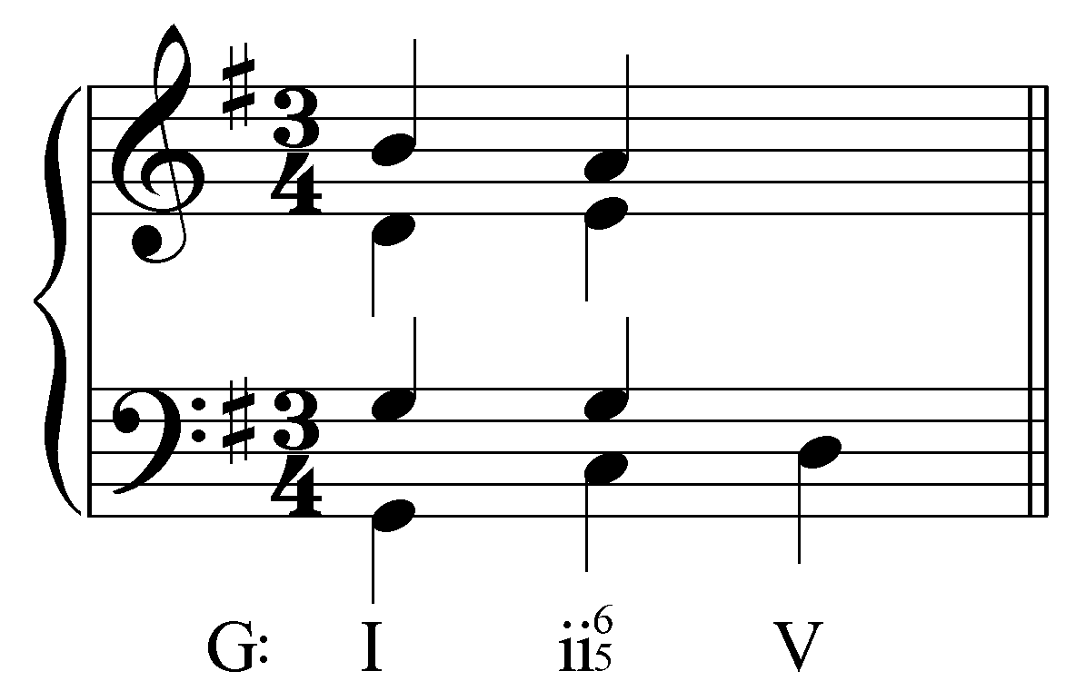
[Answer: F#. Response if correct: “Correct! The chordal seventh resolves down by step to F#.” Response if incorrect: “Incorrect. Remember, the chordal seventh must resolve down by step. Try again.”]
[Follow-up activity:] Complete the V chord by adding the resolution of the chordal seventh and the two remaining voices.
[Answers:
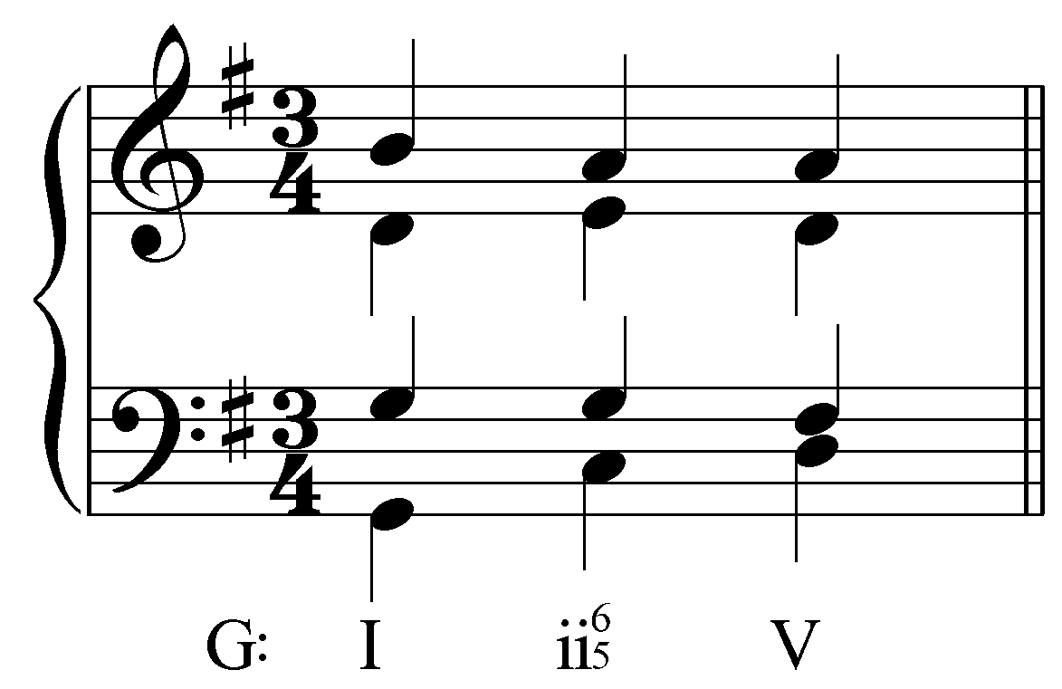 or 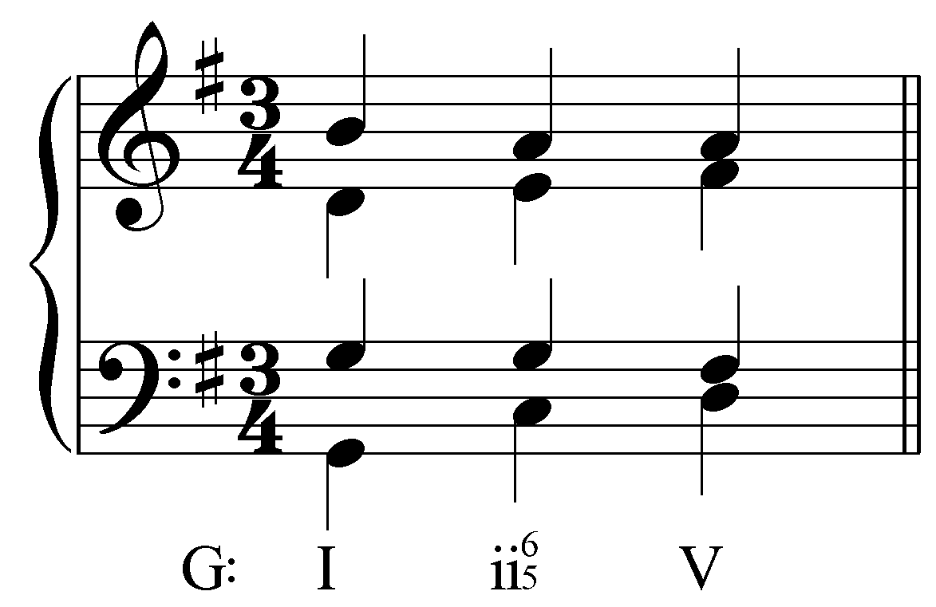]

Exercise 7.6b:
Where should the chordal seventh of the ii${}_{5}^{6}$ (E^{b}) chord resolve to?
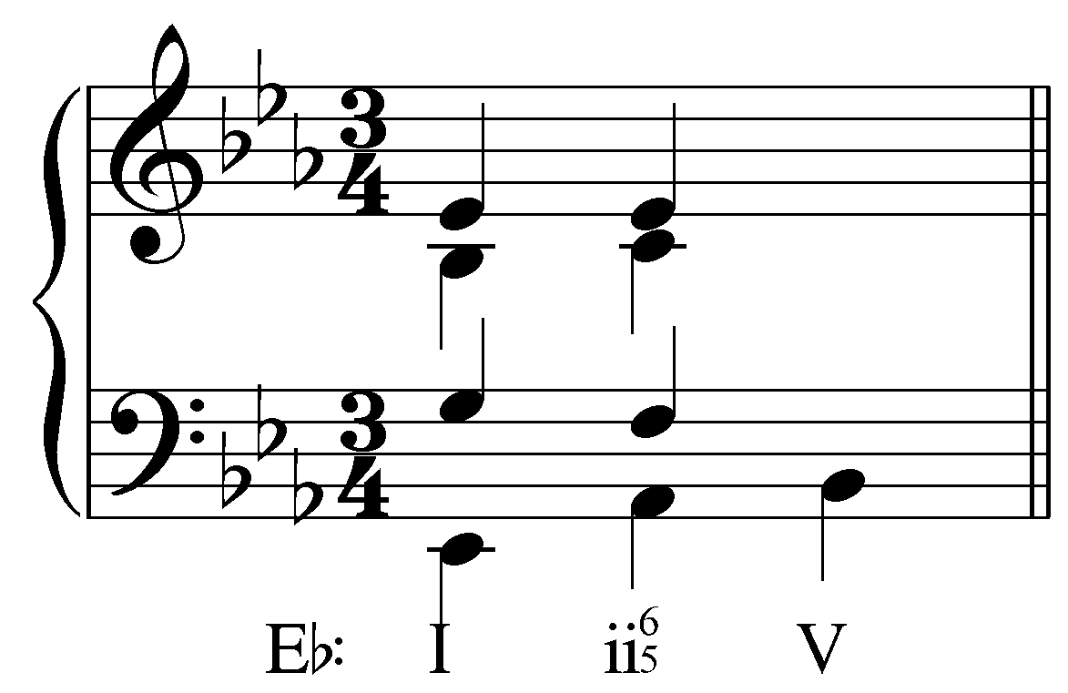

[Answer: D. Response if correct: “Correct! The chordal seventh resolves down by step to D.” Response if incorrect: “Incorrect. Remember, the chordal seventh must resolve down by step. Try again.”]
[Follow-up activity:] Complete the V chord by adding the resolution of the chordal seventh and the two remaining voices.
[Answers:
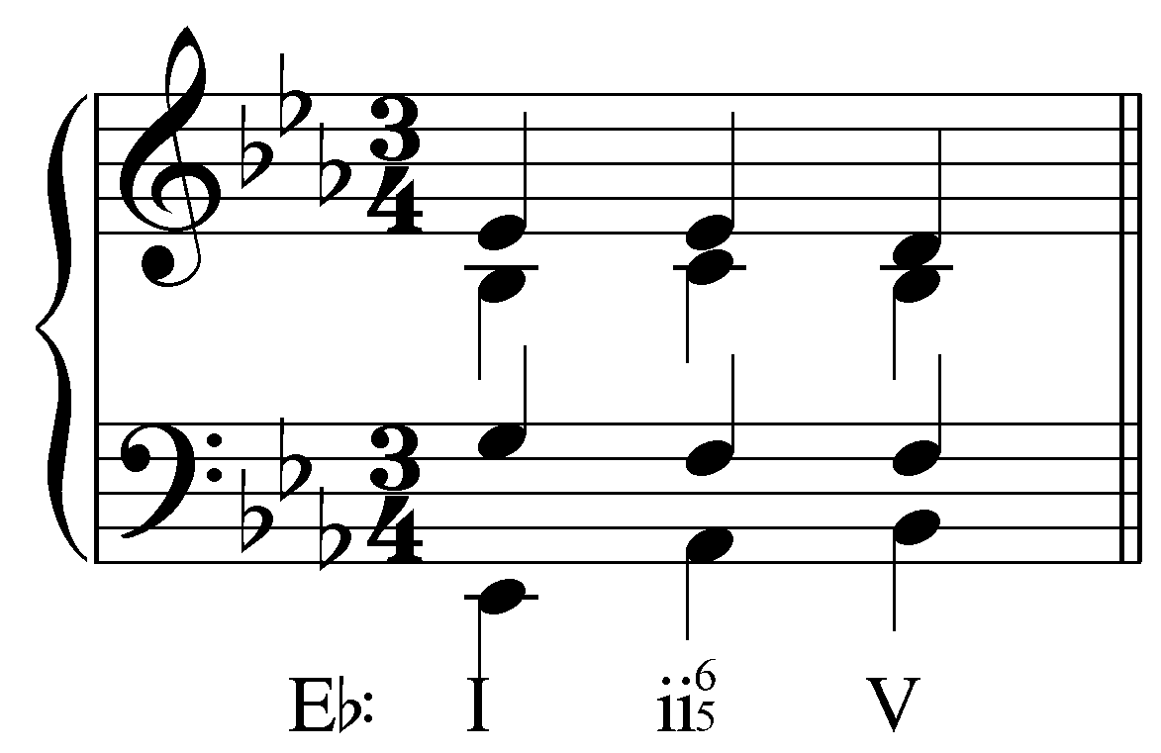 or 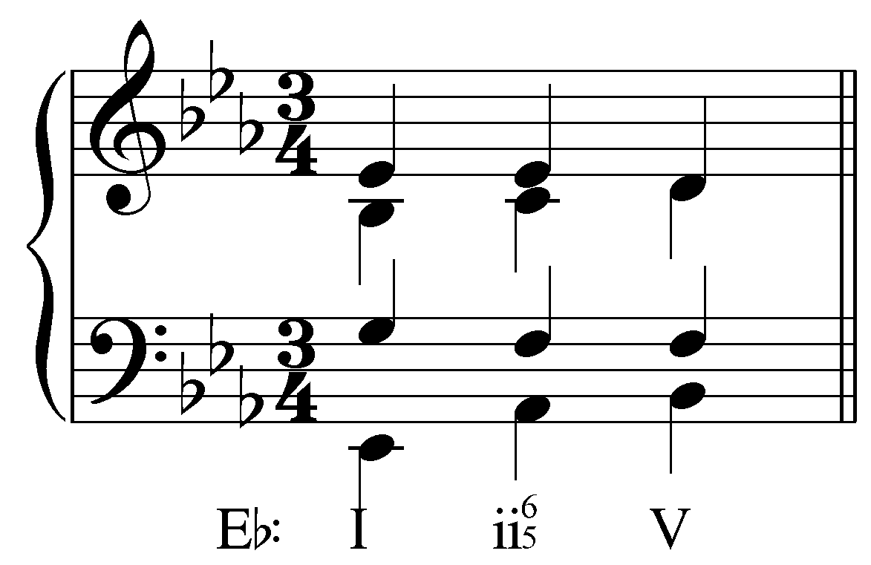]

Exercise 7.6c:
Where should the chordal seventh of the ii${}_{5}^{6}$ (A) chord resolve to?
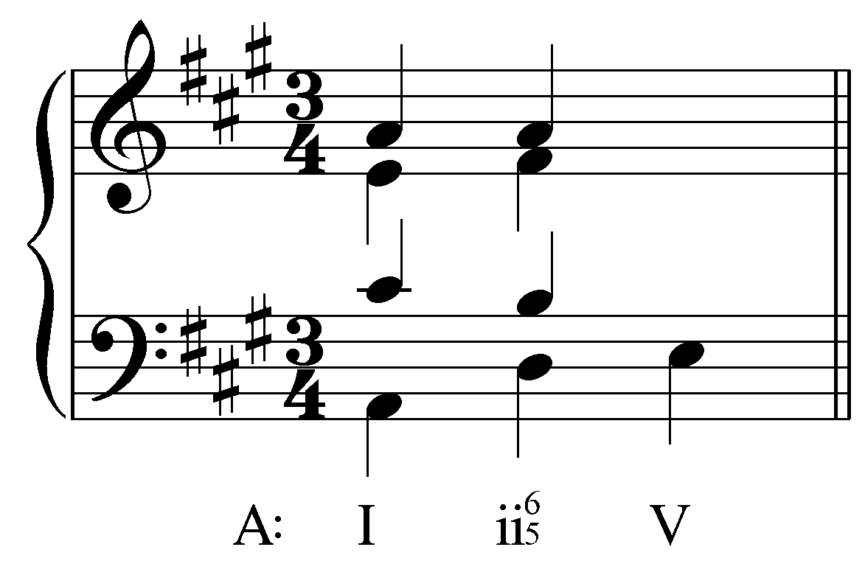

[Answer: G#. Response if correct: “Correct! The chordal seventh resolves down by step to G#.” Response if incorrect: “Incorrect. Remember, the chordal seventh must resolve down by step. Try again.”]
[Follow-up activity:] Complete the V chord by adding the resolution of the chordal seventh and the two remaining voices.
[Answers:
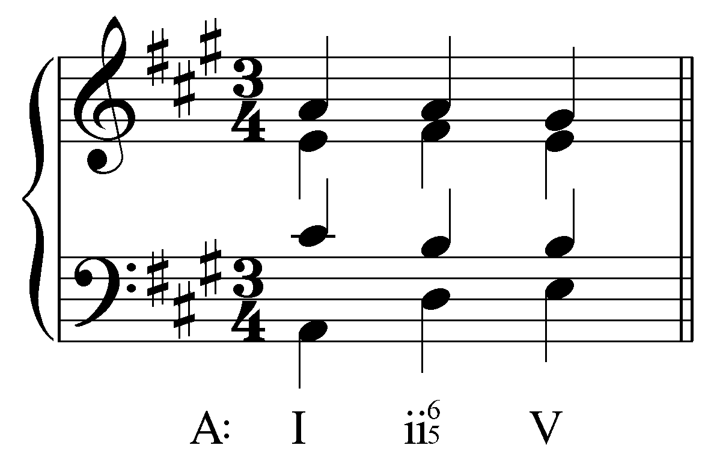 or 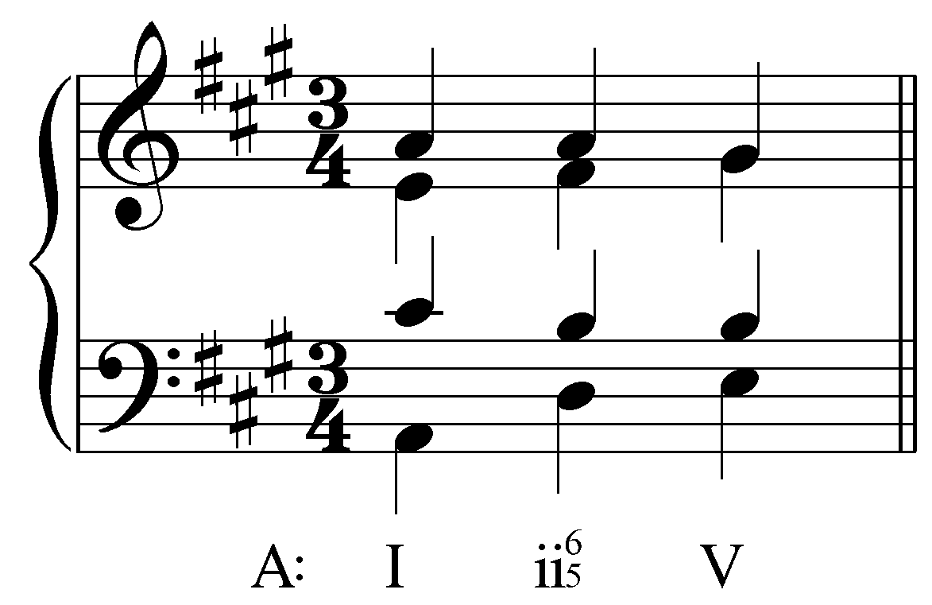]

Exercise 7.6d:
Where should the chordal seventh of the ii${}_{5}^{6}$ (F) chord resolve to?
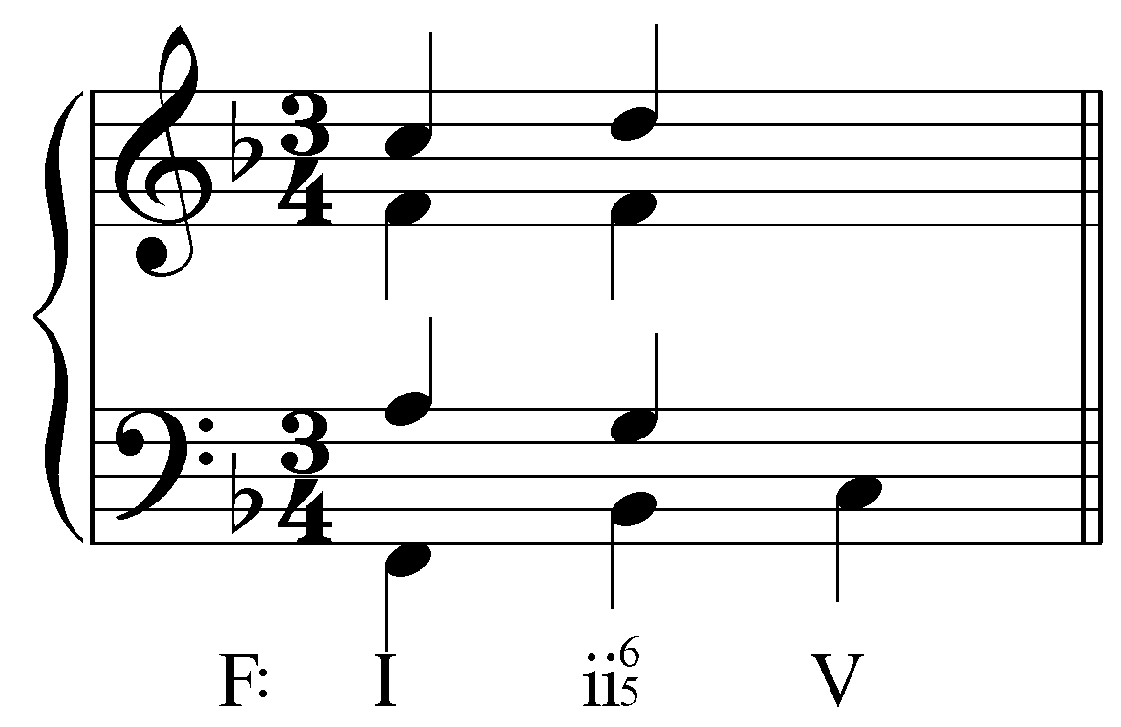
[Answer: E. Response if correct: “Correct! The chordal seventh resolves down by step to E.” Response if incorrect: “Incorrect. Remember, the chordal seventh must resolve down by step. Try again.”]
[Follow-up activity:] Complete the V chord by adding the resolution of the chordal seventh and the two remaining voices.
[Answers:
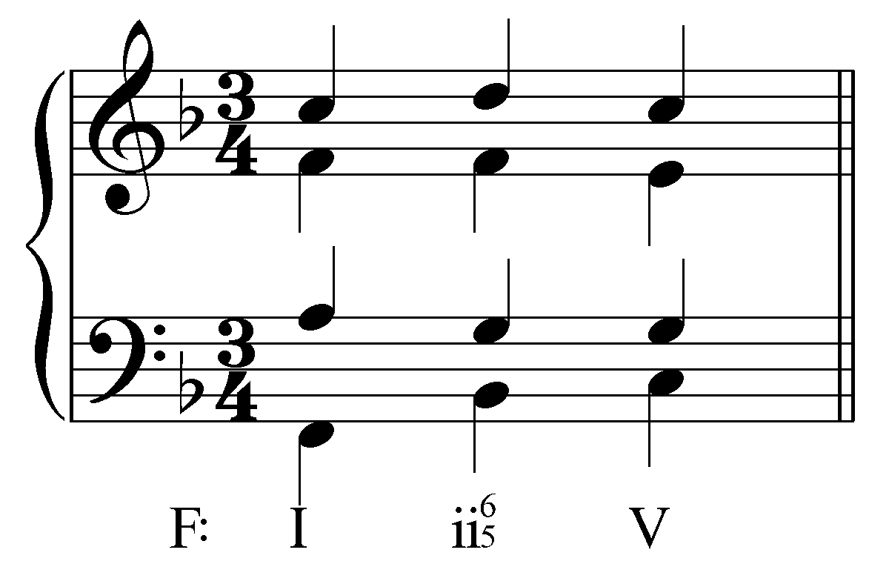 or 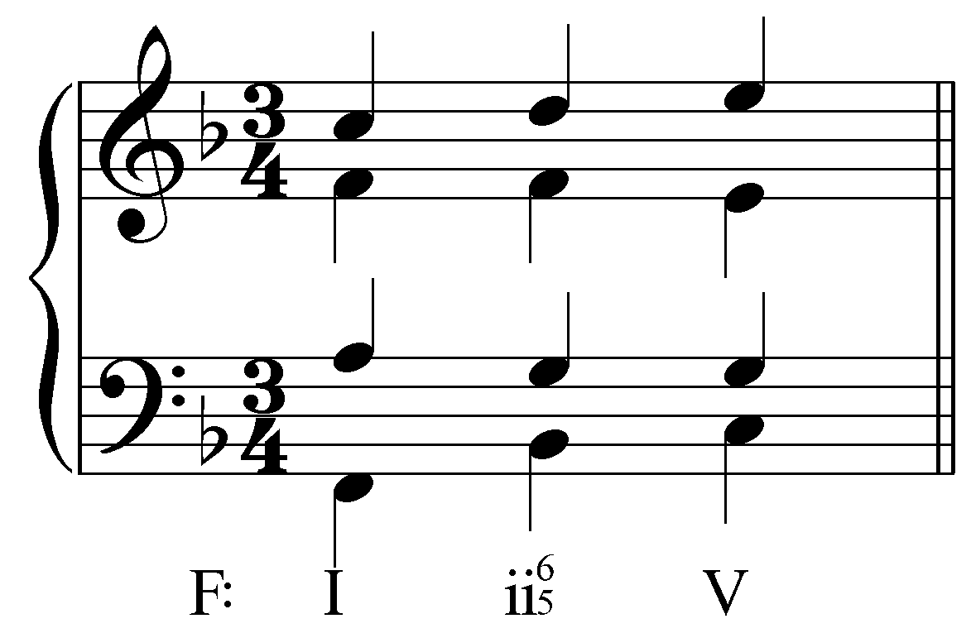]

Example 6 demonstrates the proper preparation and resolution of a chordal seventh using a ii⁷ chord as an example, but this treatment can be used for any seventh chord. Consider the following example:

Example 7:
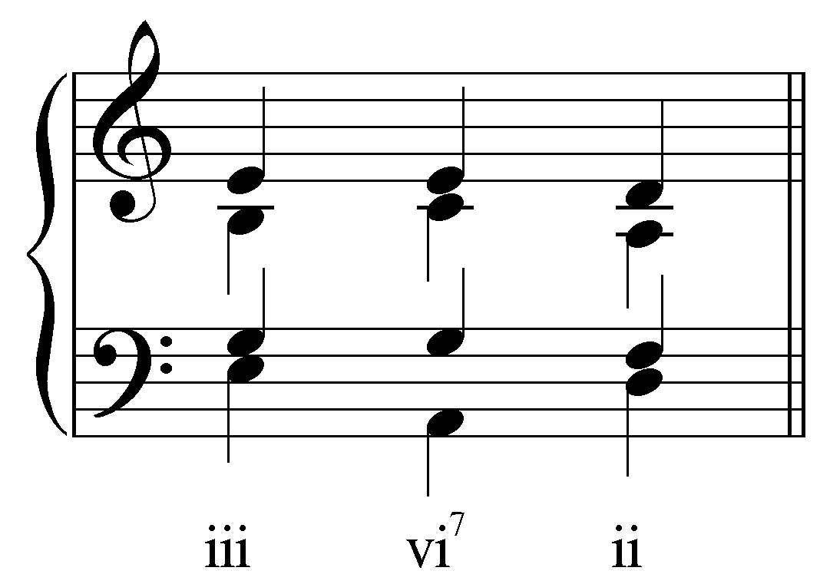

Example 7 shows a progression where a vi⁷ chord, prepared by a iii chord, resolves to a ii chord. Again, we see the falling-fifth motion between the root of the vi⁷ chord (A) and the resolution ii chord (D). The seventh of the vi⁷ chord (G) is prepared as a common tone in the preceding iii chord, and resolved downwards by step to F. These same rules may be used for any other seventh chord. A iii⁷ chord, for example, typically resolves to vi. (These two seventh chords, vi⁷ and iii⁷, are usually found in root position.)

Popup Box: Because chordal sevenths are inherently dissonant, they must be treated carefully. Keep the following guidelines in mind when approaching and resolving seventh chords.
- Chordal seventh should be prepared as a common tone: Ideally, a chordal seventh should be prepared as a common tone by the preceding harmony in order to lead as smoothly as possible into the dissonance. If the seventh cannot be prepared as a common tone, approach by step is the next best alternative. Leaping to the chordal seventh should be avoided.
- Falling-fifth root motion: In most cases, the root of the chord of resolution will be a fifth below the root of the seventh chord.
- Chordal seventh descends by step: Because of the origin as accented passing tones, chordal sevenths must always resolve downwards by step.

Specific seventh chords and their functions:

Some seventh chords have specific functions. In the following sections, we will explore the unique roles played by several seventh chords: the supertonic seventh chord, the subdominant seventh chord, and the leading-tone seventh chord.

The supertonic seventh chord (ii⁷ in major; ii ^{ø7} in minor):

Second to the dominant seventh chord (V⁷), the supertonic seventh chord (ii⁷ in major; ii ^{ø7} in minor) is the most commonly used seventh chord. Recall that the triad built on scale degree 2 typically functions as a pre-dominant. The seventh of the supertonic seventh chord heightens that pre-dominant function because the dissonant seventh increases the necessity for resolution, and creates a sense of motion toward V.

As a pre-dominant, the supertonic seventh chord often appears in progressions approaching V. The supertonic seventh chord may appear in any position, but first inversion (${}_{5}^{6}$) is quite common. Example 8 shows the progression used above in which a ii${}_{5}^{6}$ chord, prepared by I, leads to V:

Example 8:

As mentioned above, the rules for proper approach and resolution of the ii${}_{5}^{6}$ chord are all in place: the chordal seventh is prepared as a common tone, the seventh chord resolves by falling-fifth root motion, and the chordal seventh resolves downwards by step.

The ii${}_{5}^{6}$ chord may also move to a dominant with ${}_{4}^{6}$ suspensions in the upper voices. Example 9 adds a ${}_{4}^{6}$ suspension to the progression given in Example 8. Note that the suspended 4th above the bass delays the obligatory descending stepwise resolution of the seventh of the ii⁷ (C in the tenor):

Example 9:
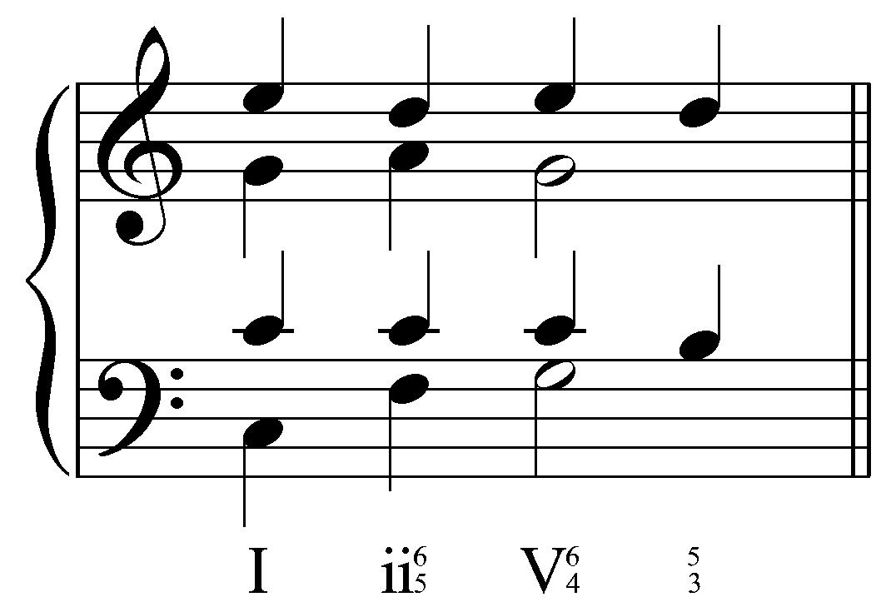

Finally, the supertonic seventh chord can also appear in root position. Though occurring less frequently than the supertonic seventh chord in first inversion, the root-position supertonic seventh chord is also a possible precursor to V.

Example 10:
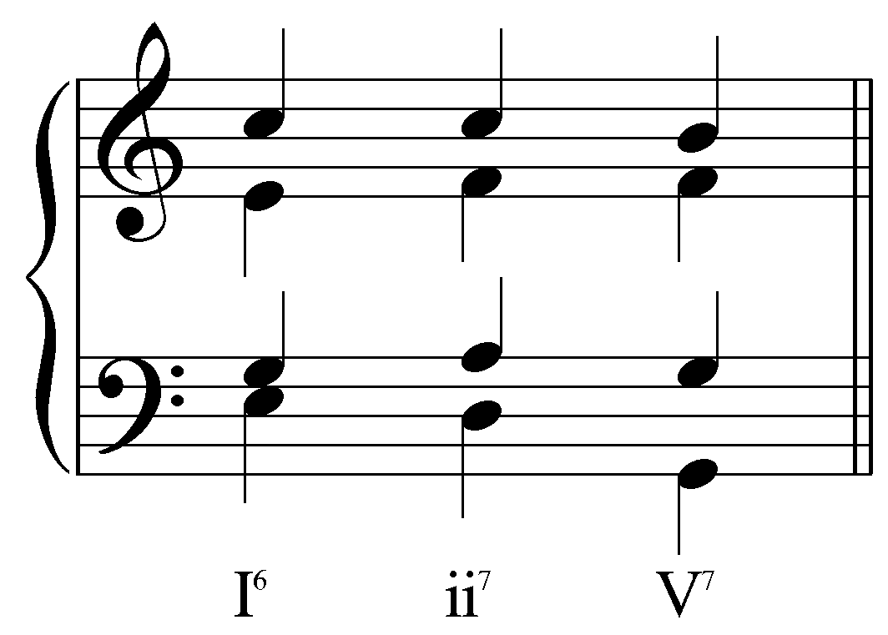

As in Example 8, the seventh of the ii⁷ chord is held over as a common tone from the I chord (this time in the soprano). In Example 10, the third of the ii⁷ chord (F) appears in an upper voice instead of the bass and is therefore not obligated to step up to the root of the V chord (see F - G in the bass of Example 8). Instead, it held as a common tone, thereby again preparing the seventh of the V7. Because of this, ii⁷ typically moves to a V⁷ chord instead of a triad. Note also the proper resolution of the seventh of the ii⁷ chord: the C in the soprano steps down to the leading tone (B) of the V⁷ chord.

Other inversions of the supertonic seventh chord (${}_{3}^{4}$ and ${}_{2}^{4}$) may be used, but do not typically appear in cadential situations but rather midstream in progressions leading up to a cadence.

The subdominant seventh chord (IV⁷ in major; iv⁷ in minor):

The diatonic seventh chord built on scale degree 4—the subdominant seventh chord (IV⁷ in major; iv⁷ in minor)—is closely related to the supertonic seventh chord differing only by one member. It too has a pre-dominant function, leading to V. By far, IV⁷ appears most frequently in root position. Example 11 shows the typical voice leading in the progression I - IV⁷ - V:

Example 11:
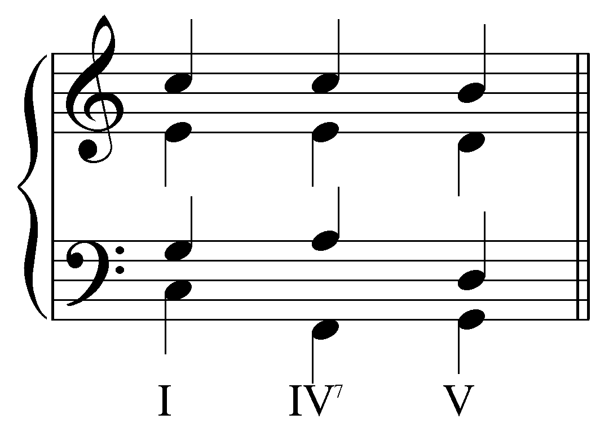

You should be able to recognize most of the same conventions from Example 6. The seventh of the IV⁷ chord (E) is prepared by common tone from the preceding I chord. As the harmony changes on the third beat, the seventh resolves downwards by step—in this case to D, the fifth of the V chord. Because the seventh chord does not resolve by falling root-motion, one exception to conventional voice leading can be found in the tenor voice. Note how the tenor leaps from A down to D as the IV⁷ moves to V. This leap is necessary in order to avoid what would otherwise have been parallel fifths between the tenor and alto had the tenor moved to the nearest member of the V chord (D). The result of the exceptional voice leading is a doubled fifth in the V chord.

Activity 7.7:
In this activity you will complete a “I - IV⁷ - V” progression in four voices. In each exercise, the voicing of the I chord has been given to you. (Remember, the seventh of the IV⁷ chord must be prepared as a common tone and must resolve downwards by step. Also, be sure to avoid parallel fifths in the move from IV⁷ to V.)

Exercise 7.7a:
Complete the following progression by filling in the remaining notes for the upper voices:
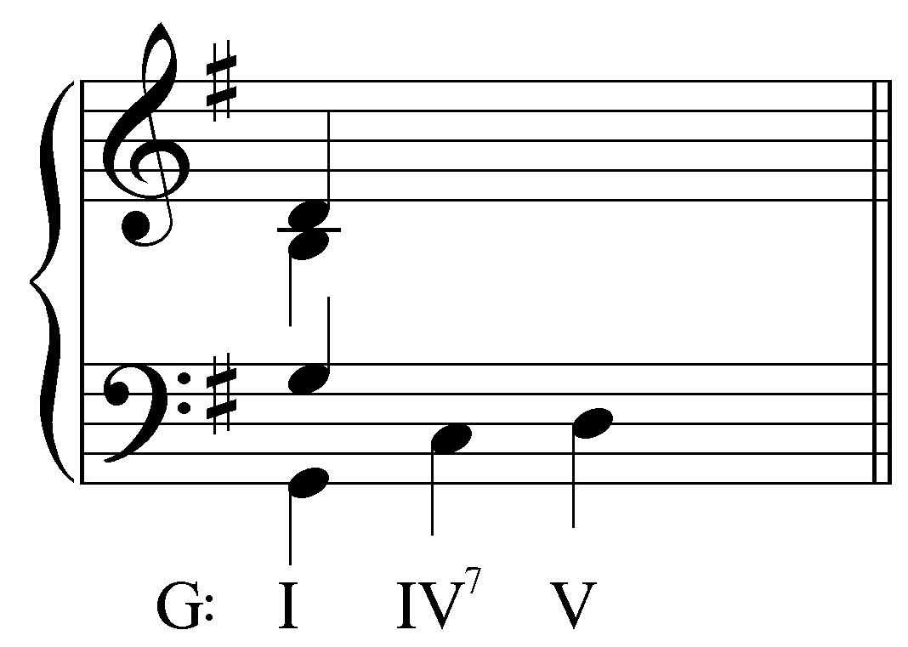
[Answer:
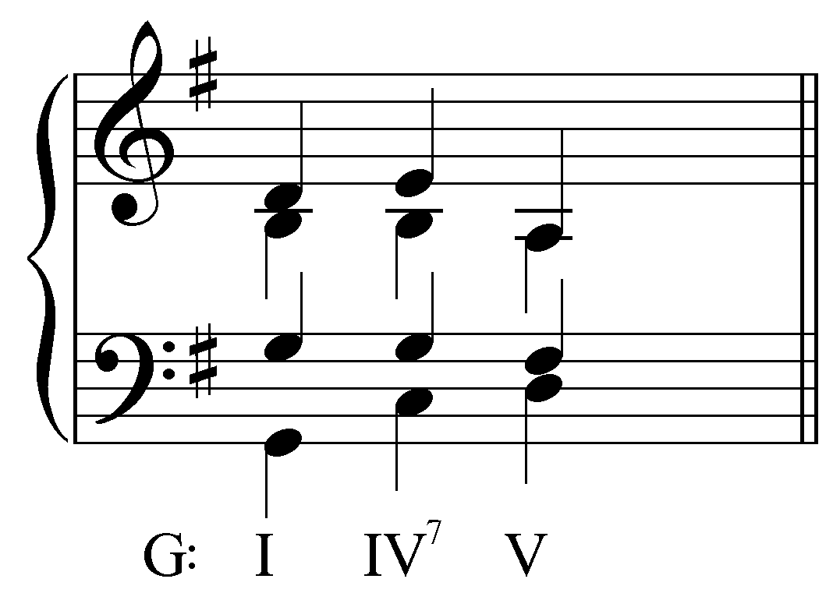]

Exercise 7.7b:
Complete the following progression by filling in the remaining notes for the upper voices:
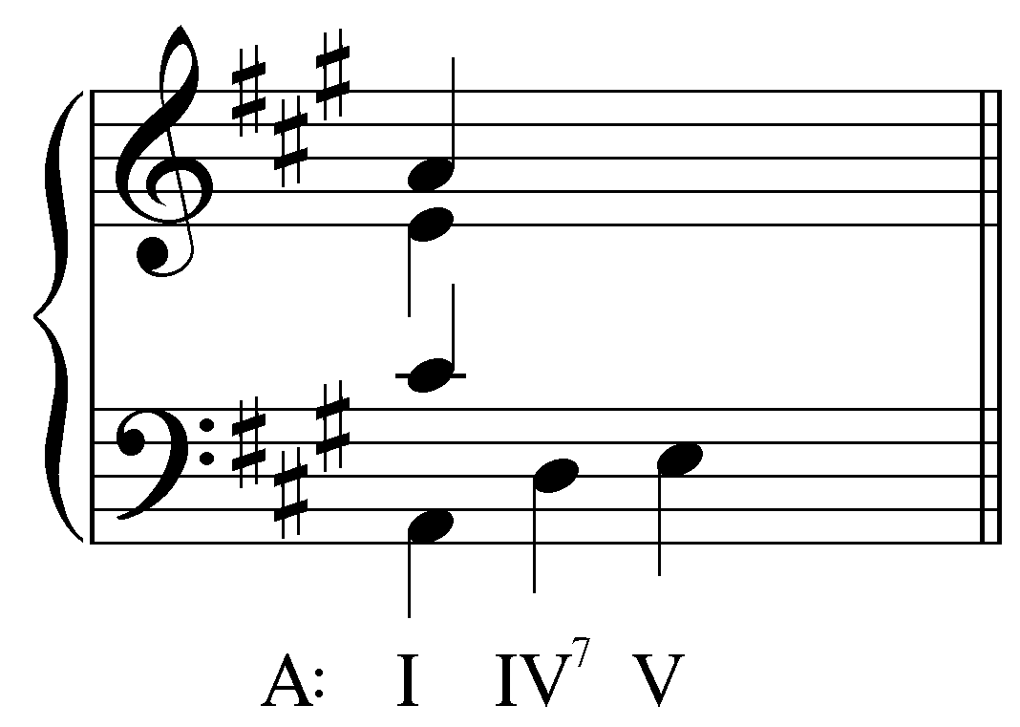
[Answer:
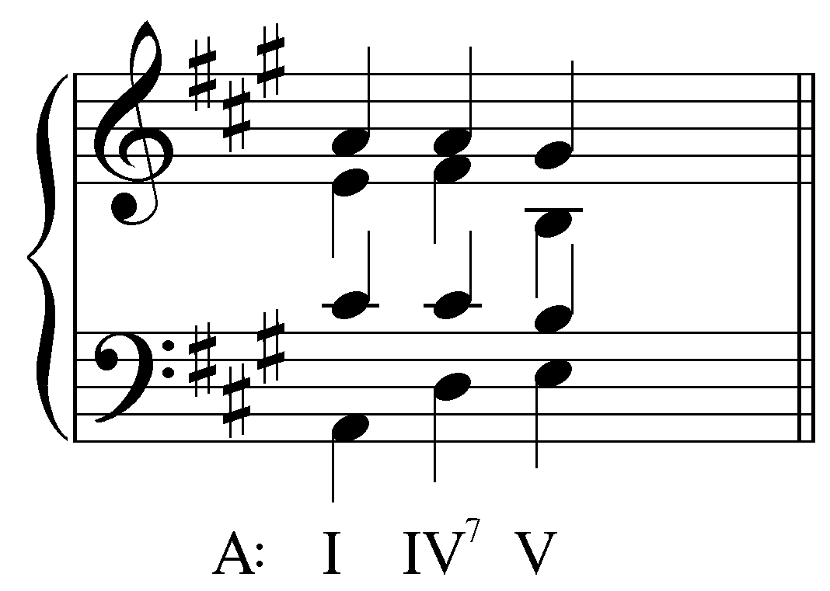]

Exercise 7.7c:
Complete the following progression by filling in the remaining notes for the upper voices:
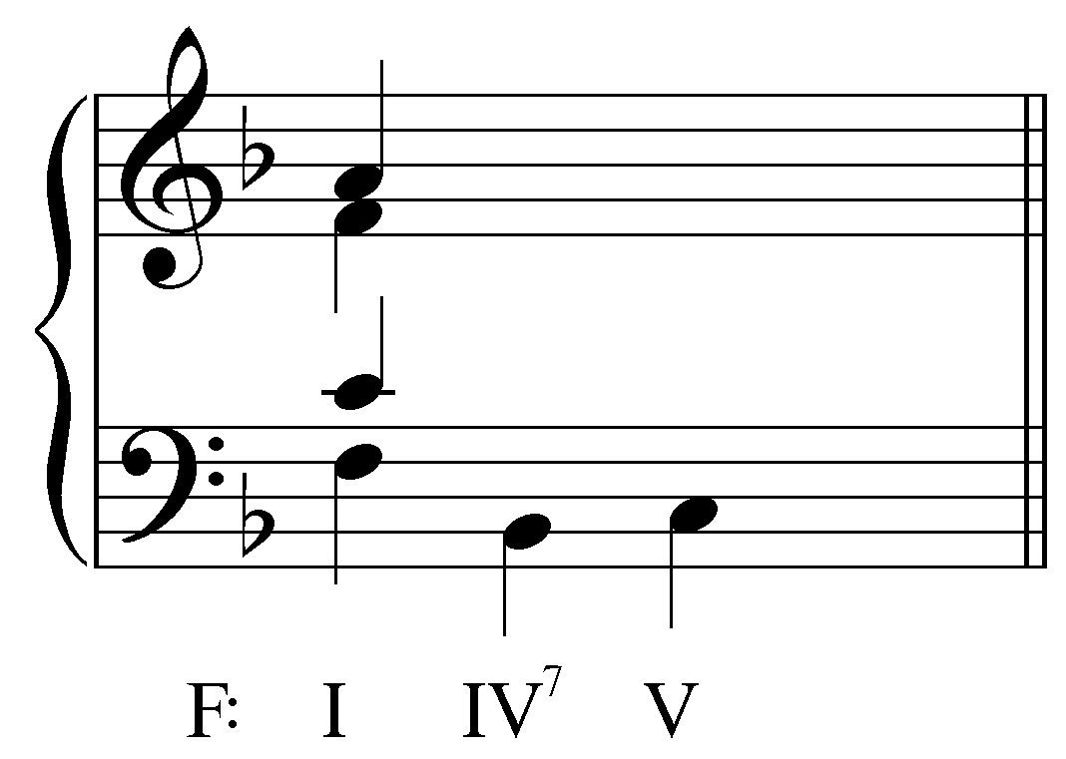
[Answer:
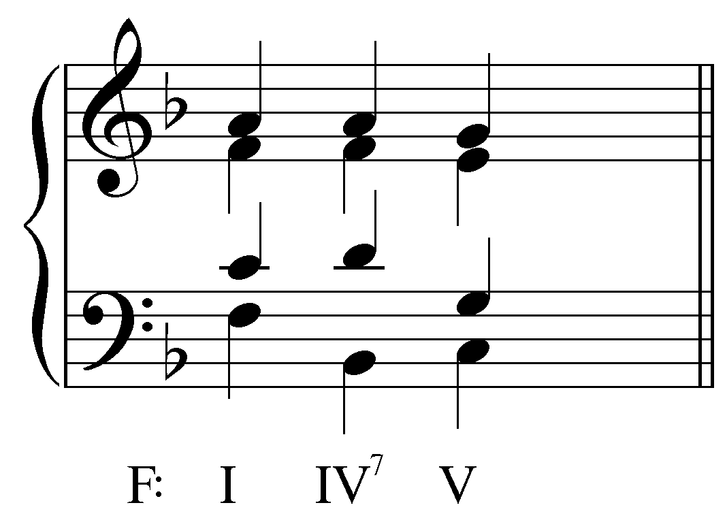]

Exercise 7.7d:
Complete the following progression by filling in the remaining notes for the upper voices:
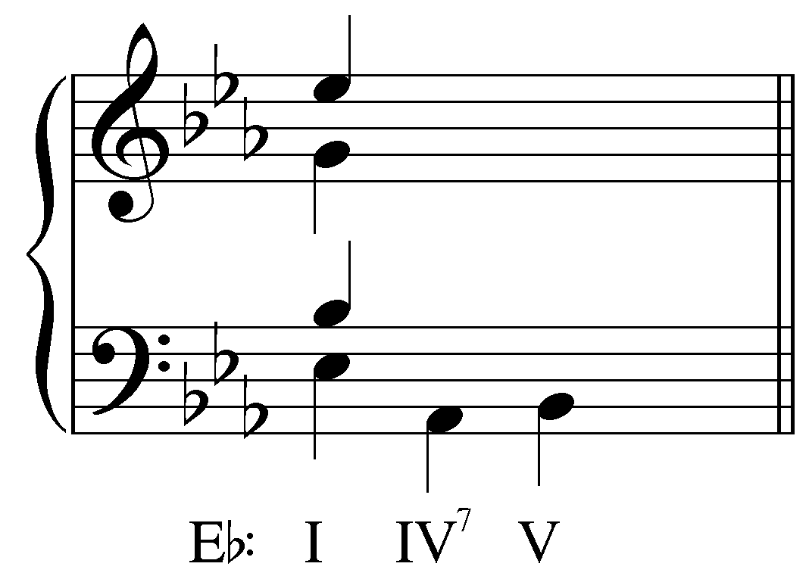
[Answer:
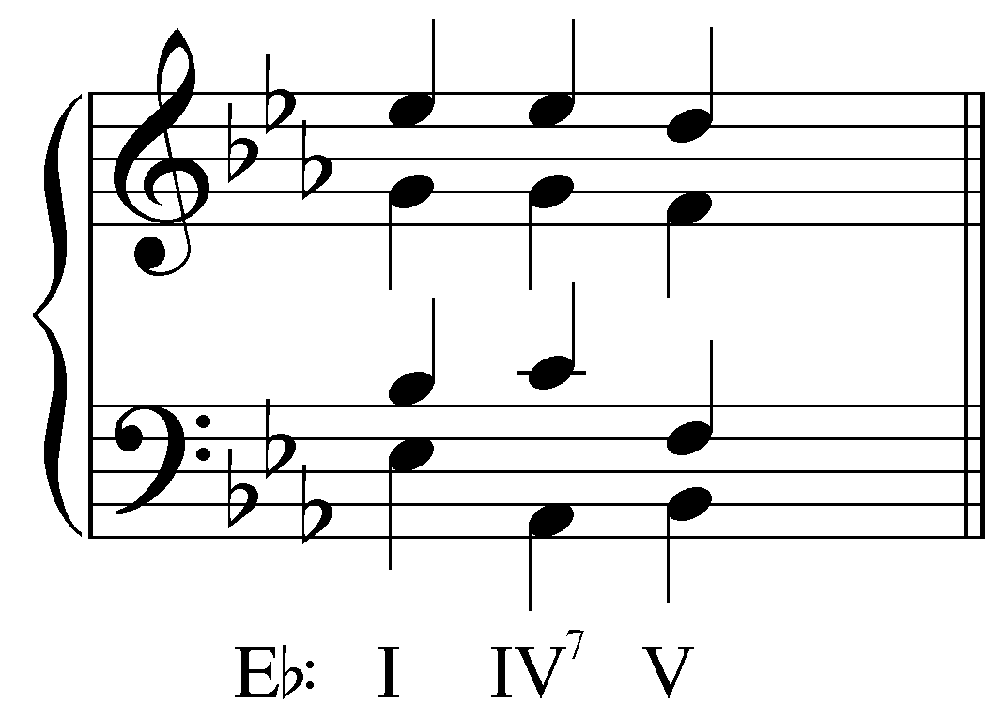]

The leading-tone seventh chord (vii^{ø7} in major; vii^{o7} in minor):

The leading-tone seventh chord (vii^{ø7} in major; vii^{o7} in minor) is a uniquely dissonant sonority. The triad built on the leading tone naturally has a diminished fifth between the root and fifth of the chord. Adding a seventh (scale degree 6) to this sonority increases the dissonance. The chordal seventh forms the interval of a minor seventh with the root in major keys, and the interval of a diminished seventh with the root in minor keys, as illustrated here:

Example 12:
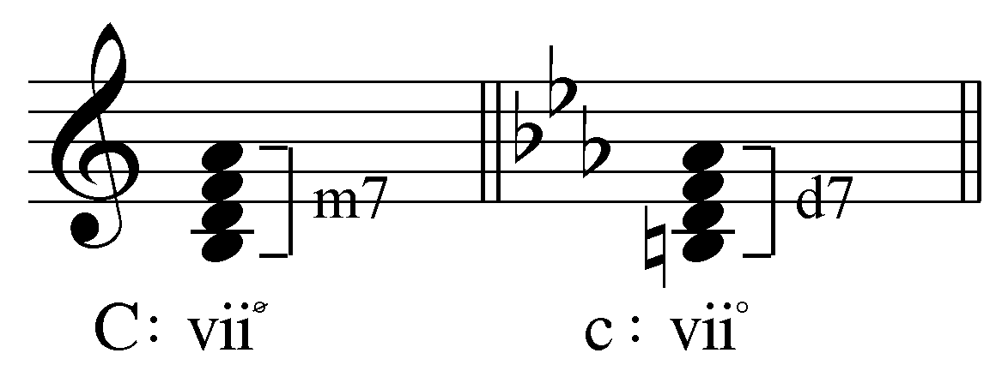

The leading-tone seventh chord differs both in content and function from supertonic and subdominant seventh chords. As its name indicates, the leading-tone seventh chord includes the leading tone as its root and also shares scale degrees 2 and 4 with the dominant seventh chord. For these reasons, the leading-tone seventh chord often serves as a substitute for a dominant harmony.

Resolution of the leading-tone seventh chord follows many of the same voice-leading conventions as the vii° triad. As discussed in Lesson FFF, the vii° triad contains a tritone, a dissonance that must be resolved properly. If the tritone appears as a diminished fifth, both voices will normally resolve inwards by step to form a third. If, on the other hand, the tritone is in the form of an augmented fourth, the voices will expand outwards by step to form a sixth. In either case, scale degrees 7 and 4 fulfill their tendencies to resolve to 1 and 3 respectively.

The fully-diminished vii°⁷ chord contains an additional tritone (between scale degrees 2 and 6). The same rules for resolution apply to this tritone. Typically, this has scale degree 2 stepping up to 3 and scale degree 6 stepping down to 5. The following example shows a typical resolution of a vii°⁷ chord. Note that resolving the two tritones normatively results in a i chord with doubled third.

Example 13:
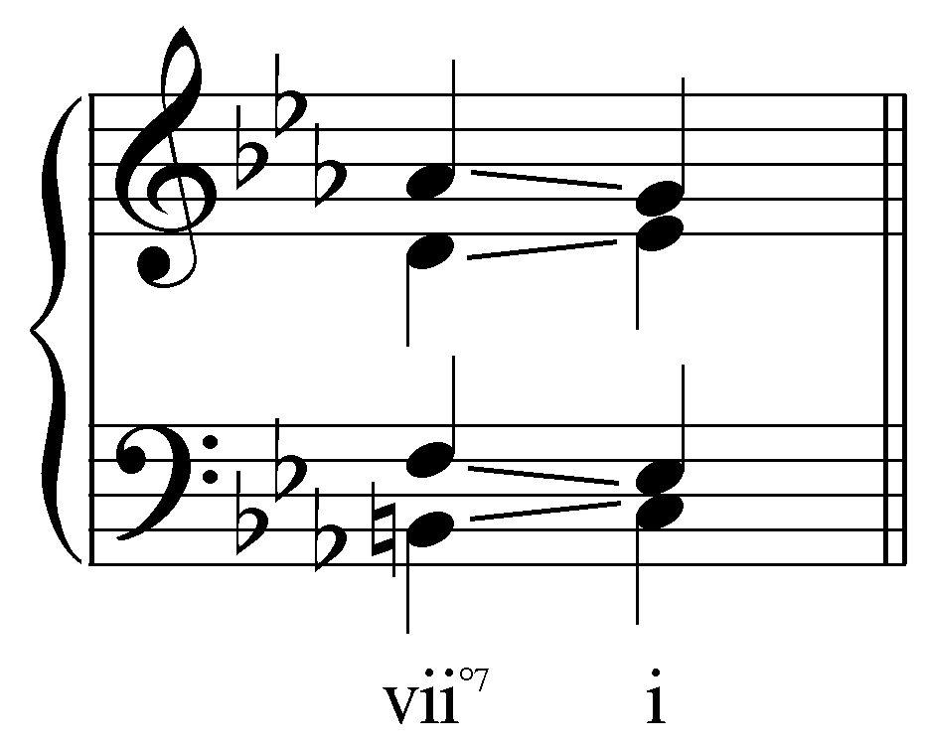

The half-diminished seventh chord (vii^{ø7} in major keys) resolves similarly. The tritone formed by the leading tone and scale degree 4 should resolve according to the interval progressions outlined in Lesson FFF. The vii^{ø7} chord differs from the vii^{o7} chord in that the interval between scale degrees 2 and 6 is a perfect fifth instead of a diminished fifth. Regardless, these two voices may resolve similarly to Example 11. Scale degree 6 tends to resolve to 5, in which case 2 must resolve upwards to 3 to avoid forming parallel fifths. The following example shows a half-diminished seventh chord resolving to I:

Example 14:
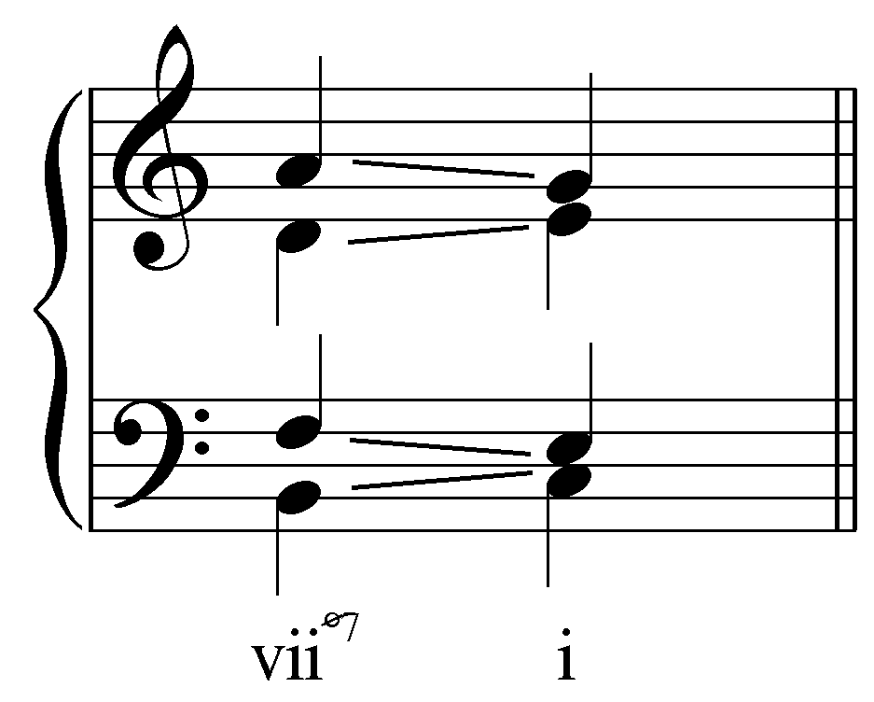

Activity 7.8:
In this activity you will be presented with a series of fully-diminished and half-diminished seventh chords. For each exercise you will be asked to identify the tritones and then resolve the chord to the tonic triad.

Exercise 7.8a:
Identify the tritones in the vii^{o7} chord:
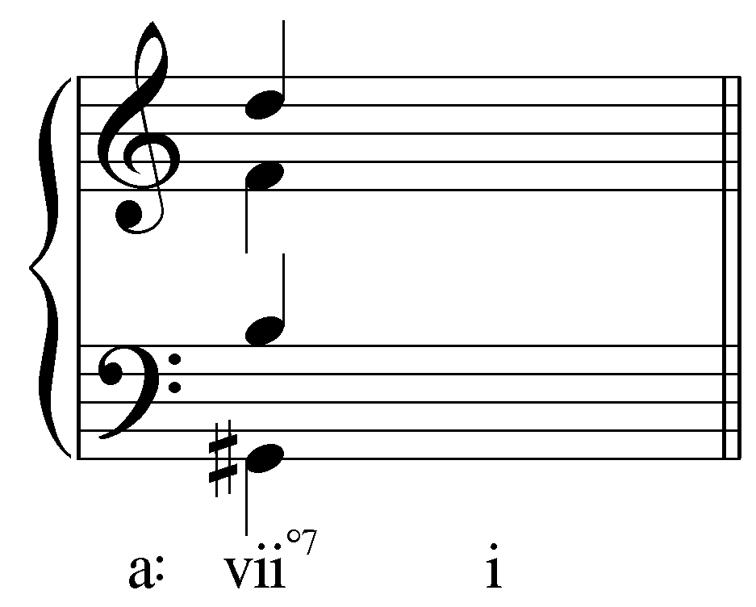
[Answer: G#/D and B/F. Response if correct: “Correct! G# and D form a diminished fifth while B and F also form a diminished fifth.” Response if incorrect: “Incorrect. Remember, in a vii^{o7} chord, scale degrees 7 and 4 form one tritone and 2 and 6 form the other. Try again.”]
[Follow-up activity:] Now resolve the vii^{o7} to i.
[Answer:
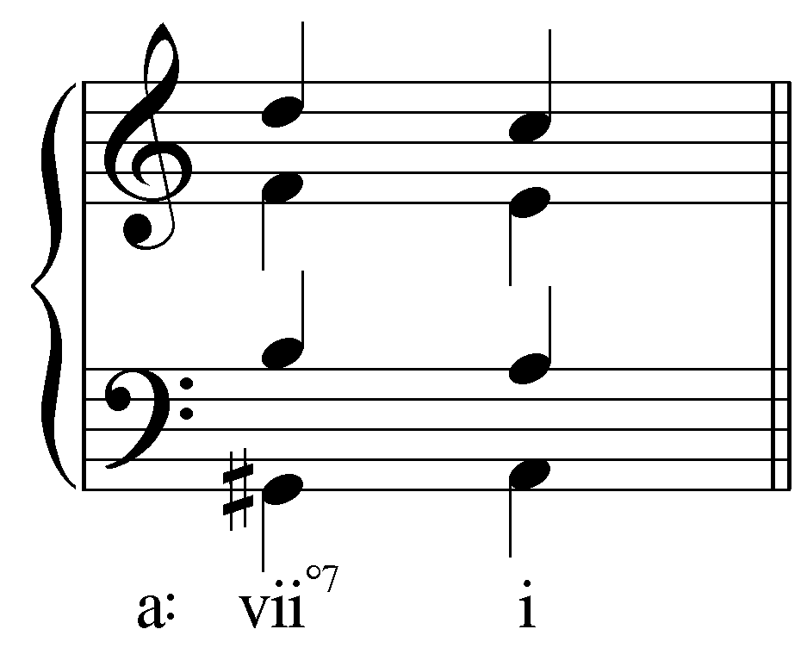]

Exercise 7.8b:
Identify the tritones in the vii^{o7} chord:
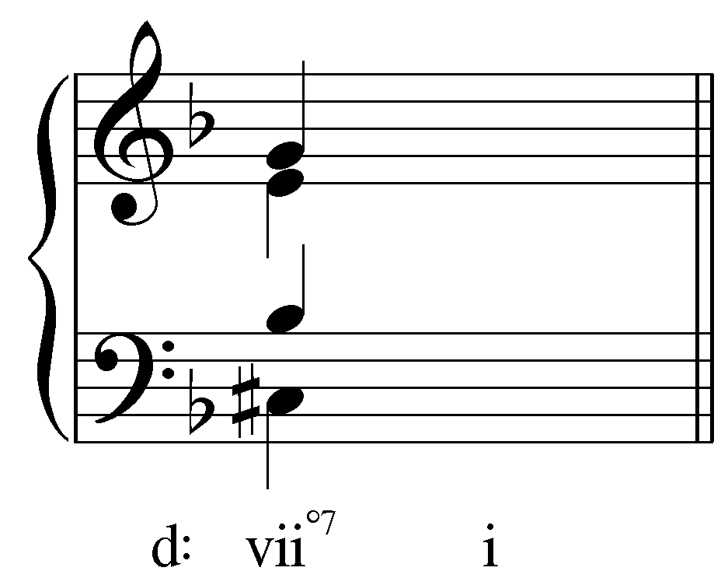
[Answer: C#/G and B^{b}/E. Response if correct: “Correct! C# and G form a diminished fifth while B^{b} and E form augmented fourth.” Response if incorrect: “Incorrect. Remember, in a vii^{o7} chord, scale degrees 7 and 4 form one tritone and 2 and 6 form the other. Try again.”]
[Follow-up activity:] Now resolve the vii^{o7} to i.
[Answer:
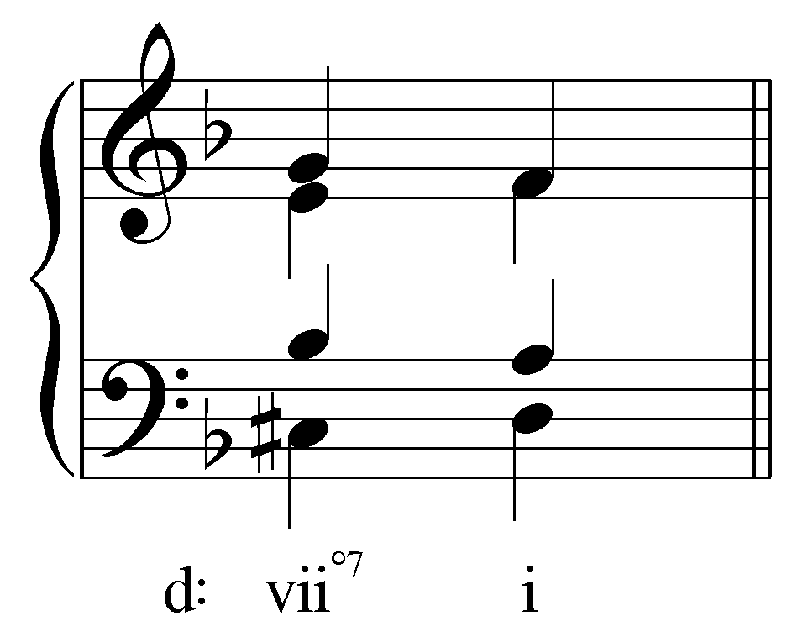]

Exercise 7.8c:
Identify the tritone in the vii^{ø7} chord:
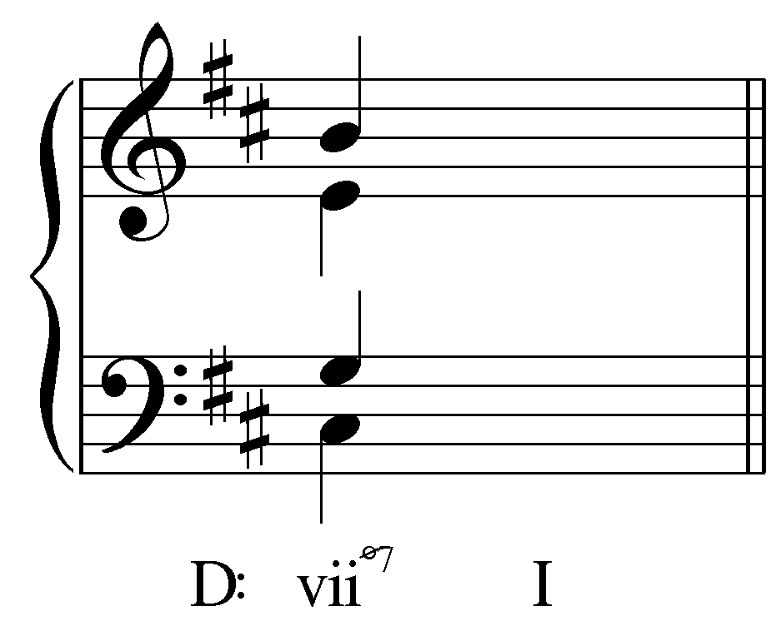
[Answer: C#/G. Response if correct: “Correct! C# and G form a diminished fifth.” Response if incorrect: “Incorrect. Remember, in a vii^{ø7} chord, scale degrees 7 and 4 form a tritone. Try again.”]
[Follow-up activity:] Now resolve the vii^{o7} to i.
[Answer:
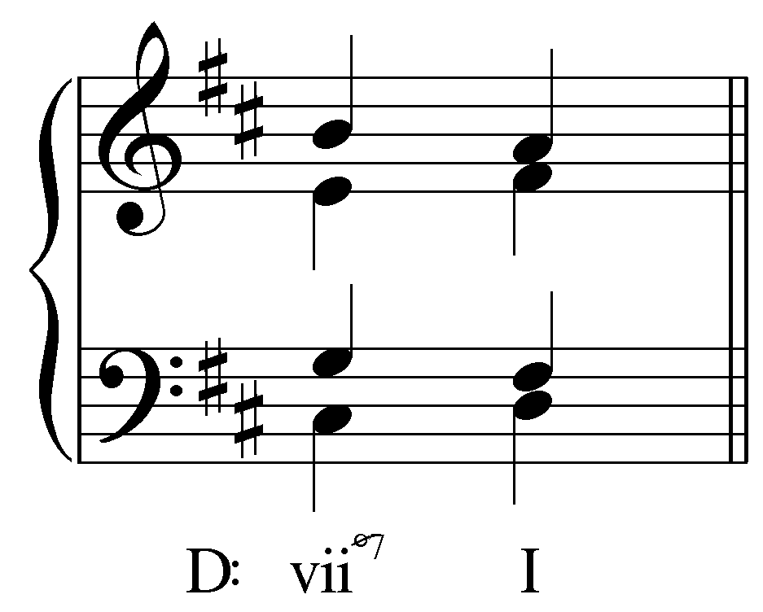]

Exercise 7.8d:
Identify the tritone in the vii^{ø7} chord:
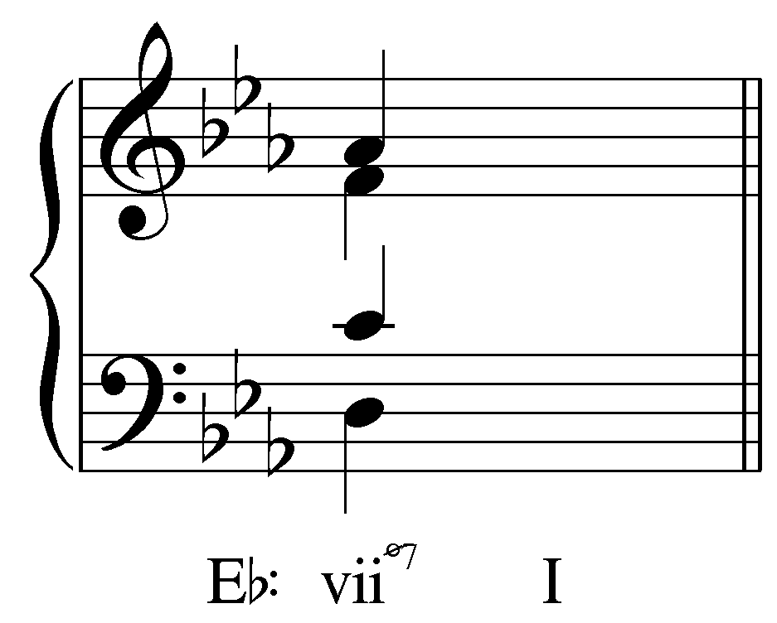
[Answer: D/A. Response if correct: “Correct! D and A form a diminished fifth.” Response if incorrect: “Incorrect. Remember, in a vii^{ø7} chord, scale degrees 7 and 4 form a tritone. Try again.”]
[Follow-up activity:] Now resolve the vii^{o7} to i.
[Answer:
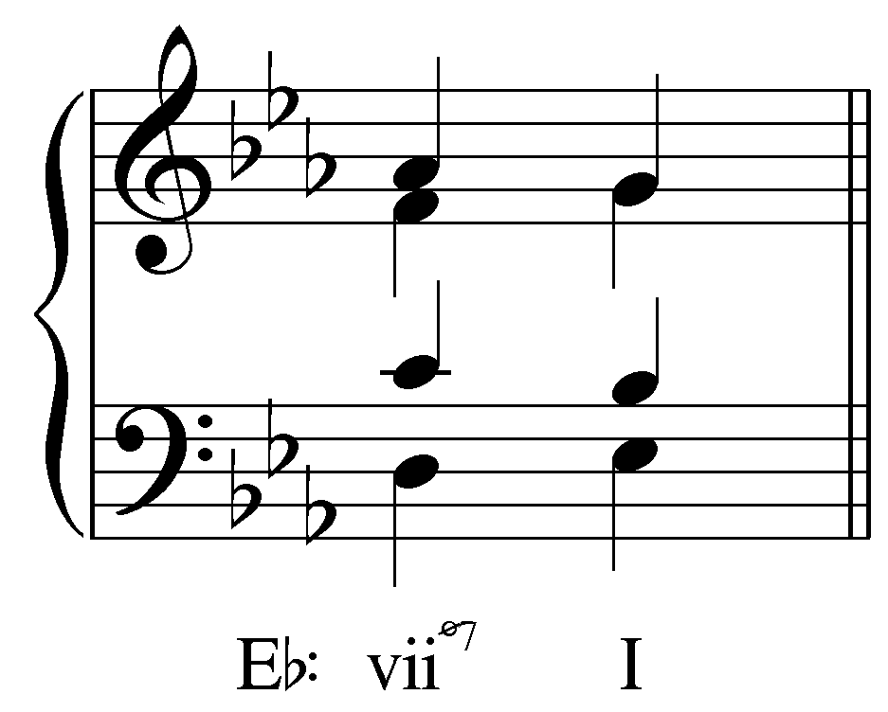]

Conclusion:

Seventh chords lend variety to the tonal landscape, offering richer, fuller textures that their triad counterparts by adding dissonance. They may be built on any scale degree. However, a I⁷ chord would undermine the importance of the tonic harmony and should therefore be analyzed as a triad.

Because of the added dissonance, seventh chords must be treated carefully. To avoid overemphasizing the dissonance, chordal sevenths are ideally prepared by common tone with the preceding chord or through stepwise motion. Seventh chords typically resolve through falling-fifth root motion. In other words, the root of the chord of resolution will be a fifth below (or a fourth above) the root of the seventh chord. Chordal sevenths have their origin as passing tones. Because of this, all chordal sevenths must resolve downwards by step.

Some seventh chords—the supertonic seventh chord, the subdominant seventh chord, the leading-tone seventh chord, and particularly the dominant seventh chord—have specific functions in tonal music. The supertonic and subdominant seventh chords have pre-dominant functions while the leading-tone seventh chord and dominant seventh chord have dominant functions.

