Lesson HHH: Nonharmonic Tones

Exam:

Question 1a: Given the following interval progression, where might a diatonic passing tone be inserted? Insert a valid diatonic passing tone.
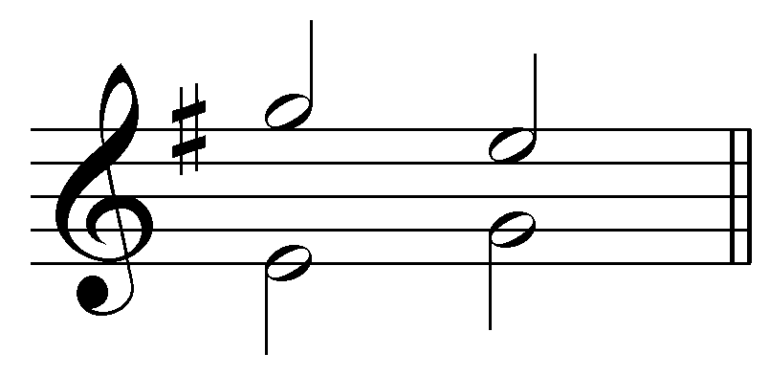
[Answer: F# between G and E in the upper voice or F# between E and G in the lower voice. Feedback if correct: “Correct!” Feedback if incorrect: “Incorrect. A passing F# could appear in either voice.”]

Question 1b: Given the following interval progression, where might a diatonic passing tone be inserted? Insert a valid diatonic passing tone.
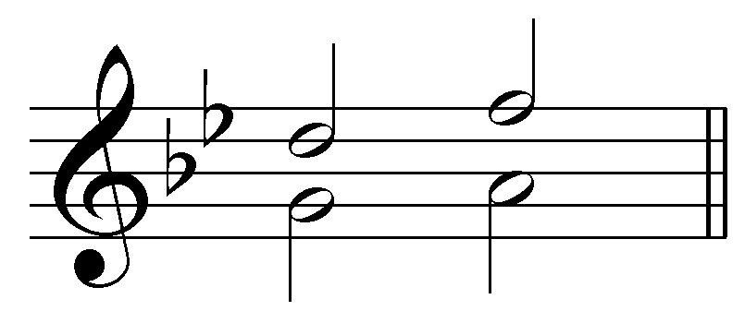
[Answer: E^{b} between D and F in the upper voice. Feedback if correct: “Correct!” Feedback if incorrect: “Incorrect. A passing E^{b} could appear in the upper voice.”]

Question 2: Insert three diatonic passing tones into the following passage: [Students can insert passing tones by entering a note or by selecting the two tangent pitches.]
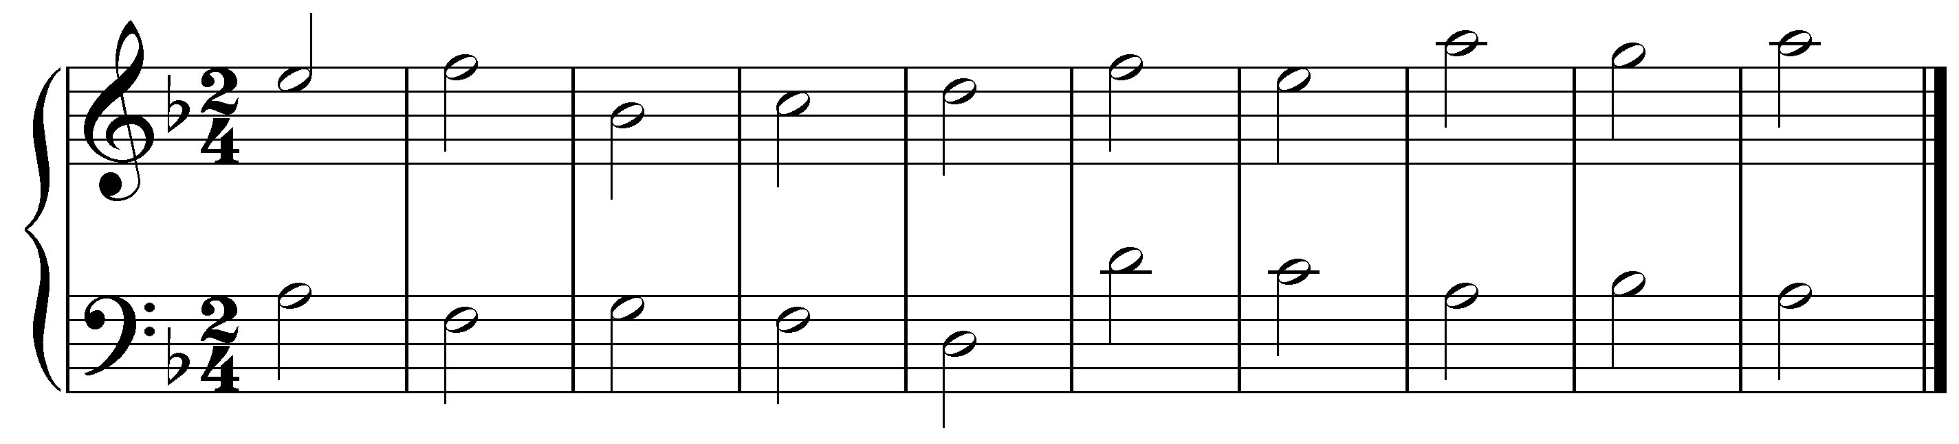
[Possible answers:
- E between D and F in upper voice m. 5
- G between A and F in lower voice m. 1
- E between F and D in lower voice m. 4
- B between C and A in lower voice m. 7
Feedback for each correct: “Correct!” Feedback for each incorrect: “Incorrect. That is not a valid diatonic passing tone.”]

Question 3a: What type of passing tone is the G in this example? [Multiple choice.]
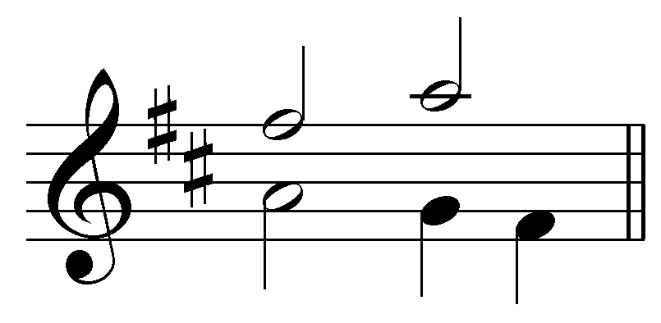
[Options:
- Unaccented diatonic passing tone
- Accented diatonic passing tone
- Unaccented chromatic passing tone
- Accented chromatic passing tone.
Answer: Accented diatonic passing tone. Feedback if correct: “Correct!” Feedback if incorrect: “Incorrect. The G is an accented diatonic passing tone.”]

Question 3b: What type of passing tone is the E natural in this example? [Multiple choice.]
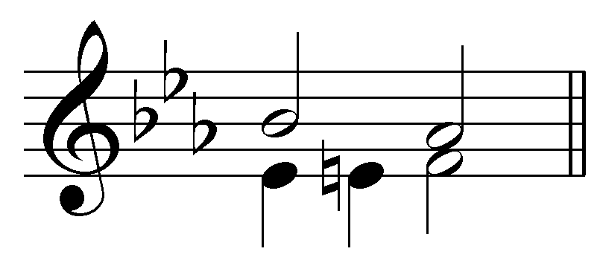
[Options:
- Unaccented diatonic passing tone
- Accented diatonic passing tone
- Unaccented chromatic passing tone
- Accented chromatic passing tone.
Answer: Unaccented chromatic passing tone. Feedback if correct: “Correct!” Feedback if incorrect: “Incorrect. The E is an Unaccented chromatic passing tone.”]

Question 4: Insert three diatonic neighbor tones into the following passage: [Students can insert neighbor tones by entering a note.]
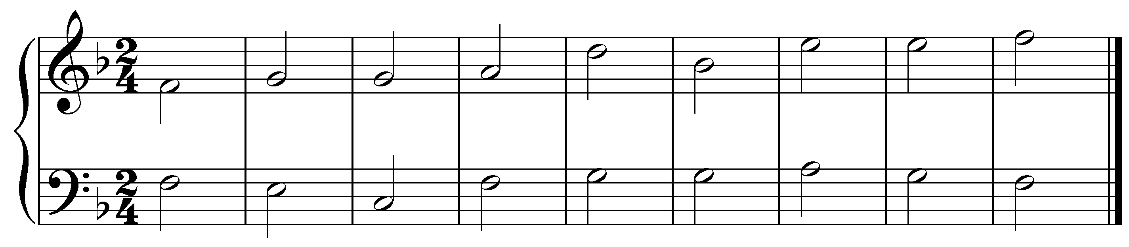
[Possible answers:
- A between the Gs in upper voice m. 2
- F between the Gs in upper voice m. 2
- F between the Es in upper voice m. 7
- D between the Es in upper voice m. 7
- A between the Gs in lower voice m. 5
- F between the Gs in lower voice m. 5
Feedback for each correct: “Correct!” Feedback for each incorrect: “Incorrect. That is not a valid diatonic neighbor tone.”]

Question 5a: What type of neighbor tone(s) appear(s) in this example? [Multiple choice.]
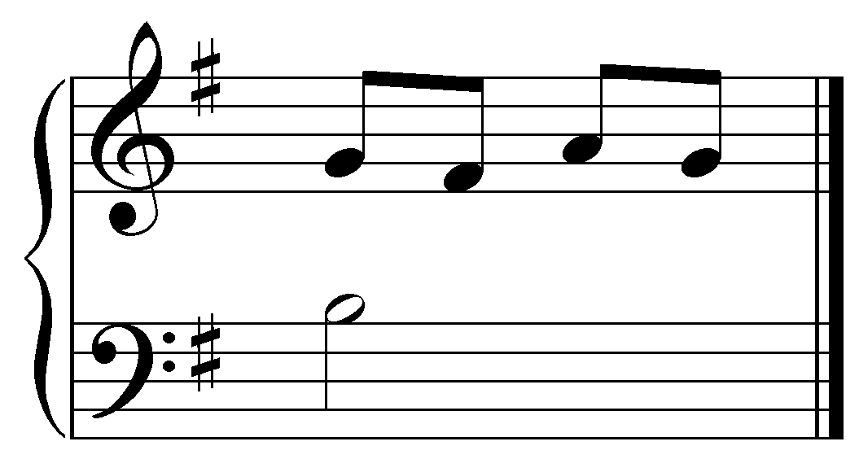
[Options:
- Upper diatonic neighbor tone
- Lower diatonic neighbor tone
- Upper chromatic neighbor tone
- Lower chromatic neighbor tone
- Double neighbor tones
Answer: Double neighbor tones. Feedback if correct: “Correct!” Feedback if incorrect: “Incorrect. The F# and A form a double neighbor tone around the G.”]

Question 5b: What type of neighbor tone(s) appear(s) in this example? [Multiple choice.]
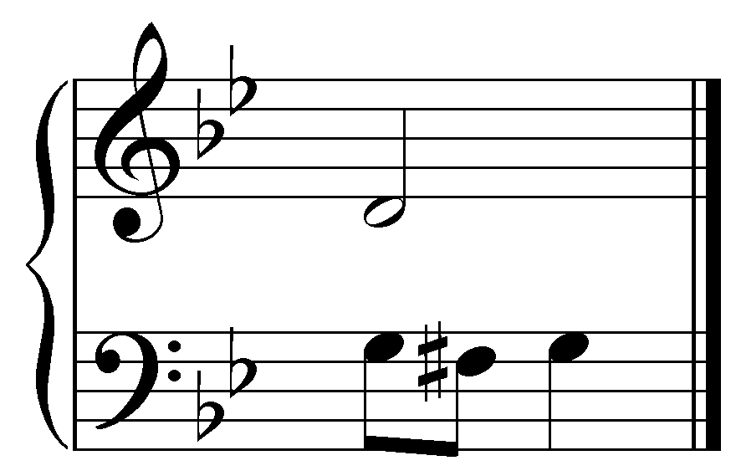
[Options:
- Upper diatonic neighbor tone
- Lower diatonic neighbor tone
- Upper chromatic neighbor tone
- Lower chromatic neighbor tone
- Double neighbor tones
Answer: Lower chromatic neighbor tone. Feedback if correct: “Correct!” Feedback if incorrect: “Incorrect. The F# is a lower chromatic neighbor tone to the G.”]

Question 6a: Identify an unaccented passing tone in this excerpt (J.S. Bach, “Als der gütige Gott vollenden wollt sein Wort,” BWV 264, mm. 1-2):
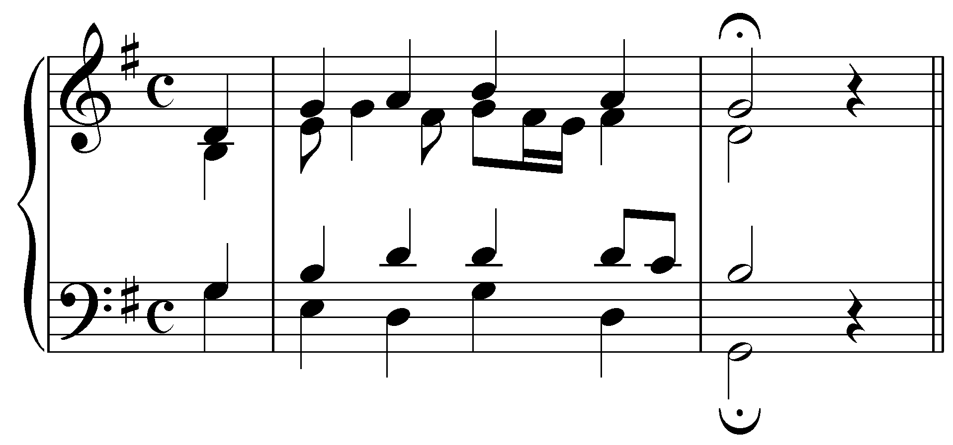
[Answer: The C in the tenor at the end of m. 1. Feedback if correct: “Correct!” Feedback if incorrect: “Incorrect. That is not an unaccented passing tone.”]

Question 6b: Identify the preparation of a “4 - 3” suspension in this excerpt (J.S. Bach, “Als der gütige Gott vollenden wollt sein Wort,” BWV 264, mm. 1-2):
[Answer: The G in the alto on the “&” of beat 1, m. 1. Feedback if correct: “Correct!” Feedback if incorrect: “Incorrect. That is not the preparation of a “4 - 3” suspension.”]

Question 7a: What type of suspension appears in the following example?
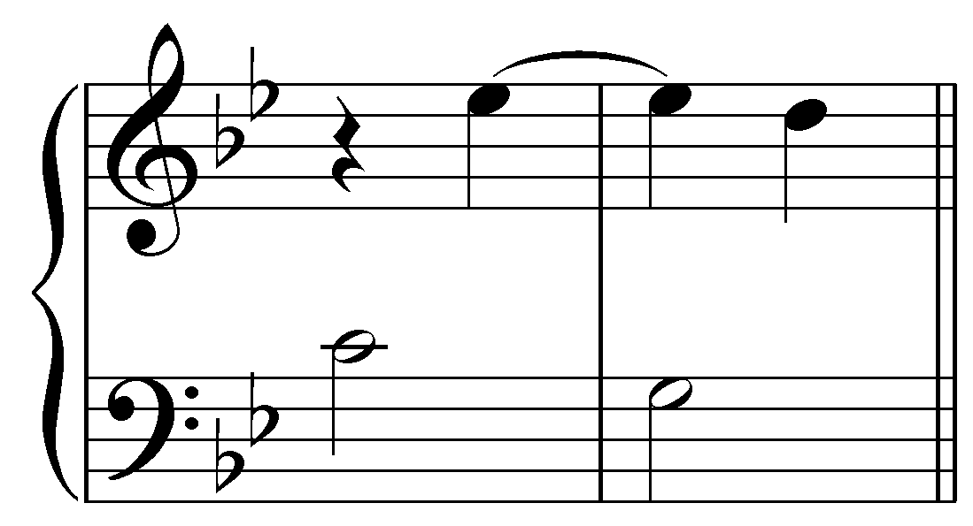
[Answer: 6-5. Feedback if correct: “Correct!” Feedback if incorrect: “Incorrect. The upper voice forms a “6 - 5” suspension with the bass.”]
Question 7b: What type of suspension appears in the following example?
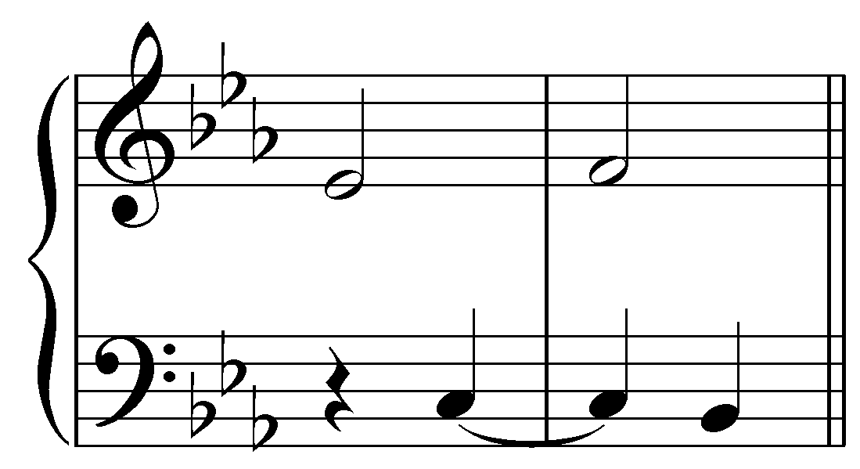
[Answer: 4-5. Feedback if correct: “Correct!” Feedback if incorrect: “Incorrect. The bass forms a “4 - 5” suspension with the upper voice.”]
Question 8a: According to this model:
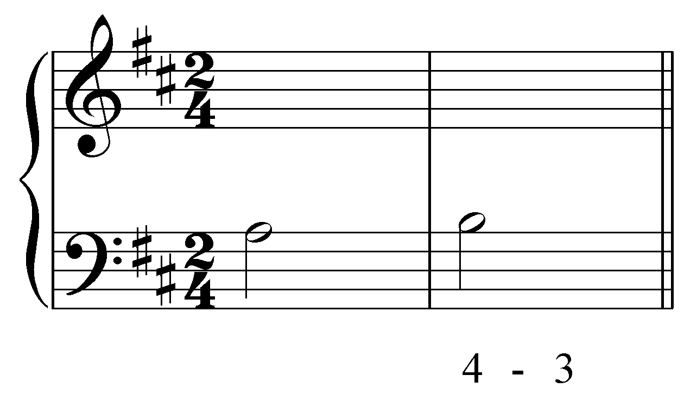 becomes… 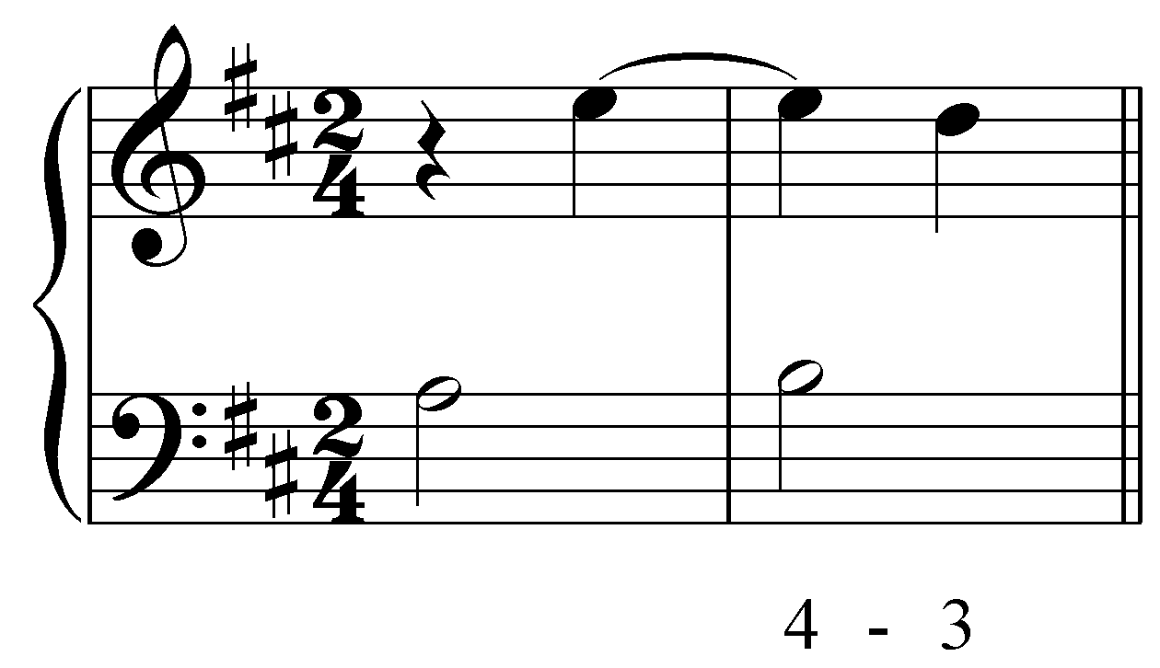
Complete the upper voice of the following suspension:
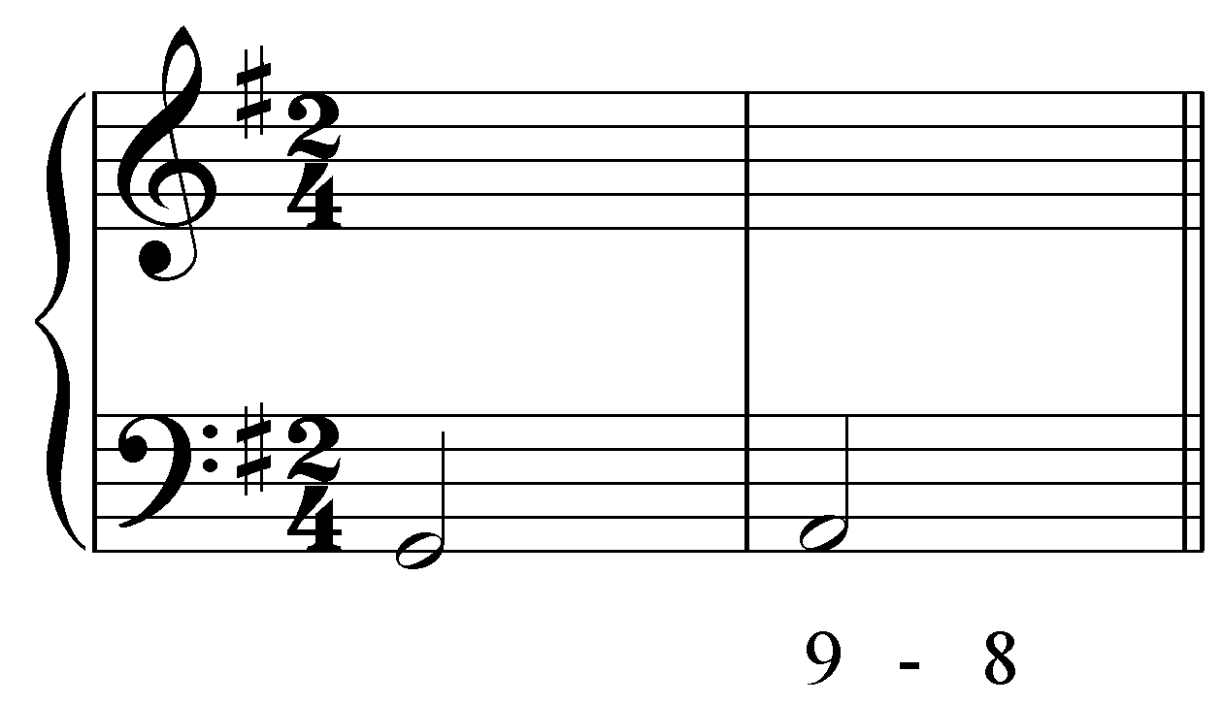
[Answer: 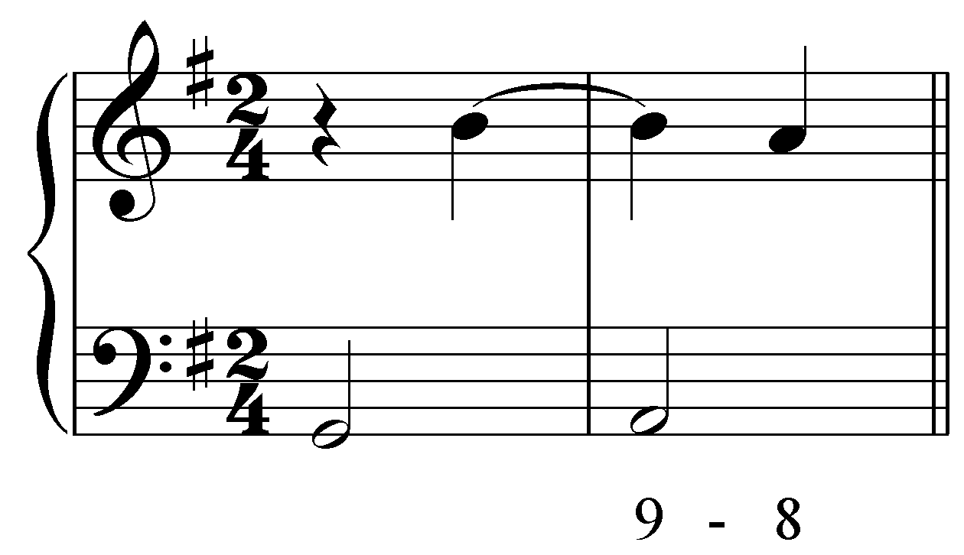 (answers may vary in register). Feedback if correct: “Correct!” Feedback if incorrect: “Incorrect. A “9 - 8” in the upper voice would have B resolving to A.”]

Question 8b: According to this model:
becomes…
Complete the upper voice of the following suspension:
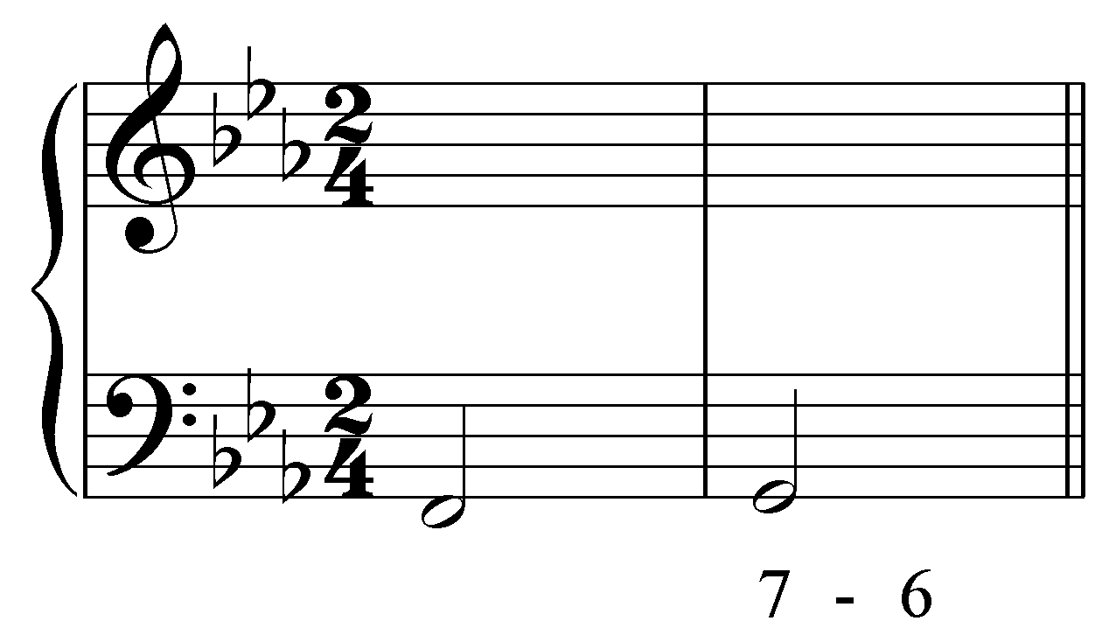
[Answer: 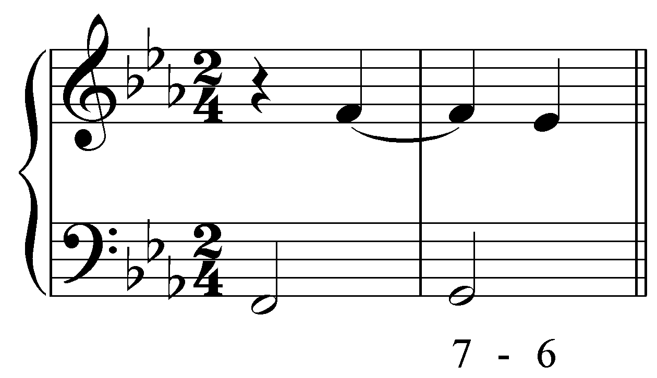 (answers may vary in register). Feedback if correct: “Correct!” Feedback if incorrect: “Incorrect. A “7 - 6” in the upper voice would have F resolving to E^{b}.”]

