Lesson HHH – Nonharmonic Tones

Introduction:

When analyzing tonal music, you will frequently find pitches that do match those of the harmonies and are therefore dissonant against them. Pitches that do not belong to the prevailing harmony are called nonharmonic tones. In tonal music, nonharmonic tones are used to embellish chords, to allow for distinctive profiles for melodic lines, and in general to animate the musical texture.

Knowing about nonharmonic tones and being able to identify and name them are indispensable for understanding tonal harmony. Without a firm grasp of the types and nature of nonharmonic tones, harmonic analysis becomes confusing and potentially nonsensical. A clear understanding of nonharmonic tones is crucial for distinguishing between structural harmonies and what we will call auxiliary sonorities, those chords that consist partially or wholly of nonharmonic tones (see Lesson III: Auxiliary Sonorities).

In this lesson we will discuss four types of nonharmonic tones. In the first section we will focus on nonharmonic tones that arise from melodic motion: passing tones and neighbor tones. We will then discuss nonharmonic tones that arise from rhythmic action: suspensions and anticipations.

Melodically derived nonharmonic tones:

Passing tones:

Passing tones are nonharmonic tones that fill in the spaces between chord tones. By definition, passing tones are always approached and left by step in the same direction. Consider the following basic interval progression (see Lesson AAA):

Example 1:
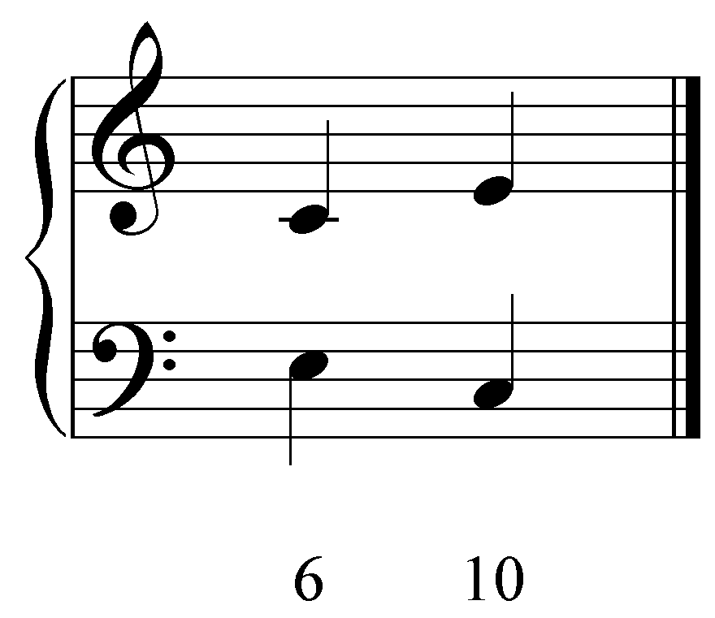

In Example 1, the upper voice may be embellished by adding a passing tone (labeled “P”):

Example 2:
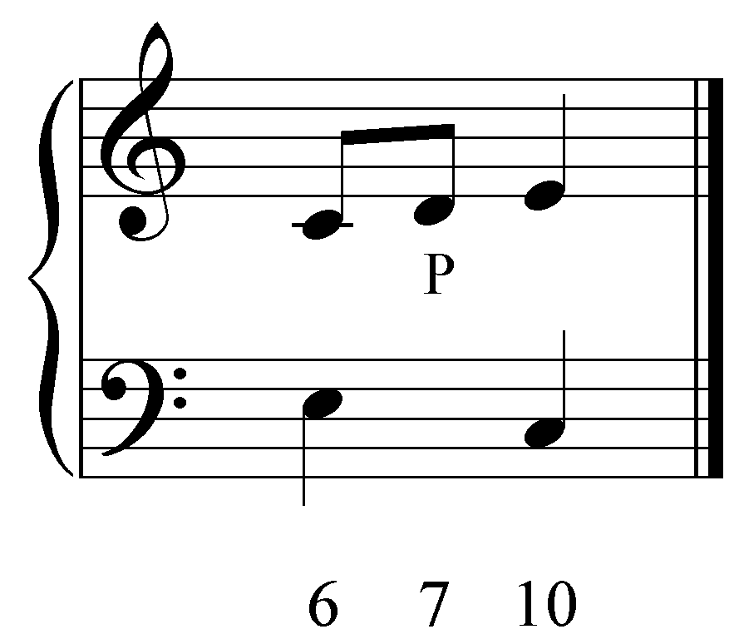

The lower voice could also be embellished with a passing tone:

Example 3:
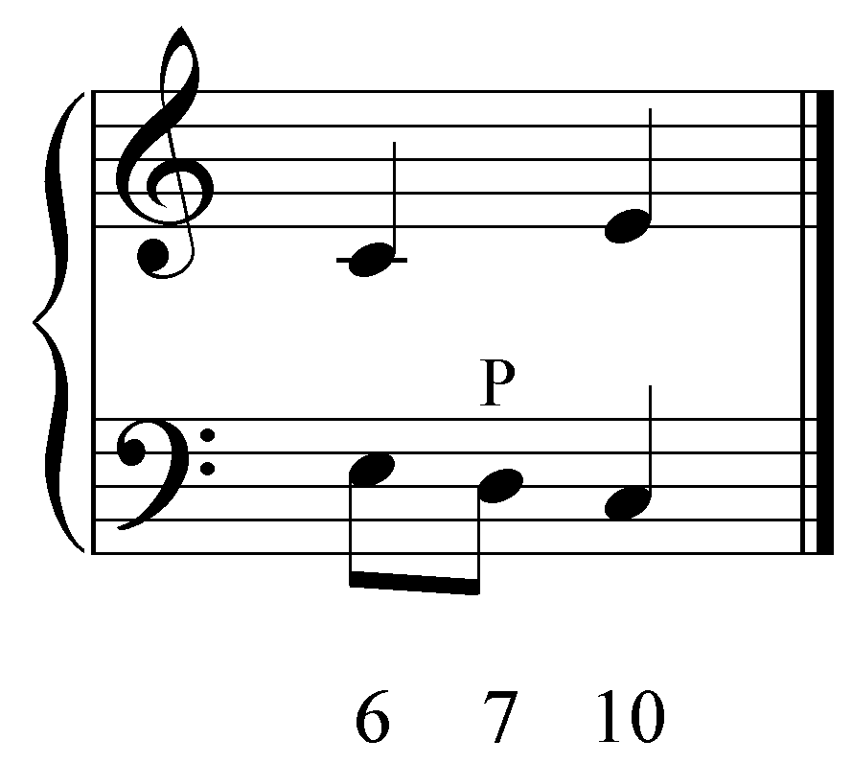

Passing tones typically create dissonance, as in Examples 2 and 3. However, a passing tone forming part of a “5 - 6” or “6 - 5” progression is of course consonant, as in Example 4:

Example 4:
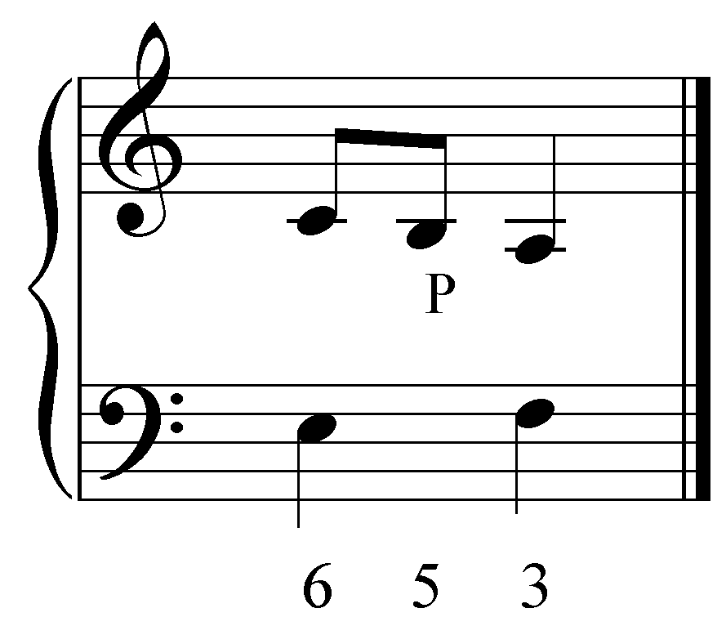

Activity 8.1:
In this activity, you will be presented with a series of basic interval progressions. For each progression, identify a potential location for a passing tone.

Exercise 8.1a:
Given the following interval progression, where might a diatonic passing tone be inserted? Insert a valid diatonic passing tone.
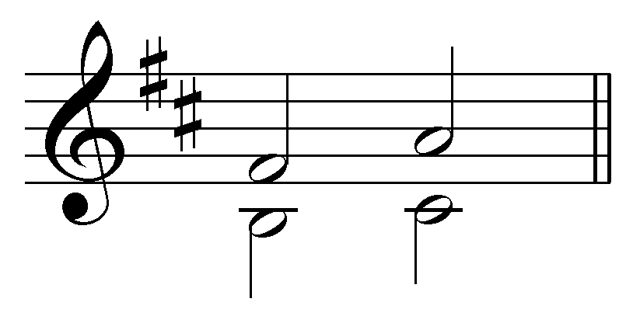
[Answer: G between F# and A in the upper voice. Incorrect answer response: “Incorrect. Try again.”]

Exercise 8.1b:
Given the following interval progression, where might a diatonic passing tone be inserted? Insert a valid diatonic passing tone.
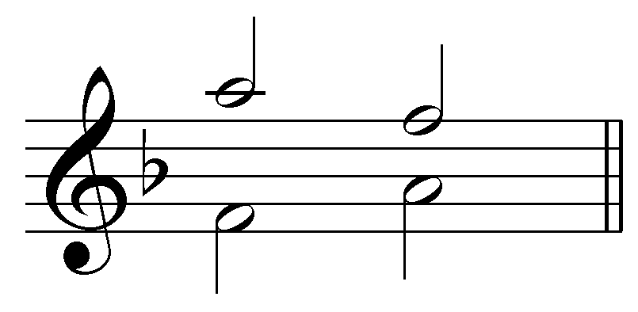
[Answer: G between A and F in the upper voice or G between F and A in the lower voice. Incorrect answer response: “Incorrect. Try again.”]

Exercise 8.1c:
Given the following interval progression, where might a diatonic passing tone be inserted? Insert a valid diatonic passing tone.
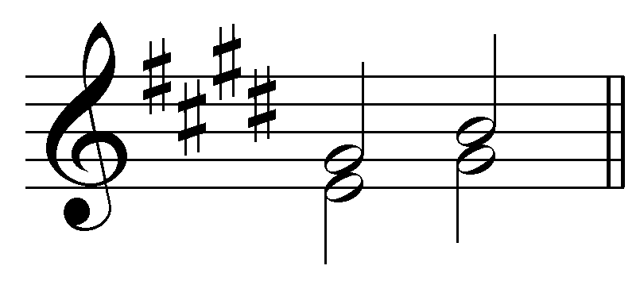
[Answers: A between G# and B in the upper voice or F# between E and G# in the lower voice. Incorrect answer response: “Incorrect. Try again.”]

Exercise 8.1d:
Given the following interval progression, where might a diatonic passing tone be inserted? Insert a valid diatonic passing tone.
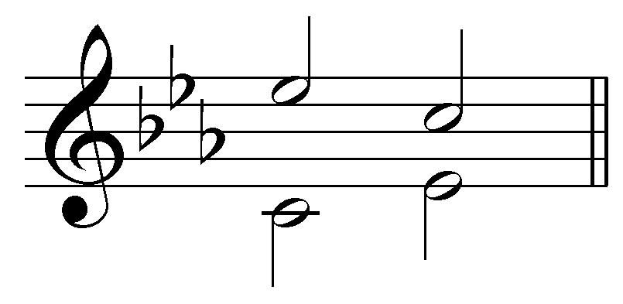
[Answer: D between E^{b} and C in the upper voice or D between C and E^{b} in the lower voice. Incorrect answer response: “Incorrect. Try again.”]

Exercise 8.2:
Insert three diatonic passing tones into the following passage: [Students can insert passing tones by entering a note or by selecting the two tangent pitches.]
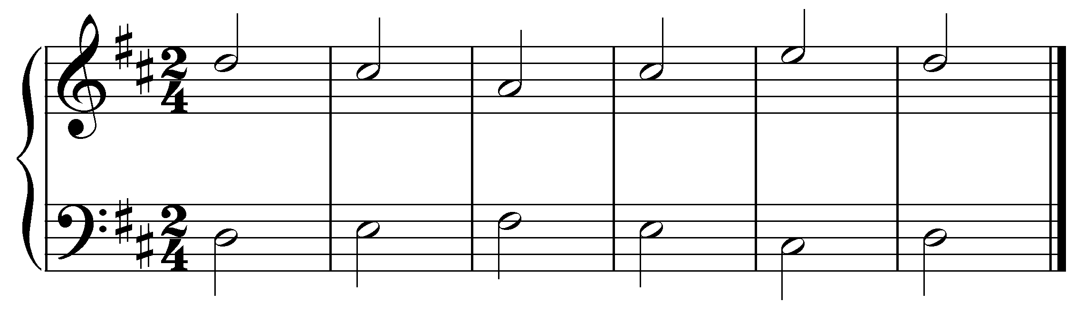
[Possible answers:
- B between C# and A in upper voice, m. 2
- B between A and C# in upper voice, m. 3
- D between C# and E in upper voice, m. 4
- D between E and C# in lower voice, m. 4
Incorrect answer response: “Incorrect. A passing tone cannot be inserted there. Try again”]

Typically, as in Examples 2 through 4, passing tones fill in the interval of a third, but two passing tones may be used consecutively to fill in a fourth between chord tones, as illustrated here.

Example 5:
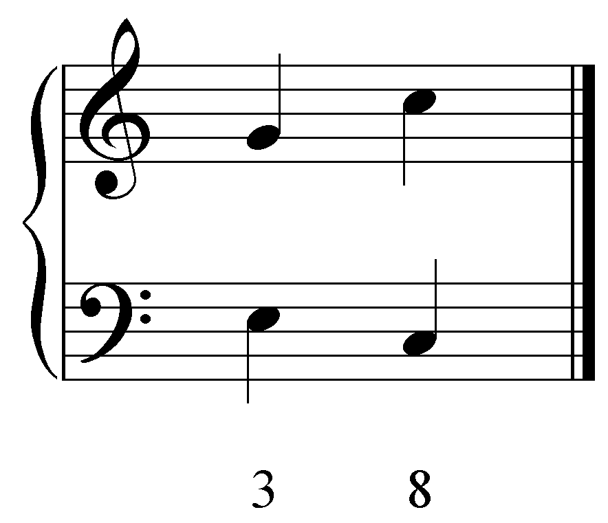

Example 6:
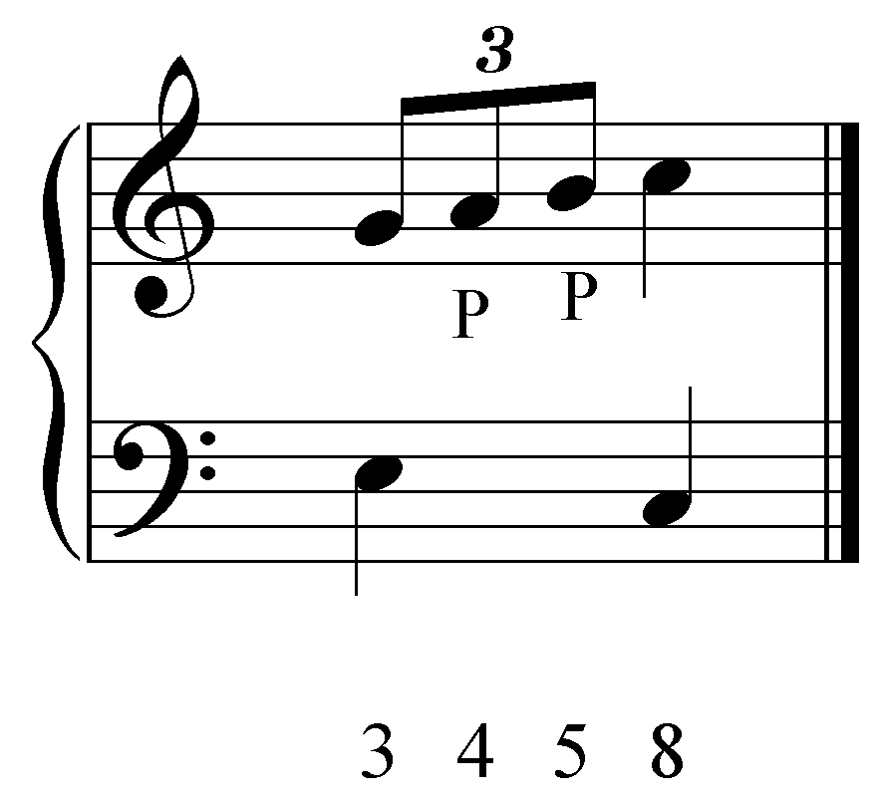

Example 5 presents an expansion of a C-major chord over two beats: the lower voice skips down from the third of the chord to the root while the upper voice skips from the fifth up to the root. The skip of a fourth in the upper voice can be filled in with two passing tones, A and B. (Although the B is consonant with the bass, it is still considered a nonharmonic passing tone since it does not belong to the prevailing C-major harmony.)

Passing tones routinely occur between beats or on metrically unaccented beats, but may also be rhythmically or metrically accented, as shown here.

Example 7:
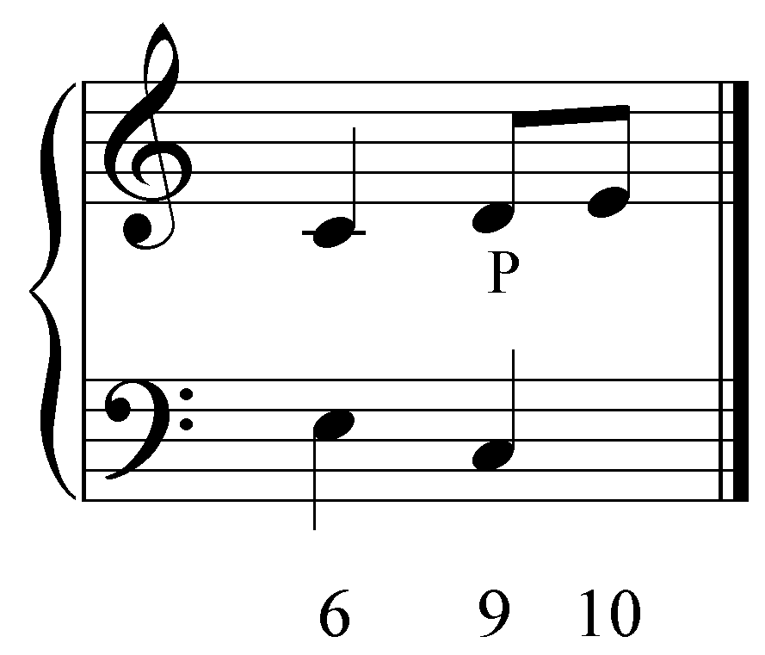

When a passing tone occurs on the beat it is called an accented passing tone. In Example 7—as in Example 2—the E in the upper voice is the chord tone and the D is the nonharmonic passing tone. The occurrence of D on the beat with C in the bass emphasizes the dissonance, giving it a sharper effect (listen again and compare Examples 2 and 7). An accented passing tone may be understood as a rhythmic displacement. The pitches are the same in Examples 2 and 7; the only difference is their rhythmic placement. In Example 7 the passing tone D has been rhythmically displaced from between beats 1 and 2 to fall directly on beat 2, for its greater effect there.

Because passing tones are nonharmonic, they are not required to be diatonic. Example 8 shows a chromatic passing tone (G#) embellishing the upper voice of a “3 - 6” progression:

Example 8:
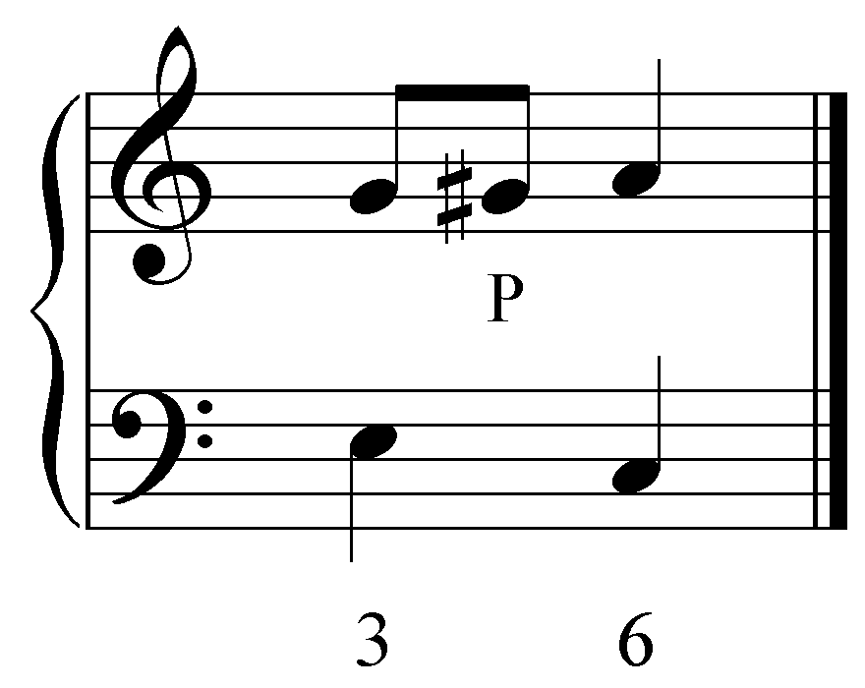

Activity 8.3:
In this activity, you will be asked to identify different kinds of passing tones and describe what type each one is.

Exercise 8.3a:
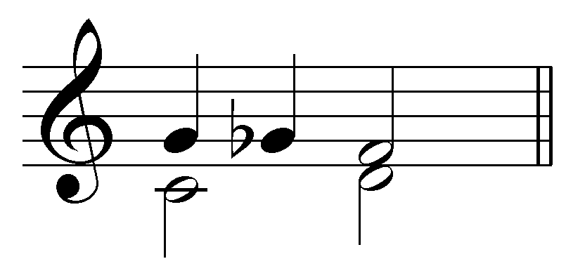
Which note is the passing tone?
[Answer: G^{b}. Incorrect answer response: “Incorrect. Try again.”]
Follow-up multiple choice question: What type of passing tone is it?
- Unaccented diatonic passing tone
- Accented diatonic passing tone
- Unaccented chromatic passing tone
- Accented chromatic passing tone
[Answer: Unaccented chromatic passing tone. Incorrect answer response: “Incorrect. Try again.”]

Exercise 8.3b:
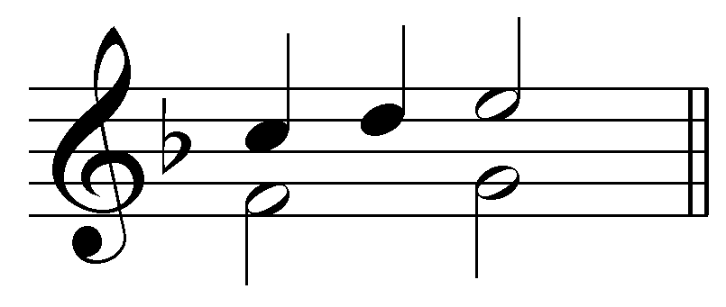
Which note is the passing tone?
[Answer: D. Incorrect answer response: “Incorrect. Try again.”]
Follow-up multiple choice question: What type of passing tone is it?
- Unaccented diatonic passing tone
- Accented diatonic passing tone
- Unaccented chromatic passing tone
- Accented chromatic passing tone
[Answer: Unaccented diatonic passing tone. Incorrect answer response: “Incorrect. Try again.”]

Exercise 8.3c:
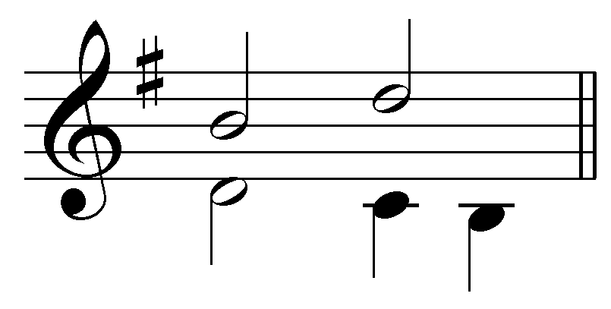
Which note is the passing tone?
[Answer: C. Incorrect answer response: “Incorrect. Try again.”]
Follow-up multiple choice question: What type of passing tone is it?
- Unaccented diatonic passing tone
- Accented diatonic passing tone
- Unaccented chromatic passing tone
- Accented chromatic passing tone
[Answer: Accented diatonic passing tone. Incorrect answer response: “Incorrect. Try again.”]

Exercise 8.3d:
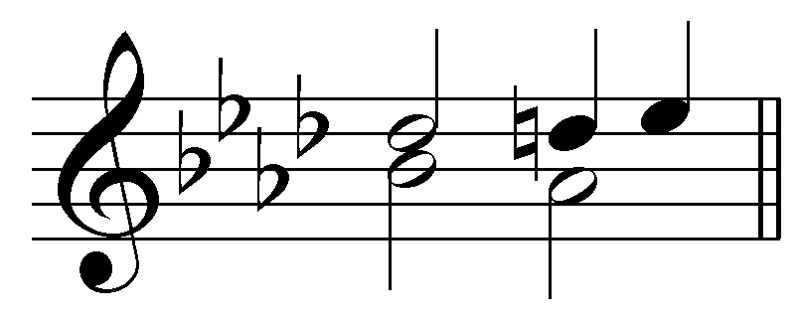
Which note is the passing tone?
[Answer: D natural. Incorrect answer response: “Incorrect. Try again.”]
Follow-up multiple choice question: What type of passing tone is it?
- Unaccented diatonic passing tone
- Accented diatonic passing tone
- Unaccented chromatic passing tone
- Accented chromatic passing tone
[Answer: Accented chromatic passing tone. Incorrect answer response: “Incorrect. Try again.”]

Neighbor tones:

While a passing tone connects two chord tones, a neighbor tone embellishes a single chord tone. In its most common form, a neighbor tone is approached by step and left by step in the opposite direction (returning to the original pitch). There are, therefore, two types of neighbor tones: upper and lower. Example 9 shows a melodic embellishment with an upper neighbor tone:

Example 9:
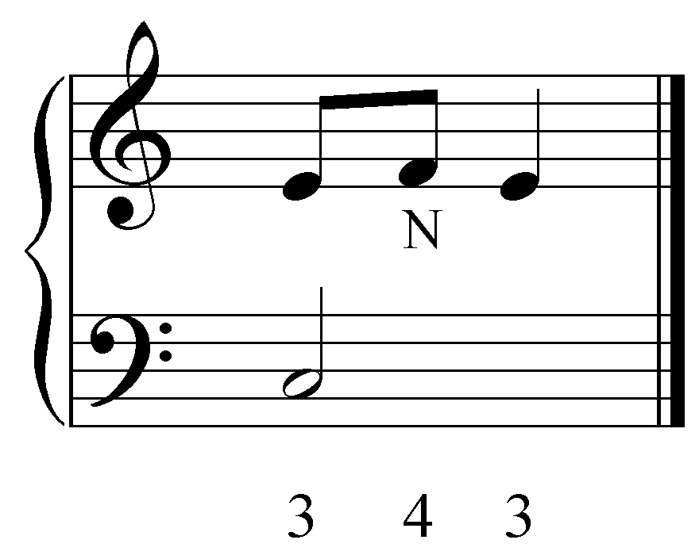

Here the E is embellished by stepping up to the dissonant F. The melody then returns to E, completing the neighbor tone figuration. Example 10 shows the same situation, though this time with a lower neighbor tone:

Example 10:
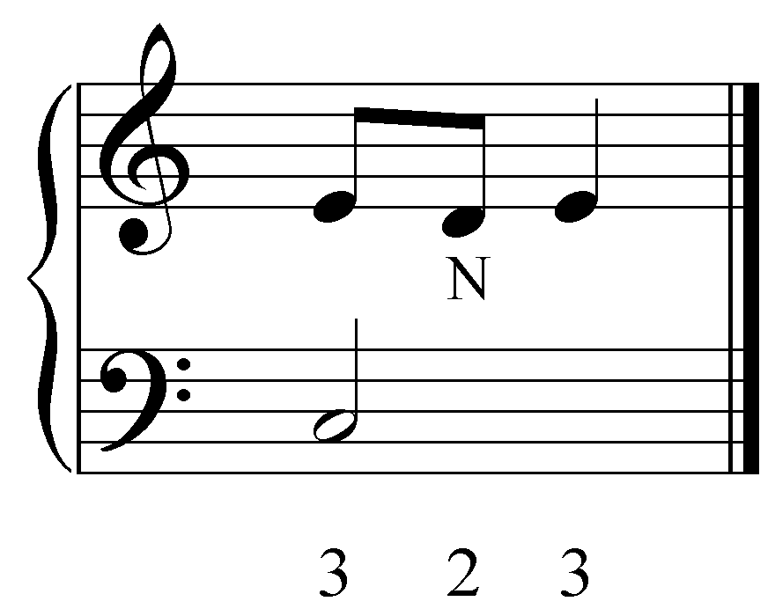

Neighbor tones, like passing tones, can be accented or unaccented; diatonic or chromatic. The following examples each show an accented neighbor tone:

Example 11:
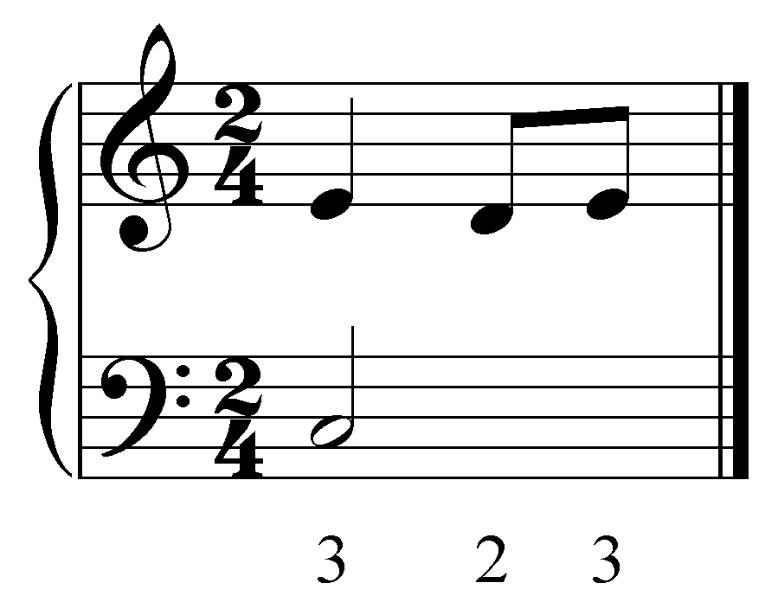

Example 12:
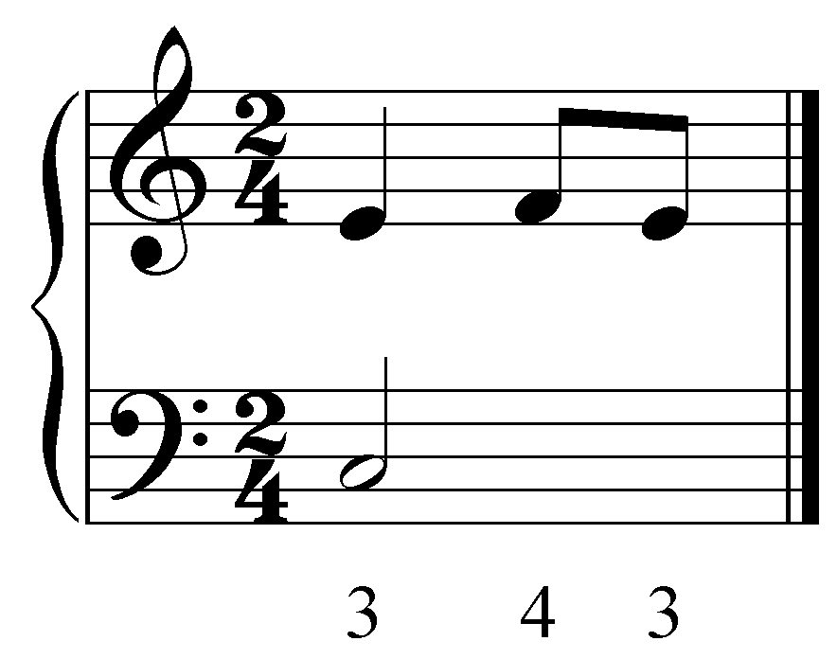

In Examples 11 and 12, the C in the bass is held for two beats. An accented neighbor note (lower in Example 11 and upper in Example 12) appears on the second beat before resolving on the second eighth note of the same beat.

Chromatic neighbor tones can occur as lower neighbors, as in Example 13:

Example 13:
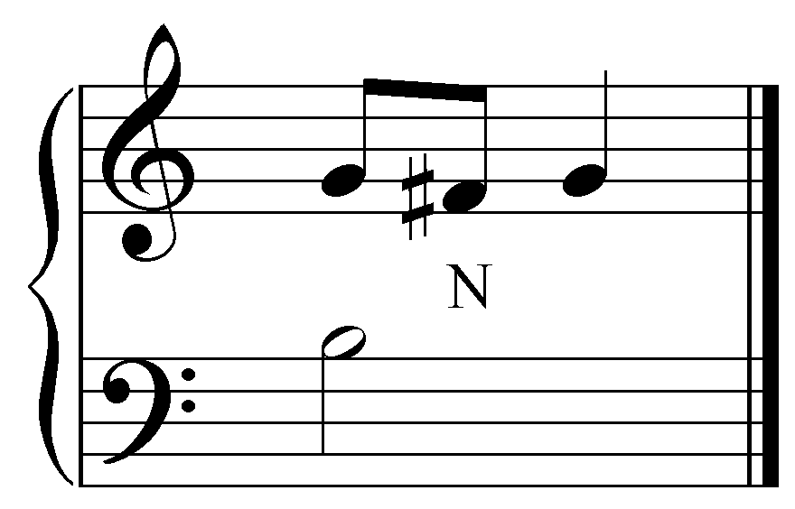

or as upper neighbors, as shown in Example 14:

Example 14
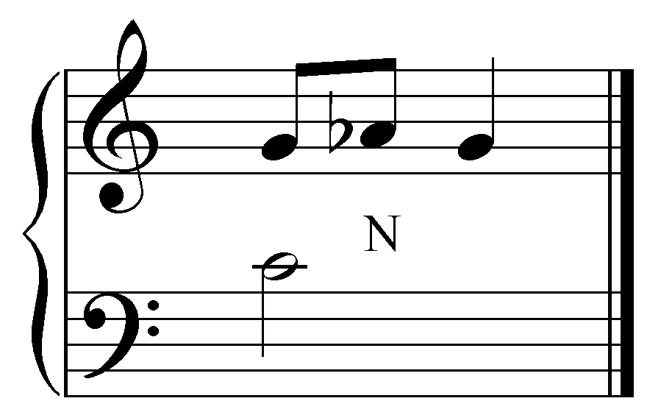

Activity 8.4:
Insert three diatonic neighbor tones into the following passage: [Students can insert neighbor tones by entering a note.]
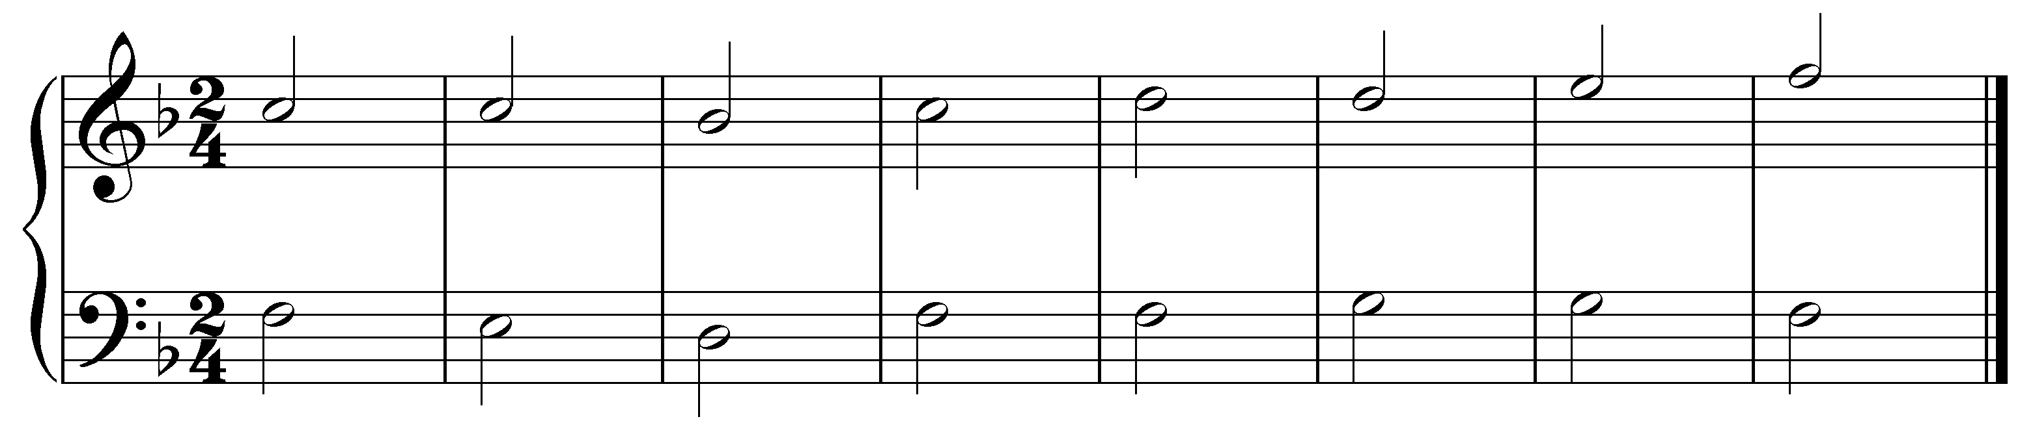
[Possible answers:
- D between the Cs in upper voice, m. 1
- B^{b} between the Cs in upper voice, m. 1
- E between the Ds in upper voice, m. 5
- C between the Ds in upper voice, m. 5
- G between the Fs in lower voice, m. 4
- E between the Fs in lower voice, m. 4
- A between the Gs in lower voice, m. 6
- F between the Gs in lower voice, m. 6
Incorrect answer response: “Incorrect. A passing tone cannot be inserted there. Try again”]

A chord tone may be decorated with two neighbor tones:

Example 15:
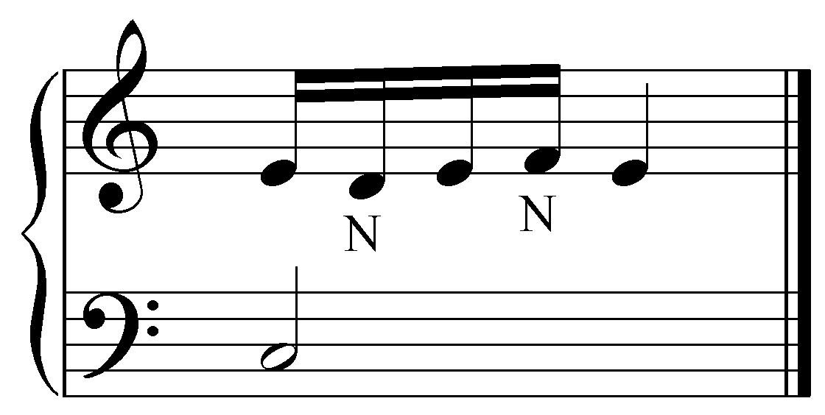

In Example 15, the E in the upper voice is first decorated with a lower neighbor (D) and then with an upper neighbor (F). A chord tone may also be embellished with two neighbor tones without returning to the main pitch in between. This figuration, known as a double neighbor, can be seen in Example 16:

Example 16:
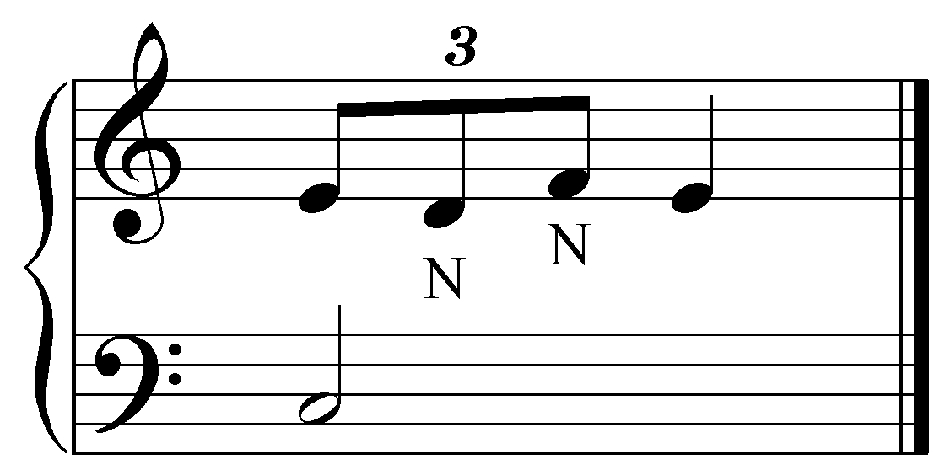

Activity 8.5:
In this activity, you will be asked to identify different kinds of passing tones and describe what type each one is.

Exercise 8.5a:
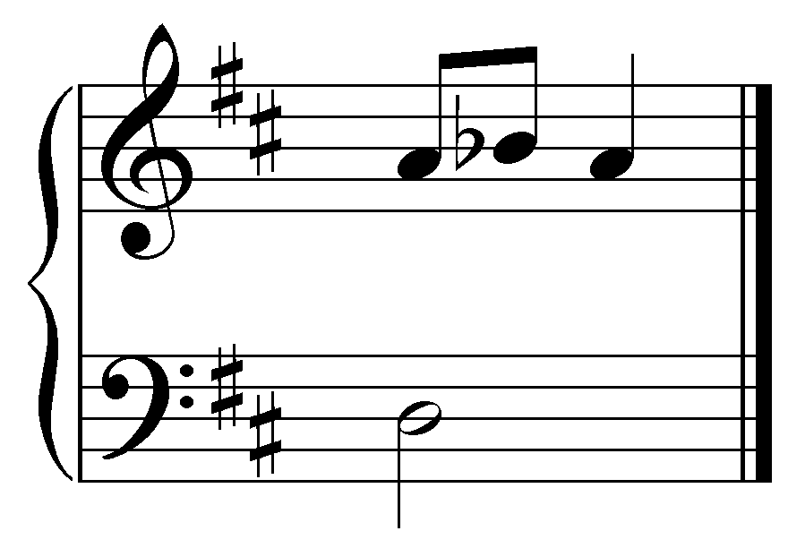
Which note is the neighbor tone?
[Answer: B^{b}. Incorrect answer response: “Incorrect. Try again.”]
Follow-up multiple choice question: What type of passing tone is it?
- Upper diatonic neighbor tone
- Lower diatonic neighbor tone
- Upper chromatic neighbor tone
- Lower chromatic neighbor tone
- Double neighbor tones
[Answer: Upper chromatic neighbor tone. Incorrect answer response: “Incorrect. Try again.”]
Exercise 8.5b:
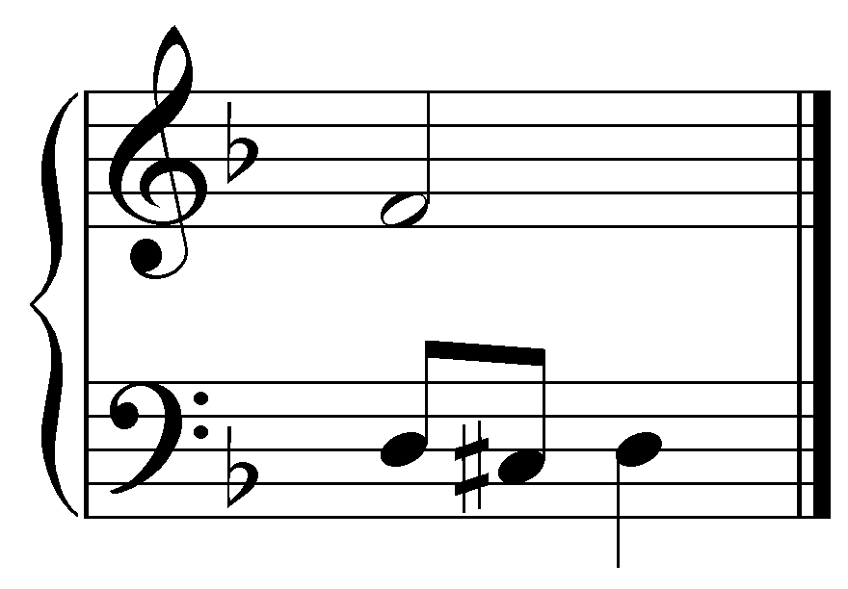
Which note is the neighbor tone?
[Answer: C# natural. Incorrect answer response: “Incorrect. Try again.”]
Follow-up multiple choice question: What type of passing tone is it?
- Upper diatonic neighbor tone
- Lower diatonic neighbor tone
- Upper chromatic neighbor tone
- Lower chromatic neighbor tone
- Double neighbor tones
[Answer: Lower chromatic neighbor tone. Incorrect answer response: “Incorrect. Try again.”]
Exercise 8.5c:
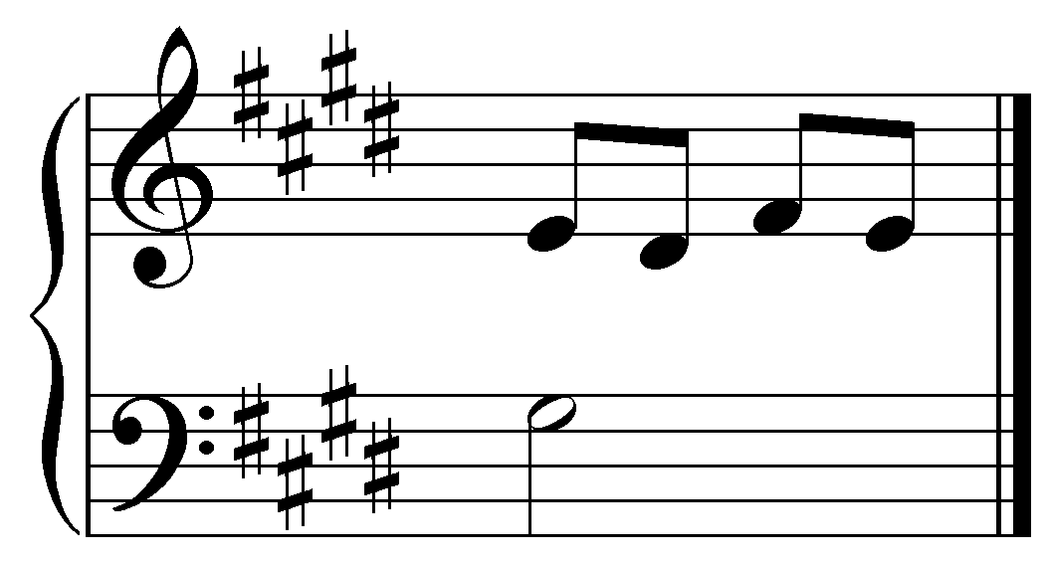
Which notes are the neighbor tones?
[Answer: D# and F#. Incorrect answer response: “Incorrect. Try again.”]
Follow-up multiple choice question: What type of passing tone is it?
- Upper diatonic neighbor tone
- Lower diatonic neighbor tone
- Upper chromatic neighbor tone
- Lower chromatic neighbor tone
- Double neighbor tones
[Answer: Double neighbor tones. Incorrect answer response: “Incorrect. Try again.”]
Exercise 8.5d:
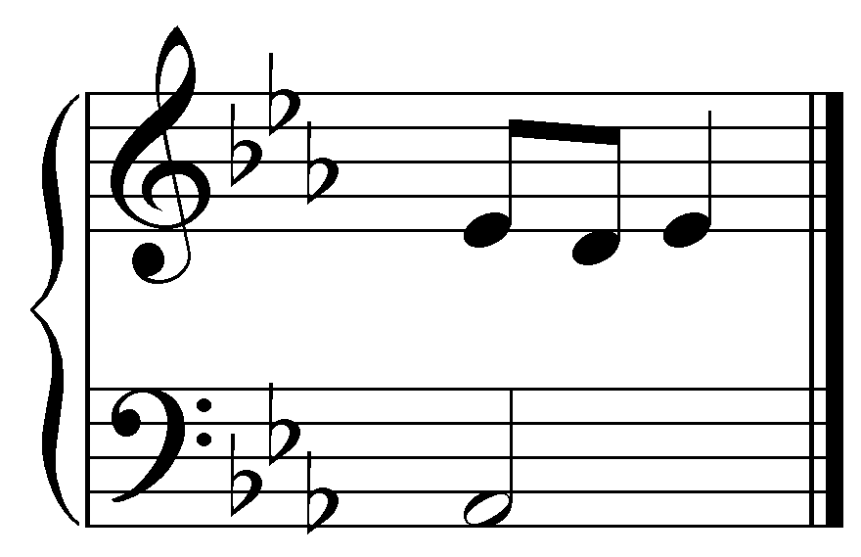
Which note is the neighbor tone?
[Answer: D. Incorrect answer response: “Incorrect. Try again.”]
Follow-up multiple choice question: What type of passing tone is it?
- Upper diatonic neighbor tone
- Lower diatonic neighbor tone
- Upper chromatic neighbor tone
- Lower chromatic neighbor tone
- Double neighbor tones
[Answer: Lower diatonic neighbor tone. Incorrect answer response: “Incorrect. Try again.”]

Incomplete neighbor tones:

Unlike passing tones, neighbor tones need not always be approached and left by step. When a neighbor tone is approached by leap and left by step, or vice versa, it is known as an incomplete neighbor tone. In the following example, the note E in the upper voice is decorated by the neighbor tone F, which is approached by leap and resolved by step.

Example 17:
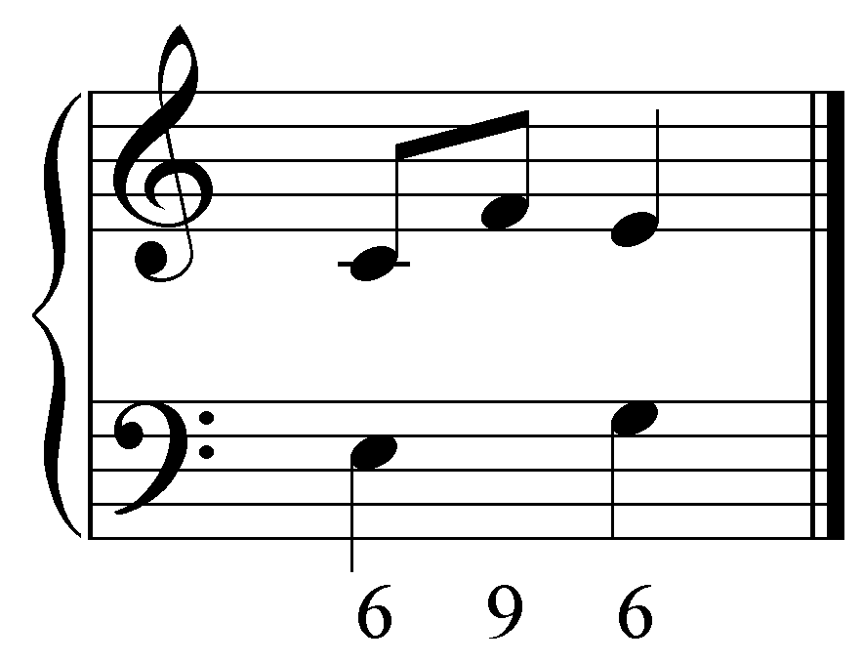

Instead of approaching the nonharmonic neighbor tone by step (as would be the case with a complete neighbor tone), the upper voice skips up from C up to the neighbor F, forming a dissonant ninth with the lower voice. The nonharmonic tone then resolves by step down to E. Example 18 shows another example of an incomplete upper neighbor, this time embellishing the first of two structural notes:

Example 18:
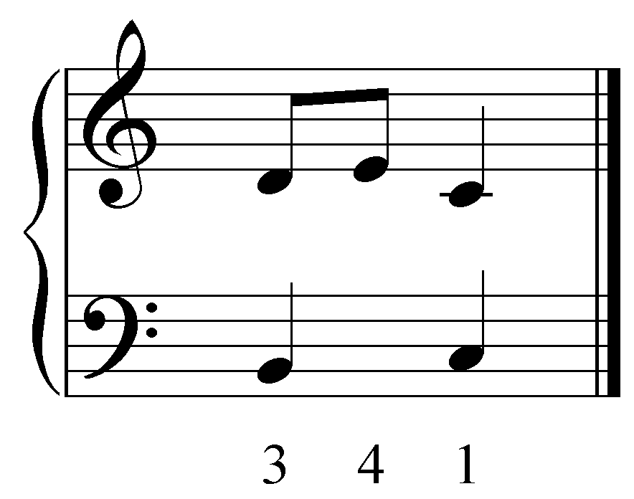

Here, the upper voice steps up to the upper neighbor E. Then, instead of resolving back down to D before continuing to C, the voice skips away from the dissonant nonharmonic tone, down to C, a chord tone, on the second beat. (This particular type of embellishment, an upper incomplete neighbor note, is called an échappée, or escape tone, by some authors.)

Lower neighbors may appear in incomplete form as well. In Example 19, the chord tone C in the upper voice is approached with a dissonant incomplete lower neighbor (B):

Example 19:
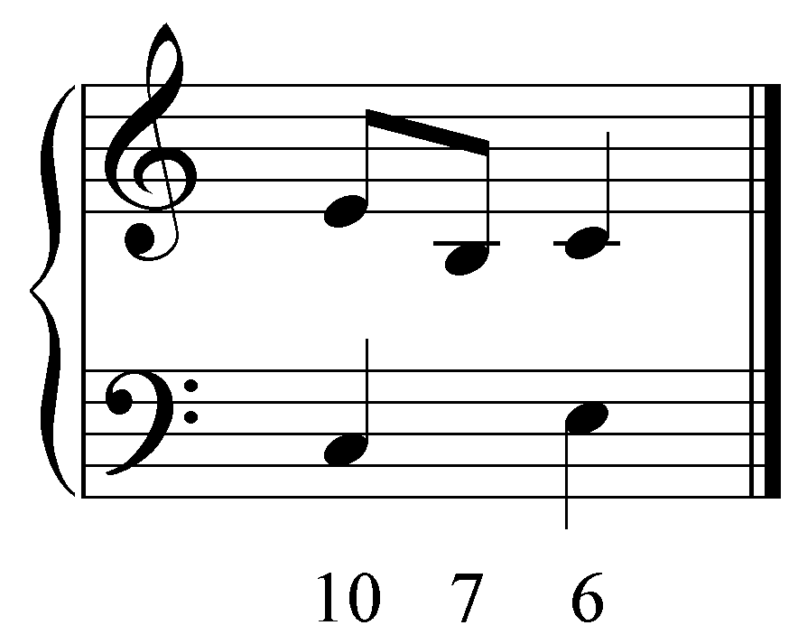

Incomplete neighbor tones have a different effect than complete neighbor tones because they involve a leap. The leap, especially when the incomplete neighbor forms a dissonance, draws attention to the nonharmonic tone by changing the contour of the melodic line.

The examples of incomplete neighbor tones shown so far are unaccented. However, they also appear in accented form. Example 20 uses the same pitches as Example 17, though here the neighbor tone is rhythmically displaced to produce an accented incomplete upper neighbor tone on beat two:

Example 20:
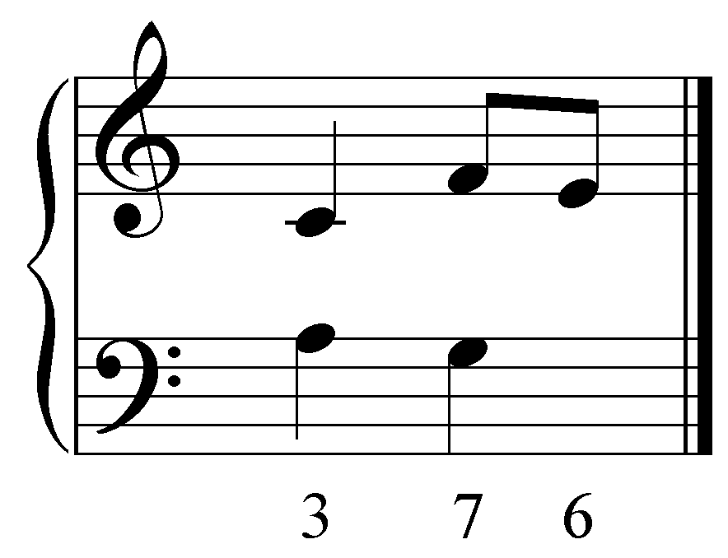

The term appoggiatura is generally used instead of the cumbersome “accented incomplete upper (or lower) neighbor tone.”

As in the example above, appoggiaturas leap into a dissonant accented neighbor tone and then resolve by step in the opposite direction.

Activity 8.6:
In this activity you will be asked to identify various types of passing and neighbor tones in several excerpts of chorales by J.S. Bach.
Exercise 8.6a:
Identify an unaccented passing tone in this excerpt (J.S. Bach, BWV 411, “Singt dem Herrn ein neues Lied,” mm. 1-2):
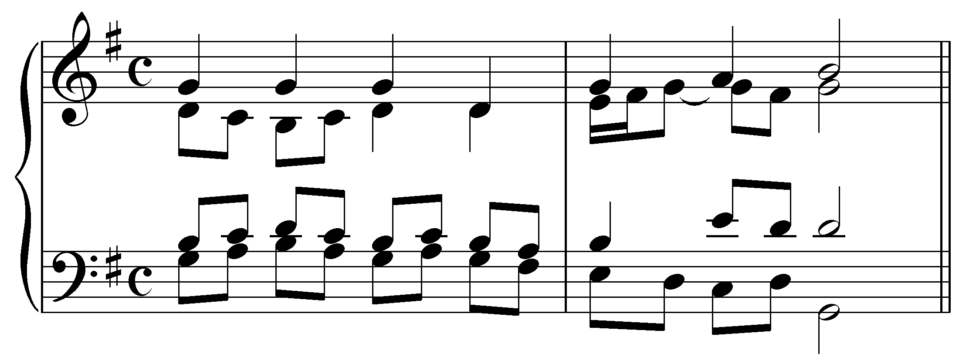
[Answers:
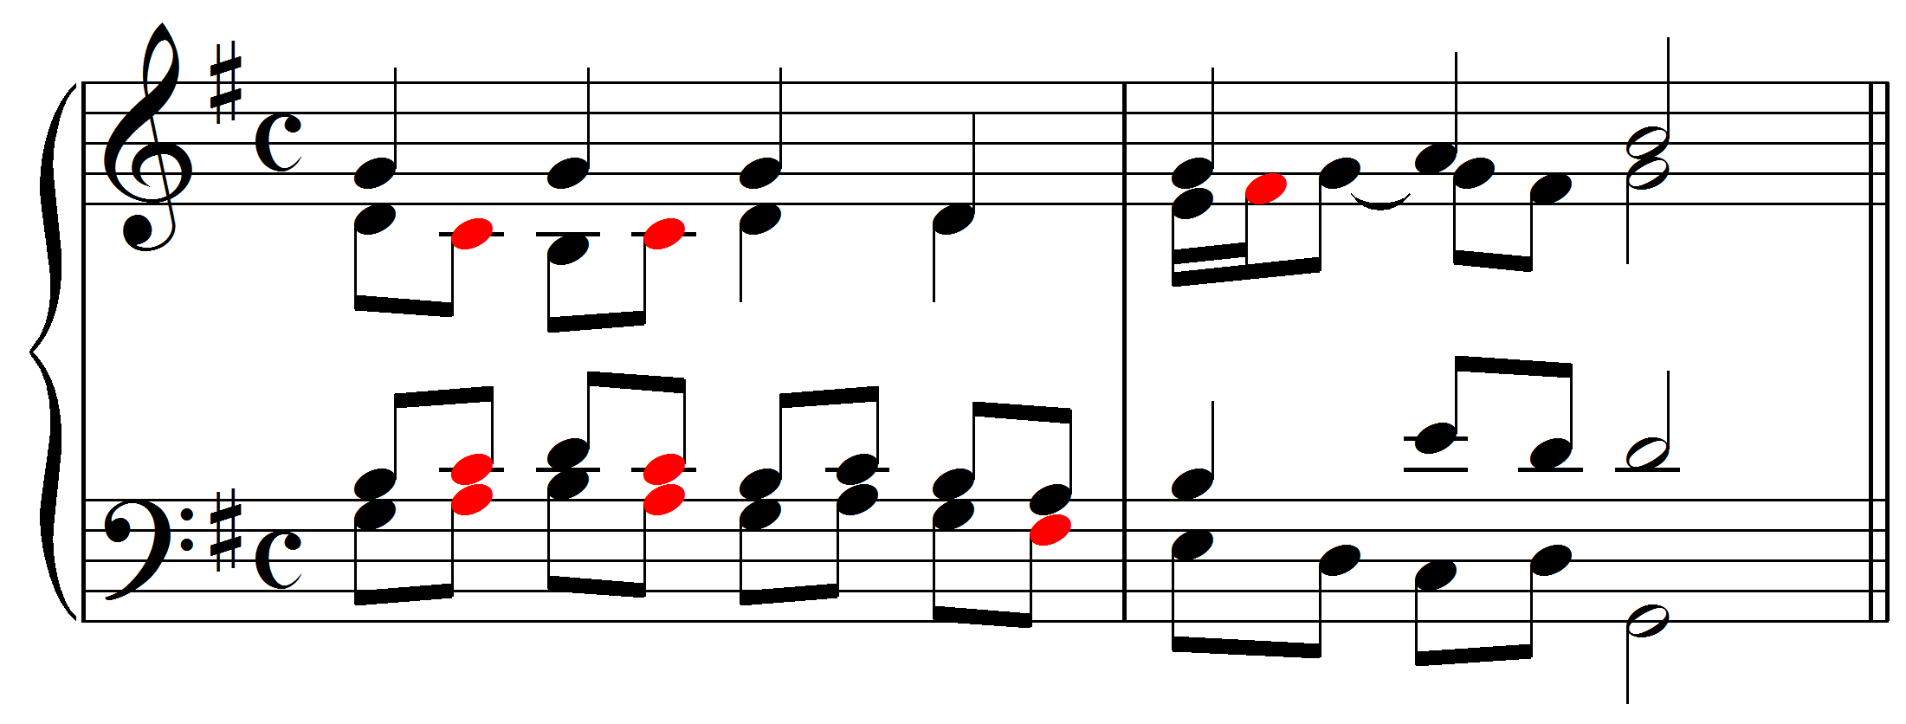]

Exercise 8.6b:
Identify an unaccented upper neighbor tone in this excerpt (J.S. Bach, BWV 411, “Singt dem Herrn ein neues Lied,” mm. 1-2):
[Answers:
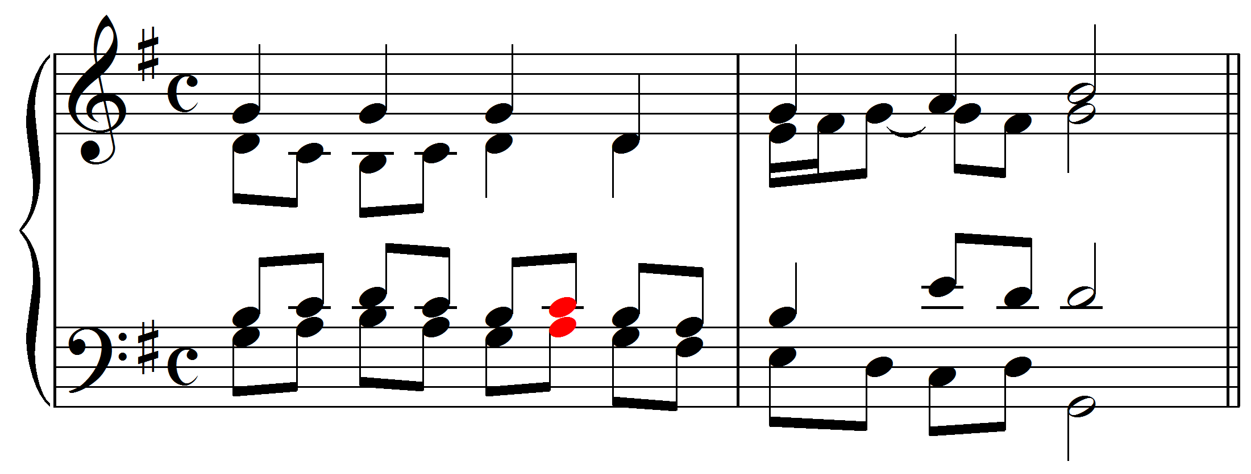]

Exercise 8.6c:
Identify an unaccented lower neighbor tone in this excerpt (J.S. Bach, BWV 411, “Singt dem Herrn ein neues Lied,” mm. 1-2):
[Answer:
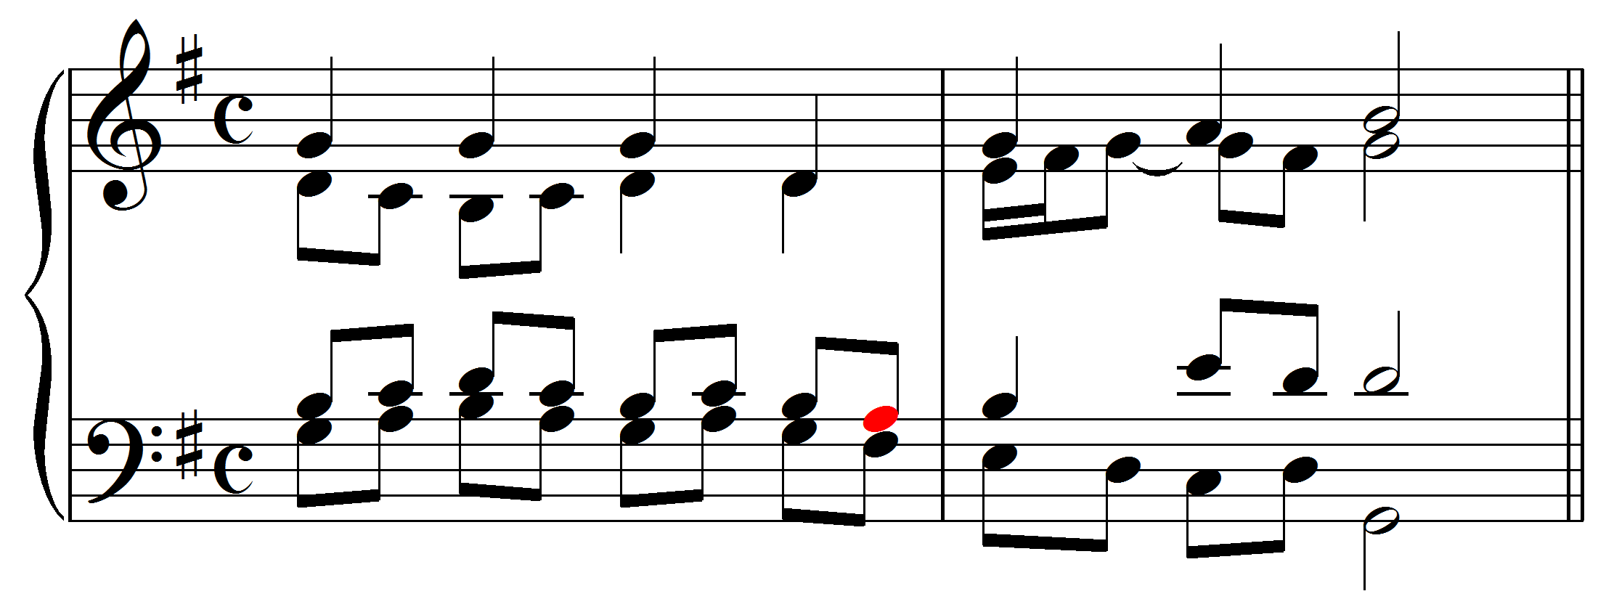]

Exercise 8.6d:
Identify an appoggiatura (accented incomplete neighbor tone) in this excerpt (J.S. Bach, BWV 153.1, “Ach Gott, vom Himmel sieh’ darein,” mm. 2-4):
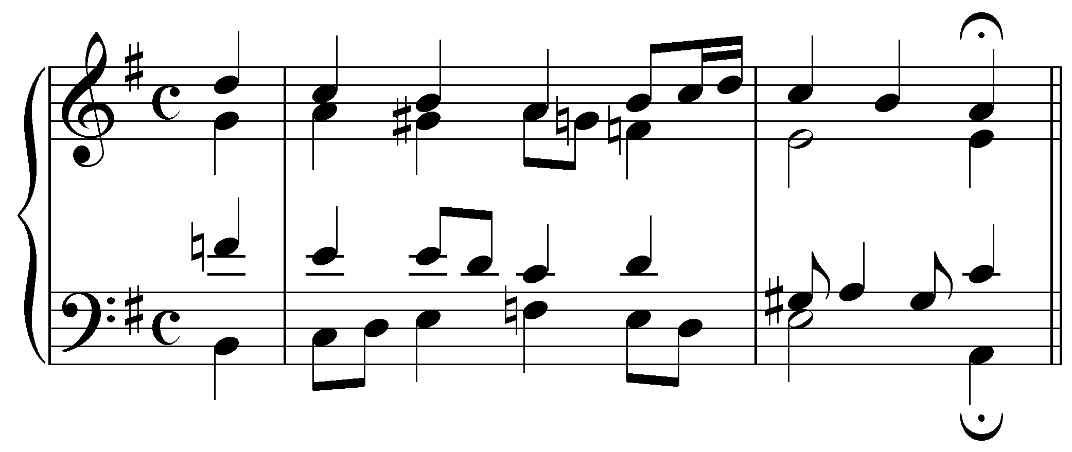
[Answer:
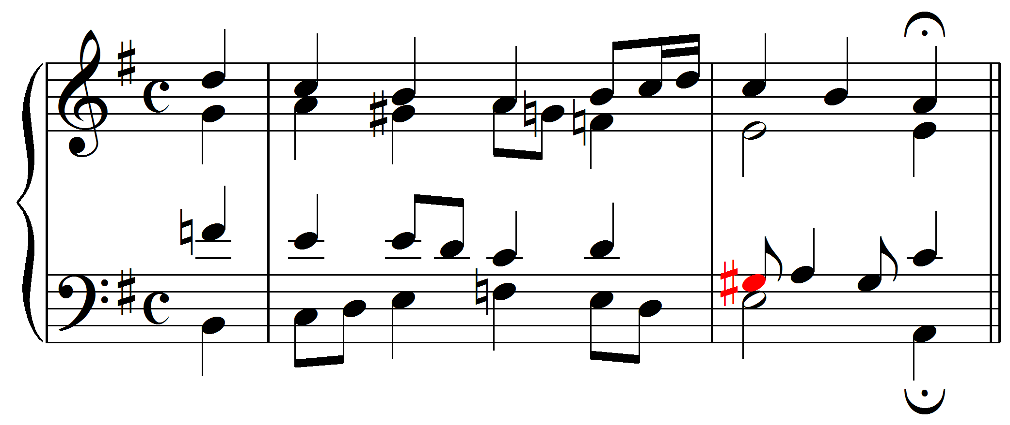]

Exercise 8.6e:
Identify an accented passing tone in this excerpt (J.S. Bach, BWV 154.8, “Meinen Jesum laß ich nicht, weil er sich für mich gegeben,” mm 1-2):
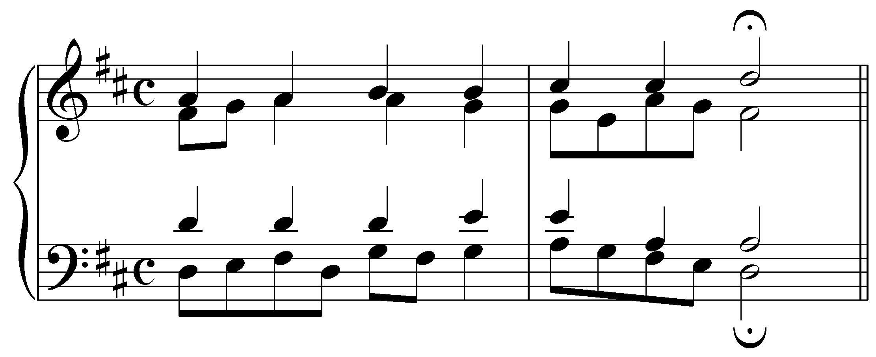
[Answer:
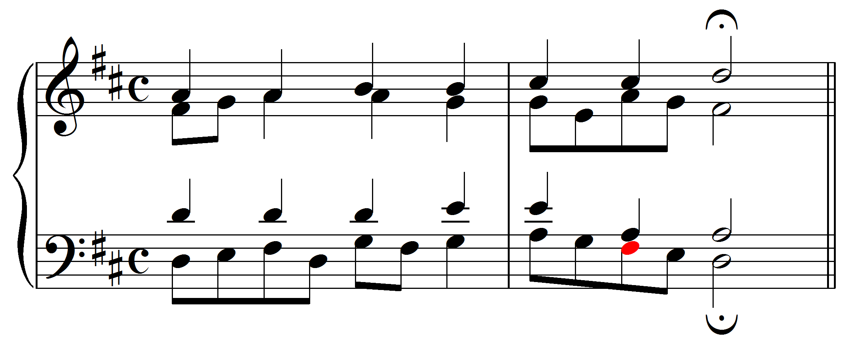]

Rhythmically derived nonharmonic tones:

Passing and neighbor tones are nonharmonic tones that fill out or embellish a melody. But that is not the case with all nonharmonic tones. Some result from rhythmic activity and do not add pitches to an underlying basic interval progression. The two main types of rhythmic figurations are suspensions and anticipations. Like passing and neighbor tones, these can be understood as alterations of a basic interval progression framework, this time affecting the rhythm instead of the melody.

Suspensions:

A suspension is a nonharmonic tone that results when a note is held over (suspended) from the preceding harmony, thus rhythmically delaying its melodic continuation, and intruding as a nonharmonic tone on the subsequent harmony. Consider the following familiar interval progression:

Example 21:
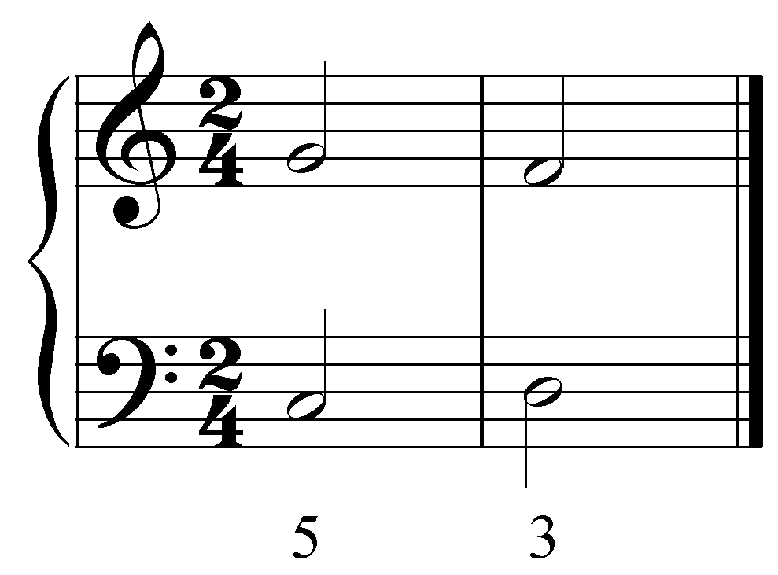

What would happen if the upper voice began one beat after than the lower voice? The G in the upper voice would be held over into the second measure while the lower voice continued its melodic ascent to D:

Example 22:
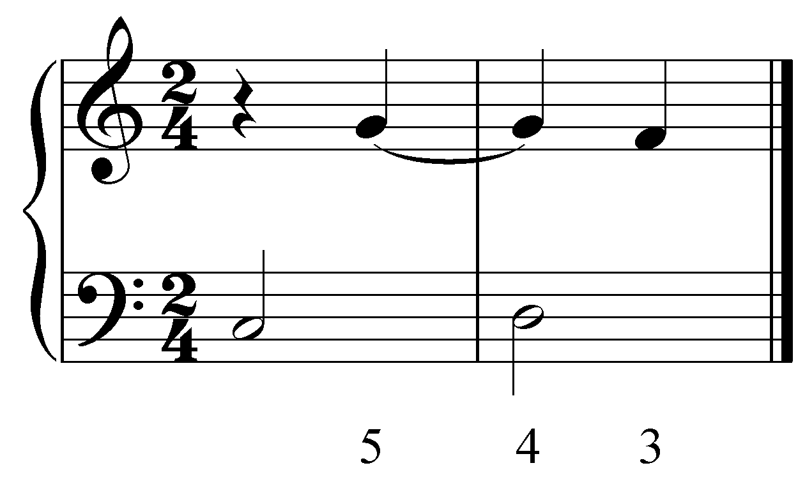

In Example 22, the consonant G of the upper voice prepares the dissonant suspension, a nonharmonic tone, on the following beat. On the downbeat of the second measure, the upper voice holds (suspends) the G as the lower voice changes, creating a dissonant fourth. This is the actual moment of suspension. Finally, the dissonant G resolves down to the chord tone F on the second quarter note of the bar. The F is the resolution of the suspension. This particular suspension is referred to as a “4 - 3 suspension.” (The suspension may be tied to the preparation, as in this case, or it may repeat the pitch.) It is helpful to think of the suspension as occurring in three consecutive stages, the preparation, the suspension, and the resolution:

Example 23:
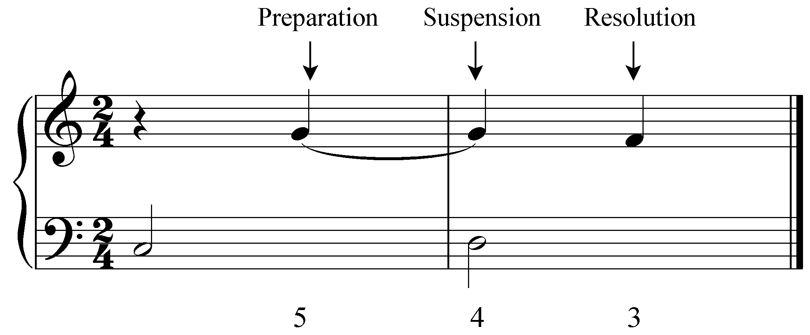

It is important to note the positions of each part of a suspension: the preparation occurs in a metrically weak position and the suspension occurs in a metrically strong position. Unlike passing and neighbor tones, suspensions are always accented. In Examples 22 and 23, the preparation occurs on the weak beat of the measure while the suspension falls on a downbeat. One common deviation from this pattern finds an extended note forming the preparation:

Example 24:
becomes… 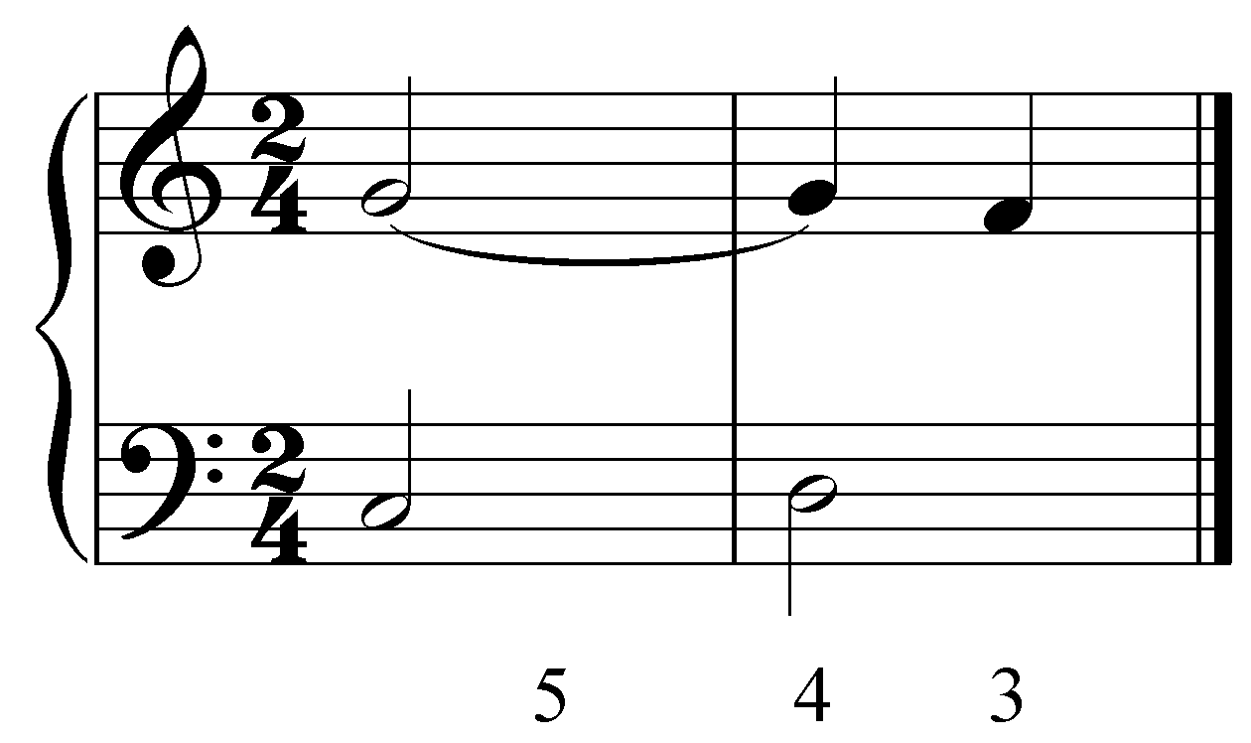

In Example 24, the G in the upper voice is extended into the second measure before stepping down to F, thus creating a dissonant “4 - 3” suspension.

There are two important rules to remember regarding the resolution of suspensions:

- Suspensions must always resolve by step (half-step or whole-step).

- Suspensions usually resolve downward. (Suspended notes that resolve upward are called retardations and will be discussed momentarily.)

Popup Box: Rule 1 above states that suspensions must always resolve by step. Occasionally a dissonant suspension will leap to a chord tone and from there leap to the expected resolution, as in the following example:

Example 25:
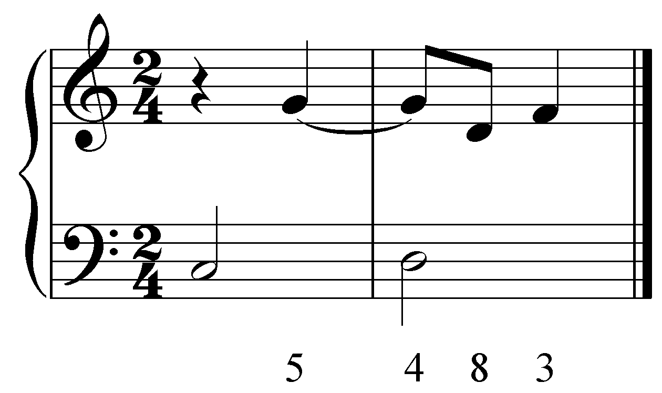

Example 26:
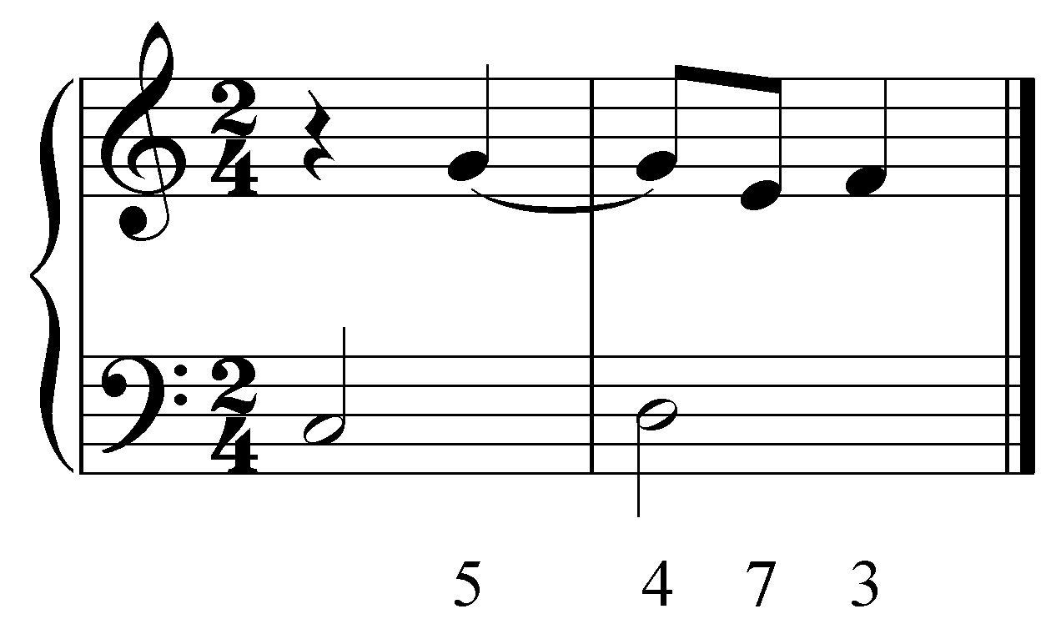

In Example 25, the upper voice first leaps down to D before leaping back up to the expected resolution F. Example 26 shows a similarly decorated suspension, this time leaping to a dissonant E (an incomplete lower neighbor) before resolving to the F.

Similarly, the suspension could be decorated with an escape tone:

Example 27:
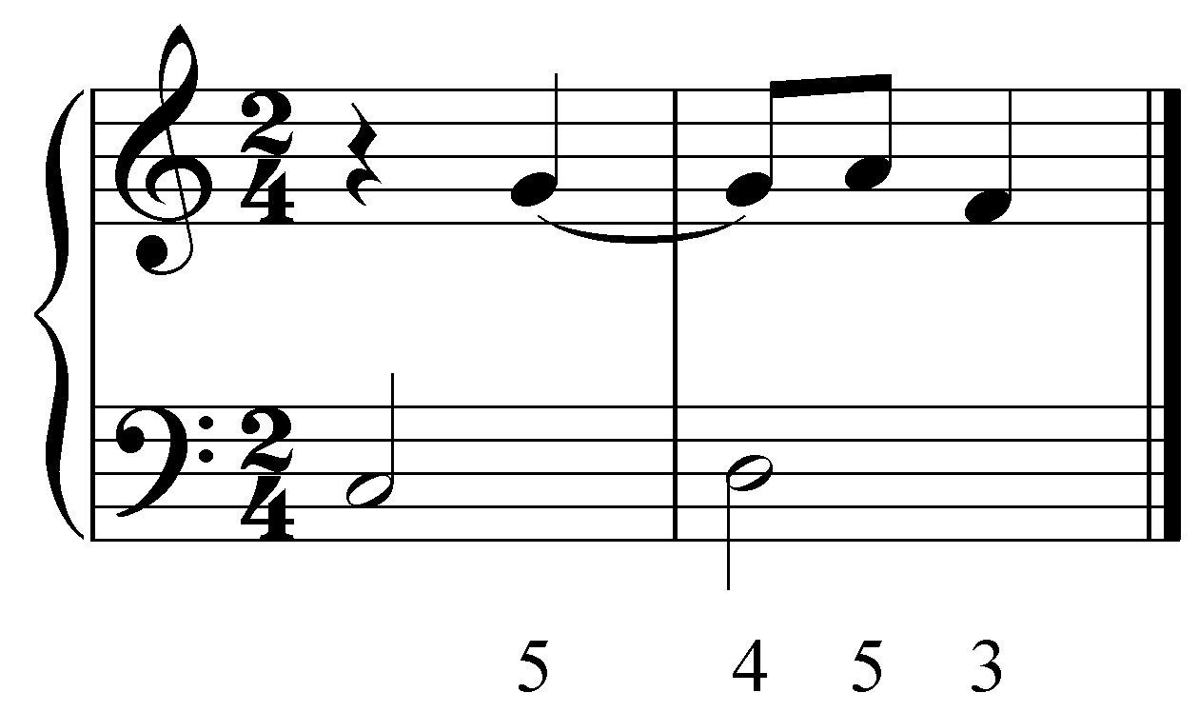

Although there is another pitch in between the suspension and the resolution, the underlying voice leading remains intact in each of these examples: the suspension resolves by step from G to F.

Suspensions are usually labeled by indicating the two intervals formed between the suspended voice and the bass. Four of the most common types of suspensions in the upper voice are shown in Example 26:

Example 28:
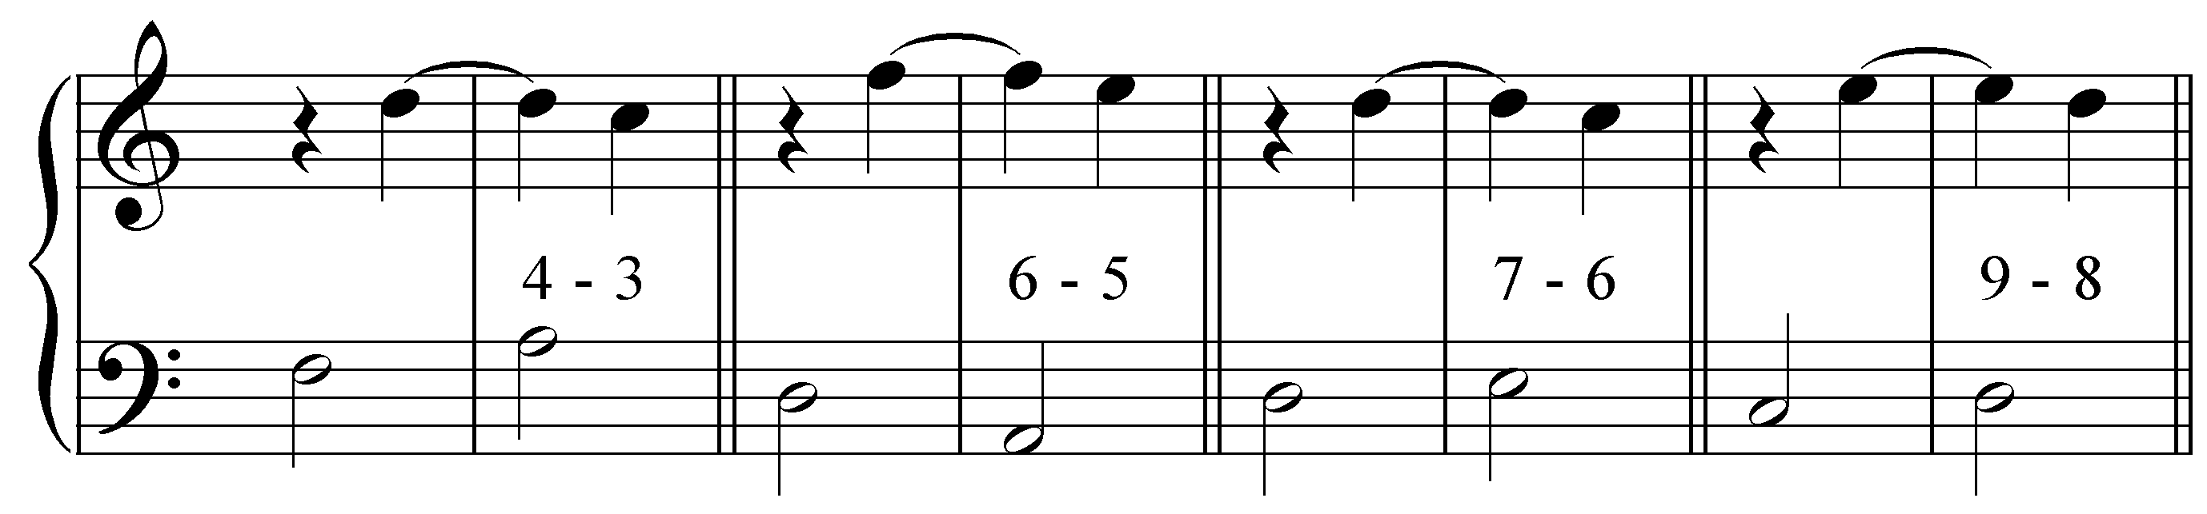

In each case, the suspended note becomes a nonharmonic tone. With the exception of the “6 - 5” suspension, all of these nonharmonic tones form a dissonance with the bass.

Suspensions may occur in the lower voice as well. Example 29 shows several common bass suspensions:

Example 29:
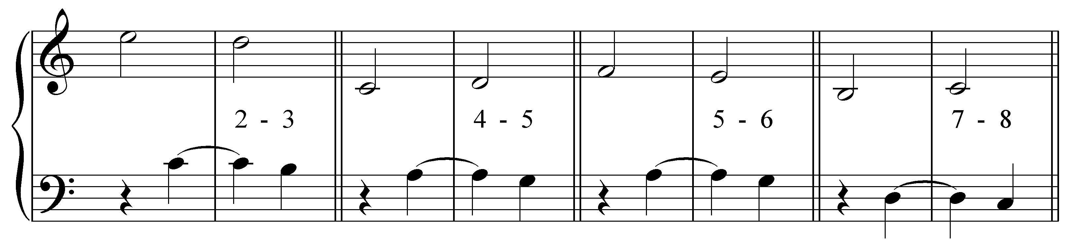

Again, with the exception of the “5 - 6” suspension, all of the nonharmonic tones form a dissonance.

Popup Box: You may have noticed that nonharmonic tone in the “9 - 8” suspension from Example 28 forms the same interval as the nonharmonic tone in the “2 - 3” suspension from Example 29: a compound second. To distinguish between the two, “9 - 8” is commonly used to indicate a compound second suspension in the upper voice and “2 - 3” is used for a suspension in the lower voice.

Activity 8.7:
Exercise 8.7a:
[Fill-in-the-blank question:] In the following example, which voice contains a suspension: soprano or bass?
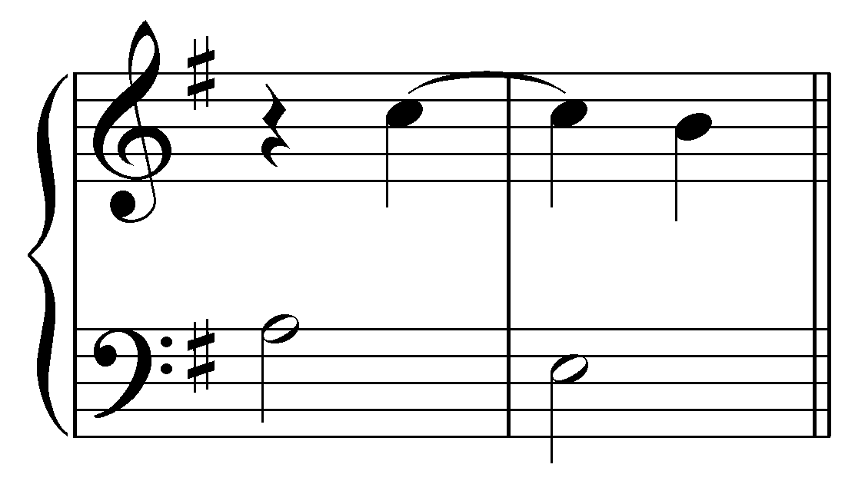
[Answer: “soprano”]
[Follow-up question:] What type of suspension is it?
[Answer: “6-5”]

Exercise 8.7b:
[Fill-in-the-blank question:] In the following example, which voice contains a suspension: soprano or bass?
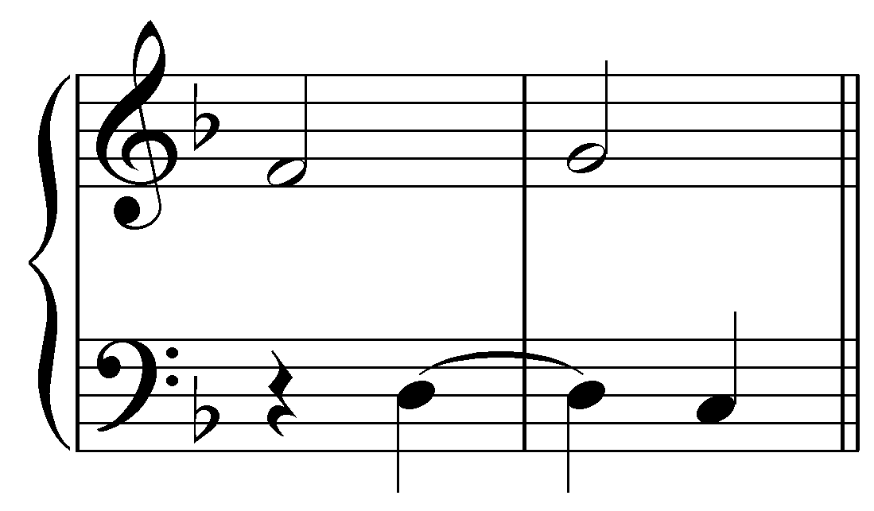
[Answer: “bass”]
[Follow-up question:] What type of suspension is it?
[Answer: “4-5”]

Exercise 8.7c:
[Fill-in-the-blank question:] In the following example, which voice contains a suspension: soprano or bass?
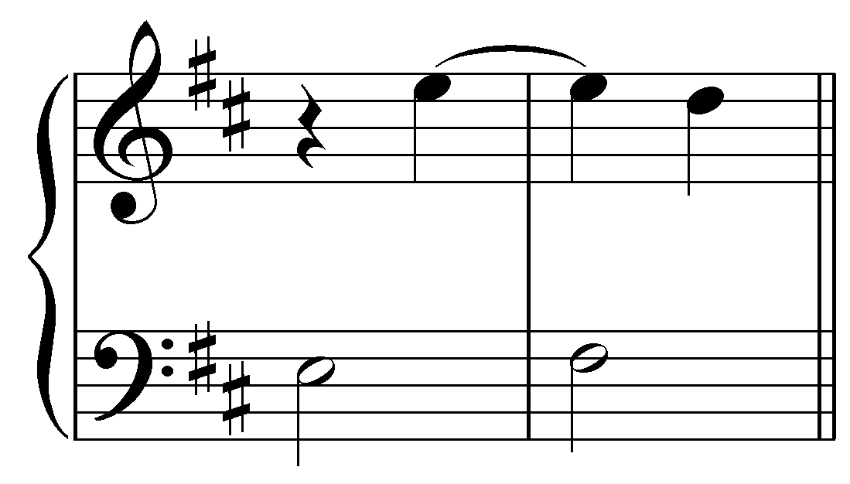
[Answer: “soprano”]
[Follow-up question:] What type of suspension is it?
[Answer: “7-6”]

Exercise 8.7d:
[Fill-in-the-blank question:] In the following example, which voice contains a suspension: soprano or bass?
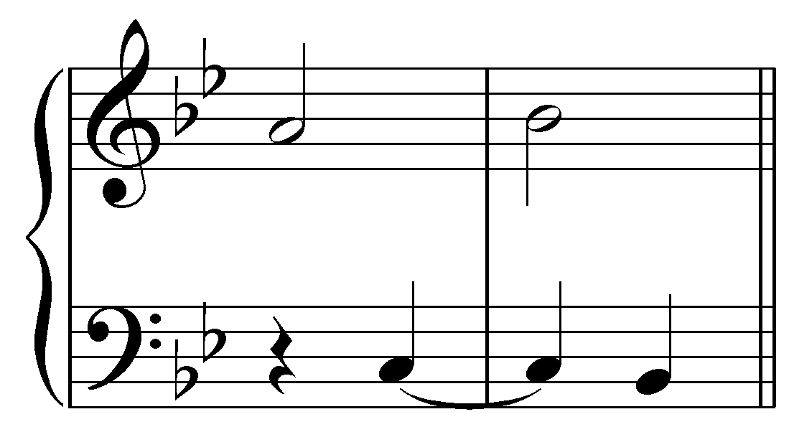
[Answer: “bass”]
[Follow-up question:] What type of suspension is it?
[Answer: “7-8”]

Exercise 8.7e:
[Fill-in-the-blank question:] In the following example, which voice contains a suspension: soprano or bass?
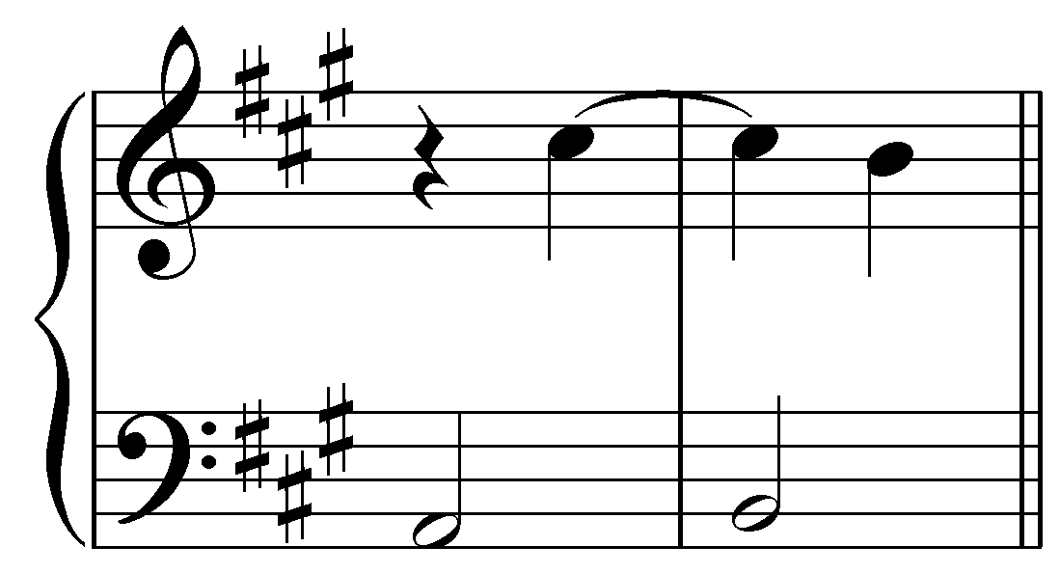
[Answer: “soprano”]
[Follow-up question:] What type of suspension is it?
[Answer: “9-8”]

Exercise 8.7f:
[Fill-in-the-blank question:] In the following example, which voice contains a suspension: soprano or bass?
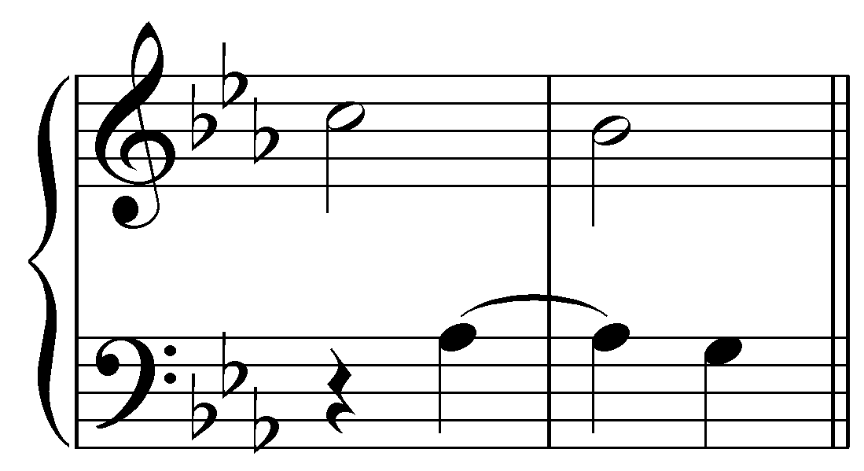
[Answer: “bass”]
[Follow-up question:] What type of suspension is it?
[Answer: “2-3”]

As mentioned above, suspensions tend to resolve downward by step. A suspended note that resolves upward to a consonance is called a retardation. In the following example, the B of the upper voice is suspended into the second measure:

Example 30:
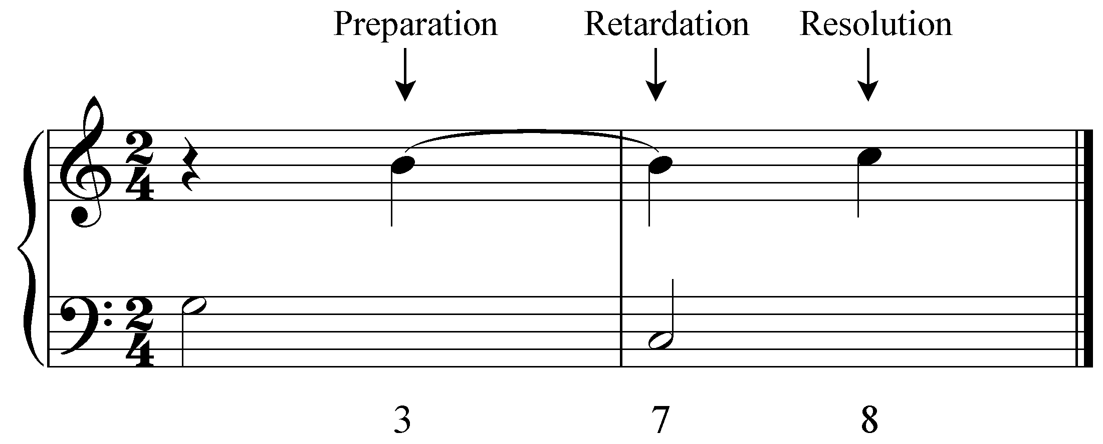

The suspended B resolves upward by half-step to the tonic pitch. A suspended leading tone typically resolves to the tonic.

Activity 8.8:
For each exercise in this activity you will be given a bass line and asked to write a suspension in the upper voice. Remember, the preparation occurs on a weak beat and the suspension itself occurs on the following strong beat, resolving on the next weak beat. Here is an example:

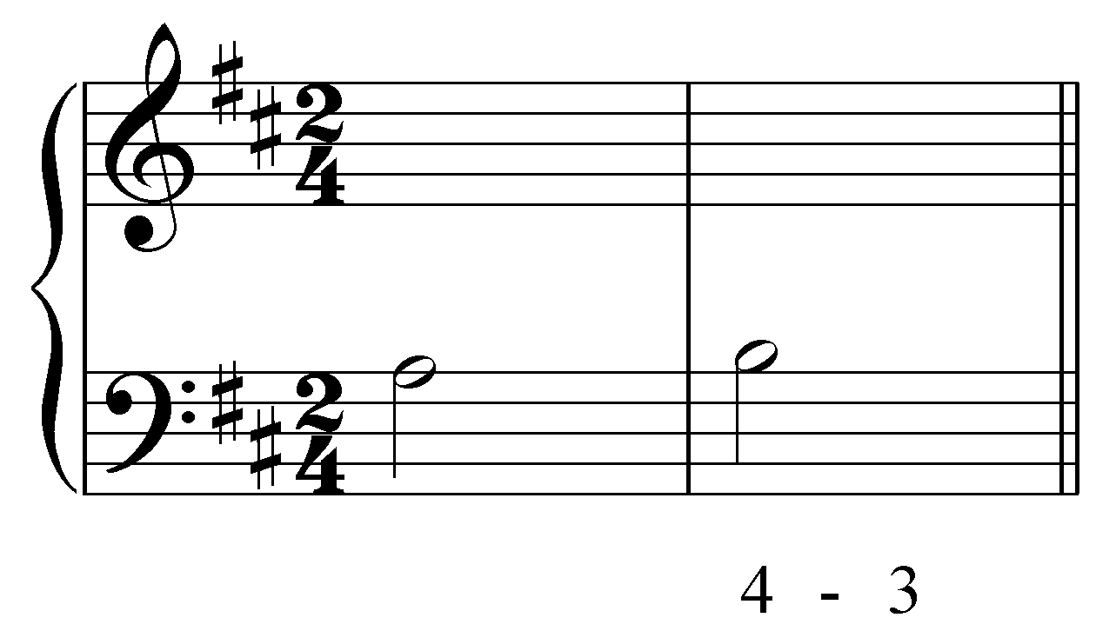 becomes… 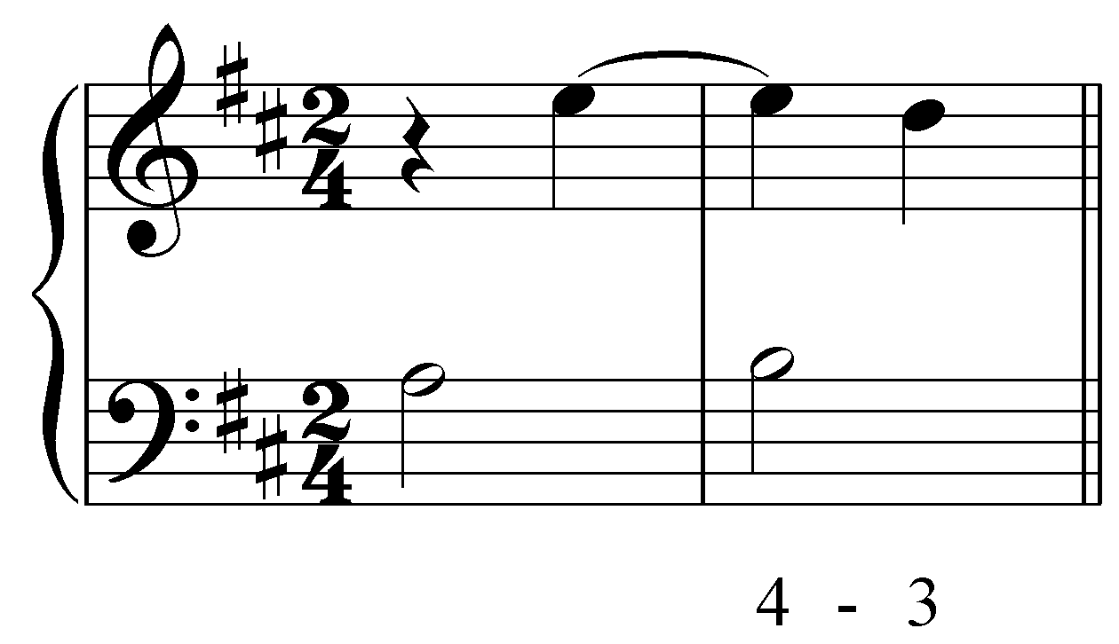

Exercise 8.8a:
Complete the following suspension by adding the upper voice:
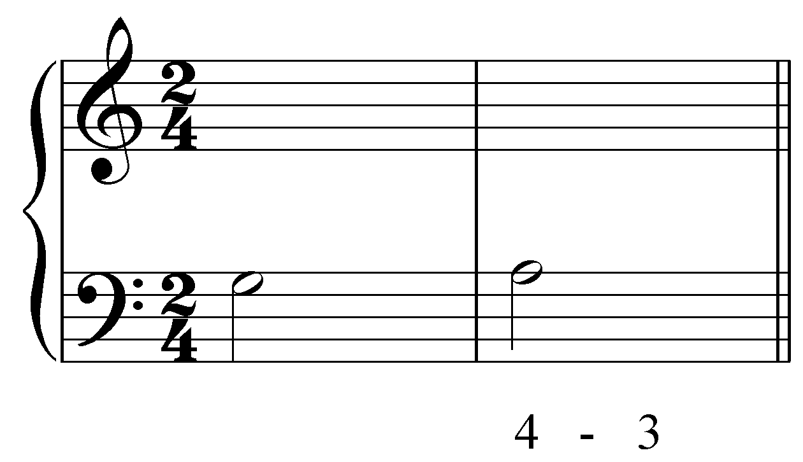
[Answers may vary by octave:
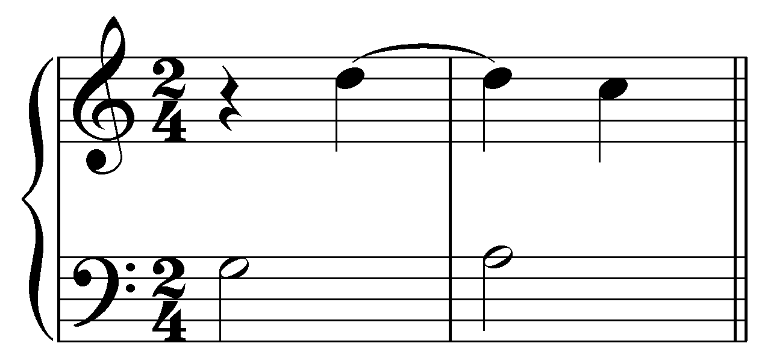]

Exercise 8.8b:
Complete the following suspension by adding the upper voice:
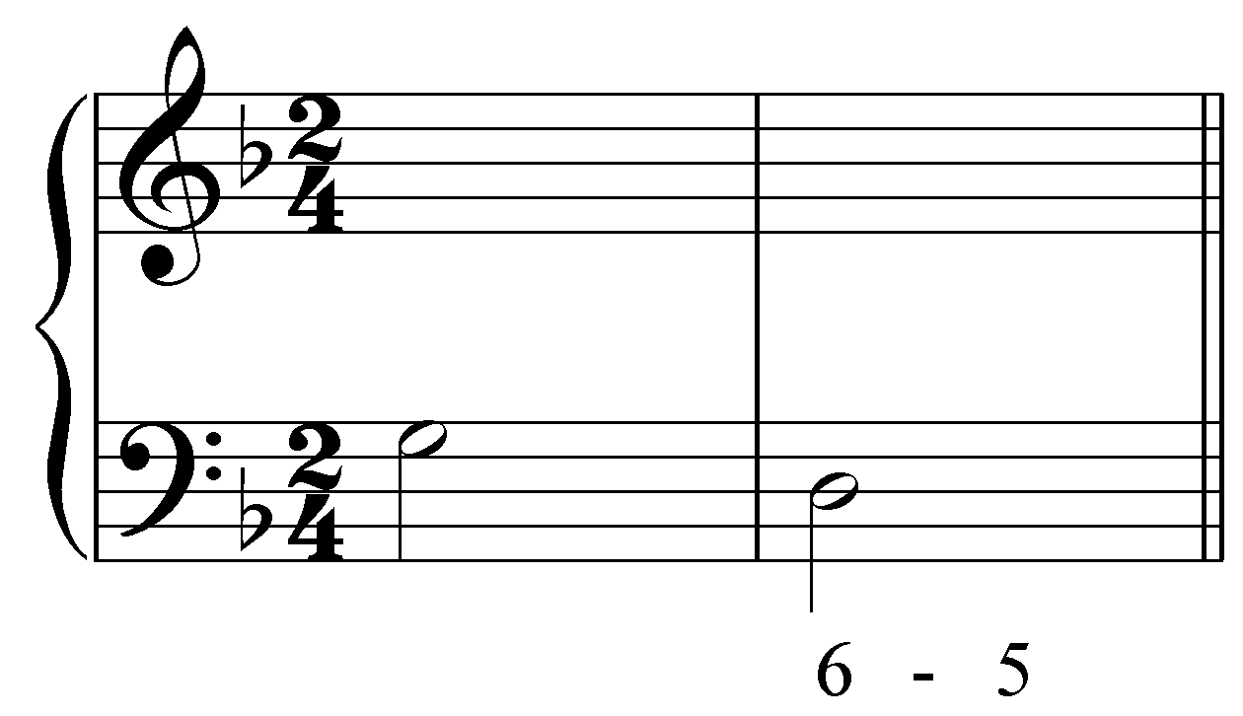
[Answers may vary by octave:
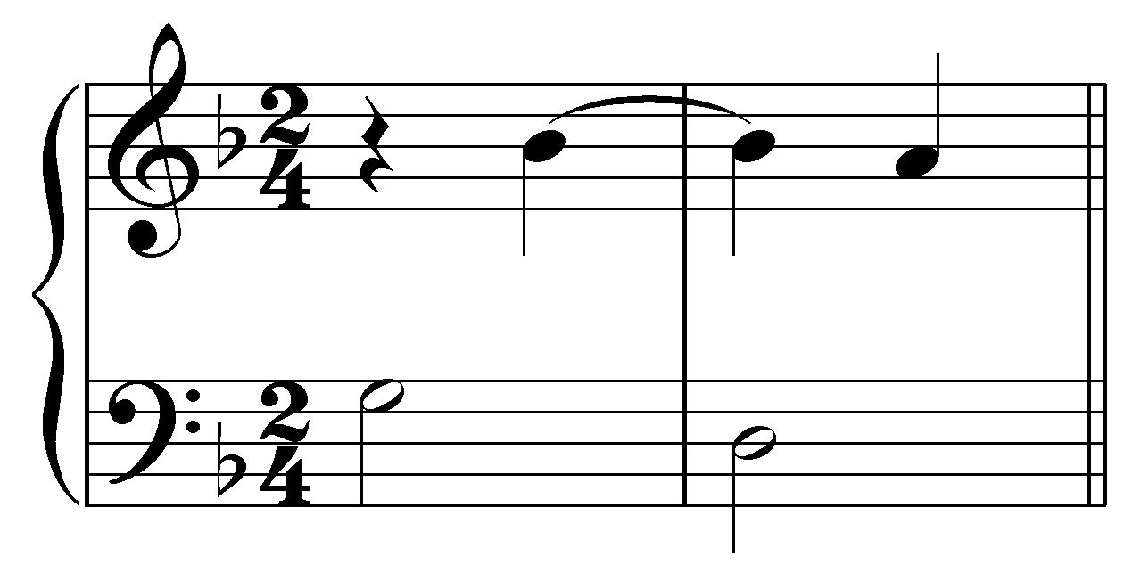]

Exercise 8.8c:
Complete the following suspension by adding the upper voice:
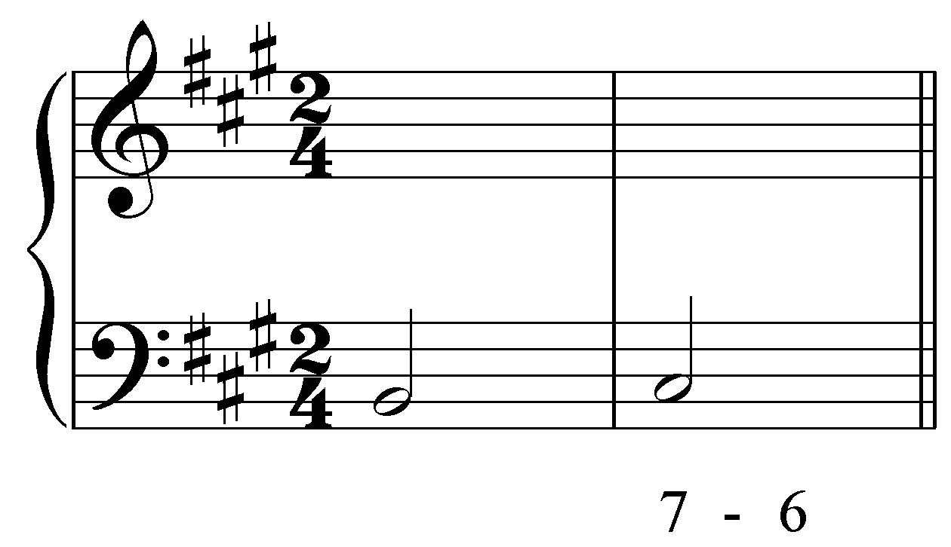
[Answers may vary by octave:
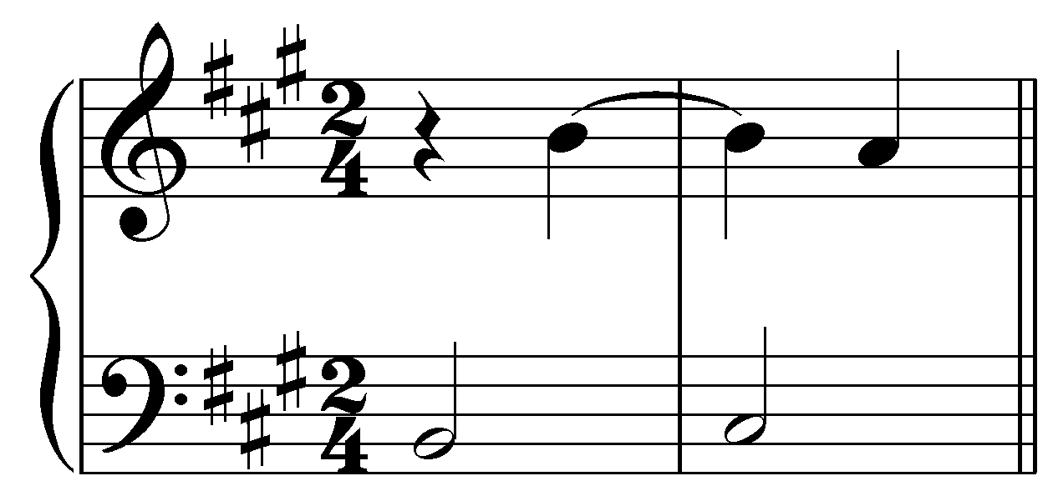]

Exercise 8.8d:
Complete the following suspension by adding the upper voice:
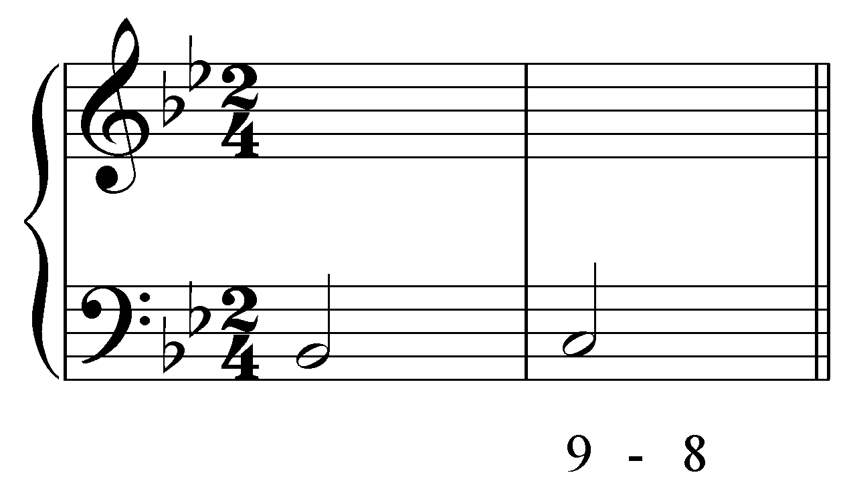
[Answers may vary by octave:
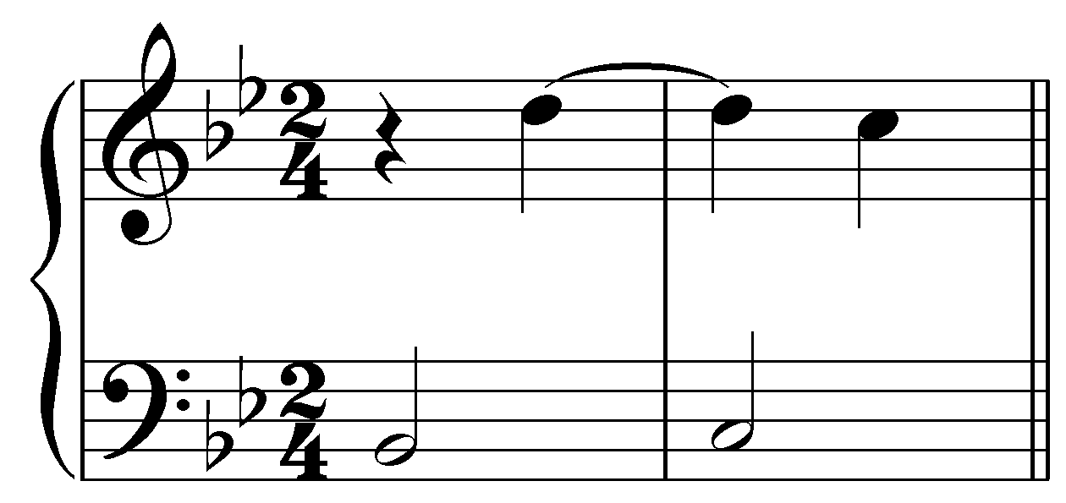]

Anticipations:

Anticipations are in a sense the reverse of suspensions. As we saw, a suspension delays a voice movement until after the harmony changes, creating a dissonance at the change. Conversely, an anticipation rushes the voice movement ahead, creating a dissonance before the harmony changes. Further, while suspensions are rhythmically accented, anticipations are unaccented. Consider again the basic interval progression “5 - 3”:

Example 31:
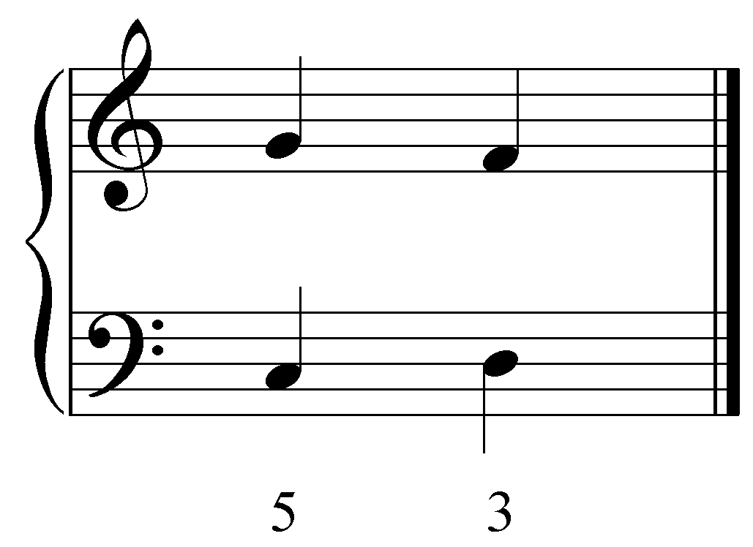

If the F in the upper voice were to arrive before the bass D on beat two, the following would result:

Example 32:
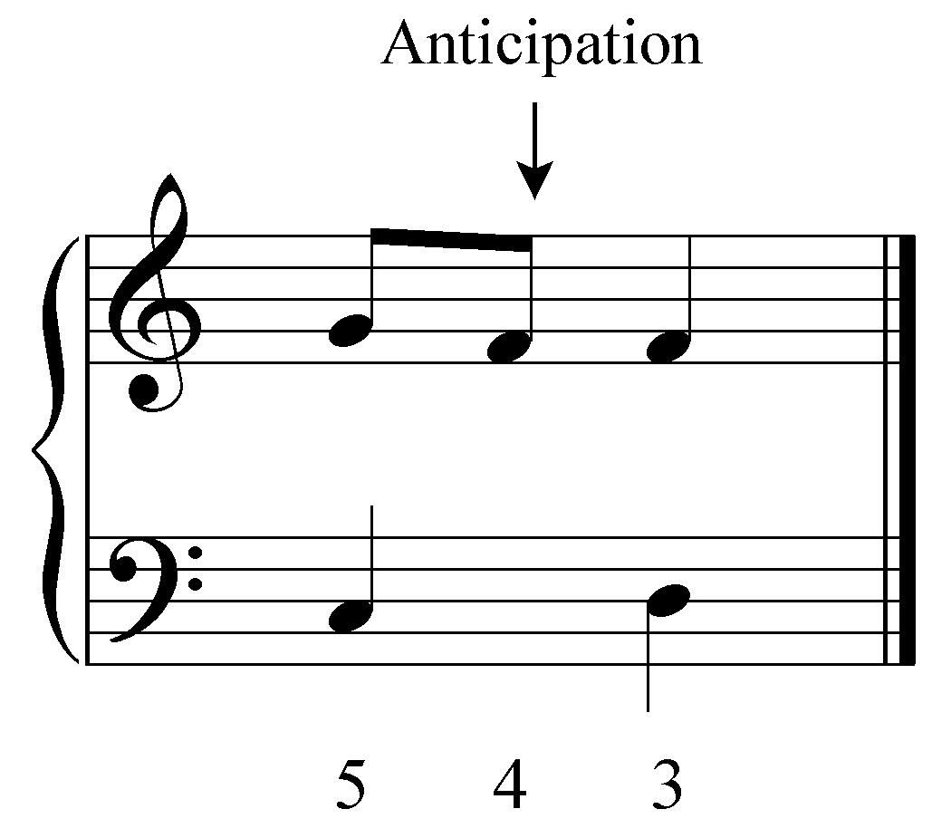

By stepping down prematurely, the upper voice anticipates the arrival of F on beat two. Anticipations usually enter by step and can be tied to the anticipated chord tone or reiterated. One of the most common anticipations occurs at V-I cadences, where scale degree 1 in the soprano is anticipated before tonic arrives in a 2 - 1 movement:

Example 33:
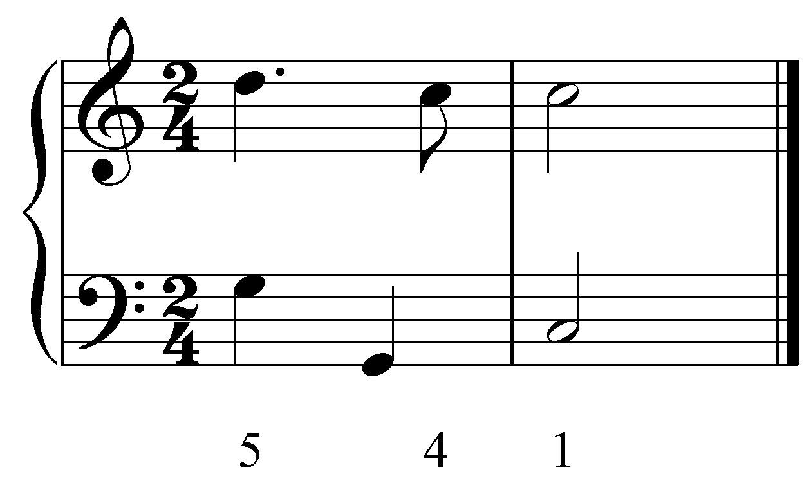

The octave leap in the bass is a typical accompaniment to this ubiquitous anticipation.

Activity 8.9:
Exercise 8.9a:
In the following excerpt (J.S. Bach, English Suite no.2, in A minor, Sarabande, BWV 807, mm. 1-12), what type of nonharmonic tone is the red note?
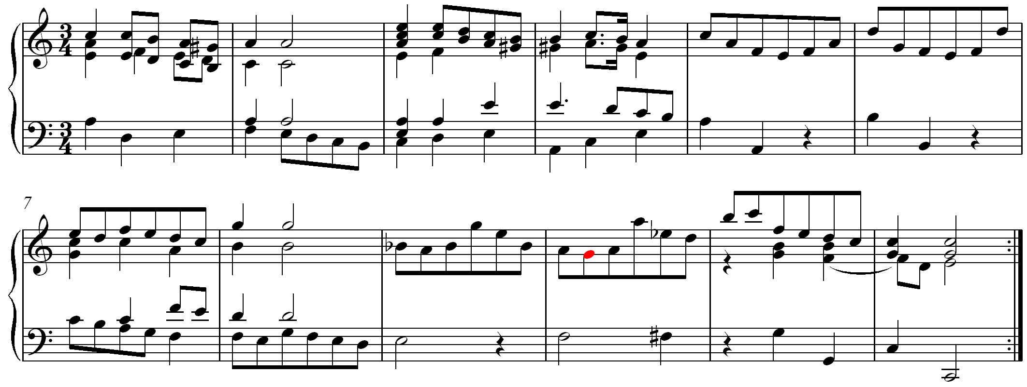
[Answer: “lower neighbor tone” or “unaccented lower neighbor tone” or “unaccented diatonic lower neighbor tone” or “diatonic lower neighbor tone”]

Exercise 8.9b:
In the following excerpt (J.S. Bach, English Suite no.2, in A minor, Sarabande, BWV 807, mm. 1-12), what type of nonharmonic tone is the red note?
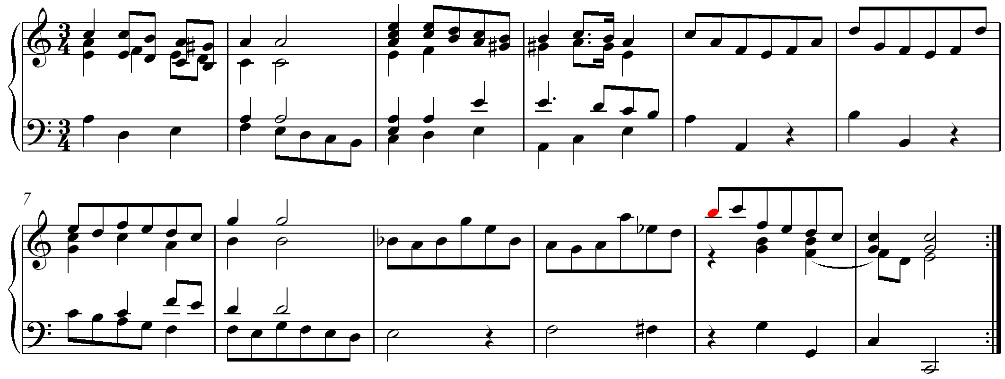
[Answer: “appoggiatura” or “incomplete lower neighbor tone” or “incomplete neighbor tone” or “accented incomplete lower neighbor tone” or “accented incomplete neighbor tone”]

Exercise 8.9c:
In the following excerpt (J.S. Bach, English Suite no.2, in A minor, Sarabande, BWV 807, mm. 1-12), what type of nonharmonic tone is the red note?
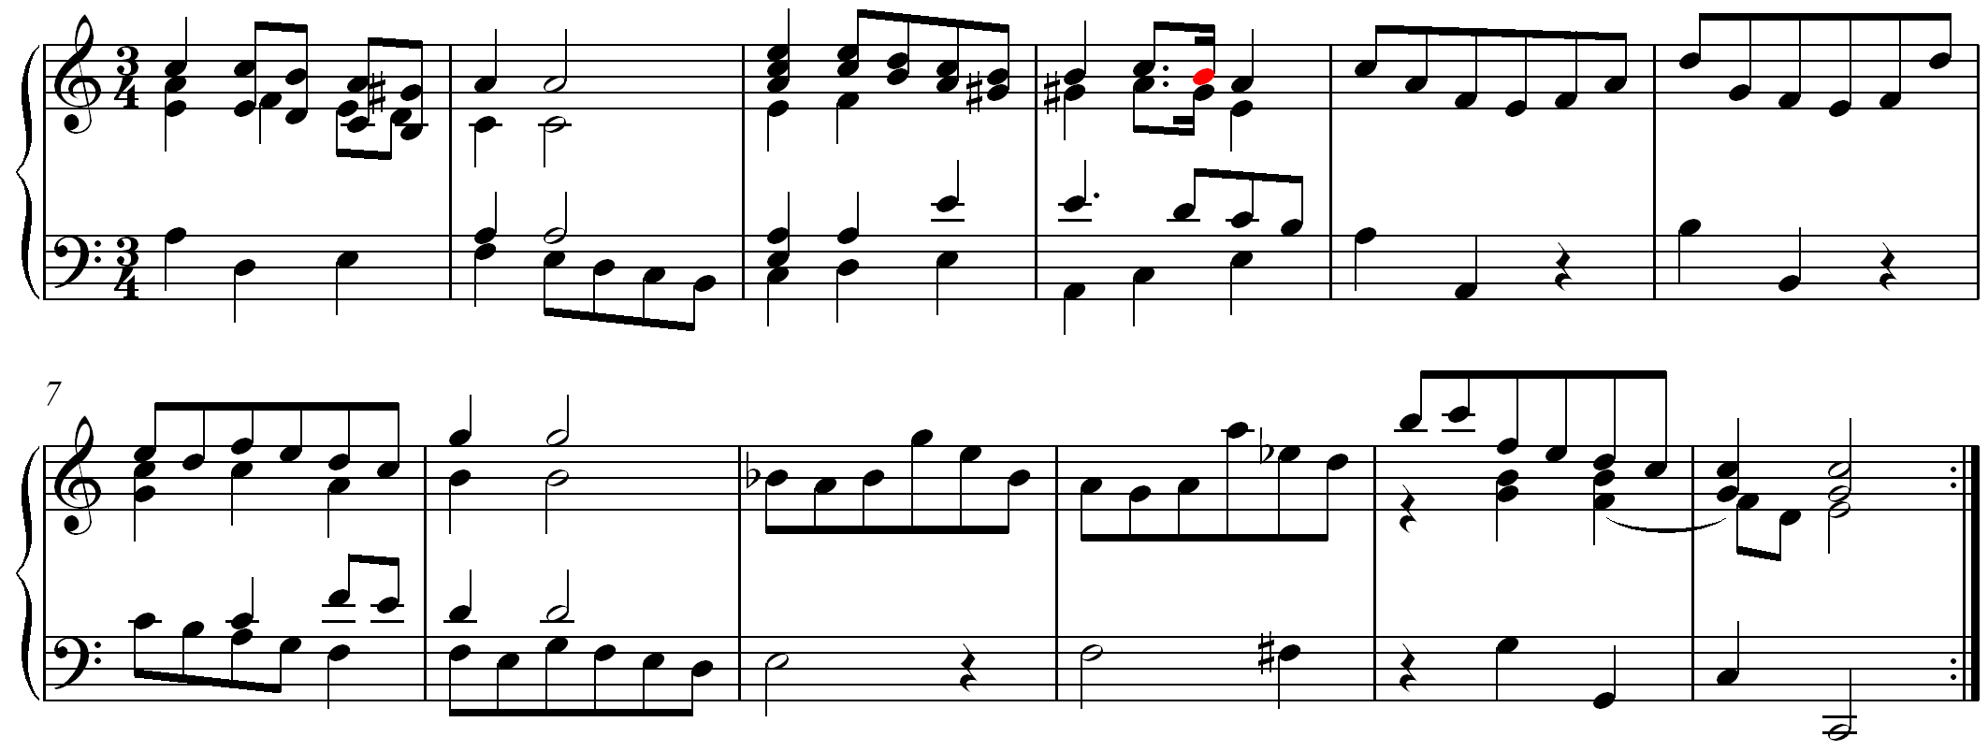
[Answer: “passing tone” or “unaccented passing tone” or “unaccented diatonic passing tone” or “diatonic passing tone”]

Exercise 8.9d:
In the following excerpt (J.S. Bach, English Suite no.2, in A minor, Sarabande, BWV 807, mm. 1-12), what type of nonharmonic tone is the red note?
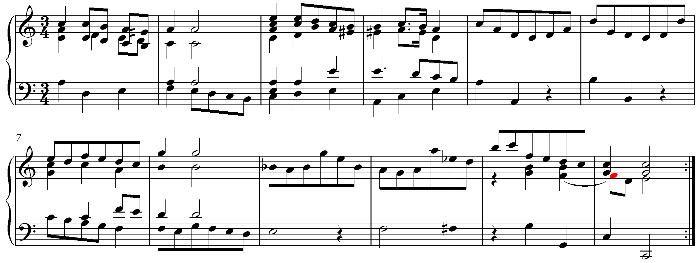
[Answer: “suspension” or “4-3 suspension” or “decorated 4-3 suspension” or “decorated suspension”]

Exercise 8.9e:
In the following excerpt (J.S. Bach, English Suite no.2, in A minor, Sarabande, BWV 807, mm. 1-12), what type of nonharmonic tone is the red note?
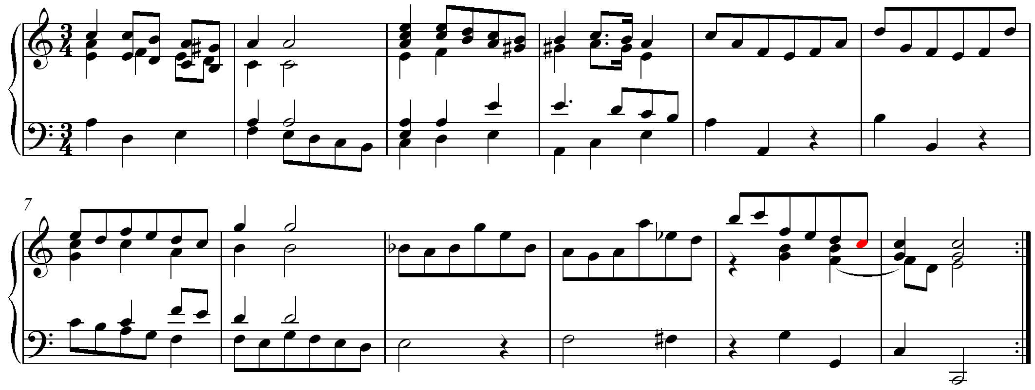
[Answer: “anticipation”]

Conclusion:

There are four main categories of nonharmonic tones: passing tones, neighbor tones, suspensions, and anticipations. Passing and neighbor tones are melodically derived embellishments. They result from melodically filling in gaps between chord tones and from embellishing chord tones in order to create interesting melodic lines. They may be accented or unaccented. Suspensions and anticipations, on the other hand, are rhythmically derived embellishments. They result from rhythmic modifications (delays, accelerations) of melodic lines. Suspensions are accented, anticipations unaccented.

Nonharmonic tones are important features of tonal music. Composers use them to enrich and enliven their compositions. A firm understanding of the functions and peculiarities of nonharmonic tones is necessary for doing accurate harmonic analysis. Be aware that they can sometimes make it difficult to identify structural harmonies.

