Lesson III: Auxiliary Sonorities

Exam:

Question 1: Complete the following expansion of the E^{b}-major reference sonority with an auxiliary sonority whose bass is a lower neighbor tone:
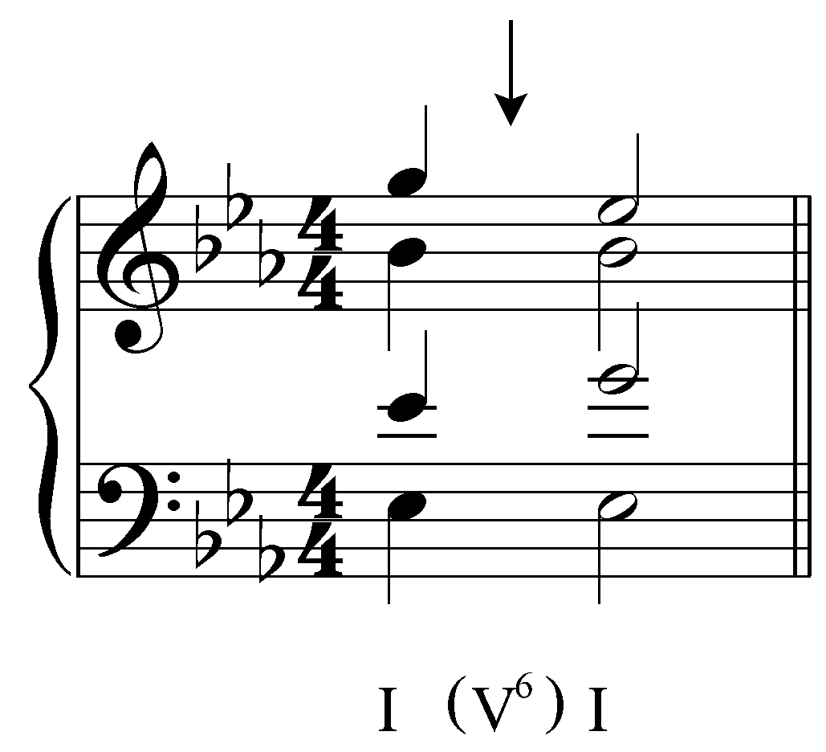
[Answer: 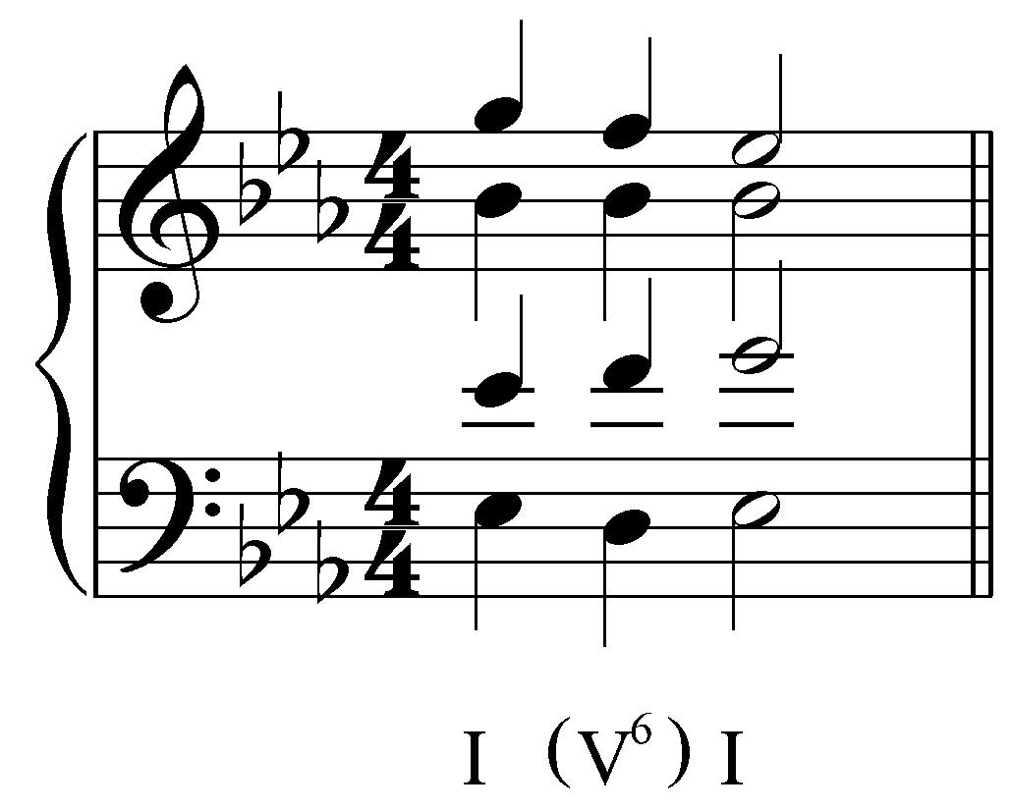. Feedback if correct: “Correct!” Feedback if incorrect: “Incorrect. Your answer should look like this:
.”]

Question 2: Complete the following expansion of the G-minor reference sonority with an auxiliary sonority that sustains the bass of the reference sonority:
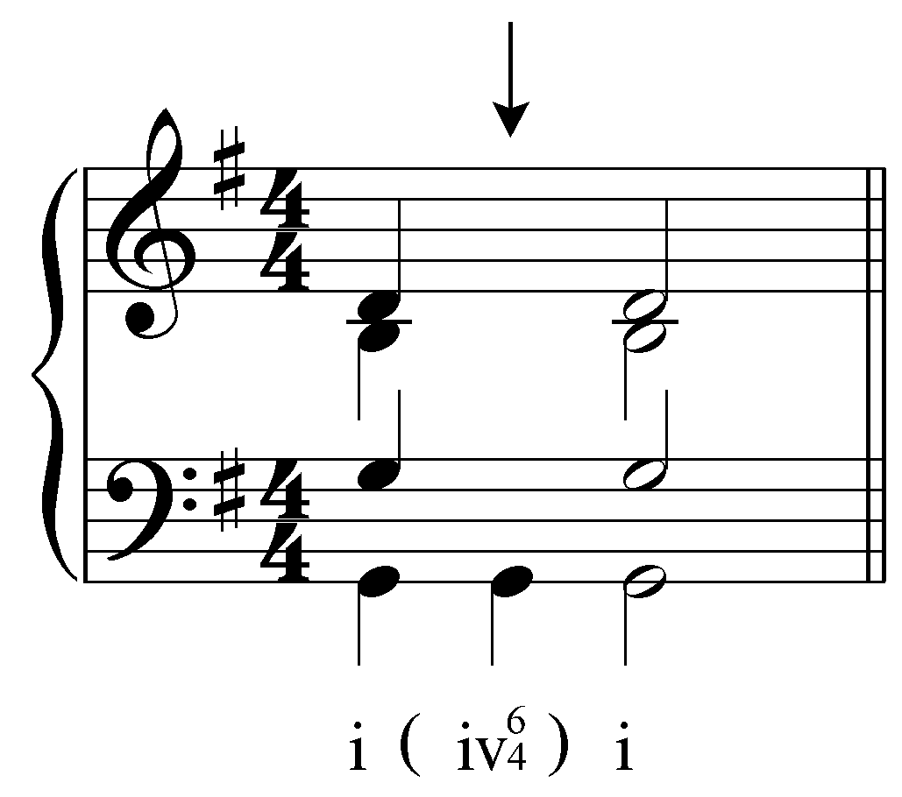
[Answer: 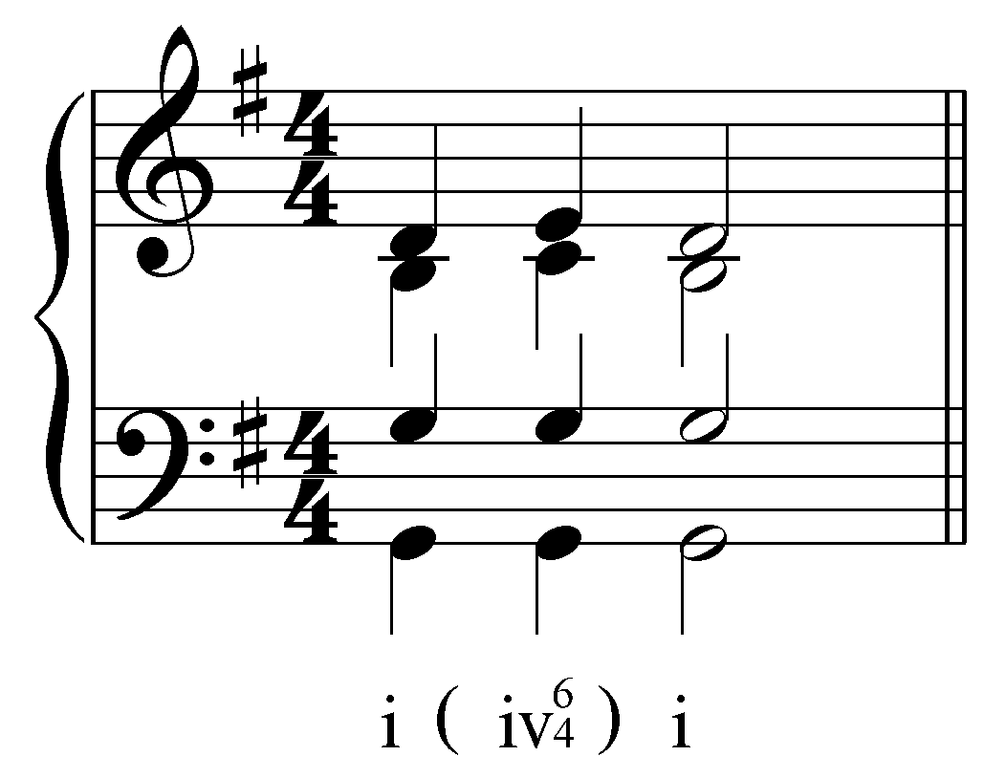. Feedback if correct: “Correct!” Feedback if incorrect: “Incorrect. Your answer should look like this:
.”]

Question 3: Complete the following expansion of the G-minor reference sonority with an auxiliary sonority that sustains the bass of the reference sonority:
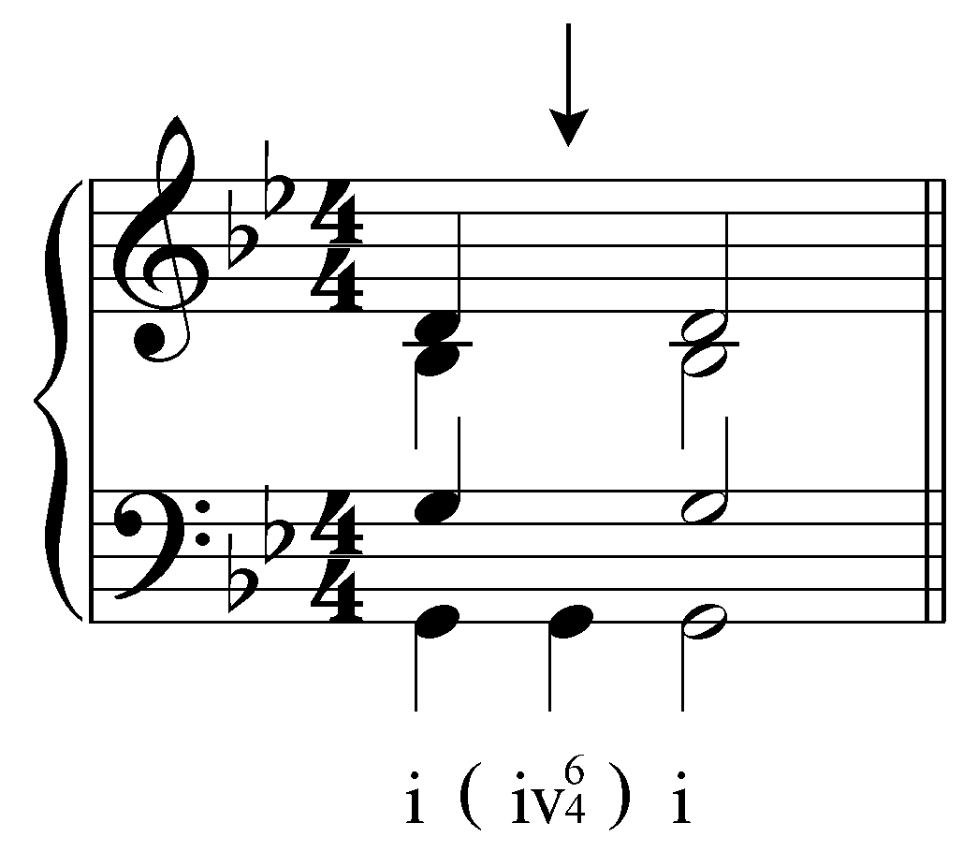
[Answer: 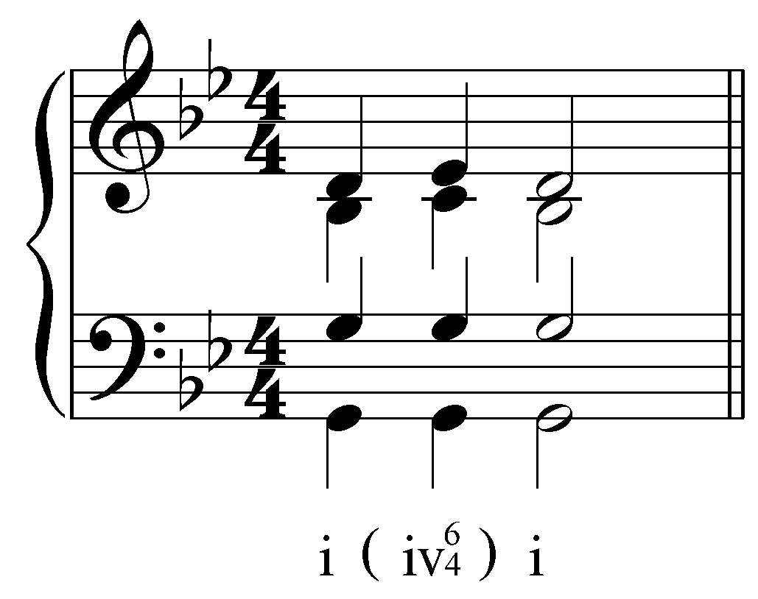. Feedback if correct: “Correct!” Feedback if incorrect: “Incorrect. Your answer should look like this:
.”]

Question 3: Embellish the following expansion by incorporating a passing auxiliary vii^{o6} chord:
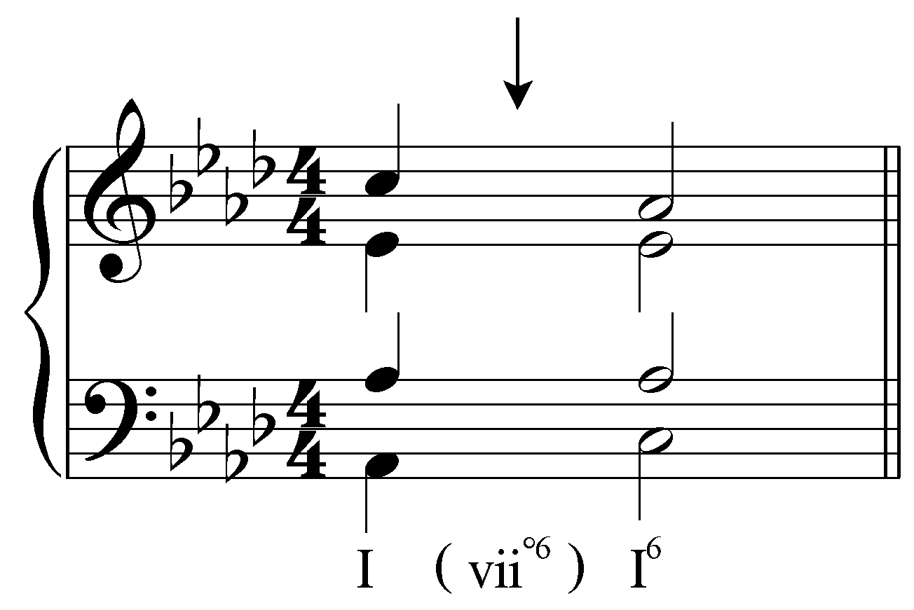
[Answer: 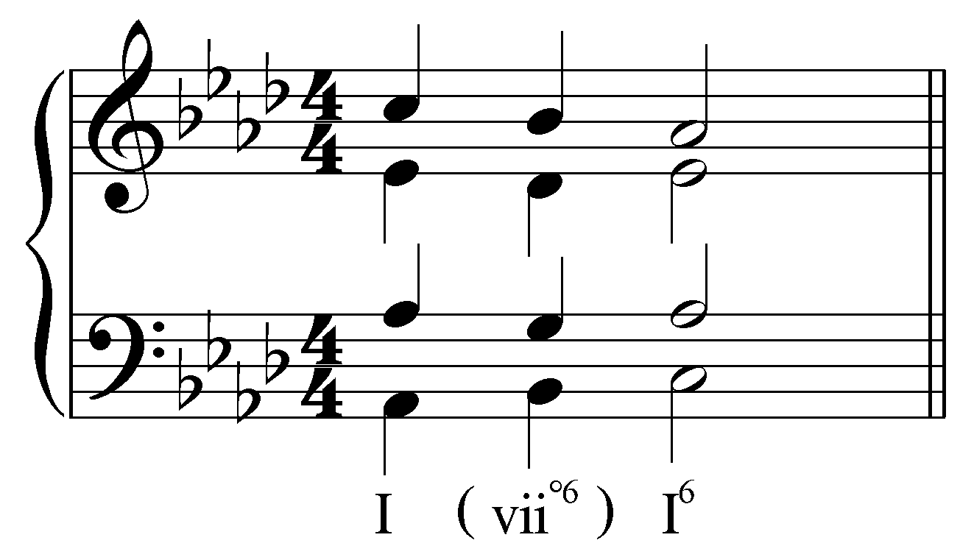. Feedback if correct: “Correct!” Feedback if incorrect: “Incorrect. Your answer should look like this:
.”]

Question 4: In the following excerpt (W.A. Mozart, Sonata No. 2 in F major, K. 280, Mvt. 3, mm. 179-190) identify an auxiliary sonority by clicking on one of the roman numerals below:
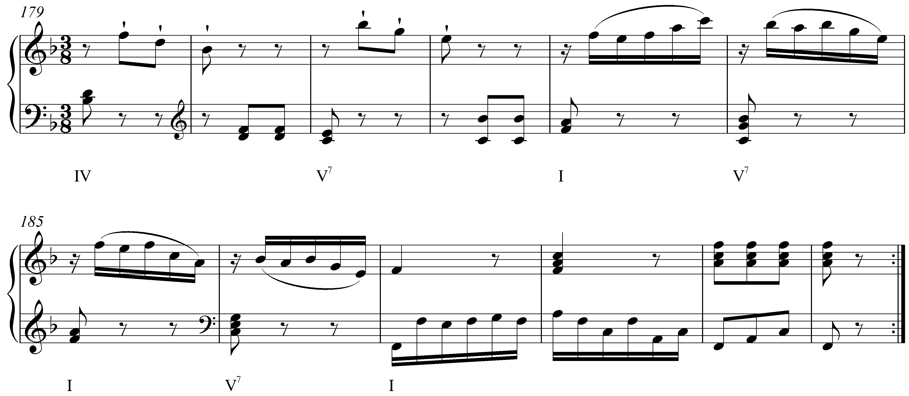
[Answer: either of the V⁷s in mm. 184 and 186. Feedback if correct: “Correct! That is an auxiliary sonority expanding the tonic harmony at the end of the movement.” Feedback if incorrect: “Incorrect. That is not an auxiliary sonority. The V7 chords in m. 184 and m. 186 are auxiliary sonorities expanding the tonic harmony at the end of the movement.”]

Question 5a: In the following passage in C major (J.S. Bach, “Christus ist erstanden, hat überwunden,” BWV 284, mm. 1-2), some non-tonic chord is expanded with an auxiliary sonority. Click on the initial reference sonority:
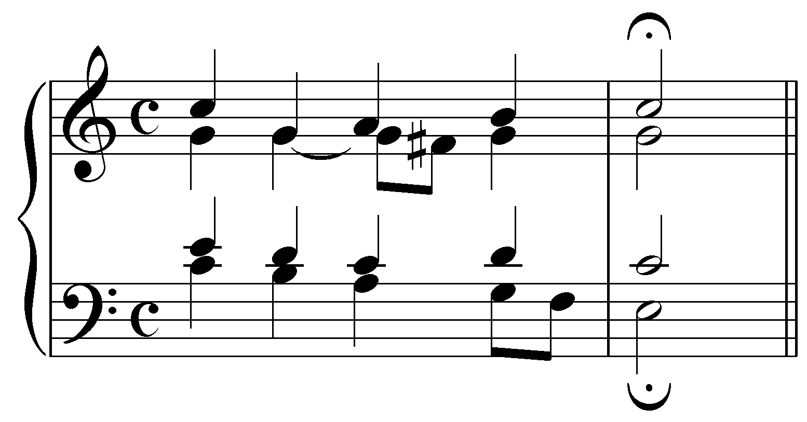
[Answer: the initial reference sonority is the chord on beat two. Feedback if correct: “Correct! ” Feedback if incorrect: “Incorrect. The V chord on beat two of m. 1 is expanded via an auxiliary sonority.”]

Question 5b: What type of auxiliary sonority expansion occurs in m. 1?
[Possible answers: “V (IV) V,” “V(vii^{o6}/V) V,” “V (I${}_{4}^{6}$) V,” “V (vi) V.” Correct answer: “V(vii^{o6}/V) V.” Feedback if correct: “Correct!” Feedback if incorrect: “Incorrect.”]

Question 6a: Identify the fourth above the bass in the cadential ${}_{4}^{6}$ chord in this excerpt (J.S. Bach, “Eins ist not, ach Herr, dies eine,” BWV 304, mm. 22-25) and identify what type of nonharmonic tone it is:
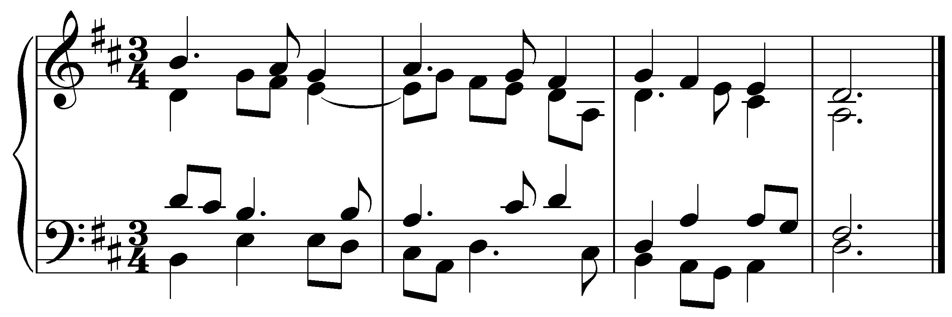
[(Students must click on the note and answer a multiple choice question.) Possible answers for multiple choice: “Anticipation,” “Appoggiatura,” “Suspension,” “Accented passing tone.” Answers: the fourth above the bass is the D dotted quarter note on the downbeat of m. 24 and it is a suspension. Feedback if correct: “Correct!” Feedback if incorrect: “Incorrect.”]

Question 6b: Identify the sixth above the bass in the cadential ${}_{4}^{6}$ chord in this excerpt (J.S. Bach, “Eins ist not, ach Herr, dies eine,” BWV 304, mm. 22-25) and identify what type of nonharmonic tone it is:
[(Students must click on the note and answer a multiple choice question.) Possible answers for multiple choice: “Anticipation,” “Appoggiatura,” “Suspension,” “Accented passing tone.” Answers: the sixth above the bass is the F quarter note on beat 2 of m. 24 and it is an accented passing tone. Feedback if correct: “Correct!” Feedback if incorrect: “Incorrect.”]

