Lesson JJJ: Applied Chords

Exam:

Question 1: Identify and label an applied dominant seventh chord in the following example in D major (J.S. Bach, “Wo Gott, der Herr, nicht bei uns halt,” BWV 258, mm. 1-2):
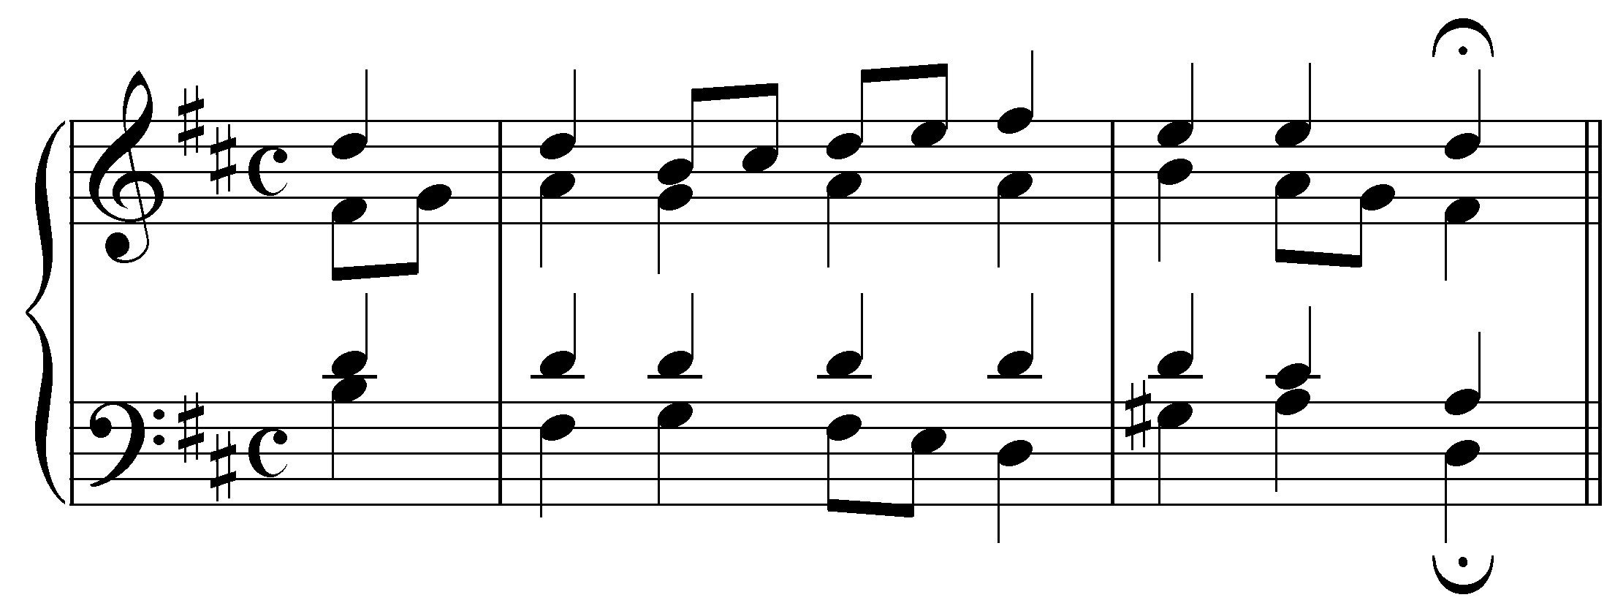
[(Students must click on the chord and fill in a blank for the roman numeral.) Answer: the chord on the downbeat of m. 2 is a V${}_{5}^{6}$/V. Feedback if correct: “Correct!” Feedback if incorrect: “Incorrect. The chord on the downbeat of m. 2 is a V${}_{5}^{6}$/V.”]

Question 2: One of the voices in the following progression contains an error as V7/V resolves to V. Adjust one of the voices in the V chord to fix the voice leading:
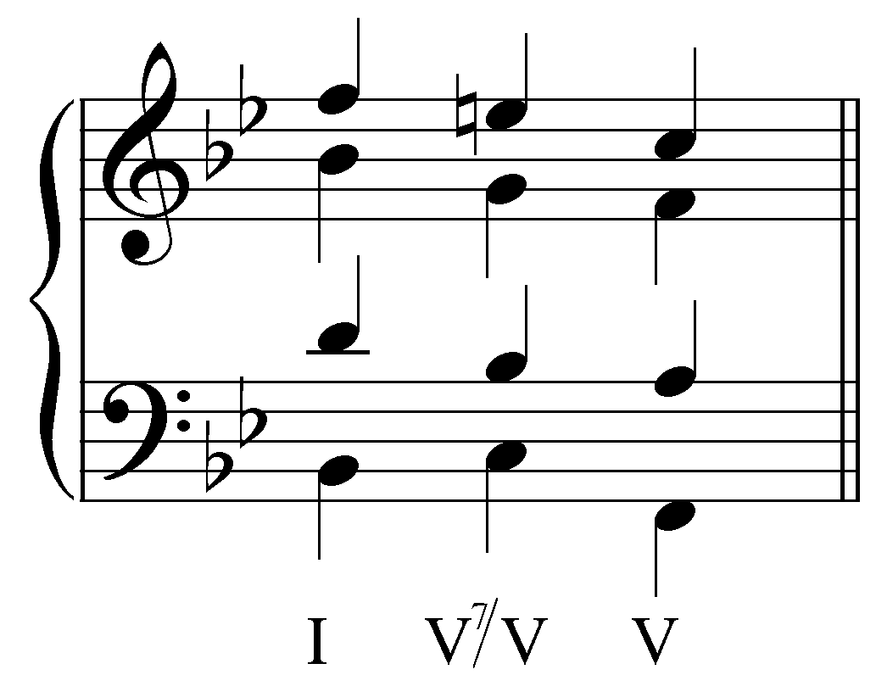
[Answer: soprano should be F instead of C. Feedback if correct: “Correct! The temporary leading tone in the applied chord should resolve to the temporary tonic, especially when it occurs in an outer voice.” Feedback if incorrect: “Incorrect. The temporary leading tone in the applied chord should resolve to the temporary tonic, especially when it occurs in an outer voice. The soprano should be F instead of C.”]

Question 3: In the following example, change one of the notes in the pre-dominant chord on beat three to create a viiº/V:
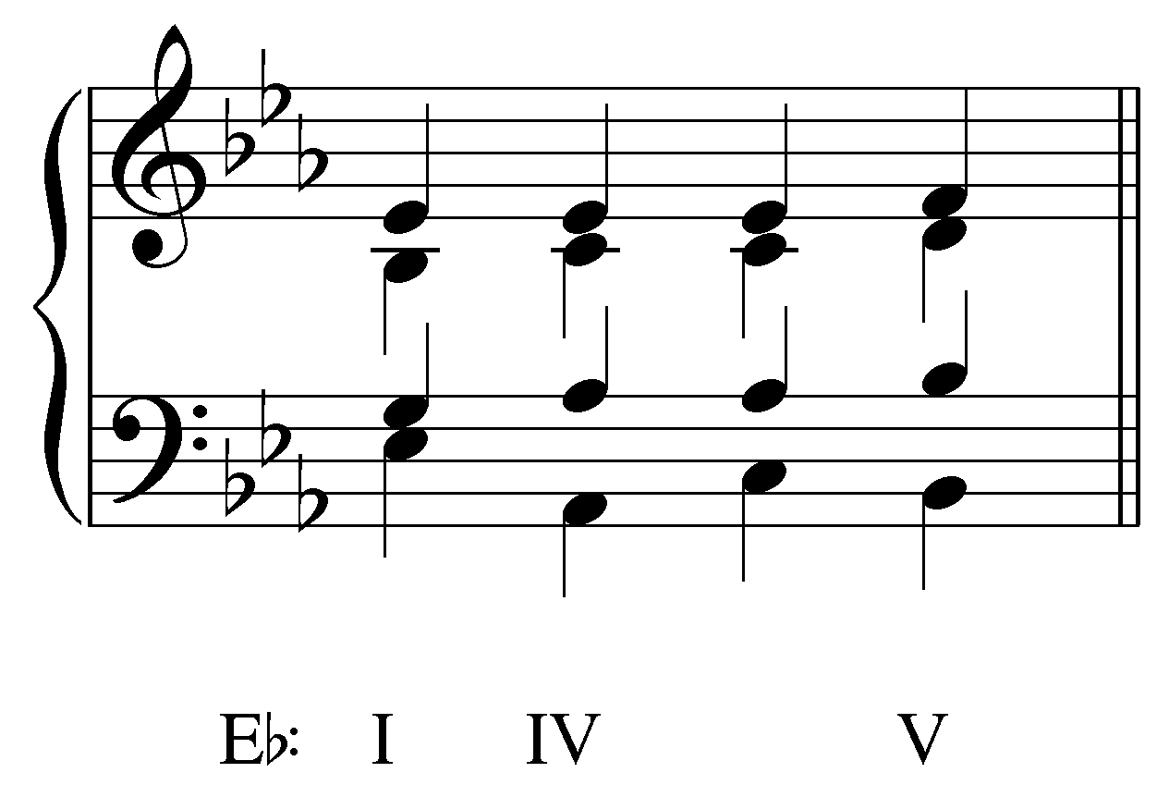
[Answer: 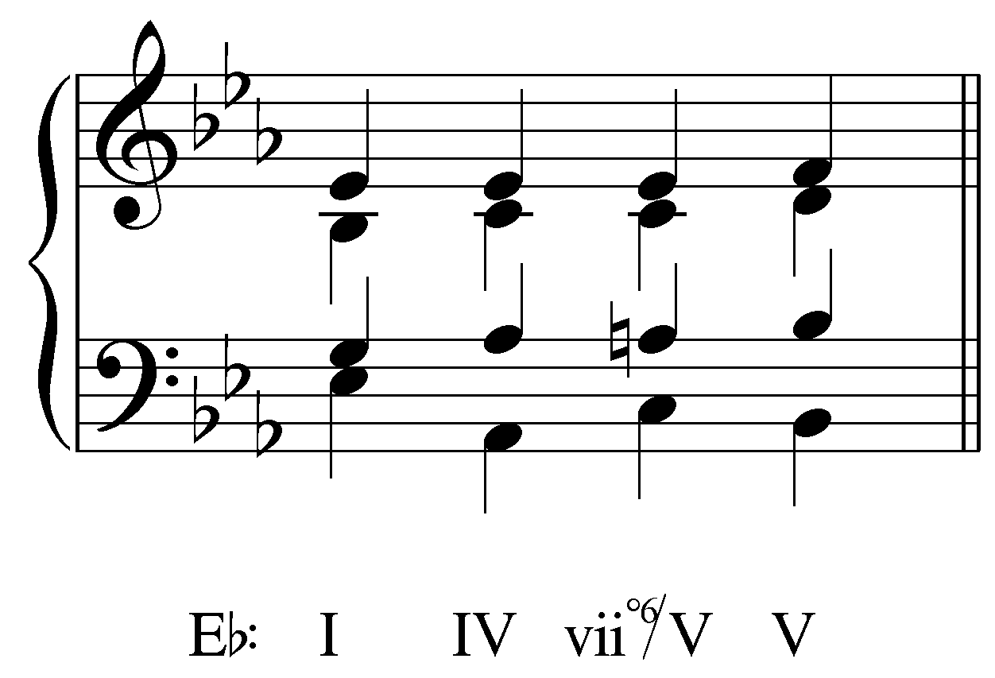. Response if correct: “Correct! Raising the tenor to A natural changes the IV chord into a viiº/V.” Response if incorrect: “Incorrect. The tenor should be raised to A natural on beat three to change the IV chord into a viiº/V.”]

Question 4: One of the voices in the following progression contains an error as vii^{o7}/V resolves to V. Adjust one of the voices in the V chord to fix the voice leading:
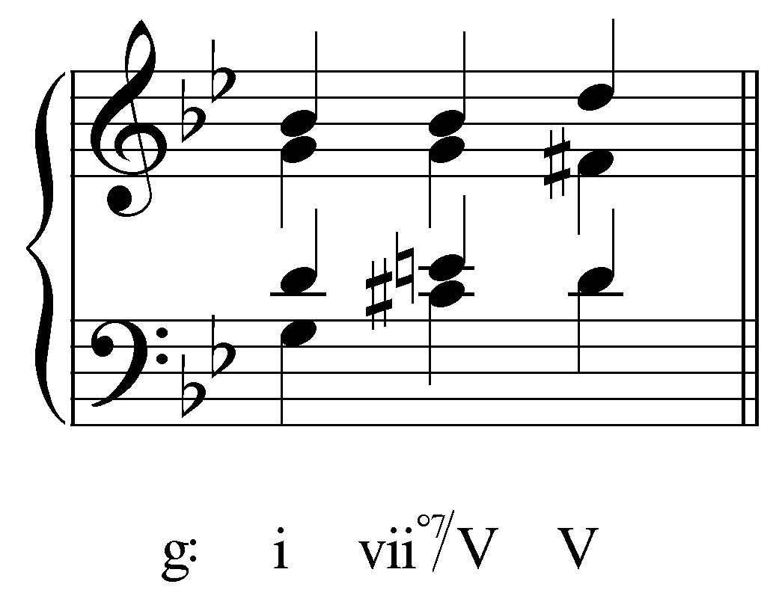
[Answer: soprano should be A instead of D. Feedback if correct: “Correct! The soprano must resolve down by step to A (resolving the tritone formed by E and B^{b} to a perfect fifth).” Feedback if incorrect: “Incorrect. The soprano must resolve down by step to A (resolving the tritone formed by E and B^{b} to a perfect fifth).”]

Question 5a: Identify the tritone in the vii^{o6}/vi of the following excerpt (J.S. Bach, “Wo Gott der Herr nicht bei uns hält,” BWV 256, mm. 3-4):
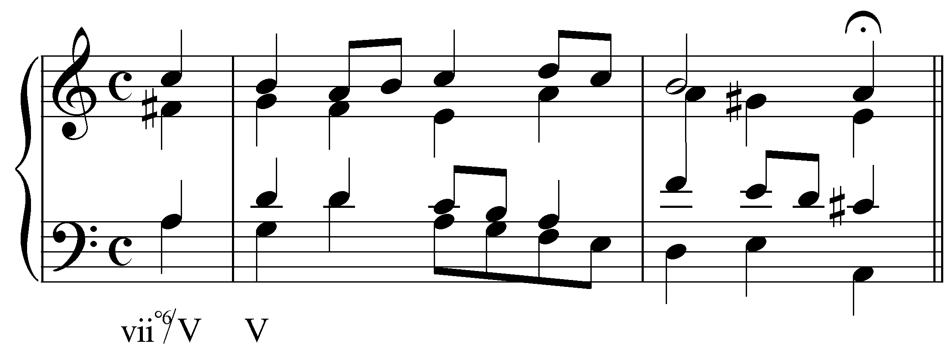
[Possible pitches: A in the bass, A in the tenor, F# in the alto, C in the soprano. Answer: F# in the alto and C in the soprano. Feedback if correct: “Correct! F# and C form a diminished fifth.” Response if incorrect: “Incorrect. Those two pitches do not form a tritone.”]

Question 5b: To what interval does the diminished fifth formed by F# and C resolve in this example?
[Answer: major third (M3). Response if correct: “Correct!” Response if incorrect: “Incorrect. The tritone resolves to a major third on the downbeat of m. 3.”]

Question 6: Complete the progression below by inserting the pitches of a V${}_{2}^{4}$/V chord in A major into the most logical voices:
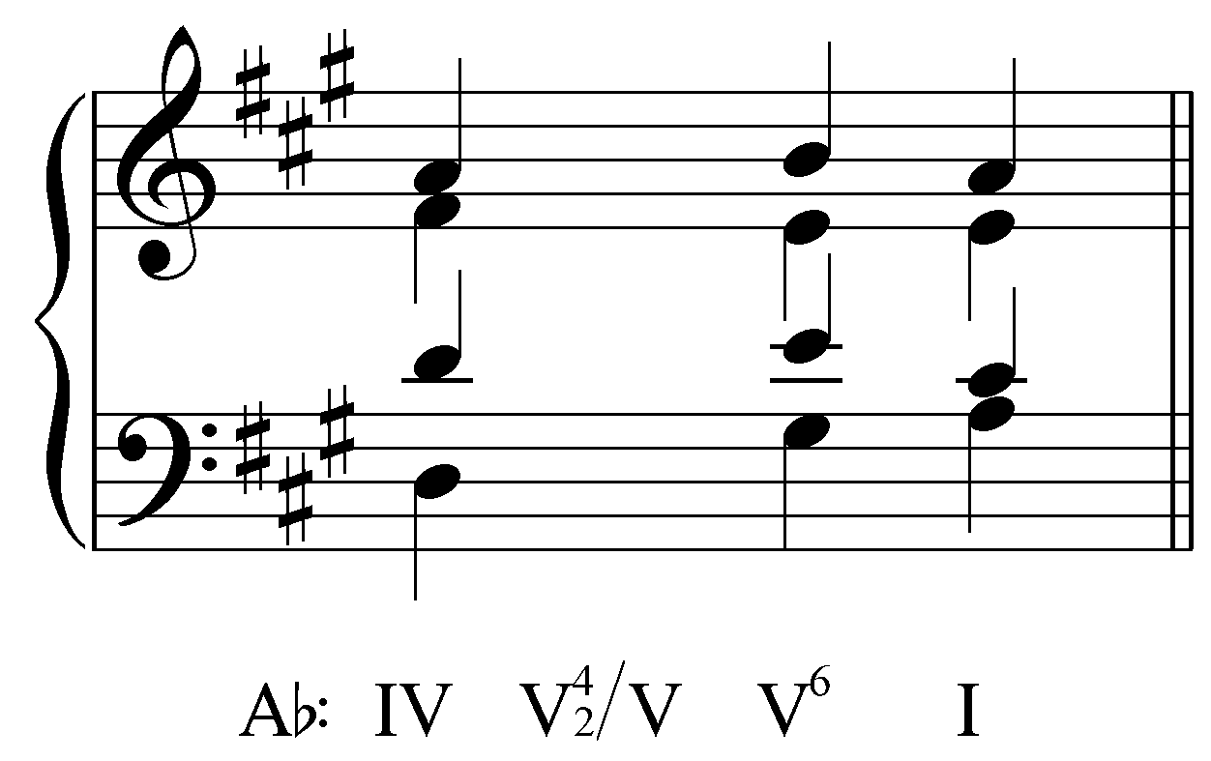
[Answer: 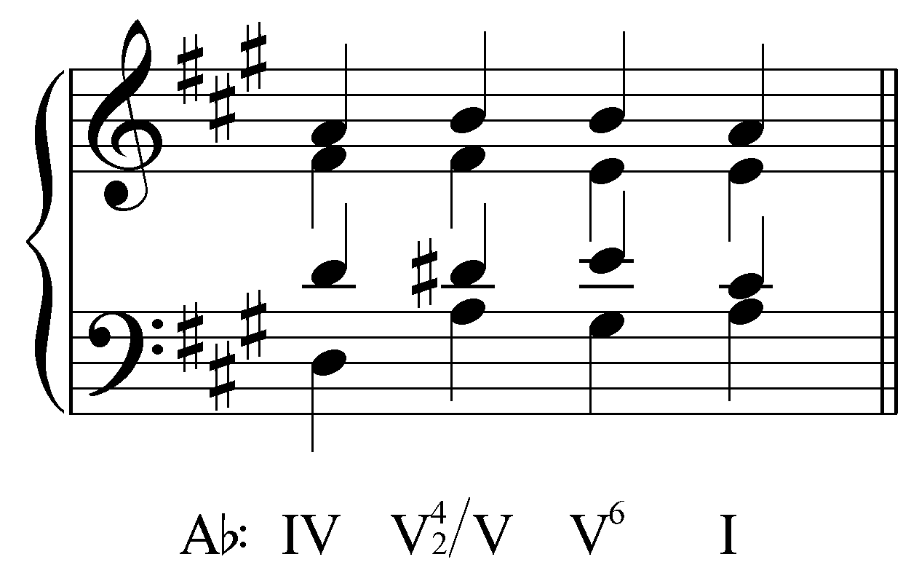. Feedback if student’s answer matches: “Correct!” Feedback if student’s answer does not match: “Incorrect. The most logical placement of the pitches of a V${}_{2}^{4}$/V chord in A major would be as follows: .”]

