Lesson JJJ – Applied Chords

Introduction:

Very frequently, when analyzing tonal music, you will encounter chords that include non-diatonic pitches. Some of them, like those discussed in Lesson III, arise from voice-leading procedures and expand a reference sonority. We will now look at another set of sonorities, known as applied chords, which also enrich the harmonic vocabulary by incorporating chromatically altered pitches.

Applied chords are ones modeled on familiar dominant-function chords (V, V⁷, viiº, vii^{o7}, and viiØ⁷) and suggest a momentary, pseudo-tonic function for a chord other than the global tonic. Momentarily highlighting such a pseudo-tonic by means of a pseudo-dominant chord is called tonicization.

In this lesson, we will first discuss the difference between modulation and tonicization. That distinction is essential for understanding how applied chords work. We will then look at several examples of applied dominant chords and applied leading-tone chords, and will discuss associated voice-leading issues.

Modulation vs. tonicization:

As mentioned above, tonicization occurs when a chord other than the global tonic is heard momentarily, or in passing, as a rival tonic. By contrast, a modulation establishes a new key more enduringly, generally as a sign of large-scale structural organization, sometimes even leading to a change in key signature. Tonicization and modulation are most clearly differentiated by duration and structural significance. A tonicization is brief, lasting from two or three chords to a phrase, and is not a factor in a work’s overall structure. A modulation, on the other hand, takes hold for a longer period, usually prevailing for an entire section, and is a factor in a work’s overall structure.

Because modulation entails a change of key, it almost always has one or more key-defining cadences, among them often a perfect authentic cadence. In the case of a tonicization, although the resolution of an applied chord sounds cadential, the tonicized chord soon loses its pseudo-tonic function and reverts to its diatonic function, with no change of key.

You may have come across such terms as “implied tonic” or “temporary tonic” to identify and describe the chord being tonicized. In these lessons we will use “pseudo-tonic.” This terminology reflects the fact that the chord being tonicized retains its function in terms of the global key. It is given tonic coloration, but never actually attains a tonic function.

As you will see in later lessons, applied chords can be used to initiate a modulation. For now, we will limit our discussion to tonicizations.

Activity 10.1:
Being able to distinguish tonicizations from modulations can be difficult. In this exercise, you will be given two hypothetical situations. One of them describes a tonicization, the other a modulation. It is up to you to decide which is which.

[Matching question:]

Situation 1: “You are analyzing a song by Schubert. The song begins in G major and stays there for two whole stanzas. In the third stanza, however, you notice that the Ds have consistently become D#s. The third stanza ends with a perfect authentic cadence on an E-minor chord. The fourth stanza ends the same way. The D#s become absent for the fifth and final stanza which ends conclusively in G major.”

Situation 2: “You are analyzing a movement from a symphony by Haydn. The movement is in B^{b} major, but towards the end you come across a single C-major chord. This chord leads immediately to an F-major harmony, and for a moment, this pair of chords seems to imply an F-major tonality. This sense is fleeting, however, and the F-major chord moves to a B^{b}-major chord. The harmony then alternates several times between F-major and B^{b}-major chords, lending a strong sense of repose to end the movement.”

[Answer: Situation 1 = modulation, Situation 2 = tonicization. Response if correct: “Correct!” Response if incorrect: “Incorrect. Remember, modulations tend to have several key-defining cadences while tonicizations are fleeting. Try again.”]

Applied dominant chords:

The pervasive dominant/tonic relationship is the most important, defining characteristic of tonal music. Precisely because that harmonic relationship is so common and characteristic, tonicization is possible. We immediately recognize the link between an applied dominant and the chord being tonicized.

In the following example, a V chord is tonicized by an applied dominant chord. We read the progression “one, five of five, five.”

Example 1:
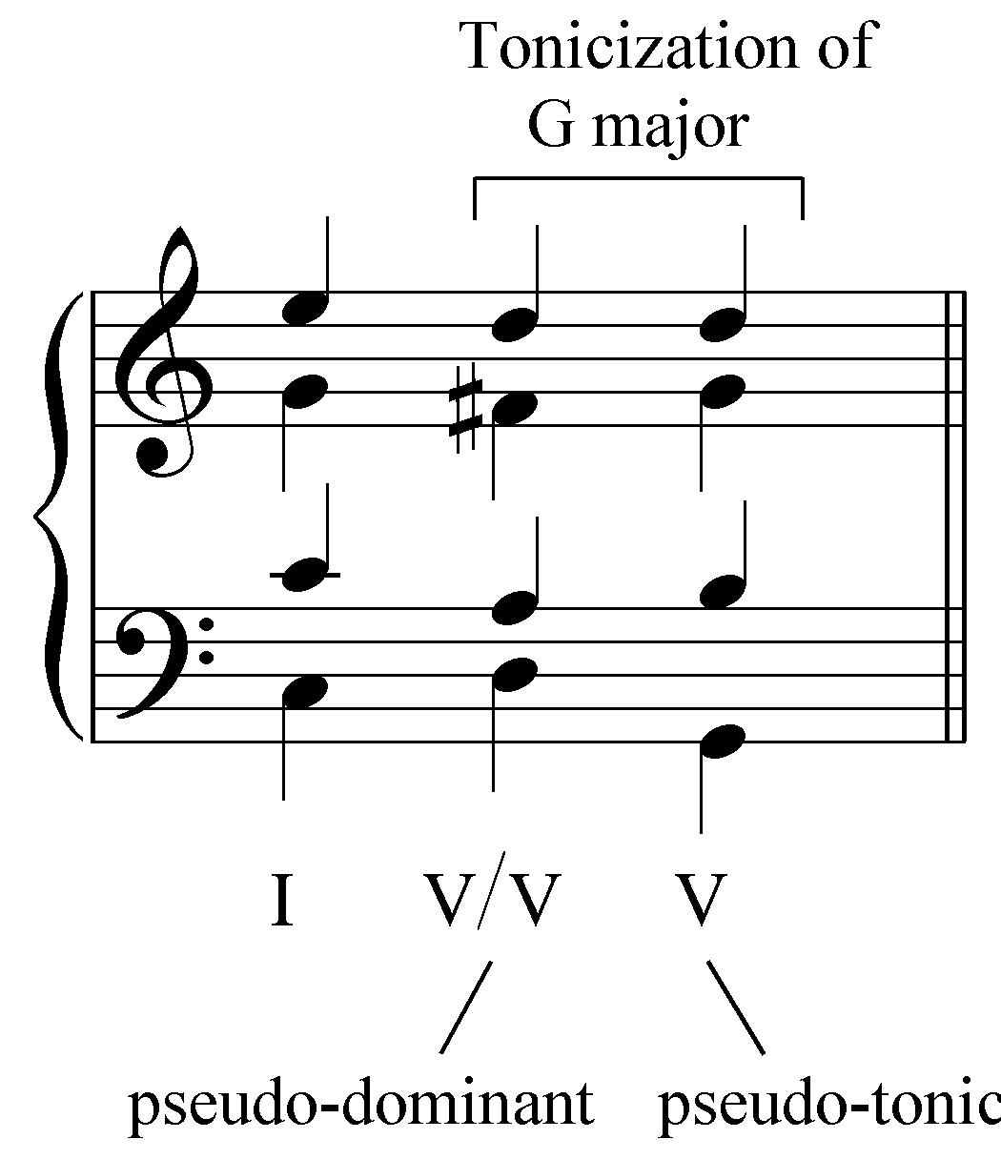

The dominant in C major is a G-major chord (the V on beat three). The applied chord is formed from the pitches of the key implied by the pseudo-tonic. Since a G-major chord is being tonicized, the applied dominant is built from the pitches of the dominant chord in G major, the pseudo-tonic key. (As mentioned above, the chord being tonicized is referred to as a pseudo-tonic because in the larger context, it does not have tonic function. In Example 1 the V chord is still the dominant.) The dominant of G major is a D major chord. Thus, the applied dominant to G major has the pitches D, F#, and A. As you can see in Example 1, the applied chord resolves normatively as if in the key of the pseudo-tonic. Most importantly, the key-defining temporary leading tone, F#, resolves up by semitone to the pseudo-tonic keynote, G.

The voice-leading from V/V to V in Example 1 can be explained using the same methods outlined in Lesson AAA (Basic Interval Progressions). The primary interval progression is formed by the bass and tenor: “5 - 8” as the bass leaps down from D to G and the tenor steps up from A to B. The alto harmonizes in parallel sixths with the tenor and the soprano forms an oblique “6 - 5” progression with the alto.

Applied chords are readily identifiable because they contain chromatic pitches. In Example 1, the V/V contains an F#. F# is the leading tone in G major and its presence in the applied dominant is indispensable for implying pseudo-tonic status for the G major chord. As with any chromatic pitch, temporary leading tones in applied dominants must be treated carefully. Ideally, the chromatic pitch should be approached by step, taking care to avoid linear augmented intervals (scale degree 3 to #4 in minor, for example), and to resolve dissonances according to established, conventional interval progressions.

The voice leading from V/V to V can be shown with the basic interval progressions from Lesson AAA: the bass and tenor form the familiar cadential “5 - 8” progression, the alto ascends in parallel sixths with the tenor, and the soprano harmonizes the alto with an oblique “6 - 5” progression. These patterns are shown in Example 2:

Example 2:
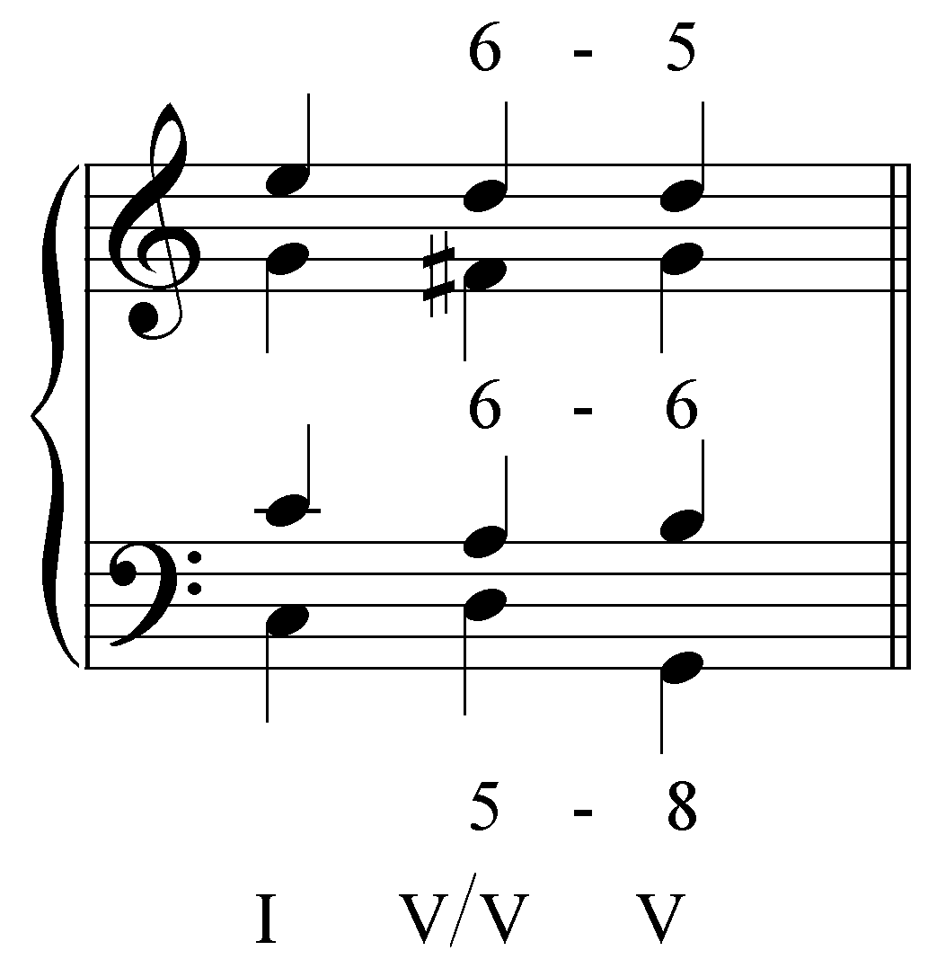

Tonicization of the V chord with an applied dominant triad occurs very frequently in tonal music. The following four examples show similar applied chords drawn from Bach chorales.

Example 3 (J.S. Bach, “Ach Gott und Herr, wie groß und schwer midi,” BWV 255, m. 1):
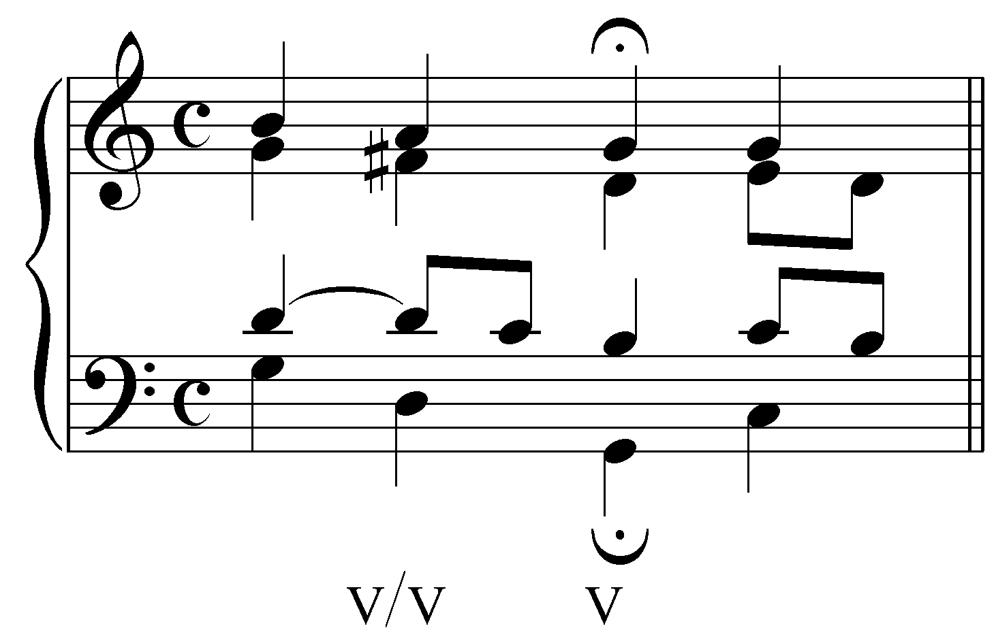

Example 4 (J.S. Bach, “Wie schön leuchtet der Morgenstern,” BWV 36(2).4, m. 2):
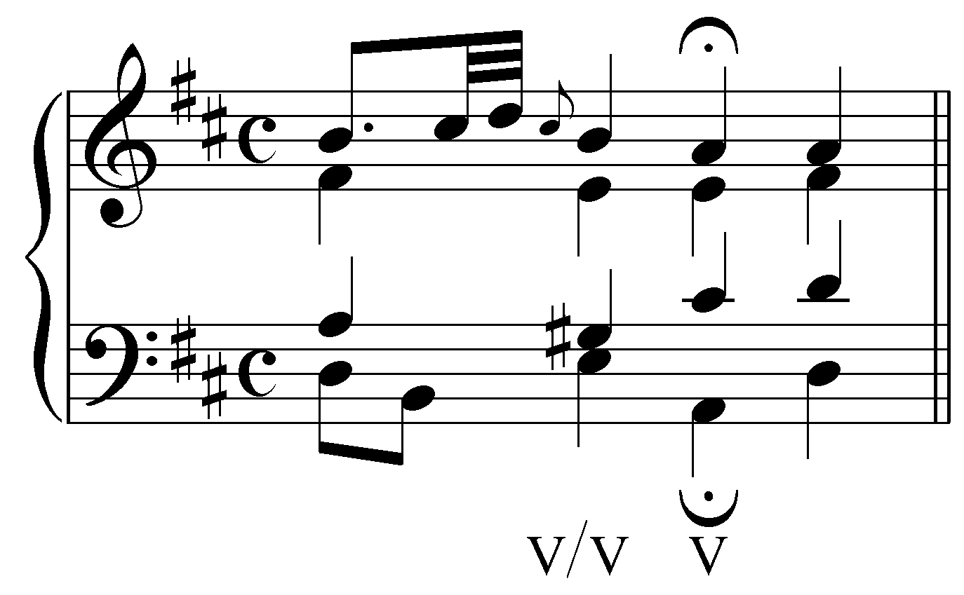

Example 5 (J.S. Bach, “Ermuntre dich, mein schwacher Geist,” BWV 43.11, mm. 3-4):
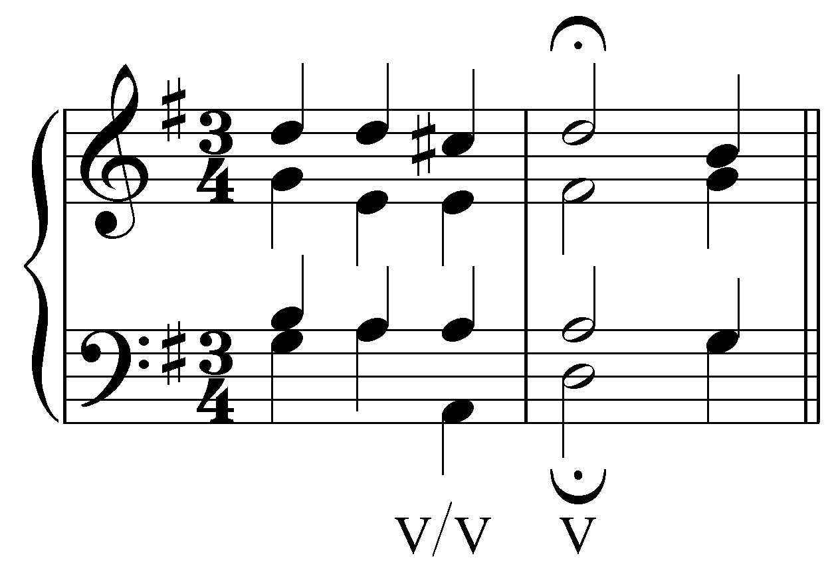

Example 6 (J.S. Bach, “Kommt her, ihr lieben Schwesterlein,” BWV 151.5, mm. 3-4):
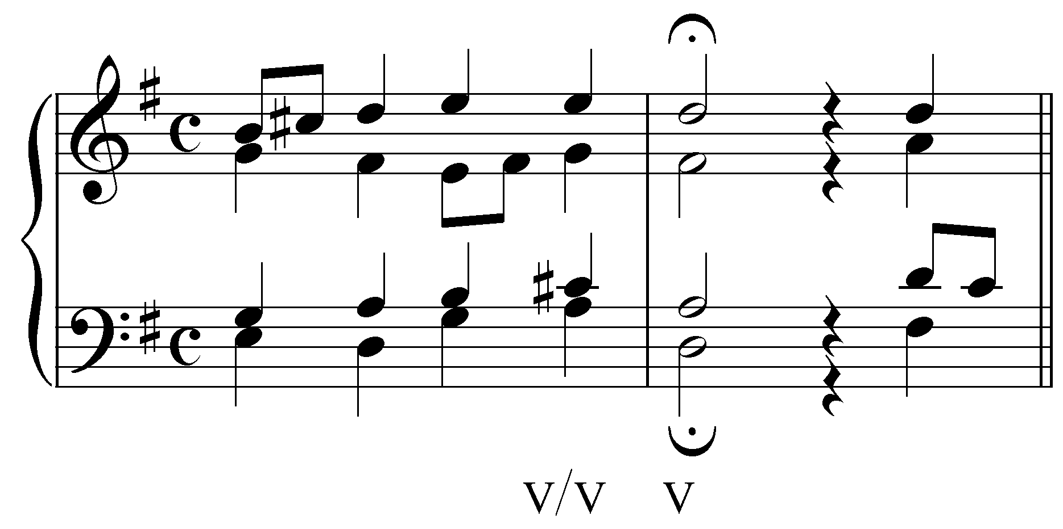

It will help you in identifying tonicizations of V by noticing that in each of the above examples, scale degree 4 is raised (the F# in Example 3, the G# in Example 4, and so on). Scale degree 4 must be raised in an applied chord in order to function as the temporary leading tone to V.

Activity 10.2:
In this activity, you will be presented with a series of chorale excerpts, each containing a tonicization of the dominant. For each exercise, first identify the leading tone, then label the chord with the appropriate roman numeral (e.g., “V/V”).

Exercise 10.2a:
In the following excerpt (J.S. Bach, BWV 41.6s, “Jesu, nun sei gepreiset,” mm. 3-4), identify a temporary leading tone:
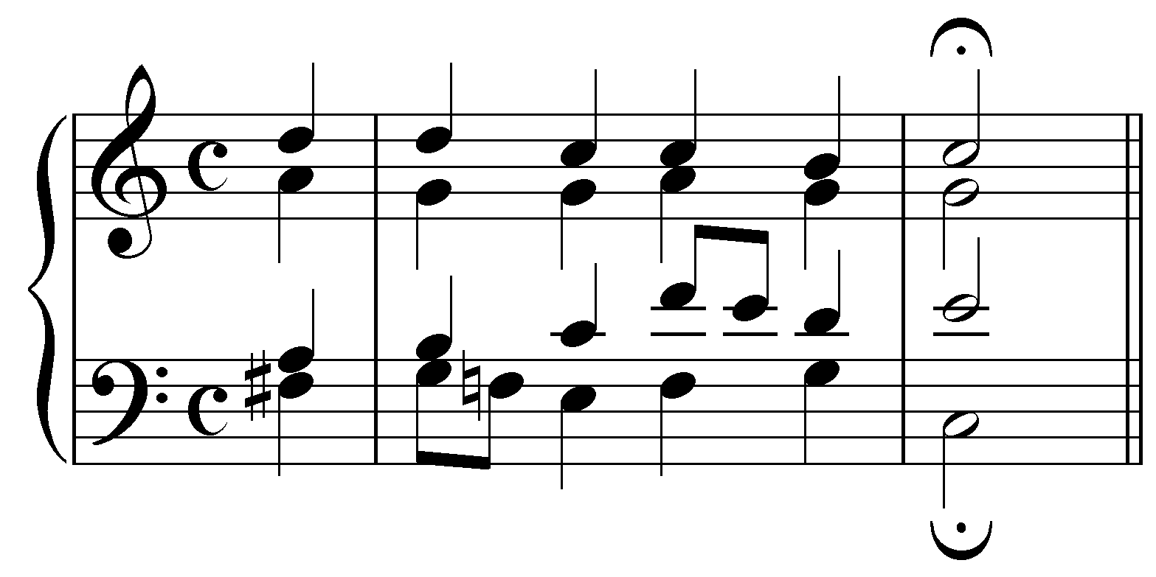
[Answer: F# in the pickup beat.]
[Follow-up question:] In the global key of C major, how should the chord containing the F# be labeled?
[Answer: “V/V”]

Exercise 10.2b:
In the following excerpt (J.S. Bach, BWV 318, “Menschenkind, merk eben,” mm. 3-6), identify a temporary leading tone:
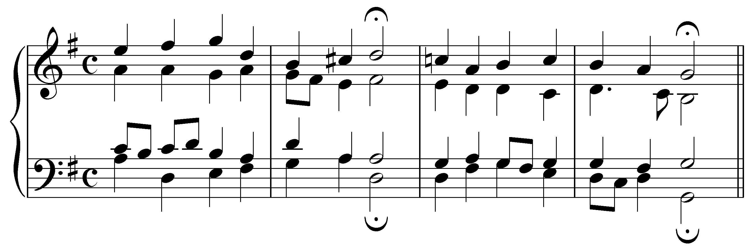
[Answer: C# in the pickup beat.]
[Follow-up question:] In the global key of G major, how should the chord containing the F# be labeled?
[Answer: “V/V”]

Exercise 10.2c:
In the following excerpt (J.S. Bach, BWV 153.9, “Herr Jesu Christ, meins Lebens Licht,” mm. 13-16), identify a temporary leading tone:
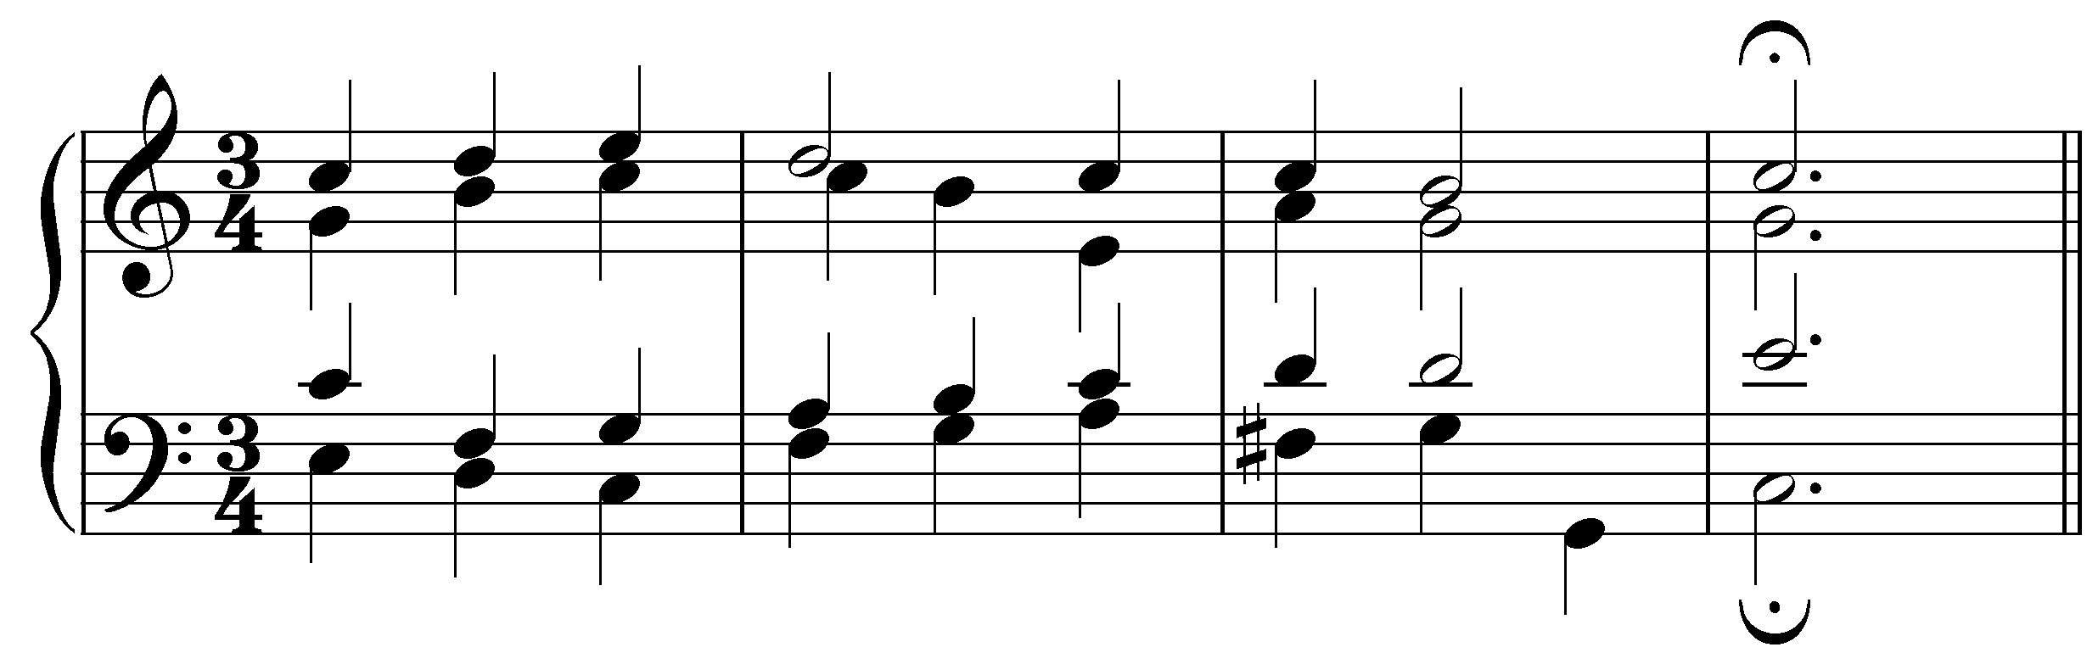
[Answer: F# in bass, m. 15.]
[Follow-up question:] In the global key of C major, how should the chord containing the F# be labeled?
[Answer: “V/V”]

Exercise 10.2d:
In the following excerpt (J.S. Bach, BWV 43.11, “Ermuntre dich, mein schwacher Geist,” mm. 1-8), identify a temporary leading tone:
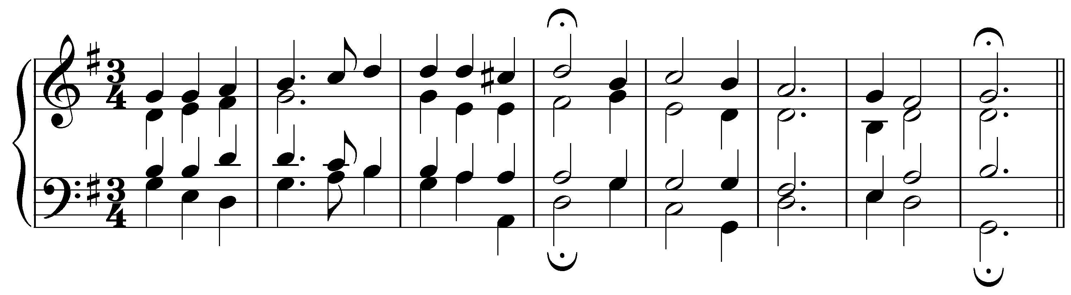
[Answer: C# in the pickup beat.]
[Follow-up question:] In the global key of G major, how should the chord containing the C# be labeled?
[Answer: “V/V”]

While the above examples illustrated applied dominant triads, applied chords can also contain a chordal seventh:

Example 7:
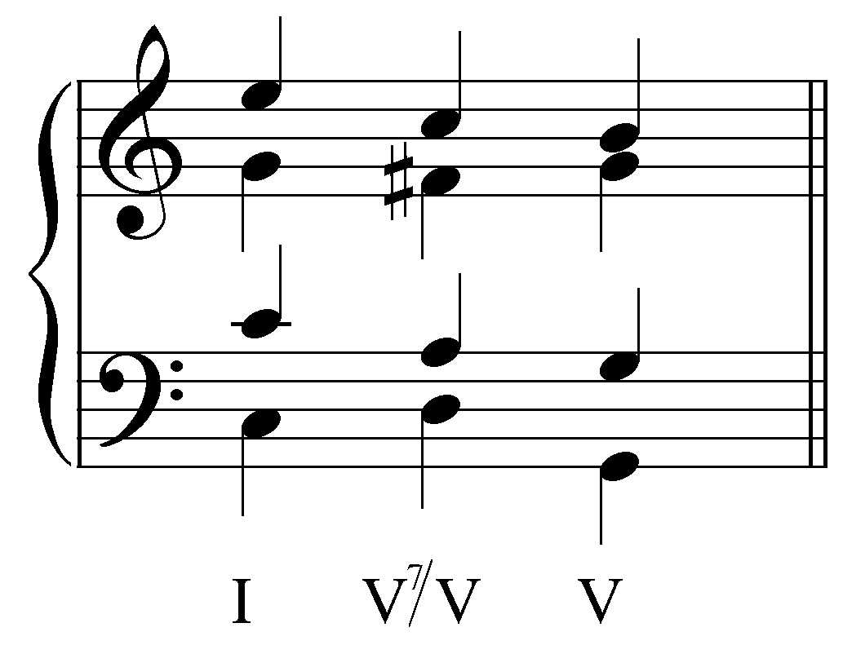

The major-minor seventh sonority is used more often than the triad because it has an immediately and unmistakably recognizable dominant function. (As discussed in Lesson GGG, the dominant seventh chord is the only diatonic major-minor seventh chord.) In other words on hearing a major-minor seventh, we instinctively assign it a dominant function. That instinct is confirmed when the chord resolves—as it does from the second to the third beat in Example 7—to the pseudo-tonic. As in Example 1, the applied dominant seventh in Example 7 resolves as it would in the key of G major. Most importantly, the leading tone resolves up by step and the chordal seventh down. (Refer to Lesson EEE to review proper treatment of dominant seventh chords.)

Applied dominant seventh chords resolve according to the same conventions of basic interval progressions presented in Lessons AAA (basic interval progressions) and GGG (the dominant seventh chord). In Example 7, the diminished fifth (F# and C) formed by alto and soprano in the applied dominant contract to form a major third (d5 - M3). The soprano and tenor illustrate basic interval progression “3 - 3,” alto and tenor “6 - 8,” and tenor and bass the special cadential progression “5 - 8”.

Example 8:
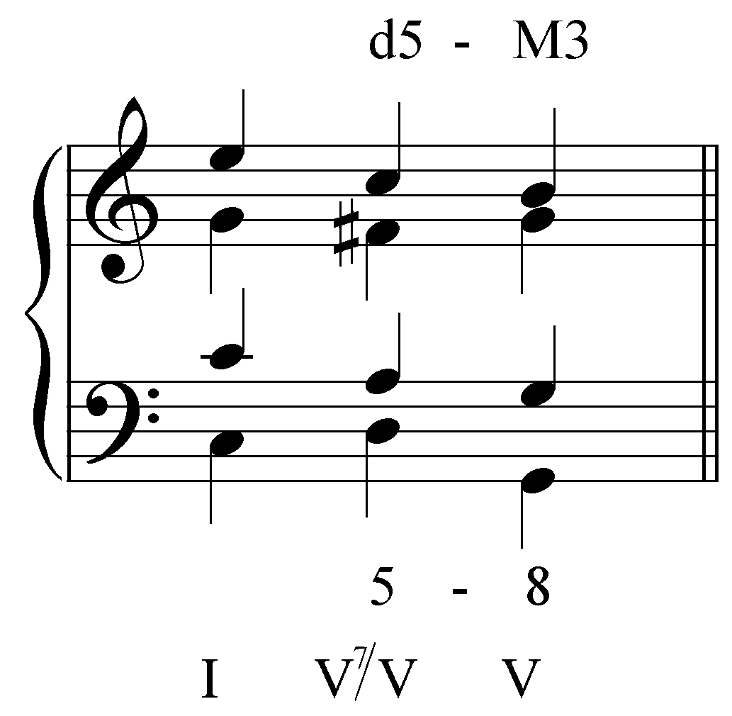

Activity 10.3:
Applied dominant seventh chords resolve according to the same conventions as diatonic dominant seventh chords. In this activity, you will analyze the voice leading in a series of brief progressions, each containing an applied dominant seventh chord.

Exercise 10.3a:
Is the voice leading in the following example correct as V⁷/V resolves to V?
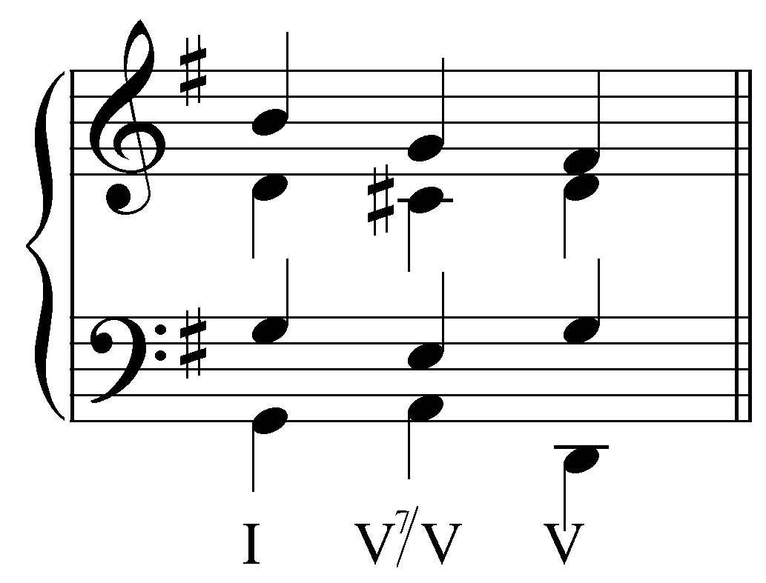
[Answer: No. Response if correct: “Correct! One of the voices in the V⁷/V chord does not resolve correctly.” Response if incorrect: “Incorrect. There is a problem with the voice leading.”]
[Follow-up activity:] Fix the voice-leading by adjusting one of the voices of the V chord.
[Answer: tenor should be D instead of G. Response if correct: “Correct! G does not actually belong to the V chord in G major. Resolving to D is a much better choice.” Response if answer moves another voice: “Incorrect. The voice leading in that voice is fine as is.” Response for any other answer: “Incorrect. Try again.”]

Exercise 10.3b:
Is the voice leading in the following example correct as V⁷/V resolves to V?
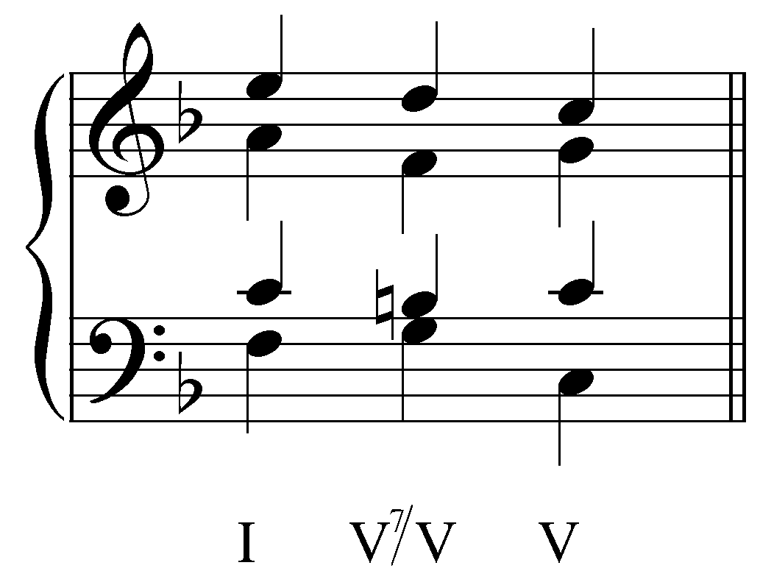
[Answer: No. Response if correct: “Correct! One of the voices in the V⁷/V chord does not resolve correctly.” Response if incorrect: “Incorrect. There is a problem with the voice leading.”]
[Follow-up activity:] Fix the voice-leading by adjusting one of the voices of the V chord.
[Answer: alto should be A instead of C. Response if correct: “Correct! The seventh of the applied dominant seventh chord should resolve down by step.” Response if answer moves another voice: “Incorrect. The voice leading in that voice is fine as is.” Response for any other answer: “Incorrect. Try again.”]

Exercise 10.3c:
Is the voice leading in the following example correct as V⁷/V resolves to V?
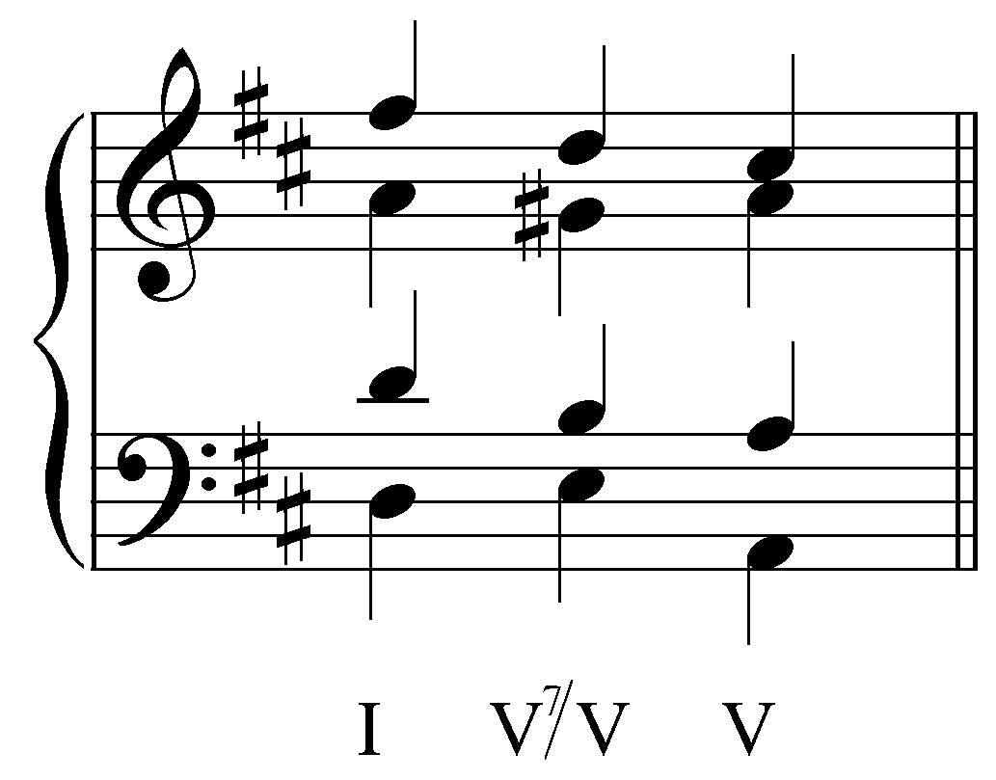
[Answer: Yes. Response if correct: “Correct! All of the voices in the V⁷/V chord resolve correctly.” Response if incorrect: “Incorrect.”]

Exercise 10.3d:
Is the voice leading in the following example correct as V⁷/V resolves to V?
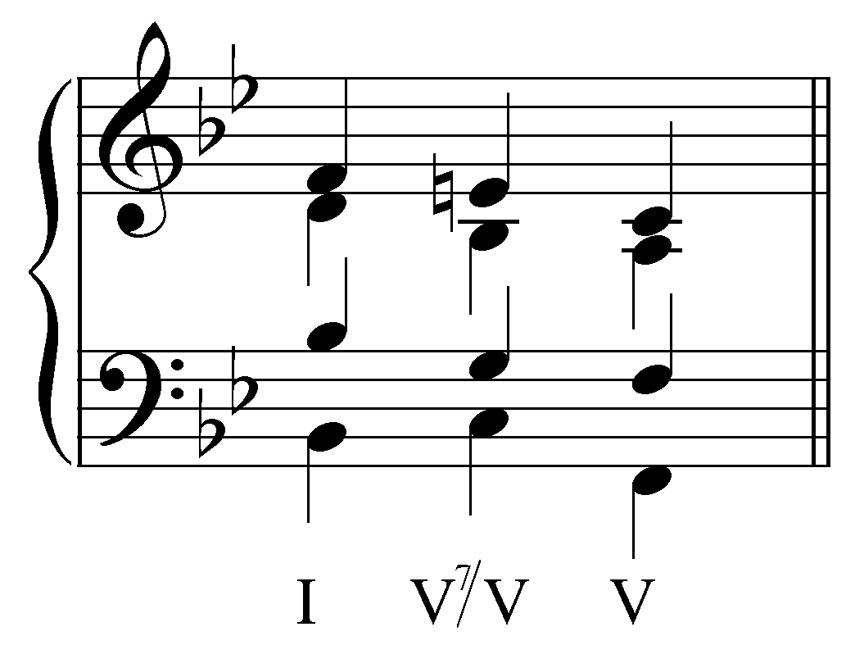
[Answer: No. Response if correct: “Correct! One of the voices in the V⁷/V chord does not resolve correctly.” Response if incorrect: “Incorrect. There is a problem with the voice leading.”]
[Follow-up activity:] Fix the voice-leading by adjusting one of the voices of the V chord.
[Answer: soprano should be F instead of C. Response if correct: “Correct! The leading tone of applied dominant should resolve to the temporary tonic.” Response if answer moves another voice: “Incorrect. The voice leading in that voice is fine as is.” Response for any other answer: “Incorrect. Try again.”]

An applied chord itself may also be expanded. The following example shows a tonicization of V with a V/V preceded by a cadential ${}_{4}^{6}$ chord:

Example 9:
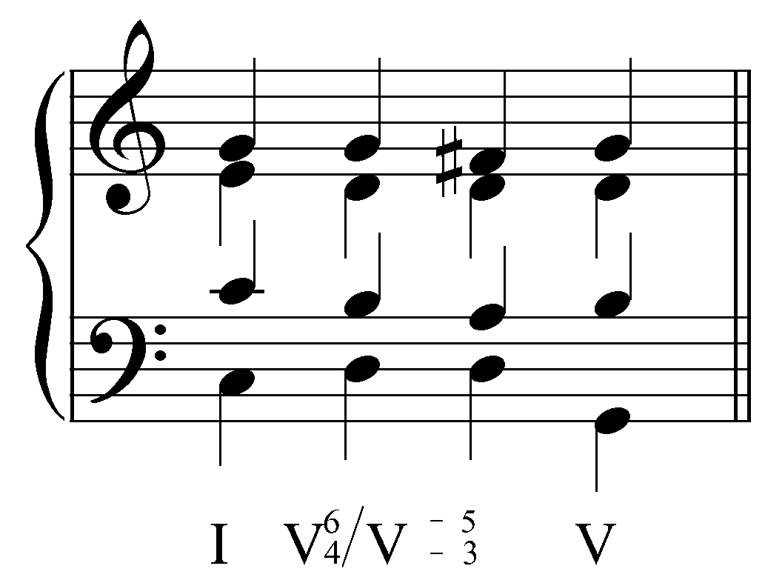

The sixth and fourth above the bass resolve downwards by step—just as they would in a typical cadential progression—creating the applied dominant harmony before resolving to the tonicized V.

Although other chords besides V may be tonicized (more on this below), tonicization of the dominant is a special case. The following example shows a common progression from the tonic to the dominant through a pre-dominant ii chord:

Example 10:
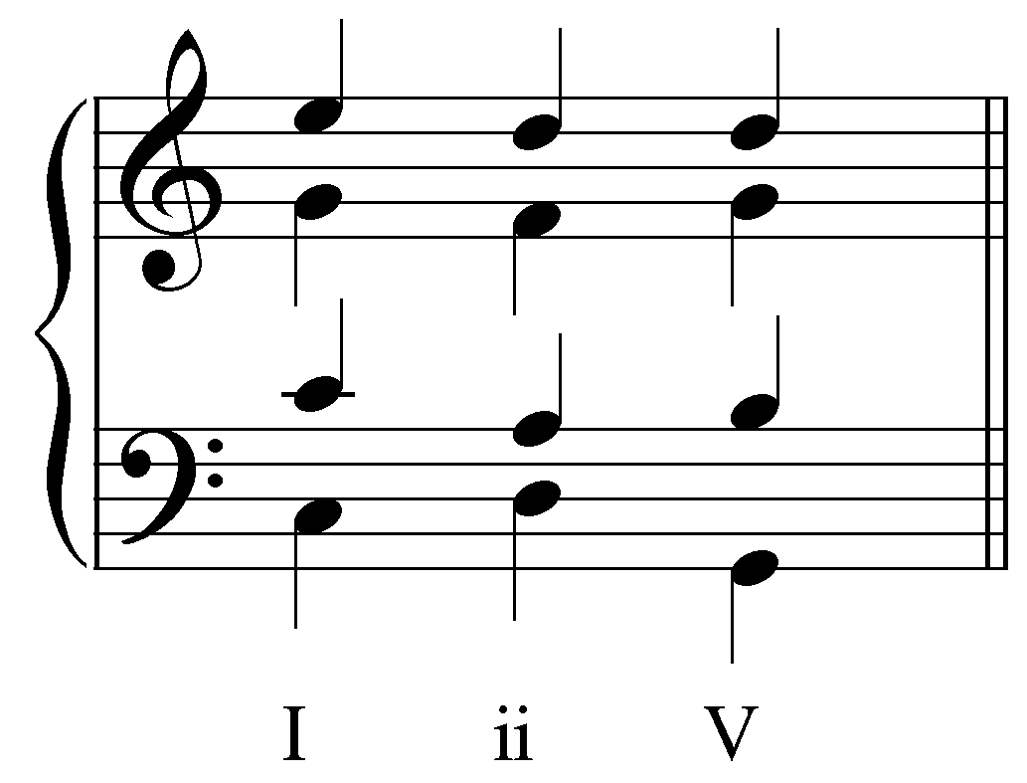

Compare Examples 1 and 10. As you can see, the only difference is the alto’s second note (F in Example 10 instead of F#). Because the applied dominant to V is a chromatically modified ii chord, V/V can replace ii in harmonic progressions. In other words, in their tonicizing function applied dominants may serve as pre-dominants.

An applied dominant can also enhance the pre-dominant function, as it does in the following two examples, where the diatonic pre-dominant function is subsequently intensified when one of its members is chromatically altered to create a tonicizing applied dominant.

Example 11:
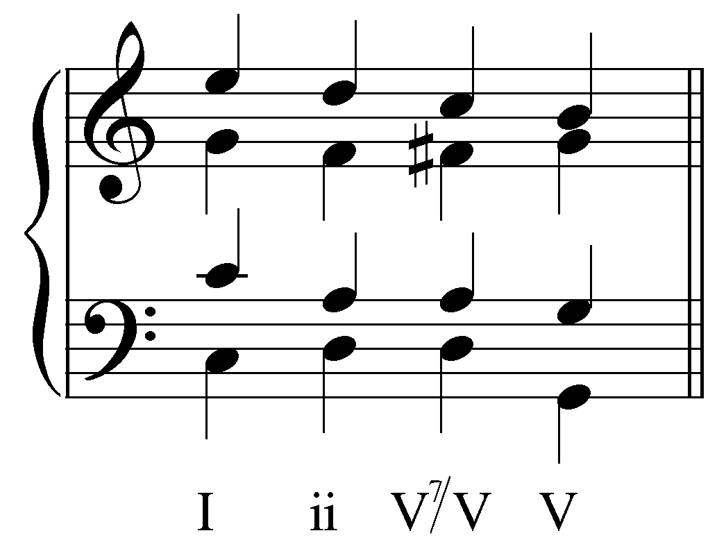

Example 12:
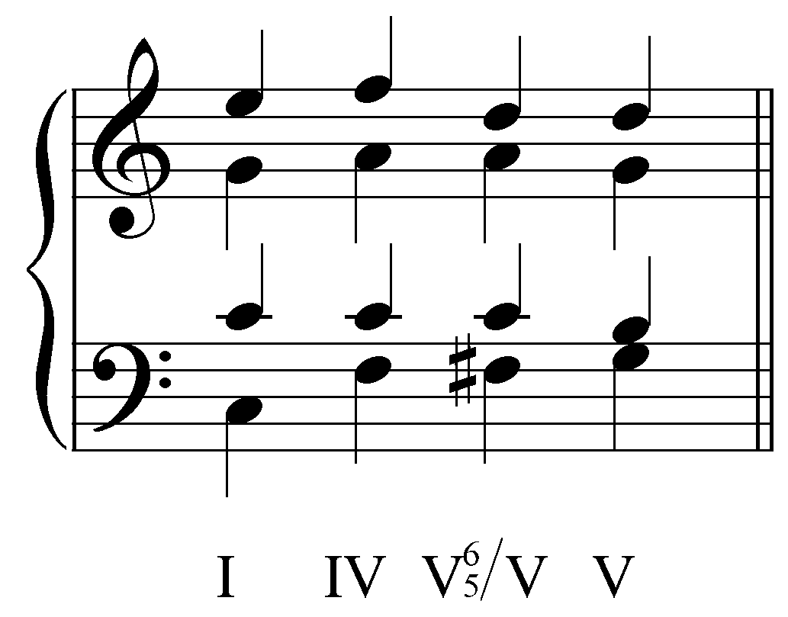

Activity 10.4:
As you saw in Examples 11 and 12, applied chords are closely related to pre-dominant chords and can enhance the pre-dominant function. In each of the following examples, alter one of the pitches of the pre-dominant chord to create an applied dominant or leading-tone chord.

Exercise 10.4a:
In the following example, change one of the notes in the pre-dominant chord on beat three to create a V${}_{5}^{6}$/V:
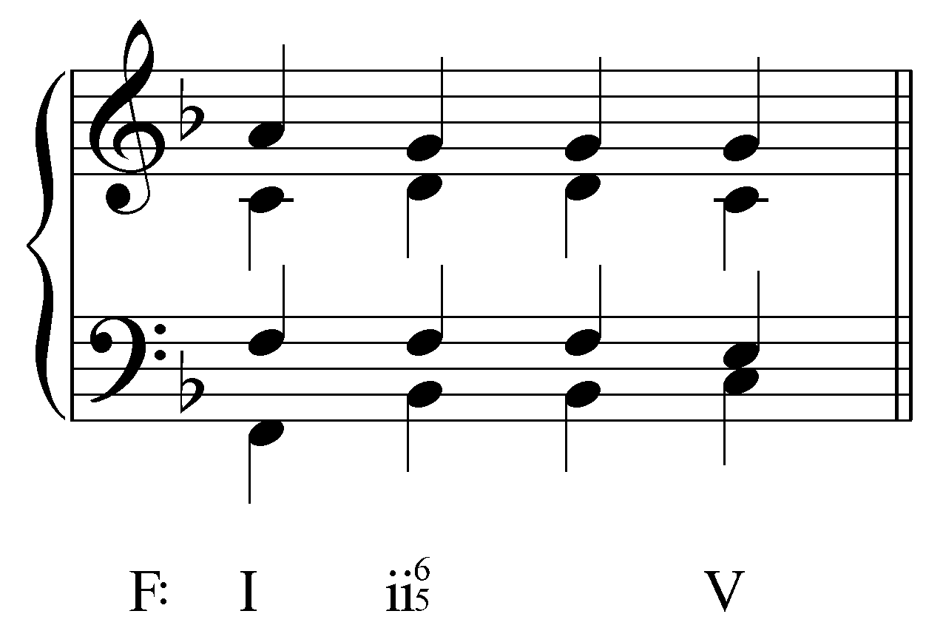

[Answer:
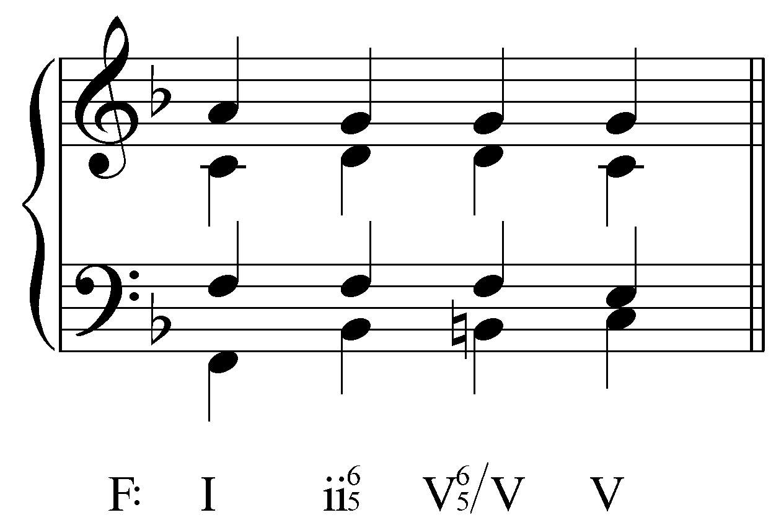. Response if correct: “Correct! Raising the bass to B natural changes the ii${}_{5}^{6}$ chord into a V${}_{5}^{6}$/V.” Response if incorrect: “Incorrect. Try again.”]

Exercise 10.4b:
In the following example, change one of the notes in the pre-dominant chord on beat three to create a viiº/V:
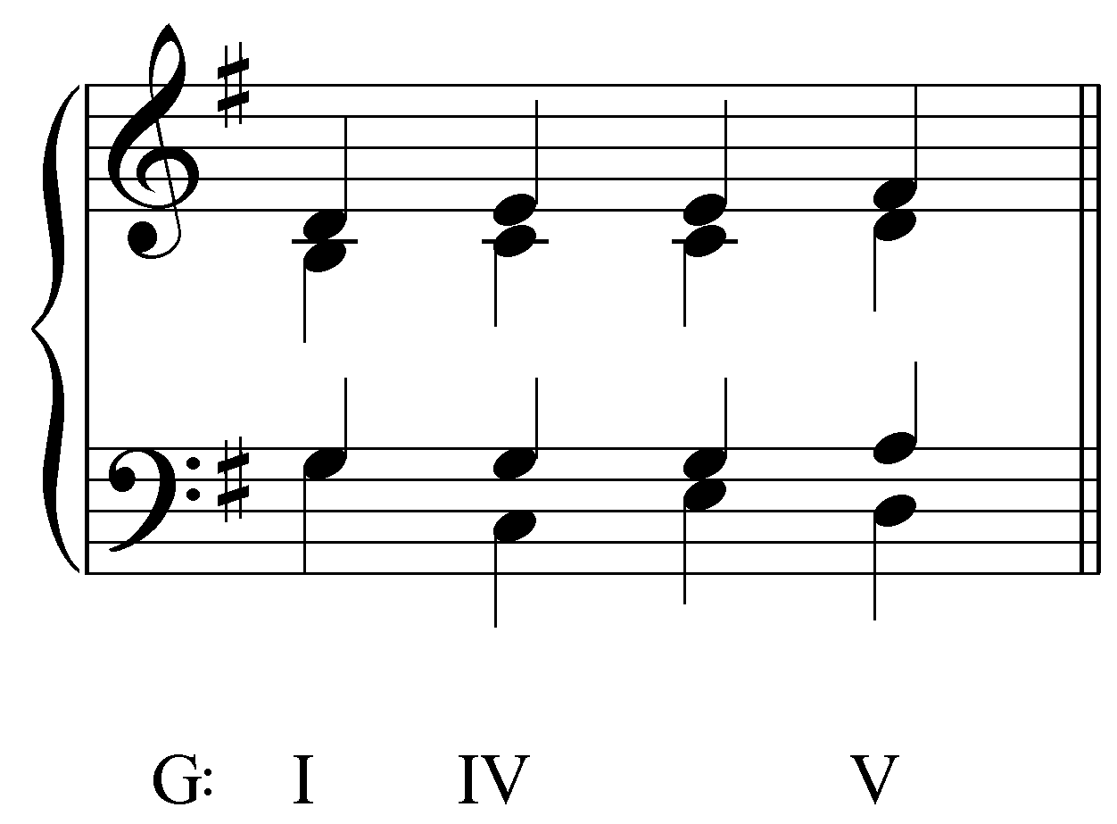

[Answer:
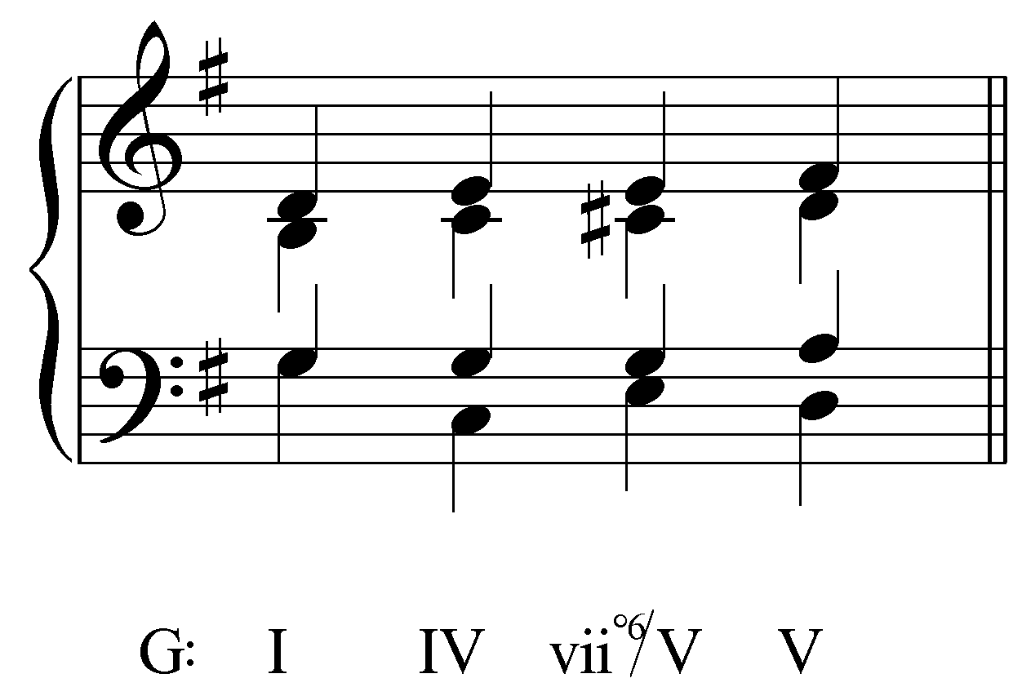. Response if correct: “Correct! Raising the bass to C# natural changes the IV chord into a viiº/V.” Response if incorrect: “Incorrect. Try again.”]

Exercise 10.4c:
In the following example, change one of the notes in the pre-dominant chord on beat three to create a V⁷/V:
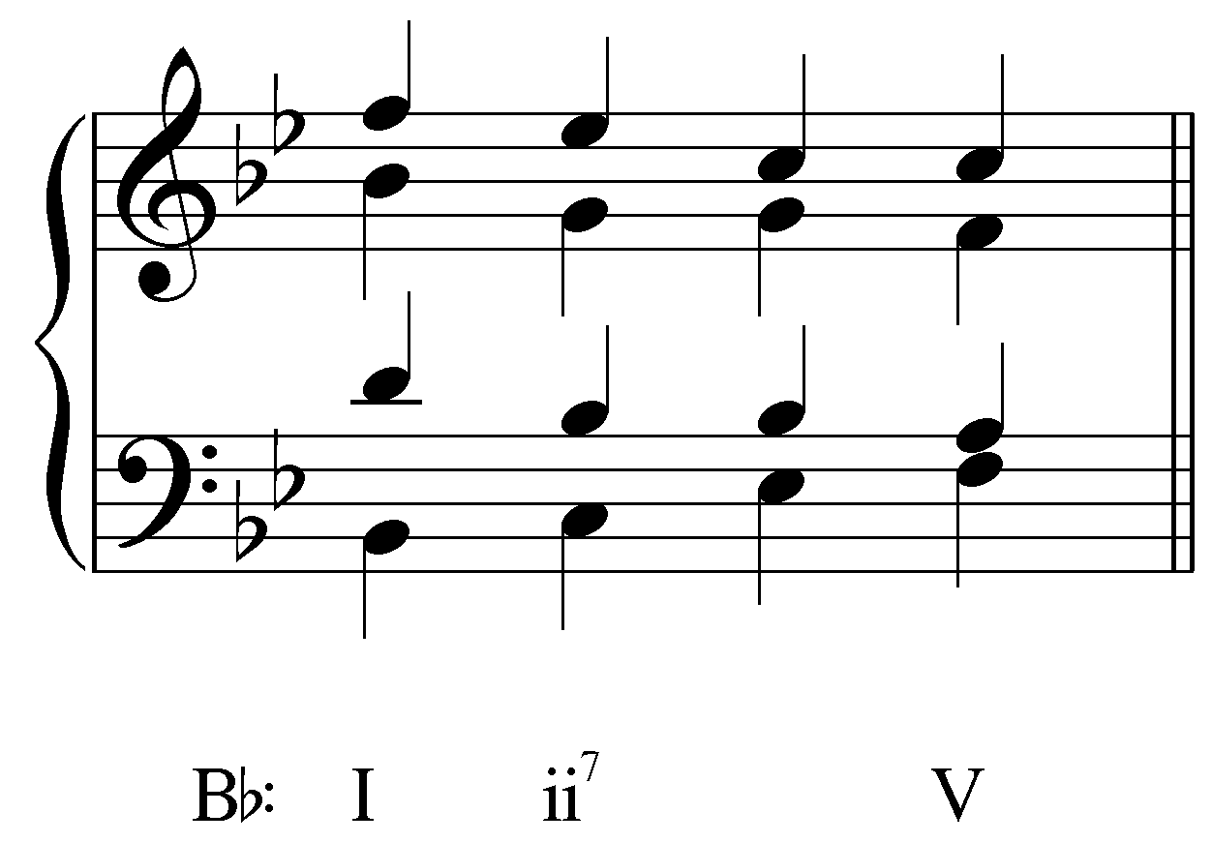

[Answer:
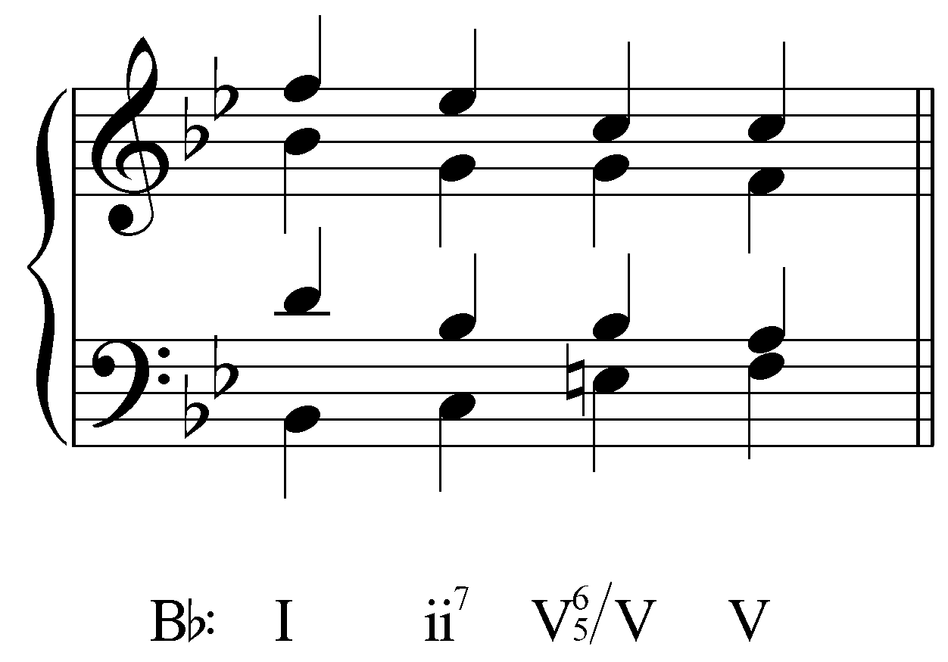. Response if correct: “Correct! Raising the soprano to E natural changes the ii⁷ chord into a V⁷/V.” Response if incorrect: “Incorrect. Try again.”]

Exercise 10.4d:
In the following example, change one of the notes in the pre-dominant chord on beat three to create a vii^{o6}/V:
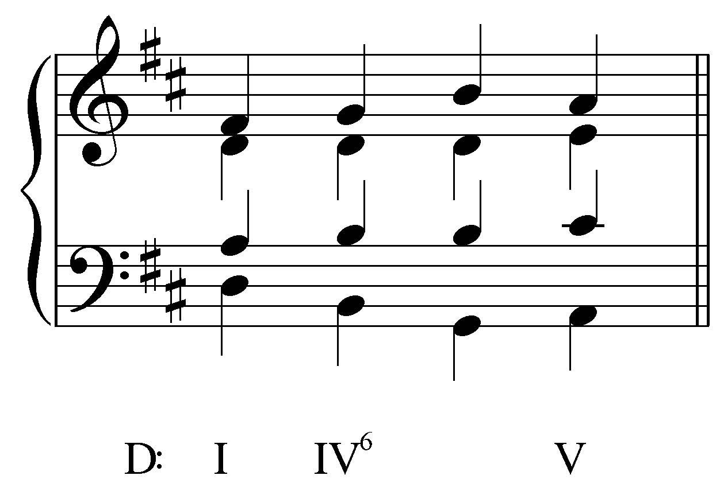
[Answer:
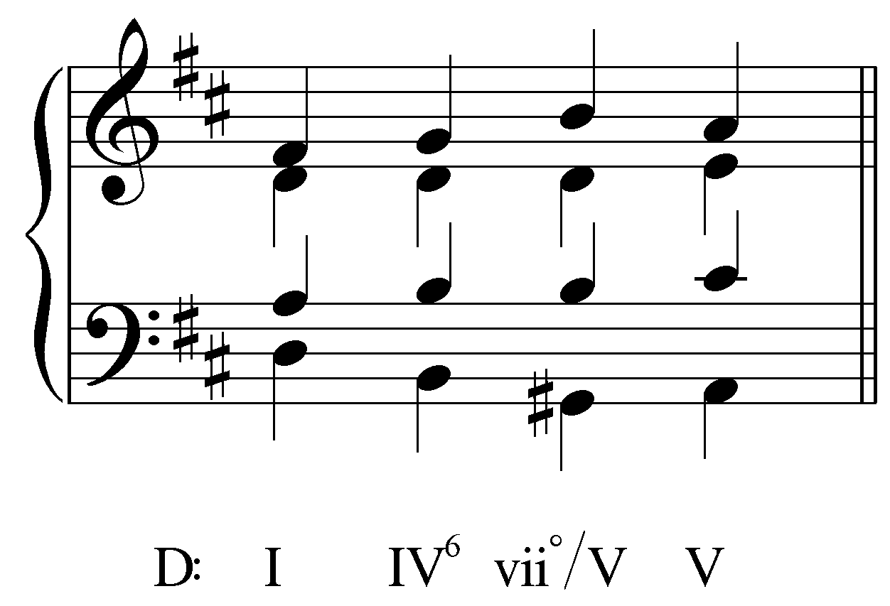. Response if correct: “Correct! Raising the soprano to G# changes the IV⁶ chord into vii^{o6}/V.” Response if incorrect: “Incorrect. Try again.”]

Applied leading-tone chords:

In addition to applied dominant chords, applied leading-tone chords are also common. The following example is similar to Example 1, but this time the leading-tone triad borrowed from the dominant key tonicizes the V chord.

Example 13:
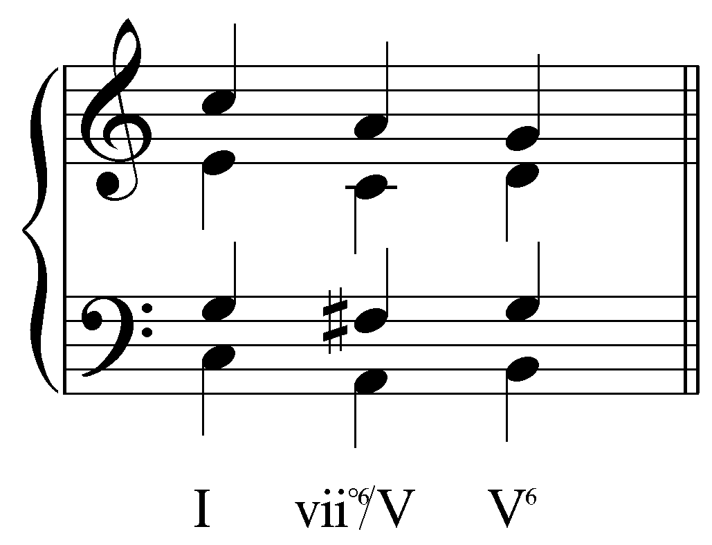

Again, the leading-tone chord resolves normatively, as it would in the key of G major. (Refer to Lesson FFF for a discussion of the leading-tone chord.) Most importantly, the leading tone (F#) steps up to the pseudo-tonic (G). The voice leading from vii^{o6}/V to V⁶ adheres to the basic intervals progressions from Lesson AAA. The tenor and alto ascend with the bass, respectively forming parallel “6 - 6” and “3 - 3” progressions, while the octave formed by the bass and soprano resolves inwards to a minor sixth (“8 - 6”).

As with any vii^{o6} chord, a tritone occurs in vii^{o6}/V as a resultant interval formed by voices that are consonant with the bass. In Example 8, the tritone formed by the tenor and alto (F# and C respectively) resolves in similar motion to a perfect fifth (G and D). Lesson FFF, on the viiº chord, illustrates the guiding “3 - 3” progression between the bass and an upper voice.

Example 14:
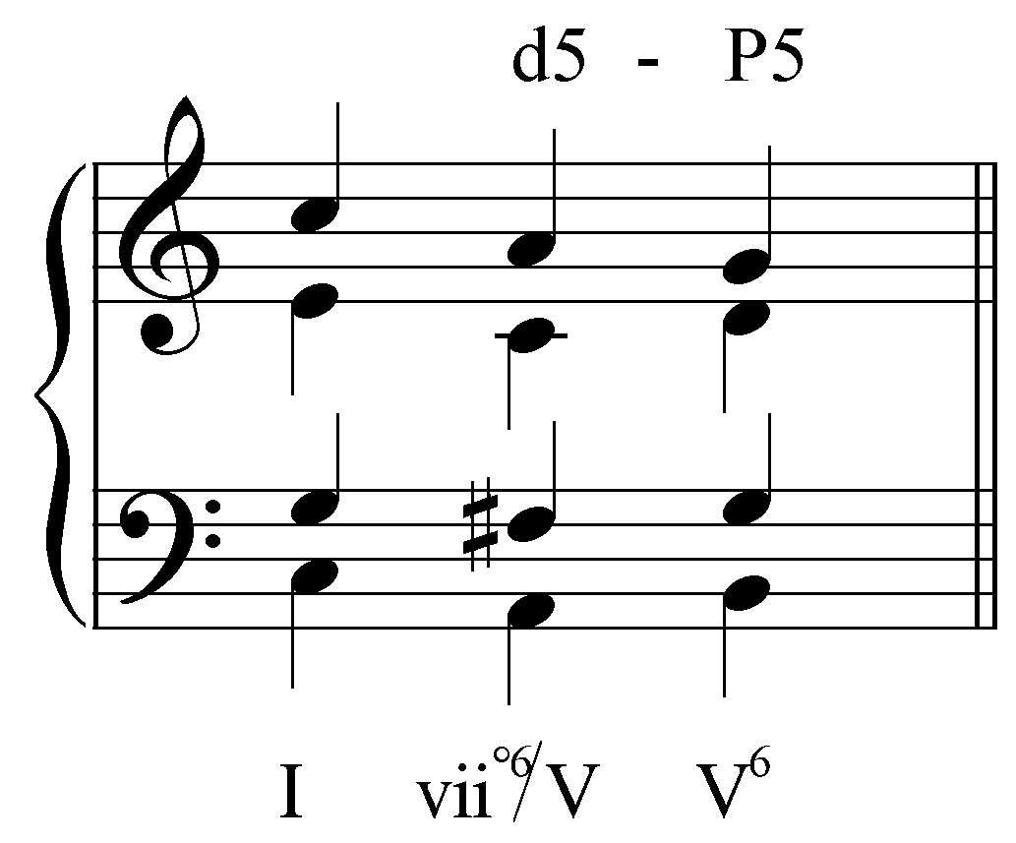

In this case, the tritone could not resolve to a major third (G and B), because to do so would be to double the leading tone of C major in the V⁶ chord, resulting in forbidden parallel octaves when both leading tones (7) resolve to 8.

Applied leading-tone triads are also abundant in the tonal repertoire. The following examples show tonicizations of V via vii^{o6}/V chords:

Example 15 (J.S. Bach, “Gott lebet noch, Seele, was verzagst du doch?,” BWV 320, mm. 1-2):
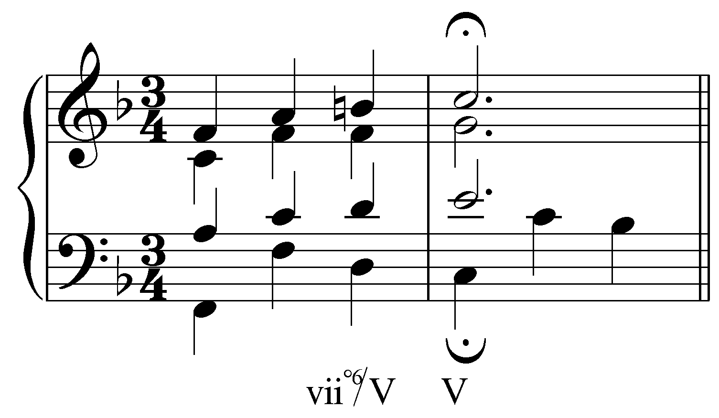

Example 16 (J.S. Bach, “Wie nach einer Wasserquelle,” BWV 39.7, m. 2):
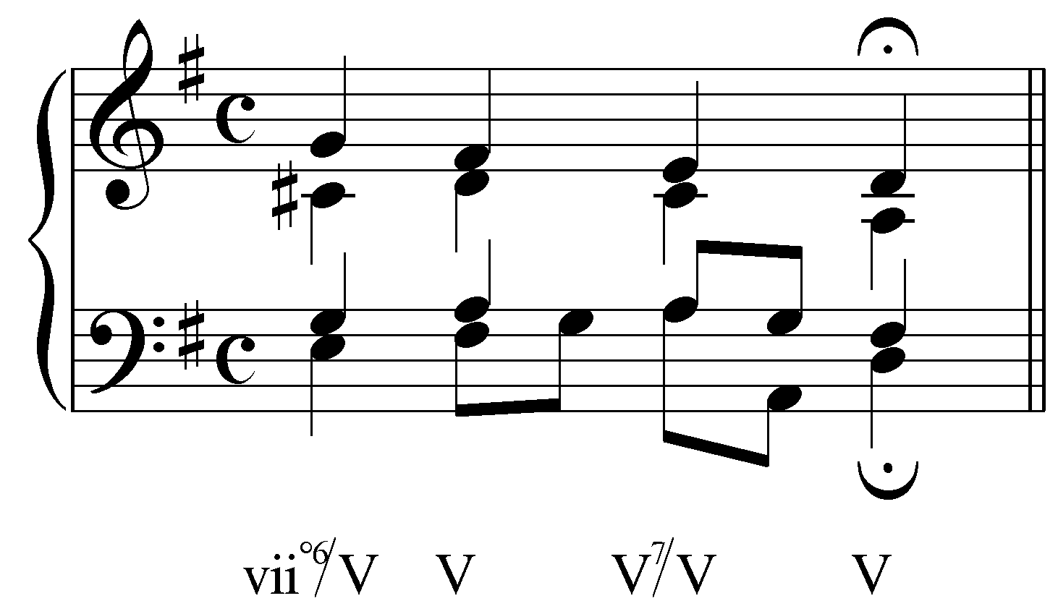

In Example 15, the tritone occurs between the soprano and the alto as an augmented fourth. It resolves properly by ascending to a perfect fourth. In Example 16, the C# in the alto creates a tritone with both the tenor (an augmented fourth) and the soprano (a diminished fifth). Both tritones resolve normatively (to a perfect fourth and major third respectively). Bach continues to tonicize V with the V⁷/V chord on beat three.

Like the related applied dominant chord, applied leading-tone chords may also include a chordal seventh. Fully-diminished applied leading-tone chords are common even when tonicizing major triads because of their immediately recognizable sonority. (Half-diminished seventh chords are less common and can only be used to tonicize major triads.) The following example tonicizes the V chord with a fully-diminished leading-tone chord:

Example 17:
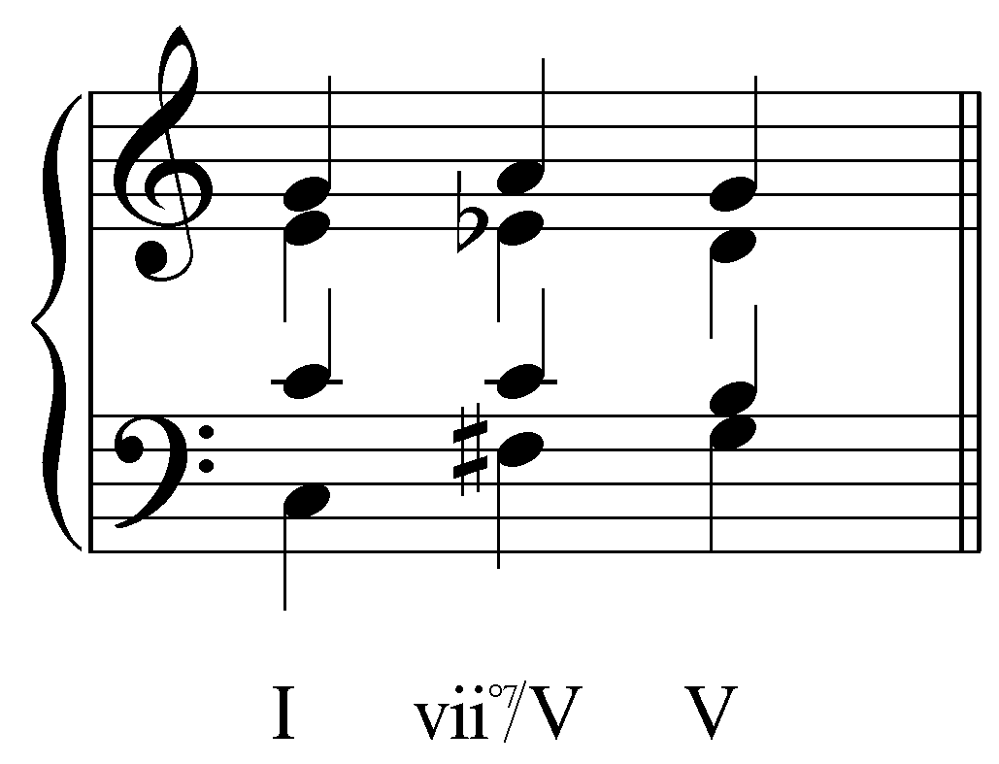

The rules for resolving diatonic leading-tone sevenths chords also hold for resolving applied leading-tone sevenths. (Refer to Lesson GGG for discussion of leading-tone seventh chord treatment.) Both tritones must resolve properly according to the basic interval progressions involving a tritone, as outlined in Lesson FFF. In this case, the bass and tenor (F# and C respectively) form a diminished fifth. This tritone is resolved normatively to a major third. The alto and soprano meanwhile (Eb and A respectively) form a diminished fourth. This tritone also resolves normatively, in similar motion to a perfect fourth:

Example 18:
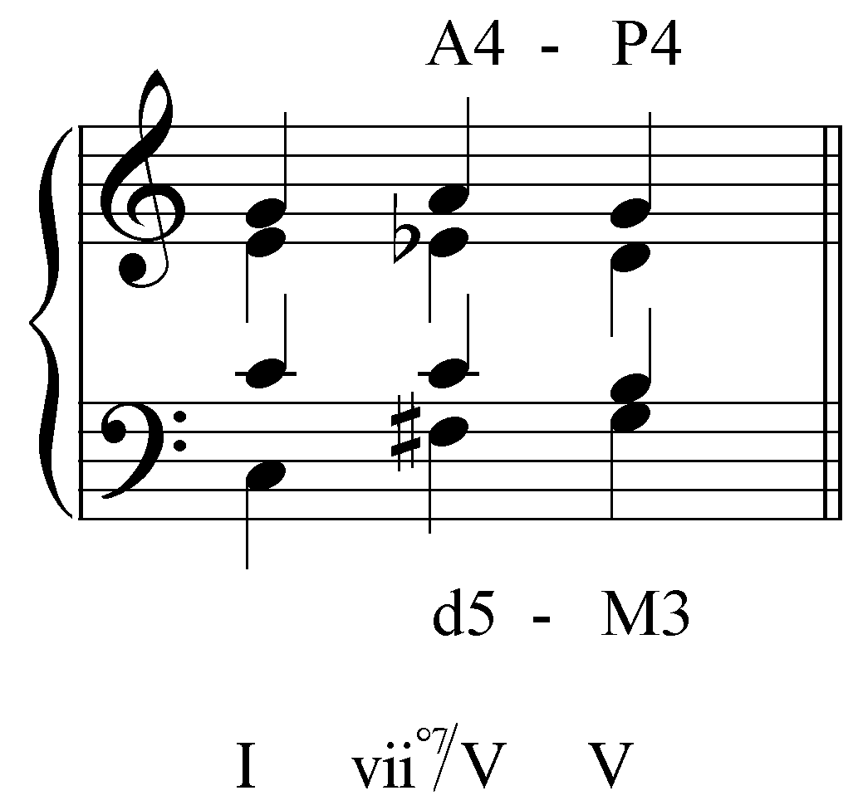

Note the adherence to basic interval progressions between the other voice pairs. The bass and soprano follow a “10 - 8” progression while the tenor moves in parallel thirds and sixths with the alto and soprano respectively. As in Example 14, care must be taken to avoid doubling the leading tone in the V chord. Here, the A steps down to G instead of resolving up to B.

Activity 10.5:
Applied leading-tone chords resolve according to the same conventions as diatonic leading-tone chords. In this activity, you will analyze the voice leading in a series of brief progressions, each containing an applied leading-tone chord.

Exercise 10.5a:
Is the voice leading in the following example correct as vii^{o7}/V resolves to V?
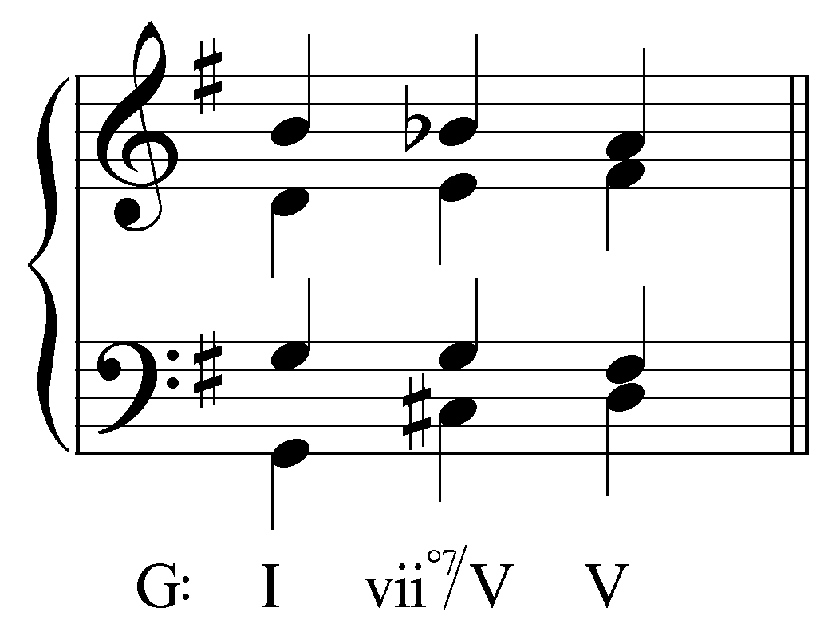
[Answer: Yes. Response if correct: “Correct! All of the voices in the vii^{o7}/V resolve properly.” Response if incorrect: “Incorrect. All of the voices in the vii^{o7}/V resolve properly.”]

Exercise 10.5b:
Is the voice leading in the following example correct as vii^{o7}/V resolves to V?
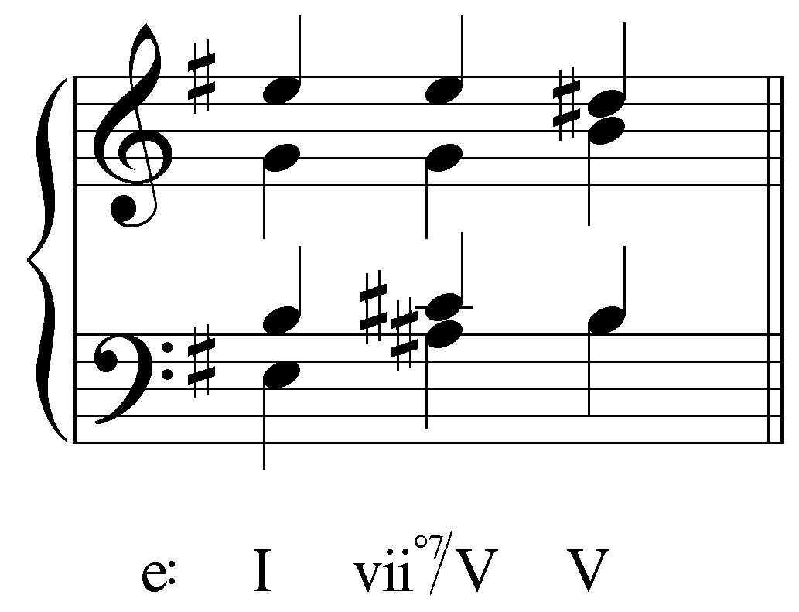
[Answer: No. Response if correct: “Correct! One of the voices in the vii^{o7}/V chord does not resolve correctly.” Response if incorrect: “Incorrect. There is a problem with the voice leading.”]
[Follow-up activity:] Fix the voice-leading by adjusting one of the voices of the V chord.
[Answer: alto should be F# instead of B. Response if correct: “Correct! The alto must resolve down by step to F# (resolving the tritone formed by C# and G to a perfect fifth).” Response if answer moves another voice: “Incorrect. The voice leading in that voice is fine as is.” Response for any other answer: “Incorrect. Try again.”]

Exercise 10.5c:
Is the voice leading in the following example correct as vii^{o7}/V resolves to V?
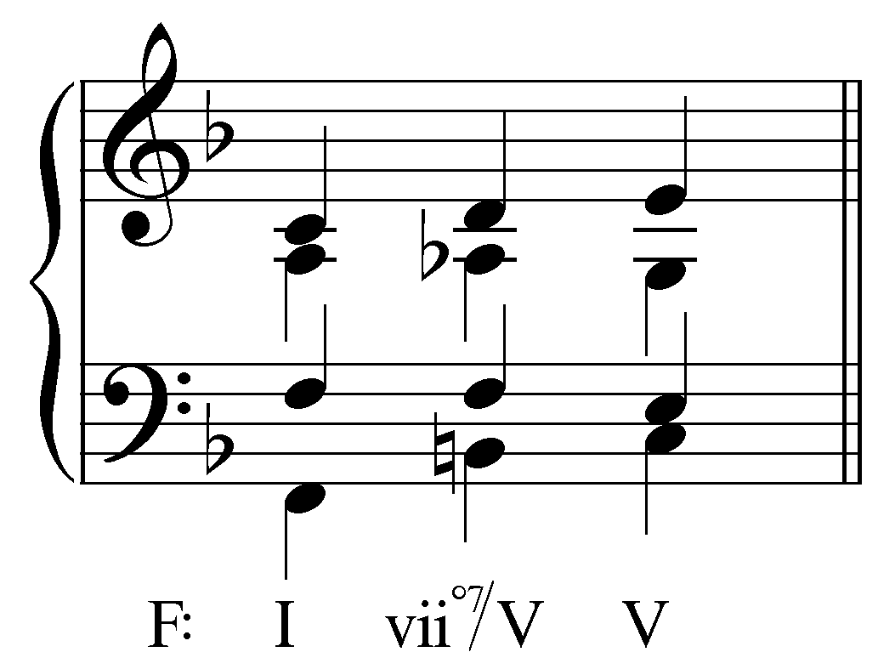
[Answer: No. Response if correct: “Correct! One of the voices in the vii^{o7}/V chord does not resolve correctly.” Response if incorrect: “Incorrect. There is a problem with the voice leading. (Hint: You should avoid doubling the leading tone in the V chord.)”]
[Follow-up activity:] Fix the voice-leading by adjusting one of the voices of the V chord.
[Answer: soprano should be C instead of E. Response if correct: “Correct! Although the tritone formed by A^{b} and D would resolve to a major sixth, the soprano cannot move to E because to do so would double the leading tone in the V chord. Resolving to C is a much better choice.” Response if answer moves another voice: “Incorrect. The voice leading in that voice is fine as is. Try again. (Hint: You should avoid doubling the leading tone in the V chord.)” Response for any other answer: “Incorrect. Try again.”]

Exercise 10.5d:
Is the voice leading in the following example correct as vii^{o7}/V resolves to V?
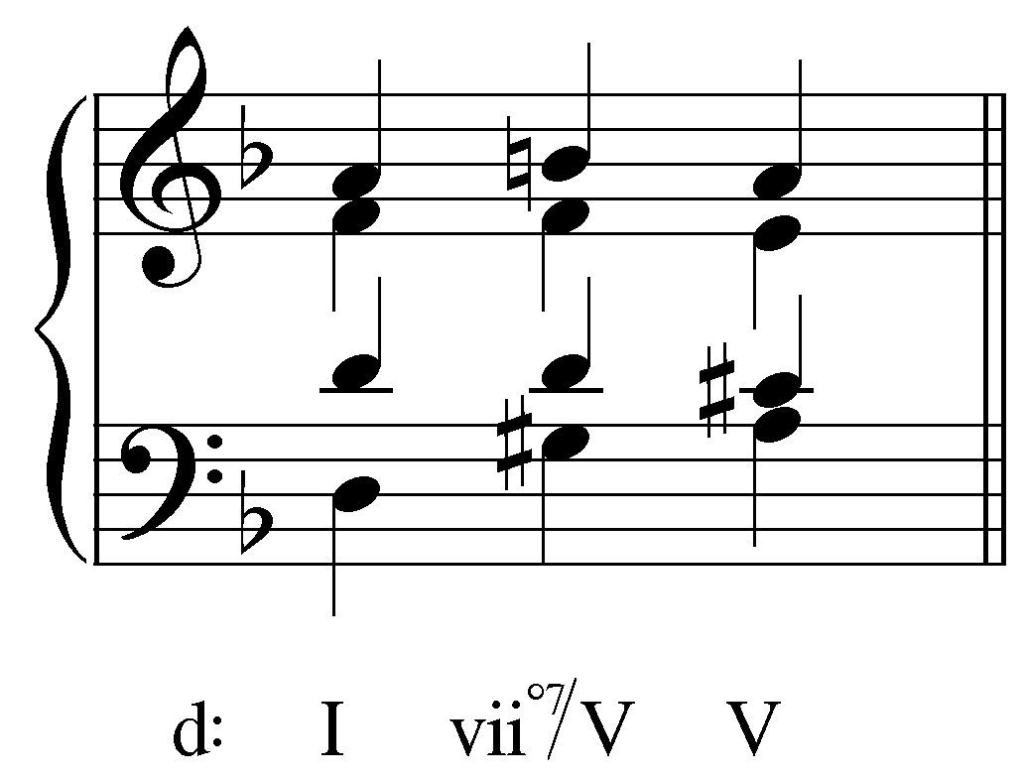
[Answer: Yes. Response if correct: “Correct! All of the voices in the vii^{o7}/V resolve properly.” Response if incorrect: “Incorrect. All of the voices in the vii^{o7}/V resolve properly.”]

Other chords that may be tonicized:

For the sake of clarity—and because V is the most commonly tonicized triad—all of the examples in this lesson so far have tonicized the dominant chord. However, applied dominants can be introduced to tonicize any diatonic major or minor triad. Thus in major keys ii, iii, IV, V, and vi can be tonicized, and in minor III, iv, v, VI, and VII.

Popup Box: Diminished triads cannot represent or imply a key. For example, in A minor, one cannot tonicize the iiº chord because there is no B-diminished key. It is for this reason that only major or minor triads can be tonicized.

The following example shows the tonicization of a ii chord:

Example 19:
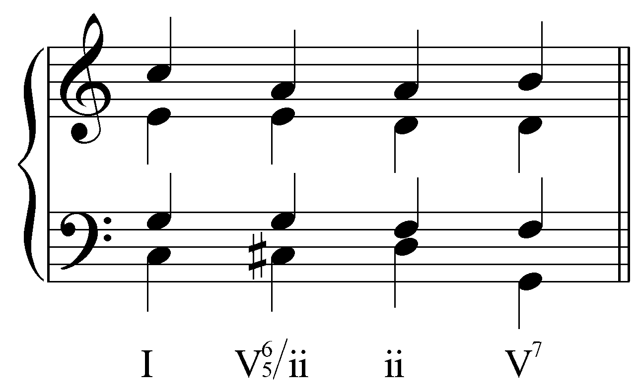

Such tonicizations of chords other than V are common in tonal music. The following two examples show Bach choral excerpts with tonicizations of the ii chord (first with an applied V${}_{5}^{6}$ chord and then with an applied vii^{o6} chord):

Example 20 (J.S. Bach, “Kommt her, ihr lieben Schwesterlein,” BWV 376, mm. 8-9):
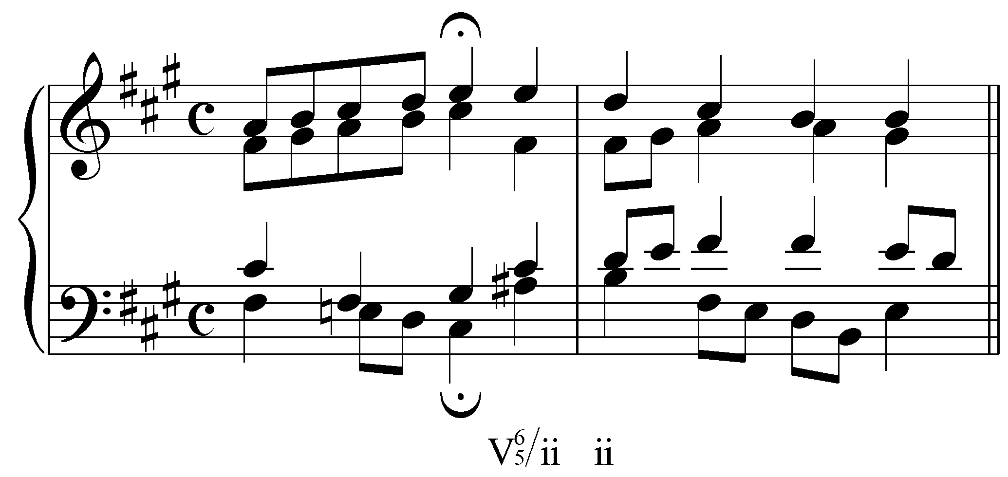

Example 21 (J.S. Bach, “Wie schön leuchtet der Morgenstern,” BWV 36(2).4, mm. 10-11):
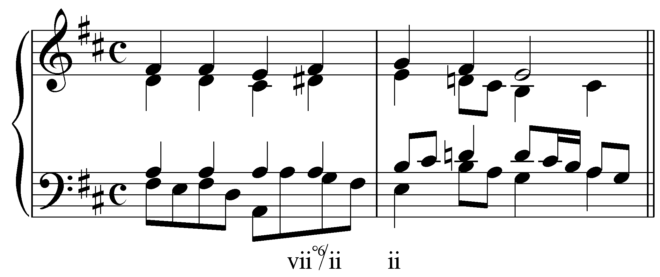

The vi chord can also be tonicized with applied chords. The following three examples show chorale excerpts with tonicizations of vi:

Example 22 (J.S. Bach, “O Ewigkeit, du Donnerwort,” BWV 20.7, mm. 4-5):
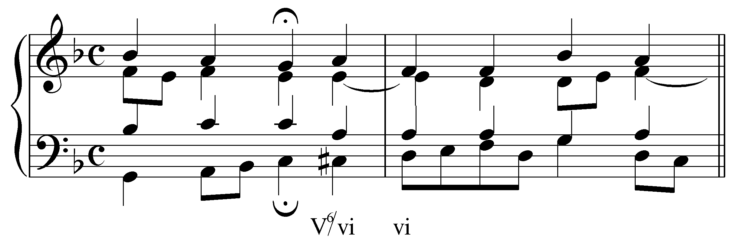

Example 23 (J.S. Bach, “Nun freut euch, lieben Christen, g'mein,” BWV 307, mm. 5-6):
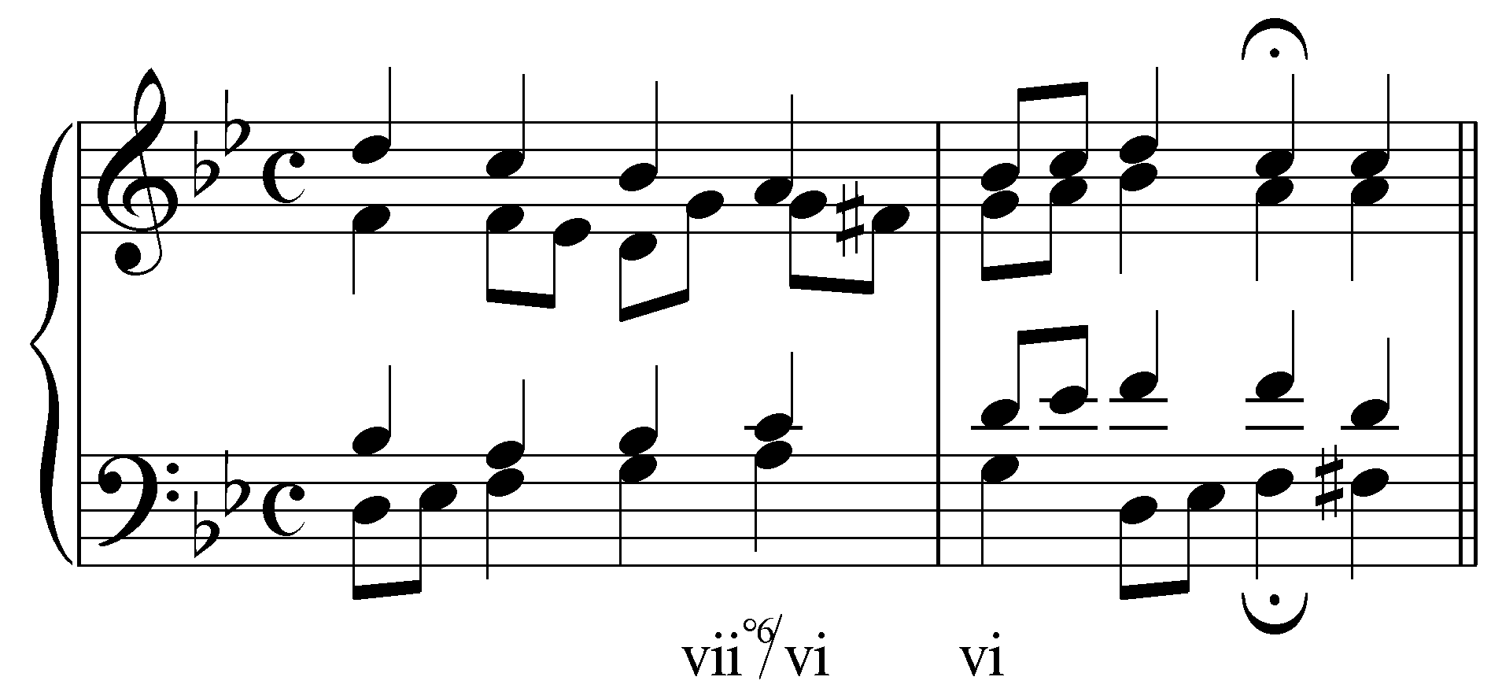

Example 24 (J.S. Bach, “Kommt her, ihr lieben Schwesterlein,” BWV 151.5, mm. 7-8):
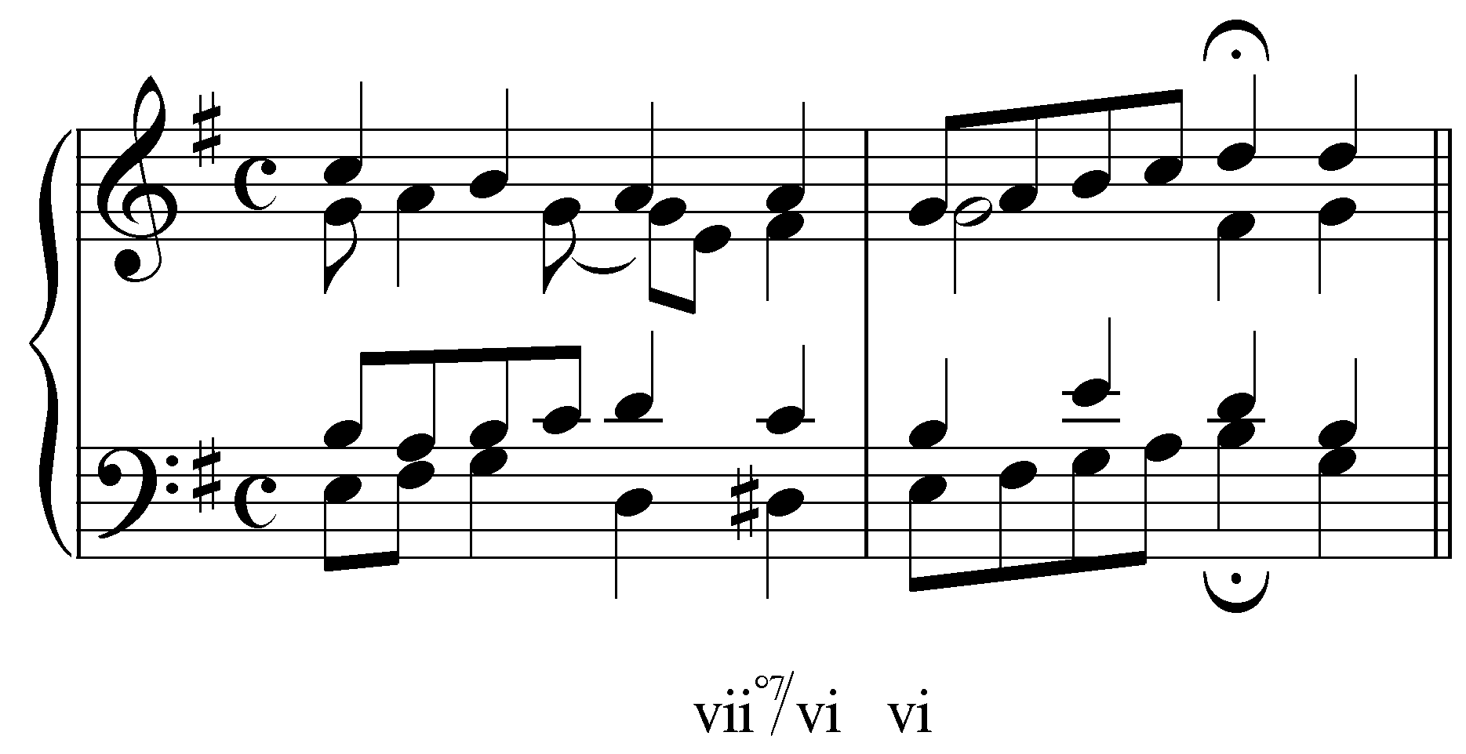

Example 22 tonicizes vi with an applied V⁶ while Examples 23 and 24 each use applied chords built on the temporary leading tone.

Activity 10.6:
In this activity you will analyze the voice leading of Example 23 and 24 to see if they conform to the voice leading rules outlined in previous lessons:

Exercise 10.6a:
Identify the tritone in the vii^{o6}/vi following excerpt (J.S. Bach, “Nun freut euch, lieben Christen, g'mein,” BWV 307, mm. 5-6):
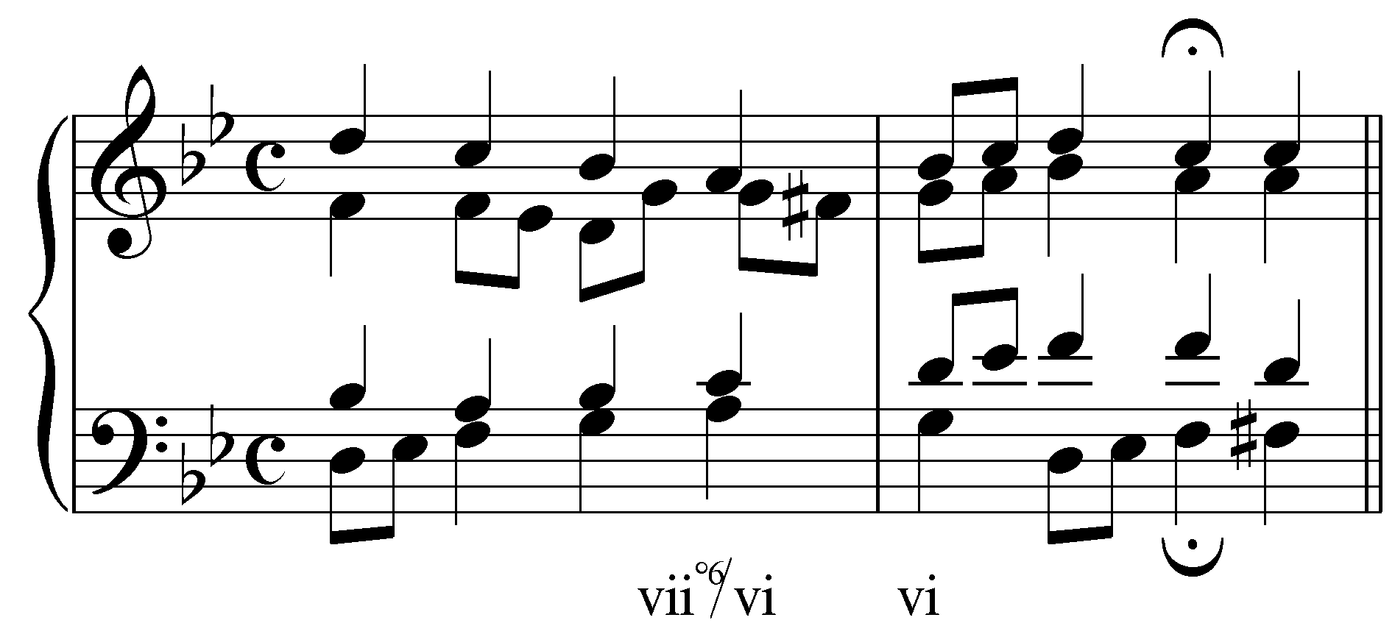
[Possible pitches: A in the bass, C in the tenor, F# in the alto, G in the alto, A in the soprano. Answer: C in the tenor and F# in the alto. Response if correct: “Correct! C and F# form an augmented fourth.” Response if G is included: “Incorrect. G is a suspension in the alto voice. F# is the chord tone. Try again.” Response if incorrect: “Incorrect. Those two pitches do not form a tritone.”]
[Follow-up question 1:] To what interval does the augmented fourth resolve?
[Answer: perfect fourth (P4). Response if correct: “Correct!” Response if incorrect: “Incorrect. Try again.”]
[Follow-up question 2:] Does the vi chord on the downbeat of m. 6 provide a valid resolution of the vii^{o6}/vi?
[Answer: Yes. Response if correct: “Correct! All of the voice leading from vii^{o6}/vi to vi in this case is valid.” Response if incorrect: “Incorrect. All of the voice leading from vii^{o6}/vi to vi in this case is valid.”]

Exercise 10.6b:
Identify one of the tritones in the vii^{o7}/vi following excerpt (J.S. Bach, “Kommt her, ihr lieben Schwesterlein,” BWV 151.5, mm. 7-8):
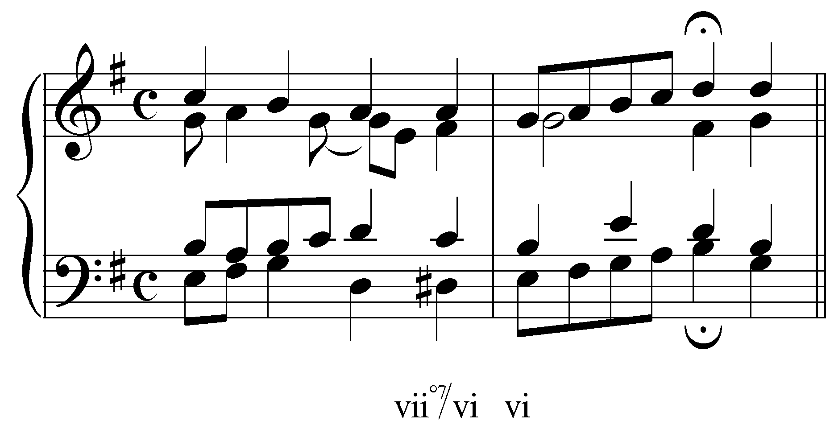
[Possible pitches: D# in the bass, C in the tenor, F# in the alto, A in the alto, A in the soprano. Answers: D#/A or C/F#. Response if D#/A: “Correct! D# and A form a diminished fifth.” Response if C/F#: “Correct! C and F# form an augmented fourth.” Response if incorrect: “Incorrect. Those two pitches do not form a tritone.”]
[Follow-up question 1:] Now identify the other tritone.
[SAME AS ABOVE: Possible pitches: D# in the bass, C in the tenor, F# in the alto, A in the alto, A in the soprano. Answers: D#/A or C/F#. Response if D#/A: “Correct! D# and A form a diminished fifth.” Response if C/F#: “Correct! C and F# form an augmented fourth.” Response if incorrect: “Incorrect. Those two pitches do not form a tritone.”]
[Follow-up question 2:] To what interval does the diminished fifth formed by D# and A resolve?
[Answer: minor third (m3). Response if correct: “Correct!” Response if incorrect: “Incorrect. Try again.”]
[Follow-up question 3:] To what interval does the augmented fourth formed by C and F# resolve?
[Answer: minor sixth (m6). Response if correct: “Correct!” Response if incorrect: “Incorrect. Try again.”]
[Follow-up question 4:] Does the vi chord on the downbeat of m. 6 provide a valid resolution of the vii^{o7}/vi?
[Answer: Yes. Response if correct: “Correct! All of the voice leading from vii^{o7}/vi to vi in this case is valid.” Response if incorrect: “Incorrect. All of the voice leading from vii^{o7}/vi to vi in this case is valid.”]

As mentioned above, for a sonority to be an applied chord it must have some kind chromatic alteration. Some progressions may at first resemble a tonicization. Consider the progression of a C-major triad to an F-major triad in a piece in C-major. One might be tempted to analyze this as “V/IV - IV,” implying that the F-major triad is being tonicized. To do so, however, would throw into question and compromise the functional centrality of the tonic.

Example 25:
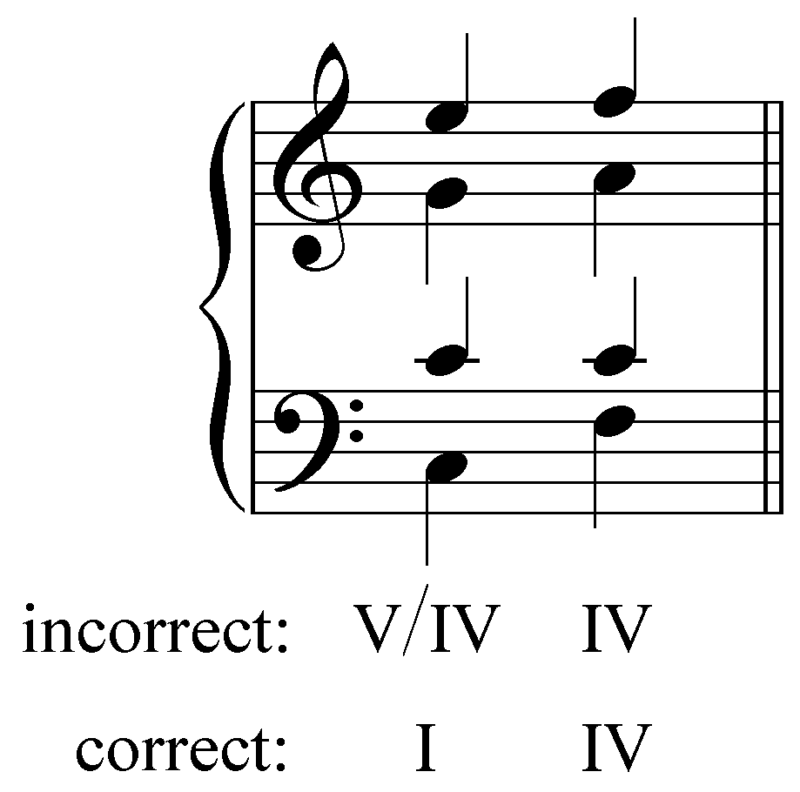

Progressions such as these are not tonicizations, but rather represent inherent characteristics of the diatonic scale. To analyze this C-major chord as anything other than “I” would obscure its fundamental role as tonic. If, on the other hand, the sonority on beat one were a major-minor (dominant) seventh chord, a chromatic alteration would be required and the progression would be analyzed as follows:

Example 26:
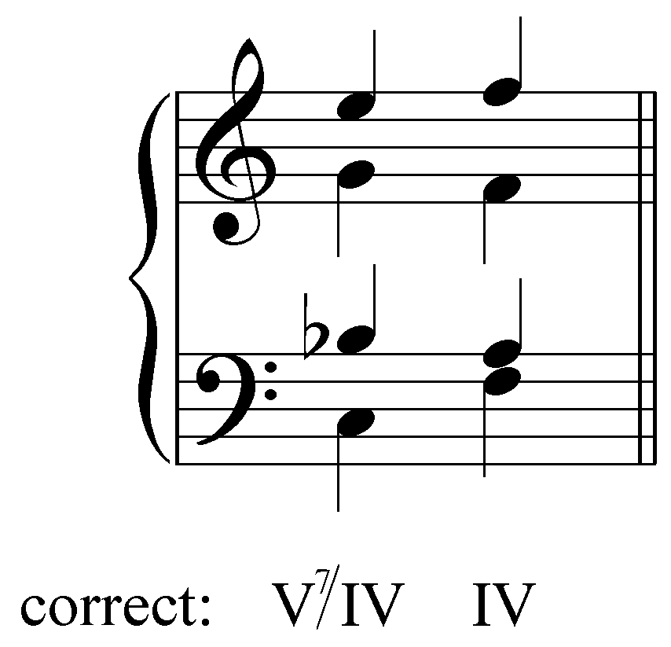

In Example 26, the V⁷/IV resolves properly to the IV chord. The chordal seventh (Bb in the tenor) resolves down to A, forming “6 - 6” with the alto and an expanding tritone, A4-6, with the soprano, while the alto forms “6 - 8” with the soprano.

The following example shows an excerpt from a chorale with a tonicization of IV, similar to example 26. The E^{b} in the bass on beat three is essential for hearing the chord as an applied dominant seventh.

Example 27 (J.S. Bach, “Christus, der ist mein Leben,” BWV 281, m. 1):
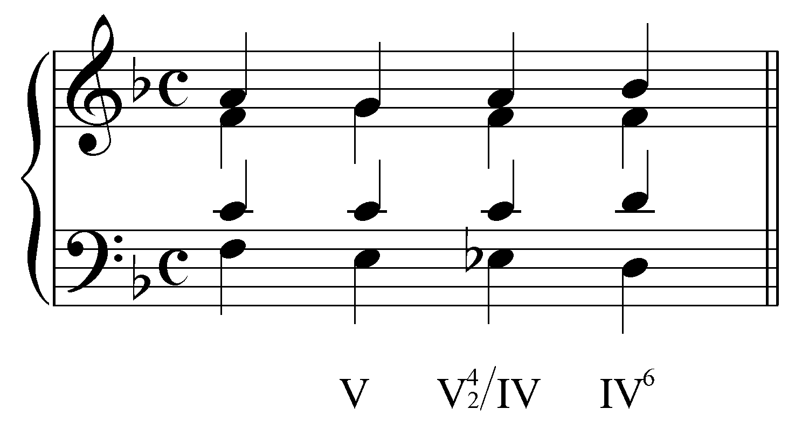

Popup Box: Examples 25 and 26 make clear why it is important to distinguish between diatonic major chords and applied dominants. By definition, applied chords must contain chromatic alterations (leading tones borrowed from related keys). Analyzing the C-major triad in Example 25 as an applied dominant, for instance (V/IV), undermines the identity of a fundamental harmonic function: the tonic!

The VII chord in a minor key is a special case. When VII, a diatonic major chord, leads to III, as it routinely does, VII sounds like an applied dominant leading to a pseudo-tonic. That sense is especially strong because III is the tonic of the relative major, which in a minor key is a prominent rival tonic, and, unlike other pseudo-tonics, requires no chromatically-altered chords (i.e. no borrowed leading tones) in order to establish itself. VII thus sounds like a V/III, and VII⁷ like a V⁷/III. Further, depending on musical context, the diatonic iiº and iiØ7 in a minor key may sound, respectively, like the viiº/III and viiØ⁷/III.

The strength of the III chord in minor keys as a rival tonic results in the possibility of diatonic chords—VII and VII⁷, iiº and ii Ø⁷—functioning as applied chords tonicizing III, even though they lack chromatic alterations. This is especially true of VII⁷ because it is immediately recognizable as a dominant seventh chord. Composers exploit this particular overlap between diatonic and applied chords in order to make smooth modulations from a minor key to its relative major. (See Lesson KKK for more on modulation to the relative major.) For the sake of clarity and uniformity, we will always label diatonic chords as such. We will therefore use VII, VII⁷, iiº, and ii Ø⁷ instead of V/III, V⁷/III, viiº/III, and vii Ø⁷/III, despite tonicizing characteristics these chords may have.

Activity 10.7:
In this activity you will be asked to give the pitches for a variety of applied chords in various keys. You will then be asked to insert these chords into a SATB setting.

Exercise 10.7a:
What pitch is in the bass of V${}_{5}^{6}$/V in A major?
[Answer: D#. Response if correct: “Correct! D# is the bass of a V${}_{5}^{6}$/V in A major.” Response if incorrect: “Incorrect. Try again.”]
[Follow-up question 1:] What pitches are in the upper voices of V${}_{5}^{6}$/V in A major?
[Answers: B, F# and A. Response if correct: “Correct!” Response if some of the pitches are correct: “That is partially correct. [X] would be found in the upper voices of V${}_{5}^{6}$/V in A major, but not [Y].” Response if completely incorrect: “Incorrect. None of those pitches are in the upper voices of V${}_{5}^{6}$/V in A major.”]
[Follow-up question 2:] Complete the progression below by inserting the pitches of V${}_{5}^{6}$/V in A major into the most logical voices:
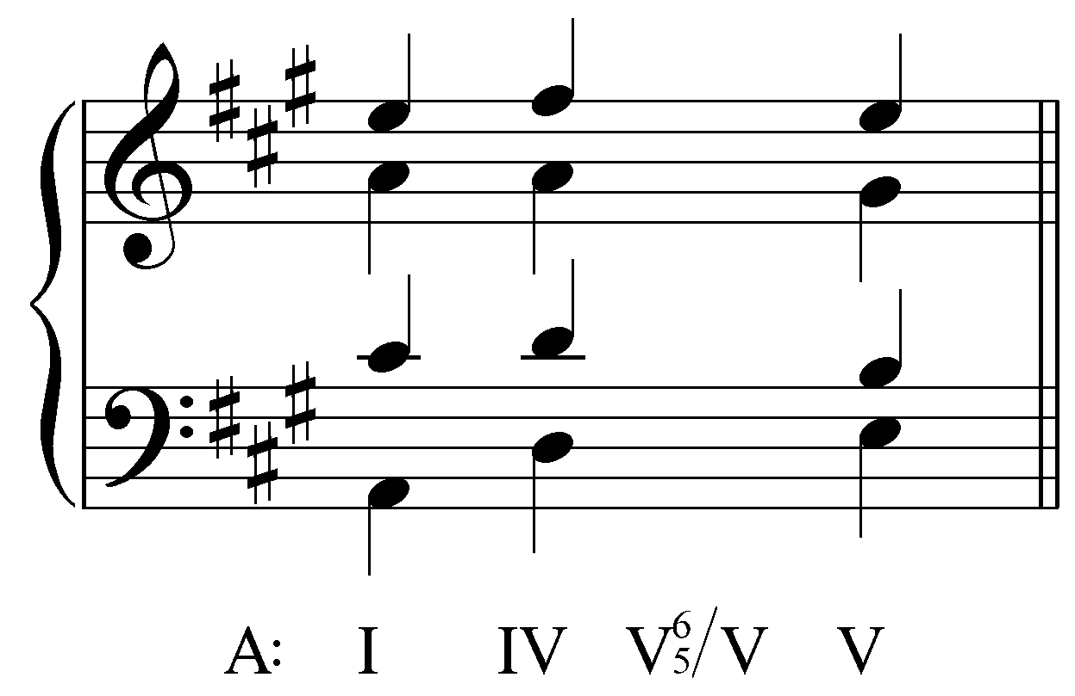
[Answer:
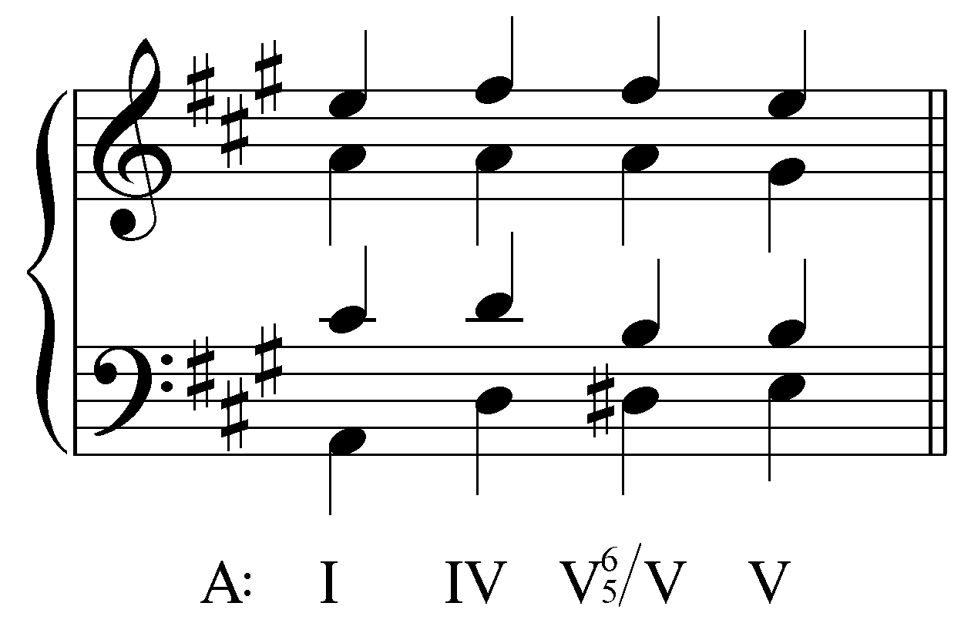. Response if student’s answer matches: “Correct!” Response if student’s answer does not match: “Incorrect. Try again. (Remember to use accidentals for any chromatically-altered pitches.)”]

Exercise 10.7b:
What pitch is in the bass of V${}_{5}^{6}$/ii in B^{b} major?
[Answer: B (natural). Response if correct: “Correct! B natural is the bass of a V${}_{5}^{6}$/ii in B^{b} major.” Response if incorrect: “Incorrect. Try again.”]
[Follow-up question 1:] What pitches are in the upper voices of V${}_{5}^{6}$/ii in B^{b} major?
[Answers: G, D and F. Response if correct: “Correct!” Response if some of the pitches are correct: “That is partially correct. [X] would be found in the upper voices of V${}_{5}^{6}$/ii in B^{b} major, but not [Y].” Response if completely incorrect: “Incorrect. None of those pitches are in the upper voices of V${}_{5}^{6}$/ii in B^{b} major.”]
[Follow-up question 2:] Complete the progression below by inserting the pitches of V${}_{5}^{6}$/ii in B^{b} major into the most logical voices:
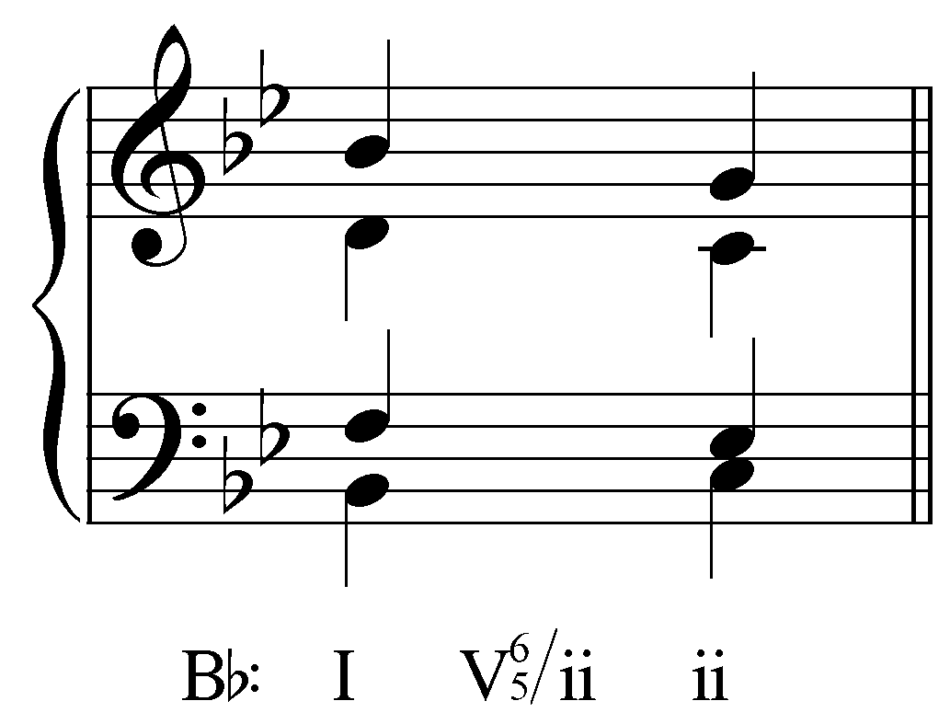

[Answer:
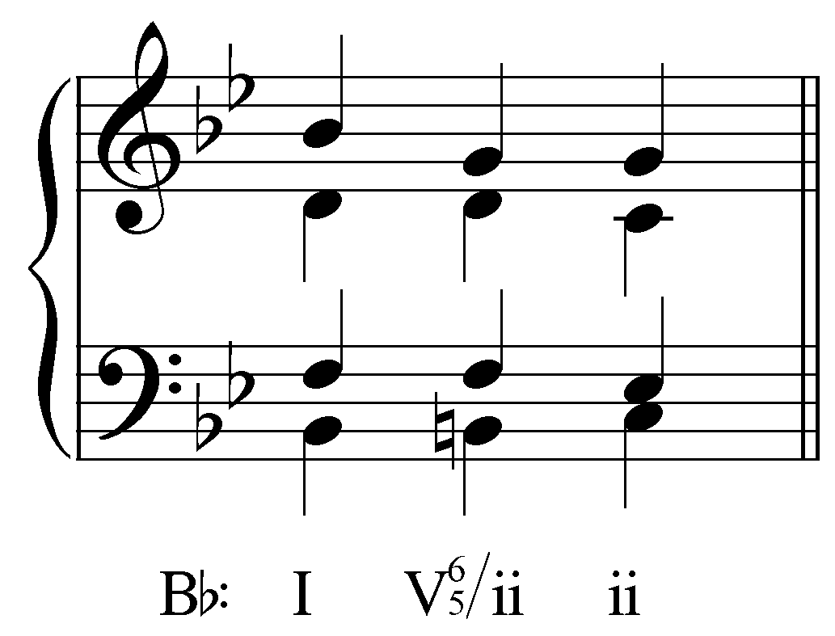. Response if student’s answer matches: “Correct!” Response if student’s answer does not match: “Incorrect. Try again. (Remember to use accidentals for any chromatically-altered pitches.)”]

Exercise 10.7c:
What pitch is in the bass of vii^{o6}/vi in G major?
[Answer: F#. Response if correct: “Correct! F# is the bass of a vii^{o6}/vi in G major.” Response if incorrect: “Incorrect. Try again.”]
[Follow-up question 1:] What pitches are in the upper voices of vii^{o6}/vi in G major?
[Answers: D# and A. Response if correct: “Correct!” Response if some of the pitches are correct: “That is partially correct. [X] would be found in the upper voices of vii^{o6}/vi in G major but not [Y].” Response if completely incorrect: “Incorrect. None of those pitches are in the upper voices of vii^{o6}/vi in G major.”]
[Follow-up question 2:] Complete the progression below by inserting the pitches of vii^{o6}/vi in G major into the most logical voices:
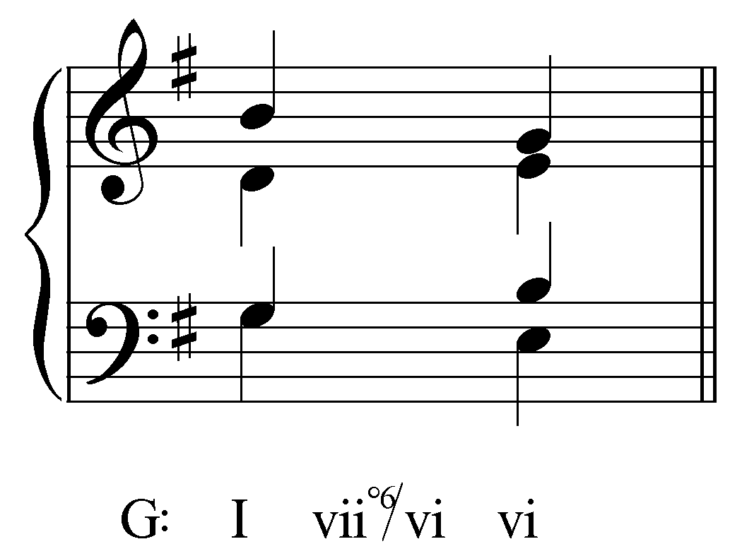
[Answer:
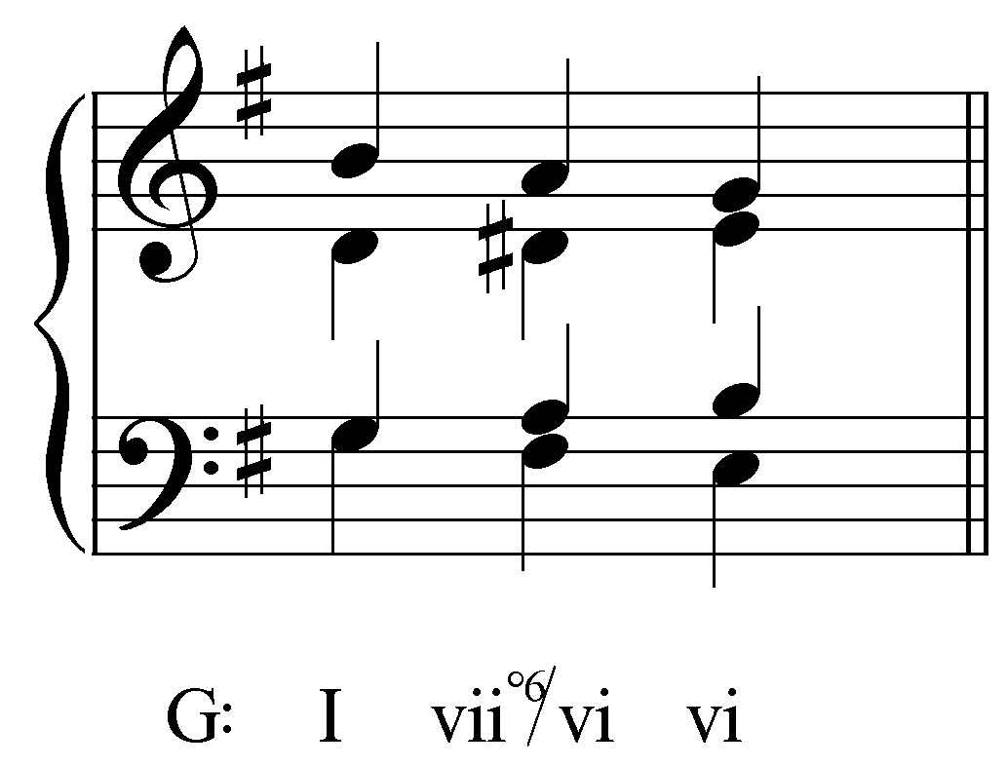
. Response if student’s answer matches: “Correct!” Response if student’s answer does not match: “Incorrect. Try again. (Remember to use accidentals for any chromatically-altered pitches.)”]

Exercise 10.7d:
What pitch is in the bass of V${}_{2}^{4}$/V in A^{b} major?
[Answer: A. Response if correct: “Correct! A is the bass of a V${}_{2}^{4}$/V in A^{b} major.” Response if incorrect: “Incorrect. Try again.”]
[Follow-up question 1:] What pitches are in the upper voices of V${}_{2}^{4}$/V in A^{b} major?
[Answers: B^{b}, D (natural) and F. Response if correct: “Correct!” Response if some of the pitches are correct: “That is partially correct. [X] would be found in the upper voices of V${}_{2}^{4}$/V in A^{b} major, but not [Y].” Response if completely incorrect: “Incorrect. None of those pitches are in the upper voices of V${}_{2}^{4}$/V in A^{b} major.”]
[Follow-up question 2:] Complete the progression below by inserting the pitches of V${}_{2}^{4}$/V in A^{b} major into the most logical voices:
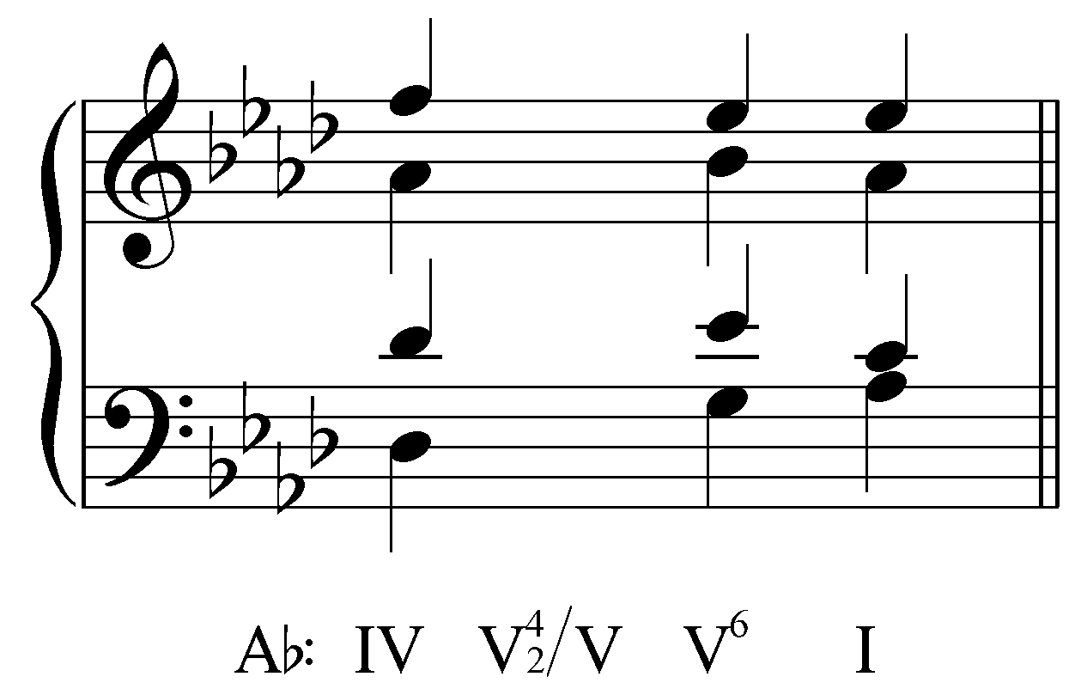
[Answer:
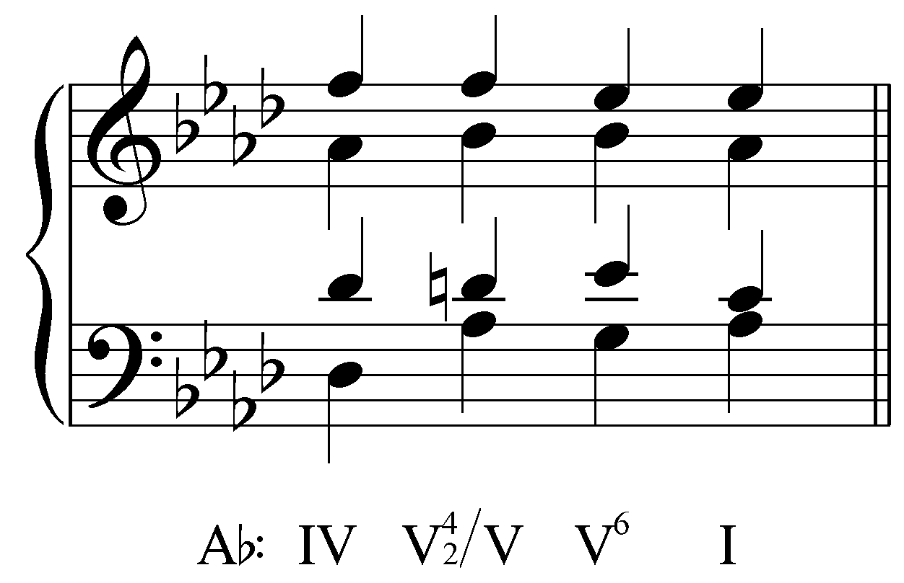. Response if student’s answer matches: “Correct!” Response if student’s answer does not match: “Incorrect. Try again. (Remember to use accidentals for any chromatically-altered pitches.)”]

Applied chords as auxiliary sonorities:

Applied chords may also appear as auxiliary sonorities used to expand a reference sonority. Consider the following example from the lesson on auxiliary sonorities (Lesson III):

Example 28:
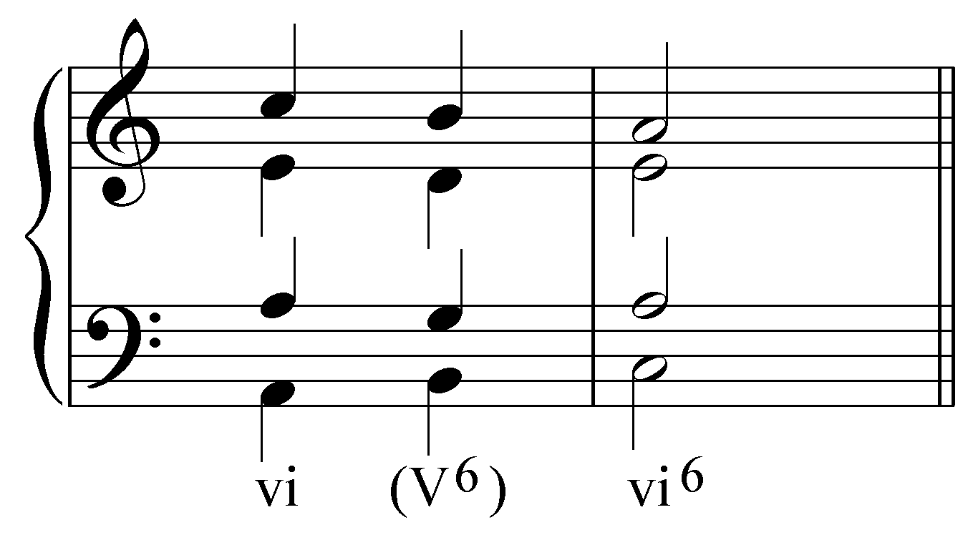

In Example 28, an auxiliary sonority coincidentally containing the pitches of a V⁶ chord is used to expand a vi chord. If tenor were to include a chromatic lower neighbor note (A - G# - A), the following expansion would result:

Example 29:
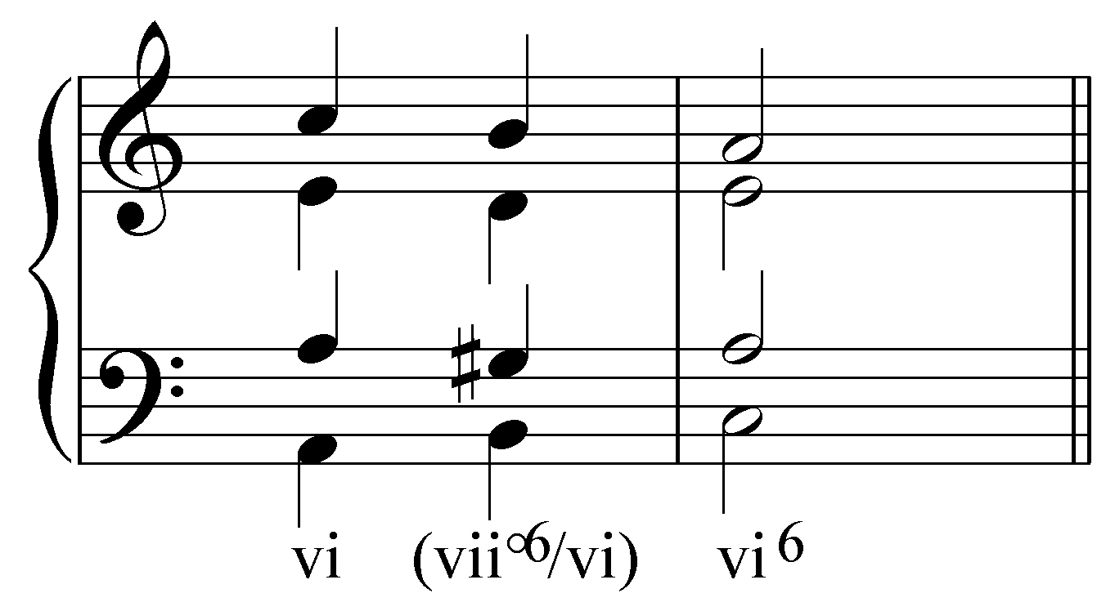

In the above example, the auxiliary sonority coincidentally produces the pitches of the vii°⁶ of A minor, tonicizing the reference chord, vi. This same type of expansion could be used on a V chord (“V - (vii°⁶/V) - V⁶”), and so on.

Conclusion:

Applied chords highlight the arrival of diatonic chords by tonicizing them. They do this by simulating the readily recognizable and pervasive dominant-tonic relationship in tonal music, thereby imparting a pseudo-tonic meaning to diatonic chords other than the reigning tonic. When a tonicized triad leads to the subsequent chord, its native diatonic function emerges clearly. Ultimately, therefore, despite chromatic alterations applied chords actually strengthen the reigning tonality rather than weaken it.

Applied chords may be built on a root either a fifth above or semitone below the chord being tonicized, and may include a chordal seventh. They should resolve according to voice leading modeled in the basic interval progressions.

It is essential to remember the difference between tonicization and modulation when dealing with applied chords. Tonicization is a local-level procedure, modulation a global-level one, with large-scale structural significance for a work. The difference is evident both from the comparatively brief influence of pseudo-tonics, and from the quick reversion of tonicized chords to their expected diatonic functions.

Applied chords are also frequently referred to as secondary dominants. This reflects the fact that they have a dominant function, but in a key other than the global tonic.

