Lesson HHH: Modulation to the Dominant

Introduction:

Until now, these lessons have focused on relatively small musical phenomena. Much of our discussion has focused on topics such as voice leading and the relationships between single chords. In this lesson, we will broaden our scope by looking at the relationships between larger portions of music that differ in key.

Almost inevitably, a piece of tonal music will explore one or more key areas other than the one in which it started. Composers incorporate non-tonic harmonic areas to provide contrast. In some pieces these new keys are more substantial and structurally significant than others. Furthermore, certain key relationships are more prevalent than others—the relationship between the tonic and the key of the dominant, for instance, is by far the most common.

In the lesson on applied chords (Lesson JJJ) we discussed the difference tonicization and modulation. This lesson will begin with a similar discussion highlighting certain characteristics of modulation. From there we will move to a generic discussion of the means by which composers modulate. Finally, we will discuss a number of common modulations for both major and minor keys.

Tonicization vs. Modulation:

Applied chords, as we saw in Lesson JJJ, are used to emphasize certain diatonic chords by momentarily giving them tonic color. The diatonic function of the chord being tonicized, however, does not change. For example, a ii chord would retain its pre-dominant function even if it was tonicized by a V⁷/ii. The “V⁷/ii - ii” motion reminds us of the ubiquitous “V⁷ - I” progression, but the ii chord never actually attains tonic function. In a modulation, on the other hand, we do hear a new tonic.

One must keep in mind, however, that even in the case of a modulation, the vast majority of tonal music eventually returns to the tonic key. In this sense, even a modulation is temporary. The important distinction between tonicization and modulation has to do with structural significance. For one thing, modulations last longer. They are also given greater weight by including one or more convincing cadential progressions in the new key. Unlike a tonicized chord, which retains its diatonic function, modulations dwell in the new key long enough to allow the listener to adjust to hearing it as a new tonic.

There are a number of clues that will help you identify modulations. Since a modulation will explore a new key area, there will be accidentals present for a prolonged period of time. Sometimes, for lengthier modulations, the composer may even choose to change the key signature. As mentioned above, strong cadential progressions are particularly effective in confirming a modulation. The presence of a cadence (or several cadences) with a pre-dominant – dominant – tonic progression in a key other than the global tonic is often a strong indication that the music has modulated. Tonicizations, on the other hand, are often limited to a single applied chord.

Methods of Modulation:

One of the most interesting aspects of the topic of modulation has to do with how the composer manages to move from one key area to another. A number of methods exist, some more commonly used than others. The simplest method of modulation is known as direct modulation.

In a direct modulation the composer will end a section in one key (typically with a cadence) and simply begin the next section in another. This method is a useful way to modulate to the dominant: a composer can end a phrase with a half cadence (the dominant chord) and then simply begin the next phrase in the dominant key. The following excerpt shows an example of this method of modulation:

Example 1, J.C. Bach, Op. 5, No. 2, 2nd movement (1765), mm. 1-23:
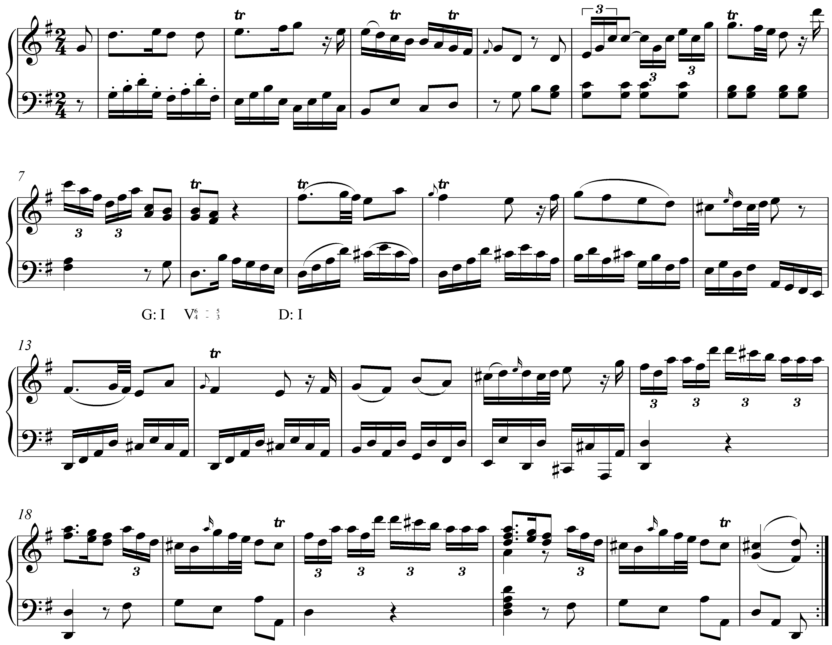

This excerpt begins in the key of G major, which is confirmed by the imperfect authentic cadence in m. 4. In m. 8 we arrive at a half cadence: a D-major chord with a ${}_{4}^{6}$ suspension in the right hand. After this moment of repose, the music continues with C#s instead of C-naturals, eventually leading to a perfect authentic cadence in m. 23. The cadence in m. 8 ends the passage in G major and D major begins directly in m. 9.

Although direct modulations are frequent in tonal music, they are often avoided because the abrupt change from one key to another can be distracting. Composers often strive for a fluidity in their music that the somewhat jarring juxtaposition of a direct modulation might disrupt.

Another method of modulation makes use of an applied chord. In this case, the modulation begins as a tonicization but simply continues on in the tonicized key. Taking our example from above, a “V⁷/ii - ii” progression, though by itself amounting only to a tonicization, may initiate a modulation if a pre-dominant – dominant – tonic progression in the key of the supertonic were to follow. Hearing the modulation initially as a tonicization helps smooth over the abruptness of the key change. (An example of this type of modulation appears below in Example 6.)

The most common method of modulation by far is with a pivot chord. A pivot chord is one that occurs diatonically in both keys. It must also have the same quality in both keys. Consider the following chord in the key of A^{b} major:

Example 2:
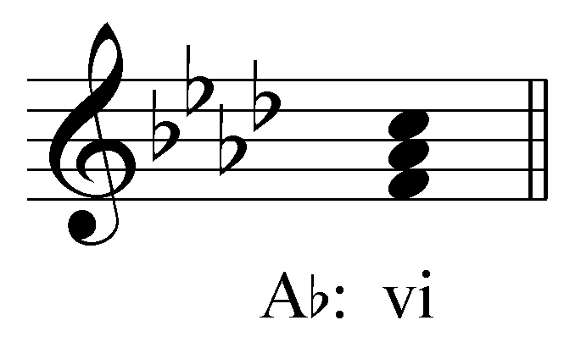

In A^{b} major, vi is an F-minor chord. This chord can function as a pivot with the dominant key (E^{b} major) because F is also a pitch of the E^{b}-major scale and because the diatonic triad built on F is also minor (the ii chord):

Example 3:
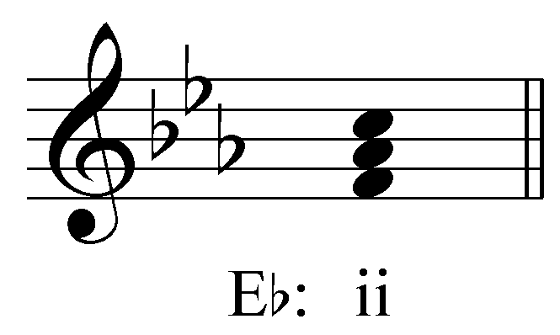

In the context of a modulation from A^{b} major to E^{b} major, the F-minor chord would initially be heard as the vi chord in A^{b} major. As the music continues in the new key, the F-minor chord more or less gradually becomes heard as the ii chord in E^{b} major. This change in function is confirmed by a strong cadence in the new key. The listener reinterprets the chord retrospectively.

Consider the following example of a pivot-chord modulation. (Pivot chords are indicated with two lines of Roman numerals: the original key on top and the new key just below it.)

Example 4: Beethoven, Piano Sonata, Op. 13 (“Pathétique”), 2nd Movement, mm. 13-23:
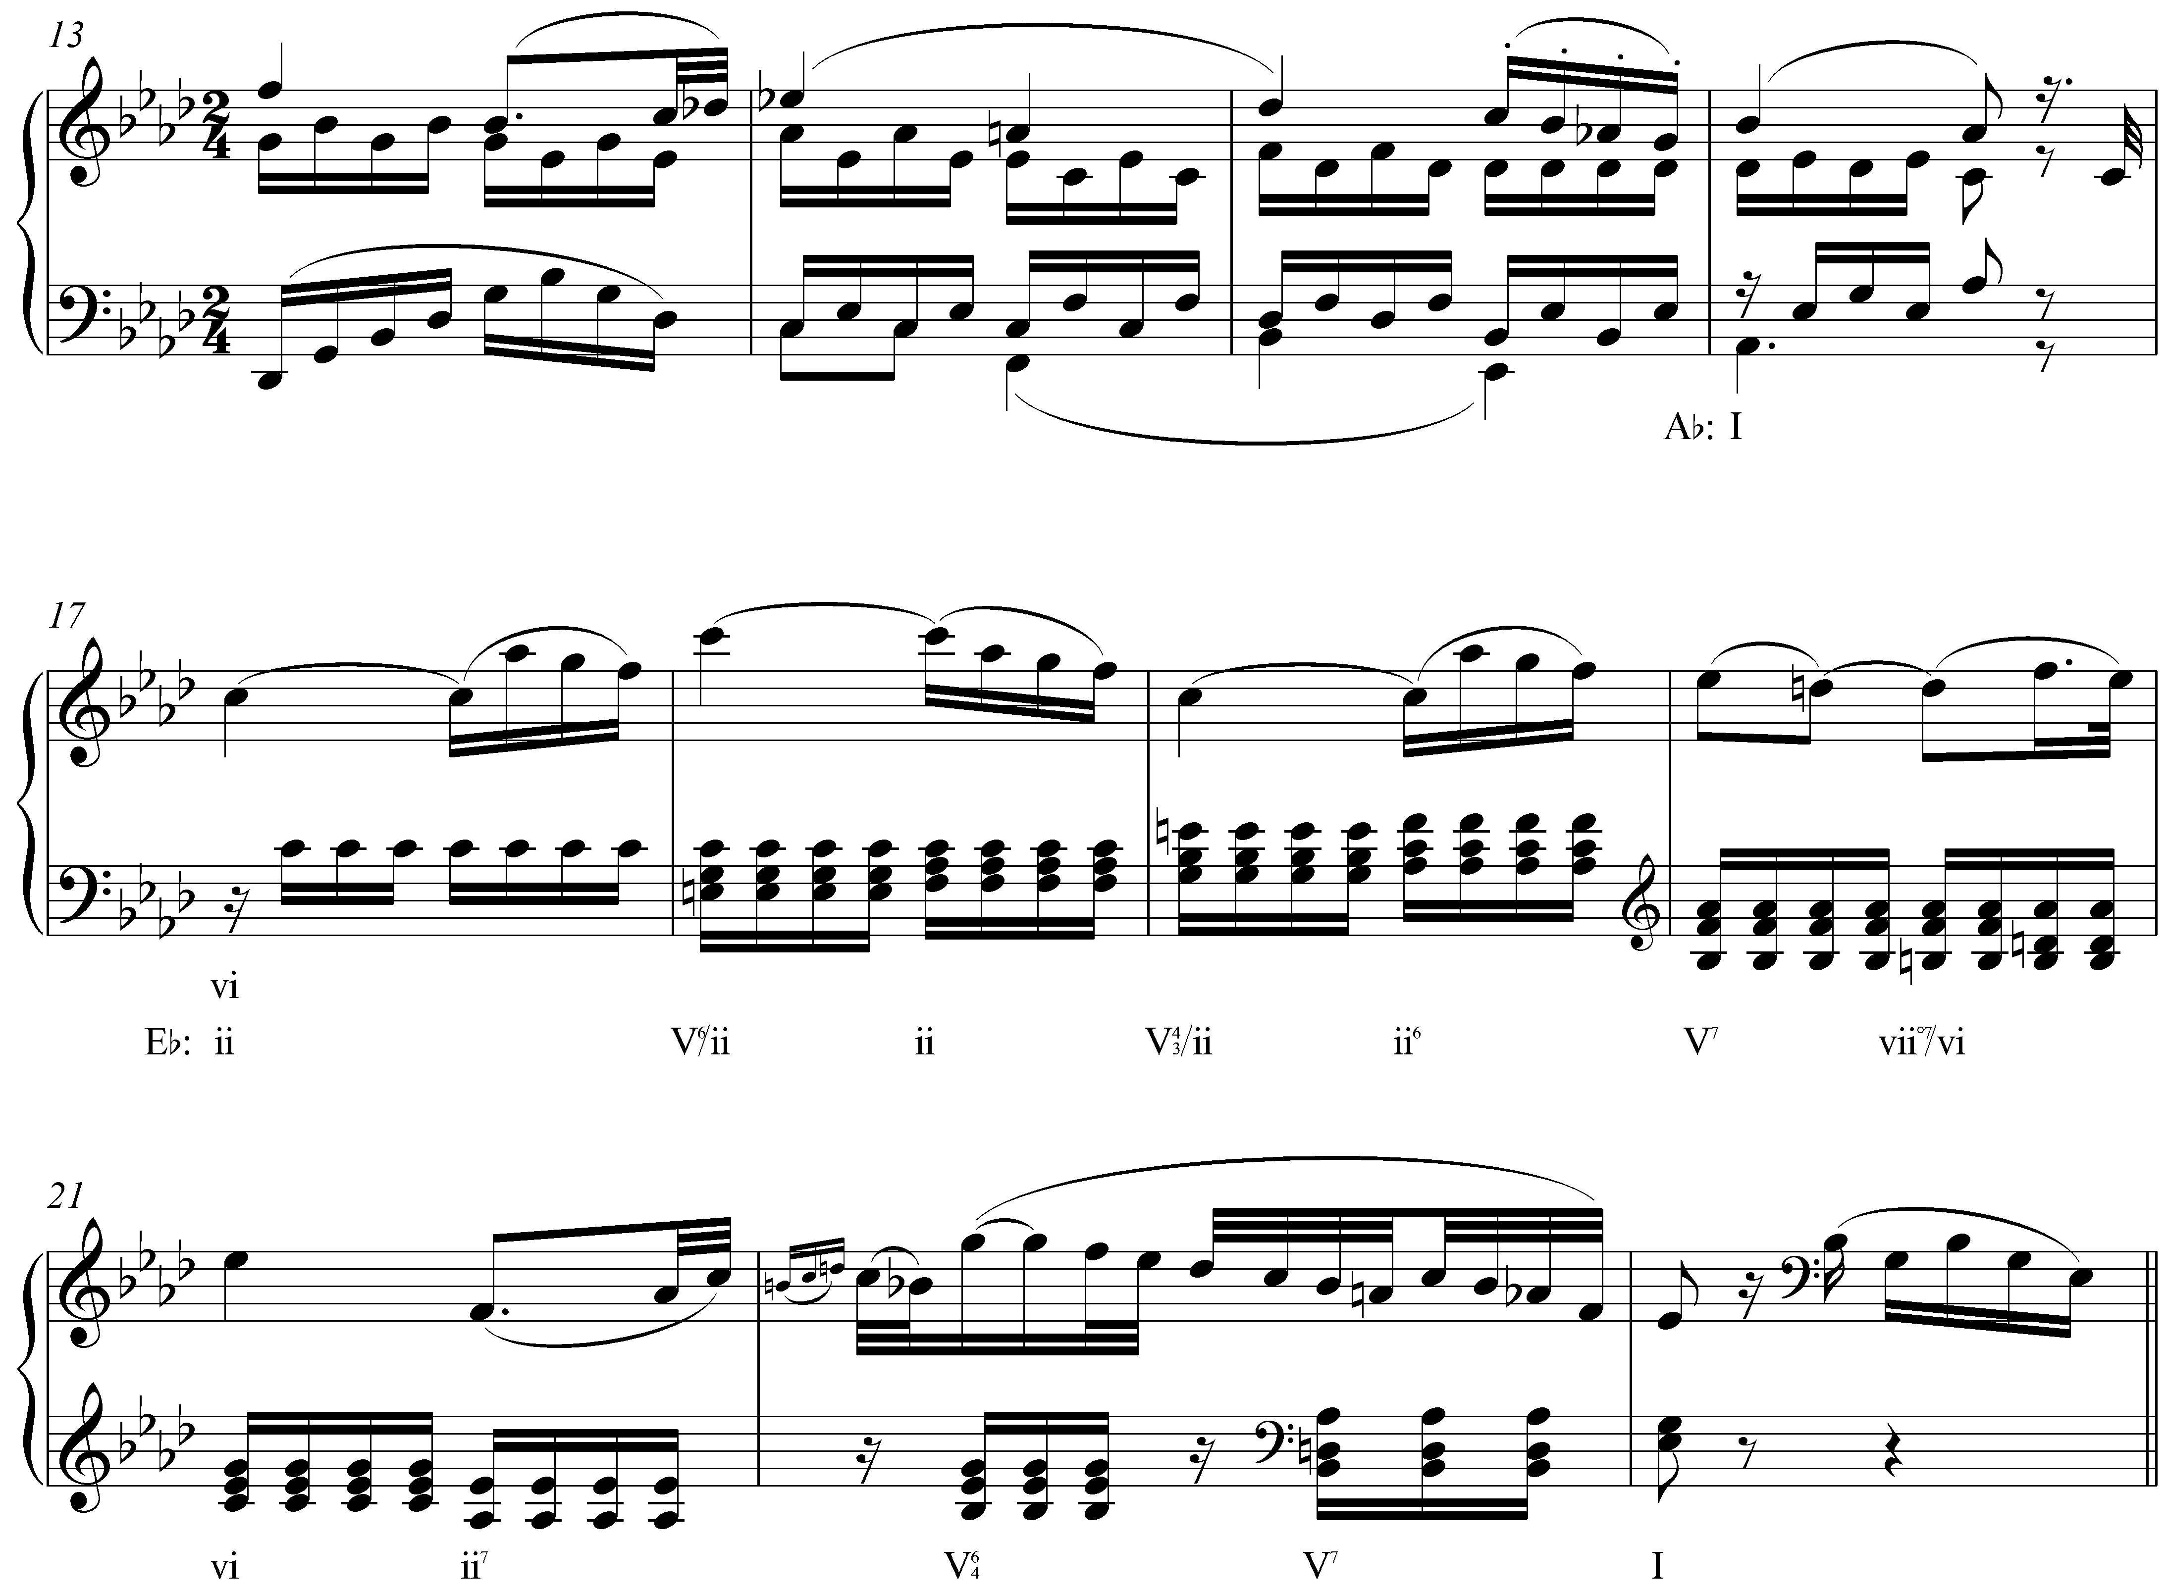

The beginning of this movement establishes the global tonic of A^{b} major and arrives at a perfect authentic cadence in m. 16. In m. 17 we encounter an F-minor chord which is prolonged through m. 19 with auxiliary applied dominant seventh chords. Initially, we hear F-minor as vi in A^{b} major. The music that follows, however, indicates a modulation to E^{b} major. The first indication is the dominant seventh chord in m. 20 (V⁷ of E^{b} major) which resolves deceptively to a C-minor chord in m. 21. The following measures present a perfect authentic cadence complete with pre-dominant chord (ii⁷) and cadential ${}_{4}^{6}$ chord. In retrospect, the prolonged F-minor chord in mm. 17-19 is reinterpreted as a ii chord in E^{b} major.

Pivot chords are most effective when they occur within the pre-dominant functional section. In the case mentioned above, the vi chord becomes a ii chord in the dominant key. This ii chord functions as a pre-dominant leading to a key-affirming cadence.

Common Modulations:

Of course, modulation is technically possible between any two keys. As the tonal practice progressed into the Romantic era, composers began to explore more and more distantly related keys. For the sake of clarity, we will limit our discussion to modulations between closely related keys.

A closely related key is one whose tonic chord is diatonic in the primary key. Example 4 contained a modulation to a closely related key: A^{b} major modulated to E^{b} major. The key of E^{b} major is considered closely related to A^{b} major because its tonic triad is a diatonic chord in A^{b} major (the V chord). If the tonic of the new key is a diatonic member of the old key, the two keys are closely related.

For any given key there are five closely related keys. For a major key, closely related keys include those whose tonics are the ii, iii, IV, V, and vi chords. (viiº is not included because no key has a diminished triad as its tonic and I has been left out because to modulate to the tonic key would not be a modulation at all!) Closely related keys to a minor key include those that have III, iv, v, VI, or VII as their tonic. These keys are also considered closely related because they share so many of their pitches with the primary key. For example, C major differs from the closely-related key of G major by only one pitch: C major has F while G major has F#, all of the other pitches are common to both keys. As you may have noticed, the tonics of all the closely related keys are the same chords that can be tonicized with applied chords.

[Potential Activity:
Students are asked to list the keys that are closely related to C major (D minor, E minor, F major, G major, and A minor).]

In the remaining sections, we will look at specific modulatory goals and discuss the potential pivot chords for arriving at them. The examples discussed below are by no means the only possible modulations. As the tonal tradition progressed into the Romantic era, composers became more adventurous in their modulation choices. It became acceptable for pieces to modulate to increasingly distant keys. Accompanying this were a host of other methods of modulation. We will, for the sake of clarity and brevity, limit our discussion to closely related keys.

Modulations from Major Keys:

By far the most common modulatory goal for a major key is to its dominant. Because of the close relationship between these two keys, modulation to the dominant simultaneously provides harmonic contrast and while maintaining unity in a piece. As mentioned above, one method of modulating to the dominant key consists of ending a phrase with a half cadence and simply continuing on with the dominant harmony becoming the new tonic. This method can also be thought of a pivot-chord modulation. The chord functions first as the dominant of the primary key. Then, when the music continues in the key of the dominant, the chord is reinterpreted in retrospect as the tonic of the new key.

There are four possible pivot chords between a major key and its dominant. The following table uses C major and G major as examples:

Table 1:
C major  (the primary key) |  | G major  (the dominant key)
I | = | IV
Iii | = | vi
V | = | I
Vi | = | ii

Each row of Table 1 shows a possible pivot chord. For example, the second row shows that the iii chord in C major (an E-minor triad) can be reinterpreted as a vi chord in G major (also an E-minor triad). Other chords in the key of C major (ii, IV, and viiº) cannot be used as pivot chords because the quality of the analogous chord in G major is different (the chord built on D in C major is minor while the chord built on D in G major is major, and so forth).

Of the four possible pivot chords outlined in Table 1, “vi = ii” is the most useful, as shown by Example 4. The “I = IV” pivot, though certainly a possible pivot chord, is used less frequently because it is difficult to hear the tonic triad as anything other than I once the key has been established. The same is true for “V = I.” It is very difficult to hear the dominant of the primary key as anything else without a chord coming before it (in which case, “V = I” is no longer the pivot chord). The “iii = vi” pivot is less commonly used because the mediant harmony does not appear as frequently in tonal music.

The following example shows a modulation to the dominant key via a “I = IV” pivot chord:

Example 5: J.S. Bach, R. 22 BWV 180.7v, mm. 4-10:
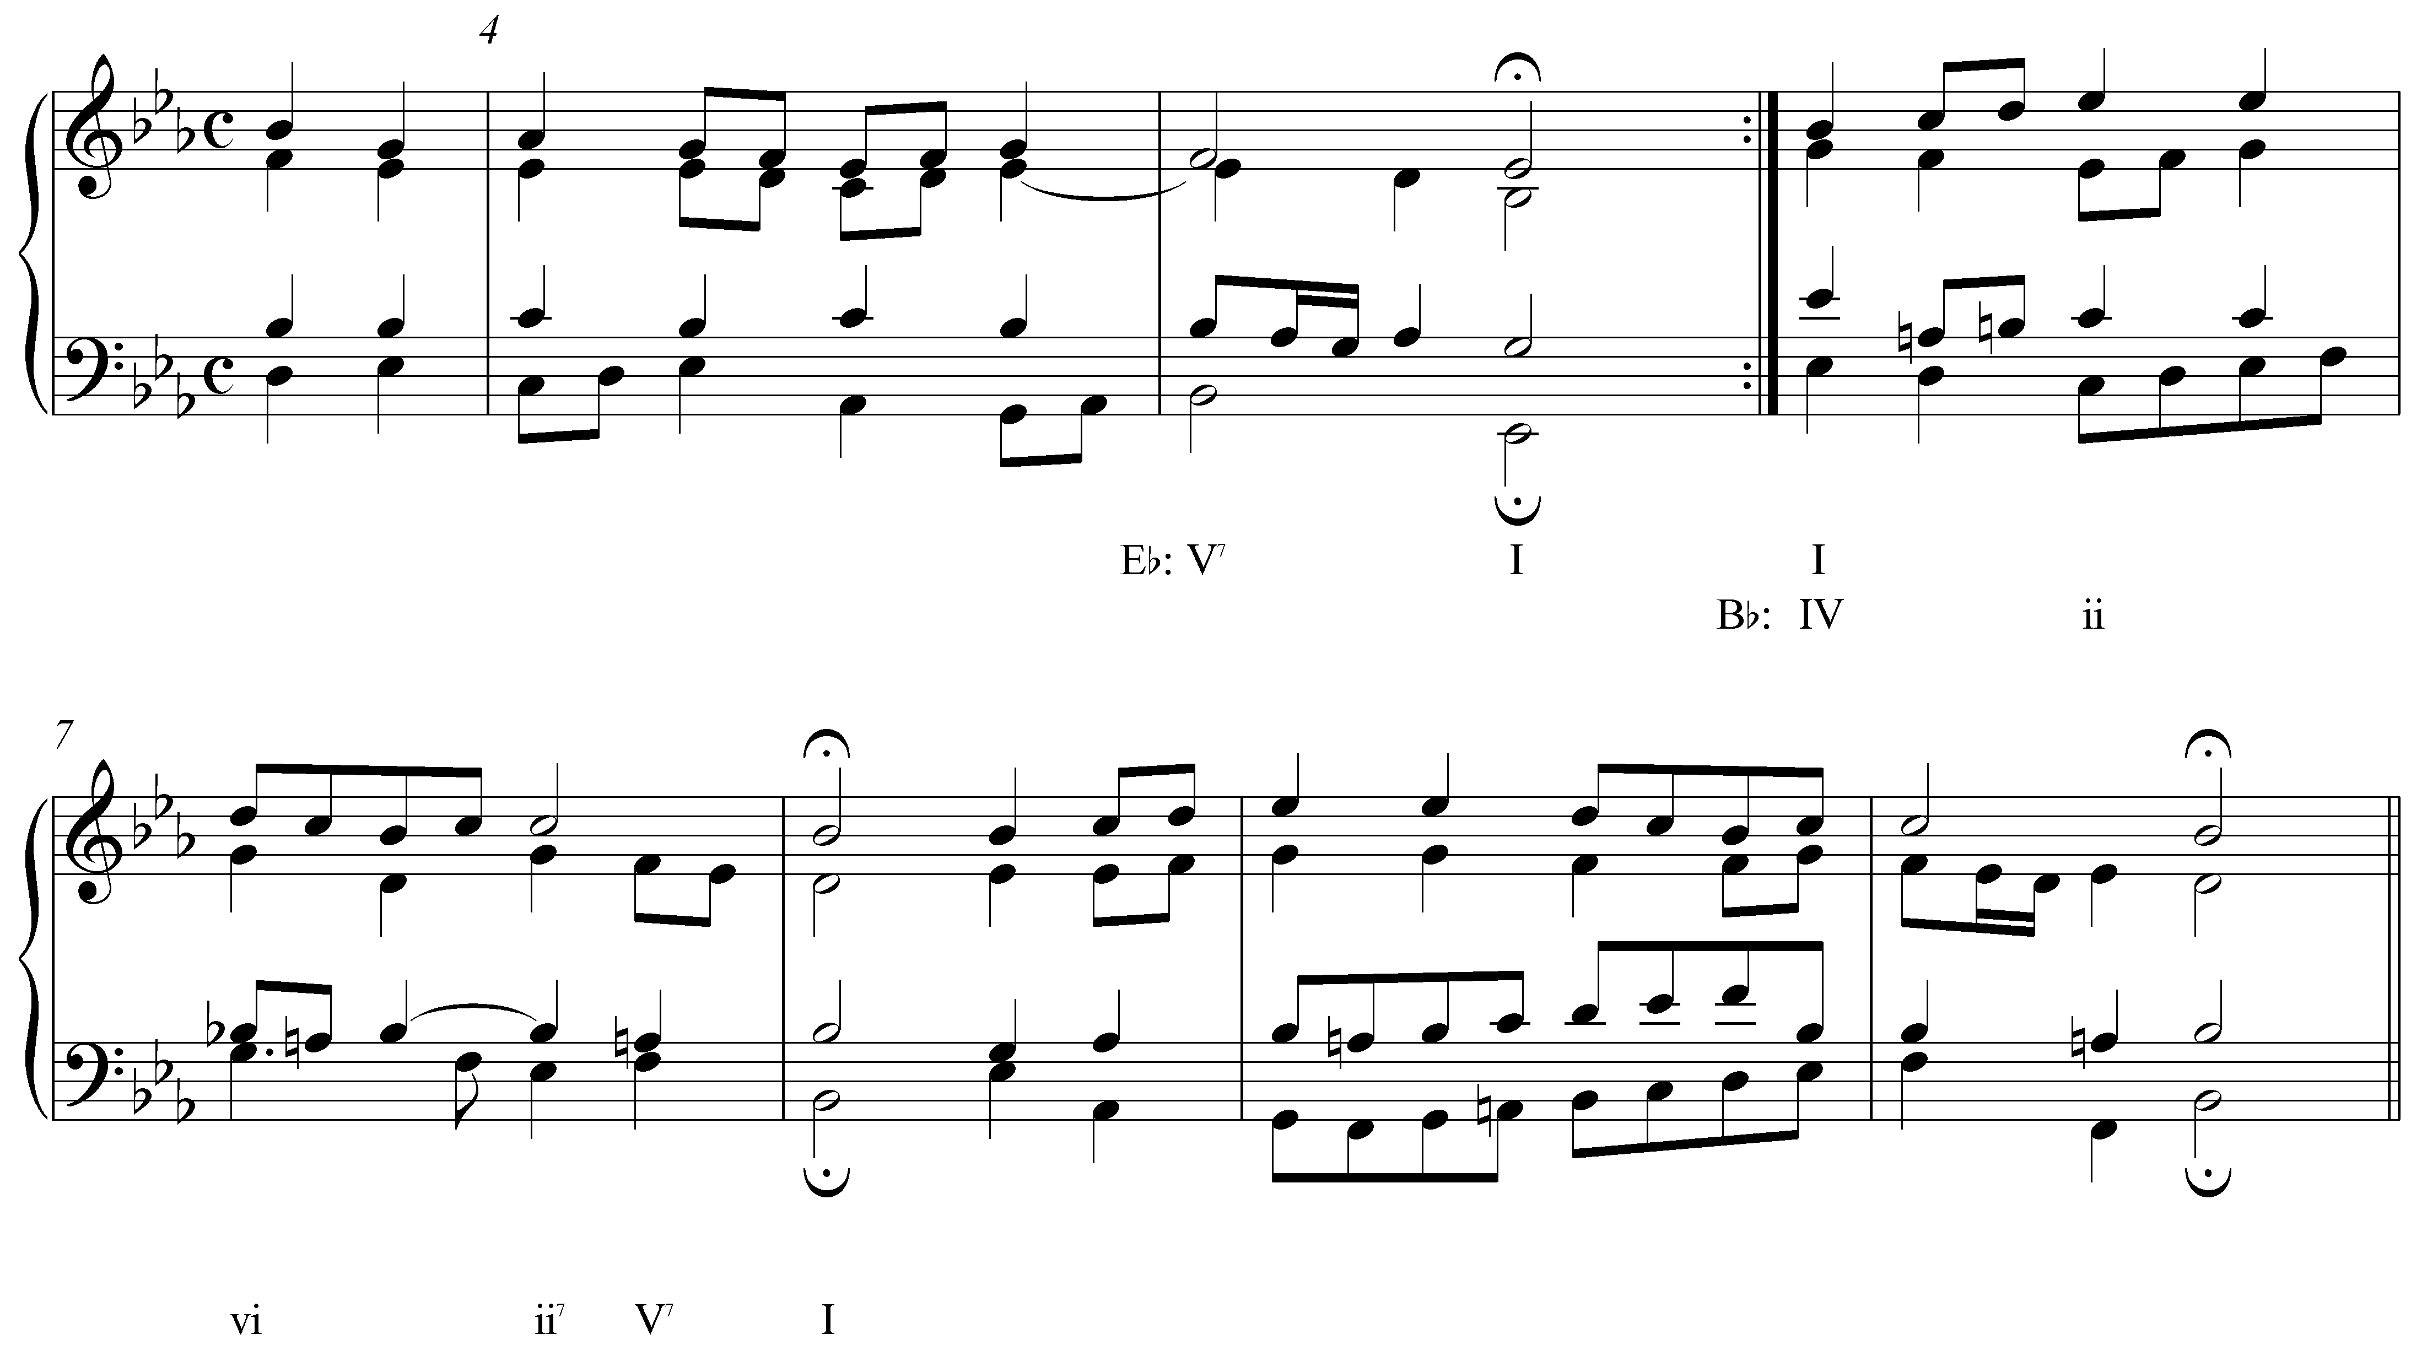

In Example 5, we find a phrase ending in the tonic key of E^{b} major with a perfect authentic cadence. After the barline, the tonic E^{b}-major harmony is repeated. From this point on, however, all of the A^{b} s have become natural and in mm. 7-8 we find a perfect authentic cadence in the key of B^{b} major. In retrospect, the E^{b}-major harmony is reinterpreted as a IV chord in B^{b} major. As mentioned above, the “I = IV” pivot chord is not used very frequently because it is difficult to reinterpret the tonic harmony as anything but. In this case, the dissonant seventh chord on beat two of m. 6—with A natural—is enough to challenge the E^{b}-major tonality.

(Some of the excerpts in this lesson, including the Bach chorale given in Example 5, are notably short and the modulations that take place therein do not last very long. One might argue that some of these modulations are in fact tonicizations due to their brevity. Nonetheless, the same modulatory procedures are present even at this small scale, and the examples will still be useful for demonstration.)

While modulation to the dominant key is the most common, the submediant is another frequent goal. The key of the submediant is the relative minor. As such, it shares all of its pitches with the primary major key and allows for smooth modulations. Because the pitch content of the two keys is exactly the same, any chord can be used as a pivot chord:

Table 2:
C major  (the primary key) |  | A minor  (the submediant key)
I | = | III
ii | = | iv
Iii | = | V
IV | = | VI
V | = | VII
vi | = | i
viiº | = | iiº

As mentioned above, pivot-chord modulations are most effective when both interpretations of the pivot chord have pre-dominant function. For this reason, “ii = iv” and “IV = VI” are the most commonly appearing pivot chords between a key and its relative minor.

Modulations to the supertonic (ii) is also possible. However, in a modulation to the key of the supertonic, all of the possible pivot chords (“I = VII,” “ii = i,” “IV = III,” and “vi = v”) are problematic because they all incorporate a tonic, mediant, or dominant chord. For this reason, modulation to the key of the supertonic is usually performed with the applied chord method. In other words, the new key is introduced with an applied dominant or leading-tone chord and simply continues the tonicization. The following excerpt shows an example of this type of modulation:

Example 6: J.S. Bach, R. 125, mm. 3-8:
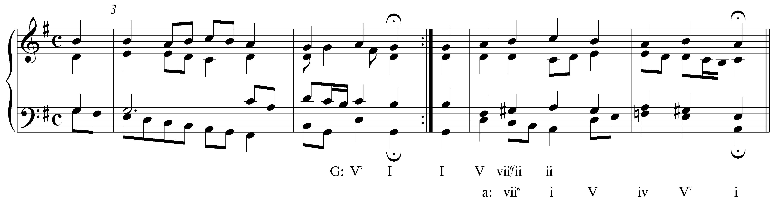

Here, following a perfect authentic cadence in the tonic key, the phrase beginning with the pickup to m. 5 appears to be in the tonic key of G major. Following the D major harmony on the downbeat of m. 5, we come across a diminished triad built on G# (the C in the bass is an accented passing tone). This sonority is an applied leading-tone chord tonicizing ii, which appears in root position on beat three. Following this tonicization, we consistently find F-naturals and G#s leading to a perfect authentic cadence in A minor in m. 6. The modulation to A minor (the supertonic of G major) was achieved with the applied chord in m. 5.

Occasionally, a piece will modulate to the key of its subdominant (IV). This modulation is less common and for good reason. In modulating to the subdominant, the tonic of the primary key must be heard as the new dominant. This change in function can be very disruptive to the listener because of the special relationship between tonic and dominant in tonal music. Modulating to IV too early in a piece can cause the listener to lose track of the home key. (This is not an issue in minor keys, because i cannot sound like V/IV because it is minor.) Nonetheless, modulations to the subdominant do occur. The possible pivot chords are as follows:

Table 3:
C major  (the primary key) |  | F major  (the subdominant key)
I | = | V
Ii | = | vi
IV | = | I
Vi | = | iii

Modulations from Minor Keys:

Because of their tendency to gravitate towards their relative majors, minor keys frequently modulate to the mediant. (You may wish to review Lesson JJJ for more information regarding the structural characteristics of the minor scale and the privileged status of the relative major.) As with major keys modulating to their relative minors, every chord is a potential pivot:

Table 4:
A minor  (the primary key) |  | C major  (the relative major)
i | = | vi
iiº | = | viiº
III | = | I
iv | = | ii
v | = | iii
VI | = | IV
VII | = | V

Of these possibilities, the most frequently used are “i = vi,” “III = I,” “iv = ii,” and “VI = IV.” The following examples show two such modulations, the first modulating to the relative major via a “VI = IV” pivot chord and the second with a “iv = ii”:

Example 7: Mozart, Piano Sonata, K.311, mm. 21-28:
(i to III via VI→IV)
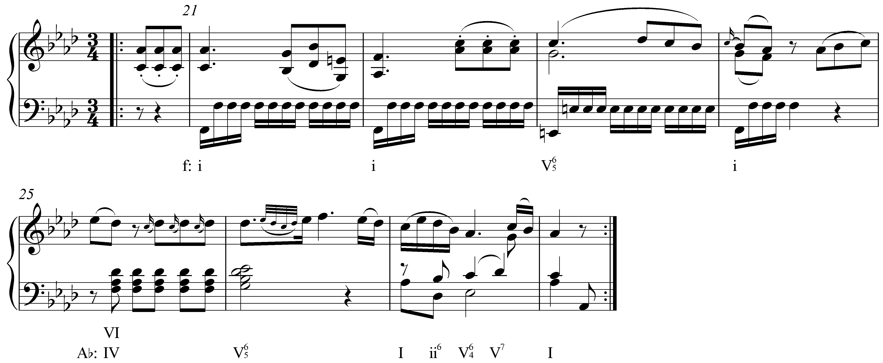

Example 8: Handel, Keyboard Suite No. 16 in G minor (HWV 542), Sarabande, mm. 1-6:
(i to III via iv → ii)
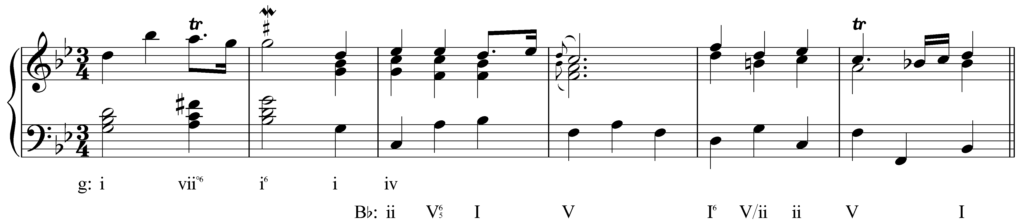

In both Examples 7 and 8, the pivot chord is followed by a dominant seventh chord in the new key. As mentioned elsewhere (see Lesson EEE on the dominant seventh chord and Lesson JJJ on applied chords), the dominant seventh sonority is unique among diatonic seventh chords and as such immediately implies a specific key. In either of the above two examples, the pivot chord functions as a pre-dominant harmony. When it is followed by a dominant seventh chord, there is already a strong implication of the new key. In both cases, the modulation is confirmed with a perfect authentic cadence in the new key.

Minor keys also modulate to the minor dominant (v). It is important to remember that the major dominant of a minor key (V) is not a closely related key. In A minor, for example, the major dominant would be the key of E major. Compare the key signatures of A minor and E major. They differ by four accidentals (the diatonic pitches of the A minor scale are all natural while E major contains four sharp pitches). When a minor key modulates to the dominant key, it modulates to the diatonic chord built on scale degree 5. In the key of A minor, this would be E minor. The possible pivot chords for modulating to the minor dominant are as follows:

Table 5:
A minor  (the primary key) |  | E minor  (the minor  subdominant key)
I | = | iv
III | = | VI
V | = | i
VII | = | III

It is also common for a piece in a minor key to modulate to the relative major temporarily on the way to the minor dominant. Consider the following example:

Example 9: J.S. Bach, R. 263:
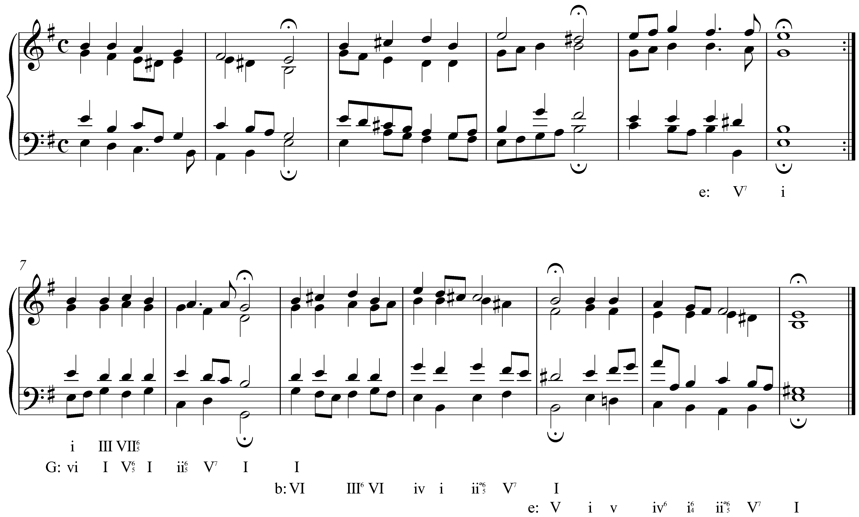

In Example 9, the first three phrases prolong the tonic key of E minor. The phrase beginning in m. 7 sounds at first like E minor as well. Despite the lack of accidentals in m. 7, it makes more sense to interpret beats two through four as an expansion of G major with an auxiliary dominant seventh chord. The cadence in the following measure supports this interpretation.

In the next phrase, the tonic harmony of G major is reinterpreted as the VI chord of B minor (the minor dominant). This modulation is also confirmed with a perfect authentic cadence. (Do not be fooled by the D# on the downbeat of m. 11. This stylistic convention is known as a Picardy third and does not indicate a modulation to B major.) The brief modulation to the key of the relative major in mm. 7-8 acts as a stepping stone to the greater modulatory goal of the minor dominant. (These modulations form a large-scale arpeggiation of the tonic triad: E – G – B!)

Conclusion:

Tonal pieces almost inevitably explore some key area other than the one they started in. The process of changing keys is known as modulation. This is differentiated from tonicization both in length and in structural significance. Whereas a tonicization temporarily lends tonic color to some chord other than the tonic, a modulation creates the sense of a new tonal center.

There are a number of different methods of modulation and a number of common modulatory goals. Common methods include direct modulation, extended tonicization, and pivot-chord modulation, among which the latter is the most common. In major keys, the most common modulatory destination is the key of the dominant, followed by the submediant, supertonic and subdominant. Minor keys, typically modulate to their relative majors or minor dominants. Other modulations are possible of course, but are beyond the scope of this lesson.

