Lesson KKK – Modulation

Introduction:

Until now, these lessons have focused on relatively small-scale musical events. Our discussion has focused on topics such as voice leading and the relationships between individual chords. In this lesson, we will broaden the scope by looking at larger contexts in order to address the topic of modulation.

Almost inevitably, a piece of tonal music explores one or more key areas besides the global tonic. Composers incorporate non-tonic key areas to provide contrast and to create anticipation for a return to the global tonic. In some pieces these non-tonic keys are more structurally significant than others. Furthermore, certain key relationships are more prevalent than others—the relationship between the tonic and the key of the dominant, for instance, being by far the most common.

In the lesson on applied chords (Lesson JJJ) we discussed the difference between tonicization and modulation. This lesson will begin with a similar discussion highlighting certain characteristics of modulation. From there we will move to a generic discussion of the technique of modulation. Finally, we will discuss a number of common modulations in both major and minor keys.

Tonicization vs. Modulation:

Applied chords, as we saw in Lesson JJJ, emphasize diatonic chords by momentarily giving them tonic color. However, the diatonic function of the tonicized chord does not change. A ii chord, for example, retains its pre-dominant function even when tonicized by a V⁷/ii. The progression“V⁷/ii - ii” reminds us of the ubiquitous “V⁷ - I”, but the ii chord remains a pseudo-tonic—it never actually attains tonic function. In a modulation, by contrast, we do hear a new tonic.

One must keep in mind, however, that even a modulation is a temporary change of key because the vast majority of tonal music eventually returns to the global tonic key. The important distinction between tonicization and modulation has to do with structural significance. First, non-tonic keys last longer; unlike a tonicized chord, which retains its diatonic function, non-tonic keys remain in effect long enough to allow listeners to adjust to hearing them as new tonics. Further, they have greater weight because they include one or more decisive cadential progressions.

There are a number of clues that will help you identify modulations. Since a modulation will explore a new key area, accidentals will appear and remain present for a prolonged period of time. Sometimes, for lengthier non-tonic key areas, the composer may temporarily change the key signature. As mentioned above, strong cadential progressions are particularly effective in confirming a modulation. The presence of a cadence (or several) with a pre-dominant – dominant – tonic progression in a key other than the global tonic is a strong indication that the music has modulated. Tonicizations, on the other hand, are often limited to a single applied chord and its resolution.

Techniques of Modulation:

One of the most interesting aspects of the topic of modulation has to do with how composers manage to move from one key area to another. Several techniques are common. The simplest one is known as direct modulation.

In a direct modulation the composer ends a section in one key (typically with a cadence) and simply begins the next section in another. This technique is a useful way to modulate to the dominant: a composer can end a phrase with a half cadence (on the dominant chord) and then simply begin the next phrase in the dominant key. The following excerpt illustrates this method:

Example 1 (J.C. Bach, Op. 5, No. 2, 2nd movement (1765), mm. 1-23):
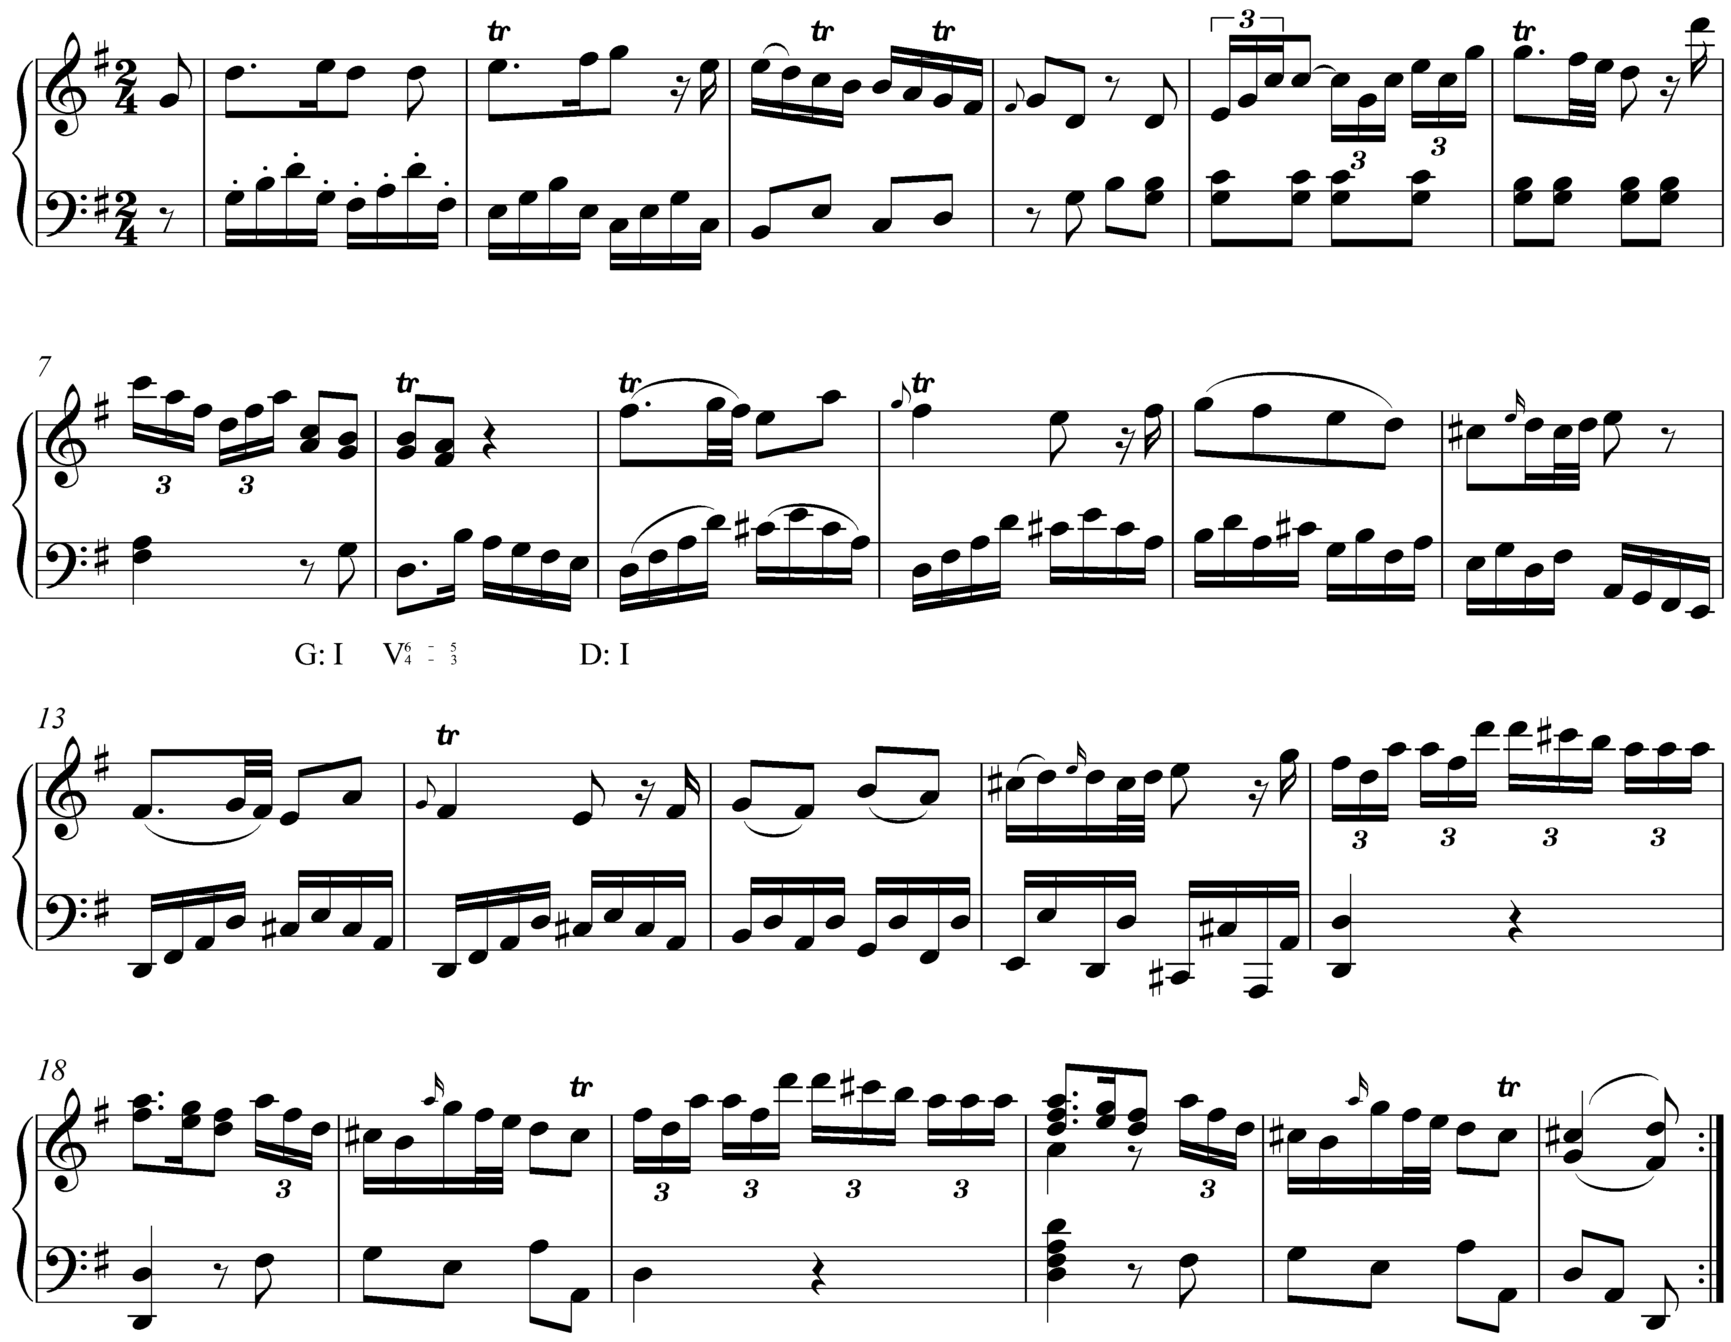

This excerpt begins in the key of G major, which is confirmed by the imperfect authentic cadence in m. 4. In m. 8 we arrive at a half cadence: a D-major chord with a ${}_{4}^{6}$ suspension in the right hand. After this moment of repose, the music continues in D major, with C#s instead of C-naturals, eventually leading to a perfect authentic cadence in m. 23. The cadence in m. 8 terminates G major, and D major begins directly in m. 9.

Example 2 shows another direct modulation:

Example 2 (J.S. Bach, BWV 244.54, “Herzlich tut mich verlangen,” mm. 1-4):
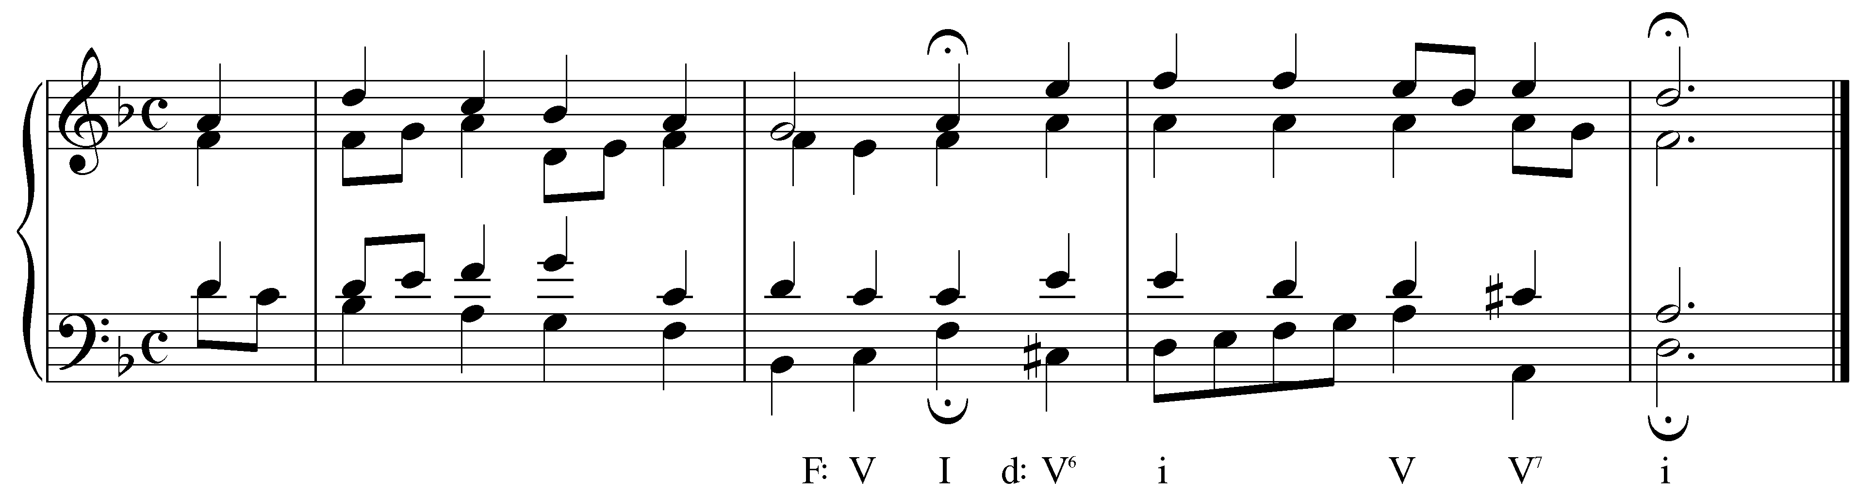

The first phrase in Example ends very clearly in the key of F major with an imperfect authentic cadence. On the fourth beat of m. 2, however, a C# is introduced in the bass. As the rest of the second phrase confirms, Bach has modulated to the D minor (the relative minor) and C# is the new leading tone. The modulation is immediate. The second phrase begins immediately after the fermata in the new key.

Although direct modulations are common in tonal music, they are not always appropriate because of the jarring effect of the abrupt change from one key to another. Composers often strive for harmonic smoothness, which a direct modulation disrupts.

Another method of modulation makes use of an applied chord. In this case, the modulation begins as a tonicization but continues in the tonicized key. Taking our example from above, a “V⁷/ii - ii” progression, though by itself a momentary tonicization, may initiate a modulation if a pre-dominant – dominant – tonic progression in the key of the supertonic were to follow. Hearing the modulation initially as a tonicization helps smooth over the abruptness of the key change. (An example of this type of modulation appears below in Example 7.)

The most common technique of modulation is with a pivot chord. A chord that occurs diatonically in both keys can serve as a pivot between them. The best choice of pivot chord is one that functions as a pre-dominant chord in the goal key. Consider the following chord in the key of A^{b} major:

Example 3:
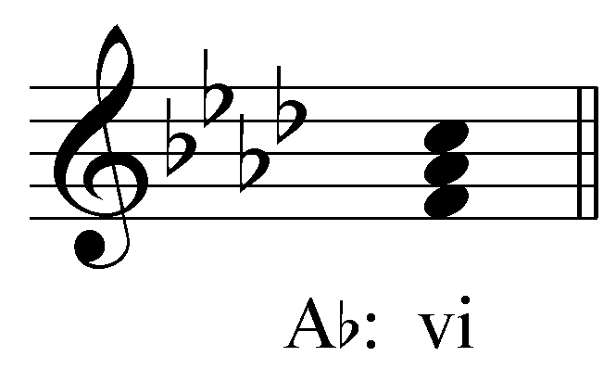

In A^{b} major, vi is an F-minor chord. That chord can function as a pivot to the dominant key (E^{b} major) because it is ii in the key of E^{b}:

Example 4:
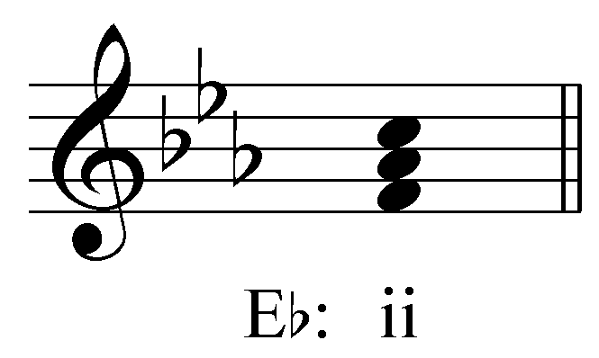

It is an effective pivot because it functions as a pre-dominant chord in the key of E^{b}, and can lead directly to the dominant which, in turn, resolves to the new tonic.

In the context of a modulation from A^{b} major to E^{b} major, the F-minor chord would initially be heard as the vi chord in A^{b} major. As the music continues in the new key, the F-minor chord is heard retroauditively and every more strongly as the ii chord in E^{b} major. This change in function is confirmed by a strong cadence in the new key. The listener reinterprets the chord retroauditively.

Consider the following example of a pivot-chord modulation. (Pivot chords are indicated with two lines of Roman numerals: the original key on top and the new key just below it.)

Example 5 (Beethoven, Piano Sonata, Op. 13 (“Pathétique”), 2nd Movement, mm. 13-23):
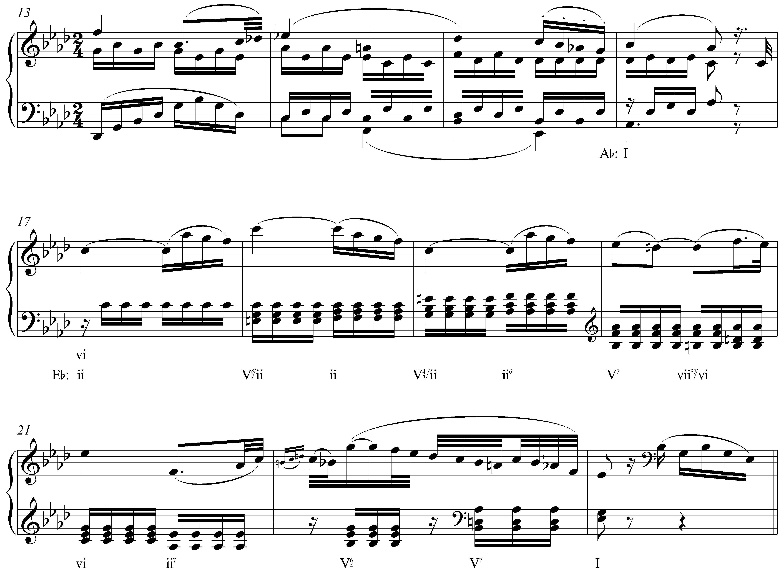

The beginning of this movement establishes the global tonic of A^{b} major and arrives at a perfect authentic cadence in m. 16. In m. 17 we encounter an F-minor chord which is prolonged through m. 19 with auxiliary applied dominant seventh chords. Initially, we hear F-minor as vi in A^{b} major. The music that follows, however, indicates a modulation to E^{b} major. The first sign is the dominant seventh chord in m. 20 (V⁷ of E^{b} major) which resolves deceptively to a C-minor chord in m. 21. The following measures present a perfect authentic cadence complete with pre-dominant chord (ii⁷) and cadential ${}_{4}^{6}$ chord. In retrospect, the prolonged F-minor chord in mm. 17-19 is reinterpreted as a ii chord in E^{b} major.

As mentioned above, pivot chords are most effective when they function as pre-dominant chords in the goal key. In Example 5 above, the vi chord becomes a ii chord in the dominant key. This ii chord functions as a pre-dominant leading to a key-affirming V-I cadence.

Common Modulations:

Modulation is technically possible between any two keys. As the tonal practice evolved in the nineteenth century, composers explored more and more distantly related keys for their expressive effects. For now, we will limit our discussion to modulations between closely related keys.

A closely related key is one whose tonic chord is diatonic in the global tonic key. Example 5 contained a modulation to a closely related key: A^{b} major modulated to its dominant, E^{b} major. The key of E^{b} major is considered closely related to A^{b} major because its tonic triad is a diatonic chord in A^{b} major (the V chord). If the tonic of the new key is a diatonic member of the old key, the two keys are closely related.
For any given key there are five closely related keys. For a major key, closely related keys include those whose tonics are the ii, iii, IV, V, and vi chords. (viiº is not included because no key has a diminished triad as its tonic and I has been left out because to modulate to the tonic key would not be a modulation at all!) Closely related keys to a minor key include those that have III, iv, v, VI, or VII as their tonic. These keys are considered closely related because they share so many pitches with the primary key. For example, C major differs from the closely-related key of G major by only one pitch: F#. All of the other pitches are common to both keys. As you may have noticed, the tonics of all the closely related keys are the same chords that can be tonicized with applied chords.

Activity 11.1:
In tonal music, most modulations move to closely related keys (keys whose tonic triad is a diatonic chord in the original key). Name the five keys that are closely related to G major.
[Answers: A minor, B minor, C major, D major, and E minor. Response for each correct answer: “Correct!” Response for any incorrect answer [X]: “Incorrect. [X] is not a diatonic chord in G major and is therefore not a closely related key. Try again.”]

In the remaining sections, we will look at specific modulatory goals and discuss the potential pivot chords for reaching them. The examples discussed below are by no means the only possible modulations. As mentioned above, over the course of the nineteenth century composers became more adventurous in their modulations for expressive purposes. It became acceptable for pieces to modulate to increasingly distant keys. Accompanying this were several modulatory techniques other than by diatonic pivot. For the purposes of these lessons, our discussion will stick to closely related keys.

Modulations from Major Keys:

By far, the most common modulatory goal for a major key is the key of the dominant. Because of the close relationship between these two keys, modulation to the dominant provides contrast while maintaining unity in a piece. As mentioned above, one method of modulating to the dominant key consists of ending a phrase with a half cadence and simply continuing with the dominant harmony treated as the new tonic. That method (direct modulation) can also be understood as a pivot-chord modulation. As the dominant chord arrives, it functions as the dominant of the primary key. As the music continues, the chord becomes tonic of the new key.

There are four possible pivot chords between a major key and its dominant. The following table uses C major and G major as examples:

Table 1:
C major  (the primary key) |  | G major  (the dominant key)
I | = | IV
iii | = | vi
V | = | I
vi | = | ii

Each row of Table 1 shows a possible pivot chord. For example, the second row shows that the iii chord in C major (an E-minor triad) can be reinterpreted as a vi chord in G major (also an E-minor triad). Other chords in the key of C major (ii, IV, and viiº) cannot be used as pivot chords because the quality of the analogous chord in G major is different (the chord built on D in C major is minor while the chord built on D in G major is major, and so forth).

Of the four possible pivot chords outlined in Table 1, “vi = ii” is the most common (see Example 5). The “I = IV” pivot, though certainly possible, is less common because it is difficult to hear the tonic triad as anything other than I once the key has been established. The same is true for “V = I.” It is difficult to hear the dominant of a key as anything else without a chord coming before it (in which case, “V = I” is no longer the pivot chord). The “iii = vi” pivot is less commonly used because the mediant harmony is relatively infrequent in tonal music.

Activity 11.2:
What is the dominant key in F major?
[Answer: C major. Response if correct: “Correct!” Response if incorrect: “Incorrect. Try again.”]

[Follow-up activity:]
Name three pivot chords that might be used in a modulation from F major to C major (remember to use uppercase roman numerals for major chords and lowercase roman numerals for minor chords):

F major C major

_____ = ____ _

_____ = ____ _

_____ = ____ _

[Possible answers: “I = IV,” “iii = vi,” “V = I,” and “vi = ii.” Feedback for each correct answer: “Correct!” Feedback for incorrect answer if first roman numeral [X] is I, iii, V, or vi: “That is incorrect. Although [X] is a potential pivot chord in a modulation from F major to C major, your equivalent roman numeral in C major is incorrect. Try again.” Feedback for all other incorrect answers: “That is incorrect. [X] is not a potential pivot chord in F major for a modulation to C major. Try again.”]

The following example shows a modulation to the dominant key via a “I = IV” pivot chord:

Example 6 (J.S. Bach, BWV 153.9, “Herr Jesu Christ, meins Lebens Licht,” mm. 1-8):
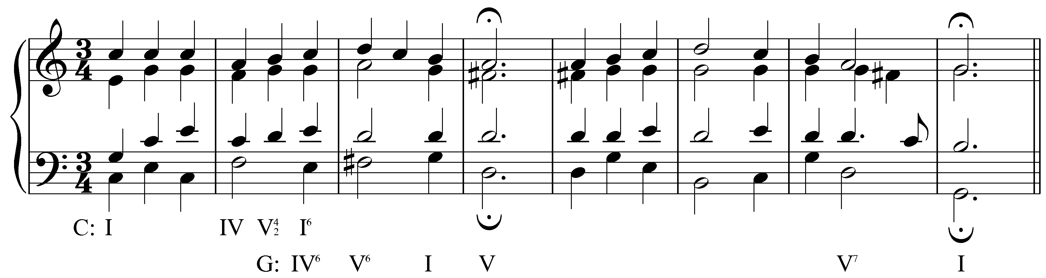

The excerpt in Example 6 begins very clearly in the key of C major (the entire first measure is devoted to tonic harmony). The first phrase ends, however, with a half cadence in G major, the key of the dominant. The modulation to G major is confirmed by the second phrase which ends with a conclusive perfect authentic cadence in m. 8. This particular modulation is achieved via a pivot chord at the end of m. 2. After the hearing the material in measures 3 and following, the C-major harmony on beat three of m. 2 is retrospectively reinterpreted as IV⁶ in G major. As mentioned above, the “I = IV” pivot chord is not used very frequently because it is difficult to reinterpret the tonic harmony as anything but. In this case, the inverted position of the C major chord helps to weaken its authority as tonic while the F# resolving to G in the following measure is heard very clearly as 7 to 1 in the new key.

(Some of the excerpts in this lesson, including the Bach chorale given in Example 6, are notably short and the modulations that take place therein do not last very long. One might argue that some of these modulations are in fact tonicizations due to their brevity. Nonetheless, the same modulatory procedures are present even at this small scale, and the examples will still be useful for demonstration.)

While modulation to the dominant key is the most common, the submediant is another frequent goal. The key of the submediant is the relative minor. As such, it shares all of its pitches with the primary major key and allows for smooth modulations. Because the pitch content of the two keys is exactly the same, any chord can be used as a pivot chord:

Table 2:
C major  (the primary key) |  | A minor  (the submediant key)
I | = | III
ii | = | iv
iii | = | v
IV | = | VI
V | = | VII
vi | = | i
viiº | = | iiº

As mentioned above, pivot-chord modulations are most effective when both interpretations of the pivot chord have pre-dominant function. For this reason, “ii = iv” and “IV = VI” are common pivot chords between a major key and its relative minor.

Activity 11.3:
What is the relative minor key in A major?
[Answer: F# minor. Response if correct: “Correct!” Response if incorrect: “Incorrect. Try again.”]

[Follow-up activity:]
For each of the following chords, give the roman numeral in A major and in F# minor (remember to use uppercase roman numerals for major chords and lowercase roman numerals for minor chords).

Exercise 11.3a:
Triad A major F# minor

B minor: _____ = ____ _

[Answers: ii/iv. Response if correct: “Correct! B minor is ii in A major and iv in F# minor.” Response if first box is incorrect [X]: “That is partially correct. B minor is iv in F# minor, but not [X] in A major. Try again.” Response if second box is incorrect [Y]: “That is partially correct. B minor is ii in A major, but not [Y] in F# minor. Try again.”]

Exercise 11.3b:
Triad A major F# minor

D major: _____ = ____ _

[Answers: IV/VI. Response if correct: “Correct! D major is IV in A major and VI in F# minor.” Response if first box is incorrect [X]: “That is partially correct. D major is VI in F# minor, but not [X] in A major. Try again.” Response if second box is incorrect [Y]: “That is partially correct. D major is IV in A major, but not [Y] in F# minor. Try again.”]

Exercise 11.3c:
Triad A major F# minor

E major: _____ = ____ _

[Answers: V/VII. Response if correct: “Correct! E major is V in A major and VII in F# minor.” Response if first box is incorrect [X]: “That is partially correct. E major is VII in F# minor, but not [X] in A major. Try again.” Response if second box is incorrect [Y]: “That is partially correct. E major is V in A major, but not [Y] in F# minor. Try again.”]

Modulation to the supertonic (ii) is also possible:

Table 3:
C major  (the primary key) |  | D minor  (the supertonic key)
I | = | VII
ii | = | i
IV | = | III
vi | = | v

However, in a modulation to the key of the supertonic, all of the possible pivot chords are problematic because they are the tonic, mediant, or dominant chord in the goal key. For this reason, modulation to the key of the supertonic usually occurs through the applied chord method. In other words, the new key is introduced with an applied dominant or leading-tone chord and simply continues the tonicization. The following excerpt shows an example of this type of modulation:

Example 7 (J.S. Bach, BWV 104.6, “Allein Gott in der Höh sei Ehr,” mm. 3-8):
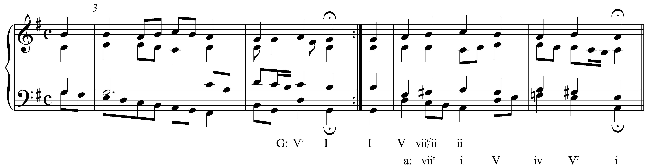

Here, following a perfect authentic cadence in the tonic key, the phrase beginning with the pickup to m. 5 appears to be in the tonic key of G major. Following the D major harmony on the downbeat of m. 5, we come across a diminished triad built on G# (the C in the bass is an accented passing tone). This sonority is an applied leading-tone chord tonicizing ii, which appears in root position on beat three. Following this tonicization, we consistently find F-naturals and G#s leading to a perfect authentic cadence in A minor in m. 6. The modulation to A minor (the supertonic of G major) was achieved with the applied chord in m. 5 (though we might think of the D-major chord on the downbeat of m. 5 as an altered iv, with raised third, in A minor, in which case D major would be the pivot: V becoming iv#.)

Activity 11.4:
What is the supertonic key in B^{b} major?
[Answer: C minor. Response if correct: “Correct!” Response if incorrect: “Incorrect. Try again.”]

[Follow-up activity:]
Name three pivot chords that might be used in a modulation from B^{b} major to C minor (remember to use uppercase roman numerals for major chords and lowercase roman numerals for minor chords):

B^{b} major C minor

_____ = ____ _

_____ = ____ _

_____ = ____ _

[Possible answers: “I = VII,” “ii = i,” “IV = III,” and “vi = v.” Feedback for each correct answer: “Correct!” Feedback for incorrect answer if first roman numeral [X] is I, ii, IV, or vi: “That is incorrect. Although [X] is a potential pivot chord in a modulation from B^{b} major to C minor, your equivalent roman numeral in C minor is incorrect. Try again.” Feedback for all other incorrect answers: “That is incorrect. [X] is not a potential pivot chord in B^{b} major for a modulation to C minor. Try again.”]

Occasionally, a piece will modulate to the key of its subdominant (IV). This modulation is less common and for good reason. In modulating to the subdominant, the tonic of the primary key must be heard as the new dominant. This change in function can be disruptive to the listener because of the special relationship between tonic and dominant in tonal music. Modulating to IV too early in a piece can cause the listener to lose track of the home key. (This is not an issue in minor keys, because i cannot sound like V/IV because it is minor.) Nonetheless, modulations to the subdominant do occur. The possible pivot chords are as follows:

Table 4:
C major  (the primary key) |  | F major  (the subdominant key)
I | = | V
ii | = | vi
IV | = | I
vi | = | iii

Example 8 (J.S. Bach, BWV 117.4, “Es ist das Heil uns kommen her,” mm. 1-2):
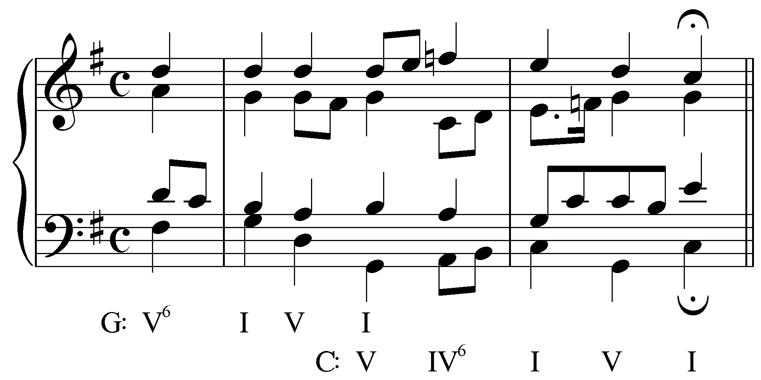

The excerpt above shows an example of modulation to the subdominant. The first phrase of this chorale begins in G major but has modulated to C major by the end of the first phrase. In this case, the modulation occurs via a pivot chord on beat three of the first full measure. This G-major chord is retroauditively reinterpreted as V in C major.

Example 8 also demonstrates the problematic nature of modulations to the subdominant. The G-major chord on beat three of m. 1 (I in G major) is preceded by a D-major chord (V in G major). The “V - I” progressions that open the piece are intended to firmly establish the tonic key of G major. In other words, retroauditive reinterpretation will require considerably more effort to hear a G major chord as V in C major.

Activity 11.5:
What is the subdominant key in F major?
[Answer: B^{b} major. Response if correct: “Correct!” Response if incorrect: “Incorrect. Try again.”]

[Follow-up activity:]
Name three pivot chords that might be used in a modulation from F major to B^{b} major (remember to use uppercase roman numerals for major chords and lowercase roman numerals for minor chords):

F major B^{b} major

_____ = ____ _

_____ = ____ _

_____ = ____ _

[Possible answers: “I = V,” “ii = vi,” “IV = I,” and “vi = iii.” Feedback for each correct answer: “Correct!” Feedback for incorrect answer if first roman numeral [X] is I, ii, IV, or vi: “That is incorrect. Although [X] is a potential pivot chord in a modulation from F major to B^{b} major, your equivalent roman numeral in B^{b} major is incorrect. Try again.” Feedback for all other incorrect answers: “That is incorrect. [X] is not a potential pivot chord in F major for a modulation to B^{b} major. Try again.”]

Modulations from Minor Keys:

Because of a strong tendency to gravitate toward the relative major, minor keys frequently modulate to the mediant. (You may wish to review Lesson CCC for more information regarding the structural characteristics of the minor scale and the privileged status of the relative major.) As with major keys modulating to their relative minors, every chord is a potential pivot:

Table 5:
A minor  (the primary key) |  | C major  (the relative major)
i | = | vi
iiº | = | viiº
III | = | I
iv | = | ii
v | = | iii
VI | = | IV
VII | = | V

Of these possibilities, the most frequently used are “i = vi,” “III = I,” “iv = ii,” and “VI = IV.”

Activity 11.6:
What is the relative major key in D minor?
[Answer: F major. Response if correct: “Correct!” Response if incorrect: “Incorrect. Try again.”]

[Follow-up activity:]
For each of the following chords, give the roman numeral in D minor and in F major (remember to use uppercase roman numerals for major chords and lowercase roman numerals for minor chords).

Exercise 11.6a:
Triad D minor F major

G minor: _____ = ____ _

[Answers: iv/ii. Response if correct: “Correct! G minor is iv in D minor and ii in F major.” Response if first box is incorrect [X]: “That is partially correct. G minor is ii in F major, but not [X] in D minor. Try again.” Response if second box is incorrect [Y]: “That is partially correct. G minor is iv in D minor, but not [Y] in F major. Try again.”]

Exercise 11.6b:
Triad D minor F major

D minor: _____ = ____ _

[Answers: i/vi. Response if correct: “Correct! D minor is the tonic in D minor and vi in F major.” Response if first box is incorrect [X]: “That is partially correct. D minor is vi in F major, but not [X] in D minor. Try again.” Response if second box is incorrect [Y]: “That is partially correct. D minor is the tonic in D minor, but not [Y] in F major. Try again.”]

Exercise 11.6c:
Triad D minor F major

B^{b} major: _____ = ____ _

[Answers: VI/IV. Response if correct: “Correct! B^{b} major is VI in D minor and IV in F major.” Response if first box is incorrect [X]: “That is partially correct. B^{b} major is IV in F major, but not [X] in D minor. Try again.” Response if second box is incorrect [Y]: “That is partially correct. B^{b} major is VI in D minor, but not [Y] in F major. Try again.”]

The following examples show two modulations to the relative major, the first via a “VI = IV” pivot chord and the second with a “iv = ii”:

Example 9 (Mozart, Piano Sonata, K.330, mvt. II, mm. 21-28):
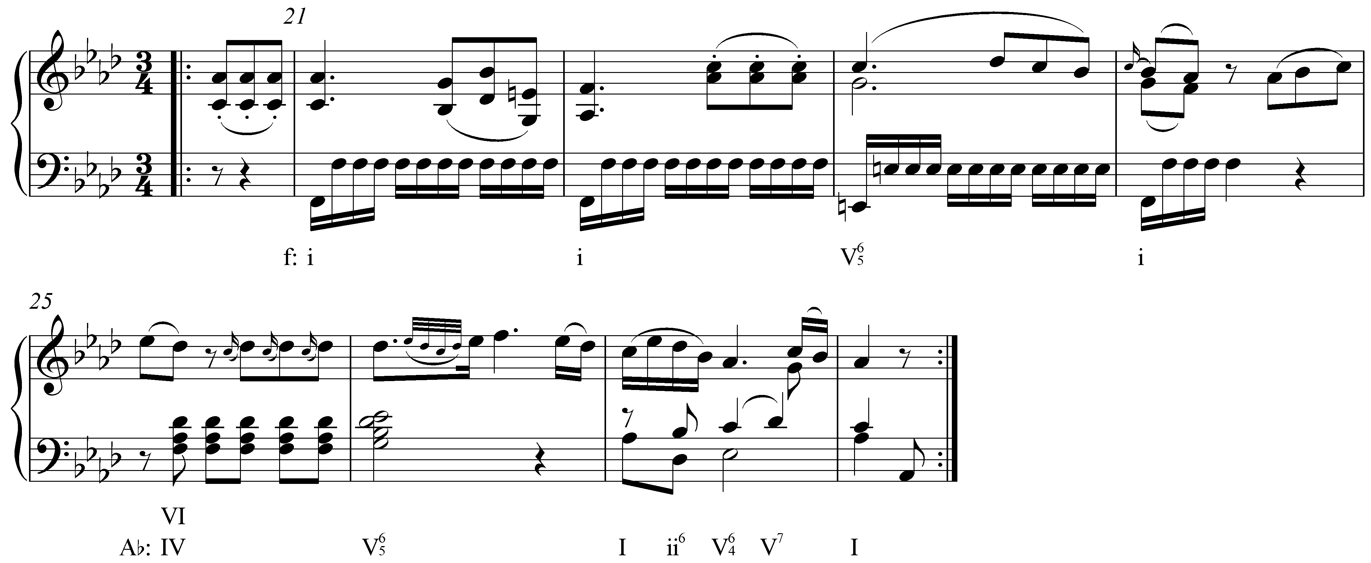

Example 10 (Handel, Keyboard Suite No. 16 in G minor (HWV 542), Sarabande, mm. 1-6):
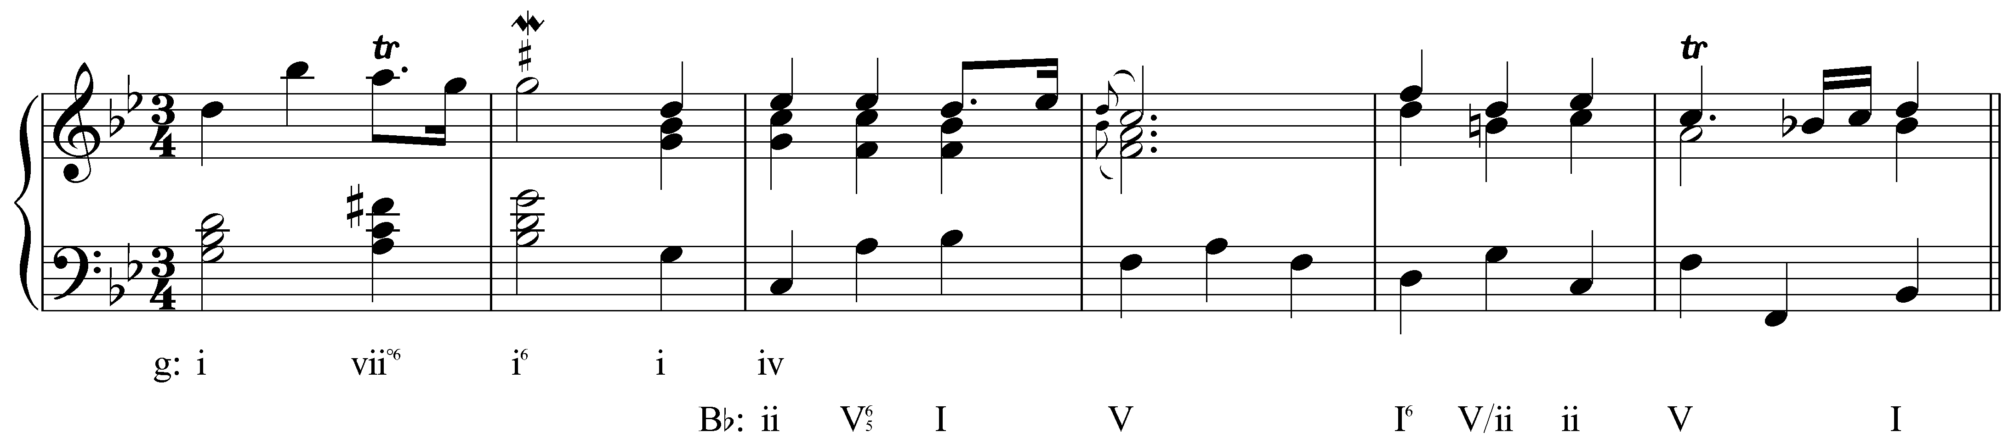

In both Examples 9 and 10, the pivot chord is followed by a dominant seventh chord in the new key. As mentioned elsewhere (see Lesson EEE on the dominant seventh chord and Lesson JJJ on applied chords), the dominant seventh sonority is unique among diatonic seventh chords, and as such immediately implies a specific key. In both of the above two examples, the pivot chord functions as a pre-dominant harmony. When it is followed by a dominant seventh chord, there is already a strong implication of the new key. In both cases, the modulation is confirmed with a perfect authentic cadence in the new key.

Minor keys also modulate to the minor dominant (v). It is important to remember that the major dominant of a minor key (V) is not a closely related key. In A minor, for example, the major dominant would be the key of E major. Compare the key signatures of A minor and E major. They differ by four accidentals (the diatonic pitches of the A minor scale are all natural while E major contains four sharps). When a minor key modulates to the dominant key, it modulates to the diatonic chord built on scale degree 5. In the key of A minor, this would be E minor. The possible pivot chords for modulating to the minor dominant are as follows:

Table 6:
A minor  (the primary key) |  | E minor  (the minor  subdominant key)
i | = | iv
III | = | VI
v | = | i
VII | = | III

It is also common for a piece in a minor key to modulate to the relative major temporarily on the way to the minor dominant. Consider the following example:

Example 11 (J.S. Bach, BWV 227.1, “Jesu, meine Freude,” mm. 1-13):
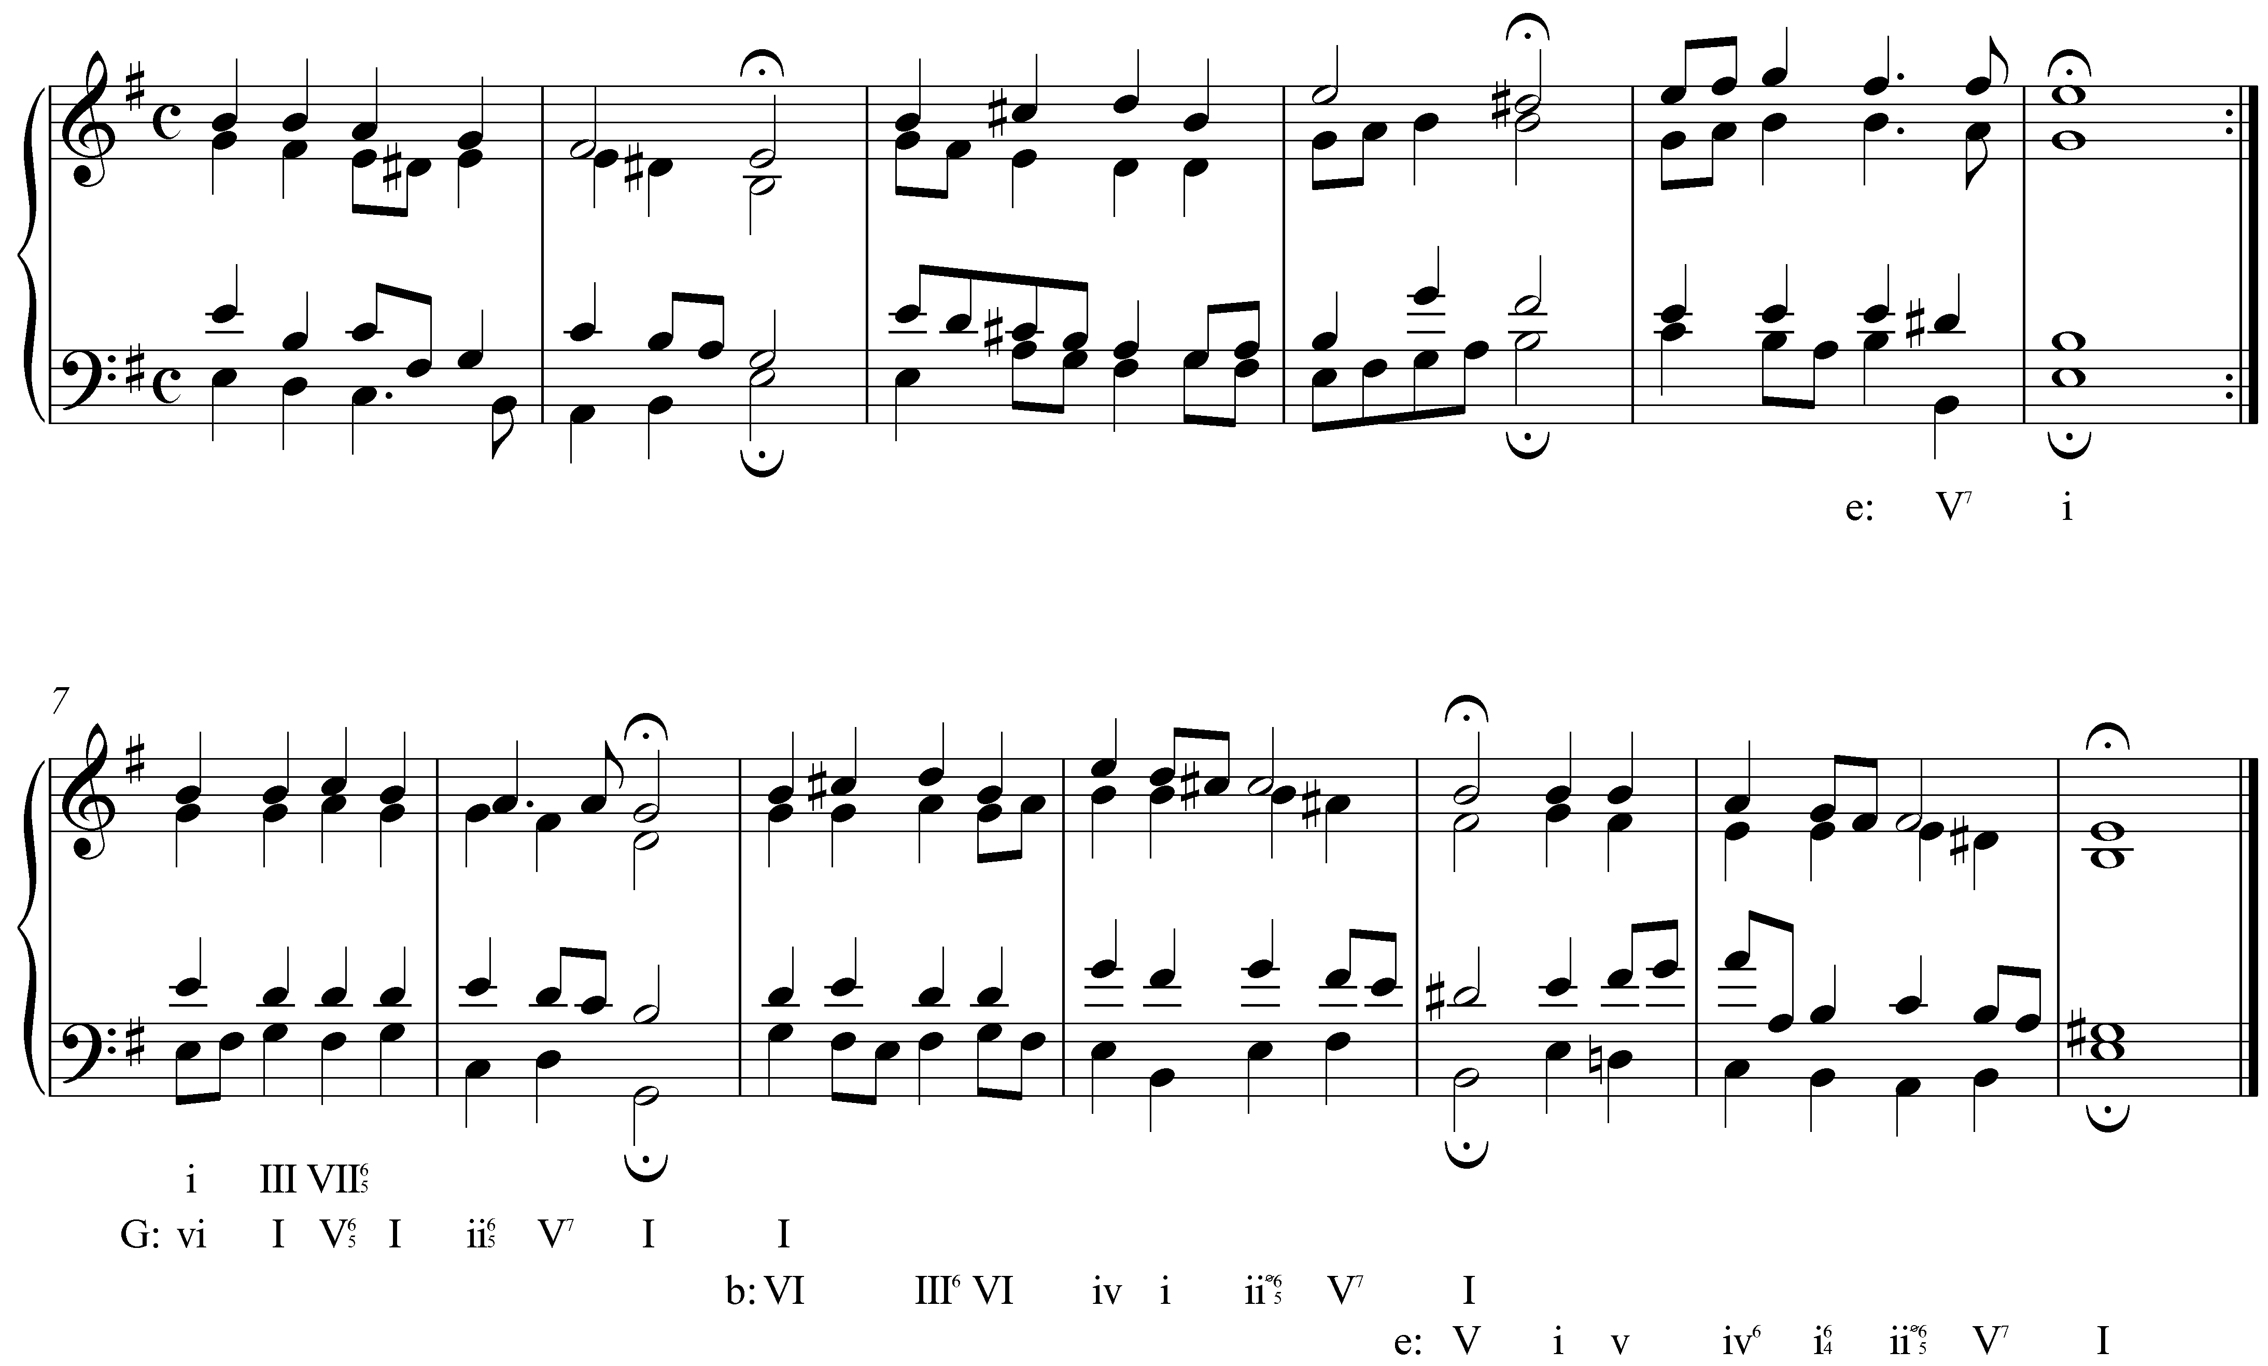

In Example 11, the first three phrases prolong the tonic key of E minor. The phrase beginning in m. 7 sounds at first like E minor as well. Despite the lack of accidentals in m. 7, it makes more sense to interpret beats two through four as an expansion of G major with an auxiliary dominant seventh chord than to hear m. 7 as though still in E minor. The cadence in the following measure supports that interpretation.

In the next phrase, the tonic harmony of G major is reinterpreted as the VI chord of B minor (the minor dominant). This modulation is also confirmed with a perfect authentic cadence. (Do not be fooled by the D# on the downbeat of m. 11. The momentarily raised third scale degree in a minor key is a stylistic convention known as a Picardy third, and does not indicate a modulation to the parallel major key.) The brief modulation to the key of the relative major in mm. 7-8 acts as a stepping stone to the broader modulatory goal of the minor dominant. (Note that the modulatory goals outline a large-scale arpeggiation of the tonic triad: E – G – B!)

Activity 11.7:
In this activity you will track several modulations in a row. The example below shows the final five phrases of a chorale by J.S. Bach (BWV 315, “Gib dich zufrieden und sei stille,” mm. 6-17).

Exercise 11.7a:
In what key does this piece begin?
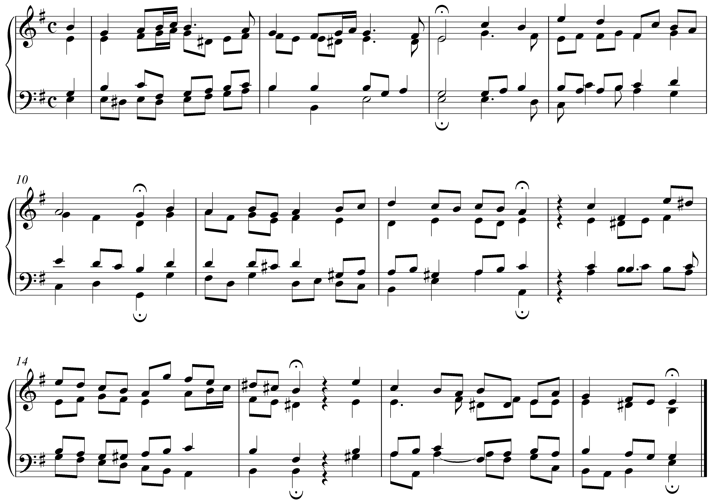
[Answer: E minor. Response if correct: “Correct!” Response if incorrect: “Incorrect. Try again.”]

Exercise 11.7b:
[Multiple choice question:] Dose the first phrase modulate or remain in the same key?
[Possible answers: “The first phrase modulates.” or “The first phrase does not modulate.” Answer: “The first phrase does not modulate.” Response if correct: “Correct, the first phrase remains in the key of E minor.” Response if incorrect: “Incorrect. Try again.”]

Exercise 11.7c:
The second phrase ends with a perfect authentic cadence in m. 10. In what key is this cadence?
[Answer: G major (III). Response if correct: “Correct! The second phrase modulates to G major.” Response if incorrect: “Incorrect. Try again.”]

[Follow-up multiple choice question:]
What key is G major in relation to the global key of E minor?
[Possible answers: “tonic,” “supertonic,” “mediant / relative major,” “subdominant,” “dominant,” “submediant,” and “subtonic.” Answer: “mediant / relative major.” Response if correct: “Correct!” Response if incorrect: “Incorrect. Try again.”]

Exercise 11.7d:
The third phrase ends with a perfect authentic cadence in m. 12. In what key is this cadence?
[Answer: A minor (iv). Response if correct: “Correct! The third phrase modulates to A minor.” Response if incorrect: “Incorrect. Try again.”]

[Follow-up multiple choice question:]
What key is A minor in relation to the global key of E minor?
[Possible answers: “tonic,” “supertonic,” “mediant / relative major,” “subdominant,” “dominant,” “submediant,” and “subtonic.” Answer: “subdominant.” Response if correct: “Correct!” Response if incorrect: “Incorrect. Try again.”]

Exercise 11.7e:
The piece ends with a perfect authentic cadence in m. 17. In what key is this cadence?
[Answer: E minor (iv). Response if correct: “Correct! The final two phrases modulate back to E minor.” Response if incorrect: “Incorrect. Try again.”]

Conclusion:

Tonal pieces routinely explore key areas other than the initial one. The process of changing keys is known as modulation. Modulation differs from tonicization both in length and in structural significance. A tonicization temporarily lends tonic color to some chord other than the tonic, while a modulation creates the sense of a new tonal center.

There are several methods of modulation and several common modulatory goals. The methods include direct modulation, extended tonicization, and pivot-chord modulation, among which the latter is the most common. In major keys, the most common modulatory destination is the key of the dominant; other possible destinations are the submediant, supertonic and subdominant. Minor keys typically modulate to their relative majors or minor dominants. Other modulations are of course possible, but are beyond the scope of this lesson.

