Lesson KKK: Modulation

Exam:

Question 1: Name the five keys that are closely related to F major.
[Answers: G minor, A minor, B^{b} major, C major, and D minor. Feedback for each correct answer: “Correct!” Feedback for any incorrect answer [X]: “Incorrect. [X] is not a diatonic chord in F major and is therefore not a closely related key.”]

Question 2a: What is the dominant key in B^{b} major?
[Answer: F major. Feedback if correct: “Correct!” Feedback if incorrect: “Incorrect.”]

Question 2b: Name three pivot chords that might be used in a modulation from B^{b} major to F major (remember to use uppercase roman numerals for major chords and lowercase roman numerals for minor chords):

B^{b} major F major

_____ = ____ _

_____ = ____ _

_____ = ____ _

[Possible answers: “I = IV,” “iii = vi,” “V = I,” and “vi = ii.” Feedback for each correct answer: “Correct!” Feedback for incorrect answer if first roman numeral [X] is I, iii, V, or vi: “That is incorrect. Although [X] is a potential pivot chord in a modulation from B^{b} major to F major, your equivalent roman numeral in C major is incorrect. Try again.” Feedback for all other incorrect answers: “That is incorrect. [X] is not a potential pivot chord in B^{b} major for a modulation to F major. Try again.”]

Question 3a: What is the relative minor key in G major?
[Answer: E minor. Feedback if correct: “Correct!” Feedback if incorrect: “Incorrect. Try again.”]

Question 3b: Give the roman numeral for an A minor chord in G major and in E minor (remember to use uppercase roman numerals for major chords and lowercase roman numerals for minor chords).

Triad G major E minor

A minor: _____ = ____ _

[Answers: ii/iv. Feedback if correct: “Correct! A minor is ii in G major and iv in E minor.” Feedback if first box is incorrect [X]: “That is partially correct. A minor is iv in E minor, but not [X] in G major. Try again.” Feedback if second box is incorrect [Y]: “That is partially correct. A minor is ii in G major, but not [Y] in E minor. Try again.”]

Question 4a: What is the supertonic key in A^{b} major?
[Answer: B^{b} minor. Feedback if correct: “Correct!” Feedback if incorrect: “Incorrect. Try again.”]

Question 4b: Name three pivot chords that might be used in a modulation from A^{b} major to B^{b} minor (remember to use uppercase roman numerals for major chords and lowercase roman numerals for minor chords):

A^{b} major B^{b} minor

_____ = ____ _

_____ = ____ _

_____ = ____ _

[Possible answers: “I = VII,” “ii = i,” “IV = III,” and “vi = v.” Feedback for each correct answer: “Correct!” Feedback for incorrect answer if first roman numeral [X] is I, ii, IV, or vi: “That is incorrect. Although [X] is a potential pivot chord in a modulation from A^{b} major to B^{b} minor, your equivalent roman numeral in B^{b} minor is incorrect. Try again.” Feedback for all other incorrect answers: “That is incorrect. [X] is not a potential pivot chord in A^{b} major for a modulation to B^{b} minor. Try again.”]

Question 5a: What is the subdominant key in D major?
[Answer: G major. Feedback if correct: “Correct!” Feedback if incorrect: “Incorrect. Try again.”]

Question 5b: Name three pivot chords that might be used in a modulation from D major to G major (remember to use uppercase roman numerals for major chords and lowercase roman numerals for minor chords):

D major G major

_____ = ____ _

_____ = ____ _

_____ = ____ _

[Possible answers: “I = V,” “ii = vi,” “IV = I,” and “vi = iii.” Feedback for each correct answer: “Correct!” Feedback for incorrect answer if first roman numeral [X] is I, ii, IV, or vi: “That is incorrect. Although [X] is a potential pivot chord in a modulation from D major to G major, your equivalent roman numeral in G major is incorrect. Try again.” Feedback for all other incorrect answers: “That is incorrect. [X] is not a potential pivot chord in D major for a modulation to G major. Try again.”]

Question 6a: What is the relative major key in B minor?
[Answer: D major. Feedback if correct: “Correct!” Feedback if incorrect: “Incorrect. Try again.”]

Question 6b: Give the roman numeral for an E-minor chord in B minor and in D major (remember to use uppercase roman numerals for major chords and lowercase roman numerals for minor chords).

Triad B minor D major

E minor: _____ = ____ _

[Answers: iv/ii. Feedback if correct: “Correct! E minor is iv in B minor and ii in D major.” Feedback if first box is incorrect [X]: “That is partially correct. E minor is ii in D major, but not [X] in B minor. Try again.” Feedback if second box is incorrect [Y]: “That is partially correct. E minor is iv in B minor, but not [Y] in D major. Try again.”]

Question 7a: The following piece (J.S. Bach, “Das alte Jahr vergangen ist,” BWV 289, mm. 5-8) begins in E minor. The third phrase ends with a perfect authentic cadence in m. 6. In what key is this cadence? 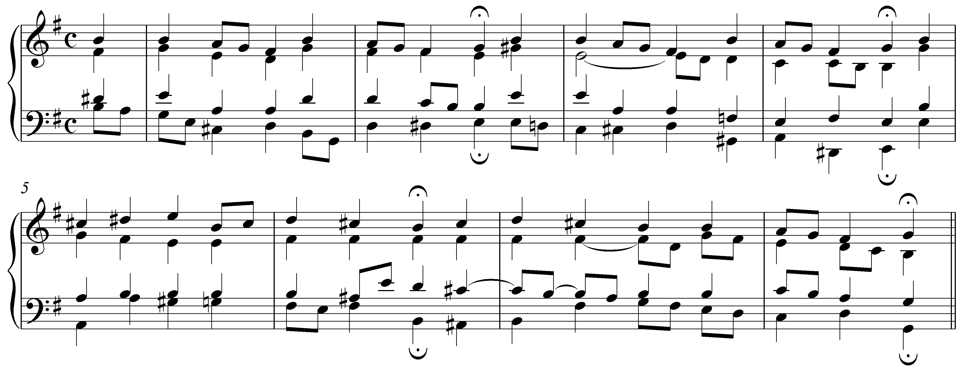
[Answer: B minor (V). Feedback if correct: “Correct! The third phrase modulates to the dominant key of B minor.” Feedback if incorrect: “Incorrect. The third phrase modulates to the dominant key of B minor.”]

Question 7b: The fourth phrase ends with a perfect authentic cadence in m. 8. In what key is this cadence?
[Answer: G major (III). Feedback if correct: “Correct! The third phrase modulates to G major, the relative major.” Feedback if incorrect: “Incorrect. The third phrase modulates to G major, the relative major.”]

