R = BWV
139 248(3).33
267 90.5
6 281
324 81.7

**********************************

Lesson LLL: Mixture

Introduction:

In Lessons 8 and 10, we discussed various sorts of chromatic pitches. As we saw, non-diatonic tones may arise as a result of melodic or harmonic embellishment, or as part of an applied chord. This is not the case, however, in the following example:

Example LLL.01 (F. Schubert, Die Schöne Müllerin, No. 6: “Der Neugierige,” mm. 23-28):
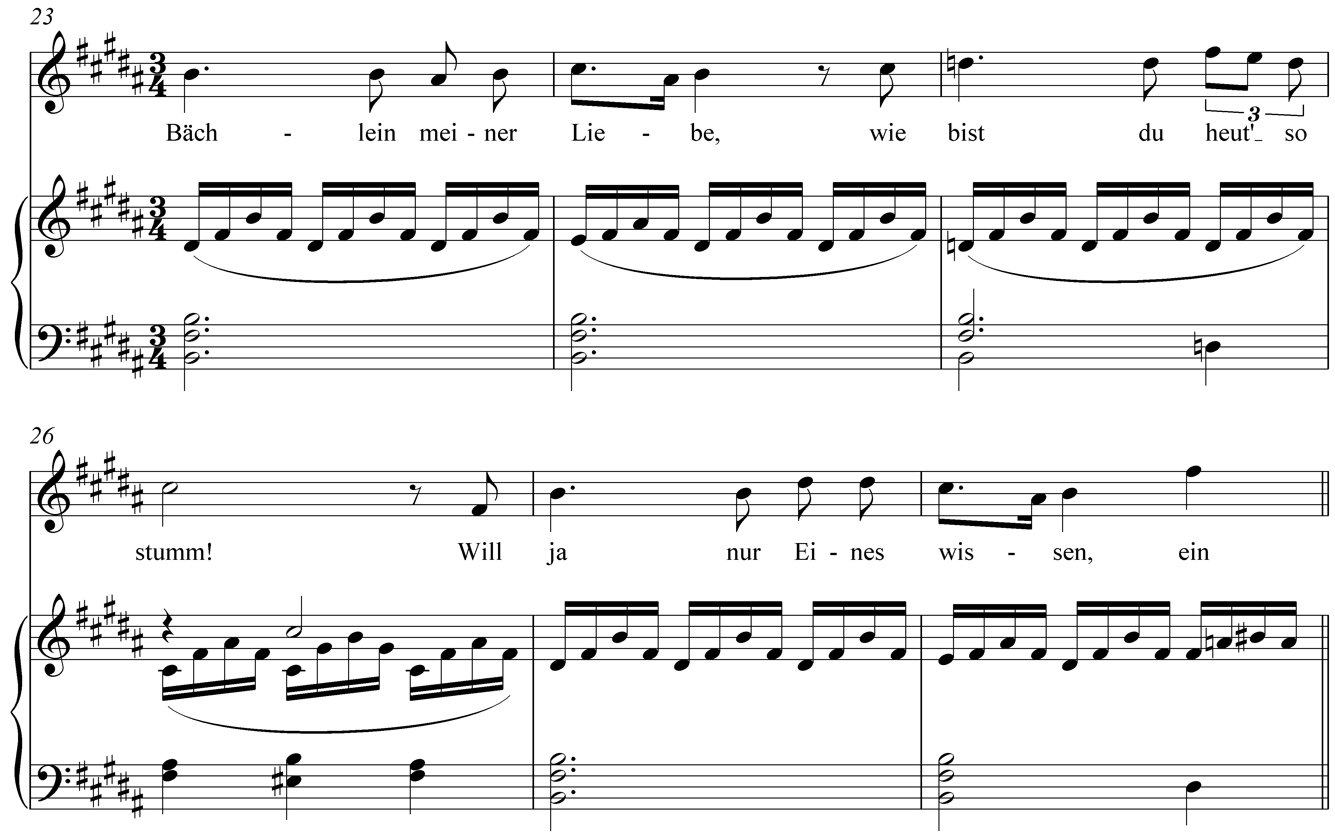

In m. 25, notice that scale degree 3 has been lowered from D# to D§. Instead of a I chord (B major), a i chord (B minor) appears there. The effect is striking. Why would Schubert make such an alteration at this point? Looking at the text of the song, we find the narrator speaking to a brook that led him to a beautiful miller’s daughter. At m. 25 he remarks, “wie bist du heut’ so stumm!” (“how quiet you are today!”) The observation marks a moment of doubt; a subtle change in mood that Schubert intensifies by presenting a minor form of the tonic triad.

This musical phenomenon is referred to as mixture, for it mixes elements of both the major and minor modes of a particular key. In other words, mixture in a major key consists of borrowing chords or tones from the parallel minor, and vice versa. As can be seen in Example LLL.01, mixture is particularly effective in music with text. The changes in color, brought about by the borrowed tones, can highlight and intensify certain words or passages. But this is not to say that words are a necessary component. Mixture is equally effective at lending drama to instrumental music.

In this lesson we will first examine the nature and mechanics of mixture. Turning to several examples from the tonal repertoire, we will look at common types of mixture. Finally, we will conclude with a discussion of the large-scale, structural uses of mixture.

The nature of mixture:

To understand mixture, we must consider the differences and similarities between parallel keys. (Refer to Lesson 3 for a more detailed discussion of the minor scale.) As Example LLL.02 demonstrates, parallel keys differ at scale degrees 3, 6, and 7:

Example LLL.02:

a. C major scale
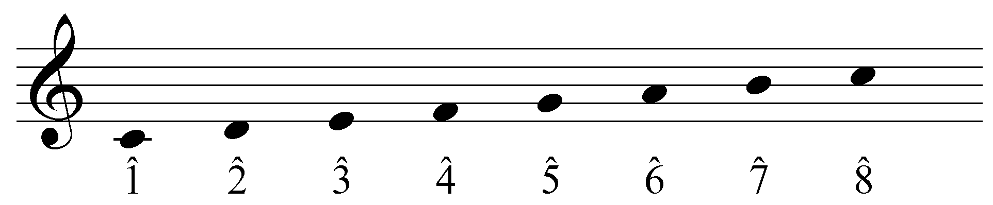

b. C minor scale (diatonic)
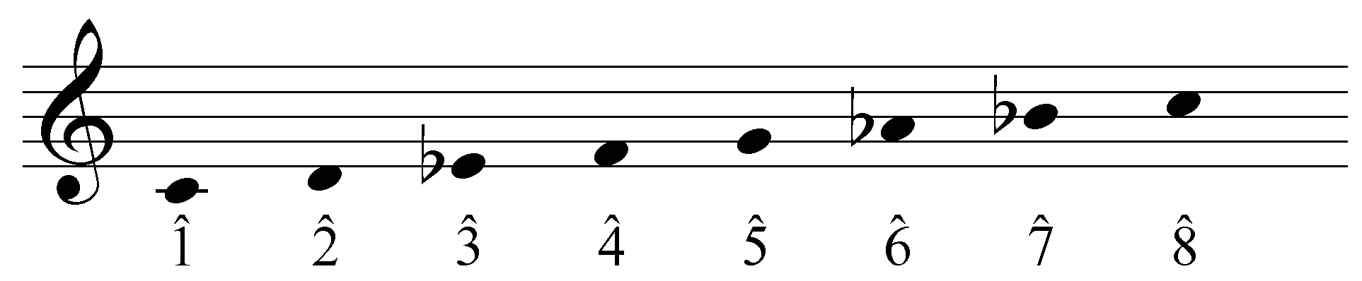

In a minor key, scale degrees 3, 6, and 7 are a semitone lower than their parallel major counterparts. Because they constitute the difference between the major and minor modes, these are sometimes referred to as the modal scale degrees. This variation is responsible for the differing qualities of the diatonic chords built on each scale degree:

Example LLL.03:

a. natural triads in C major
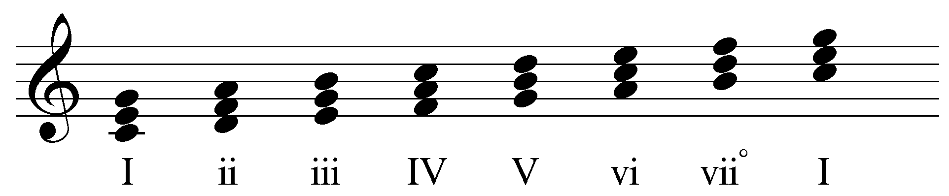

b. natural triads in C minor
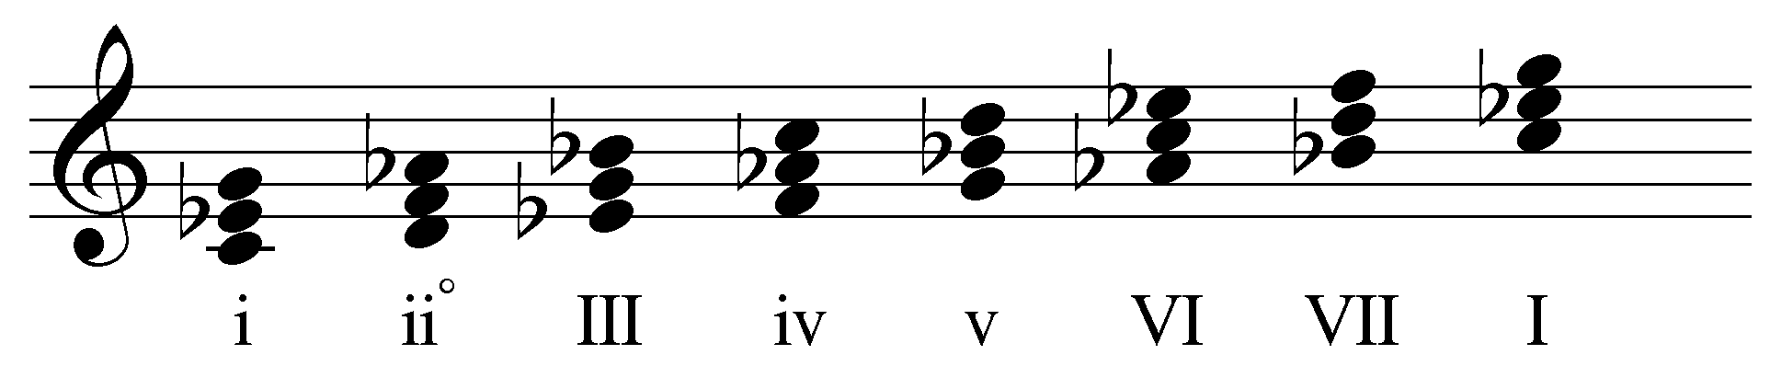

As you can see, the difference in scale degrees 3, 6, and 7 affects the quality of each diatonic chord. (Note that the leading tone has not been adjusted for the chords built on scale degrees 5 and 7 in Example LLL.03b. This will be addressed momentarily.)

Instances of mixture—often referred to as borrowed tones or chords—include one or more of the modal scale degrees from the parallel key. In other words, mixture in a major key will lower scale degrees 3, 6, or 7, while mixture in a minor key will raise them. These non-diatonic pitches bring with them all the expressive capabilities of the opposite mode. By incorporating elements of the parallel key in this manner, composers can expand and enhance their creative musical palette.

Labeling instances of mixture:

Because mixture alters the members and qualities of the affected harmonies, we must address the conventions for labeling borrowed chords. As you know, the case of a Roman numeral indicates the quality of the chord: uppercase for major chords and lowercase for minor. This should remain consistent in cases of mixture.

Example LLL.04 (J.S. Bach, BWV 248(3).33, “Warum sollt ich mich denn grämen,” mm. 1-3):
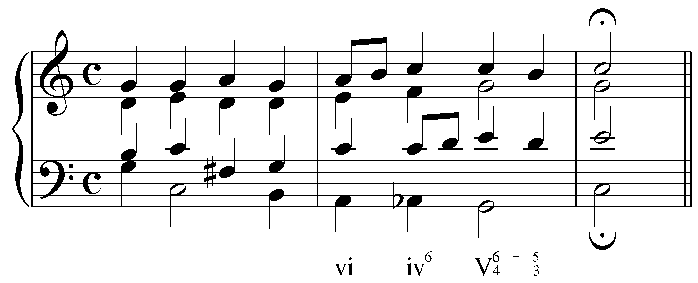

The progression in Example LLL.04 uses b6 (a lowered scale degree 6; Ab in this case), resulting in a minor triad on beat two of the second measure. The Roman numerals are consistent with this change in quality, using “iv” instead of “IV.”

To further accommodate the changes brought about by borrowing from the parallel mode, accidentals are also used in conjunction with Roman numerals. An accidental before a Roman numeral indicates an altered root:

Example LLL.05 (J.S. Bach, BWV 90.5, “Vater unser im Himmelreich,” mm. 9-10):
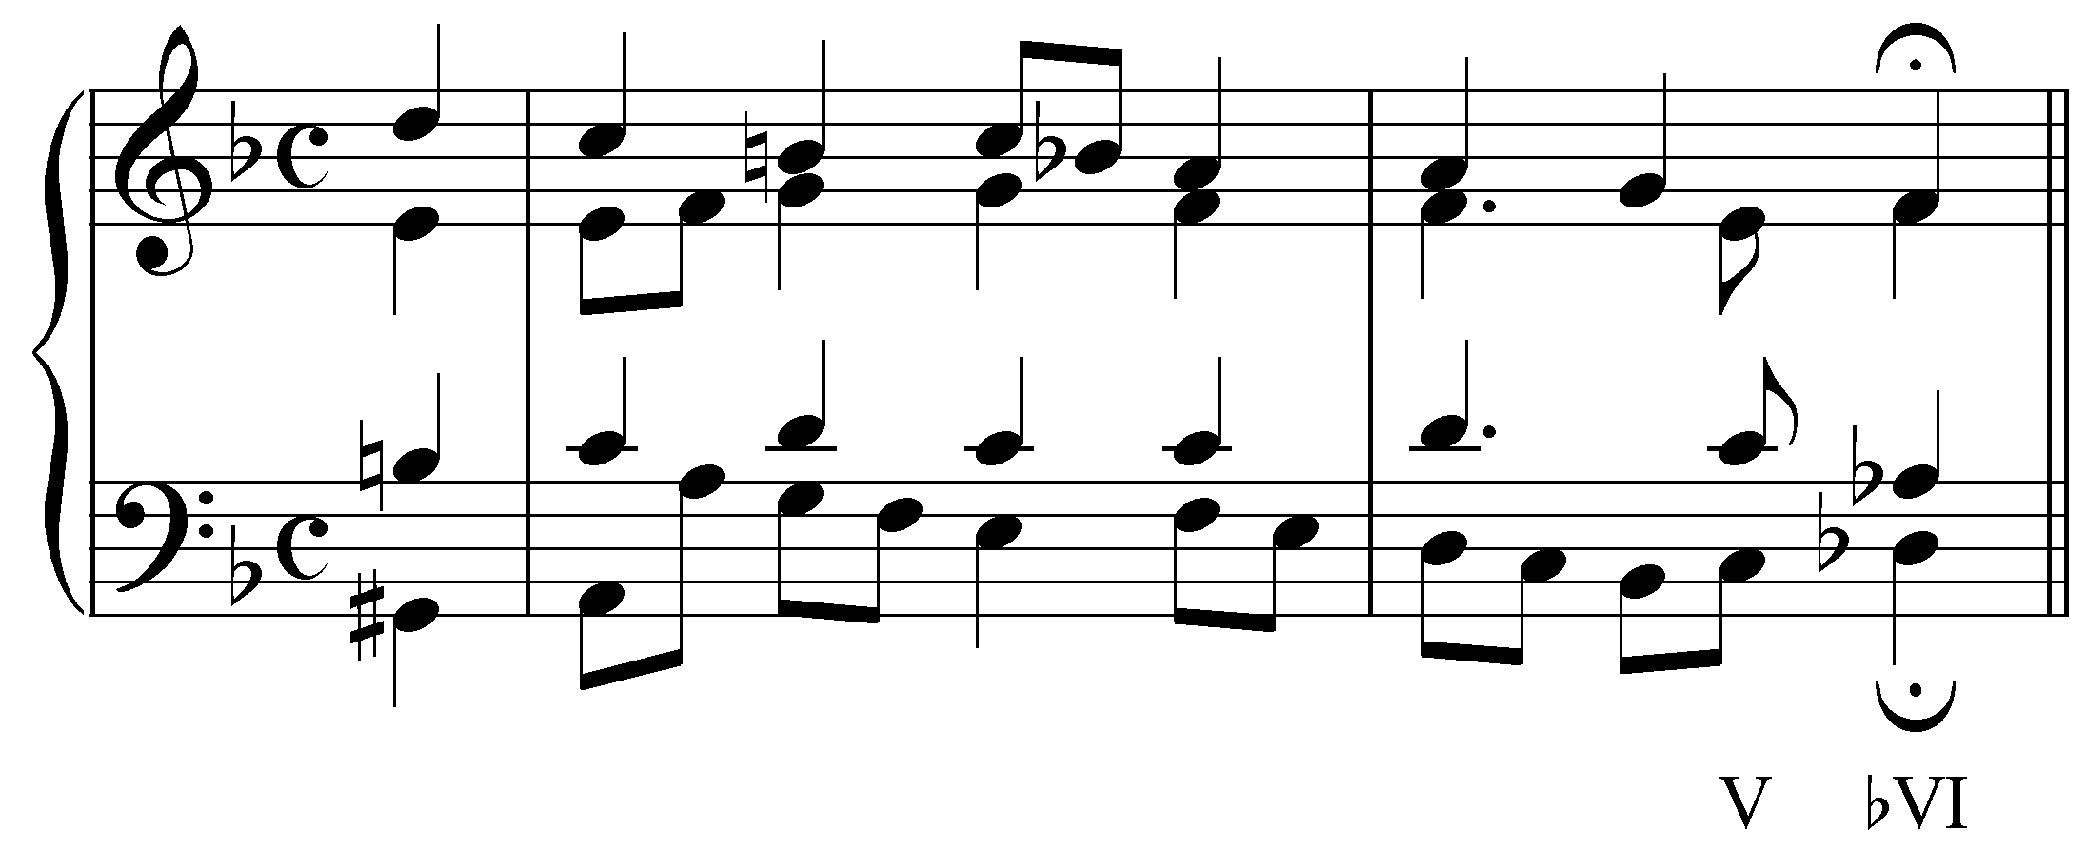

In the example above, the final chord is built on the lowered sixth scale degree (Db). The altered root is indicated by the accidental: bVI.

As usual, accidentals next to figured bass numerals affect the indicated pitches.

Note: Occasionally, a borrowed scale degree will negate one of the sharps or flats in the key signature. If this is the case, a natural sign should be used in conjunction with the appropriate Roman numeral:

Example LLL.06 (J.S. Bach, BWV 90.5, “Vater unser im Himmelreich,” mm. 9-10; transposed
to A major):
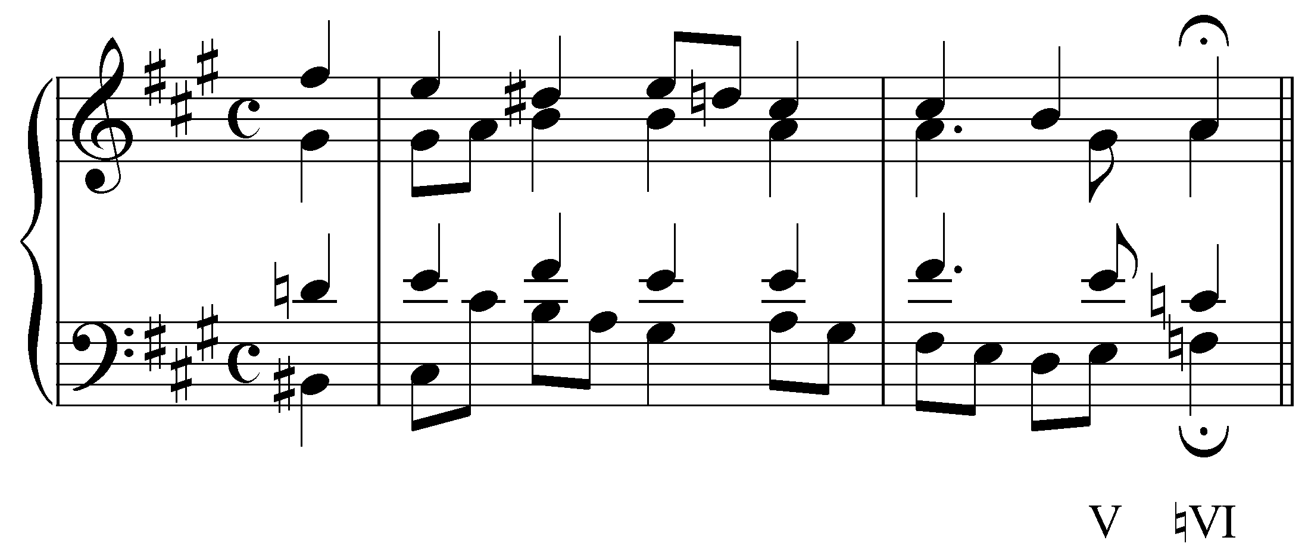

Like Example LLL.05, the final chord in this example is built on a lowered sixth scale degree. But because the key signature includes F#, the lowered root is indicated with a natural sign. Natural signs are only used in specific cases like this one. When referring to altered chords generically, a lowered root is always indicated with a b and a raised root is always indicated with a #.

John: In the callout box at the bottom of p. 3/top of p. 4, you write: "Note: Occasionally, a borrowed scale degree will negate one of the sharps or flats in the key signature. If this is the case, a natural sign should be used in conjunction with the appropriate Roman numeral..."
So what if your example had been in Db major? Scale degree 6 is Bb. So the deceptive cadence is from Ab to a Bbb major triad, right? Is the Roman numeral bbVI, then? I think it might be worth clarifying, especially since I am not used to this convention and it is possible that other users may also be confused. I've always used bVI no matter what (I may have been taught differently, may have learned wrong, may have forgotten...). In the case of the Neapolitan, using N makes the discussion moot, of course.

Lee: Regarding the use of a natural sign, used in conjunction with a roman numeral, to cancel out a sharp, you remarked:

So what if your example had been in Db major? Scale degree 6 is Bb. So
the deceptive cadence is from Ab to a Bbb major triad, right?

Correct (of course)

Is the
Roman numeral bbVI, then?

No. VI in Db major is built on a Bb, so the normal (diatonic, unmixed) roman numeral is simply VI (the flat for B, making the root Bb) is in the signature. The flat placed in front of the roman numeral in this case -- bVI -- lowers the signature-derived, diatonic Bb to become Bbb. Hence the correct roman numeral to indicate a chord rooted on the note Bbb is bVI, not bbVI. The latter would indicate that the b6 root (Bbb) is lowered yet again, to Bbbb (wow!). You go on to write that you've been accustomed to using the mixture-modified roman numeral bVI to generically indicate all lowered sixth roots. That's fine, and Andre does point that out. In the case of a sharp key, though, you will find lowered roots of chords indicated by a natural sign, so natural-VI, showing that a sharp has been "naturaled out," so to speak, rather than bVI, though the latter is not incorrect.

John: Is the
Roman numeral bbVI, then?

No. VI in Db major is built on a Bb, so the normal (diatonic, unmixed) roman
numeral is simply VI (the flat for B, making the root Bb) is in the signature.

[snip]

I was being rhetorical, but I can see how you took me literally. Sorry about that. I was trying to take the voice of someone who either doesn't know this quirk of Roman "numerology" or, like me, learned differently. So someone could misread Andre's correct statement by thinking, well since Bb is an accidental in the key signature of Db, then I need to negate it somehow (by doing who-knows-what).

Lee: Students will do anything and everything. We know that. I suppose a pop-up box could be used to explain with a general statement -- about the need to take the prevailing signature into account when deciding whether to use a flat, sharp, or natural sign ahead of the roman numeral to modify a triads root-- and with a few select examples to demonstrate a straightforward case (bVI in C major) and a few that could confuse (e.g. natural-VI in, say, A major or B major, and bVI in Db major and Gb major).

I'm thinking that, if time allows, we should have a lesson on advanced Roman numeral usage. For example, what if, in some contrived instance, the bVI chord were in first inversion? What happens to the figures, if they are negating a flat or sharp in the key signature? Those kinds of questions could be addressed.

Could the pop-up box handle it, or is that too brief and informal?

Mixture in major keys:

John: In your section on "Mixture in major keys" (p. 4), you write: "A lowered scale degree 6 is used to color and intensify chords built on 2 or 4." This is true if you are only considering triads. But what about the seventh chord built on the leading tone in major? Instead of a half-diminished 7th chord, we have a fully-diminished 7th chord. I can't think of examples off-hand, but doesn't it happen often enough to warrant mentioning? Plus the full-dim 7th can lead to all kinds of harmonic adventures...

In major keys, instances of mixture usually incorporate b3, b6, or both. (b7 is generally avoided because its presence would subvert the important dominant function of the V and viiº chords.)

A lowered scale degree 6 is used to color and intensify chords built on 2 or 4. The presence of b6 will make a ii chord diminished (iiº) and a IV chord minor (iv) as in the following examples:

Example LLL.07 (J.S. Bach, BWV 281, “Christus, der ist mein Leben,” mm. 7-8):
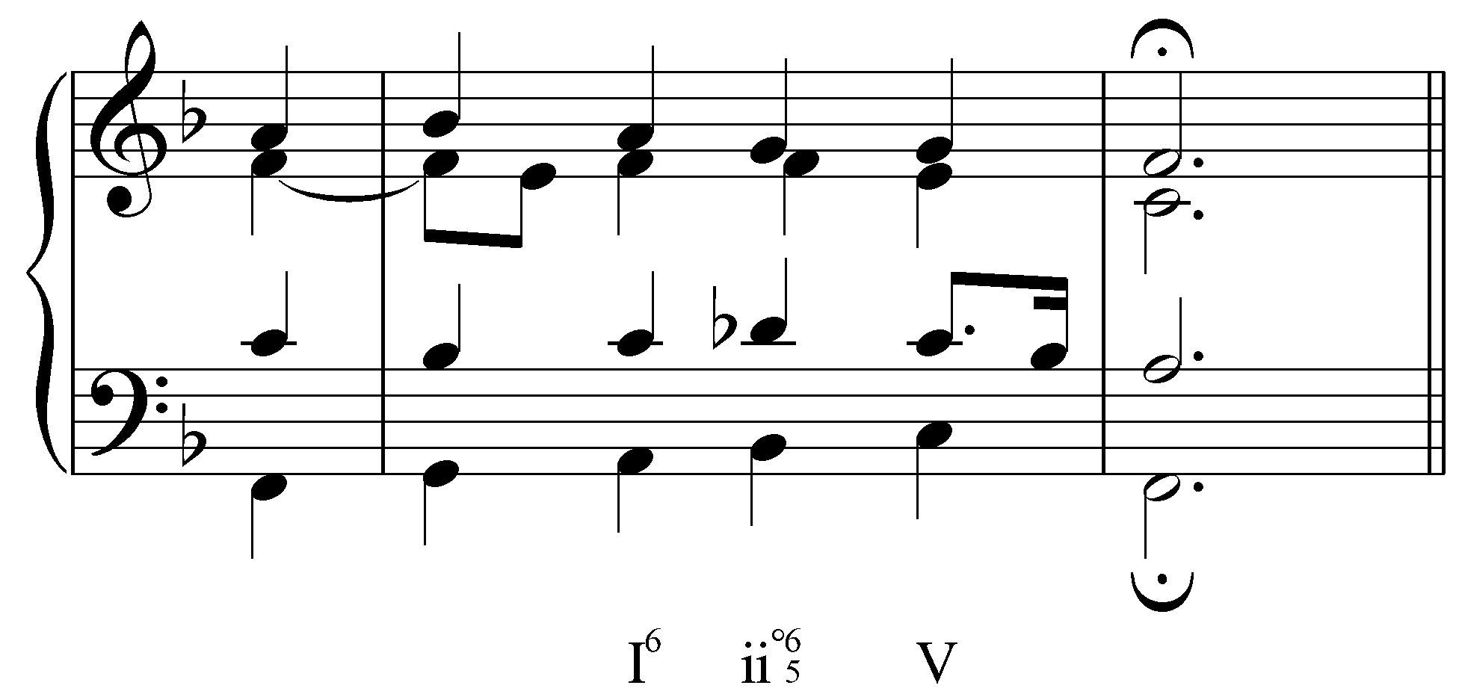

Example LLL.08 (J.S. Bach, BWV 248(3).33, “Warum sollt ich mich denn grämen,” mm. 1-3):

In Example LLL.07, the third beat of m. 7 has a b6 (Db), making the first-inversion ii chord diminished. Similarly, in Example LLL.08, the second beat of m. 2 has Ab in the bass, changing the quality of the subdominant chord to minor. Seventh chords can likewise be affected by mixture. A ii⁷ chord, for example, would become ii^{ø7} with the addition of b6. In all of the cases mentioned thus far, mixture chords retain the harmonic functions of their unaltered forms. The adjusted chords in Examples LLL.07-08, for example, have the same pre-dominant function they would have without b6.

A lowered scale degree 3 is sometimes used to produce a minor tonic where one would normally expect a major harmony:

Example LLL.09:
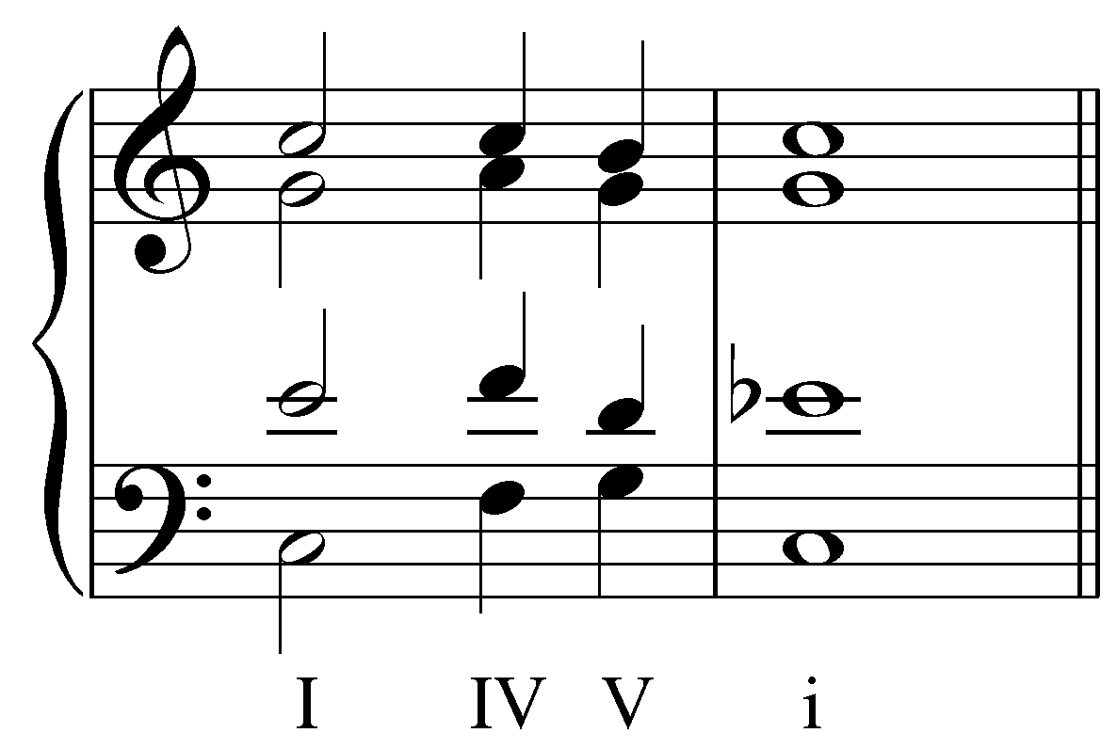

In this example, the concluding tonic harmony is made minor by the presence of Eb, borrowed from the parallel minor. The presence of b3 in a tonic harmony can have a surprising and dramatic effect! Consider the following example:

Example LLL.10 (F. Schubert, Die Schöne Müllerin, No. 4: “Danksagung an den Bach,” mm. 16-24):
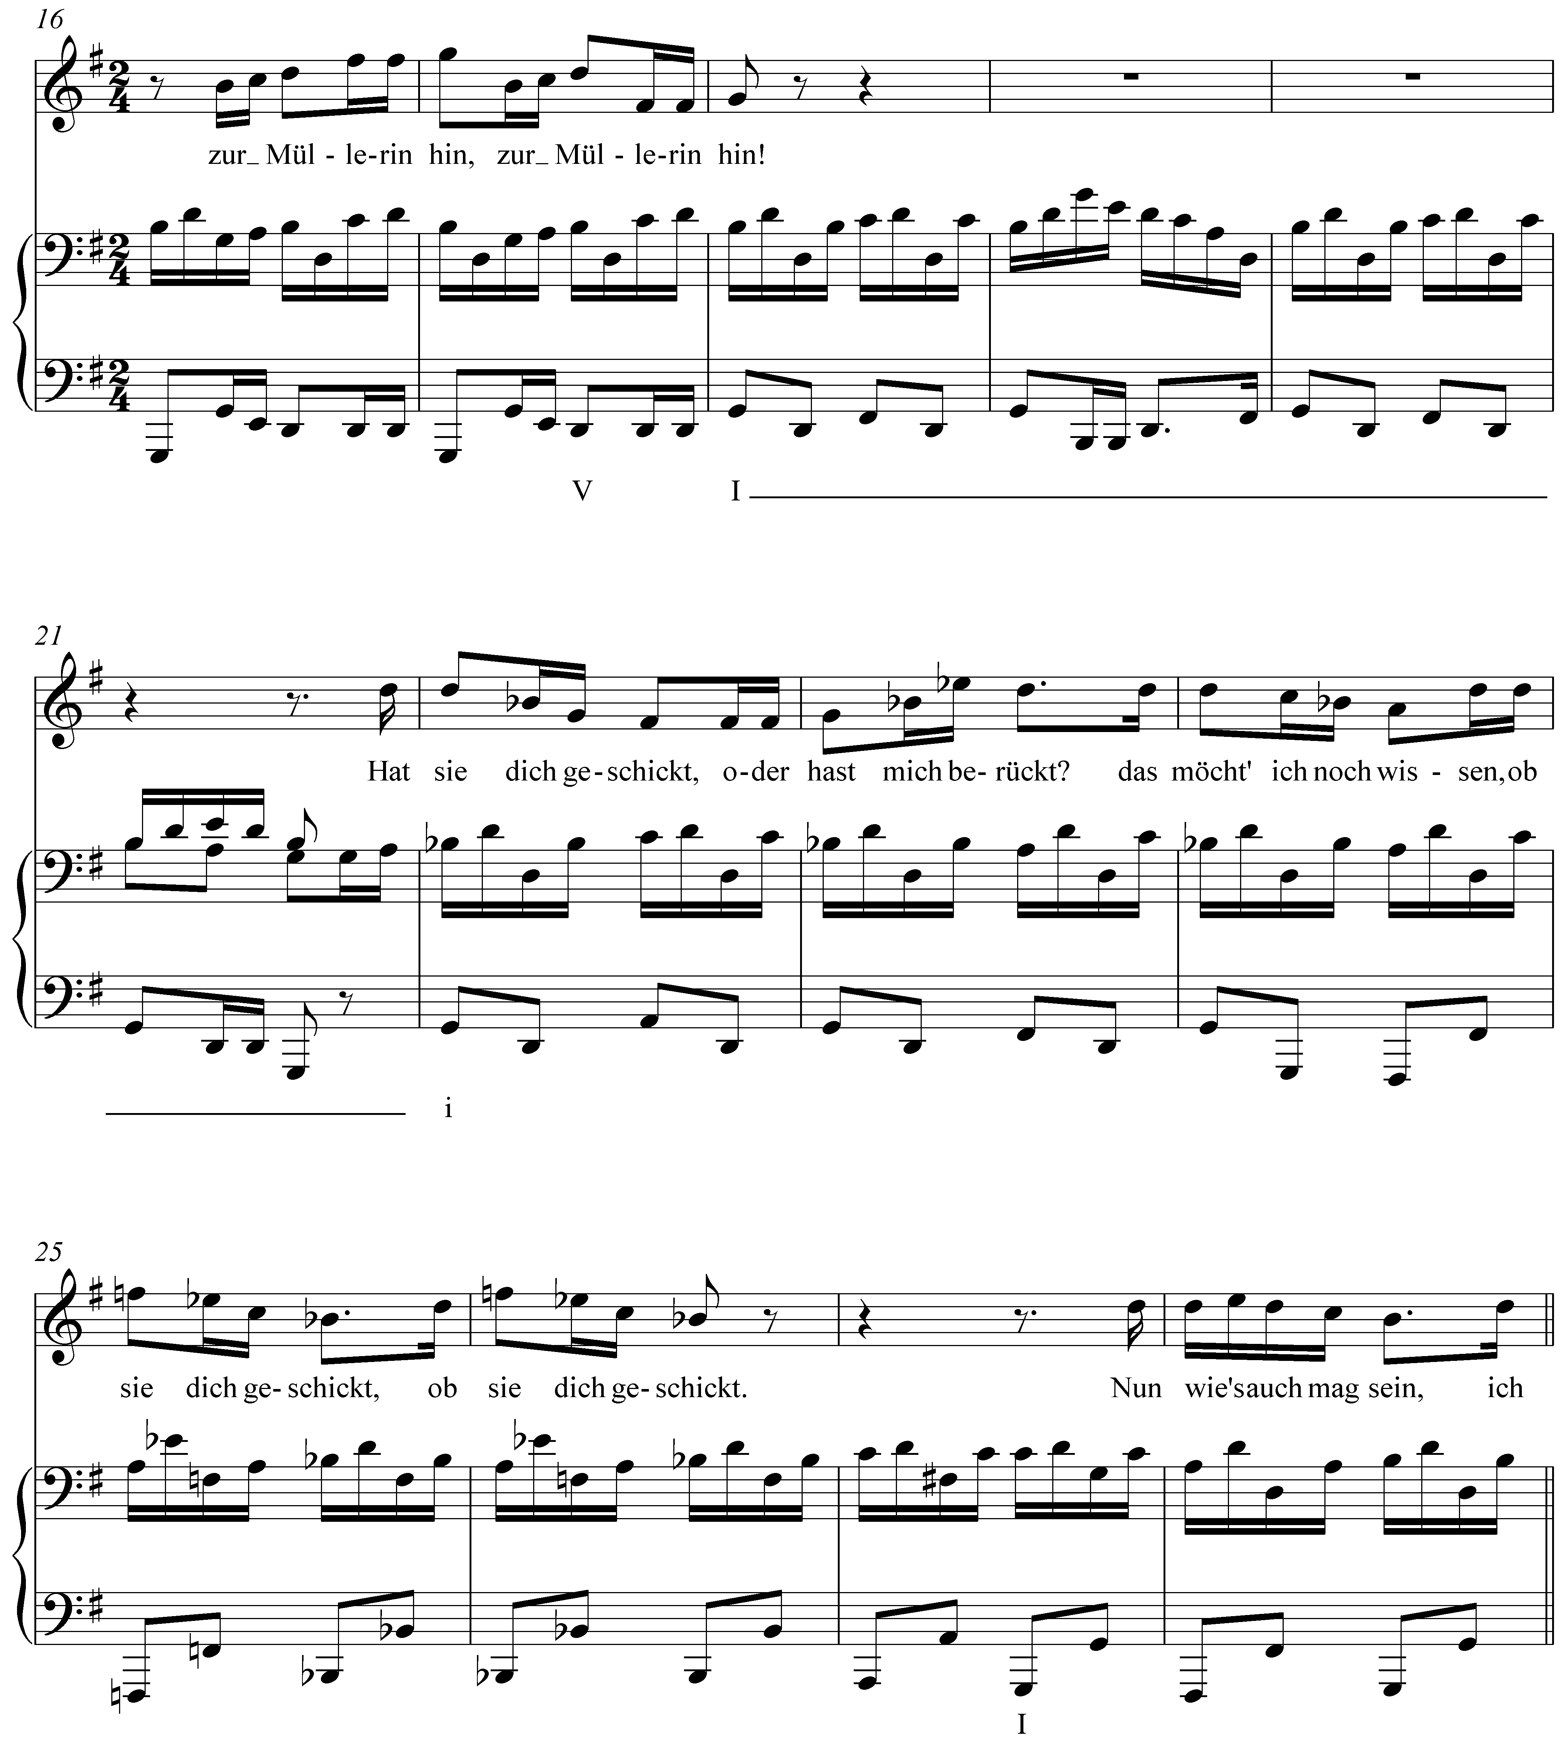

Like Example LLL.01, this Schubert song uses a minor tonic to reflect a change in mood in the song’s text. Following a strong cadence in the key of G major in mm. 17-18, we encounter a minor tonic (i) in m. 22. Again, the effect is startling and intensifies the emotional tension of the moment.

Combining b3 and b6 will result in the bVI chord mentioned above. The bVI chord is one of the most commonly borrowed chords in a major key. When used in a deceptive cadence it increases the dramatic effect by thwarting to an even greater degree the listener’s expectation of tonic harmony. The following example does just this:

Example LLL.11 (J.S. Bach, BWV 90.5, “Vater unser im Himmelreich,” mm. 9-10):

Mixture in minor keys:

Lesson 3 introduced the concepts of the harmonic and melodic minor composites which feature raised scale degrees 6 and 7. These adjustments can be seen as examples of mixture, where elements of the parallel major are borrowed to suit certain harmonic and melodic contexts. Other than the ubiquitous raising of the leading tone and submediant, mixture is far less common in minor keys than it is in major keys.

Occasionally, composers will incorporate #6 or #3 to lend color to iv and i chords (iv becomes IV and i becomes I with the raising, respectively, of scale degrees 6 and 3). [NOTE: This previous sentence was confused. It spoke, correctly, of raising ^6 to produce a major-chord IV in minor (which would otherwise have been a minor chord), and then, incorrectly, of raising ^3 to produce a major-chord VI, which would otherwise have been a minor chord. That is not true. Raising ^3 in a minor key does not produce a major-chord VI. It produces a major-chord tonic. In a minor key, the VI is, diatonically, a major chord, and it cannot be converted into a minor chord through parallel-mode mixture, which is for the most part what we’re talking about in this chapter. To produce a minor-chord VI in a minor key, we’d need ^b1! The next sentence, beginning “Another type...”, is now no longer necessary because the opening of the paragraph already addresses the major-chord I through the use of raised ^3. The paragraph needs to be revised to work toward Ex. LLL.12, with the Picardy third. Since you’ve spoken about the major-chord IV in a minor key, we should have an example of that. I’ll try and find one. That chord is of course generally used, at least in Bach chorales for reasons of voice leading, not coloring, namely to avoid an aug. 2nd in moving from ^#6 to ^#7. So, we need an example where major-chord IV in minor is used for coloring/intensification rather than voice leading. Start looking.] Another type of borrowed chord that does appear quite frequently uses #3 to make a tonic harmony major. Consider the following example:

Example LLL.12 (J.S.Bach, BWV 81.7, “Jesu, meine Freude,” mm. 12-13):
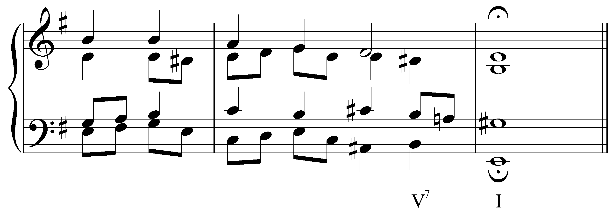

The G# in the final chord of this example makes the tonic major. The raised third of a tonic chord in a minor key is usually referred to as a Picardy third. Composers will commonly employ a Picardy third at the end of a piece in minor, coloring the conclusion with character of a major tonic.

Mixture and basic interval progressions:

John: The only other thing that I would add to Lee's comments, is that I wonder if it is possible to bring in earlier the basic interval progressions? It would seem to me that the fact that the basic interval progressions are never violated in voiceleading contexts would be part of the "nature of mixture" and could be added right after your discussion about the major and minor modes. But then that might affect your opening, which demonstrates mixture as coloration.

Lee: Finally, you wondered whether the discussion of BIPs might come earlier in the lesson.

The only other thing that I would add to Lee's comments, is that I wonder
if it is possible to bring in earlier the basic interval progressions? It
would seem to me that the fact that the basic interval progressions are
never violated in voiceleading contexts would be part of the "nature of
mixture" and could be added right after your discussion about the major
and minor modes. But then that might affect your opening, which
demonstrates mixture as coloration.

This is a tough one to decide. It's hard to start introducing the BIPs until we know what chords we're talking about, which requires us to illustrate those chords and explain them a bit, as derivatives of a mixed-mode scale. That introduction, it seems to me, can be done without talking about voice leading yet. However, after showing some mixture chords and explaining their mixed-mode origin, it would be possible at that point to show how the mixture chords involve standard BIP voice leading. The BIP discussion could be moved to an earlier point in the lesson, but that will require some rewriting and reorganization of the flow (and of the introduction of specific musical examples). I understand the point of doing that, and it certainly makes good sense. Personally, though, I am comfortable with the flow as it is: several examples illustrating substitution of a mixed-mode degree for a diatonic one, and then showing what's at work, behind the scenes, so to speak, in the voice leading. If you feel strongly about it, we'll try to rework the flow and sequence of musical examples so that the BIP discussion can enter relatively early.

Re: BIPs. The lesson really does read very well as it is, so I am OK
leaving this alone.

Yes, I think, too, that the sequence should remain as is.

Instances of mixture are often the result of adjustments made to the basic interval progressions outlined in Lesson 1. In all of the harmonic progressions considered in this lesson, the voiceleading is governed by the same basic interval progressions whether mixture is present or not. In some cases, however, mixture strengthens the underlying interval progressions.

The motion from a major third to a unison is intensified by altering one of the voices to introduce semitone motion:

Example LLL.13:

a. b.
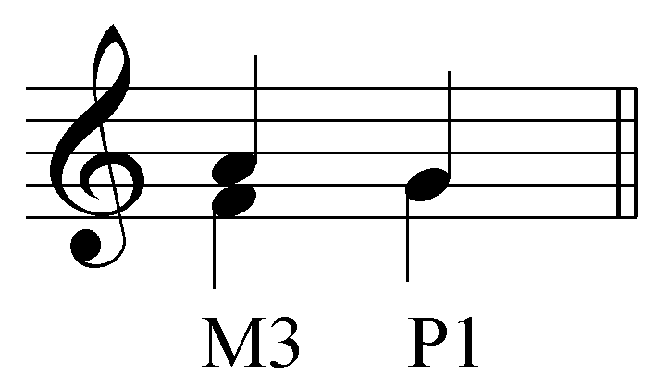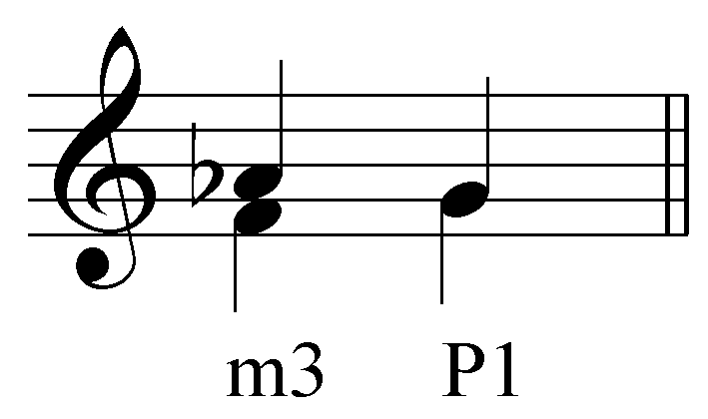

The following example puts this into context in a Bach chorale:

Example LLL.14 (J.S. Bach, BWV 281, “Christus, der ist mein Leben,” mm. 7-8):
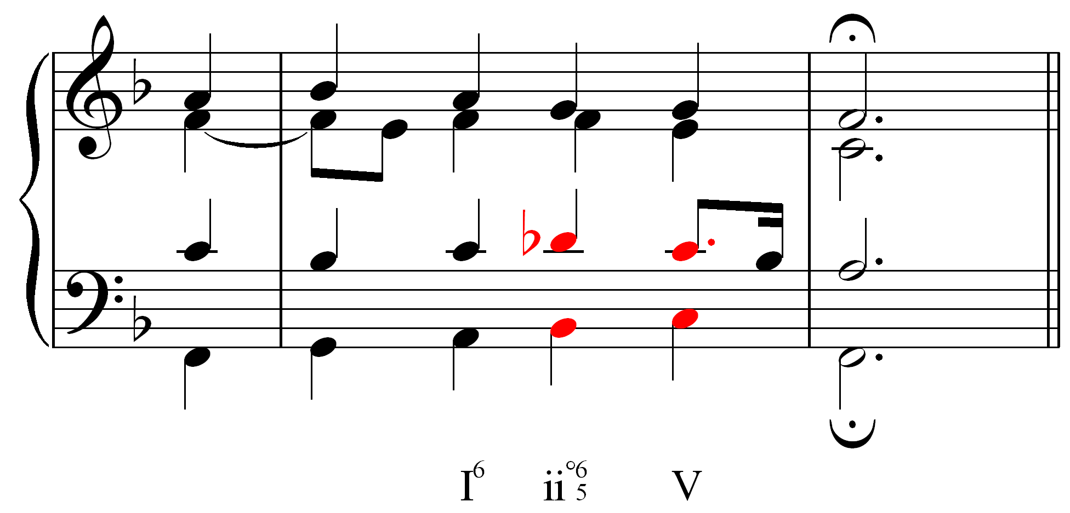

Whereas typically the motion from a major third to a unison consists of both voices moving by wholetones, moving from a minor third to a unison reduces one voice’s movement to a semitone. The result is similar to the strong semitone/wholetone motion of a major sixth to an octave. Similarly, the motion from a major sixth to a perfect fifth is made stronger by contracting the upper-voice motion to a semitone:

Example LLL.15:

a. b.
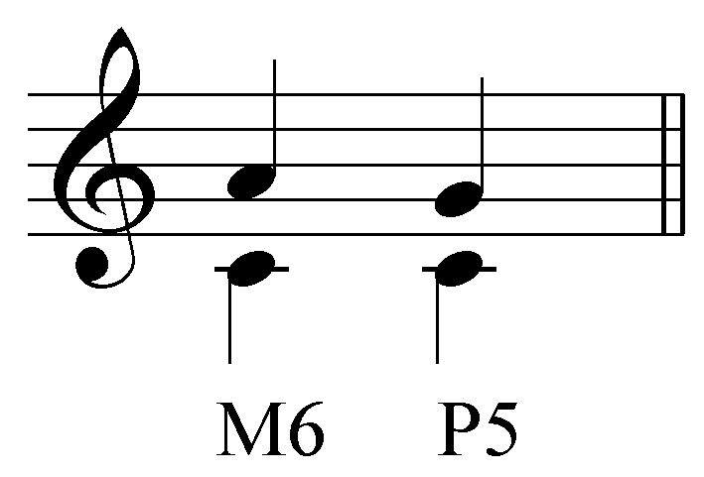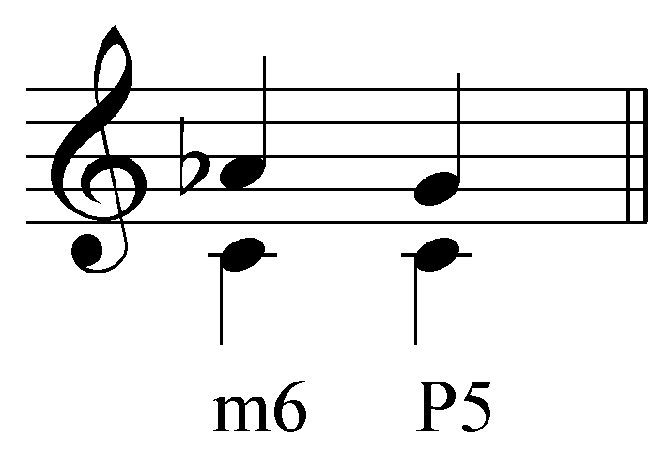

The following example puts this adjustment into context (Example LLL.14b provides a reduction of LLL.14a to clarify the voiceleading):

Example LLL.16 (J. Brahms, “Wie Melodien Zieht es mir, ” Op. 105, no. 1, mm 25-28):

a.
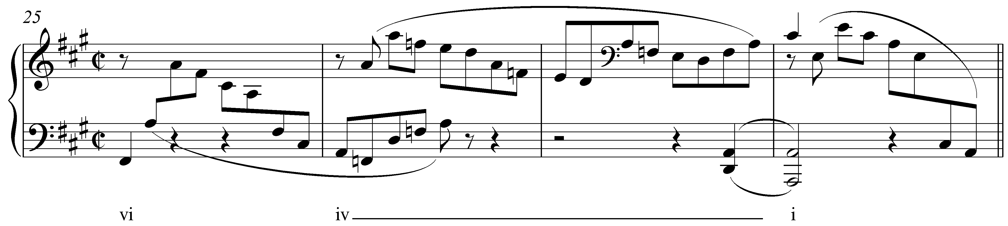

b.
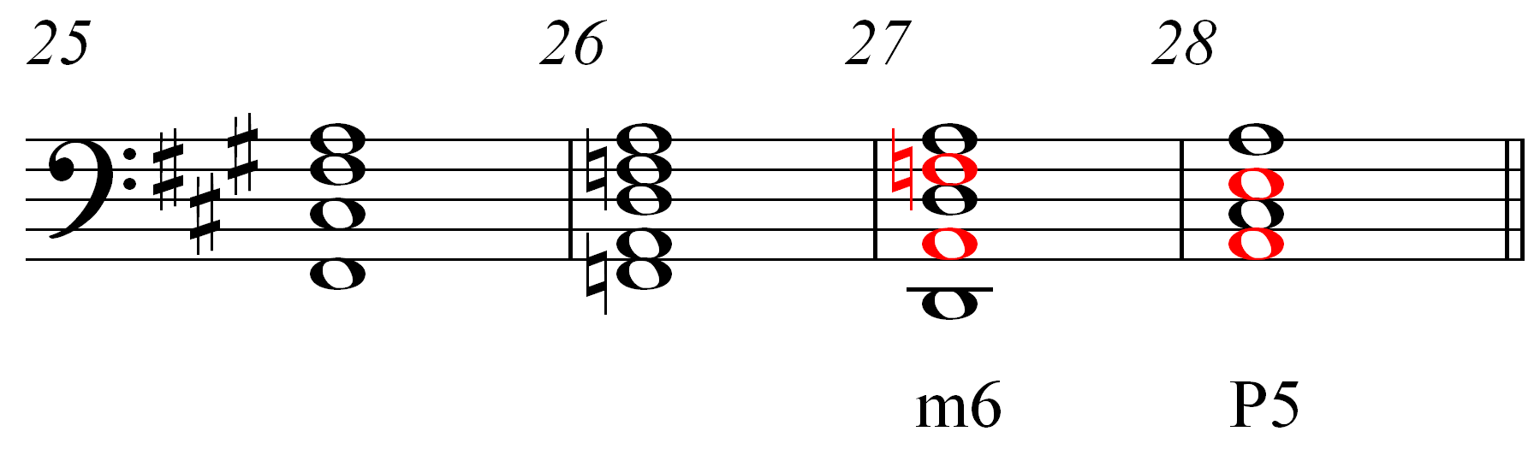

By lowering the F# to F natural, Brahms strengthens the motion to the tonic triad from m. 26 to m. 28.

While mixture often results from such voiceleading, it need not always. Sometimes, mixture is used strictly for purposes of coloration. Consider the following example from Mozart:

Example LLL.17 (W.A. Mozart, Piano Sonata in F, K. 332/ii, mm. 1-8):
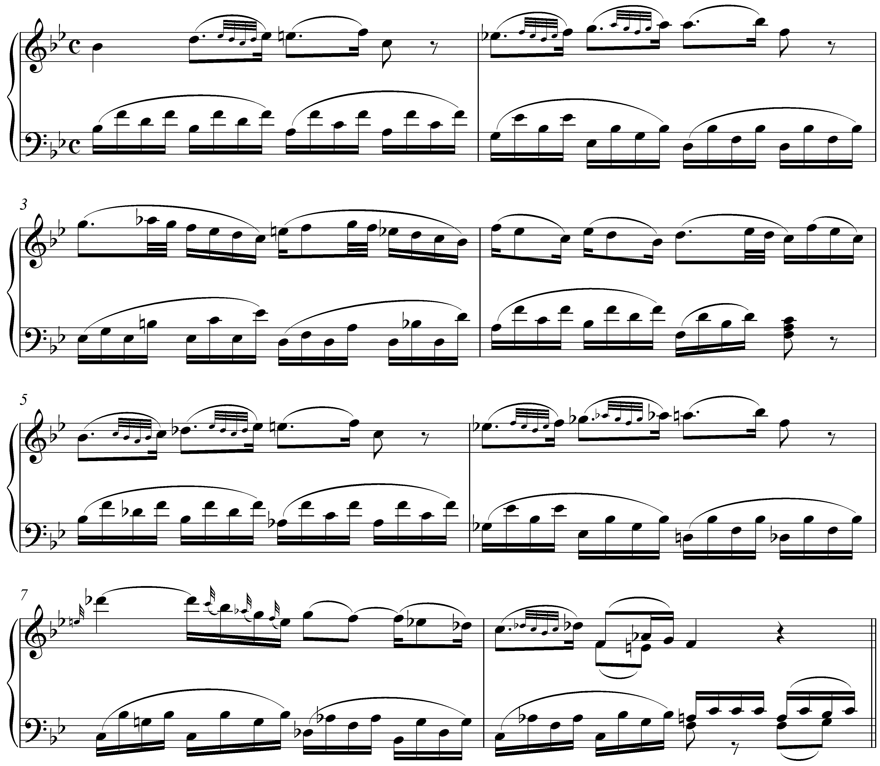

In this beginning to a piano sonata movement, Mozart first presents a melody in Bb major. He then repeats the melody in mm. 5-8, this time in Bb minor to heighten the expressiveness of the music.

Secondary mixture and other chromatic chords:

All of the examples of mixture presented so far have been relatively straightforward. In each case, one or two tones are borrowed from the parallel key to emphasize or intensify certain harmonies. Occasionally, however, you will encounter instances of mixture that cannot be explained in such simple terms.

Example LLL.18 (F. Chopin, Etude, Op. 10, no. 5, mm. 53-57):
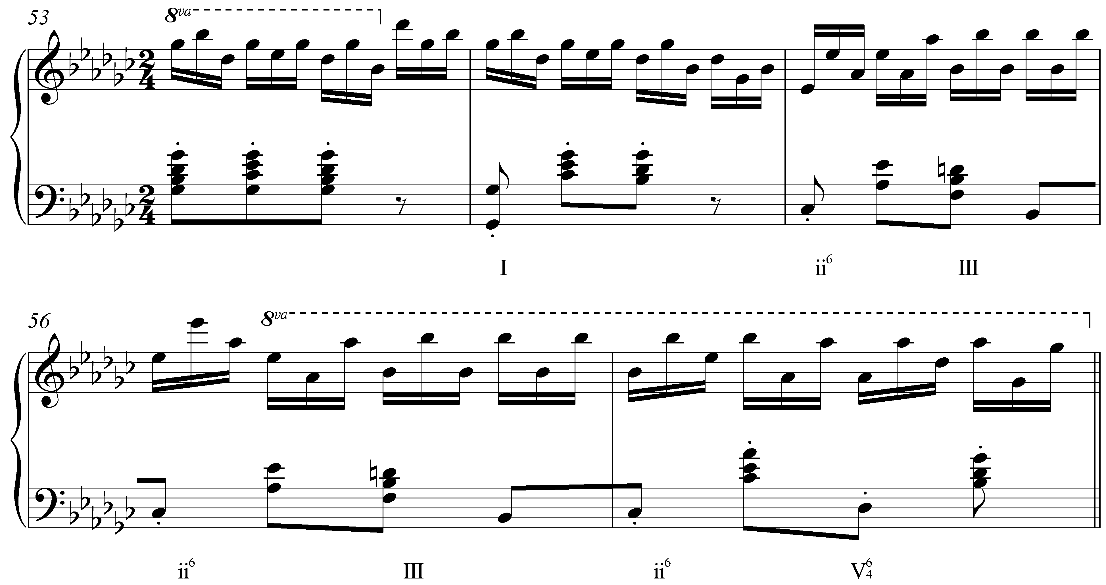

At first glance, this may appear to be a typical case of mixture. The III chord in m. 55 is major, as it would be in the parallel key of G minor. [NOTE: This is incorrect. The parallel key here is Gb minor, not G minor, and there is no Bb major chord in Gb minor. You got confused here and went off track. The Bb-major chord here is an example of what Aldwell/Schachter call “secondary” mixture, a term you introduce here, too, following them—which is fine. But secondary mixture does not involve any parallel key. That’s why A/S call it secondary mixture (as opposed to what they call “simple” mixture, i.e. primary mixture). The Bb-major chord arises here owing to a scale other than the parallel minor one. The chord arises from an allusion to the relative minor, Eb minor. The progression in m. 55 simulates iv-V in that key, except that Eb minor never appears. Since the progression to tonic never materializes, the Bb-major chord “hangs” in harmonic space, as a quasi-independent chord, used as an opposite-mode coloration of what diatonically would have been a Bb-minor chord (iii). That is what A/S mean by “secondary” mixture: simply taking the modal property of a chord and transforming it into its opposite but, crucially, without invoking notes from the parallel key. An instance of secondary mixture would using an E-major chord in the key of C major, where that E-major chord is used independently, as a III#, a coloration of iii, and not as an applied chord to vi. There is no G# in the parallel key of C major, hence the term “secondary” mixture (= not from parallel mode). In the Chopin example, the Bb-major chord, in its context, really does sound like a V/vi, at least in my opinion, especially coming after the ii6, which sounds so much like a iv followed by a V in Eb minor (so: V/vi). For that reason, for me the Chopin is not a good illustration of non-parallel-mode (“secondary”) mixture. Let’s find another, clear-cut, irrefutable example of secondary mixture.]

However, D natural is foreign to both G major and G minor. A major chord built on the scale degree 3 in a major key incorporates elements of both modes simultaneously. The III chord in Example LLL.18 is built on a diatonic tone, but has the major quality that would be expected of a borrowed mediant. (A typical mediant borrowing would be bIII.) [NOTE: All of the preceding is out, obviously.]
Though not technically a case of mixture, this type of chromaticism is sometimes referred to as secondary mixture. Like regular mixture, the quality of the chord in question is altered, but not through any borrowing of tones from the parallel key. Similar alterations of chords built on scale degree 6 also appear from time to time and become more common with later tonal music.

A different type of chromatic chord can be seen in Example LLL.19:

Example LLL.19 (L. Beethoven, Sonata in C# minor (“Moonlight”), Op. 27, no. 2, mm. 1-5):
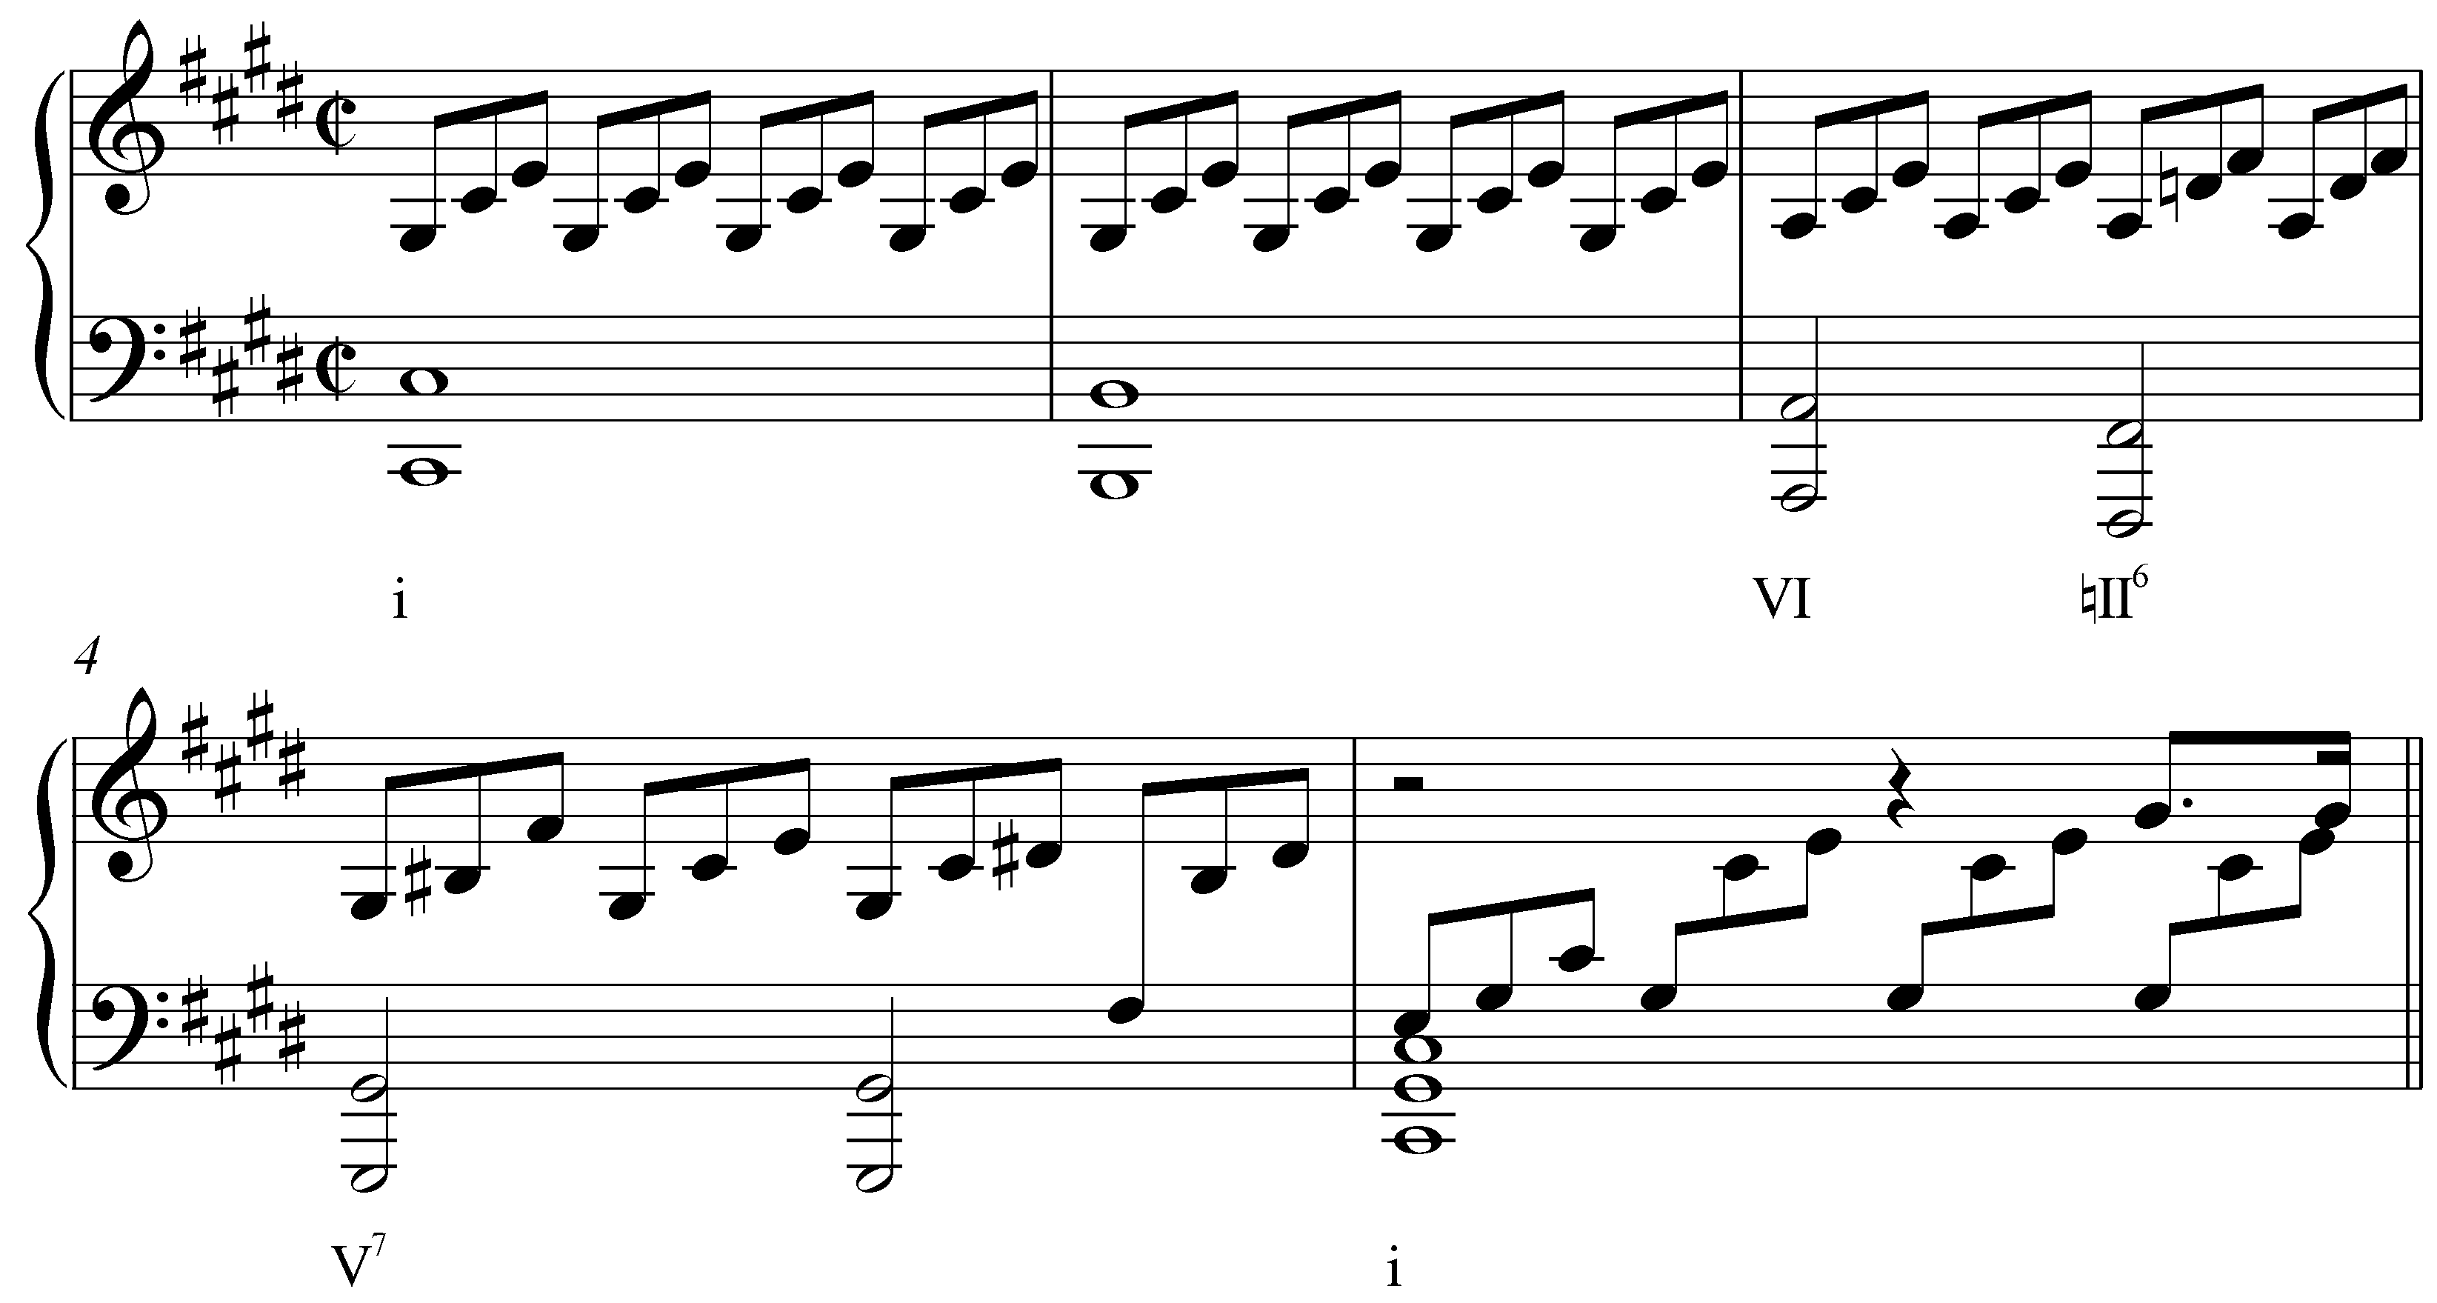

Following a prolonged tonic chord (with passing Bs in the bass), the harmony moves to VI and then a chord built on the lowered scale degree 2 before moving to the dominant. Obviously, this is not a typical case of a borrowed chord since D natural appears in neither C major nor C minor. Furthermore, there is no such thing as a major diatonic II chord.

This particular sonority, bII, nonetheless appears quite frequently. It is commonly referred to as a Neapolitan chord and typically appears in first inversion. (In addition to bII⁶, it is often labeled as N⁶.) Though not a case of mixture in the purest sense of the word, Neapolitan chords are often grouped with borrowed chords for this similarity in behavior. (A more detailed discussion of the Neapolitan chord can be found in Lesson MMM.)

Mixture and modulation:

Most of the examples we have looked at so far are relatively small in scale. Composers borrow specific tones from the parallel key to color a chord here or there and thus dramatize the passage. But mixture can affect larger areas of music as well, particularly with regards to modulation. This is evident in Example LLL.10, where an abrupt minor i chord is tonicized for several measures.

Mixture can also initiate a modulation directly, as it does in the following example:

Example LLL.20 (W.A. Mozart, Piano Sonata in C, K. 330/ii, mm. 1-28):
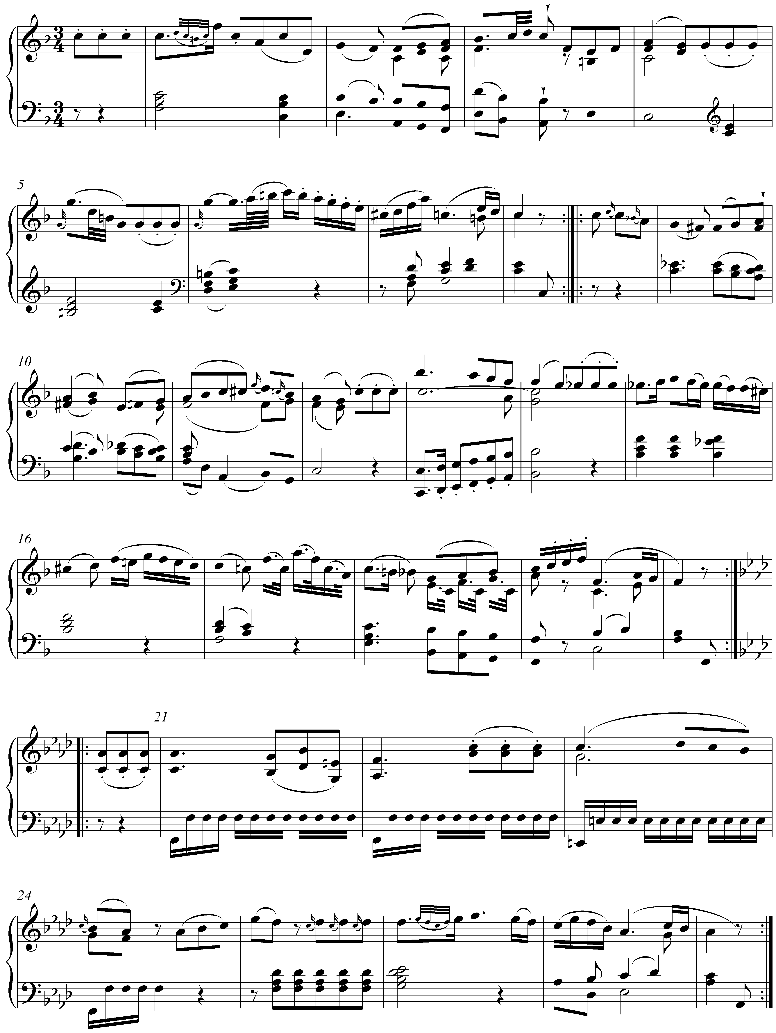

In this beginning to a piano sonata movement, the entire opening A section (mm. 1-20) is in the key of F major. For the B section (beginning with the pickup to m. 21), however, Mozart moves directly to F minor, key signature and all. Rather than inflect the quality of the tonic by lowering scale degree 3, Mozart simply shifts to the parallel minor key.

Modulations via mixture are not limited only to the parallel key of the global tonic. The following example in F major modulates to the key of C minor:

Example LLL.21 (W.A. Mozart, Piano Sonata in F, K. 332/iii, mm. 47-57):
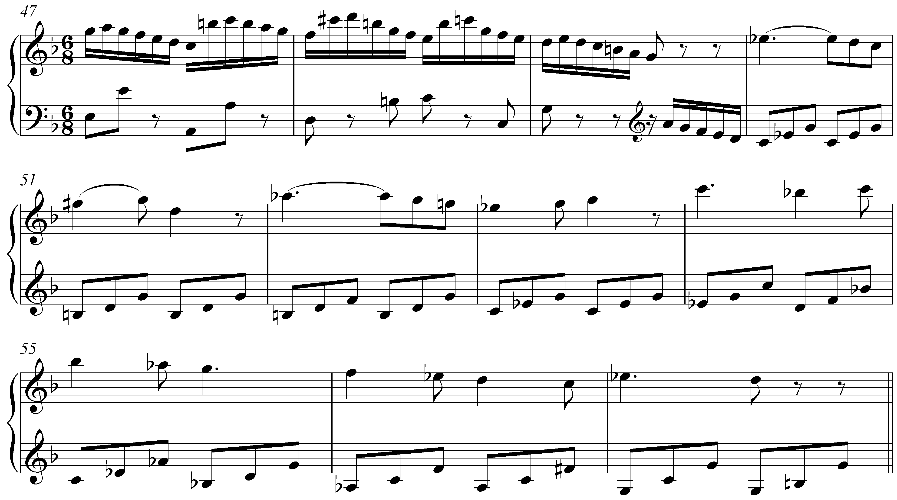

In sonatas such as this one, it is quite common to encounter modulations to the key of the dominant. After a transition section ending in m. 49, we expect to just that: a theme in C major. Instead, the melody beginning in m. 50 is clearly in C minor. The result is a remarkable instance of mixture. Mozart has moved to the rather distantly-related key of C minor through a mixture shift.

Conclusion:

Mixture consists of the incorporation of elements from the parallel key. Parallel keys differ at scale degrees 3, 6, and 7, so it is at these points that mixture will occur. In both major and minor keys, chords borrowed from the parallel key can intensify the drama of a musical texture.

Some instances of mixture can be seen as a result of strengthening the basic interval progressions governing the voiceleading of harmonic progression. This is not always the case, however, since some cases of mixture are employed strictly for color, variation, and drama. The term mixture is also expanded to include similar instances of chromatic pitches including those in double mixture chords and the Neapolitan.

Mixture can have an effect on larger spans of music as well. It can initiate modulation to foreign keys via a tonicization of a borrowed chord or by moving directly a mixture-related key area.

By incorporating chromatic pitches in this manner, composers are able to expand and enrich their options for musical expression. Though common in pieces from across the tonal repertoire, mixture is especially prevalent in music from the Romantic era. Composers in that style period were particularly concerned with the emotional impact of their music and mixture provided an effective means of heightening the level of expression.

