Lesson LLL: Mixture

Introduction:

In Lessons 8 and 10, we discussed various sorts of chromatic pitches. As we saw, non-diatonic tones may arise as a result of melodic or harmonic embellishment, or as part of an applied chord. This is not the case, however, in the following example:

Example LLL.01 (F. Schubert, Die Schöne Müllerin, No. 6: “Der Neugierige,” mm. 23-28):
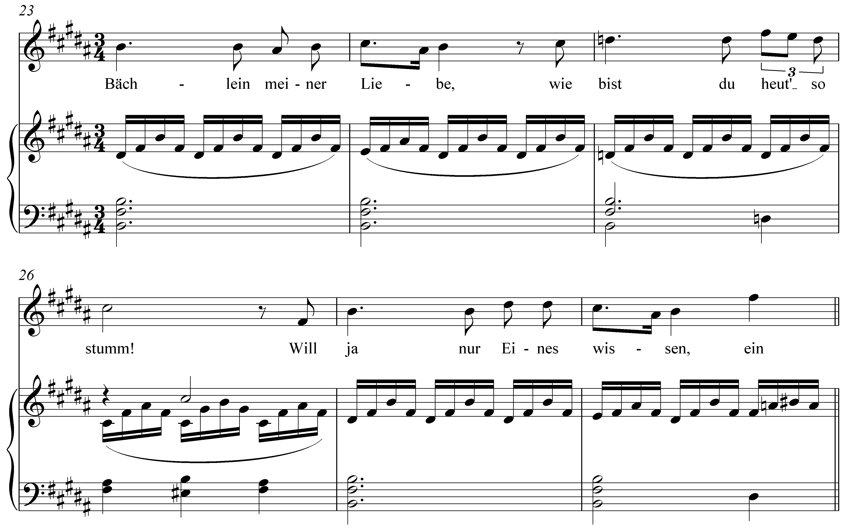

In m. 25, notice that scale degree 3 has been lowered from D# to D§. Instead of a I chord (B major), a i chord (B minor) appears there. The effect is striking. Why would Schubert make such an alteration at this point? Looking at the text of the song, we find the narrator speaking to a brook that led him to a miller’s beautiful daughter. At m. 25, having just asked the brook to tell him whether his heart has mistakenly led him to believe that the maid loves him, he remarks (to the brook), “wie bist du heut’ so stumm!” (“how quiet you are today!”) The observation marks a moment of doubt; a subtle change in mood that Schubert intensifies by presenting a minor form of the tonic triad.

This musical phenomenon is referred to as mixture, for it mixes elements of both the major and minor modes of a particular key. In other words, mixture in a major key consists of borrowing chords or tones from the parallel minor, and vice versa. As can be seen in Example LLL.01, mixture is particularly effective in music with text. The changes in color, brought about by the borrowed tones, can highlight and intensify certain words or passages. But this is not to say that words are a necessary component. Mixture is equally effective at lending drama to instrumental music.

In this lesson we will first examine the nature and mechanics of mixture. Turning to several examples from the tonal repertoire, we will look at common types of mixture. Finally, we will conclude with a discussion of the large-scale, structural uses of mixture.

The nature of mixture:

To understand mixture, we must consider the differences and similarities between parallel keys. (Refer to Lesson 3 for a more detailed discussion of the minor scale.) As Example LLL.02 demonstrates, parallel keys differ at scale degrees 3, 6, and 7:

Example LLL.02:

a. C major scale
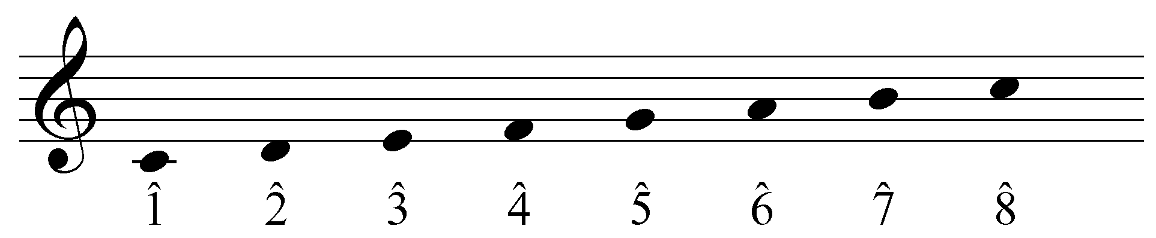

b. C minor scale (diatonic)
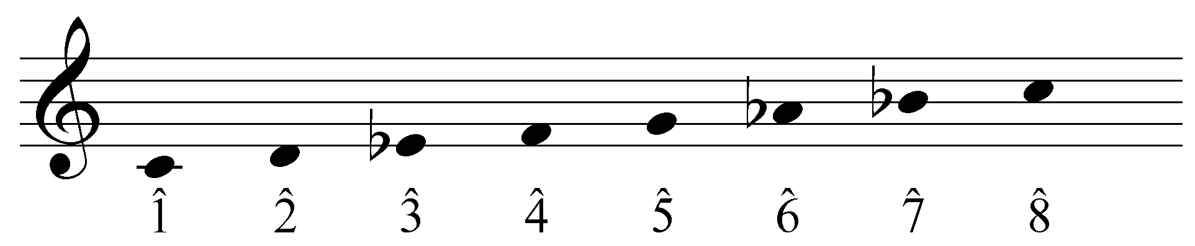

In a minor key, scale degrees 3, 6, and 7 are a semitone lower than their parallel major counterparts. Because they constitute the difference between the major and minor modes, these are sometimes referred to as the modal scale degrees. This variation is responsible for the differing qualities of the diatonic chords built on each scale degree:

Example LLL.03:

a. natural triads in C major
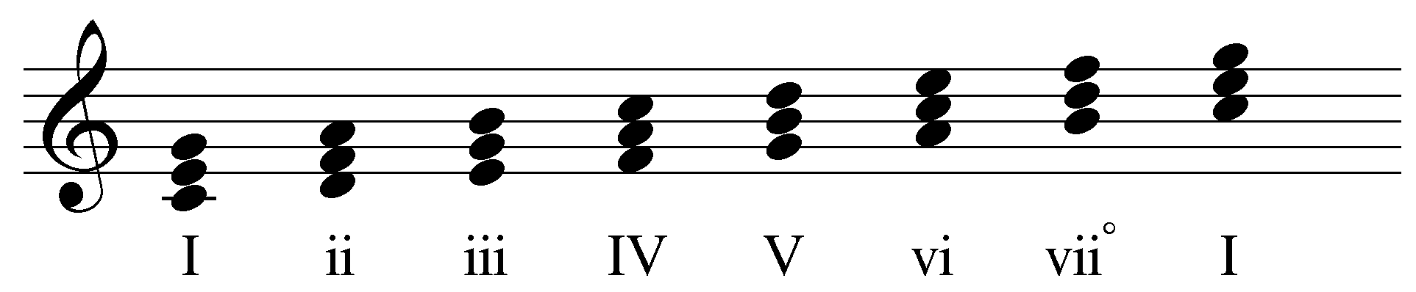

b. natural triads in C minor
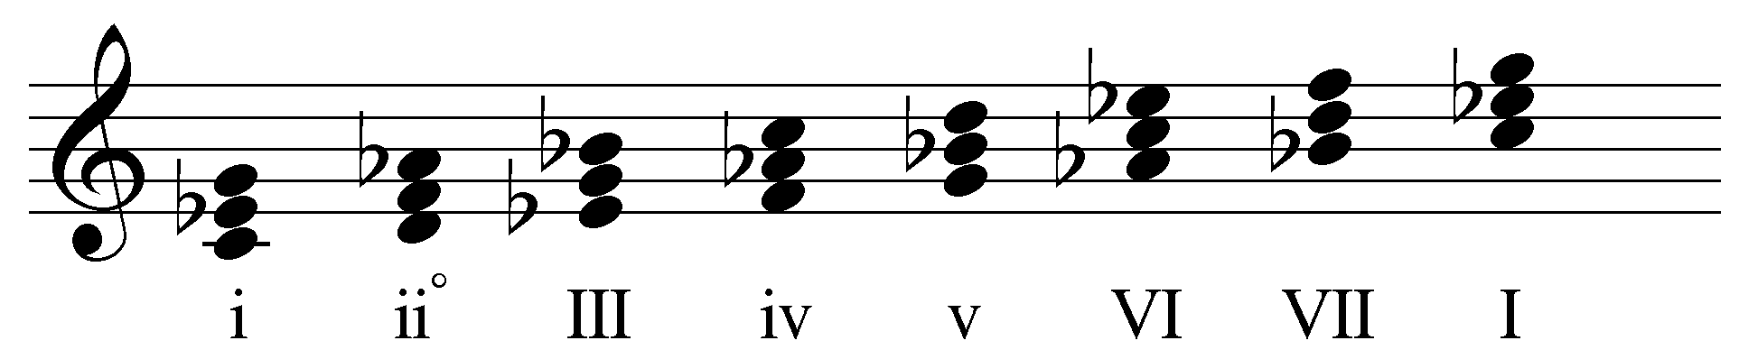

As you can see, the difference in scale degrees 3, 6, and 7 affects the quality of each diatonic chord. (Note that the leading tone has not been adjusted for the chords built on scale degrees 5 and 7 in Example LLL.03b. This will be addressed momentarily.)

Instances of mixture—often referred to as borrowed tones or chords—include one or more of the modal scale degrees from the parallel key. In other words, mixture in a major key will lower scale degrees 3, 6, or 7, while mixture in a minor key will raise them. These non-diatonic pitches bring with them all the expressive capabilities of the opposite mode. By incorporating elements of the parallel key in this manner, composers can expand and enhance their creative musical palette.

Labeling instances of mixture:

Because mixture alters the members and qualities of the affected harmonies, we must address the conventions for labeling borrowed chords. As you know, the case of a Roman numeral indicates the quality of the chord: uppercase for major chords and lowercase for minor. This should remain consistent in cases of mixture.

Example LLL.04 (J.S. Bach, BWV 248(3).33, “Warum sollt ich mich denn grämen,” mm. 1-3):
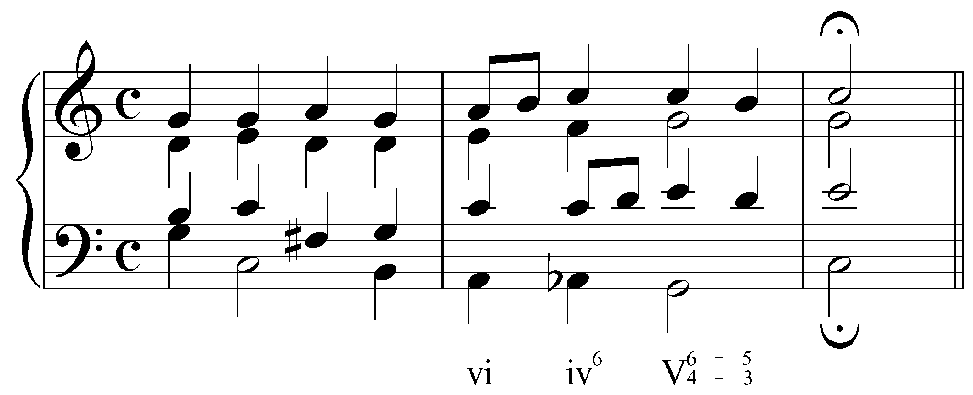

The progression in Example LLL.04 uses b6 (a lowered scale degree 6; Ab in this case), resulting in a minor triad on beat two of the second measure. The Roman numerals are consistent with this change in quality, using “iv” instead of “IV.”

To further accommodate the changes brought about by borrowing from the parallel mode, accidentals are also used in conjunction with Roman numerals. An accidental before a Roman numeral indicates an altered root:

Example LLL.05 (J.S. Bach, BWV 90.5, “Vater unser im Himmelreich,” mm. 9-10):
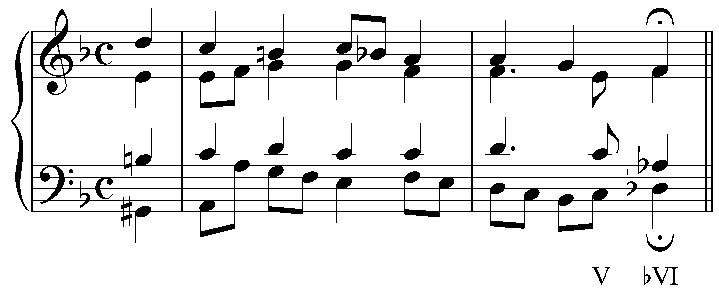

In the example above, the final chord is built on the lowered sixth scale degree (Db). The altered root is indicated by the accidental: bVI.

As usual, accidentals next to figured bass numerals affect the indicated pitches.

Note: Occasionally, a borrowed scale degree will negate one of the sharps or flats in the key signature, as in the following example:

Example LLL.06 (J.S. Bach, BWV 90.5, “Vater unser im Himmelreich,” mm. 9-10; transposed
to A major):
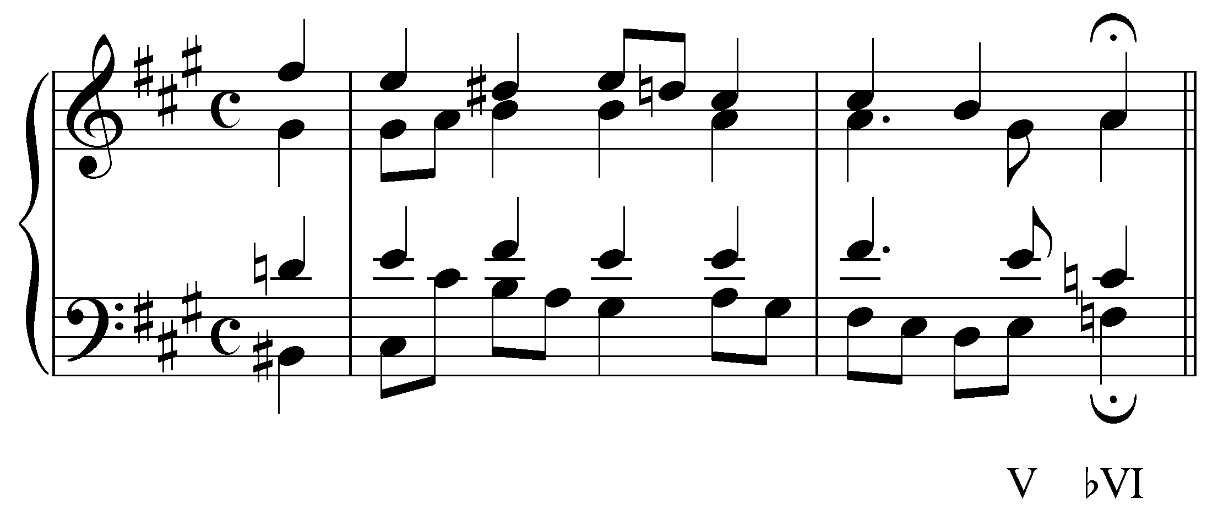

Example LLL.06 ends with a VI chord whose root, F natural, negates the F# in the key signature. Nonetheless, it has still been labeled “bVI.” You may occasionally encounter books that would label this chord “ªVI.” For the sake of clarity and consistency, we will follow this convention: use a flat for a lowered root and a sharp for a raised root, regardless of the key signature.

Mixture in major keys:

In major keys, instances of mixture usually incorporate b3, b6, or both. (b7 is generally avoided because its presence would subvert the important dominant function of the V and viiº chords.)

A lowered scale degree 6 is used to color and intensify chords built on 2 or 4. The presence of b6 will make a ii chord diminished (iiº) and a IV chord minor (iv) as in the following examples:

Example LLL.07 (J.S. Bach, BWV 281, “Christus, der ist mein Leben,” mm. 7-8):
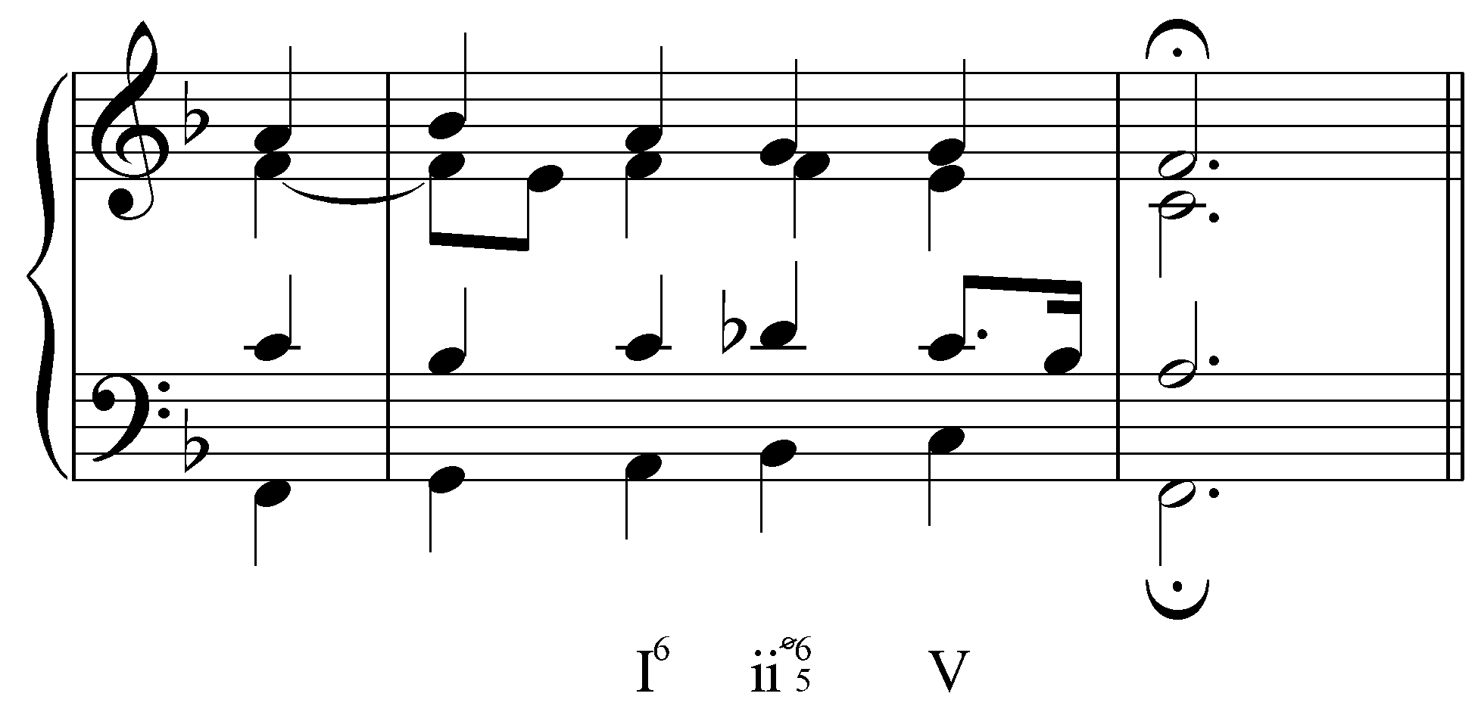

Example LLL.08 (J.S. Bach, BWV 248(3).33, “Warum sollt ich mich denn grämen,” mm. 1-3):

In Example LLL.07, the third beat of m. 7 has a b6 (Db), making the first-inversion ii chord diminished. Similarly, in Example LLL.08, the second beat of m. 2 has Ab in the bass, changing the quality of the subdominant chord to minor. In all of the cases mentioned thus far, mixture chords retain the harmonic functions of their unaltered forms. The adjusted chords in Examples LLL.07-08, for example, have the same pre-dominant function they would have without b6.

Seventh chords can likewise be affected by mixture. A ii⁷ chord, for example, would become ii^{ø7} with the addition of b6. Borrowing b6 in a seventh chord built on scale degree 7 will change a half-diminished seventh chord to fully-diminished. The following example, from Bach’s Well-Tempered Klavier, borrows Ab from C minor in m. 14:

Example LLL.09 (J.S. Bach, Prelude and Fugue 1 in C major, BWV 846, mm. 13-15):
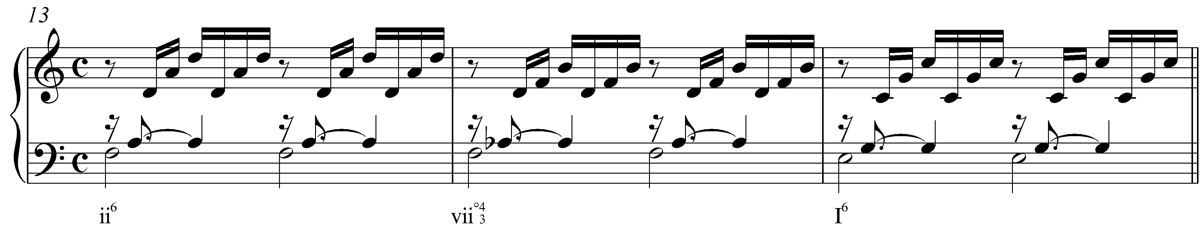

The Ab in m. 14 changes the quality of the leading-tone seventh chord from half- to fully-diminished. (Refer to Lesson PPP for a lengthier discussion of fully-diminished seventh chords.)

A lowered scale degree 3 is sometimes used to produce a minor tonic where one would normally expect a major harmony:

Example LLL.10:
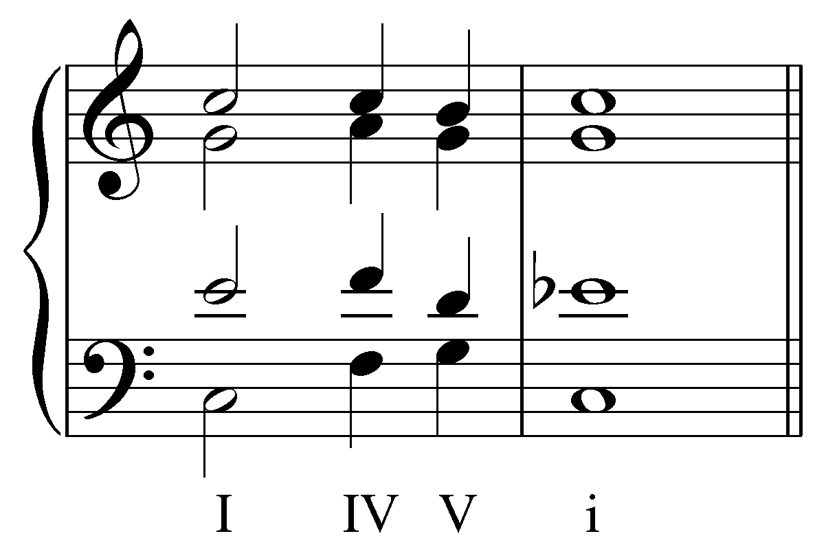

In this example, the concluding tonic harmony is made minor by the presence of Eb, borrowed from the parallel minor. The presence of b3 in a tonic harmony can have a surprising and dramatic effect! Consider the following example:

Example LLL.11 (F. Schubert, Die Schöne Müllerin, No. 4: “Danksagung an den Bach,” mm. 16-24):
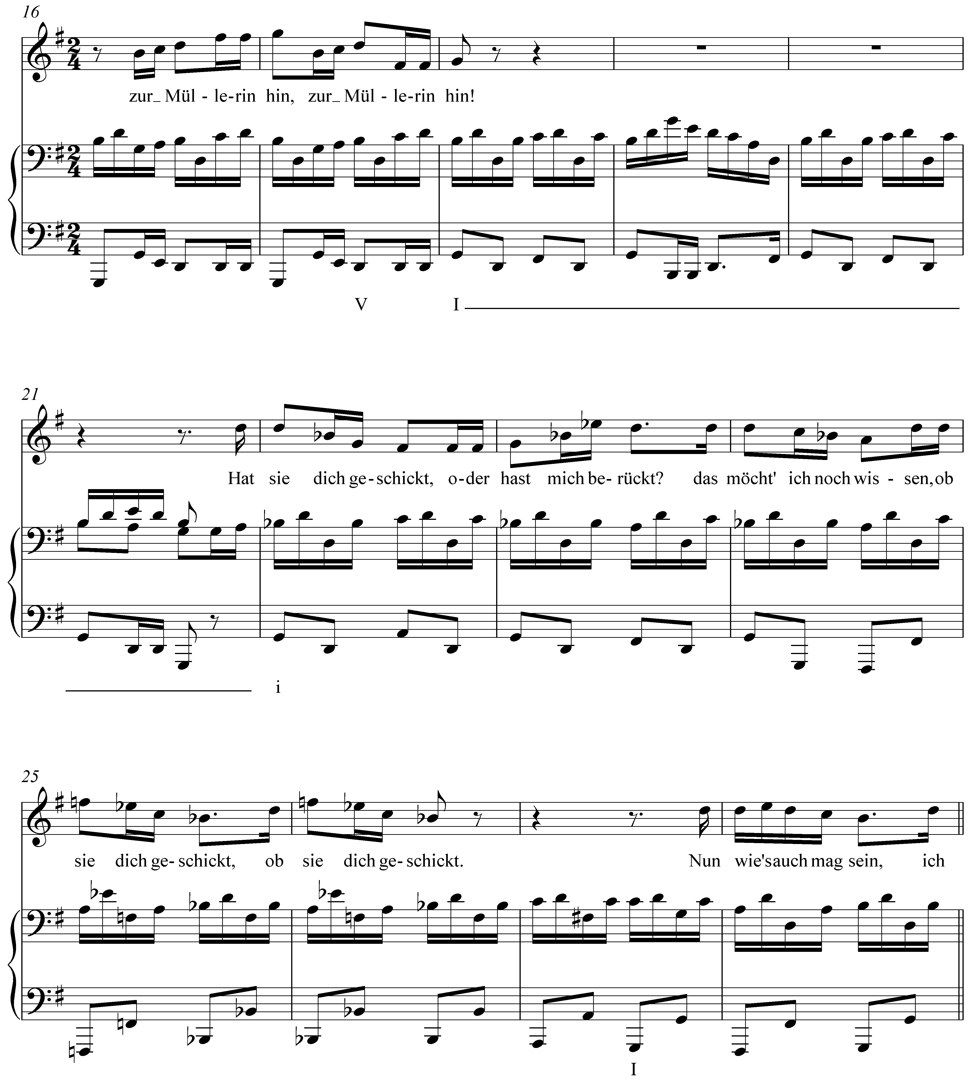

Like Example LLL.01, this Schubert song uses a minor tonic to reflect a change in mood in the song’s text. Following a strong cadence in the key of G major in mm. 17-18, we encounter a minor tonic (i) in m. 22. Again, the effect is startling and intensifies the emotional tension of the moment.

Combining b3 and b6 will result in the bVI chord mentioned above. The bVI chord is one of the most commonly borrowed chords in a major key. When used in a deceptive cadence it increases the dramatic effect by thwarting to an even greater degree the listener’s expectation of tonic harmony. The following example does just this:

Example LLL.12 (J.S. Bach, BWV 90.5, “Vater unser im Himmelreich,” mm. 9-10):

Mixture in minor keys:

Lesson 3 introduced the concepts of the harmonic and melodic minor composites which feature raised scale degrees 6 and 7. These adjustments can be seen as examples of mixture, where elements of the parallel major are borrowed to suit certain harmonic and melodic contexts. Other than the ubiquitous raising of the leading tone and submediant, mixture is far less common in minor keys than it is in major keys.

Occasionally, composers will incorporate #3 or #6 to lend color to i and iv chords (i becomes I and iv becomes IV with the raising, respectively, of scale degrees 3 and 6). The following example incorporates one such borrowed scale degree in m. 3:

Example LLL.13 (J.S. Bach, BWV 87.7, “Jesu, meine Freude,” mm. 3-4):
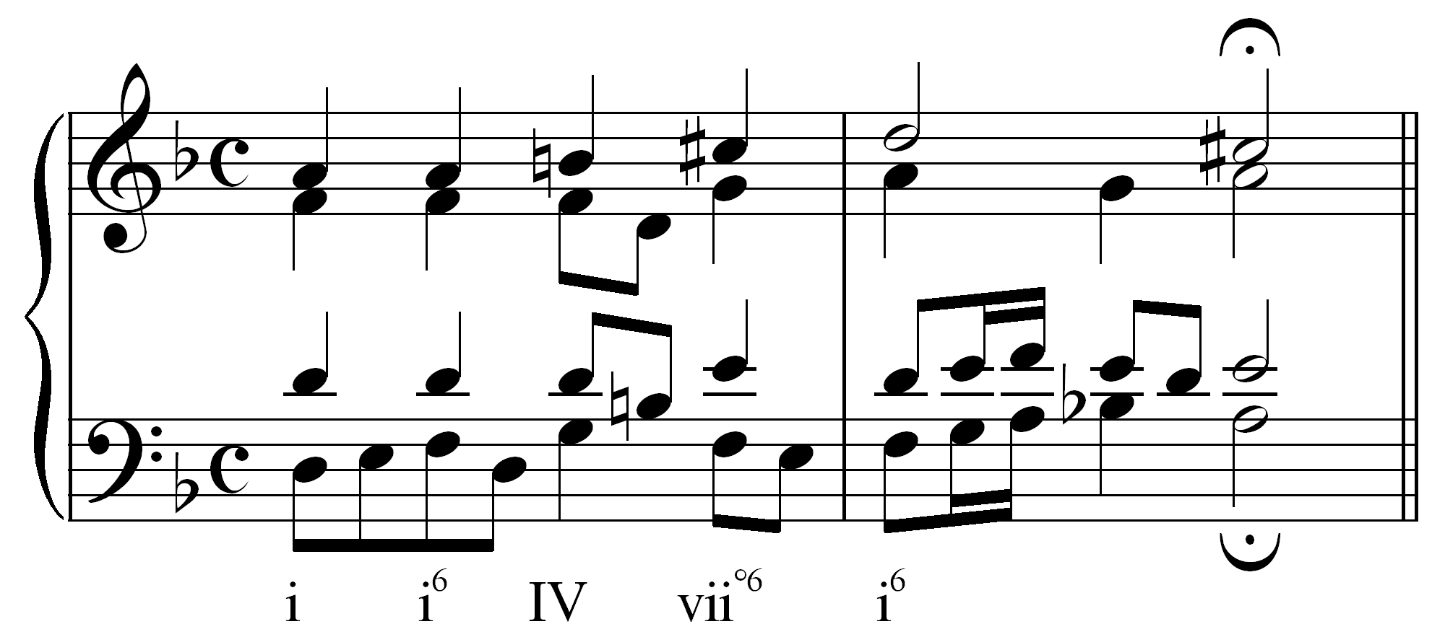

In this example, the chord on the third beat has a B natural in the soprano and then in the tenor. This raised third (scale degree 6) changes the quality of the chord to major (IV). (The C# in the following vii^{o6} chord is an example of mixture via the harmonic minor composite.)

The following example uses a borrowed scale degree in the final chord:

Example LLL.14 (J.S.Bach, BWV 81.7, “Jesu, meine Freude,” mm. 12-13):
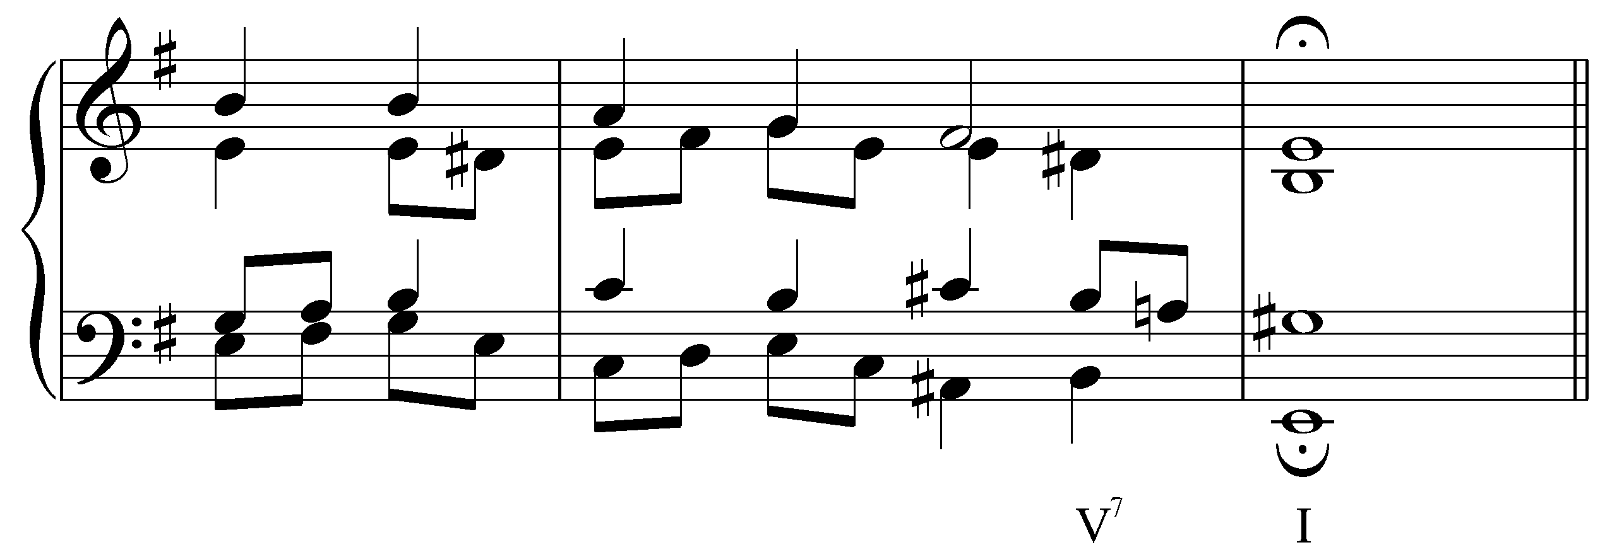

The G# in the final chord of this example makes the tonic major. The raised third of a tonic chord in a minor key is usually referred to as a Picardy third. Composers will commonly employ a Picardy third at the end of a piece in minor, coloring the conclusion with character of a major tonic.

Mixture and basic interval progressions:

Instances of mixture are often the result of adjustments made to the basic interval progressions outlined in Lesson 1. In all of the harmonic progressions considered in this lesson, the voiceleading is governed by the same basic interval progressions whether mixture is present or not. In some cases, however, mixture strengthens the underlying interval progressions.

The motion from a major third to a unison is intensified by altering one of the voices to introduce semitone motion:

Example LLL.15:

a. b.
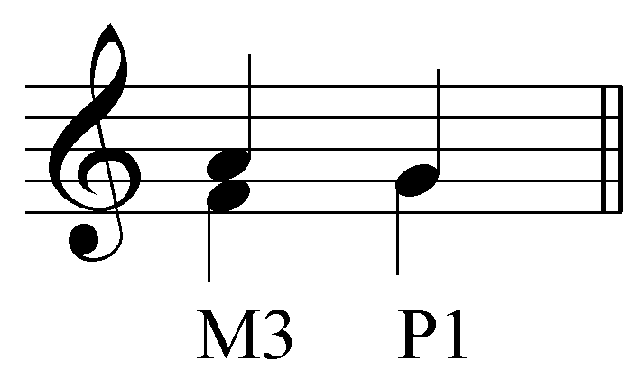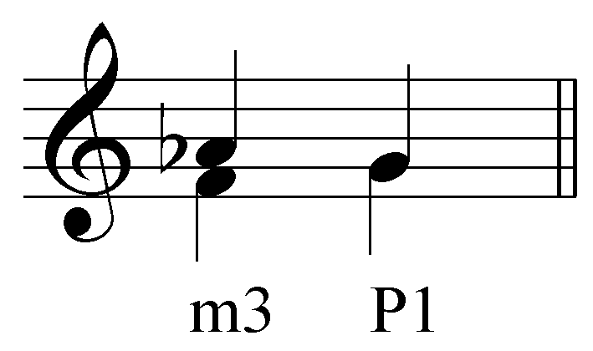

The following example puts this into context in a Bach chorale:

Example LLL.16 (J.S. Bach, BWV 281, “Christus, der ist mein Leben,” mm. 7-8):
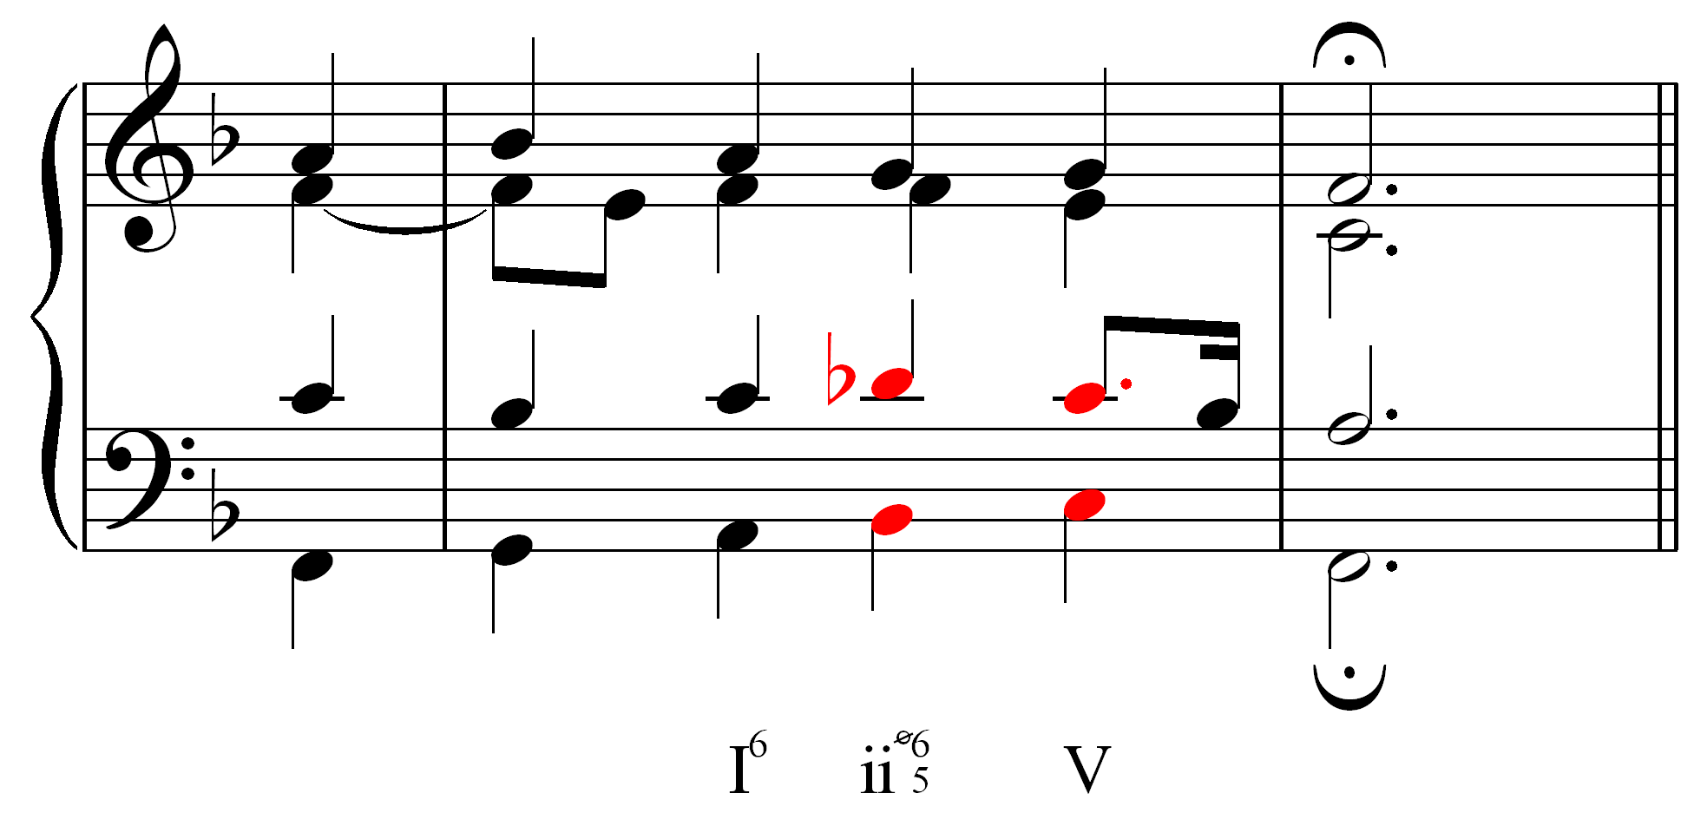

Whereas typically the motion from a major third to a unison consists of both voices moving by wholetones, moving from a minor third to a unison reduces one voice’s movement to a semitone. The result is similar to the strong semitone/wholetone motion of a major sixth to an octave. Similarly, the motion from a major sixth to a perfect fifth is made stronger by contracting the upper-voice motion to a semitone:

Example LLL.17:

a. b.
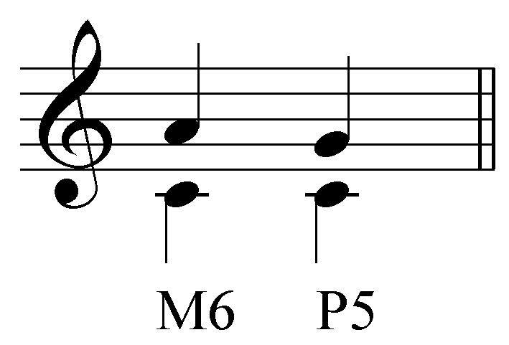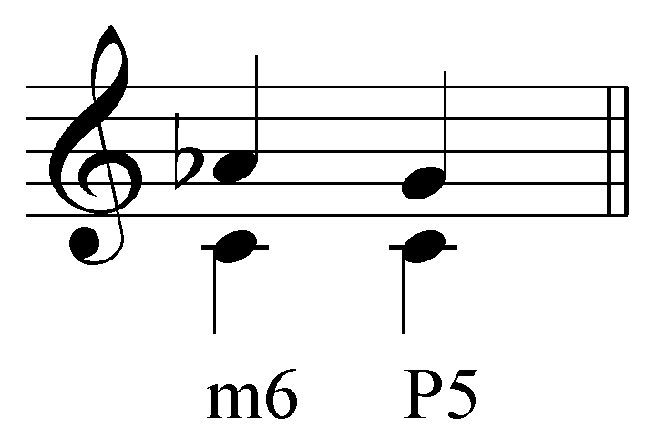

The following example puts this adjustment into context (Example LLL.18b provides a reduction of LLL.18a to clarify the voiceleading):

Example LLL.18 (J. Brahms, “Wie Melodien Zieht es mir, ” Op. 105, no. 1, mm 25-28):

a.
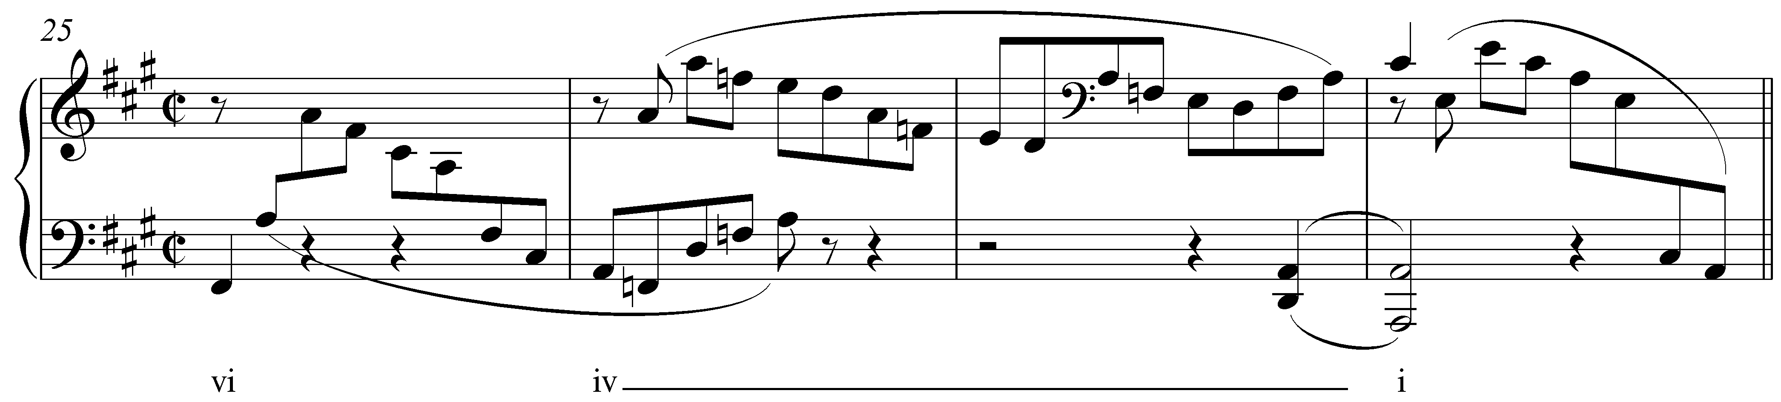

b.
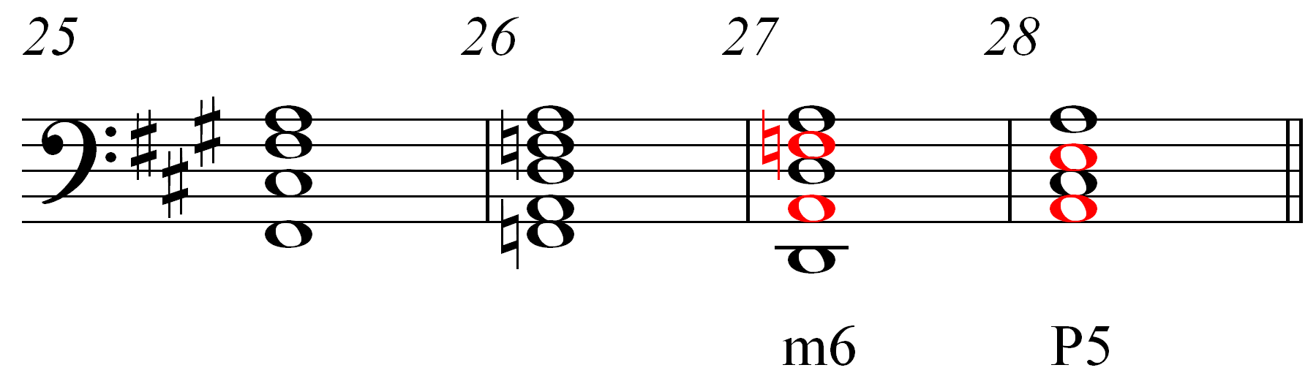

By lowering the F# to F natural, Brahms strengthens the motion to the tonic triad from m. 26 to m. 28.

While mixture often results from such voiceleading, it need not always. Sometimes, mixture is used strictly for purposes of coloration. Consider the following example from Mozart:

Example LLL.19 (W.A. Mozart, Piano Sonata in F, K. 332/ii, mm. 1-8):
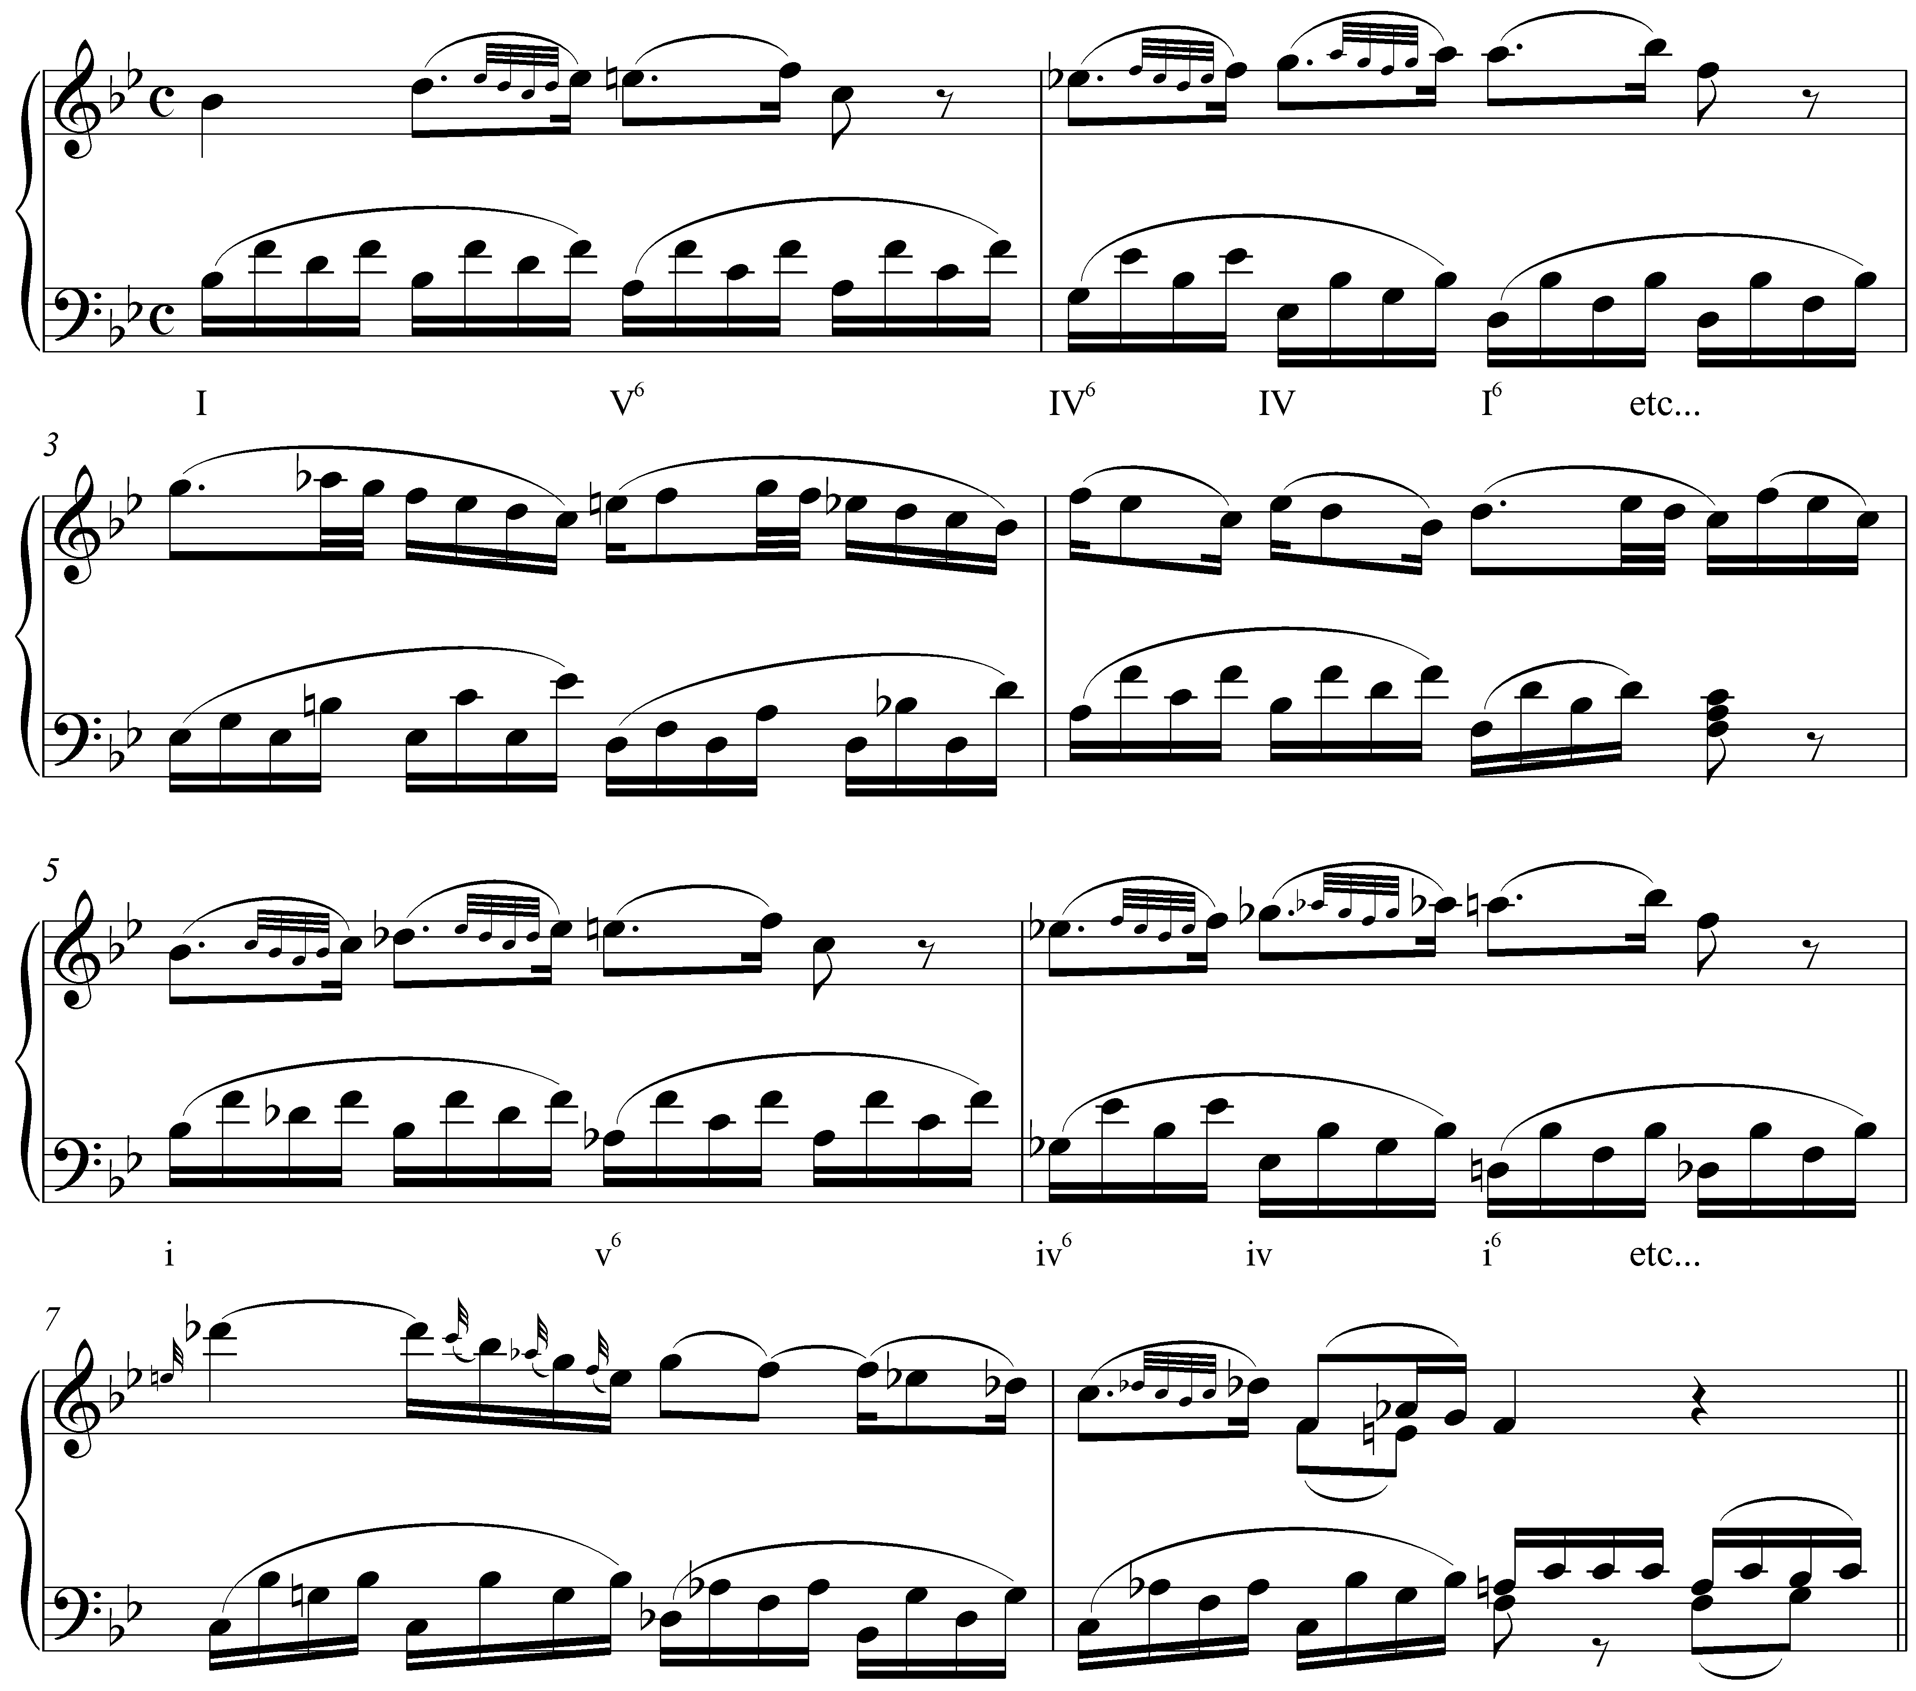

In this beginning to a piano sonata movement, Mozart first presents a melody in Bb major. He then repeats the melody in mm. 5-8, this time in Bb minor to heighten the expressiveness of the music.

Double mixture, secondary mixture, and other chromatic chords:

All of the examples of mixture presented so far have been relatively straightforward. In each case, one or two tones are borrowed from the parallel key to emphasize or intensify certain harmonies. Occasionally, however, you will encounter instances of mixture that cannot be explained in such simple terms.

Example LLL.20 (F. Schubert, “"Die Liebe hat gelogen” D. 751, mm 3-6):
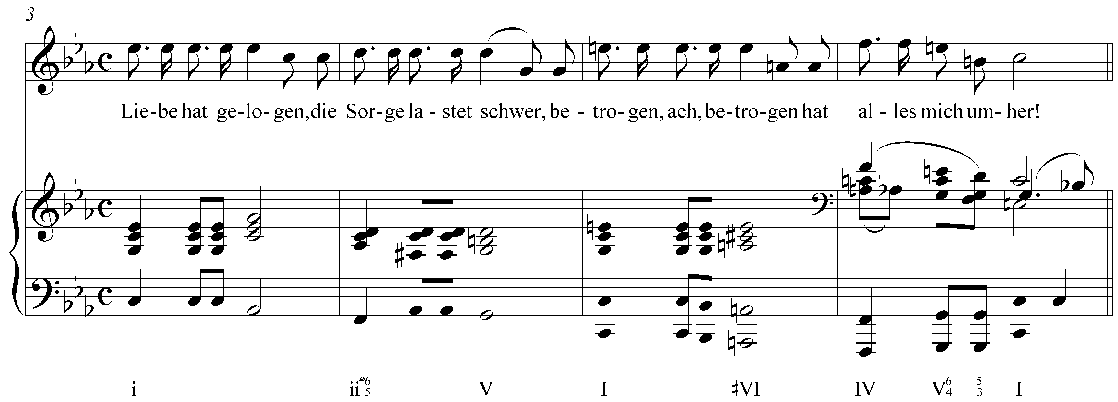

This passage from a Schubert song begins in C minor. At the beginning of m. 5 we find a clear cut case of mixture: the E naturals in both the voice and the piano change the quality of the tonic triad to major and C major is tonicized with an authentic cadence in m. 6. In the second half of m. 5, however, we find an A major triad (#VI). All three members of the triad have been raised with regards to C minor. This is not a simple case of mixture, since C major does not include C#. Rather, this is a case of double mixture. Double mixture consists of changing the quality of a chord derived from simple mixture. In other words we would expect to find an A minor triad (#vi) but instead find A major (#VI) in a case of mixture upon mixture.

Now consider the following example from a Schubert sonata:

Example LLL.21 (F. Schubert, Piano Sonata in D major, D. 850, Trio, mm. 53-61):
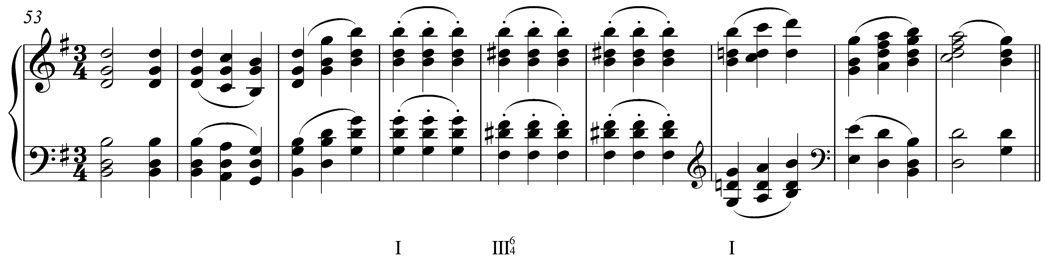

At first glance, the major III chord in m. 57 may appear to be a typical case of mixture. However, the altered pitch (D#, the raised scale degree 5) does not belong to either the tonic key (G major) or the parallel minor (G minor). Though not technically a case of mixture, this type of chromaticism is sometimes referred to as secondary mixture. Like regular mixture, the quality of the chord in question is altered, but not through any borrowing of tones from the parallel key. In this example, scale degree 5 reverts back to D natural in m. 59. Similar alterations of chords built on scale degree 6 also appear from time to time and become more common with later tonal music.

A different type of chromatic chord can be seen in Example LLL.22:

Example LLL.22 (L. Beethoven, Sonata in C# minor (“Moonlight”), Op. 27, no. 2, mm. 1-5):
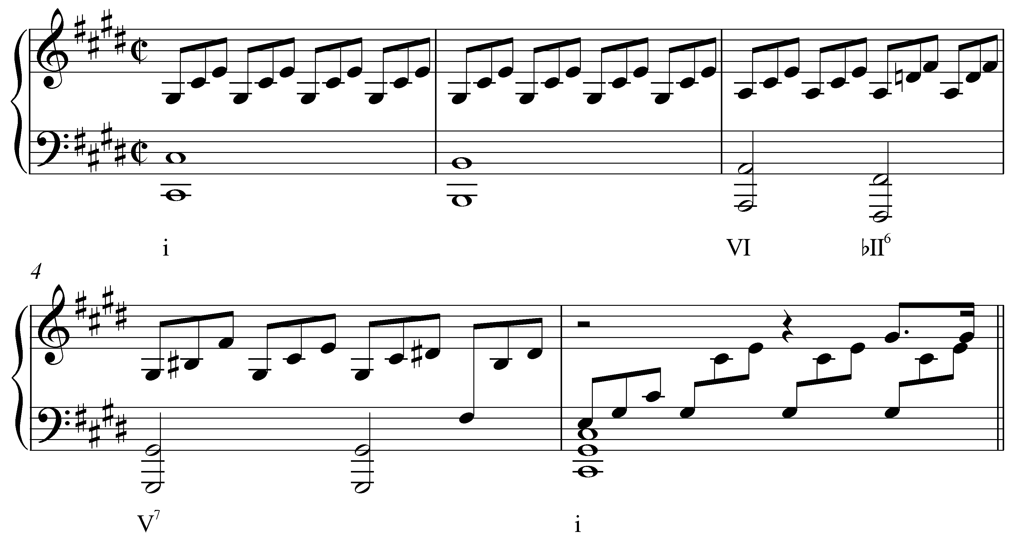

Following a prolonged tonic chord (with passing Bs in the bass), the harmony moves to VI and then a chord built on the lowered scale degree 2 before moving to the dominant. Obviously, this is not a typical case of a borrowed chord since D natural appears in neither C major nor C minor. Furthermore, there is no such thing as a major diatonic II chord.

This particular sonority, bII, nonetheless appears quite frequently. It is commonly referred to as a Neapolitan chord and typically appears in first inversion. (In addition to bII⁶, it is often labeled as N⁶.) Though not a case of mixture in the purest sense of the word, Neapolitan chords are often grouped with borrowed chords for this similarity in behavior. (A more detailed discussion of the Neapolitan chord can be found in Lesson MMM.)

Mixture and modulation:

Most of the examples we have looked at so far are relatively small in scale. Composers borrow specific tones from the parallel key to color a chord here or there and thus dramatize the passage. But mixture can affect larger areas of music as well, particularly with regards to modulation. This is evident in Example LLL.11, where an abrupt minor i chord is tonicized for several measures.

Mixture can also initiate a modulation directly, as it does in the following example:

Example LLL.23 (W.A. Mozart, Piano Sonata in C, K. 330/ii, mm. 1-28):
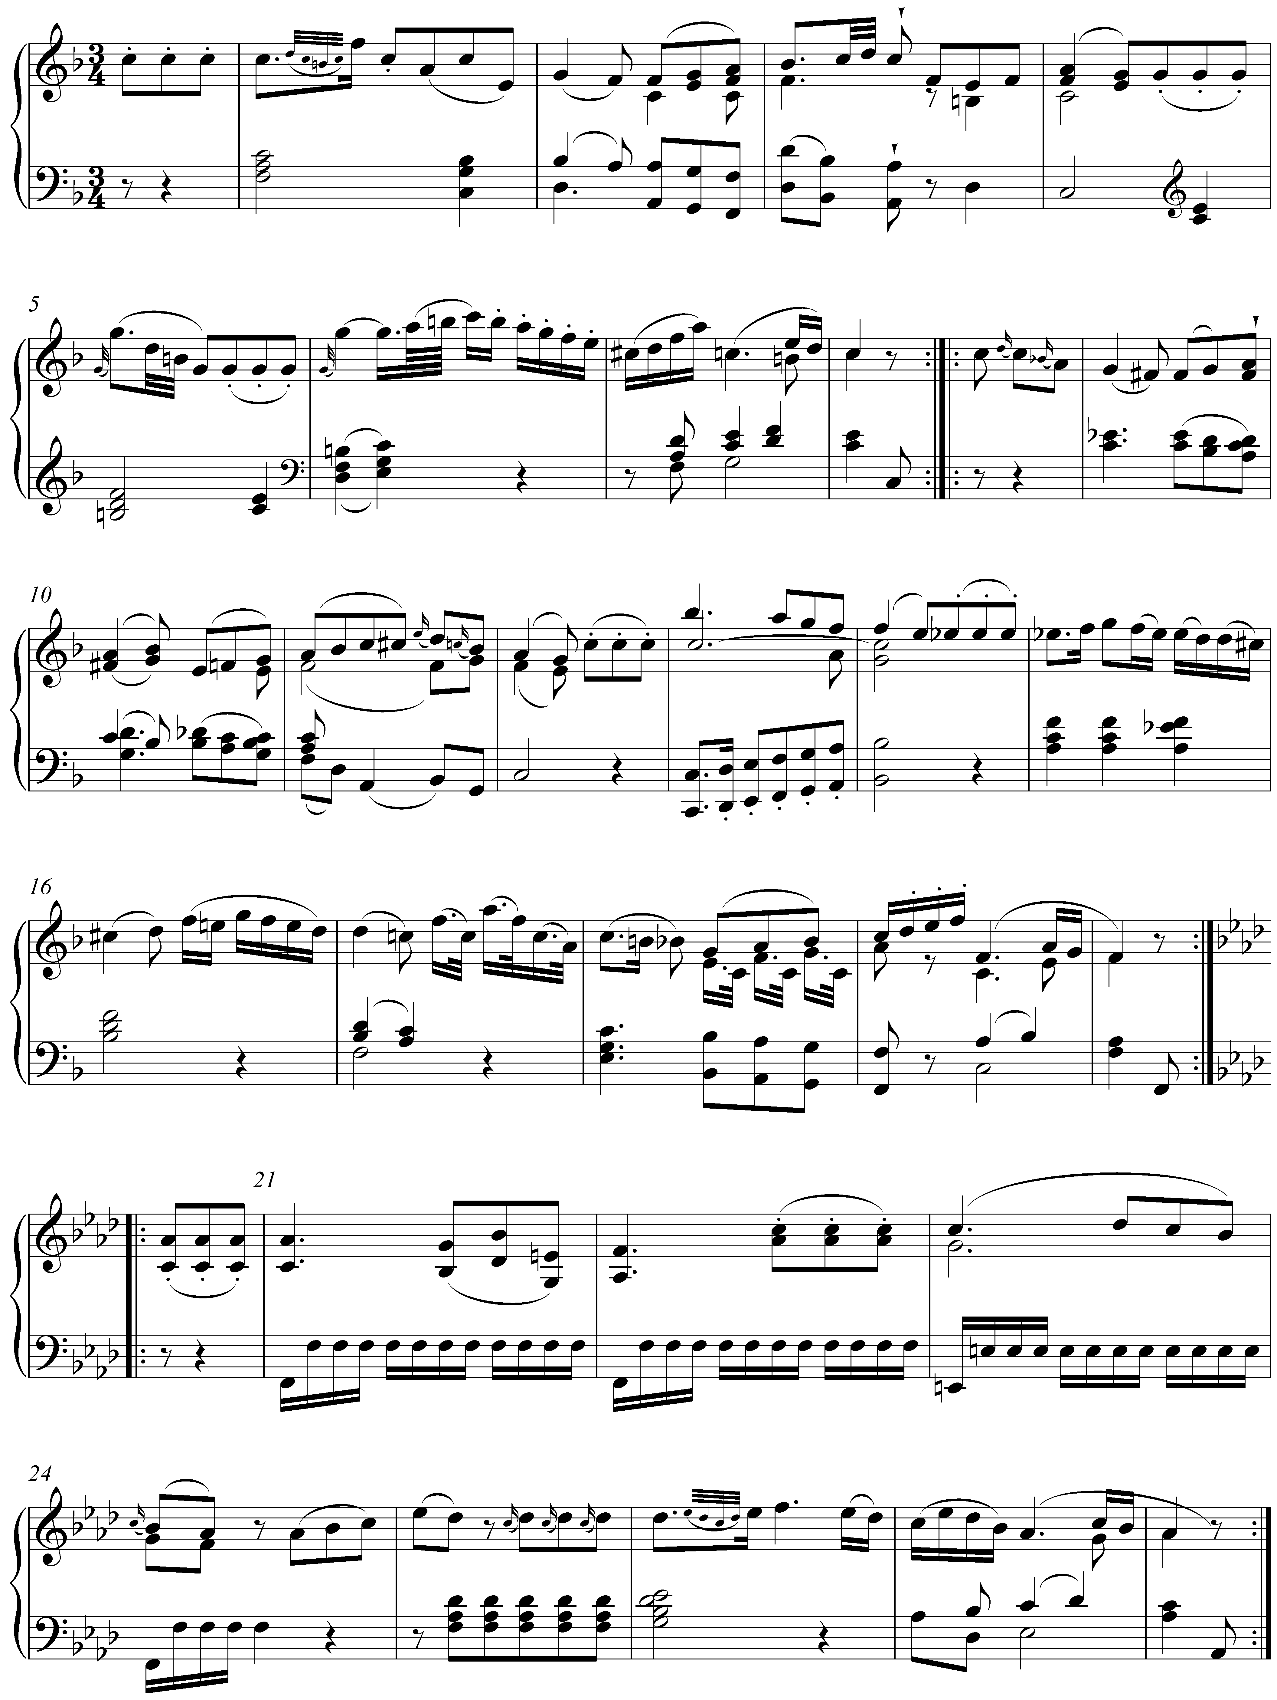

In this beginning to a piano sonata movement, the entire opening A section (mm. 1-20) is in the key of F major. For the B section (beginning with the pickup to m. 21), however, Mozart moves directly to F minor, key signature and all. Rather than inflect the quality of the tonic by lowering scale degree 3, Mozart simply shifts to the parallel minor key.

Modulations via mixture are not limited only to the parallel key of the global tonic. The following example in F major modulates to the key of C minor:

Example LLL.24 (W.A. Mozart, Piano Sonata in F, K. 332/iii, mm. 47-57):
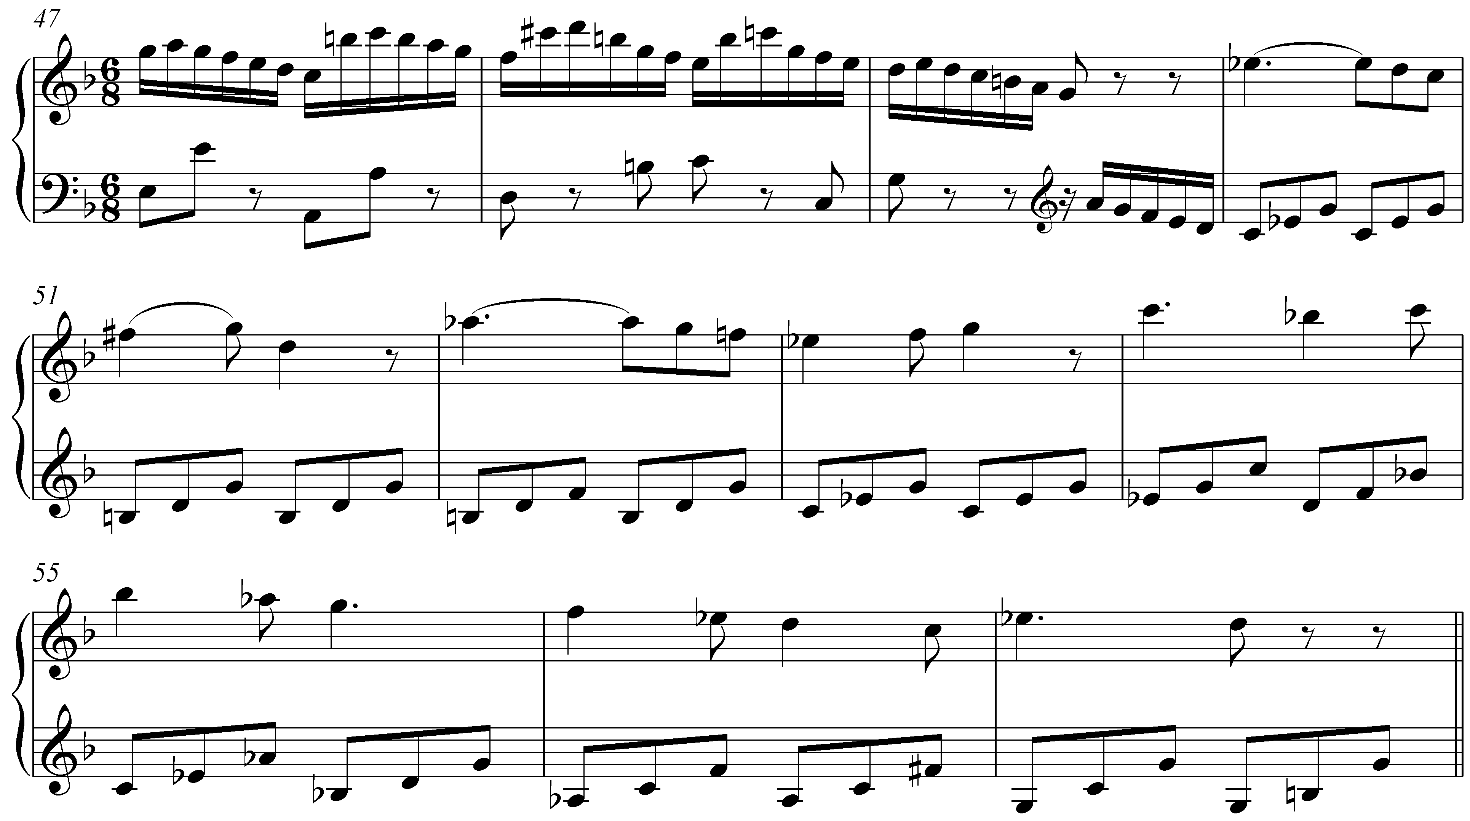

In sonatas such as this one, it is quite common to encounter modulations to the key of the dominant. After a transition section ending in m. 49, we expect just that: a theme in C major. Instead, the melody beginning in m. 50 is clearly in C minor. The result is a remarkable instance of mixture. Mozart has moved to the rather distantly-related key of C minor through a mixture shift.

Conclusion:

Mixture consists of the incorporation of elements from the parallel key. Parallel keys differ at scale degrees 3, 6, and 7, so it is at these points that mixture will occur. In both major and minor keys, chords borrowed from the parallel key can intensify the drama of a musical texture.

Some instances of mixture can be seen as a result of strengthening the basic interval progressions governing the voiceleading of harmonic progression. This is not always the case, however, since some cases of mixture are employed strictly for color, variation, and drama. The term mixture is also expanded to include similar instances of chromatic pitches including those in double mixture chords and the Neapolitan.

Mixture can have an effect on larger spans of music as well. It can initiate modulation to foreign keys via a tonicization of a borrowed chord or by moving directly to a mixture-related key area.

By incorporating chromatic pitches in this manner, composers are able to expand and enrich their options for musical expression. Though common in pieces from across the tonal repertoire, mixture is especially prevalent in music from the Romantic era. Composers in that style period were particularly concerned with the emotional impact of their music and mixture provided an effective means of heightening the level of expression.

