Lesson LLL: Mixture

Introduction:

In Lessons 8 and 10, we discussed various sorts of chromatic pitches. As we saw, non-diatonic tones may arise as a result of melodic or harmonic embellishment, or as part of an applied chord. This is not the case, however, in the following example:

Example 1 (F. Schubert, Die Schöne Müllerin, No. 6: “Der Neugierige,” mm. 23-28):
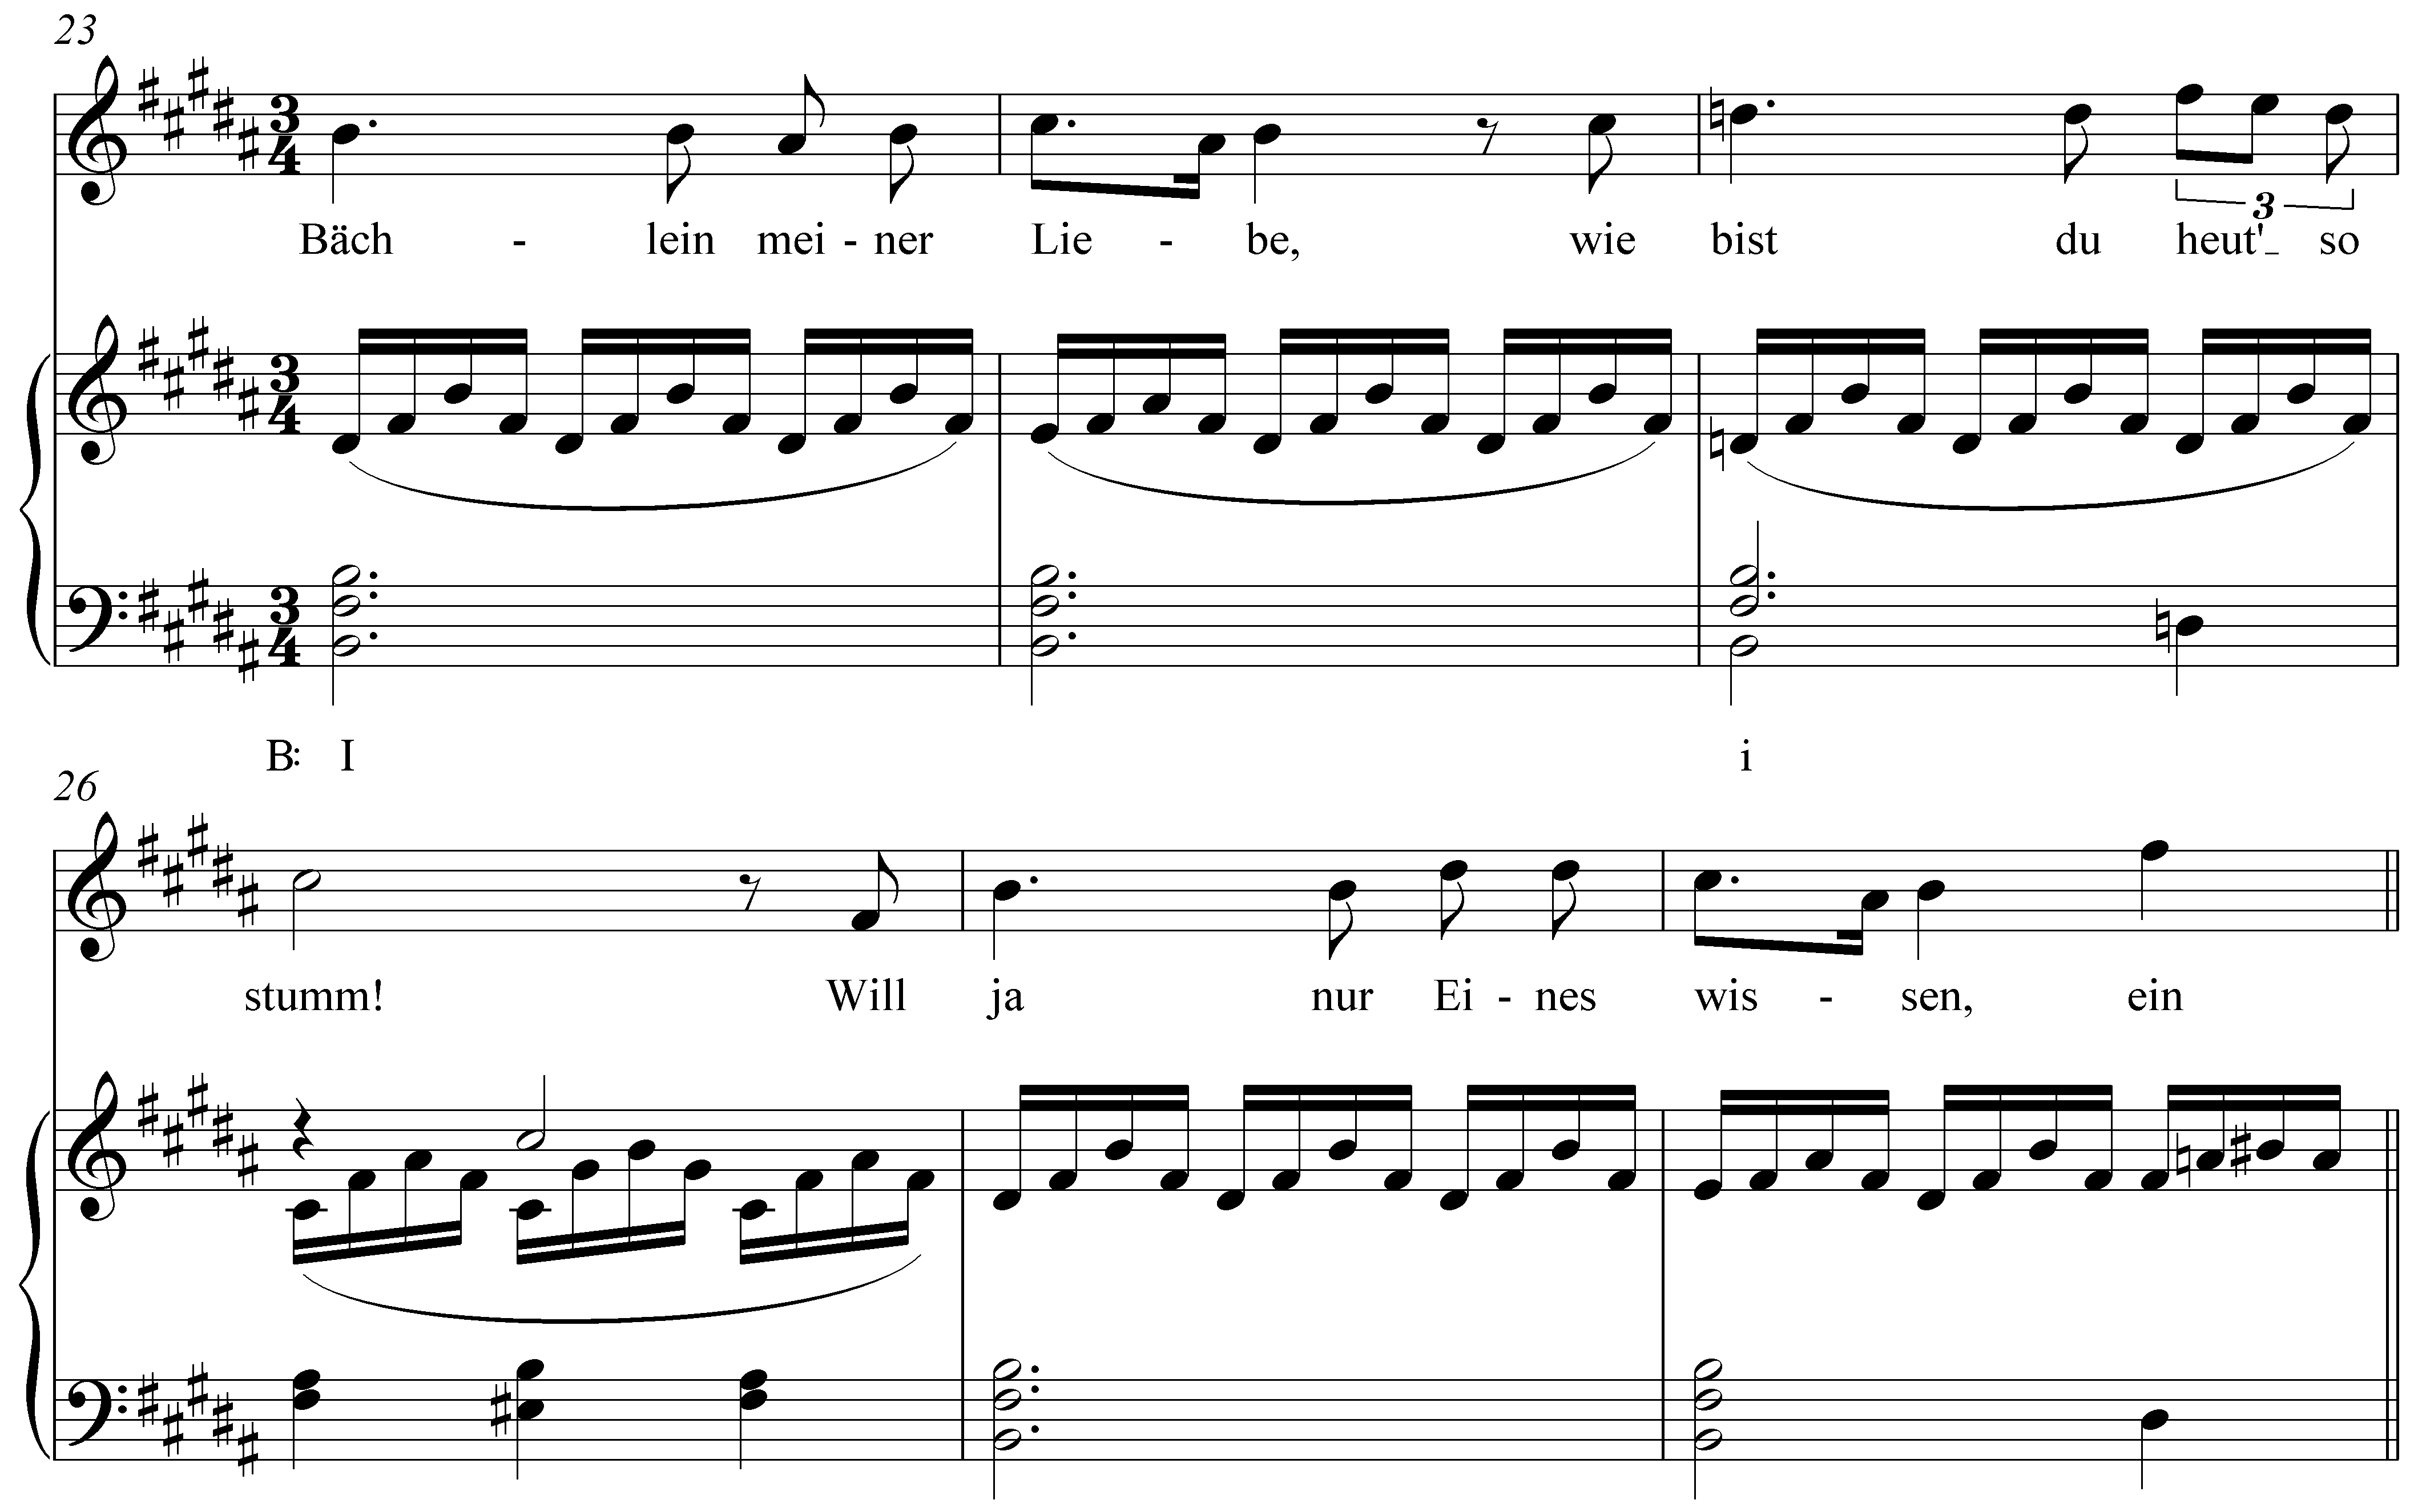

In m. 25, notice that scale degree 3 has been lowered from D# to D§. Instead of a I chord (B major), a i chord (B minor) appears there. The effect is striking. Why would Schubert make such an alteration at this point? Looking at the text of the song, we find the narrator speaking to a brook that led him to a miller’s beautiful daughter. At m. 25, having just asked the brook to tell him whether his heart has mistakenly led him to believe that the maid loves him, he remarks (to the brook), “wie bist du heut’ so stumm!” (“how quiet you are today!”) The observation marks a moment of doubt; a subtle change in mood that Schubert intensifies by presenting a minor form of the tonic triad.

This musical phenomenon is referred to as mixture, for it mixes elements of both the major and minor modes of a particular key. In other words, mixture in a major key consists of borrowing chords or tones from the parallel minor, and vice versa. As can be seen in Example 1, mixture is particularly effective in music with text. The changes in color, brought about by the borrowed tones, can highlight and intensify certain words or passages. But this is not to say that words are a necessary component. Mixture is equally effective at lending drama to instrumental music.

In this lesson we will first examine the nature and mechanics of mixture. Turning to several examples from the tonal repertoire, we will look at common types of mixture. Finally, we will conclude with a discussion of the large-scale, structural uses of mixture.

The nature of mixture:

To understand mixture, we must consider the differences and similarities between parallel keys. (Refer to Lesson 3 for a more detailed discussion of the minor scale.) As Example 2 demonstrates, parallel keys differ at scale degrees 3, 6, and 7:

Example 2:

a. C major scale
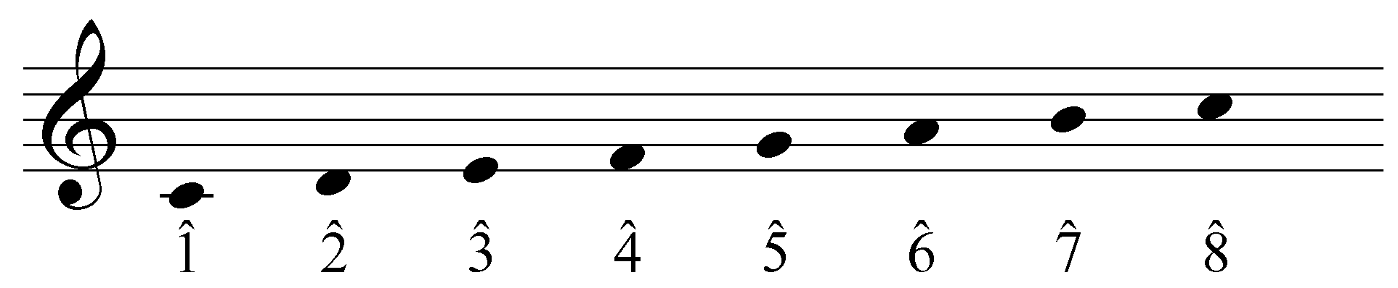

b. C minor scale (diatonic)
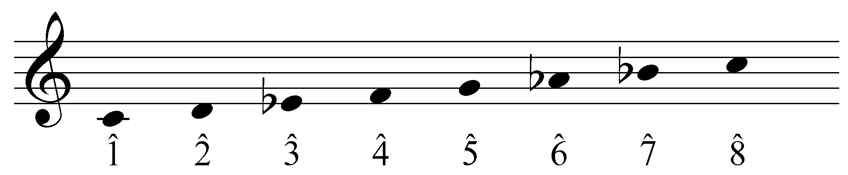

In a minor key, scale degrees 3, 6, and 7 are a semitone lower than their parallel major counterparts. Because they constitute the difference between the major and minor modes, these are sometimes referred to as the modal scale degrees. This variation is responsible for the differing qualities of the diatonic chords built on each scale degree:

Example 3:

a. natural triads in C major
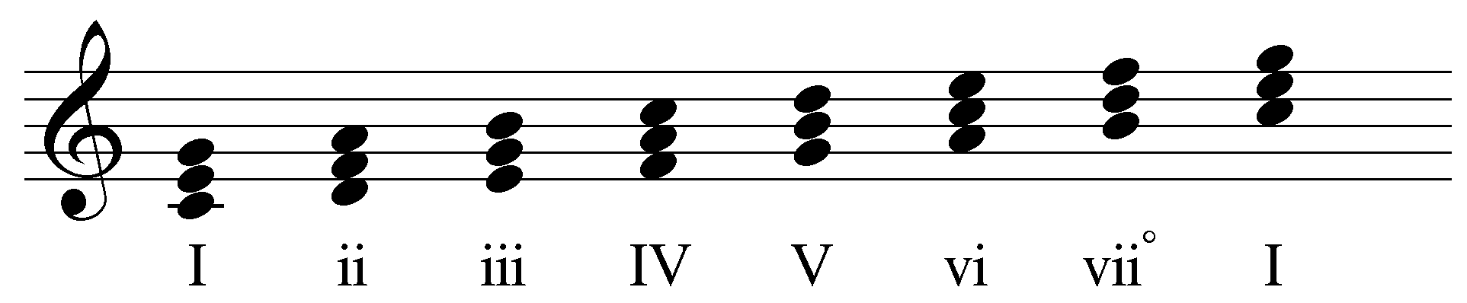

b. natural triads in C minor
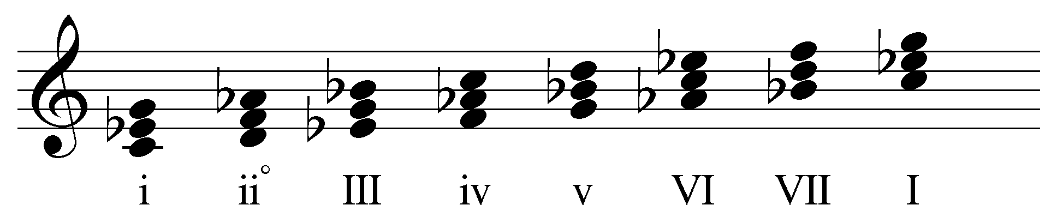

As you can see, the difference in scale degrees 3, 6, and 7 affects the quality of each diatonic chord. (Note that the leading tone has not been adjusted for the chords built on scale degrees 5 and 7 in Example 3b. This will be addressed momentarily.)

Instances of mixture—often referred to as borrowed tones or chords—include one or more of the modal scale degrees from the parallel key. In other words, mixture in a major key will lower scale degrees 3, 6, or 7, while mixture in a minor key will raise them. These non-diatonic pitches bring with them all the expressive capabilities of the opposite mode. By incorporating elements of the parallel key in this manner, composers can expand and enhance their creative musical palette.

Activity LLL.01:
For each of the following keys, indicate the three tones that may be borrowed from the parallel major or minor.

Exercise LLL.01a:
In the key of A major, what three tones may be borrowed from the parallel minor?
[Answers: C (natural), F (natural), and G (natural). Response if correct: “Correct!” Response if incorrect: “Incorrect. (Hint: Remember, the modal scale degrees are 3, 6, and 7.)”]

Exercise LLL.01b:
In the key of C minor, what three tones may be borrowed from the parallel major?
[Answers: E (natural), A (natural), and B (natural). Response if correct: “Correct!” Response if incorrect: “Incorrect. (Hint: Remember, the modal scale degrees are 3, 6, and 7.)”]

Exercise LLL.01c:
In the key of F major, what three tones may be borrowed from the parallel minor?
[Answers: Ab, Db, and Eb. Response if correct: “Correct!” Response if incorrect: “Incorrect. (Hint: Remember, the modal scale degrees are 3, 6, and 7.)”]

Exercise LLL.01d:
In the key of B minor, what three tones may be borrowed from the parallel major?
[Answers: D#, G#, and A#. Response if correct: “Correct!” Response if incorrect: “Incorrect. (Hint: Remember, the modal scale degrees are 3, 6, and 7.)”]

Labeling instances of mixture:

Because mixture alters the members and qualities of the affected harmonies, we must address the conventions for labeling borrowed chords. As you know, the case of a Roman numeral indicates the quality of the chord: uppercase for major chords and lowercase for minor. This should remain consistent in cases of mixture.

Example 4 (J.S. Bach, BWV 248(3).33, “Warum sollt ich mich denn grämen,” mm. 1-3):
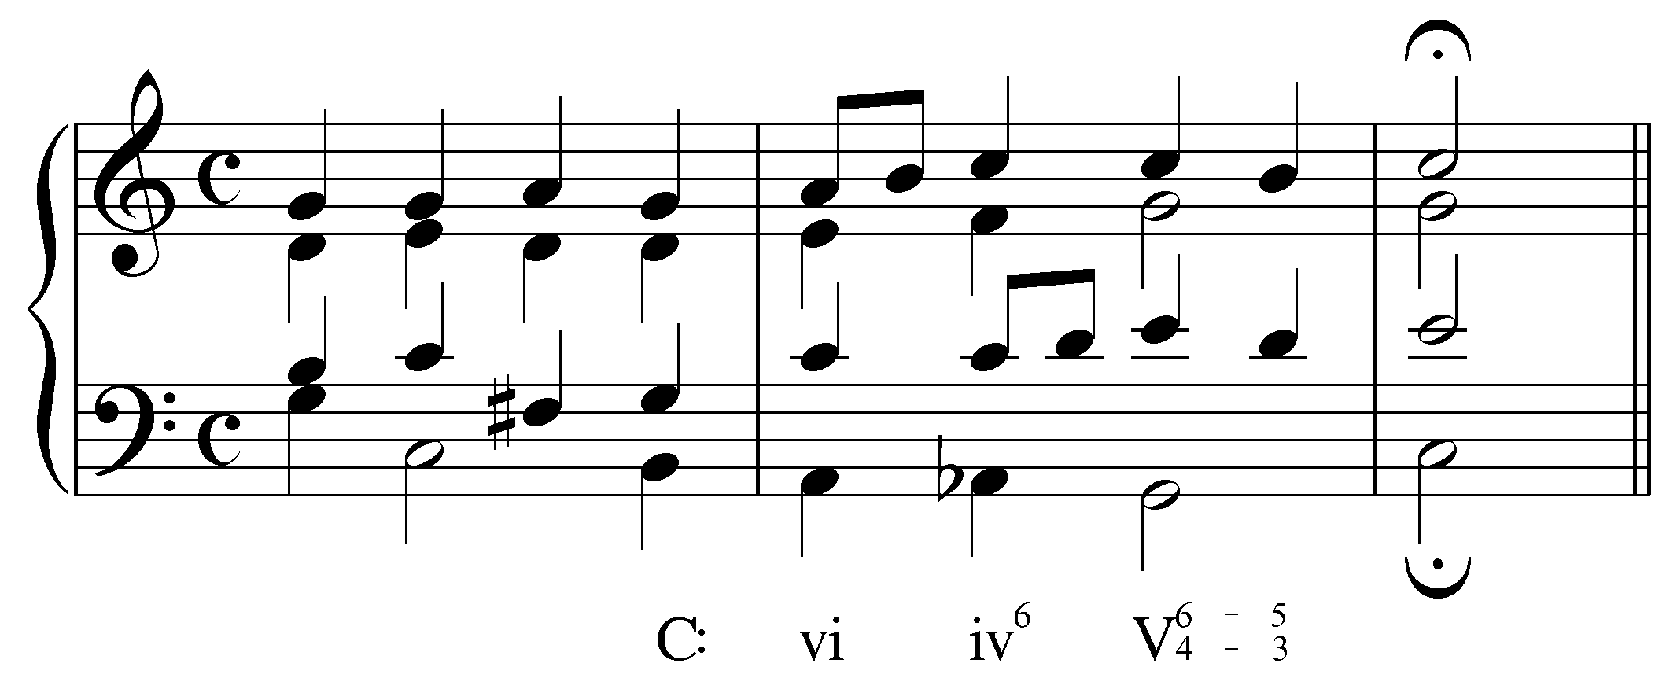

The progression in Example 4 uses b6 (a lowered scale degree 6; Ab in this case), resulting in a minor triad on beat two of the second measure. The Roman numerals are consistent with this change in quality, using “iv” instead of “IV.”

Note: You may have previously encountered a different method of labeling with Roman numerals that uses only capital letters. In this system, accidentals appearing after the Roman numeral indicate alterations made to the third of the chord. According to this system, the mixture chord in Example 4 would be labeled IV⁶b, the “b” indicating the lowered third of the chord. Though this method has merits, it will not be used here. Please refer to Lesson QQQ for a more detailed discussion of advanced Roman numeral usage.

To further accommodate the changes brought about by borrowing from the parallel mode, accidentals are also used in conjunction with Roman numerals. An accidental before a Roman numeral indicates an altered root:

Example 5 (J.S. Bach, BWV 90.5, “Vater unser im Himmelreich,” mm. 9-10):
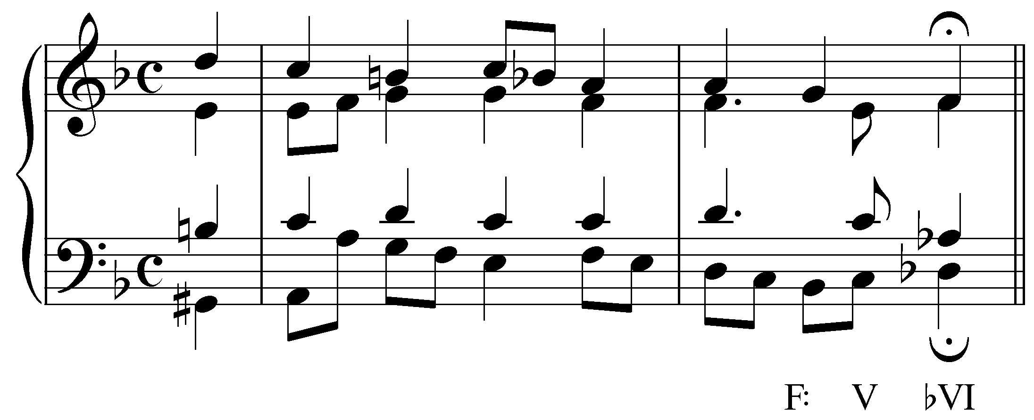

In the example above, the final chord is built on the lowered sixth scale degree (Db). The altered root is indicated by the accidental: bVI.

As usual, accidentals next to figured bass numerals affect the indicated pitches.

Note: Occasionally, a borrowed scale degree will negate one of the sharps or flats in the key signature, as in the following example:

Example 6 (J.S. Bach, BWV 90.5, “Vater unser im Himmelreich,” mm. 9-10; transposed to A major):
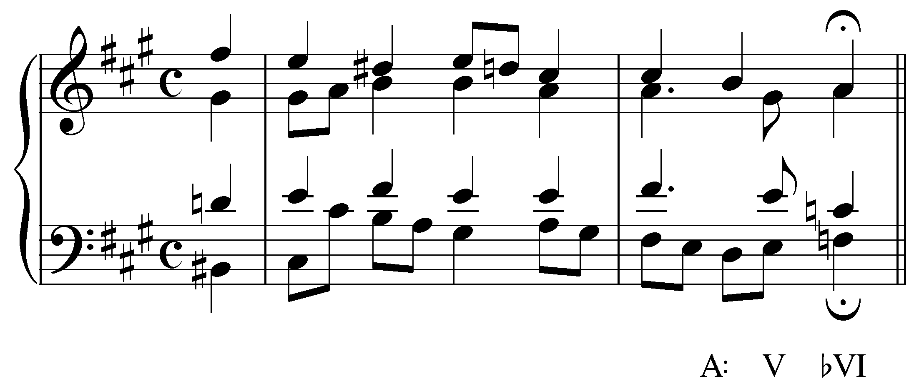

Example 6 ends with a VI chord whose root, F natural, negates the F# in the key signature. Nonetheless, it has still been labeled “bVI.” You may occasionally encounter books that would label this chord “ªVI.” For the sake of clarity and consistency, we will follow this convention: use a flat for a lowered root and a sharp for a raised root, regardless of the key signature.

Activity LLL.02:
Each of the following exercises shows a chord in a given key with at least one borrowed tone. Label each of the chords according to the conventions outlined above. Be sure to use capital letters for major chords, lowercase for minor, and so on. (Note: All of the chords are in root position, so there is no need to indicate the position.)

Exercise LLL.02a
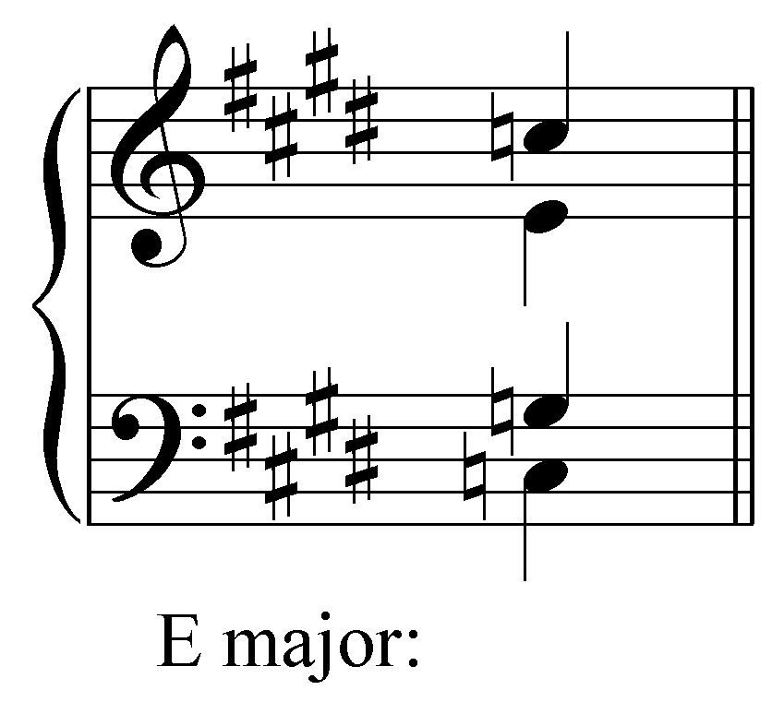
How should this chord be labeled in the key of E major?
[Answer: bVI. Response if correct: “Correct!” Response if incorrect: “Incorrect. Remember to use the correct case for indicating the quality of the chord and to place an accidental before the Roman numeral if the root is altered.”]

Exercise LLL.02b
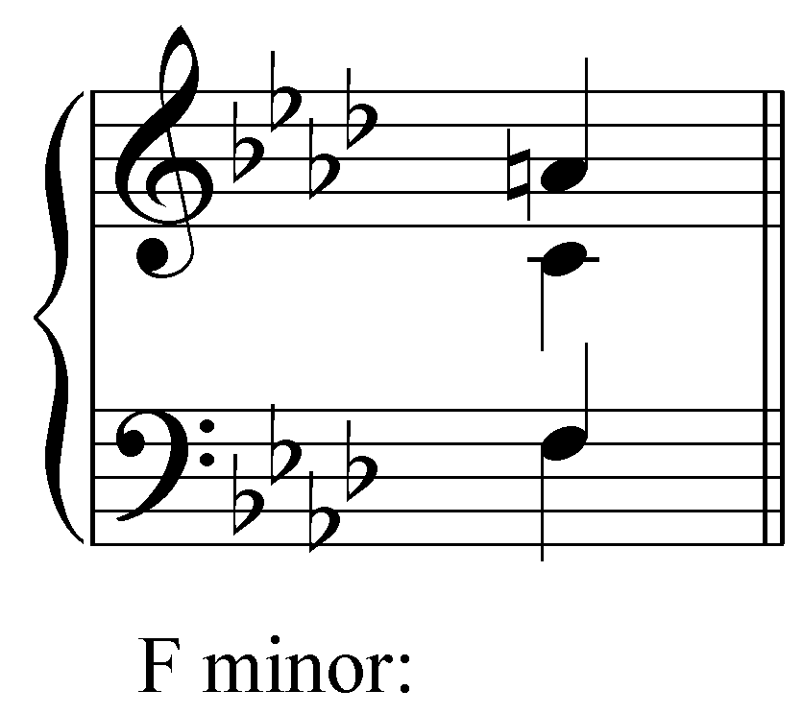
How should this chord be labeled in the key of F minor?
[Answer: I. Response if correct: “Correct!” Response if incorrect: “Incorrect. Remember to use the correct case for indicating the quality of the chord and to place an accidental before the Roman numeral if the root is altered.”]

Exercise LLL.02c
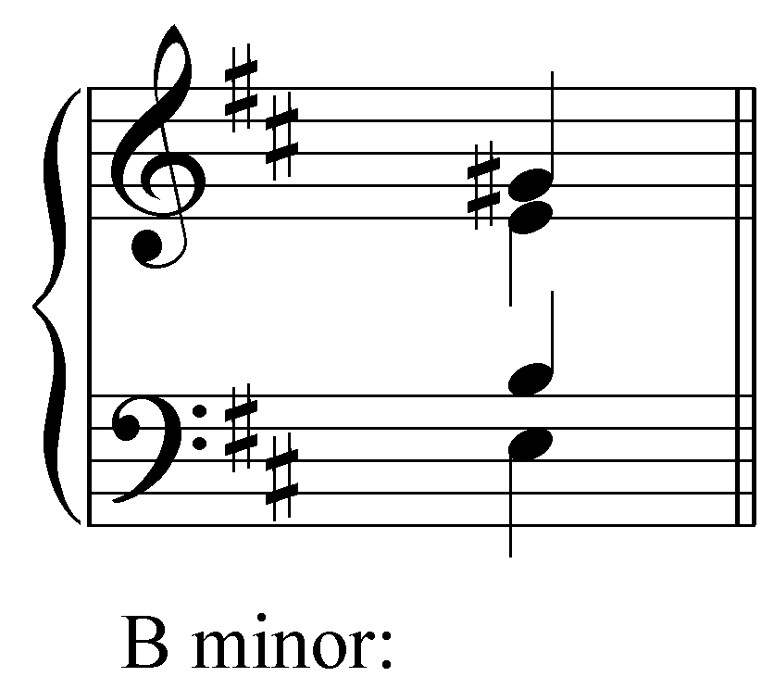
How should this chord be labeled in the key of B minor?
[Answer: IV. Response if correct: “Correct!” Response if incorrect: “Incorrect. Remember to use the correct case for indicating the quality of the chord and to place an accidental before the Roman numeral if the root is altered.”]

Exercise LLL.02d
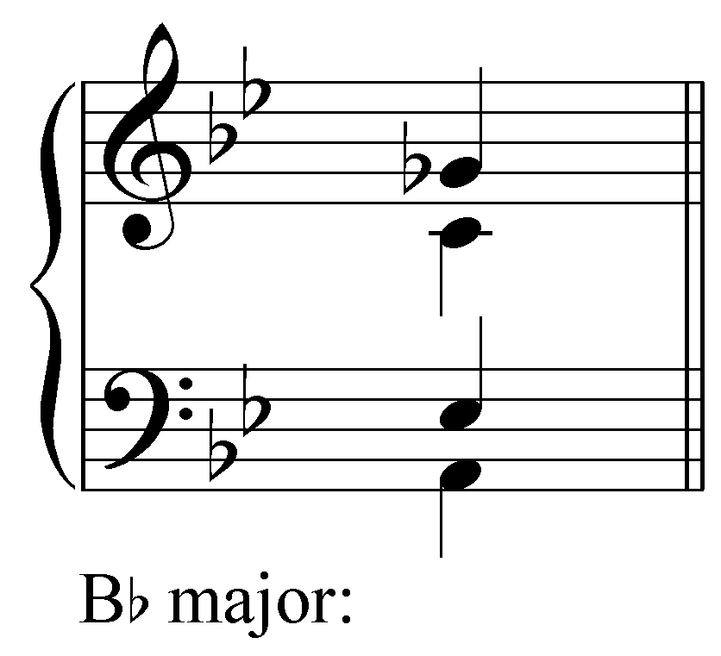
How should this chord be labeled in the key of Bb major?
[Answer: vii^{o7}. Response if correct: “Correct!” Response if incorrect: “Incorrect. Remember to use the correct case for indicating the quality of the chord and to place an accidental before the Roman numeral if the root is altered.”]

Mixture in major keys:

In major keys, instances of mixture usually incorporate b3, b6, or both. (b7 is generally avoided because its presence would subvert the important dominant function of the V and viiº chords.)

A lowered scale degree 6 is used to color and intensify chords built on 2 or 4. The presence of b6 will make a ii chord diminished (iiº) and a IV chord minor (iv) as in the following examples:

Example 7 (J.S. Bach, BWV 281, “Christus, der ist mein Leben,” mm. 7-8):
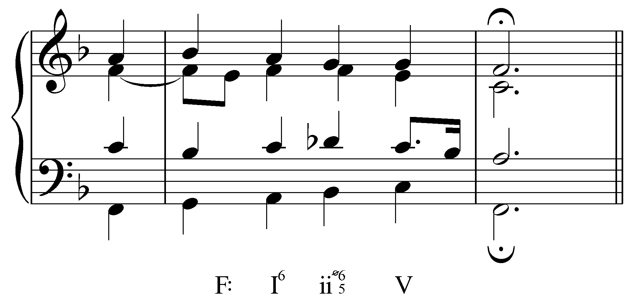

In Example 7, the third beat of m. 7 has a b6 (Db), making the first-inversion ii chord diminished. In this case—and in many similar cases—mixture chords retain the harmonic functions of their unaltered forms. In other words, the adjusted chord in Example 7 has the same pre-dominant function it would have without b6.

Example 8 (F. Chopin, Prelude, Op. 28, no. 9, m. 9):
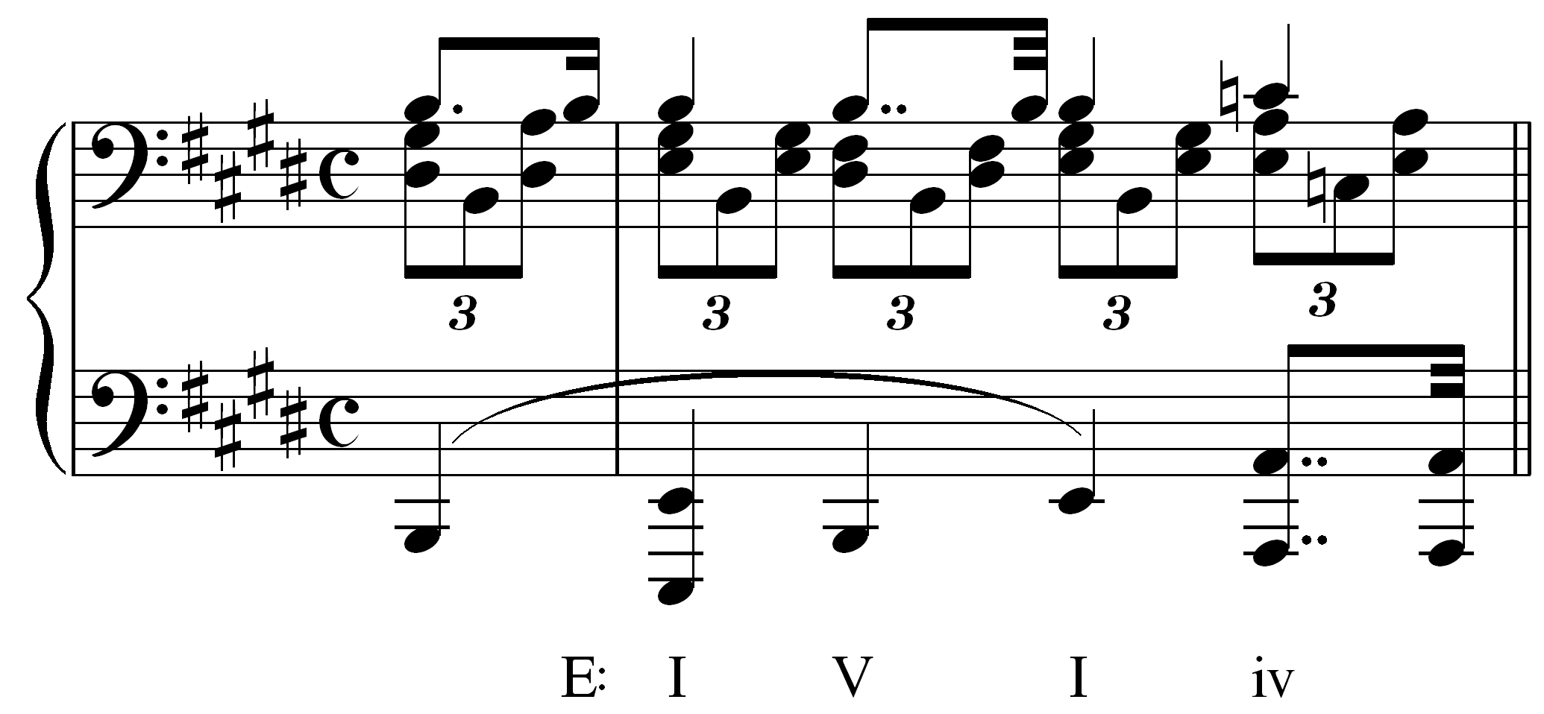

In Example 8, the fourth beat of m. 9 has C naturals in the upper voices, changing the quality of the subdominant chord to minor. Mixture of this sort is abundant in the music of Chopin and other Romantic composers. Though not typical to Bach chorales, it does appear from time to time. Consider the following example where a chromatic passing tone in the bass briefly produces a minor iv chord:

Example 9 (J.S. Bach, BWV 248(3).33, “Warum sollt ich mich denn grämen,” mm. 1-3):
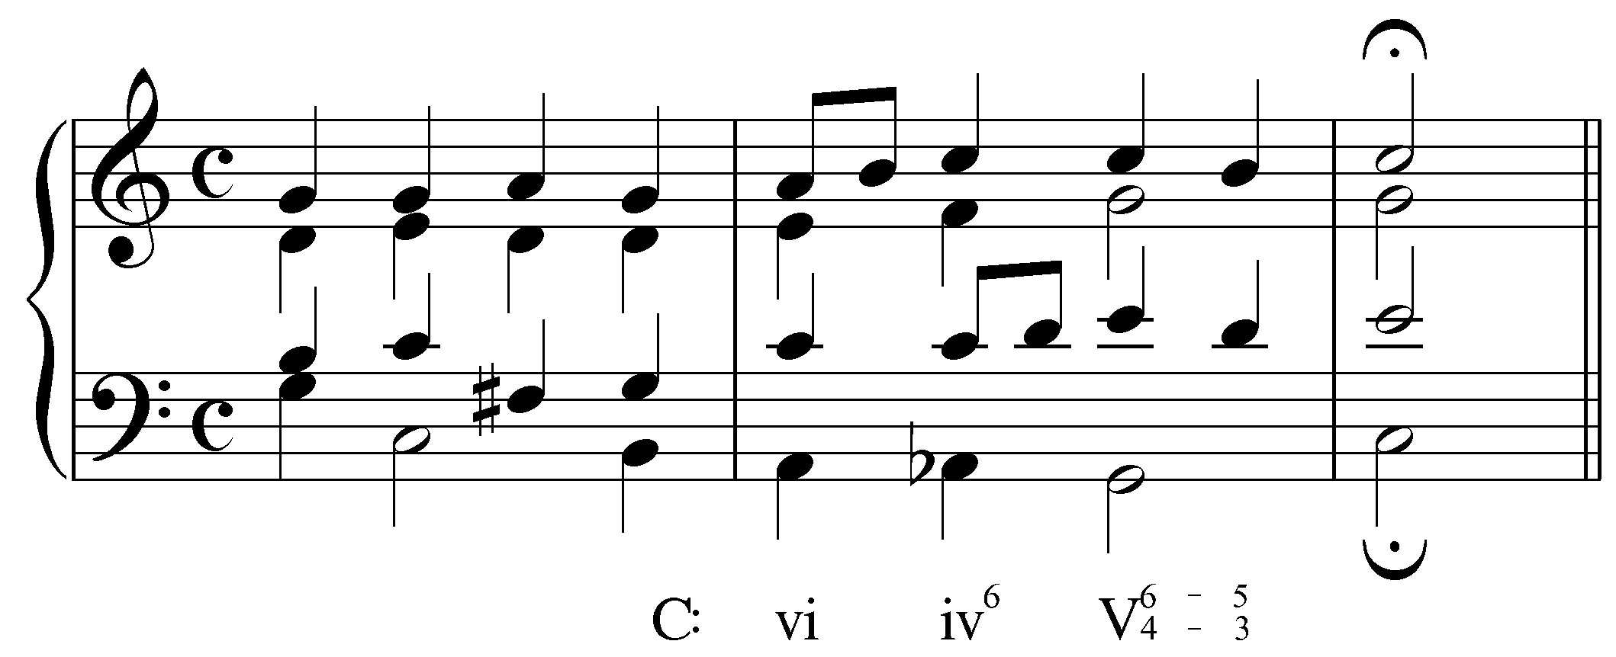

Seventh chords can likewise be affected by mixture. A ii⁷ chord, for example, would become ii^{ø7} with the addition of b6. Borrowing b6 in a seventh chord built on scale degree 7 will change a half-diminished seventh chord to fully-diminished. The following example, from Bach’s Well-Tempered Klavier, borrows an Ab from C minor in m. 14:

Example 10 (J.S. Bach, Prelude and Fugue 1 in C major, BWV 846, mm. 13-15):
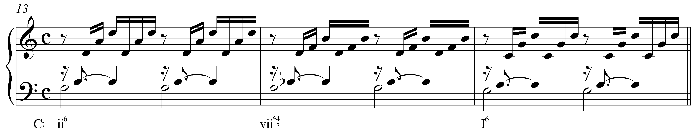

The Ab in m. 14 changes the quality of the leading-tone seventh chord from half- to fully-diminished. (Refer to Lesson PPP for a lengthier discussion of fully-diminished seventh chords.)

A lowered scale degree 3 is sometimes used to produce a minor tonic where one would normally expect a major harmony:

Example 11:
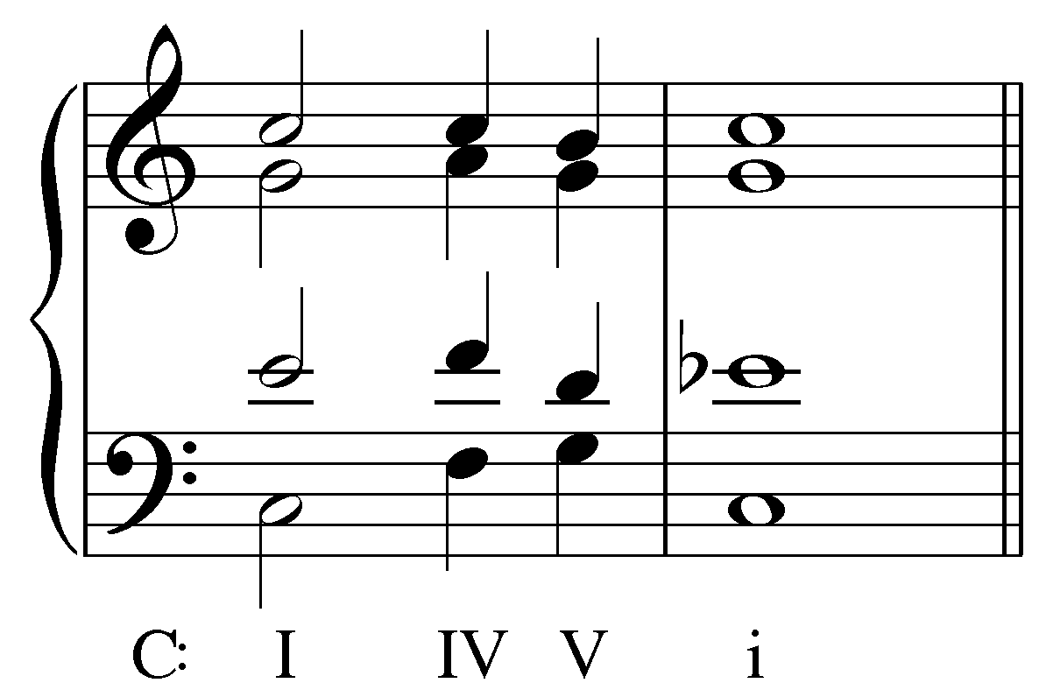

In this example, the concluding tonic harmony is made minor by the presence of Eb, borrowed from the parallel minor. The presence of b3 in a tonic harmony can have a surprising and dramatic effect! Consider the following example:

Example 12 (F. Schubert, Die Schöne Müllerin, No. 4: “Danksagung an den Bach,” mm. 16-24):
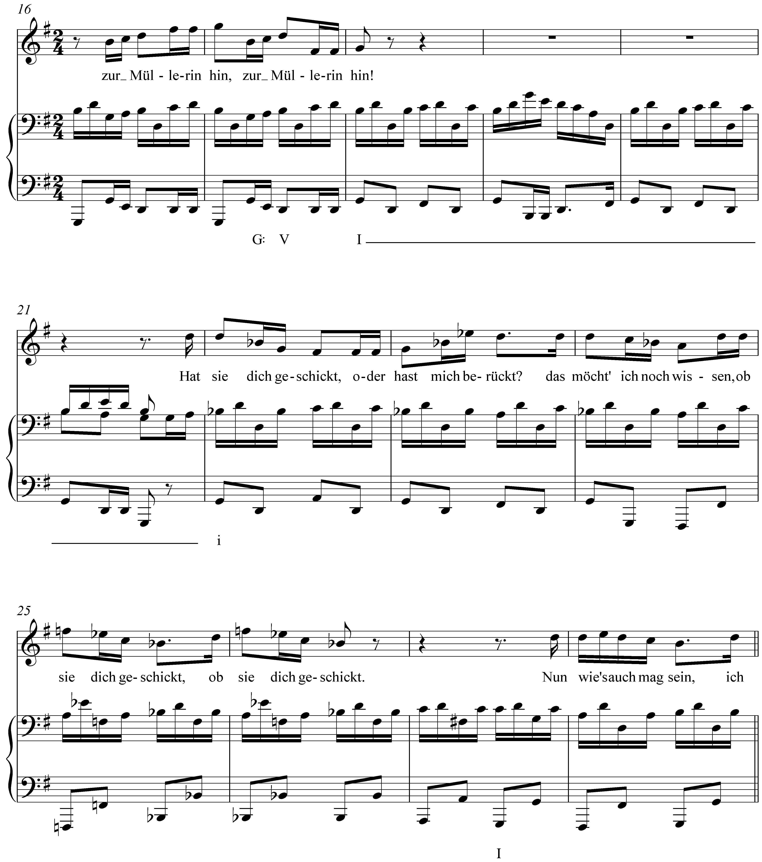

Like Example 1, this Schubert song uses a minor tonic to reflect a change in mood in the song’s text. Following a strong cadence in the key of G major in mm. 17-18, we encounter a minor tonic (i) in m. 22. Again, the effect is startling and intensifies the emotional tension of the moment.

Combining b3 and b6 will result in the bVI chord mentioned above. The bVI chord is one of the most commonly borrowed chords in a major key. When used in a deceptive cadence it increases the dramatic effect by thwarting to an even greater degree the listener’s expectation of tonic harmony. The following example does just this:

Example 13 (J.S. Bach, BWV 90.5, “Vater unser im Himmelreich,” mm. 9-10):
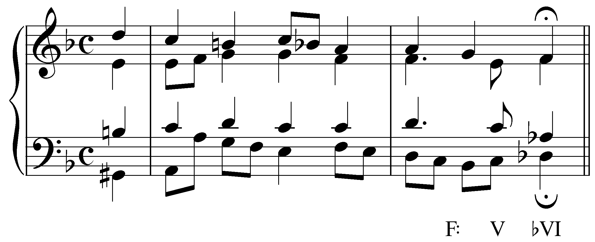

Activity LLL.03:
The ability to recognize and identify instances of mixture is an important skill. In what key is the following excerpt from a Chopin nocturne (Op. 32, no. 2, mm. 1-2)?

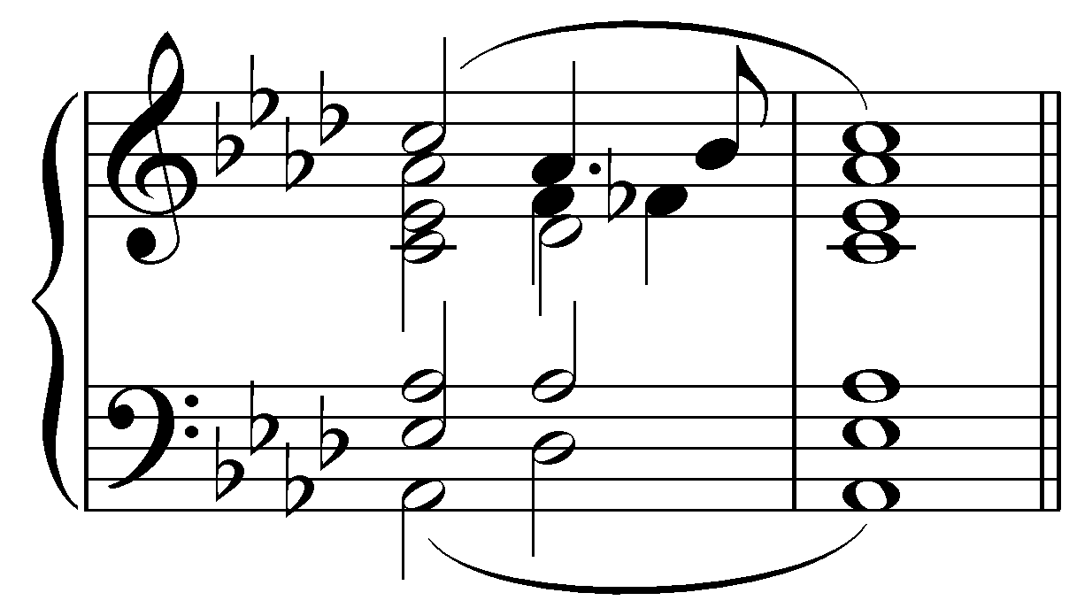

[Answer: Ab major. Response if correct: “Correct!” Response if incorrect: “Incorrect. (Hint: What chord does the excerpt begin and end with?)”]

[Follow-up question:]
What Roman numeral should appear at beat four in the first measure (before the Bb in the uppermost voice)?
[Answer: iv. Response if correct: “Correct!” Response if incorrect: “Incorrect. (Hint: Identify the root of the chord to determine the Roman numeral, then adjust the case accordingly to match the quality.)”]

Mixture in minor keys:

Lesson 3 introduced the concepts of the harmonic and melodic minor composites which feature raised scale degrees 6 and 7. These adjustments can be seen as examples of mixture, where elements of the parallel major are borrowed to suit certain harmonic and melodic contexts. Other than the ubiquitous raising of the leading tone and submediant, mixture is far less common in minor keys than it is in major keys.

Occasionally, composers will incorporate #3 or #6 to lend color to i and iv chords (i becomes I and iv becomes IV with the raising, respectively, of scale degrees 3 and 6). The following example incorporates one such borrowed scale degree in m. 3:

Example 14 (J.S. Bach, BWV 87.7, “Jesu, meine Freude,” mm. 3-4):
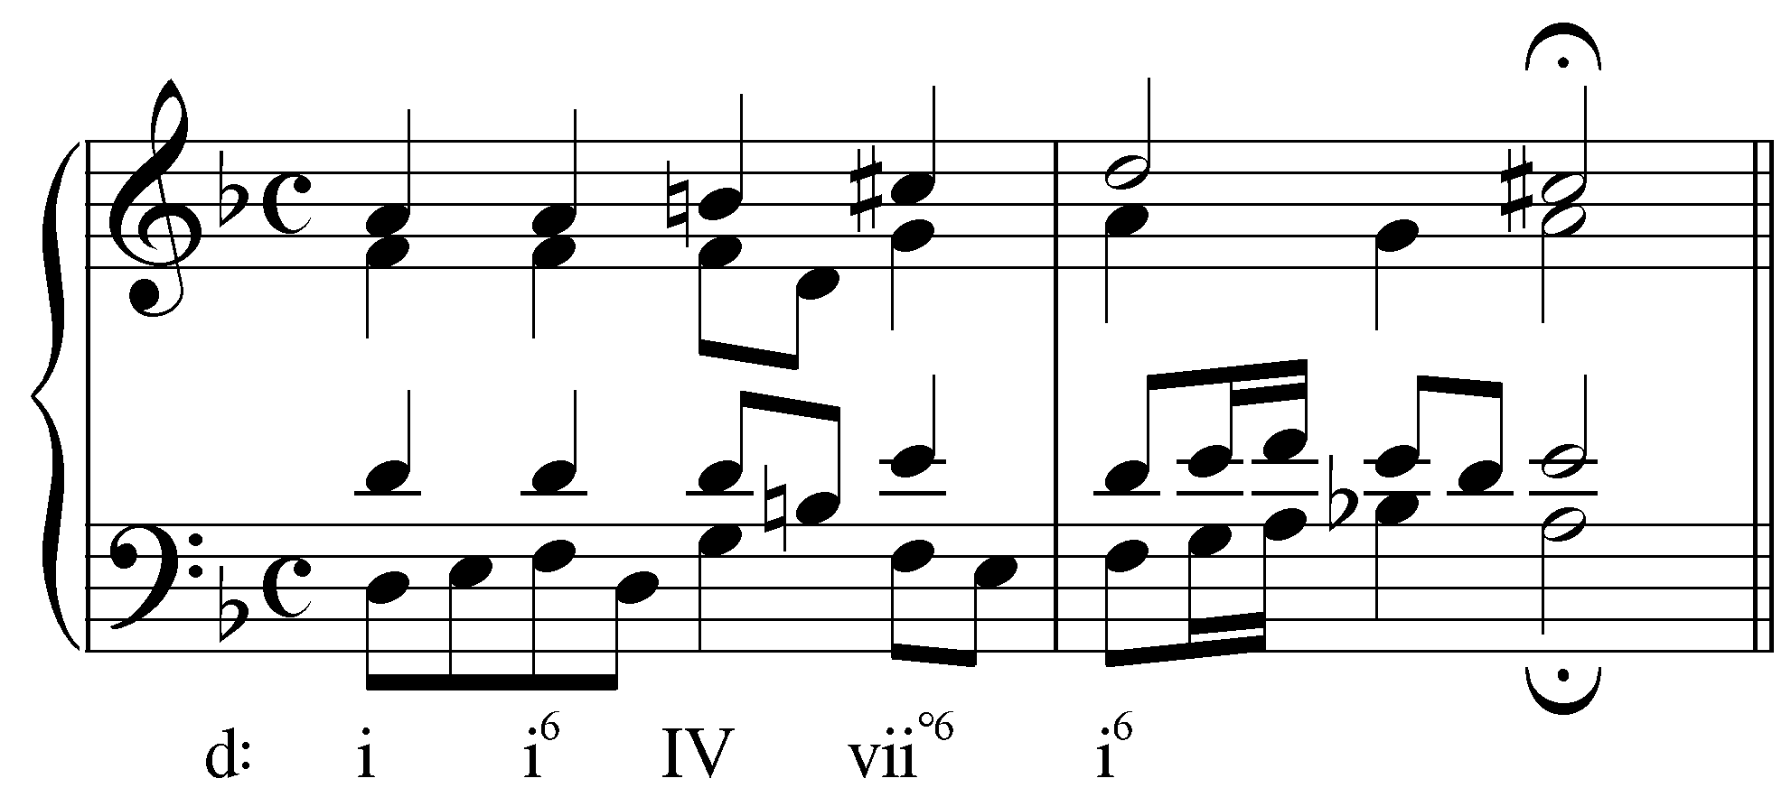

In this example, the chord on the third beat has a B natural in the soprano and then in the tenor. This raised third (scale degree 6) changes the quality of the chord to major (IV). (The C# in the following vii^{o6} chord is an example of mixture via the harmonic minor composite.)

The following example uses a borrowed scale degree in the final chord:

Example 15 (J.S.Bach, BWV 81.7, “Jesu, meine Freude,” mm. 12-13):
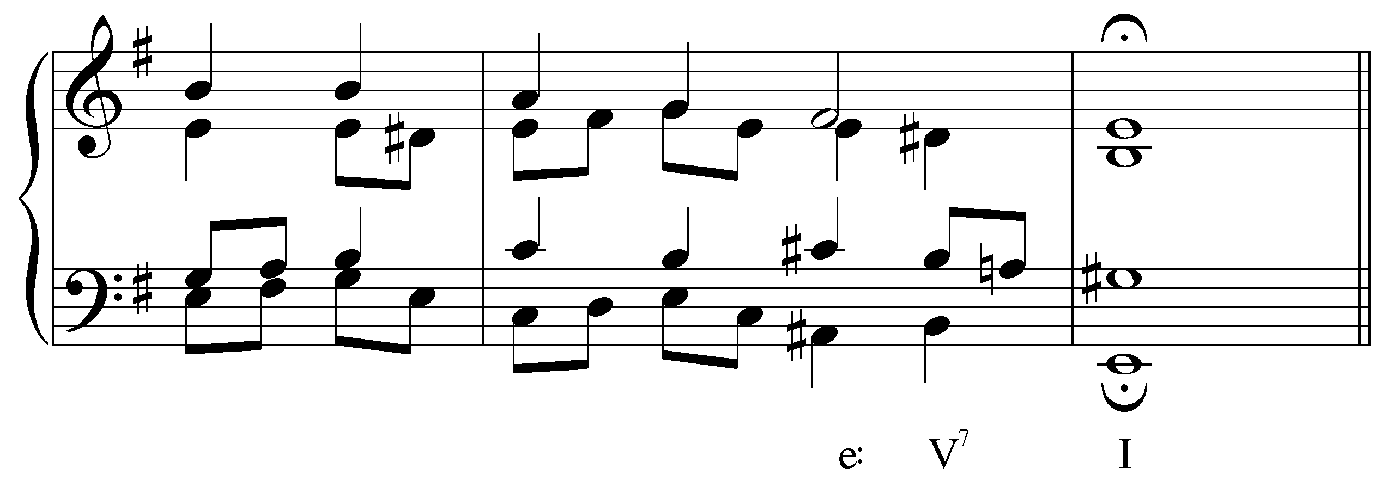

The G# in the final chord of this example makes the tonic major. The raised third of a tonic chord in a minor key is usually referred to as a Picardy third. Composers will commonly employ a Picardy third at the end of a piece in minor, coloring the conclusion with character of a major tonic.

Activity LLL.04:
In what key is the following excerpt from a Bach chorale (BWV 352, „Wachet doch, erwacht, ihr Schläfer,“ mm. 15-16)?

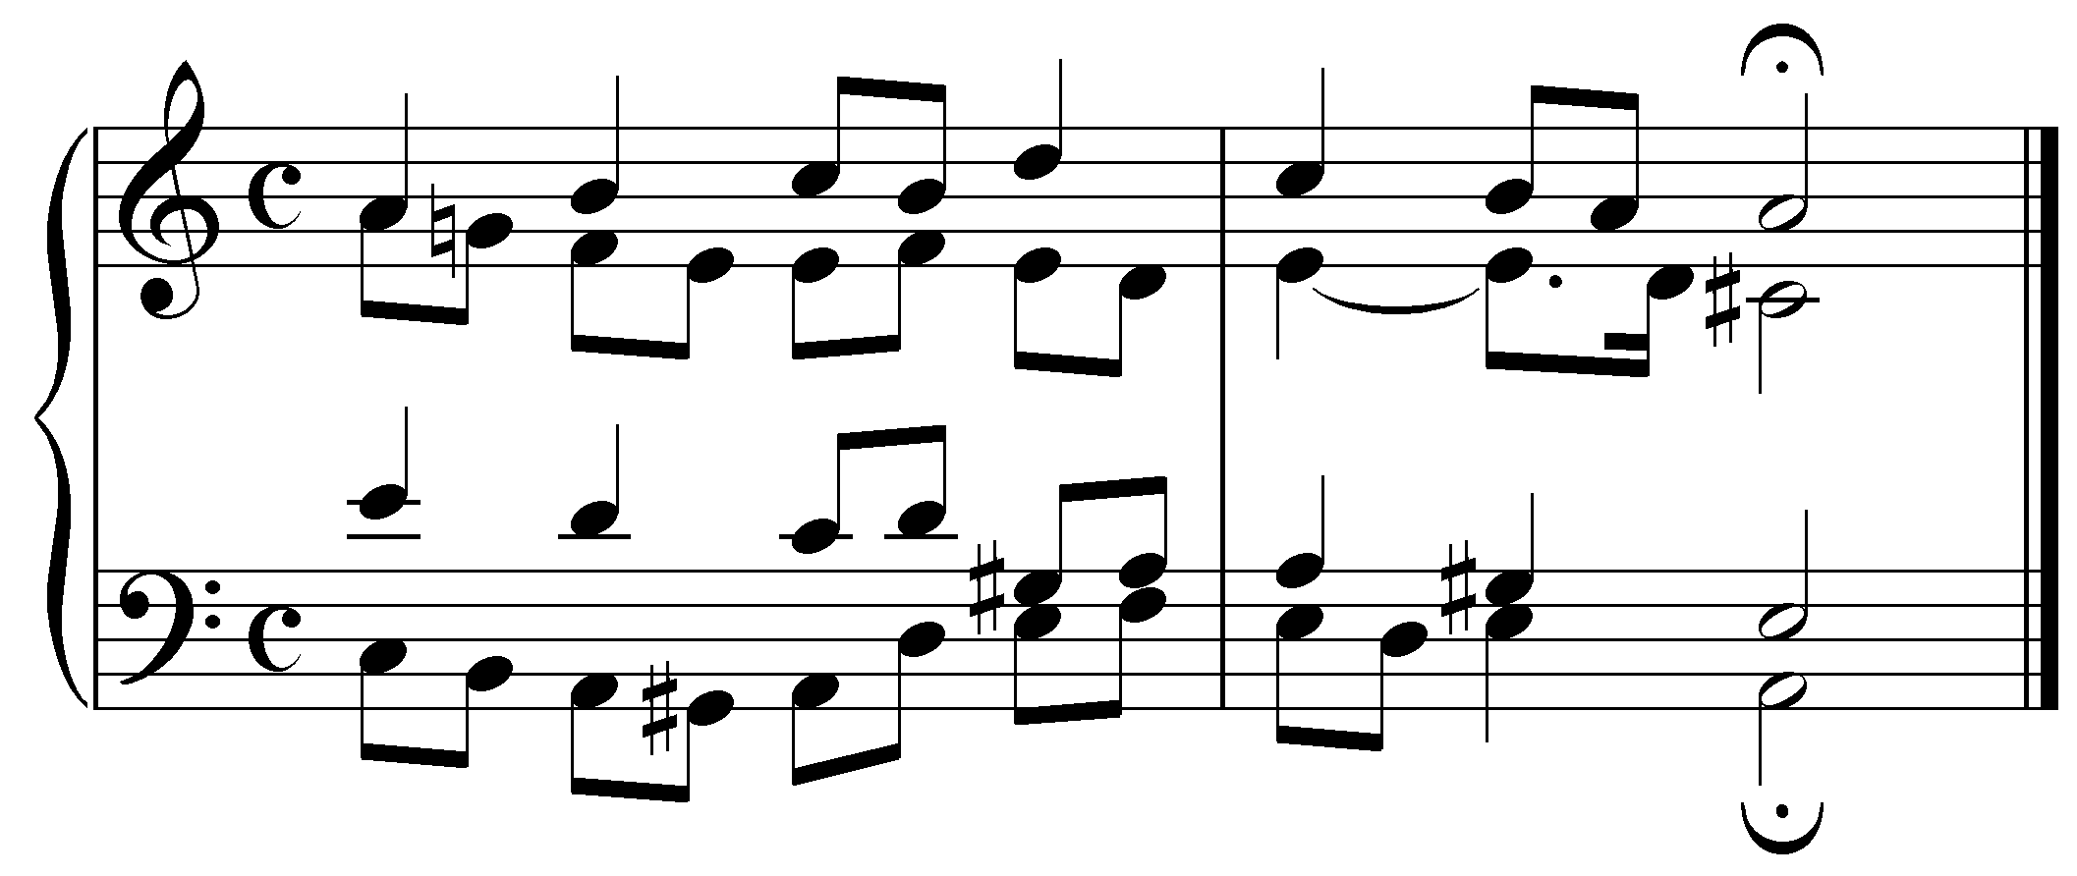

[Answer: A minor. Response if correct: “Correct!” Response if incorrect: “Incorrect. Try again.”]

[Follow-up question:]
What Roman numeral should appear under the final harmony (the chord with the fermata)?
[Answer: I. Response if correct: “Correct!” Response if incorrect: “Incorrect. (Hint: Identify the root of the chord to determine the Roman numeral, then adjust the case accordingly to match the quality.)”]

[Follow-up question:]
What is the common name for this particular kind of mixture?
[Answer: “Picardy third” or “Picardy 3rd” or “Picardy.” Response if correct: “Correct!” Response if incorrect: “Incorrect. Try again.”]

Mixture and basic interval progressions:

Instances of mixture are often the result of adjustments made to the basic interval progressions outlined in Lesson 1. In all of the harmonic progressions considered in this lesson, the voiceleading is governed by the same basic interval progressions whether mixture is present or not. In some cases, however, mixture strengthens the underlying interval progressions.

The motion from a major third to a unison is intensified by altering one of the voices to introduce semitone motion:

Example 16:
a. b.
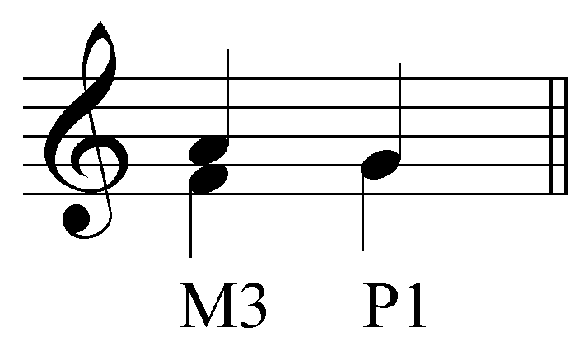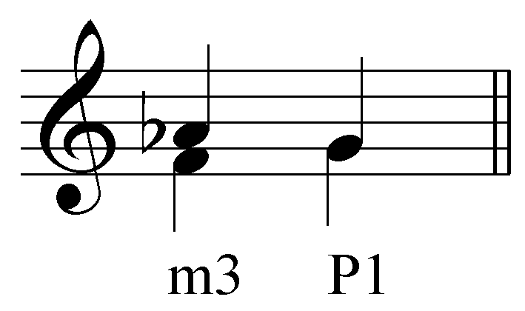

The following example puts this into context in a Bach chorale:

Example 17 (J.S. Bach, BWV 281, “Christus, der ist mein Leben,” mm. 7-8):
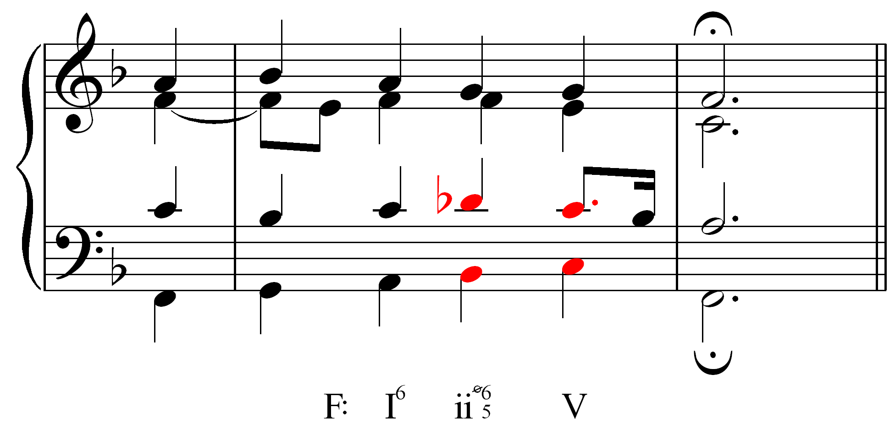

Whereas typically the motion from a major third to a unison consists of both voices moving by wholetones, moving from a minor third to a unison reduces one voice’s movement to a semitone. The result is similar to the strong semitone/wholetone motion of a major sixth to an octave. Similarly, the motion from a major sixth to a perfect fifth is made stronger by contracting the upper-voice motion to a semitone:

Example 18:
a. b.
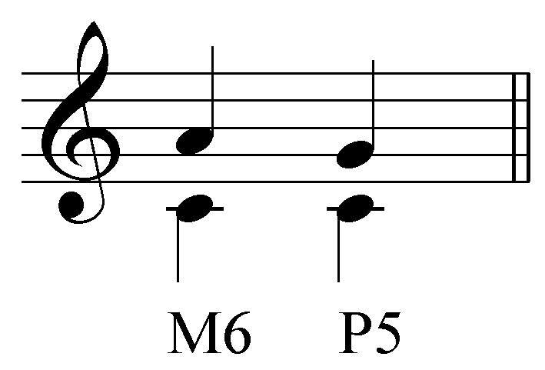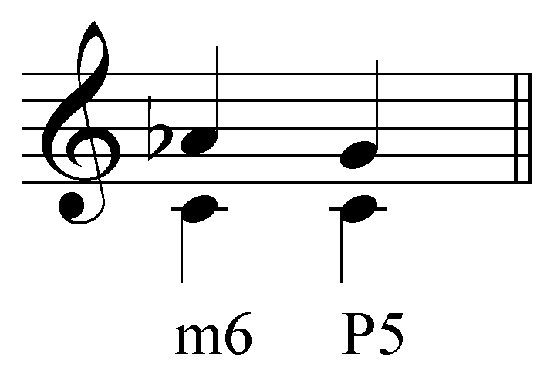

The following example puts this adjustment into context (Example 19b provides a reduction of Example 19a to clarify the voiceleading):

Example 19 (J. Brahms, “Wie Melodien Zieht es mir, ” Op. 105, no. 1, mm 25-28):

a.
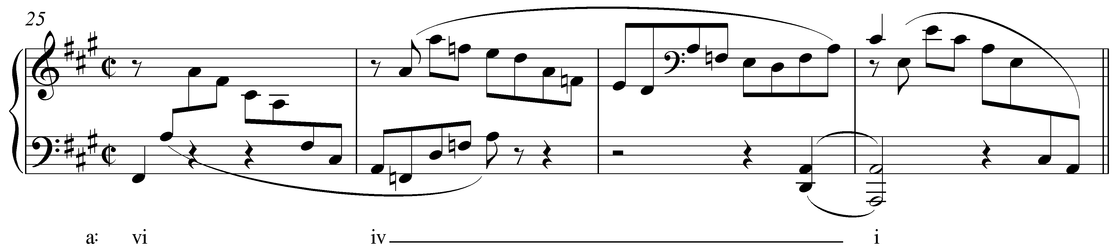

b.
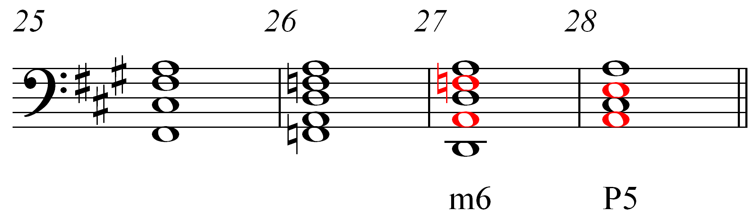

By lowering the F# to F natural, Brahms strengthens the motion to the tonic triad from m. 26 to m. 28.

Activity LLL.05:
Instances of mixture are often the result of adjustments made to underlying basic interval progressions. In the following excerpt from a Bach chorale (BWV 281, “Christus, der ist mein Leben,” mm.7-8), fill in the blanks for the intervals found between the tenor and bass (be sure to specify the quality of the intervals):

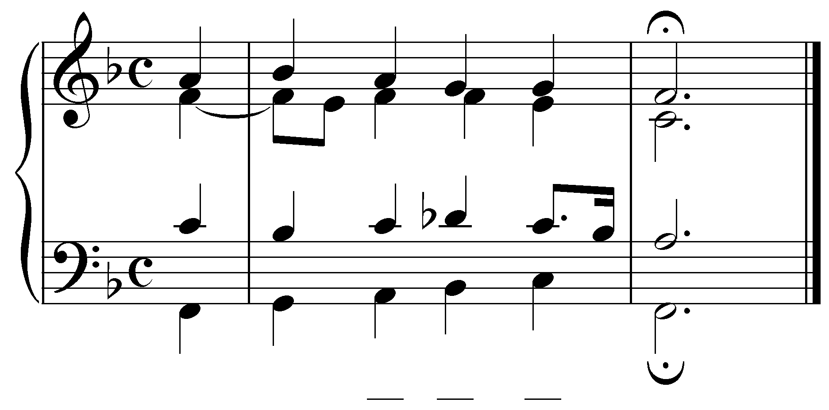
[Answers: m3, m3, P1 (P8). Response for each correct answer: “Correct!” Response for each incorrect answer: “Incorrect. Try again.”]

[Follow-up question:]
By lowering scale degree 6, Bach intensifies the voiceleading. The lowered scale degree also affects the quality of the chord. What Roman numeral should appear at beat three in m. 7?
[Answer: iiØ65. Response if correct: “Correct!” Response if incorrect: “Incorrect. Try again.”]

While mixture often results from such voiceleading, it need not always. Sometimes, mixture is used strictly for purposes of coloration. Consider the following example from Mozart:

Example 20 (W.A. Mozart, Piano Sonata in F, K. 332/ii, mm. 1-8):
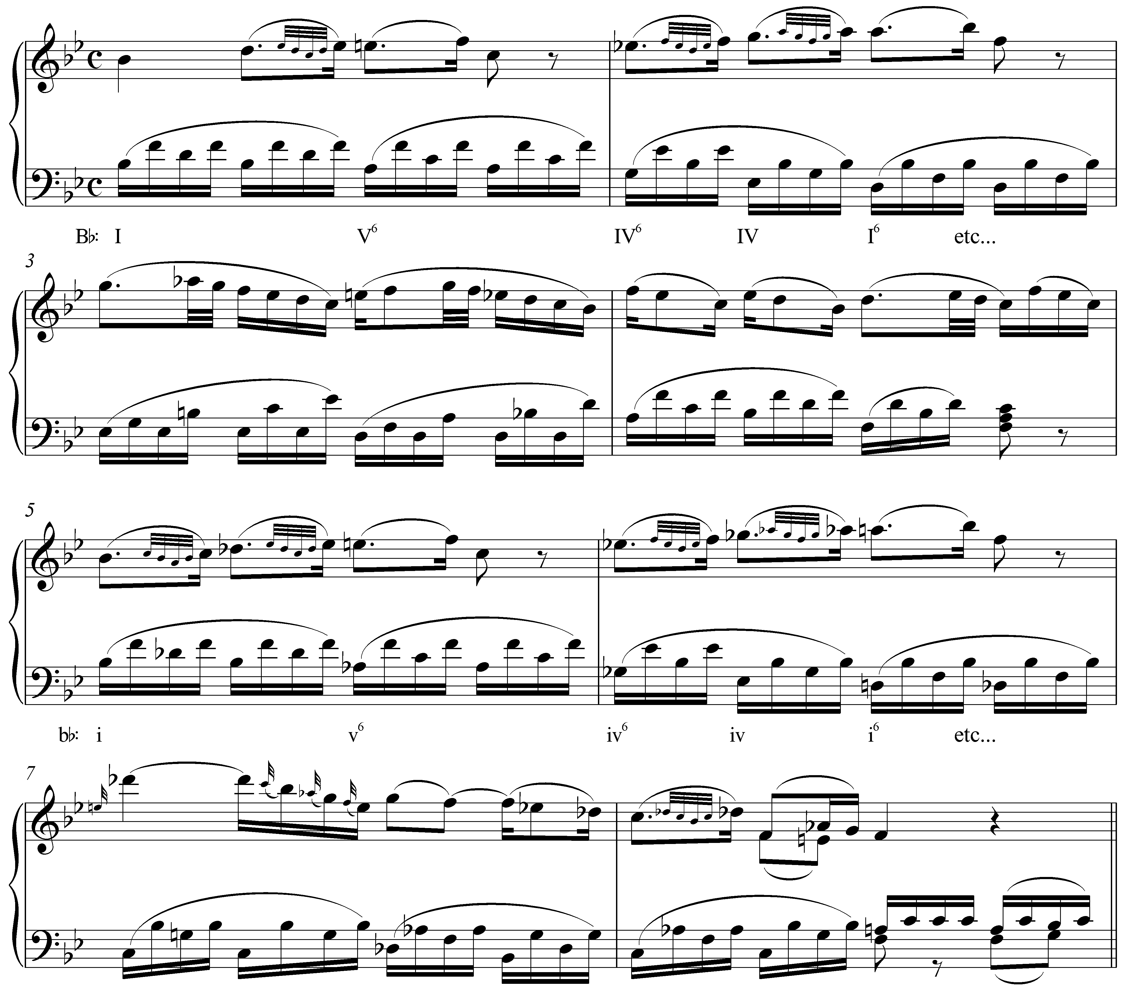

In this beginning to a piano sonata movement, Mozart first presents a melody in Bb major. He then repeats the melody in mm. 5-8, this time in Bb minor to heighten the expressiveness of the music.

Secondary mixture, double mixture, and other chromatic chords:

All of the examples of mixture presented so far have been relatively straightforward. In each case, one or two tones are borrowed from the parallel key to emphasize or intensify certain harmonies. Occasionally, however, you will encounter instances of mixture that cannot be explained in such simple terms.

Example 21 (F. Schubert, Piano Sonata in D major, D. 850, Trio, mm. 53-61):
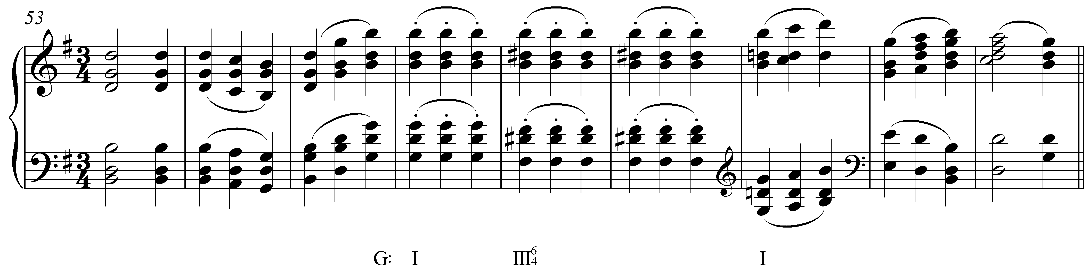

The major III chord in m. 57 is not a case of simple mixture since D# (#5), as well as the associated triad, B major, is not drawn from the parallel minor key (G minor). This type of alteration, where a chord’s third is modified by an accidental that is not borrowed from the parallel key, is sometimes referred to as secondary mixture. Like regular mixture, the quality of the chord in question is changed, but not through borrowing of tones from the parallel key. In Example 21, scale degree 5 soon reverts back to D natural (m. 59). Similar alterations of chords built on scale degree 6 also appear from time to time and become common in late nineteenth-century music.

Now consider the following example from a Schubert song:

Example 22 (F. Schubert, “"Die Liebe hat gelogen” D. 751, mm 3-6):
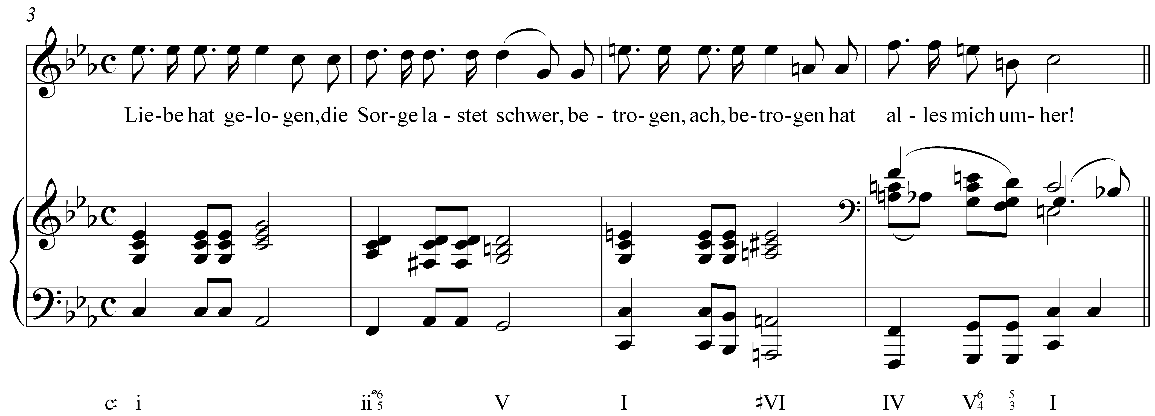

This passage begins in C minor. At the beginning of m. 5 we find a clear-cut case of mixture: the E naturals in both the voice and the piano change the quality of the tonic triad from minor to major, and C major is then tonicized with an authentic cadence in m. 6. However, in the second half of m. 5, we find an A major triad (#VI). With respect to C minor, all three members of that triad have been raised. This is not a case of simple mixture because C major, the parallel to C minor, does not include C#. Rather, this is a case of double mixture. Double mixture involves changing the quality of a chord derived from simple mixture. In the key of C minor, simple mixture allows for an A-minor triad (#vi). Instead we encounter A major (#VI): a case of secondary mixture upon simple mixture, hence double mixture.

Activity LLL.06:
The following triads exhibit various types of mixture: simple (borrows tones from the parallel key), secondary (alters the quality with pitches not from the parallel key), or double (secondary mixture applied to chords derived through simple mixture). For each exercise, label the triad with the appropriate Roman numeral and identify the type of mixture present:

Exercise LLL.06a
Provide a Roman numeral for the following triad in G major:
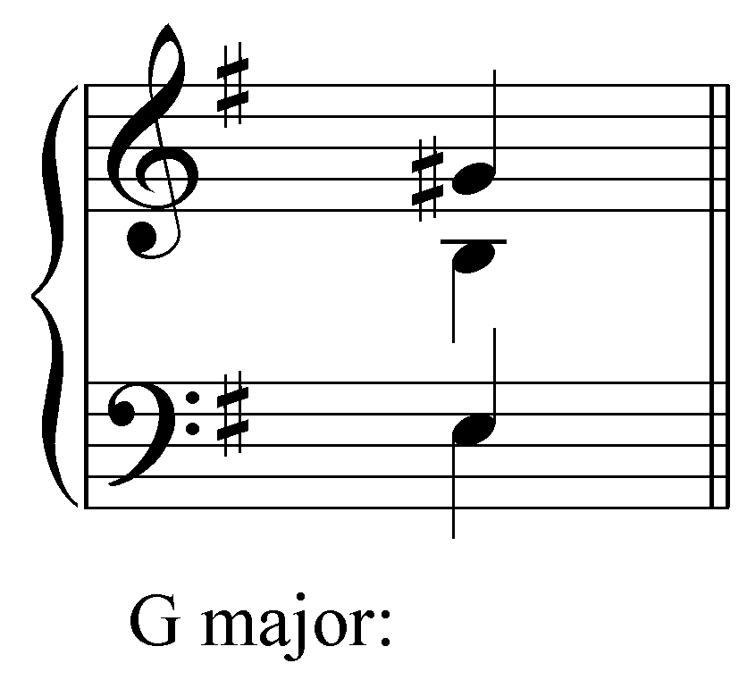
[Answer: VI. Response if correct: “Correct!” Response if incorrect: “Incorrect. Remember to match the case of the Roman numerals with the quality of the triad and indicate altered roots with accidentals.”]

[Follow-up multiple-choice question:]
What type of mixture is exhibited by this triad?
[Choices: “simple”, “secondary”, “double”.]
[Answer: secondary. Response if correct: “Correct!” Response if incorrect: “Incorrect. Try again.”]

Exercise LLL.06b
Provide a Roman numeral for the following triad in D minor:
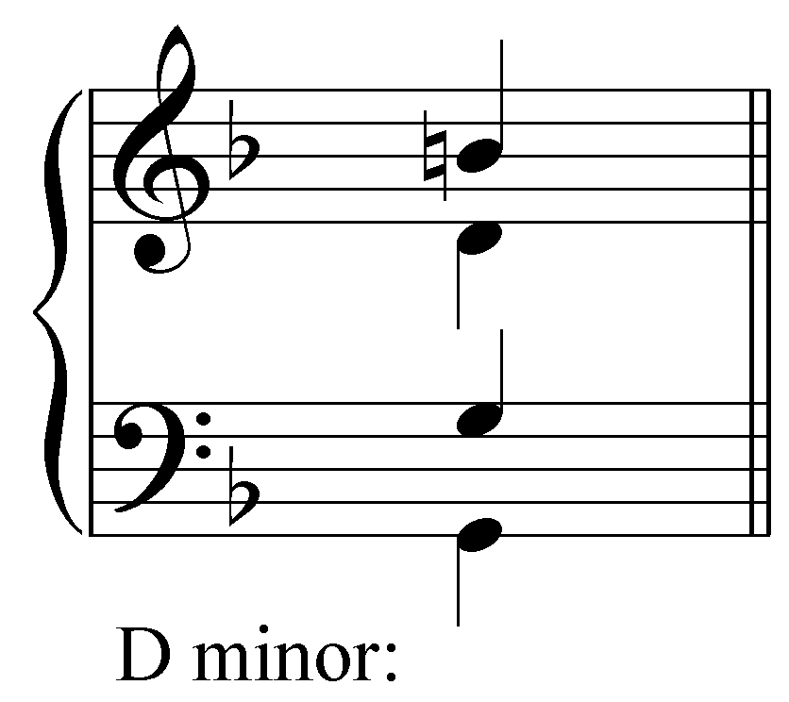

[Answer: IV. Response if correct: “Correct!” Response if incorrect: “Incorrect. Remember to match the case of the Roman numerals with the quality of the triad and indicate altered roots with accidentals.”]

[Follow-up multiple-choice question:]
What type of mixture is exhibited by this triad?
[Choices: “simple”, “secondary”, “double”.]
[Answer: simple. Response if correct: “Correct!” Response if incorrect: “Incorrect. Try again.”]

Exercise LLL.06c
Provide a Roman numeral for the following triad in B minor:
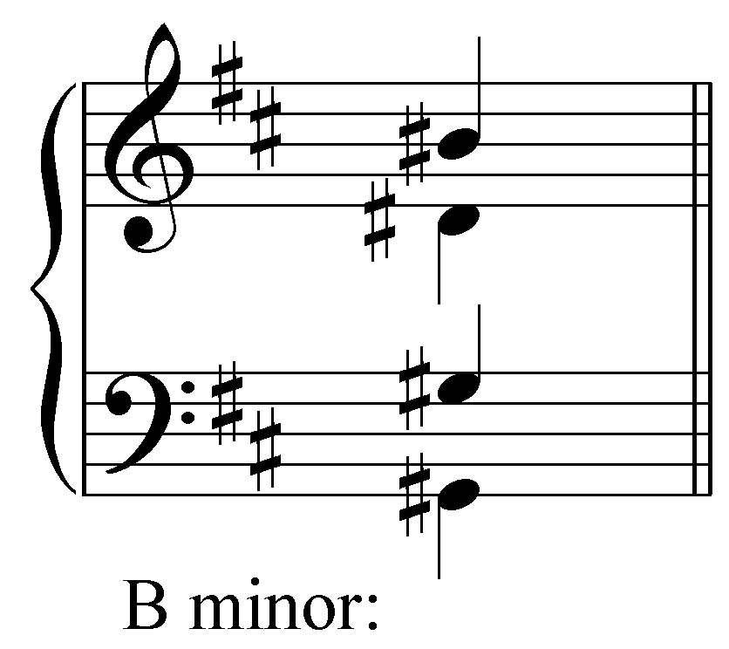
[Answer: #VI. Response if correct: “Correct!” Response if incorrect: “Incorrect. Remember to match the case of the Roman numerals with the quality of the triad and indicate altered roots with accidentals.”]

[Follow-up multiple-choice question:]
What type of mixture is exhibited by this triad?
[Choices: “simple”, “secondary”, “double”.]
[Answer: double. Response if correct: “Correct!” Response if incorrect: “Incorrect. Try again.”]

Exercise LLL.06d
Provide a Roman numeral for the following triad in Bb major:
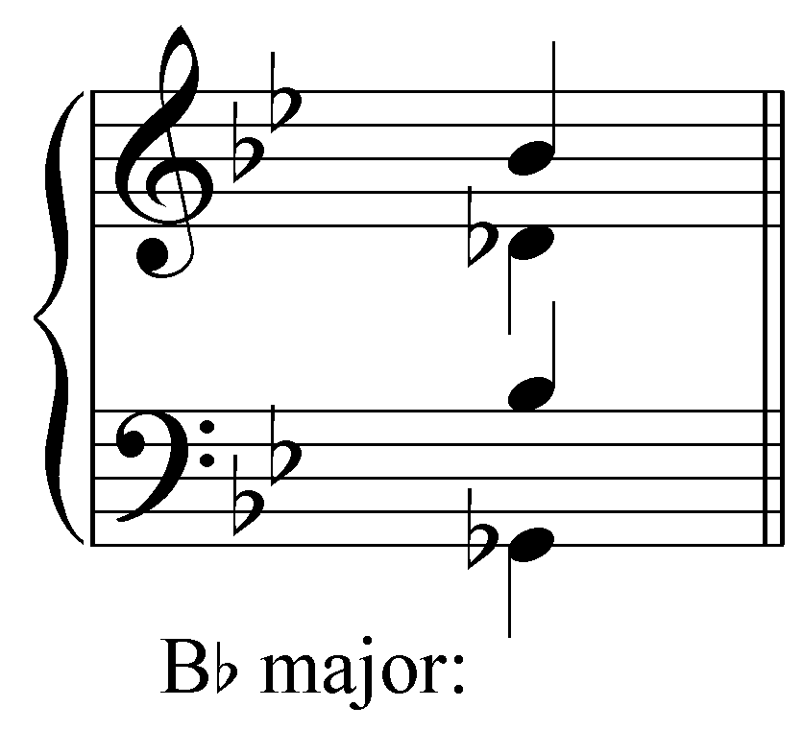
[Answer: bVI. Response if correct: “Correct!” Response if incorrect: “Incorrect. Remember to match the case of the Roman numerals with the quality of the triad and indicate altered roots with accidentals.”]

[Follow-up multiple-choice question:]
What type of mixture is exhibited by this triad?
[Choices: “simple”, “secondary”, “double”.]
[Answer: simple. Response if correct: “Correct!” Response if incorrect: “Incorrect. Try again.”]

Exercise LLL.06e
Provide a Roman numeral for the following triad in A major:
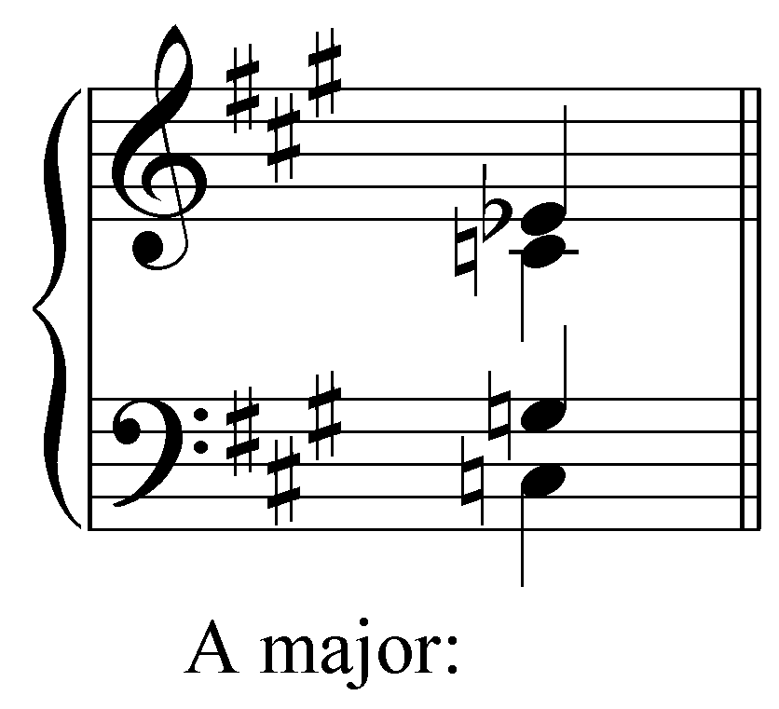
[Answer: biii. Response if correct: “Correct!” Response if incorrect: “Incorrect. Remember to match the case of the Roman numerals with the quality of the triad and indicate altered roots with accidentals.”]

[Follow-up multiple-choice question:]
What type of mixture is exhibited by this triad?
[Choices: “simple”, “secondary”, “double”.]
[Answer: double. Response if correct: “Correct!” Response if incorrect: “Incorrect. Try again.”]

Exercise LLL.06f
Provide a Roman numeral for the following triad Eb major:
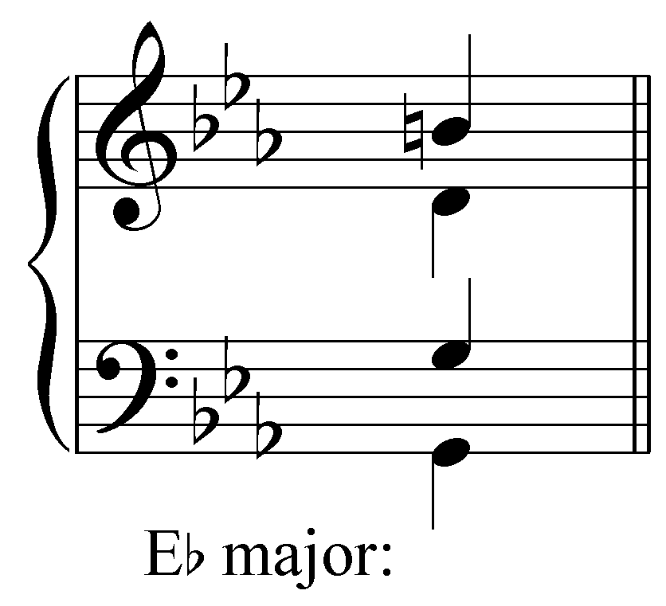
[Answer: III. Response if correct: “Correct!” Response if incorrect: “Incorrect. Remember to match the case of the Roman numerals with the quality of the triad and indicate altered roots with accidentals.”]

[Follow-up multiple-choice question:]
What type of mixture is exhibited by this triad?
[Choices: “simple”, “secondary”, “double”.]
[Answer: secondary. Response if correct: “Correct!” Response if incorrect: “Incorrect. Try again.”]

A different type of chromatic chord can be seen in Example 23:

Example 23 (L. Beethoven, Sonata in C# minor (“Moonlight”), Op. 27, no. 2, mm. 1-5):

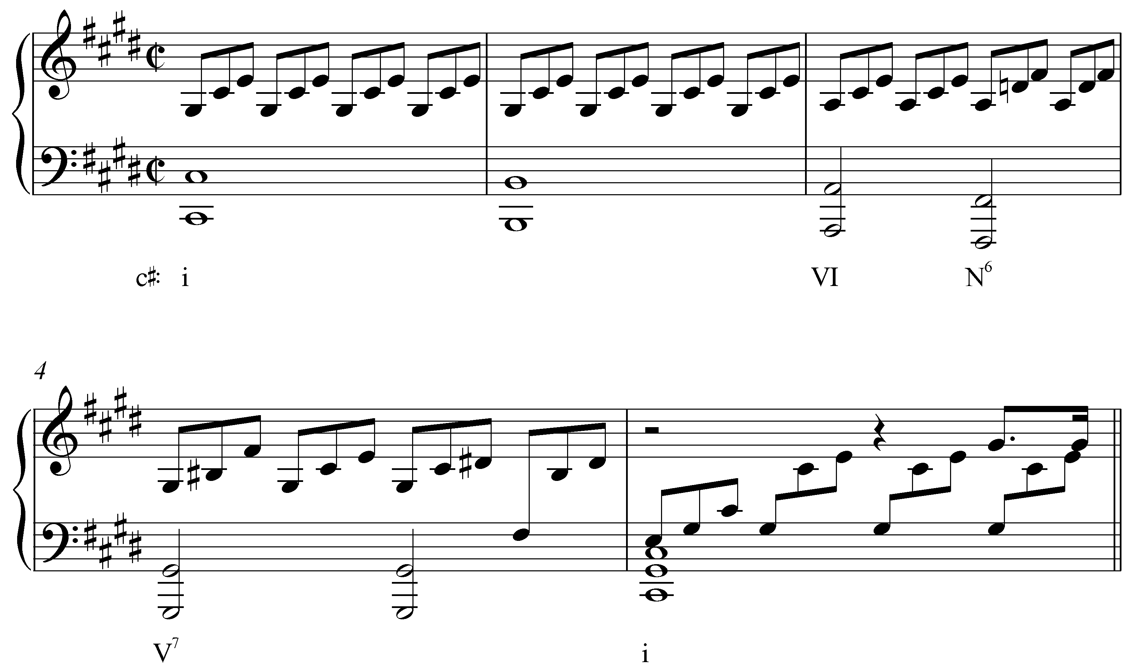

Following a prolonged tonic chord (with passing Bs in the bass), the harmony moves to VI and then a chord with a lowered scale degree 2 (labeled “N⁶”) before moving to the dominant. Obviously, this is not a typical case of a borrowed chord since D natural appears in neither C# major nor C# minor. Furthermore, there is no such thing as a major diatonic II chord.

This particular sonority nonetheless appears quite frequently. It is commonly referred to as a Neapolitan chord and typically appears with scale degree 4 in the bass. It is a derived chord that can arise in different ways, so we label it “N⁶” to avoid the confusion of Roman numerals. Though not a case of mixture in the purest sense of the word, Neapolitan chords are often grouped with borrowed chords for this similarity in behavior. (A more detailed discussion of the Neapolitan chord can be found in Lesson MMM.)

Mixture and modulation:

Most of the examples we have looked at so far are relatively small in scale. Composers borrow specific tones from the parallel key to color a chord here or there and thus dramatize the passage. But mixture can affect larger areas of music as well, particularly with regards to modulation. This is evident in Example 12, where an abrupt minor i chord is tonicized for several measures.

Mixture can also initiate a modulation directly, as it does in the following example:

Example 24 (W.A. Mozart, Piano Sonata in C, K. 330/ii, mm. 1-28):
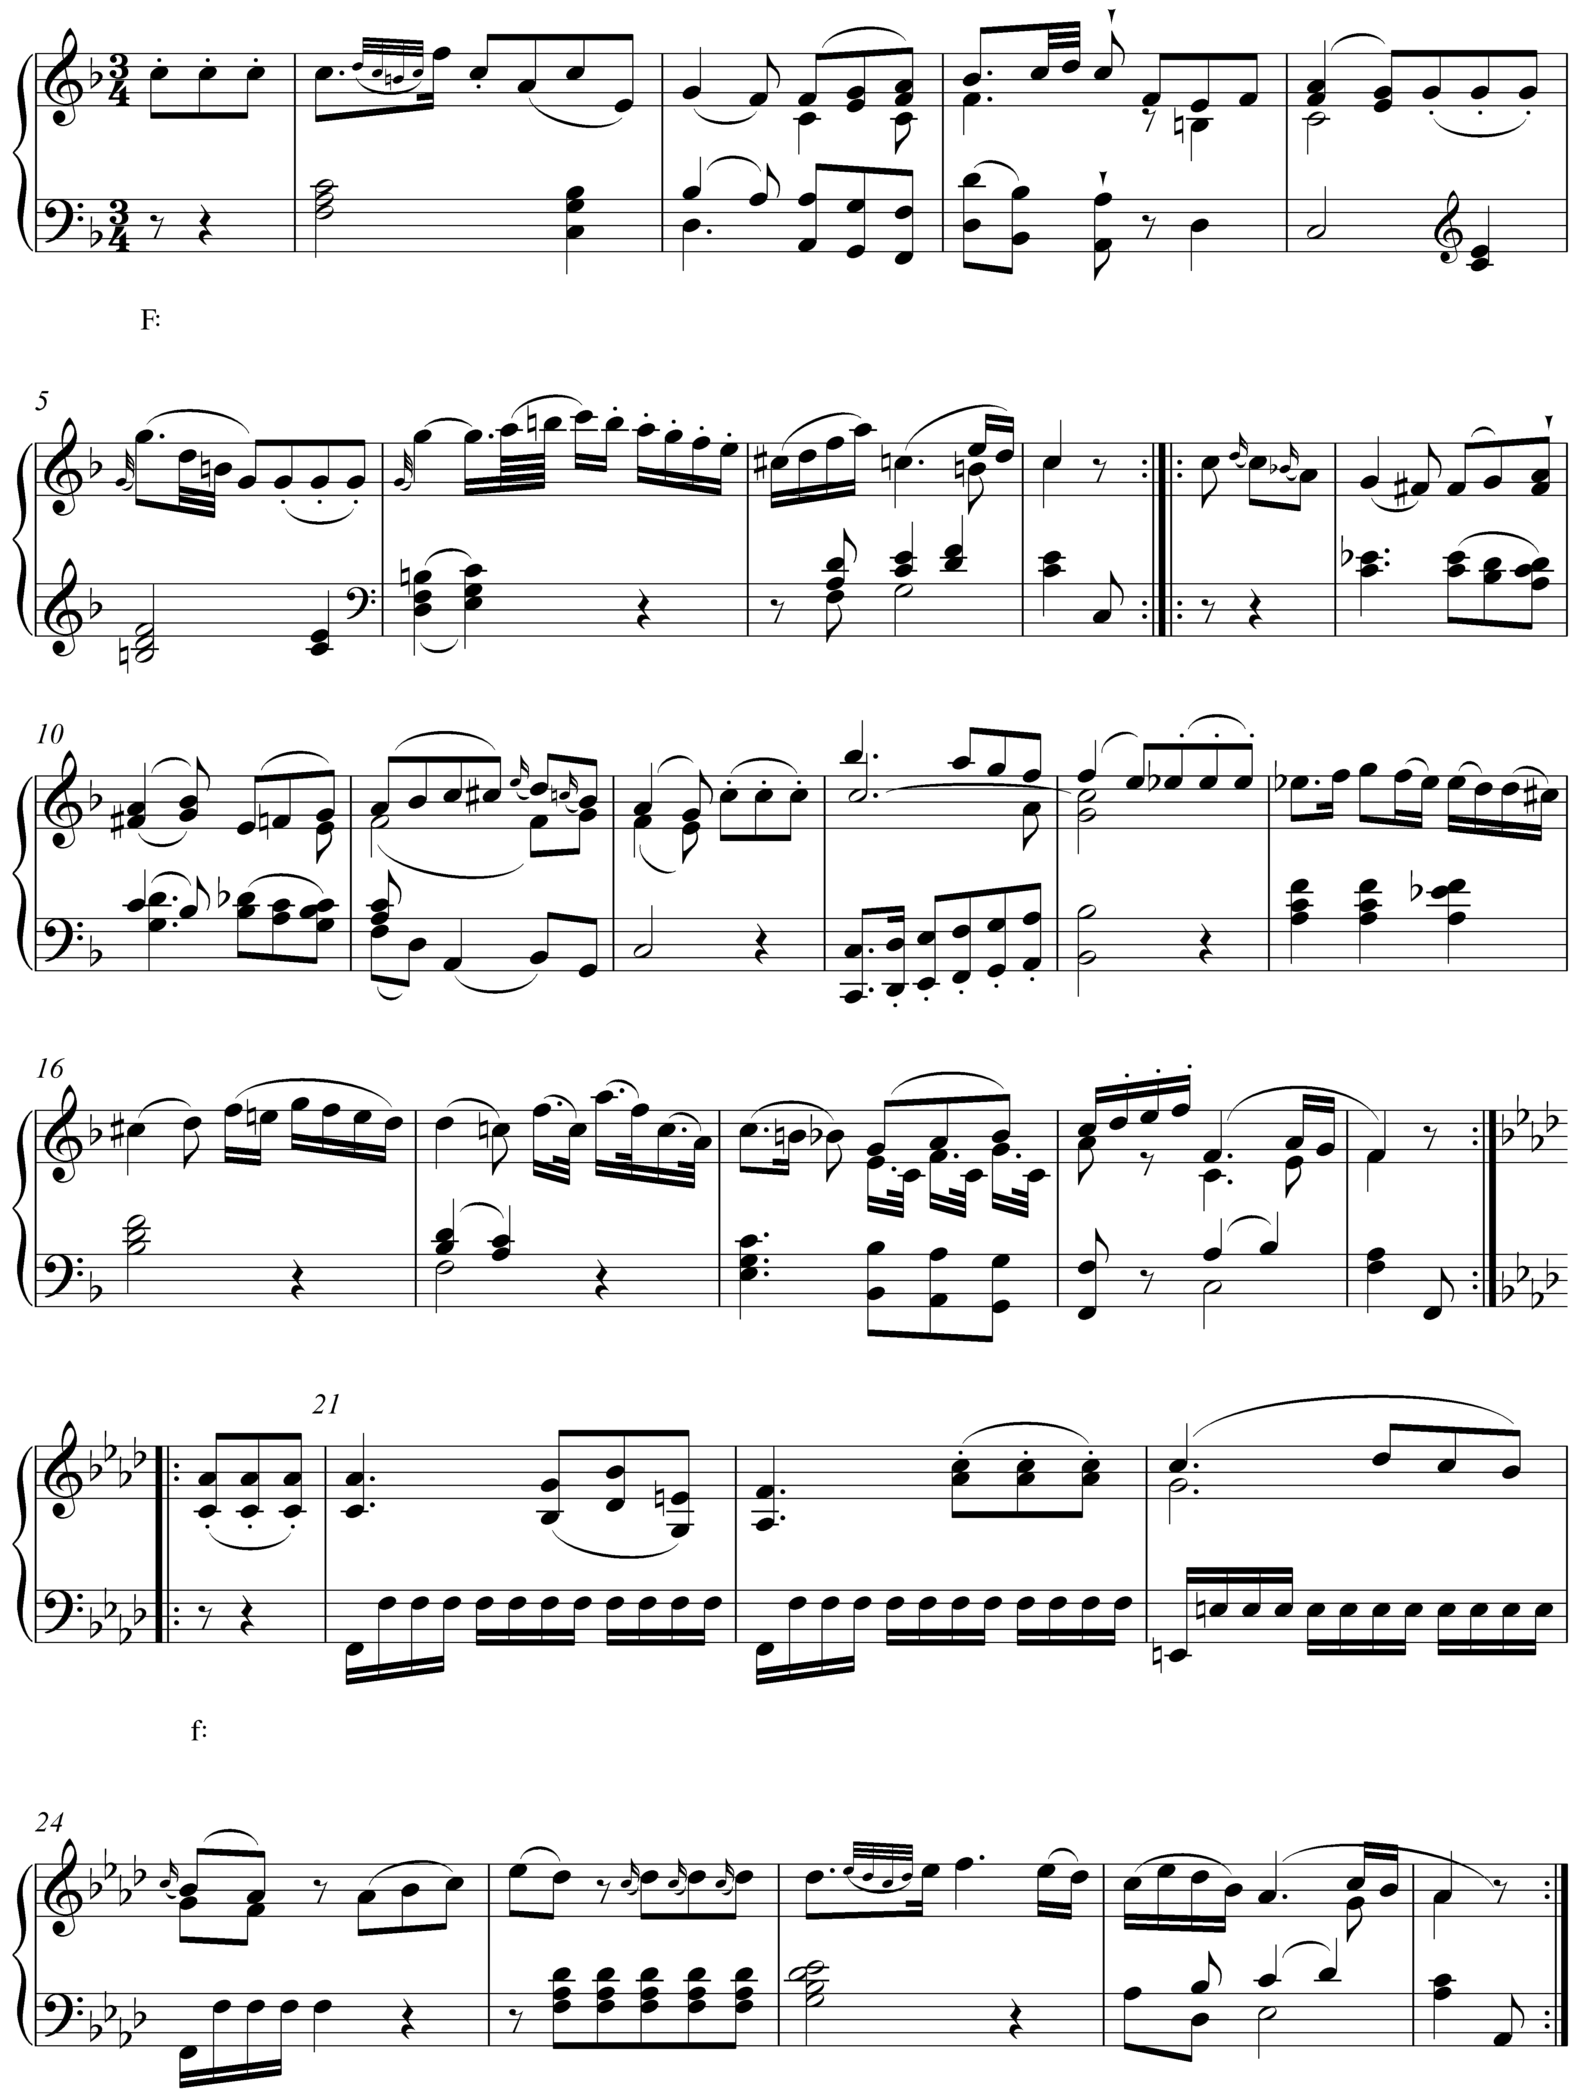

In this beginning to a piano sonata movement, the entire opening A section (mm. 1-20) is in the key of F major. For the B section (beginning with the pickup to m. 21), however, Mozart moves directly to F minor, key signature and all. Rather than inflect the quality of the tonic by lowering scale degree 3, Mozart simply shifts to the parallel minor key.

Modulations via mixture are not limited only to the parallel key of the global tonic. The following example in F major modulates to the key of C minor:

Example 25 (W.A. Mozart, Piano Sonata in F, K. 332/iii, mm. 47-57):
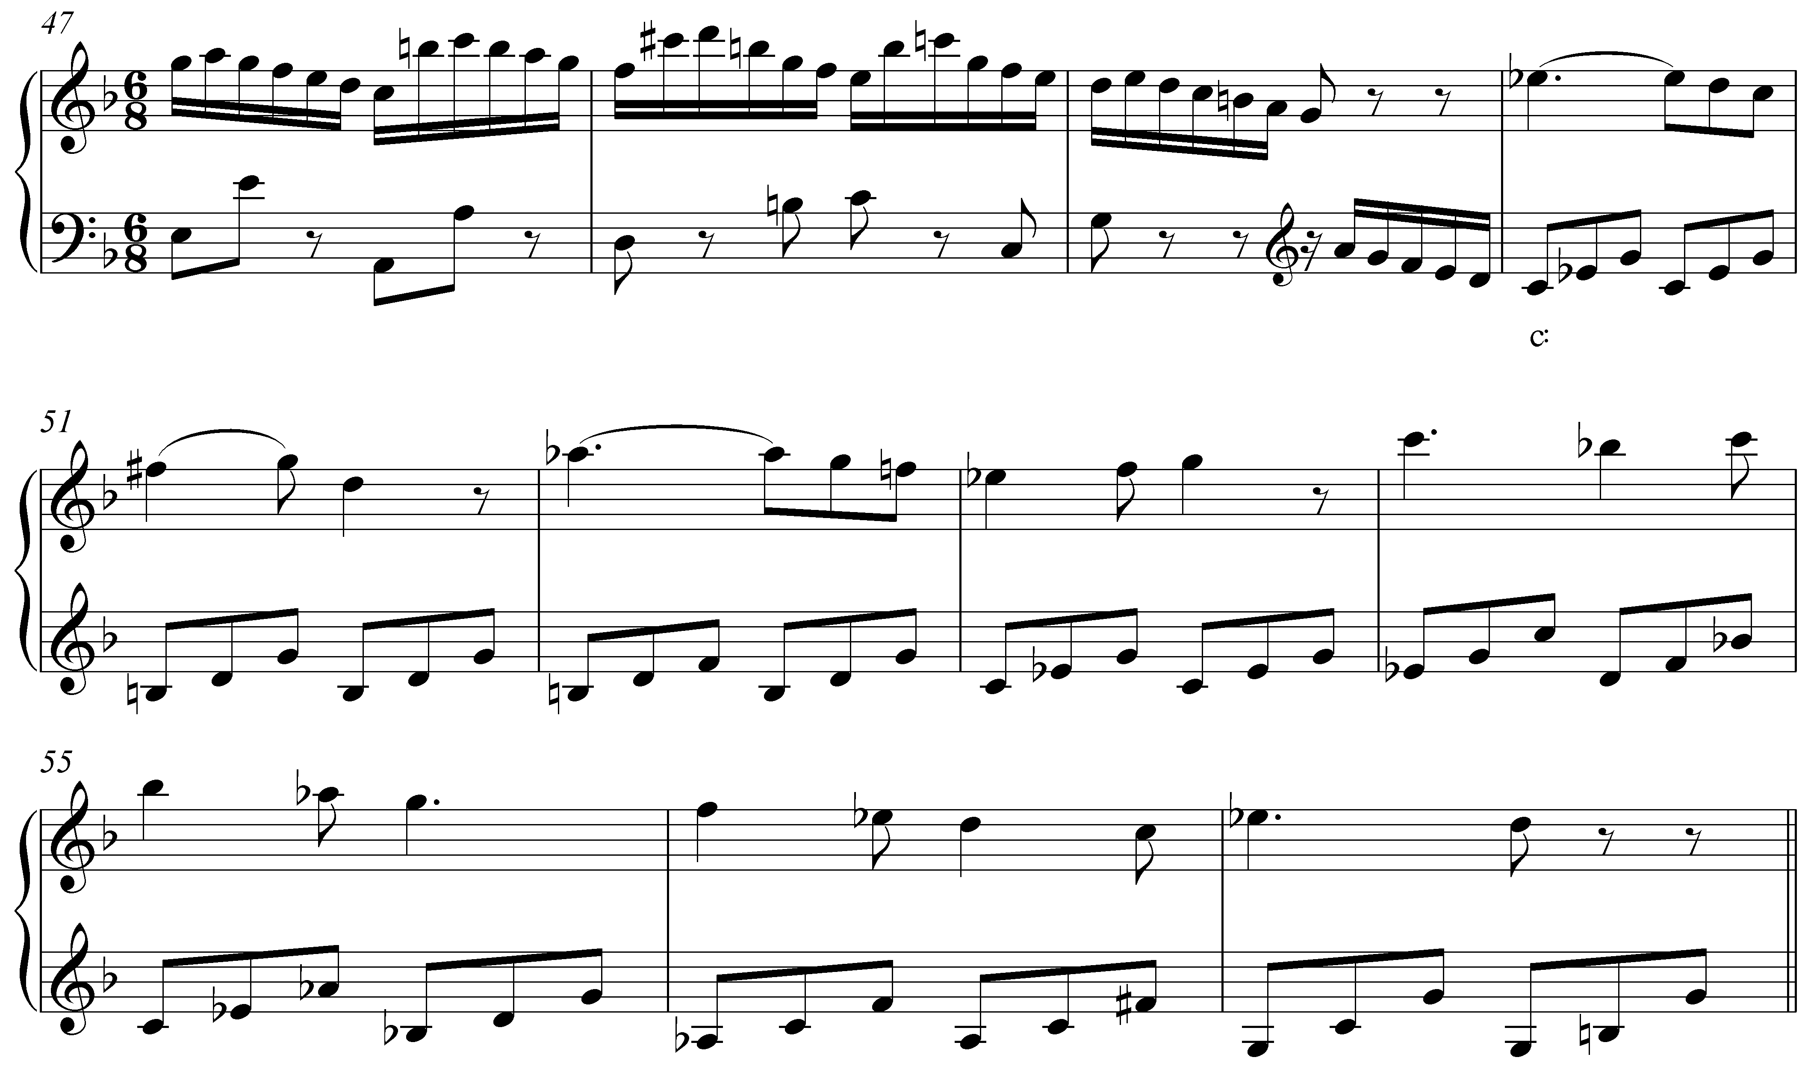

In sonatas such as this one, it is quite common to encounter modulations to the key of the dominant. After a transition section ending in m. 49, we expect just that: a theme in C major. Instead, the melody beginning in m. 50 is clearly in C minor. The result is a remarkable instance of mixture. Mozart has moved to the rather distantly-related key of C minor through a mixture shift.

Activity LLL.07:
The following excerpt from a Mozart piano sonata (K. 331/iii, mm. 1-33) begins in A minor but modulates in m. 24. To which key does it modulate?
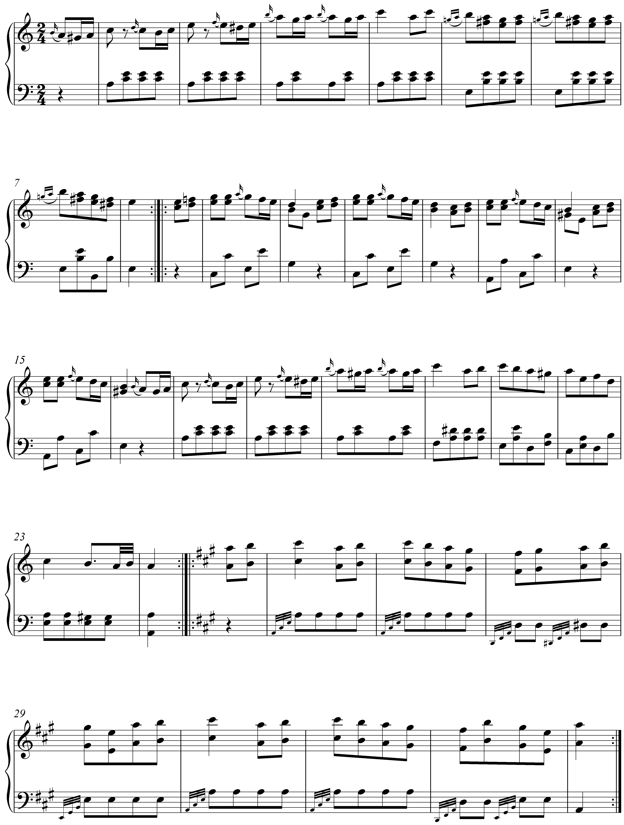
[Answer: A major. Response if correct: “Correct!” Response if incorrect: “Incorrect. (Hint: The excerpt modulates to the parallel major.)”]

[Follow-up question:]
The excerpt modulates to A major, the parallel major. In the tonic key of A minor, what Roman numeral would be used to represent an A major triad?
[Answer: I. Response if correct: “Correct!” Response if incorrect: “Incorrect. (Hint: The root of an A major triad is the same as the root of the tonic triad in A minor.)”]

Conclusion:

Mixture consists of the incorporation of elements from the parallel key. Parallel keys differ at scale degrees 3, 6, and 7, so it is at these points that mixture will occur. In both major and minor keys, chords borrowed from the parallel key can intensify the drama of a musical texture.

Some instances of mixture can be seen as a result of strengthening the basic interval progressions governing the voiceleading of harmonic progression. This is not always the case, however, since some cases of mixture are employed strictly for color, variation, and drama. The term mixture is also expanded to include similar instances of chromatic pitches including those in double mixture chords and the Neapolitan.

Mixture can have an effect on larger spans of music as well. It can initiate modulation to foreign keys via a tonicization of a borrowed chord or by moving directly to a mixture-related key area.

By incorporating chromatic pitches in this manner, composers are able to expand and enrich their options for musical expression. Though common in pieces from across the tonal repertoire, mixture is especially prevalent in music from the Romantic era. Composers in that style period were particularly concerned with the emotional impact of their music and mixture provided an effective means of heightening the level of expression.

