Lesson MMM: The Neapolitan Chord

Introduction:

In the lesson on mixture (Lesson LLL) we introduced the Neapolitan chord: a type of chromatic chord that is notated as a major triad built on the lowered second scale degree (b2). Another example of this sonority can be found in m. 126 of the following excerpt from a Mozart piano trio:

Example 1 (W.A. Mozart, Piano Trio, K. 542/iii, mm. 122-128):
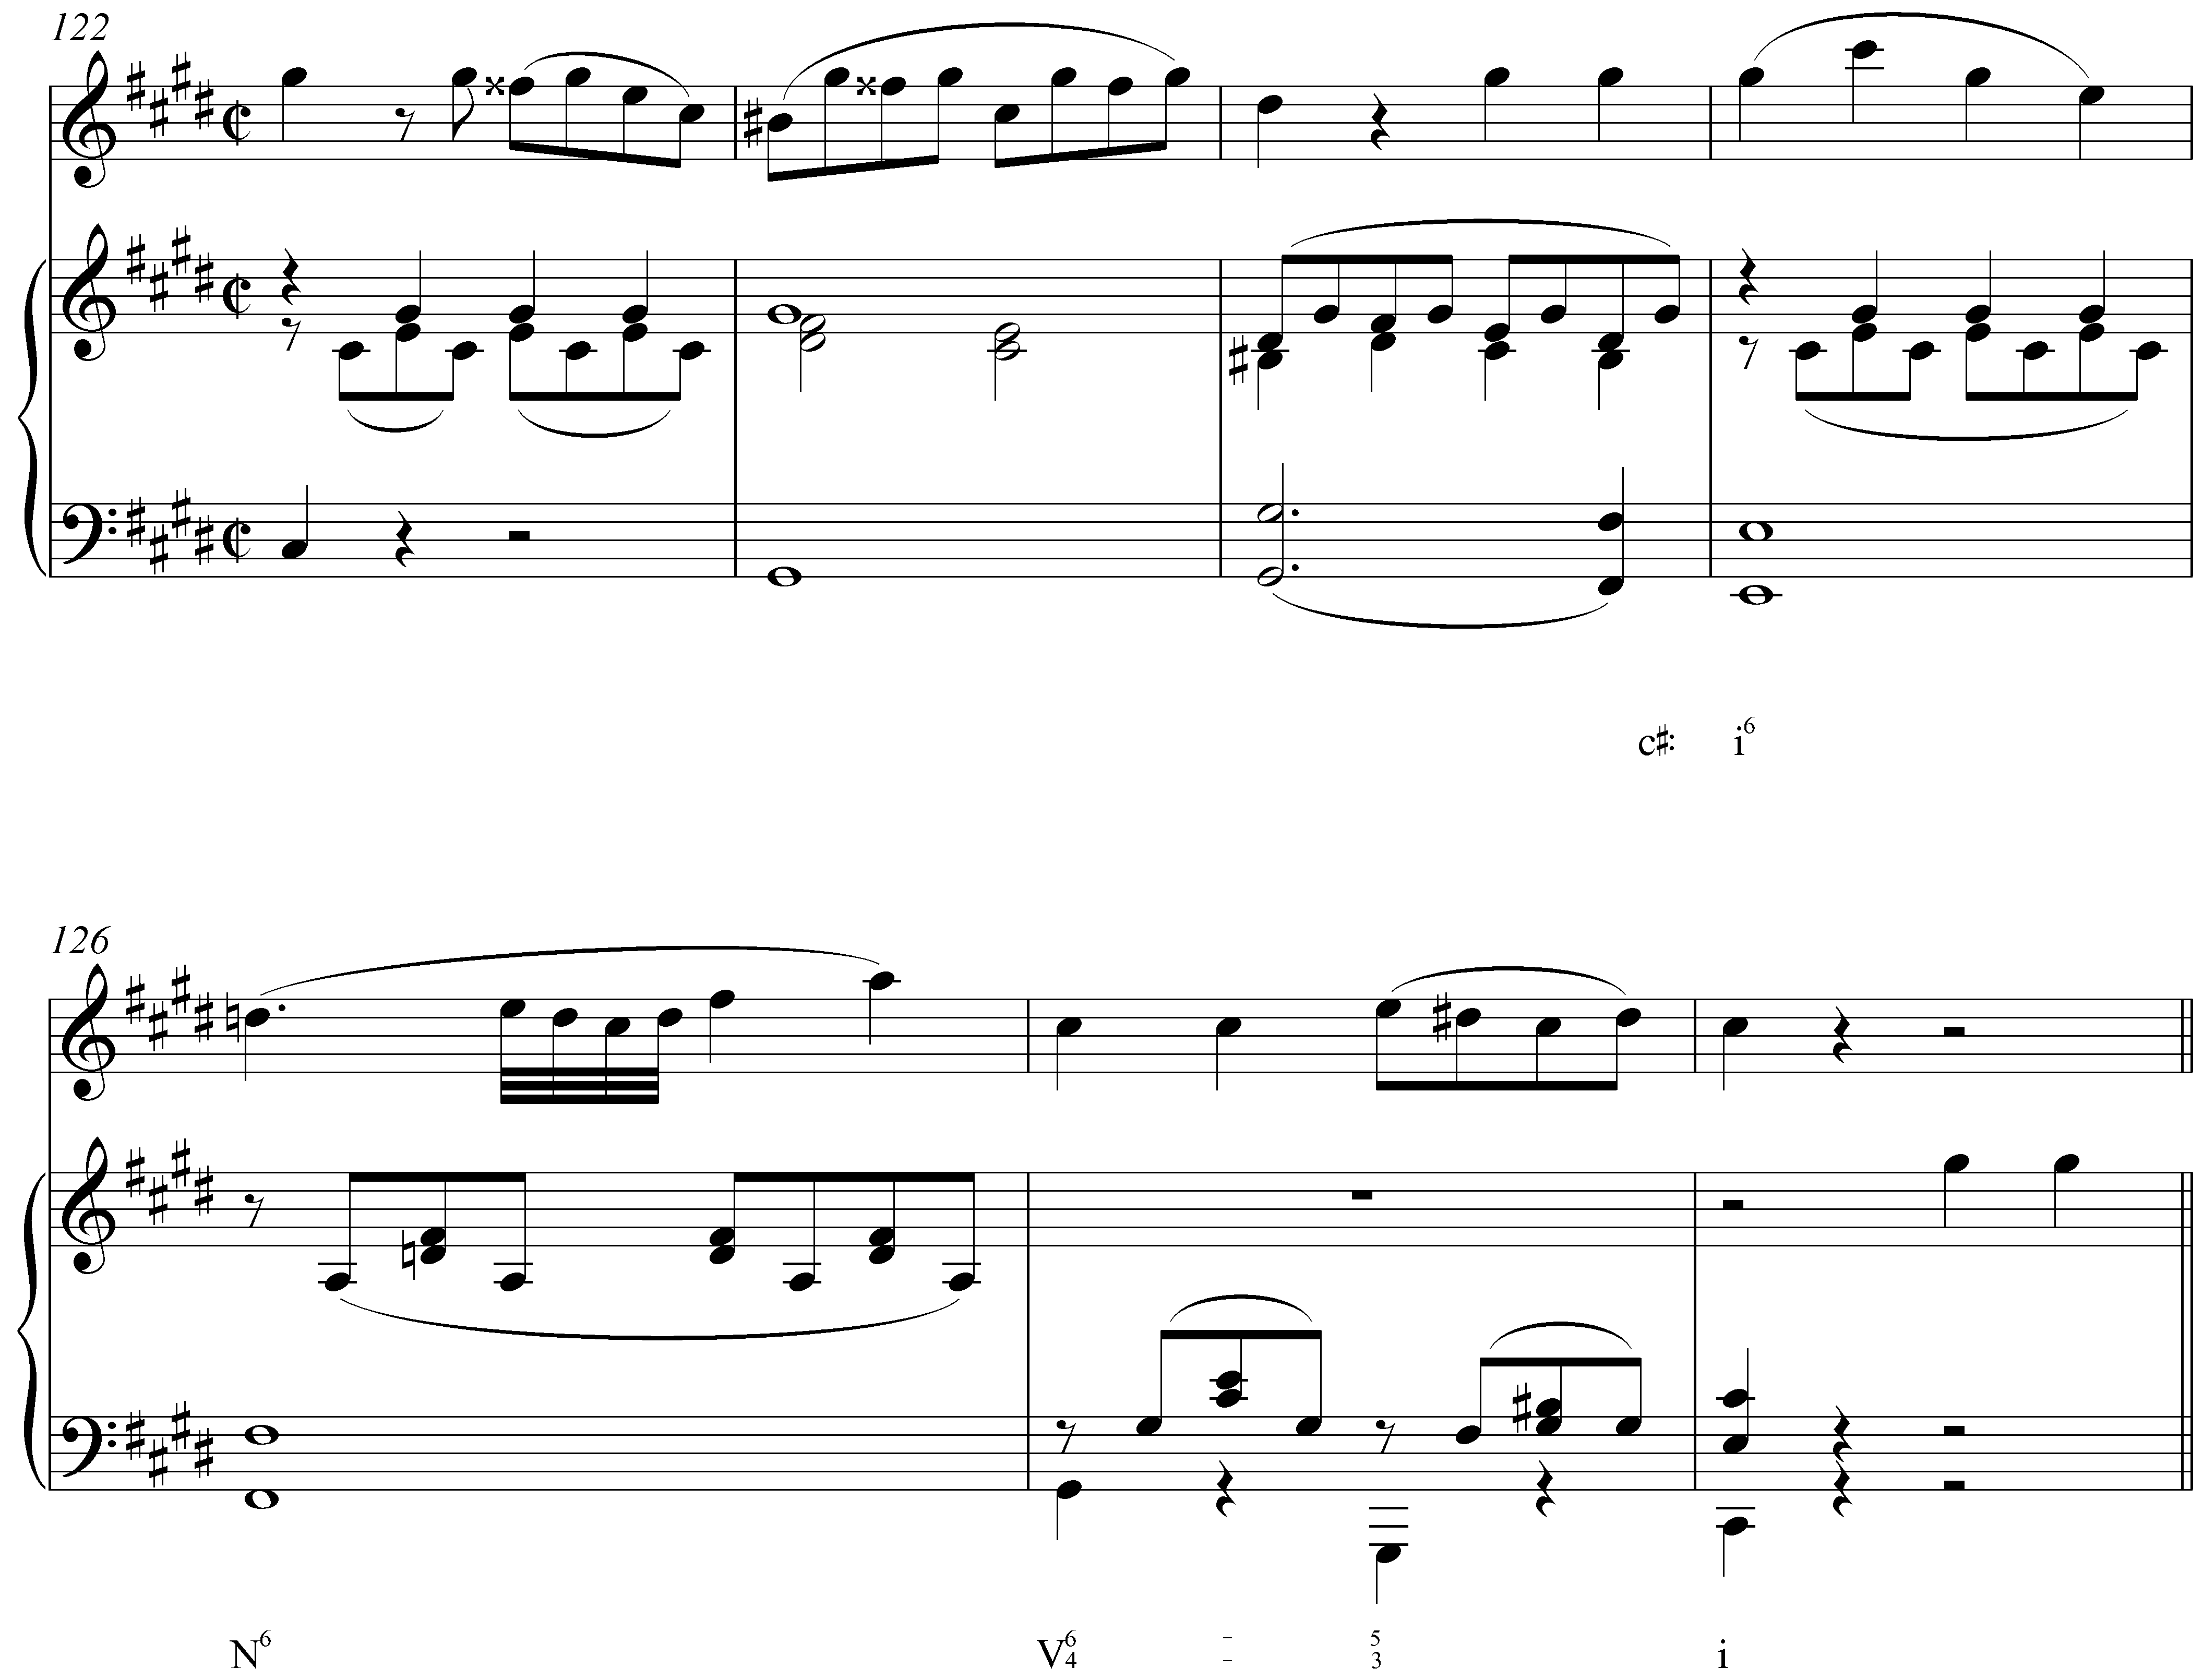

With its major quality and lowered second scale degree, the effect of the Neapolitan chord (N⁶) is striking. As you can see and hear, Mozart’s use of N⁶ brings dramatic weight to the ensuing cadence and intensifies the passage in a way that the diatonic predominant chord cannot.

In this lesson, we will examine the origins and structure of the Neapolitan chord. Depending on the context, the Neapolitan can be derived in several ways. With an understanding of how these derivations work, we will investigate how the Neapolitan functions in various conditions. We will also discuss how the Neapolitan behaves over larger spans when it is tonicized or used in a modulation.

Origin and structure:

The Neapolitan chord is a voiceleading sonority derived from an embellished subdominant triad:

Example 2:
a. b. c.
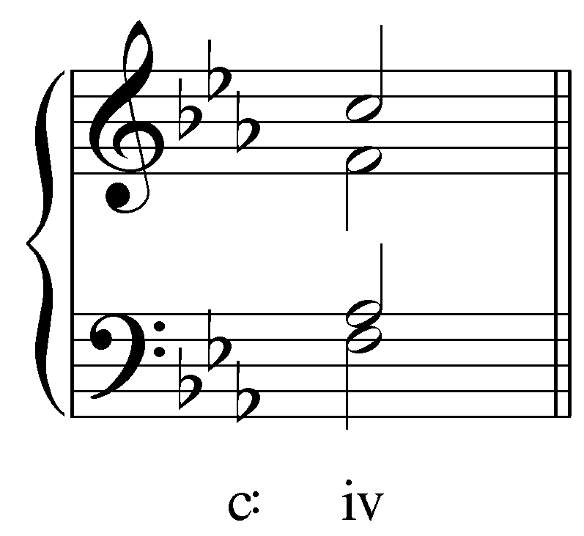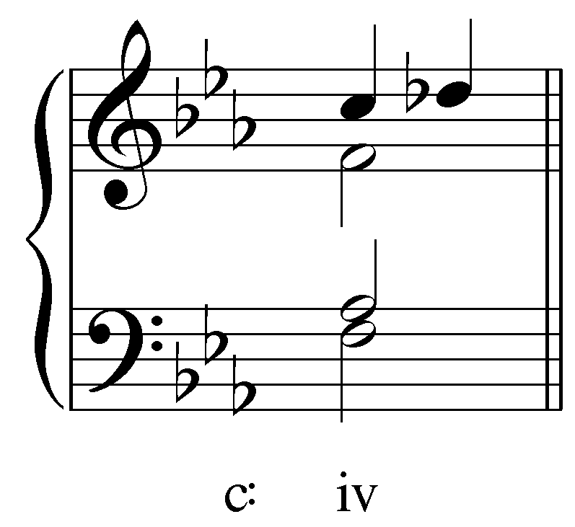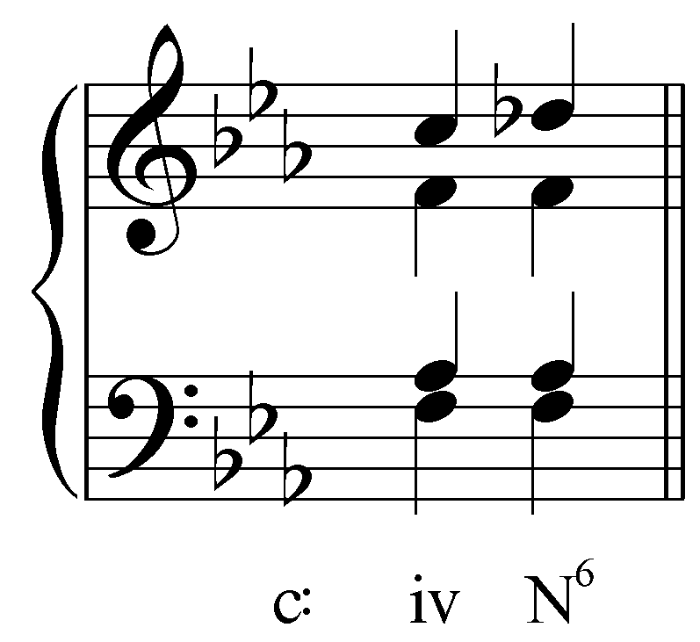

Example 2.a shows a iv chord in C minor. Example 2.b shows the same iv with its fifth decorated by a chromatic upper neighbor tone (Db). The root and third of the iv chord are sustained under the upper neighbor and, with that neighbor “frozen,” so to speak. The chromatic neighbor is assimilated into the chord, and a new consonant triad is formed (Example 2.c).

This understanding of the Neapolitan accounts for its tendency to appear in what looks like a first- inversion triad, with the chordal third doubled. If the Neapolitan is considered a derivation of iv, it is in fact the root (the bass) that is being doubled—the norm for root-position triads! Consider the following example:

Example 3 (W.A. Mozart, Piano Trio, K. 542/iii, mm. 141-144):
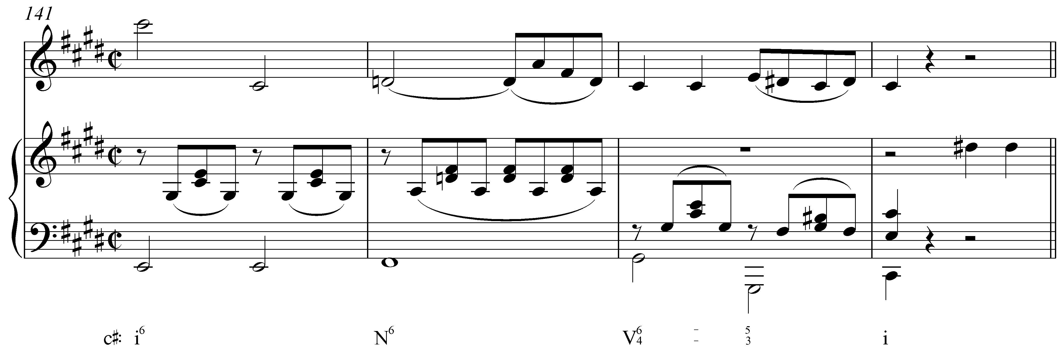

Here, a Neapolitan chord appears in m. 142. The F# in the bass allows for a smooth, stepwise ascent to scale degree 5 (m. 143). As you can see in the melody, the D natural is a chromatic upper neighbor to C#. The following example restores Mozart’s D natural with a diatonic C# in m. 142:

Example 4 (W.A. Mozart, Piano Trio, K. 542/iii, mm. 141-144; with diatonic iv instead of N⁶):
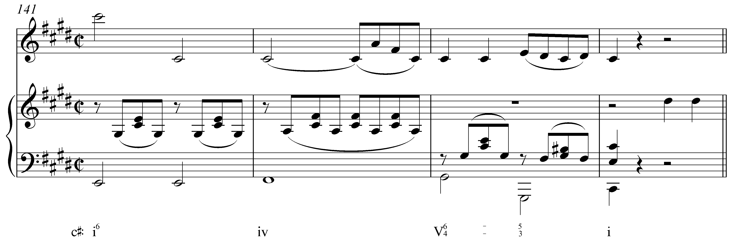

With C# sustained through m. 142, the resultant sonority would be a iv chord in root position. Like a root-position iv chord, the Neapolitan usually appears with scale degree 4 in the bass (see also Example 1).

Activity MMM.01:
The Neapolitan can also be thought of as an embellishment of a minor subdominant triad. Each of the following examples shows an unaltered iv chord. Make the necessary adjustments to create Neapolitan chords.

Exercise MMM.01a
Adjust the necessary pitch in the following iv chord to create a Neapolitan in B minor:
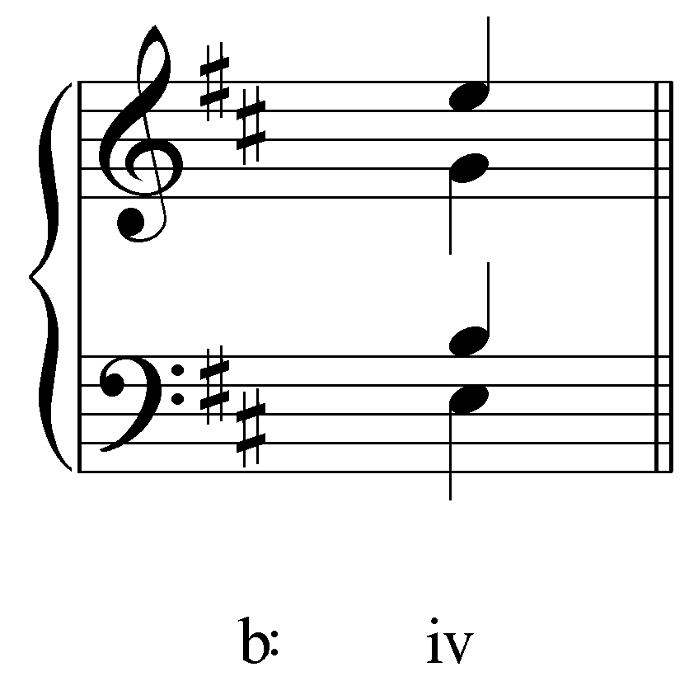
[Answer: B → C natural. Response if correct: “Correct!” Response if incorrect: “Incorrect. (Hint: In order to make a Neapolitan out of a iv chord, you need to replace the fifth with its chromatic upper neighbor.)”]

Exercise MMM.01b
Adjust the necessary pitch in the following iv chord to create a Neapolitan in E minor:
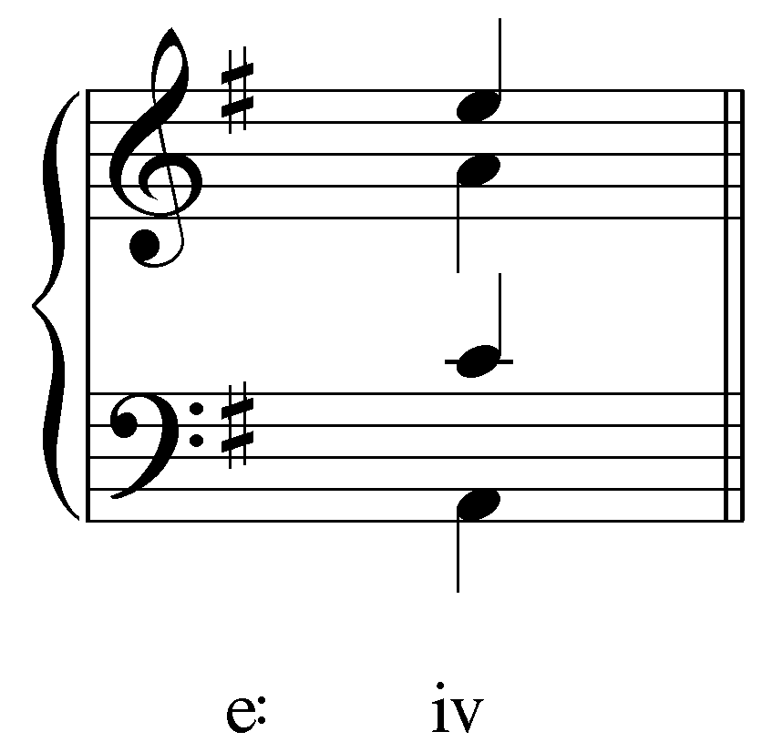
[Answer: E → F natural. Response if correct: “Correct!” Response if incorrect: “Incorrect. (Hint: In order to make a Neapolitan out of a iv chord, you need to replace the fifth with its chromatic upper neighbor.)”]

Exercise MMM.01c
Adjust the necessary pitch in the following iv chord to create a Neapolitan in G minor:
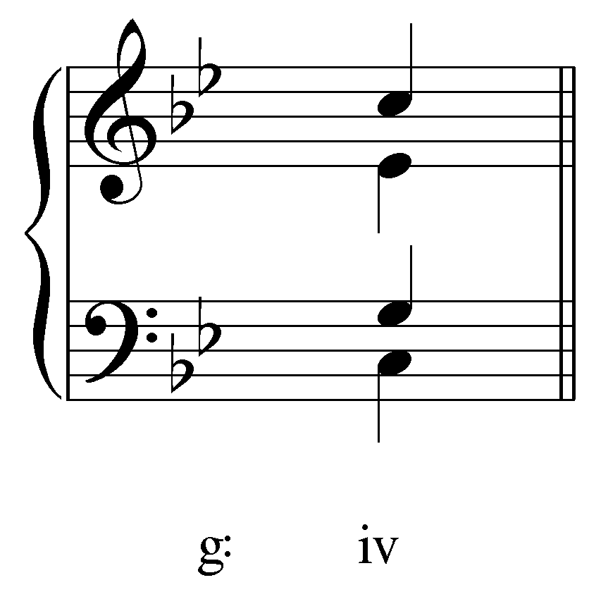
[Answer: G → Ab. Response if correct: “Correct!” Response if incorrect: “Incorrect. (Hint: In order to make a Neapolitan out of a iv chord, you need to replace the fifth with its chromatic upper neighbor.)”]

Exercise MMM.01d
Adjust the necessary pitch in the following iv chord to create a Neapolitan in D minor:
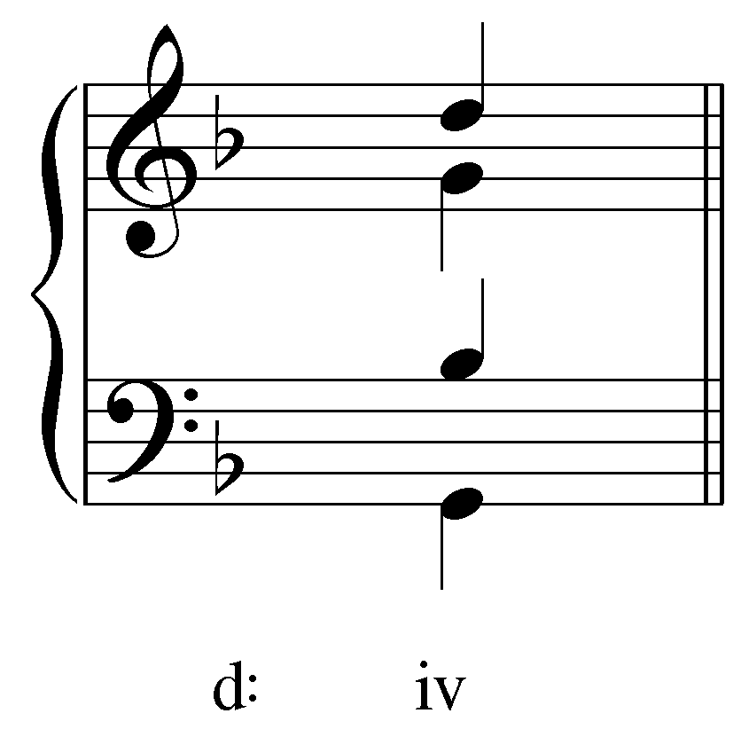
[Answer: D → Eb. Response if correct: “Correct!” Response if incorrect: “Incorrect. (Hint: In order to make a Neapolitan out of a iv chord, you need to replace the fifth with its chromatic upper neighbor.)”]

Note: The name of the Neapolitan chord links it to the so-called “Neapolitan school”—a group of composers active in and around Naples, Italy in the 18th century. However, there is little historical justification for this as the chord was certainly used earlier and by composers as far away as England.

You might also see the chord labeled “Phrygian II,” referring to Phrygian scale which differs from major and minor scales by beginning with a minor second between the first and second scale degrees. (This name should not be taken to imply that the music has shifted to Phrygian, but rather that the chord has some similarity in sound with the scale.) Other texts use the abbreviation bII ⁶, since the chord can also be thought of as a major triad built on b2. For our purposes, we will label the chord N⁶ and will refer to it as the Neapolitan.

The Neapolitan chord can also be thought of as a chromatic alteration of the diatonic ii chord. Example 5 shows how Neapolitan chords can be derived this way in both major (a) and minor (b) keys:

Example 5
a.
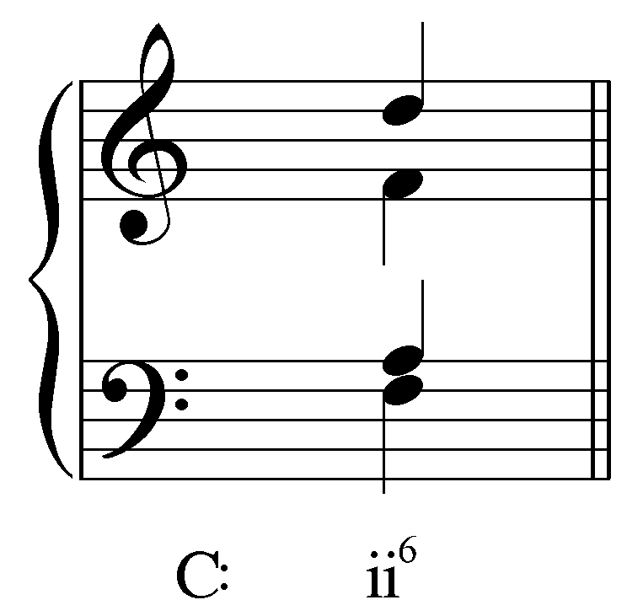 becomes… 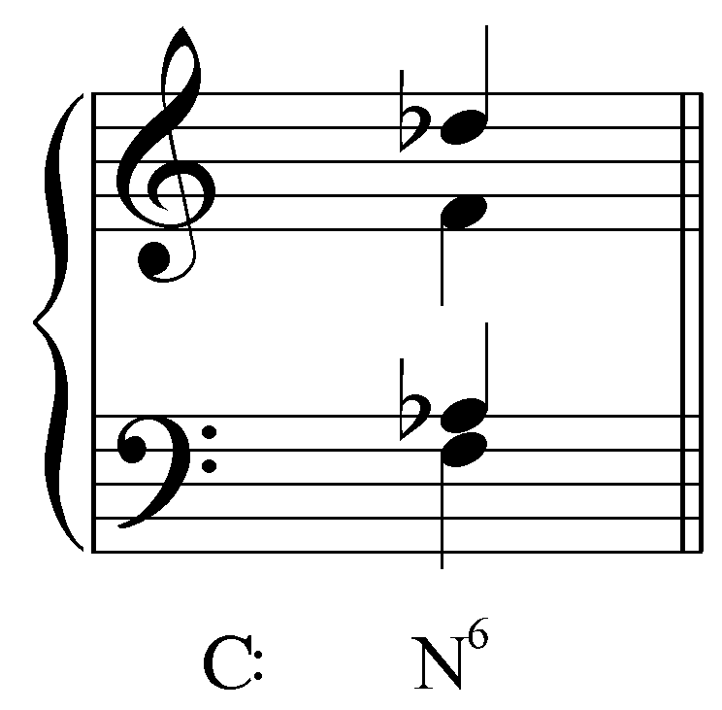

b.
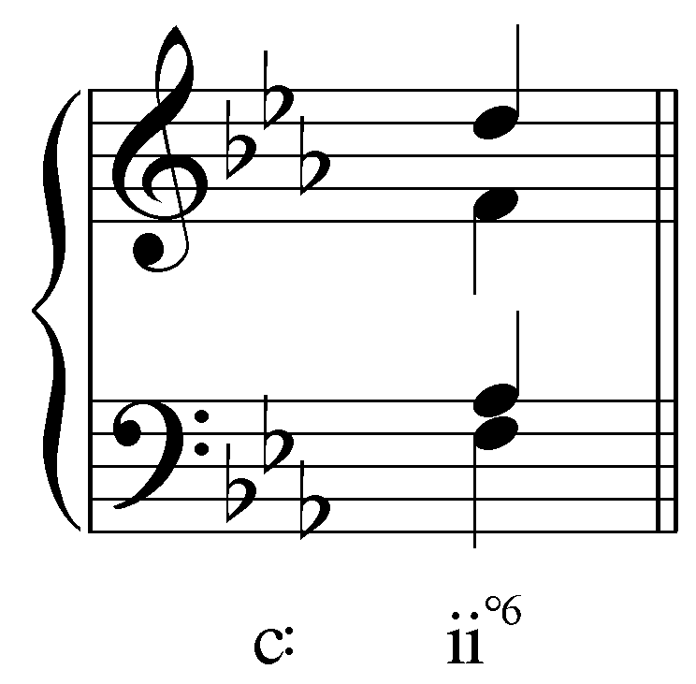 becomes… 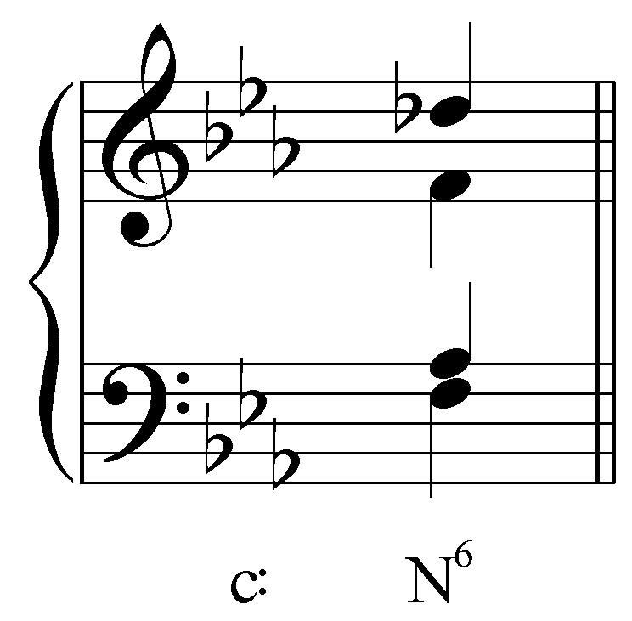

In both cases, the resultant chord consists of the same three tones. Note that in major keys, however, the Neapolitan requires two accidentals: b2 (Db in this case) and b6 (Ab). Though not rare in major keys, Neapolitan chords more commonly in minor. The major quality of the Neapolitan differs dramatically from the diminished diatonic iiº chord and provides an effective means of stabilizing it by eliminating the tritone between its root and fifth (minor scale degrees 2 and 6).

The following example, from a well known passage in Beethoven’s Seventh Symphony, shows a Neapolitan derived from an altered ii chord (Example 7 provides a reduction of Example 6):

Example 6 (L. Beethoven, Symphony No. 7, Mvt. I, mm. 364-370):
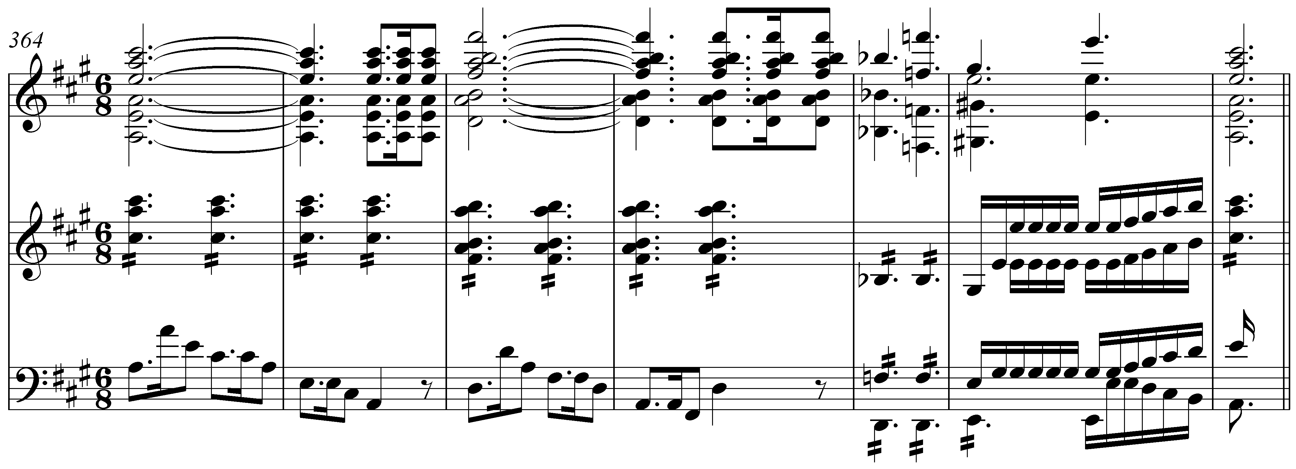

Example 7 (reduction of L. Beethoven, Symphony No. 7, Mvt. I, mm. 364-370):
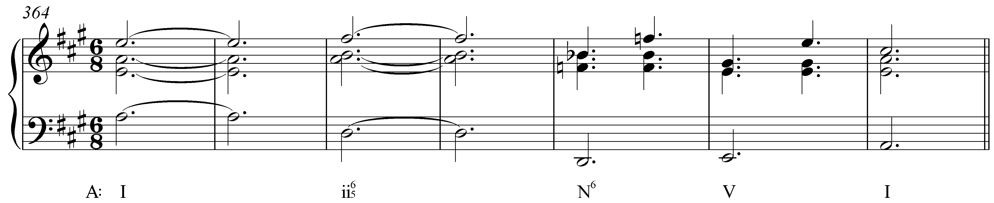

[NOTE: The first note in the treble of Ex. 7 should be c# not e.]

The ii chord in m. 366 leads to a Neapolitan in m. 368. Following the voiceleading in the upper parts, we can see that the Bb of the Neapolitan comes directly from the root of the ii chord (B natural). Though it has the same construction as a Neapolitan derived by embellishing iv, this Neapolitan is clearly an altered ii chord. Nonetheless, scale degree 4 in the bass once again supports the Neapolitan.

Activity MMM.02:
The Neapolitan chord can be derived by altering a ii chord (iiº in minor) to make a major triad built on the lowered second scale degree. Each of the following examples shows an unaltered supertonic chord. Make the necessary adjustments to create Neapolitan chords.

Exercise MMM.02a
Adjust the necessary pitch or pitches in the following ii⁶ chord to create a Neapolitan in G major: 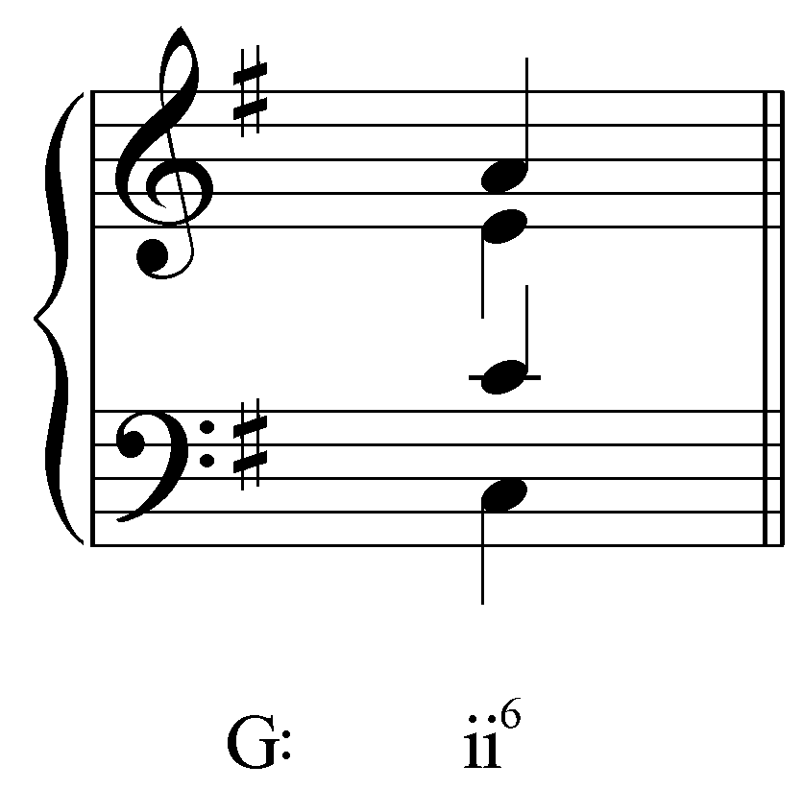
[Answer: A → Ab and E → Eb. Response if correct: “Correct!” Response if partially correct: “Almost… Remember, in a major key, the root and fifth of the ii⁶ chord need to be lowered.” Response if incorrect: “Incorrect. Try again.”]

Exercise MMM.02b
Adjust the necessary pitch or pitches in the following ii^{o6} chord to create a Neapolitan in C minor:
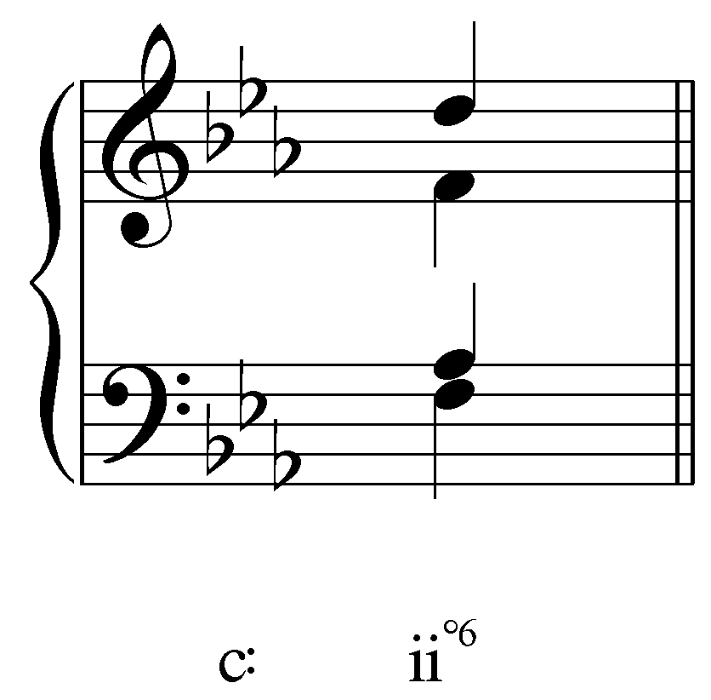
[Answer: D → Db. Response if correct: “Correct!” Response if incorrect: “Incorrect. Try again.”]

Exercise MMM.02c
Adjust the necessary pitch or pitches in the following ii^{o6} chord to create a Neapolitan in F# minor:
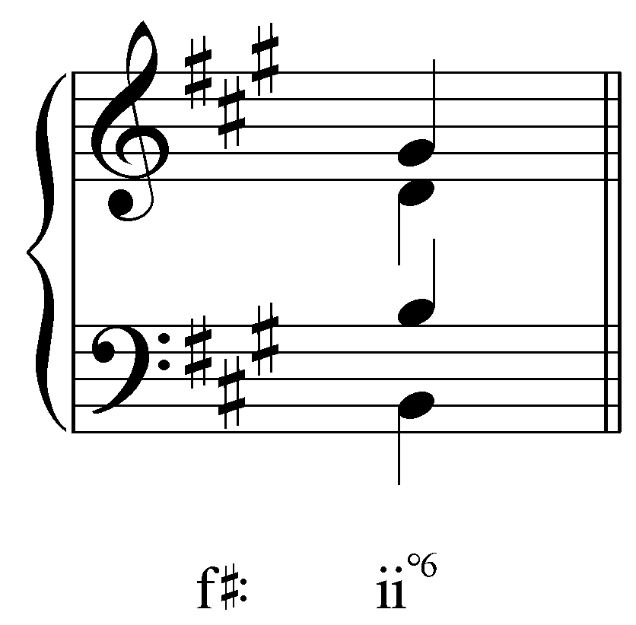
[Answer: G# → G natural. Response if correct: “Correct!” Response if incorrect: “Incorrect. Try again.”]

Exercise MMM.02d
Adjust the necessary pitch or pitches in the following ii⁶ chord to create a Neapolitan in F major: 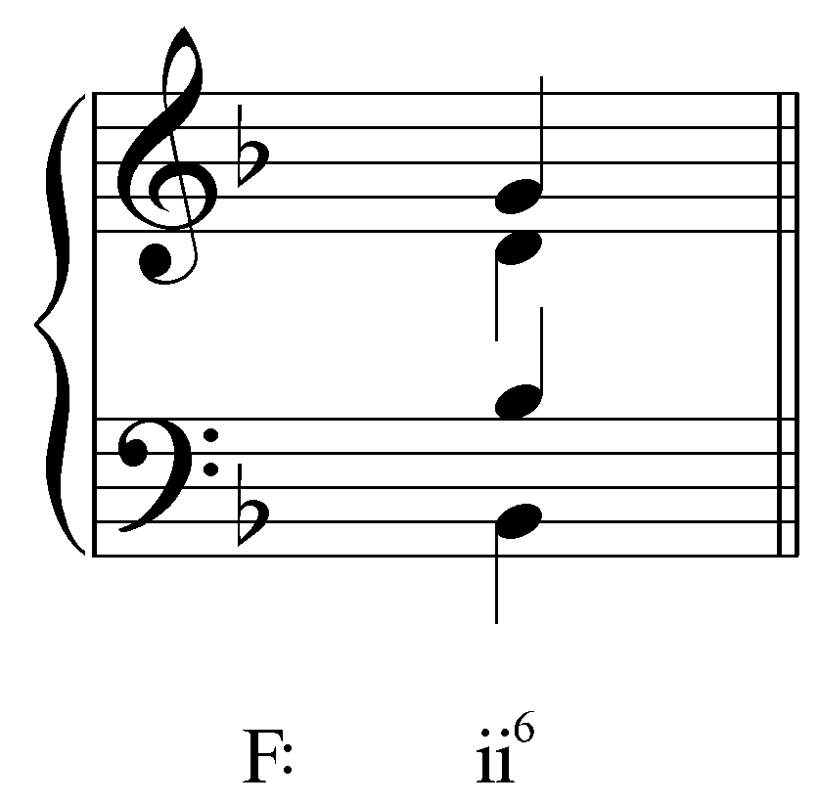
[Answer: G → Gb and D → Db. Response if correct: “Correct!” Response if partially correct: “Almost… Remember, in a major key, the root and fifth of the ii⁶ chord need to be lowered.” Response if incorrect: “Incorrect. Try again.”]

To summarize, the Neapolitan can be thought of in two ways. In the first, the fifth of a subdominant triad is replaced by its own chromatic upper neighbor. The resultant sonority is a major triad: N⁶. (Note that in this case, “⁶” does not indicate an inversion, since scale degree 4 is still the foundation. Rather, it is a bass figure and indicates that a sixth appears above the lowest note.) In the second conception, the Neapolitan is derived by chromatically lowering the root of a diatonic iiº chord. (In major keys, scale degree 6 must also be lowered.)

Of the two, the latter is more common today since the usual notation of the Neapolitan more readily resembles a bII⁶ chord than a iv chord with an altered fifth. Nonetheless, it is important for analysis that you be able to conceive of the Neapolitan in both ways. Consider the following example:

Example 8 (F. Chopin, Nocturne, Op. 55, no. 1, mm. 5-8):
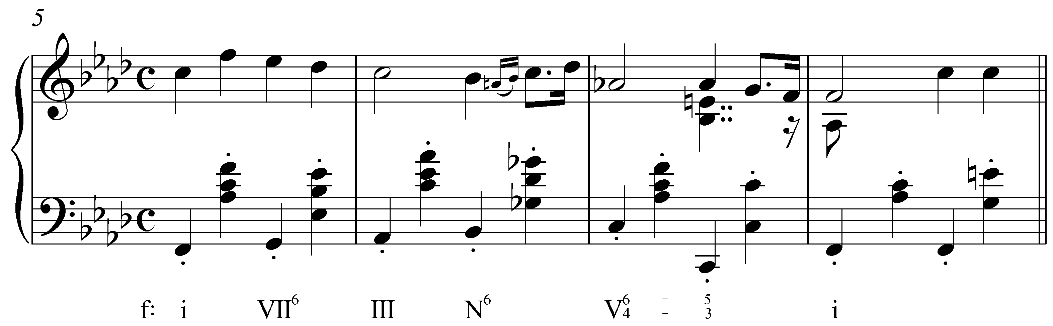

In this excerpt from a Chopin Nocturne, we find a Neapolitan following a root position III chord. In this case, the Neapolitan must be considered an embellished iv. To view this Neapolitan as bII⁶ would be counterintuitive and would contradict all the norms of harmonic root movement. The Neapolitan is a passing chord from III to V. In other words, the progression III – iv^{b6} – V makes much more sense than III – bII⁶ – V.

Now consider the following example (Example 10 provides a reduction):

Example 9 (F. Schubert, String Quartet no. 12, D 703, mm. 7-19):
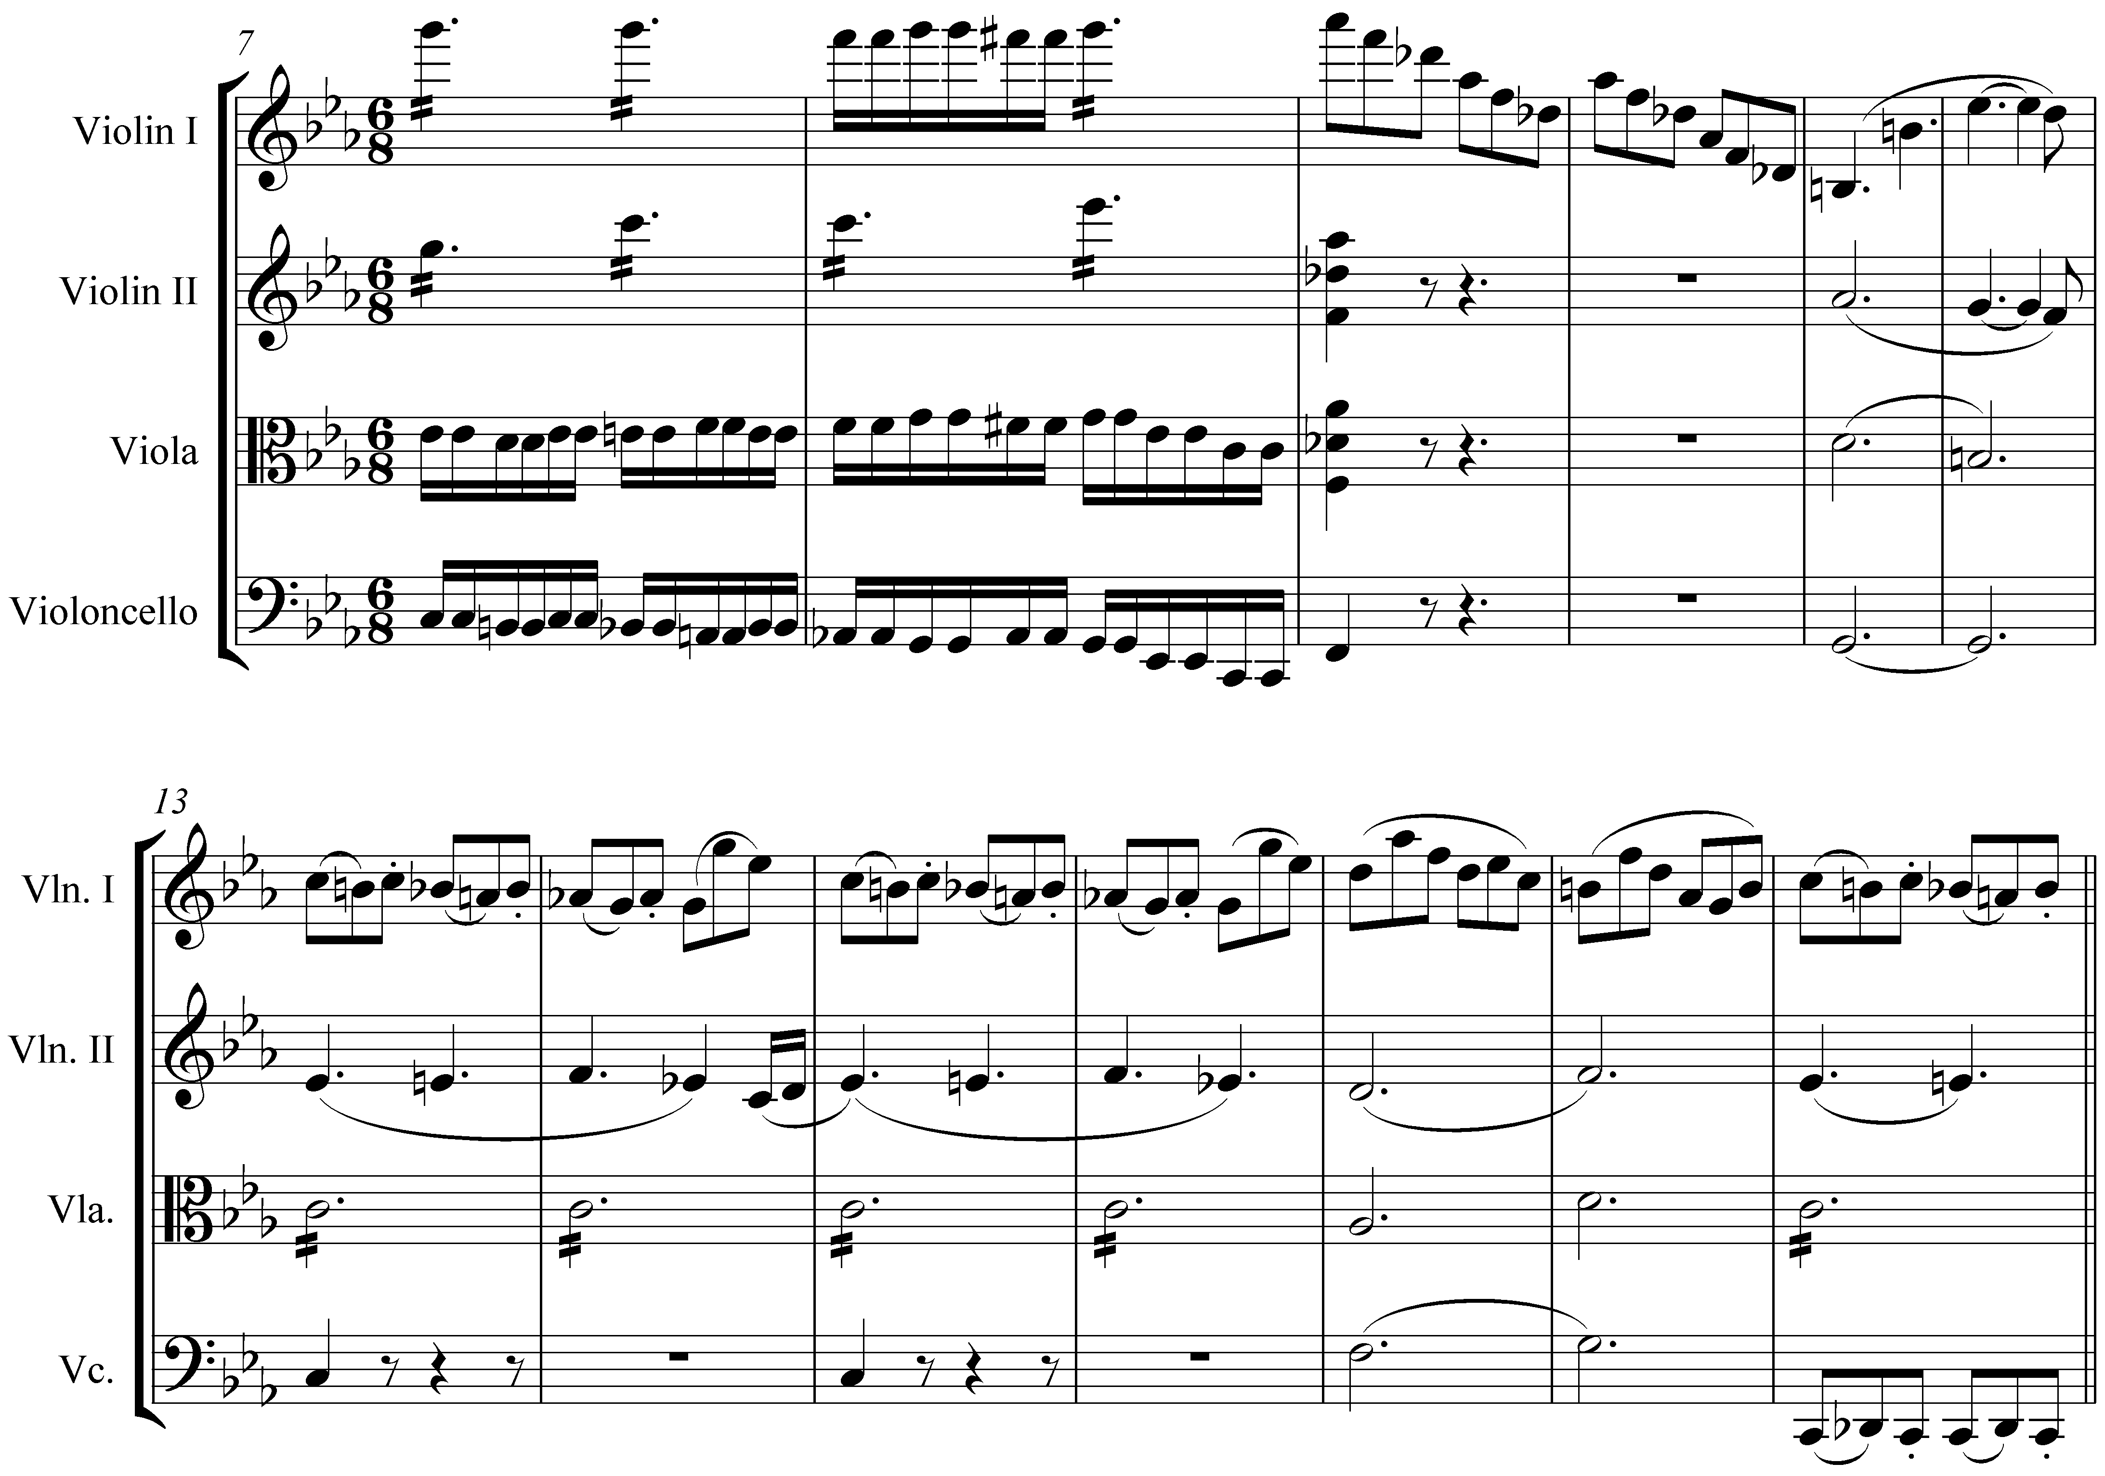

Example 10 (reduction of F. Schubert, String Quartet no. 12, D 703, mm. 7-19):
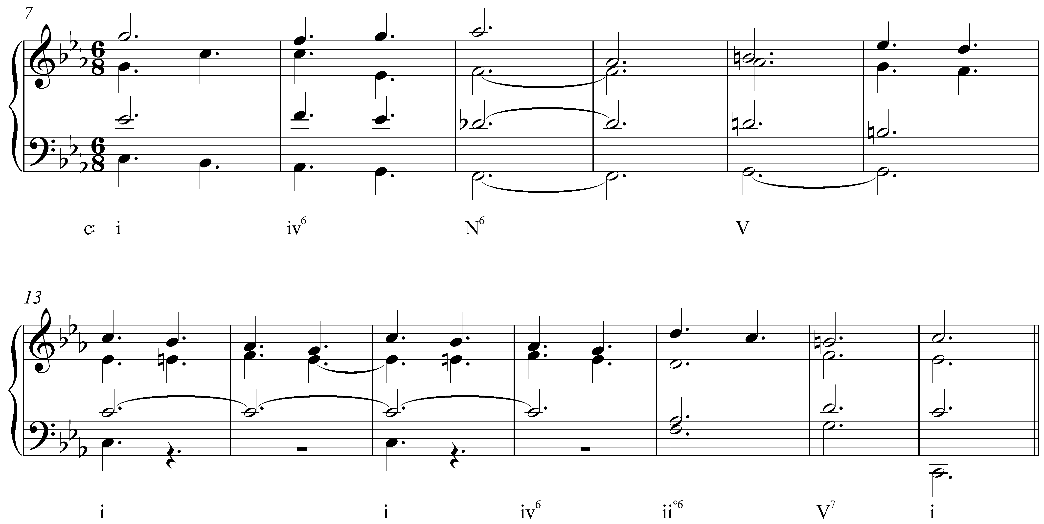

This passage consists of two parallel phrases. The first of these (mm. 7-13) includes a Neapolitan chord as an extension of iv: i – iv⁶ – N⁶ – V – i. A parallel phrase follows in mm. 15-19. This time, however, the Neapolitan has been replaced by ii^{o6}. By presenting these two chords—N⁶ with its b2 and then ii^{o6} with its diatonic 2—within parallel phrases in close proximity, Schubert highlights the contrast between different versions of the ii chord. As you can see, it is important that you be able to conceptualize the Neapolitan in both ways.

Activity MMM.03:
Write Neapolitan chords as indicated.

Exercise MMM.03a
Write a Neapolitan chord with scale degree 4 in the bass in C minor:
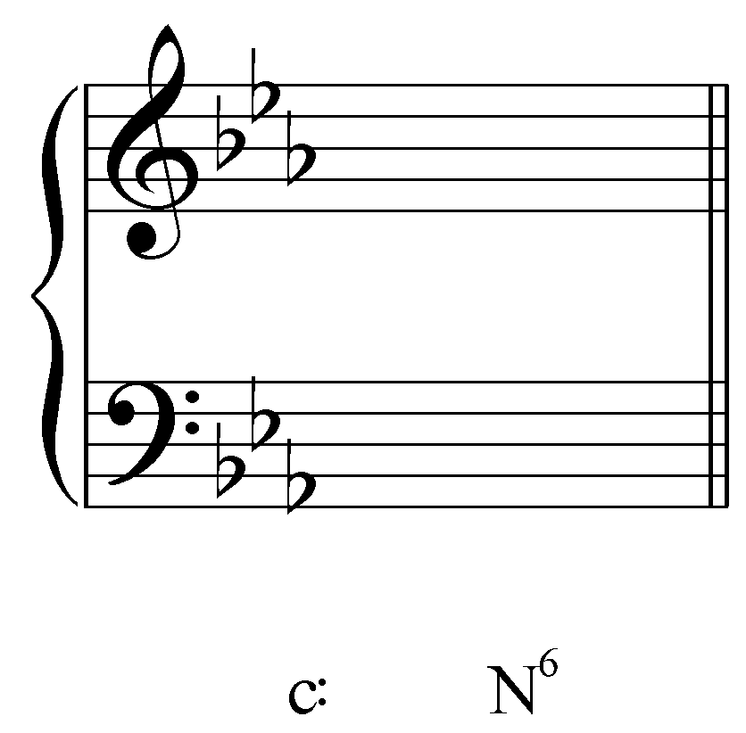
[Answer: 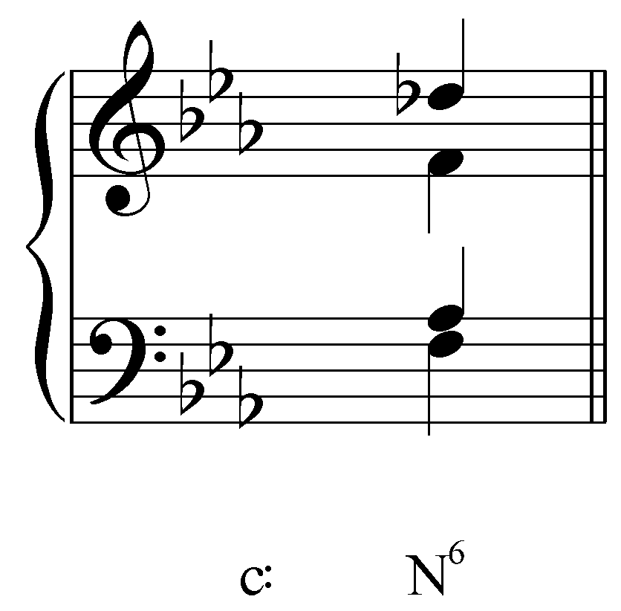 (answers may vary as long as F is the lowest pitch and the upper voices consist of Db, F and Ab). Response if correct: “Correct!” Response if partially correct: “Almost! Remember, a Neapolitan resembles a major triad built on b2 with 4 in the bass.” Response if incorrect: “Incorrect. Remember, a Neapolitan resembles a major triad built on b2 with 4 in the bass.”]

Exercise MMM.03b
Write a Neapolitan chord with scale degree 4 in the bass in F minor:
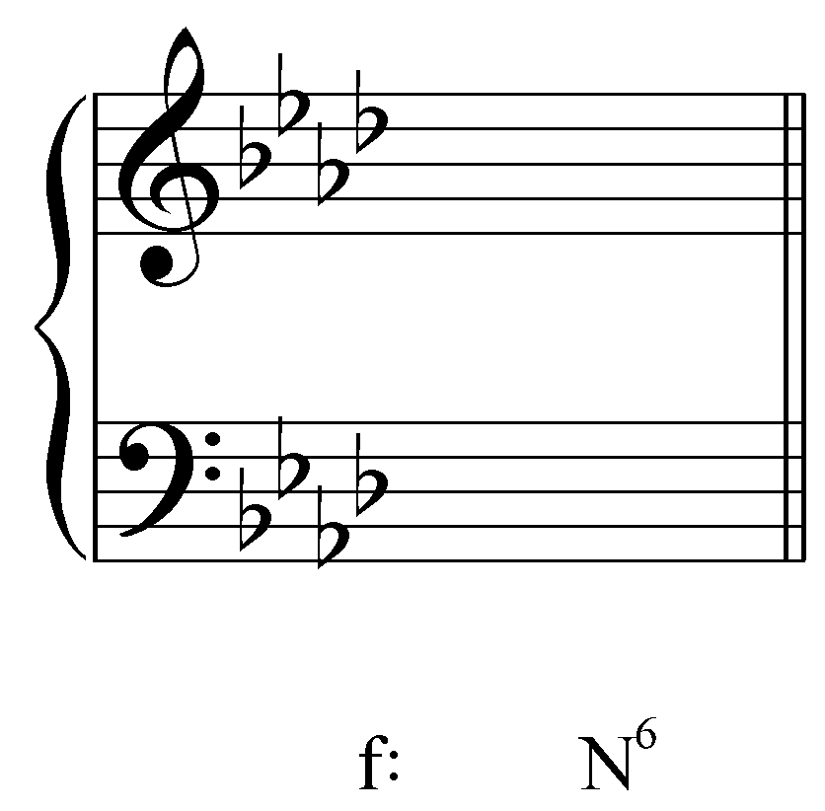

[Answer: 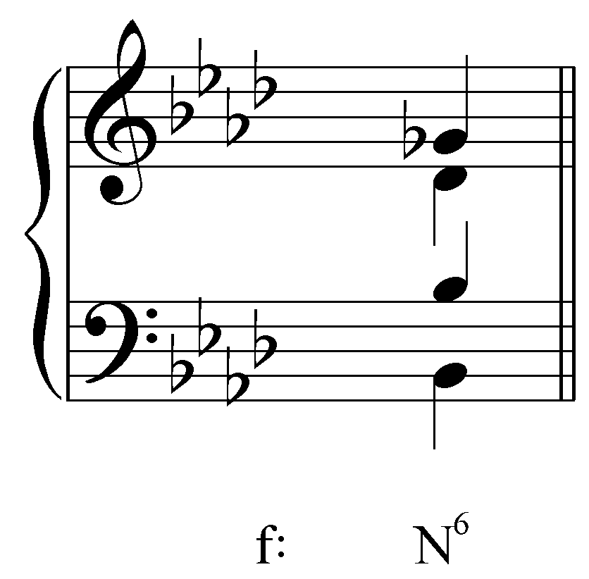 (answers may vary as long as Bb is the lowest pitch and the upper voices consist of Gb, Bb and Db). Response if correct: “Correct!” Response if partially correct: “Almost! Remember, a Neapolitan resembles a major triad built on b2 with 4 in the bass.” Response if incorrect: “Incorrect. Remember, a Neapolitan resembles a major triad built on b2 with 4 in the bass.”]

Exercise MMM.03c
Write a Neapolitan chord with scale degree 4 in the bass in A major:
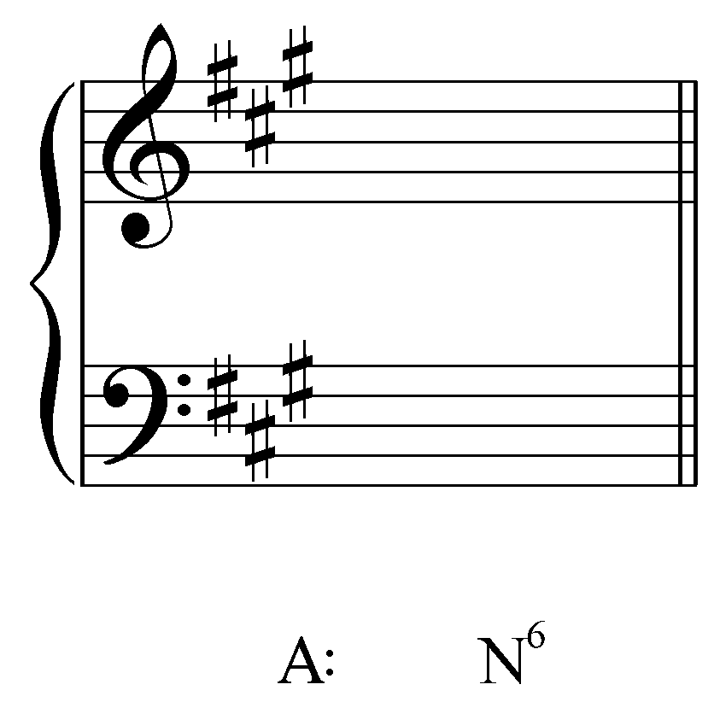
[Answer: 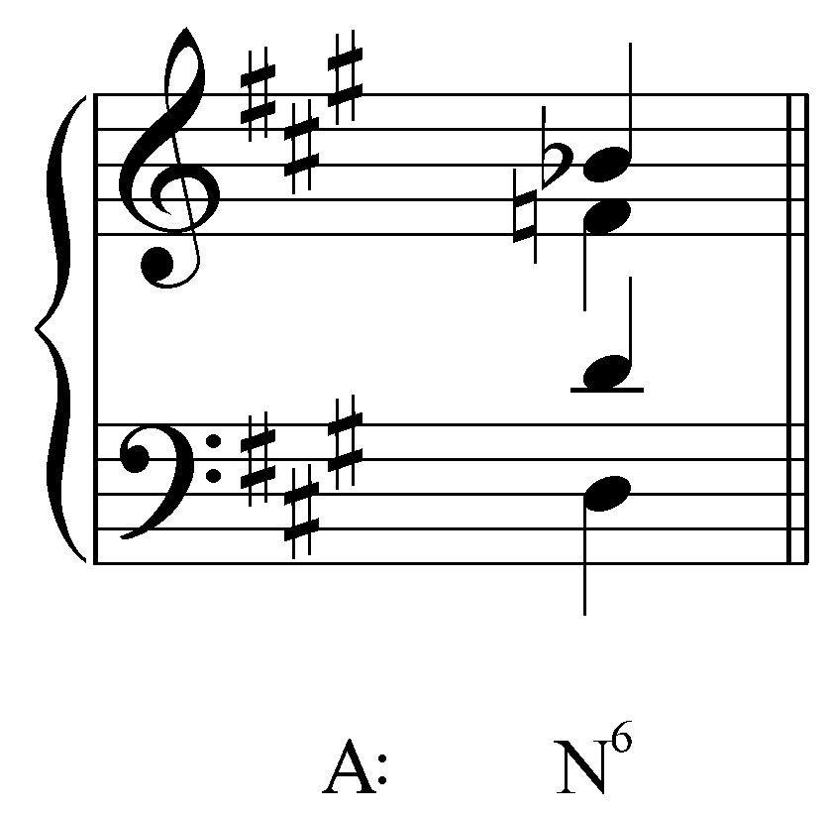 (answers may vary as long as D is the lowest pitch and the upper voices consist of Bb, D and F natural). Response if correct: “Correct!” Response if partially correct: “Almost! Remember, a Neapolitan resembles a major triad built on b2 with 4 in the bass.” Response if incorrect: “Incorrect. Remember, a Neapolitan resembles a major triad built on b2 with 4 in the bass.”]

Exercise MMM.03d
Write a Neapolitan chord with scale degree 4 in the bass in C# minor:
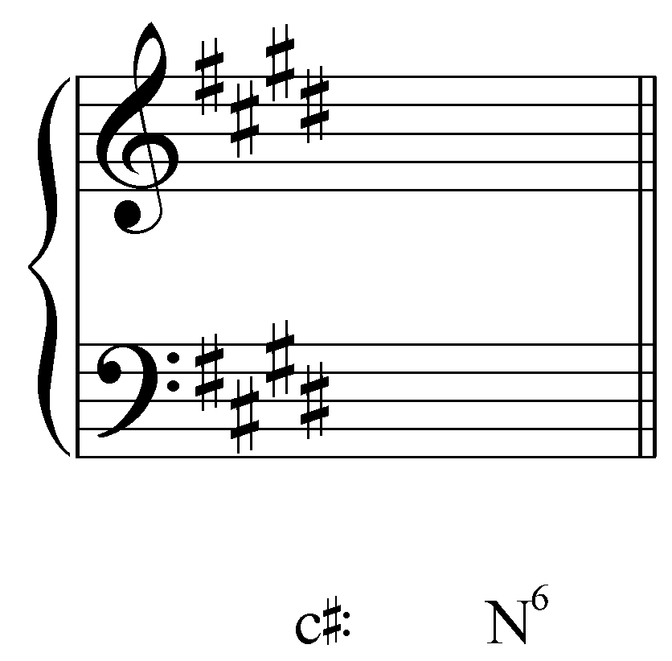
[Answer: 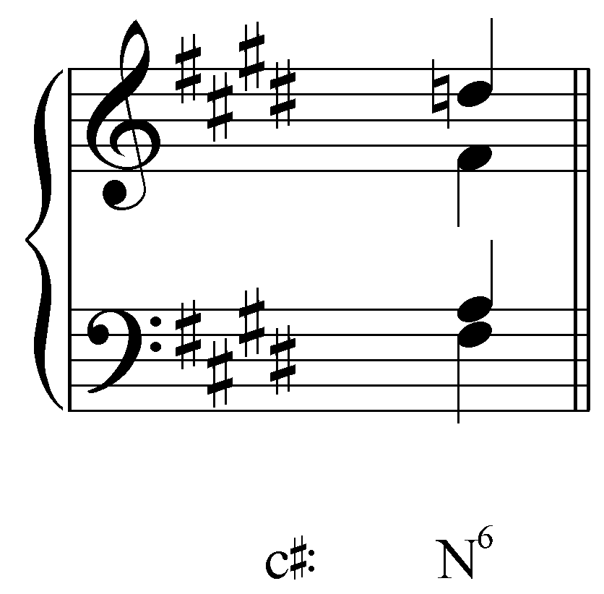 (answers may vary as long as F# is the lowest pitch and the upper voices consist of D natural, F# and A). Response if correct: “Correct!” Response if partially correct: “Almost! Remember, a Neapolitan resembles a major triad built on b2 with 4 in the bass.” Response if incorrect: “Incorrect. Remember, a Neapolitan resembles a major triad built on b2 with 4 in the bass.”]

Other positions of the Neapolitan:

Although the Neapolitan usually appears with scale degree 4 in the bass, other positions are possible. The following example shows one such instance:

Example 11 (F. Chopin, Prelude, Op. 28, no. 20, mm. 11-13):
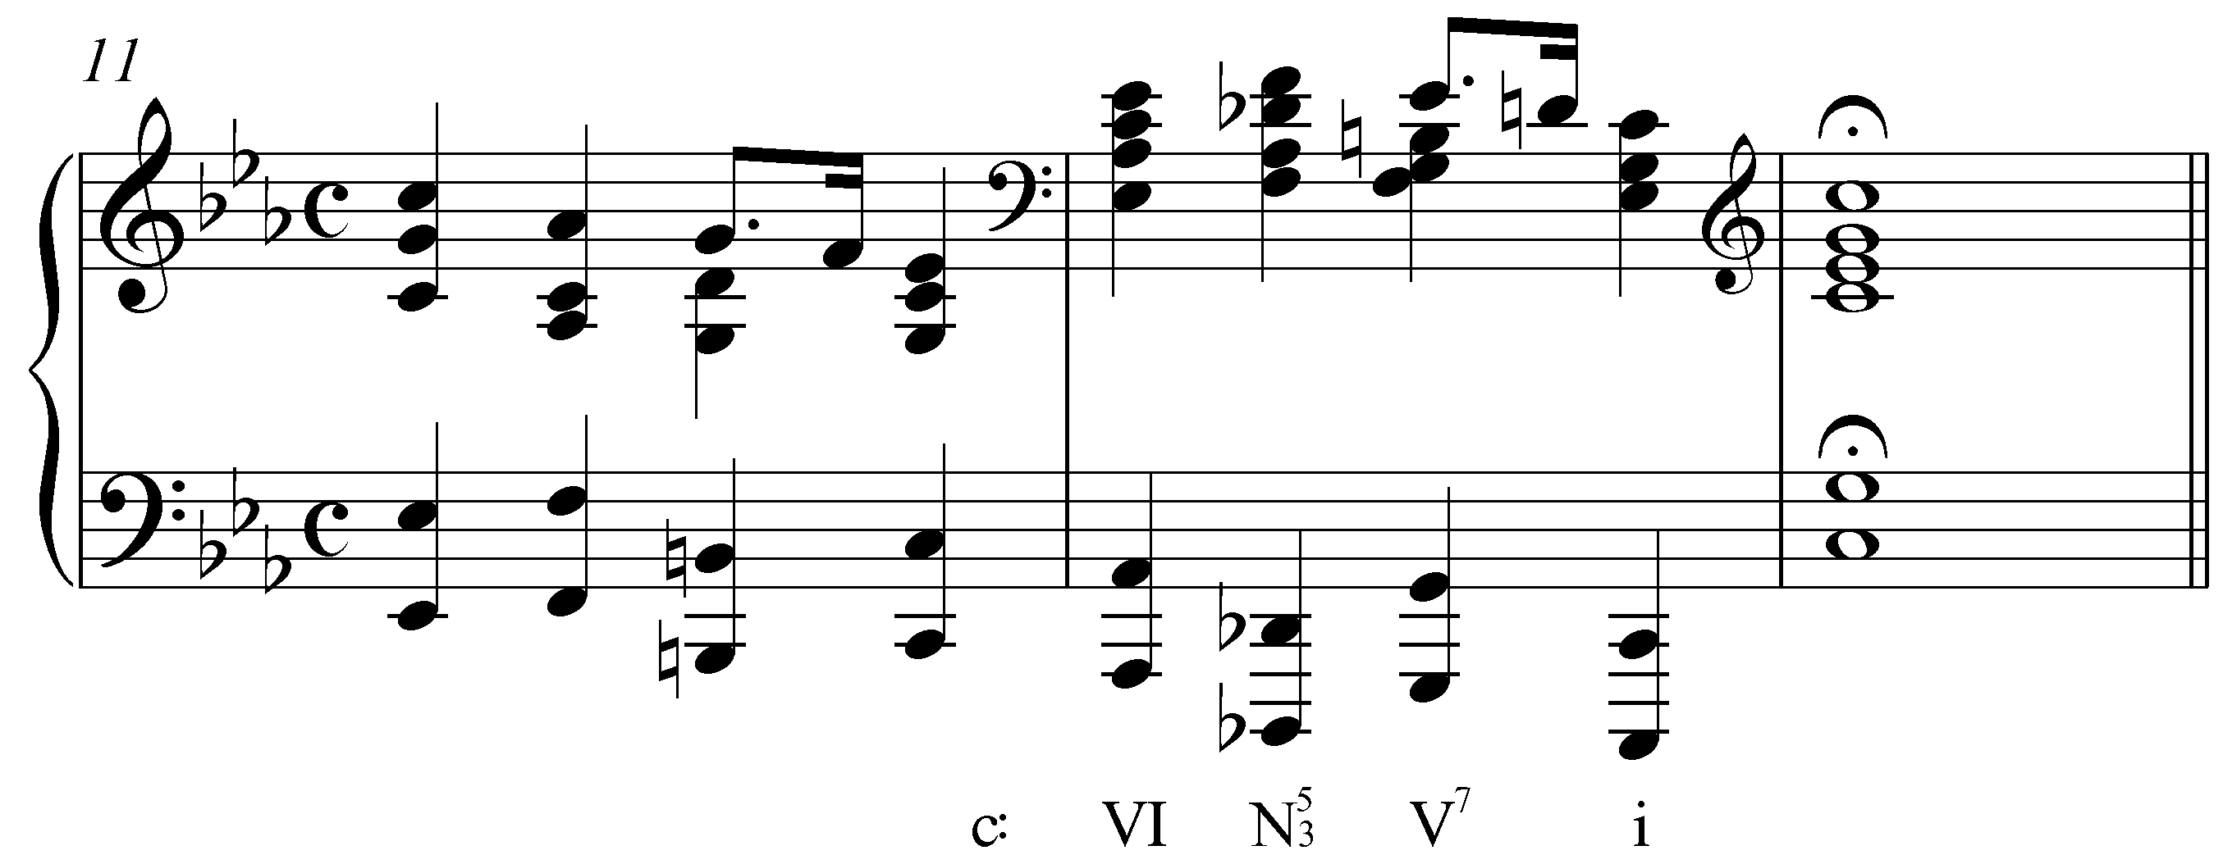

On the second beat of m. 12, Chopin uses a Neapolitan chord with the chromatic pitch (b2) in the bass. (Note that instead of N6, the chord is labeled N indicating the third and fifth that appear above the bass.) In doing so, he brings out the chord’s startling, dramatic effect by dramatizing the tritone in the low register when the bass, reinforced by octaves, leaps from Db to G. Cases of b2 in the bass supporting a Neapolitan are far less frequent than those with 4 in the bass.

Function and context:

Regardless of how you think of the Neapolitan chord— as a “frozen” neighbor-note embellishment of iv (IV in major) or as a chromatic root-alteration of iiº (ii in major)—it retains the pre-dominant function of its origin. In other words, the Neapolitan chord routinely signals and leads to some form of dominant. It frequently moves directly to the dominant (V or V⁷), as in the following excerpt from a song by Schubert:

Example 12 (F. Schubert, “Der Müller und der Bach,” from Die Schöne Müllerin, mm. 6-10):
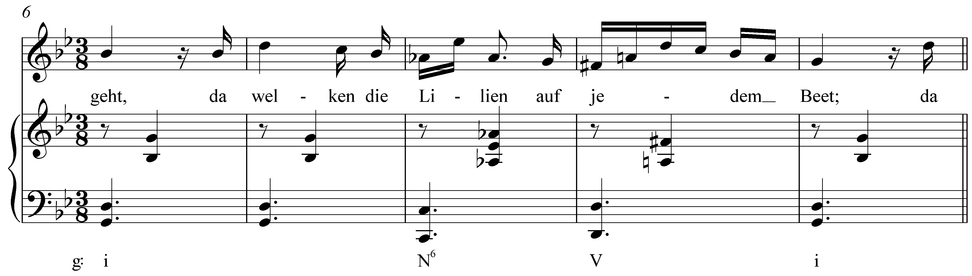

Here the Neapolitan chord appears in m. 8 after two full measures of tonic harmony. It then moves directly to a V chord in the following measure which in turn resolves to i at the end of the phrase.

Note that in Example 12, b2 (Ab) is emphasized as the highest note in the piano part and leaps down a diminished third to the leading tone (F#). While a diminished melodic interval would typically be avoided, composers tend to highlight it in the case of the Neapolitan by putting it in the soprano. Like the leading tone, b2 is only a semitone away from the tonic and as such has a strong tendency to resolve to 1. However, because the Neapolitan is a pre-dominant chord, the dominant chord further delays the resolution to 1. The heightened harmonic tension brought on by this delay makes the Neapolitan chord a potent dramatic tool.

The lowered second scale degree can also lead to the diatonic second scale degree. This tends to be restricted to inner voices, however, since the upward motion contradicts the tendency for b2 to resolve down to 1. In Example 12, Ab moves to A natural in an inner voice.

Activity MMM.04:
When analyzing Neapolitan chords, it is essential that you be able to recognize the altered pitch or pitches and trace the voiceleading from one chord to the next.

Exercise MMM.04
Identify the Neapolitan chord in the following excerpt from Beethoven’s “Moonlight” sonata (Op, 27, no. 2/i, mm. 1-5):
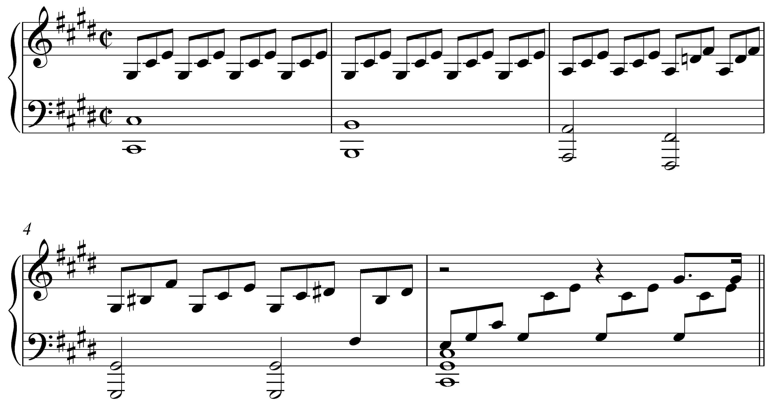
[Answer: students should click on the second half of m. 3. Response if correct: “Correct!” Response if incorrect: “Incorrect. Try again.”]

[Follow-up multiple-choice question:]
The second half of m. 3 has a Neapolitan chord. Does the b2 of the Neapolitan move to the leading tone or diatonic 2?
[Choices: “leading tone”, “diatonic 2”.]
[Answer: leading tone. Response if correct: “Correct! b2 leaps down a diminished third to the leading tone.” Response if incorrect: “Incorrect. Try again.”]

In other cases, the Neapolitan does not move directly to the dominant. Instead, an intervening chord may delay the dominant. Consider the following examples:

Example 13 (F. Schubert, “Erlkönig,” mm. 140-148):
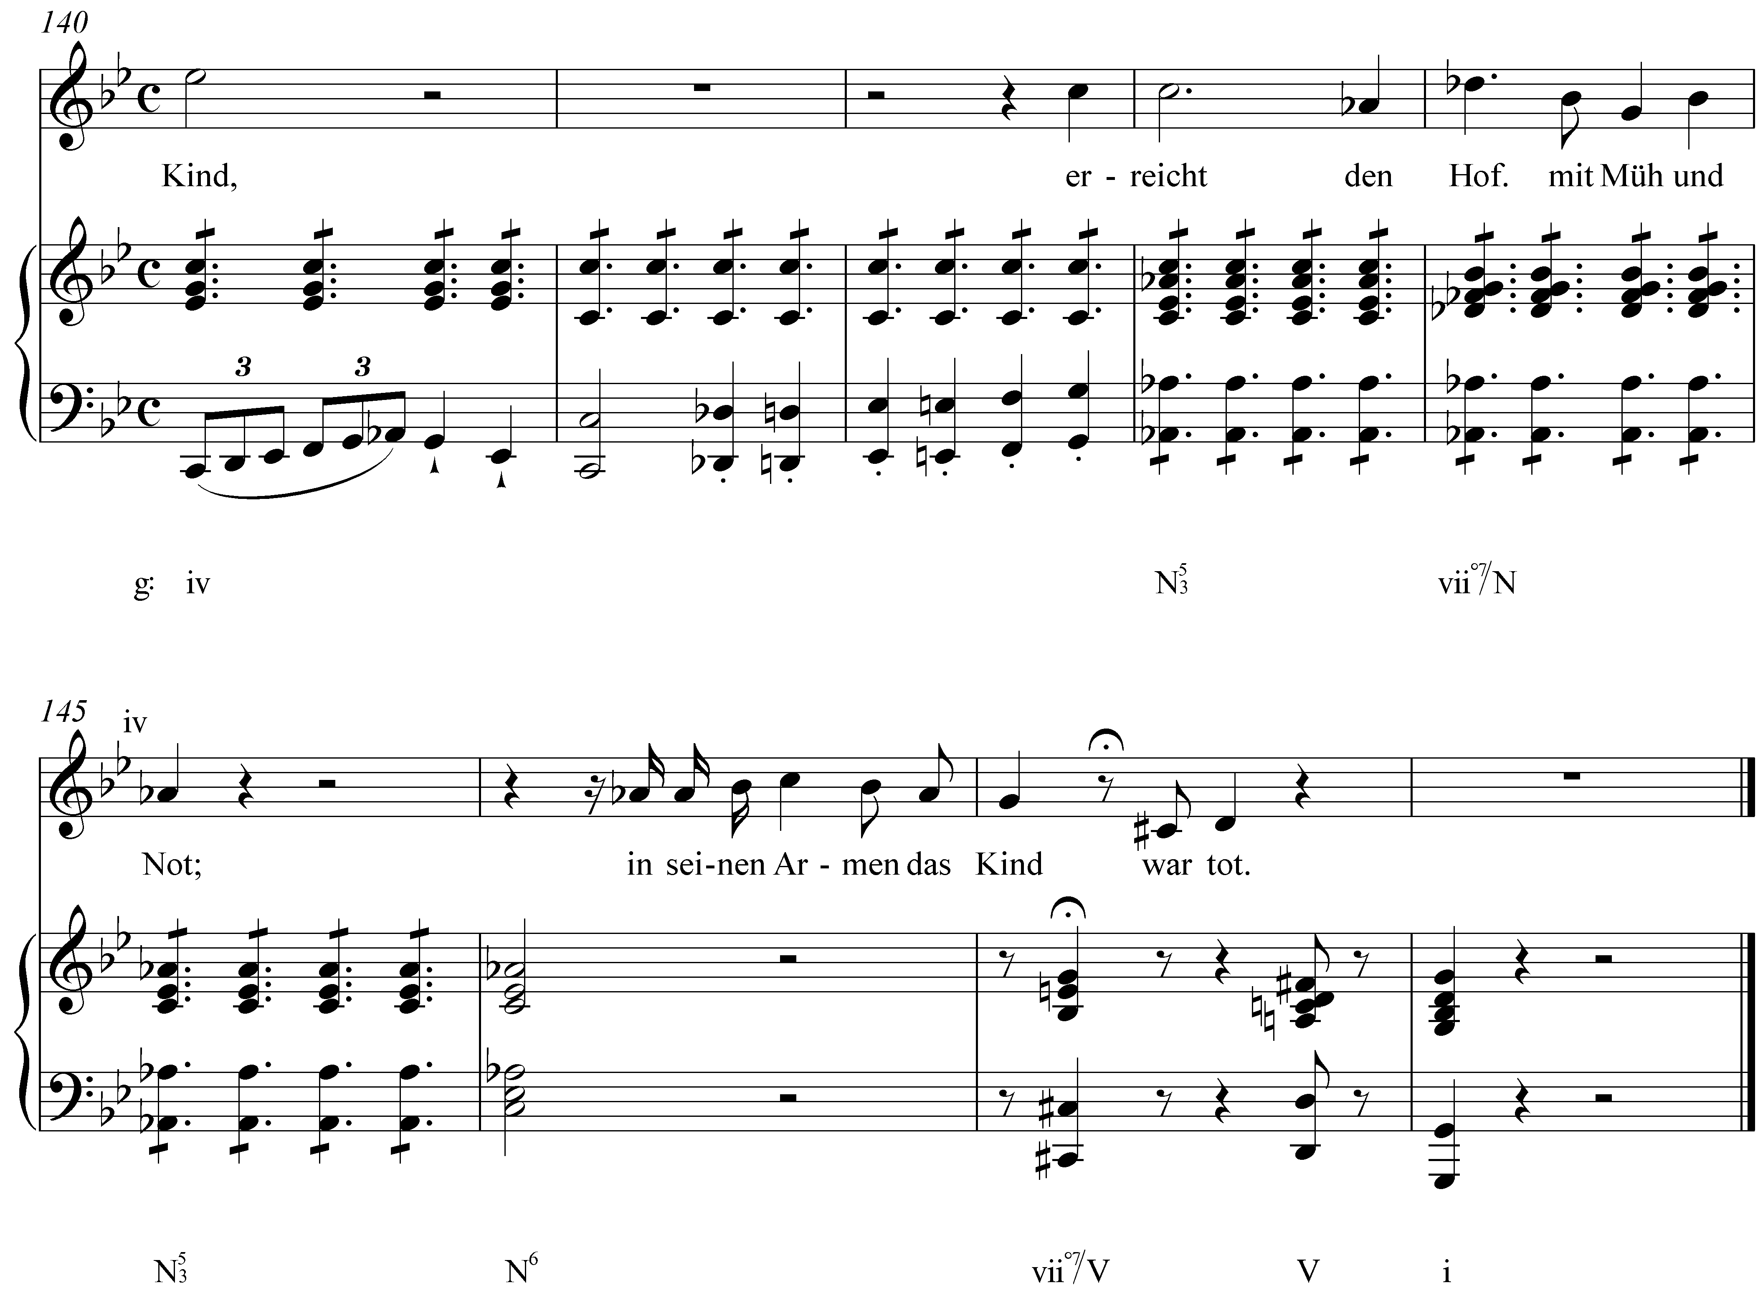

Example 14 (J.S. Bach, BWV 2.6, “Ach Gott, vom Himmel sieh’ darein,” mm. 1-4):
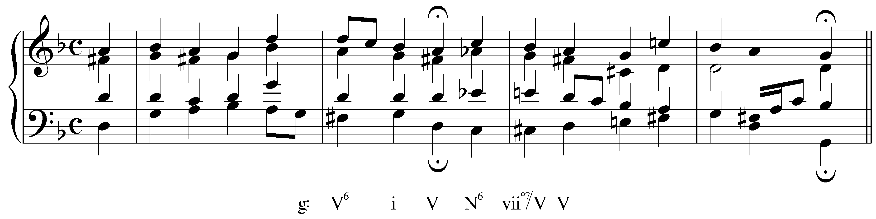

The Neapolitan chord in Example 13—itself embellished with an auxiliary sonority in m. 144—leads to an applied vii^{o7}/V in m. 147 before moving to the cadential V chord. Bach found use for this same technique a century earlier, as shown in Example 14. Here, an unprepared Neapolitan is used to begin a phrase following a half cadence. A vii^{o7}/V delays the dominant, which arrives one beat later. (Note that despite the key signature of a single flat, this excerpt is in G minor. In Bach’s time, it was common for minor key signatures to be written with one less accidental, owing to remnants of the modal system.)

Example 15 shows a similar situation in which the Neapolitan leads to a cadential chord:

Example 15 (F. Mendelssohn, Song Without Words, Op. 102, no. 4, mm. 3-7):
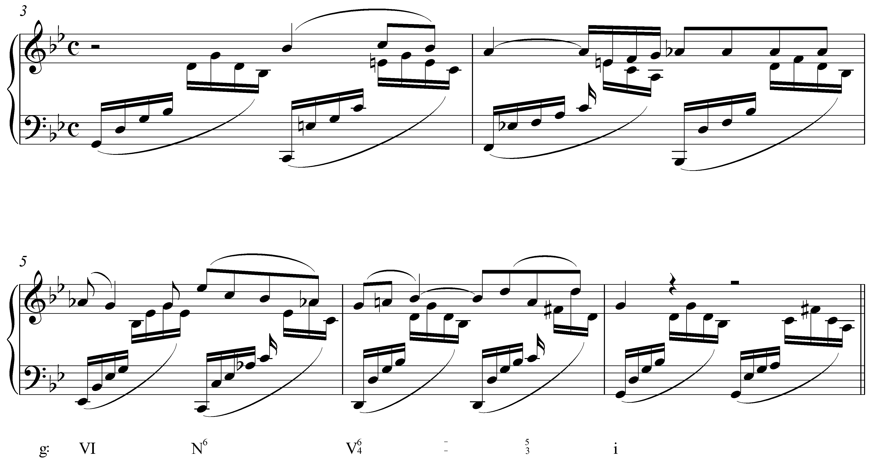

Note that in this example, the VI chord preceding the Neapolitan can also be interpreted as an applied dominant (continuing falling fifth pattern from the previous measures). If the first half of m. 5 is regarded as V/N, then the Neapolitan in this case has loosened its ties to the original iv chord with 5-6 motion over the bass (4). The Neapolitan has taken on a harmonic identify of its own, by virtue of the preceding applied dominant. We will return to this topic momentarily in the section on tonicizing the Neapolitan.

Whether the Neapolitan proceeds to an applied diminished seventh chord (as in Examples Example 13 and Example 14) or to a cadential (Example 15), b2 may at first appear to resolve melodically directly to 1. But that 1 is a false resolution and is not heard as a true arrival since it is not supported by consonance with the bass. It acts instead as a passing tone—a dissonant diminished fifth or perfect fourth above the bass—on the way to the leading tone. The melodic resolution of b2 occurs with the arrival of the leading tone over V, and the harmonic resolution occurs when that V resolves to I.

Activity MMM.05:
As a pre-dominant chord, the Neapolitan leads to dominant harmony. Sometimes, however, another pre-dominant chord intervenes. Recognizing this delay in the arrival of the dominant is an important part of analysis.

Exercise MMM.05
Identify the first appearance of the Neapolitan chord in the following excerpt from a Haydn piano sonata (Hob. 37/i, mm. 28-35). (Note that despite the key signature, this passage is in the key of A major.):
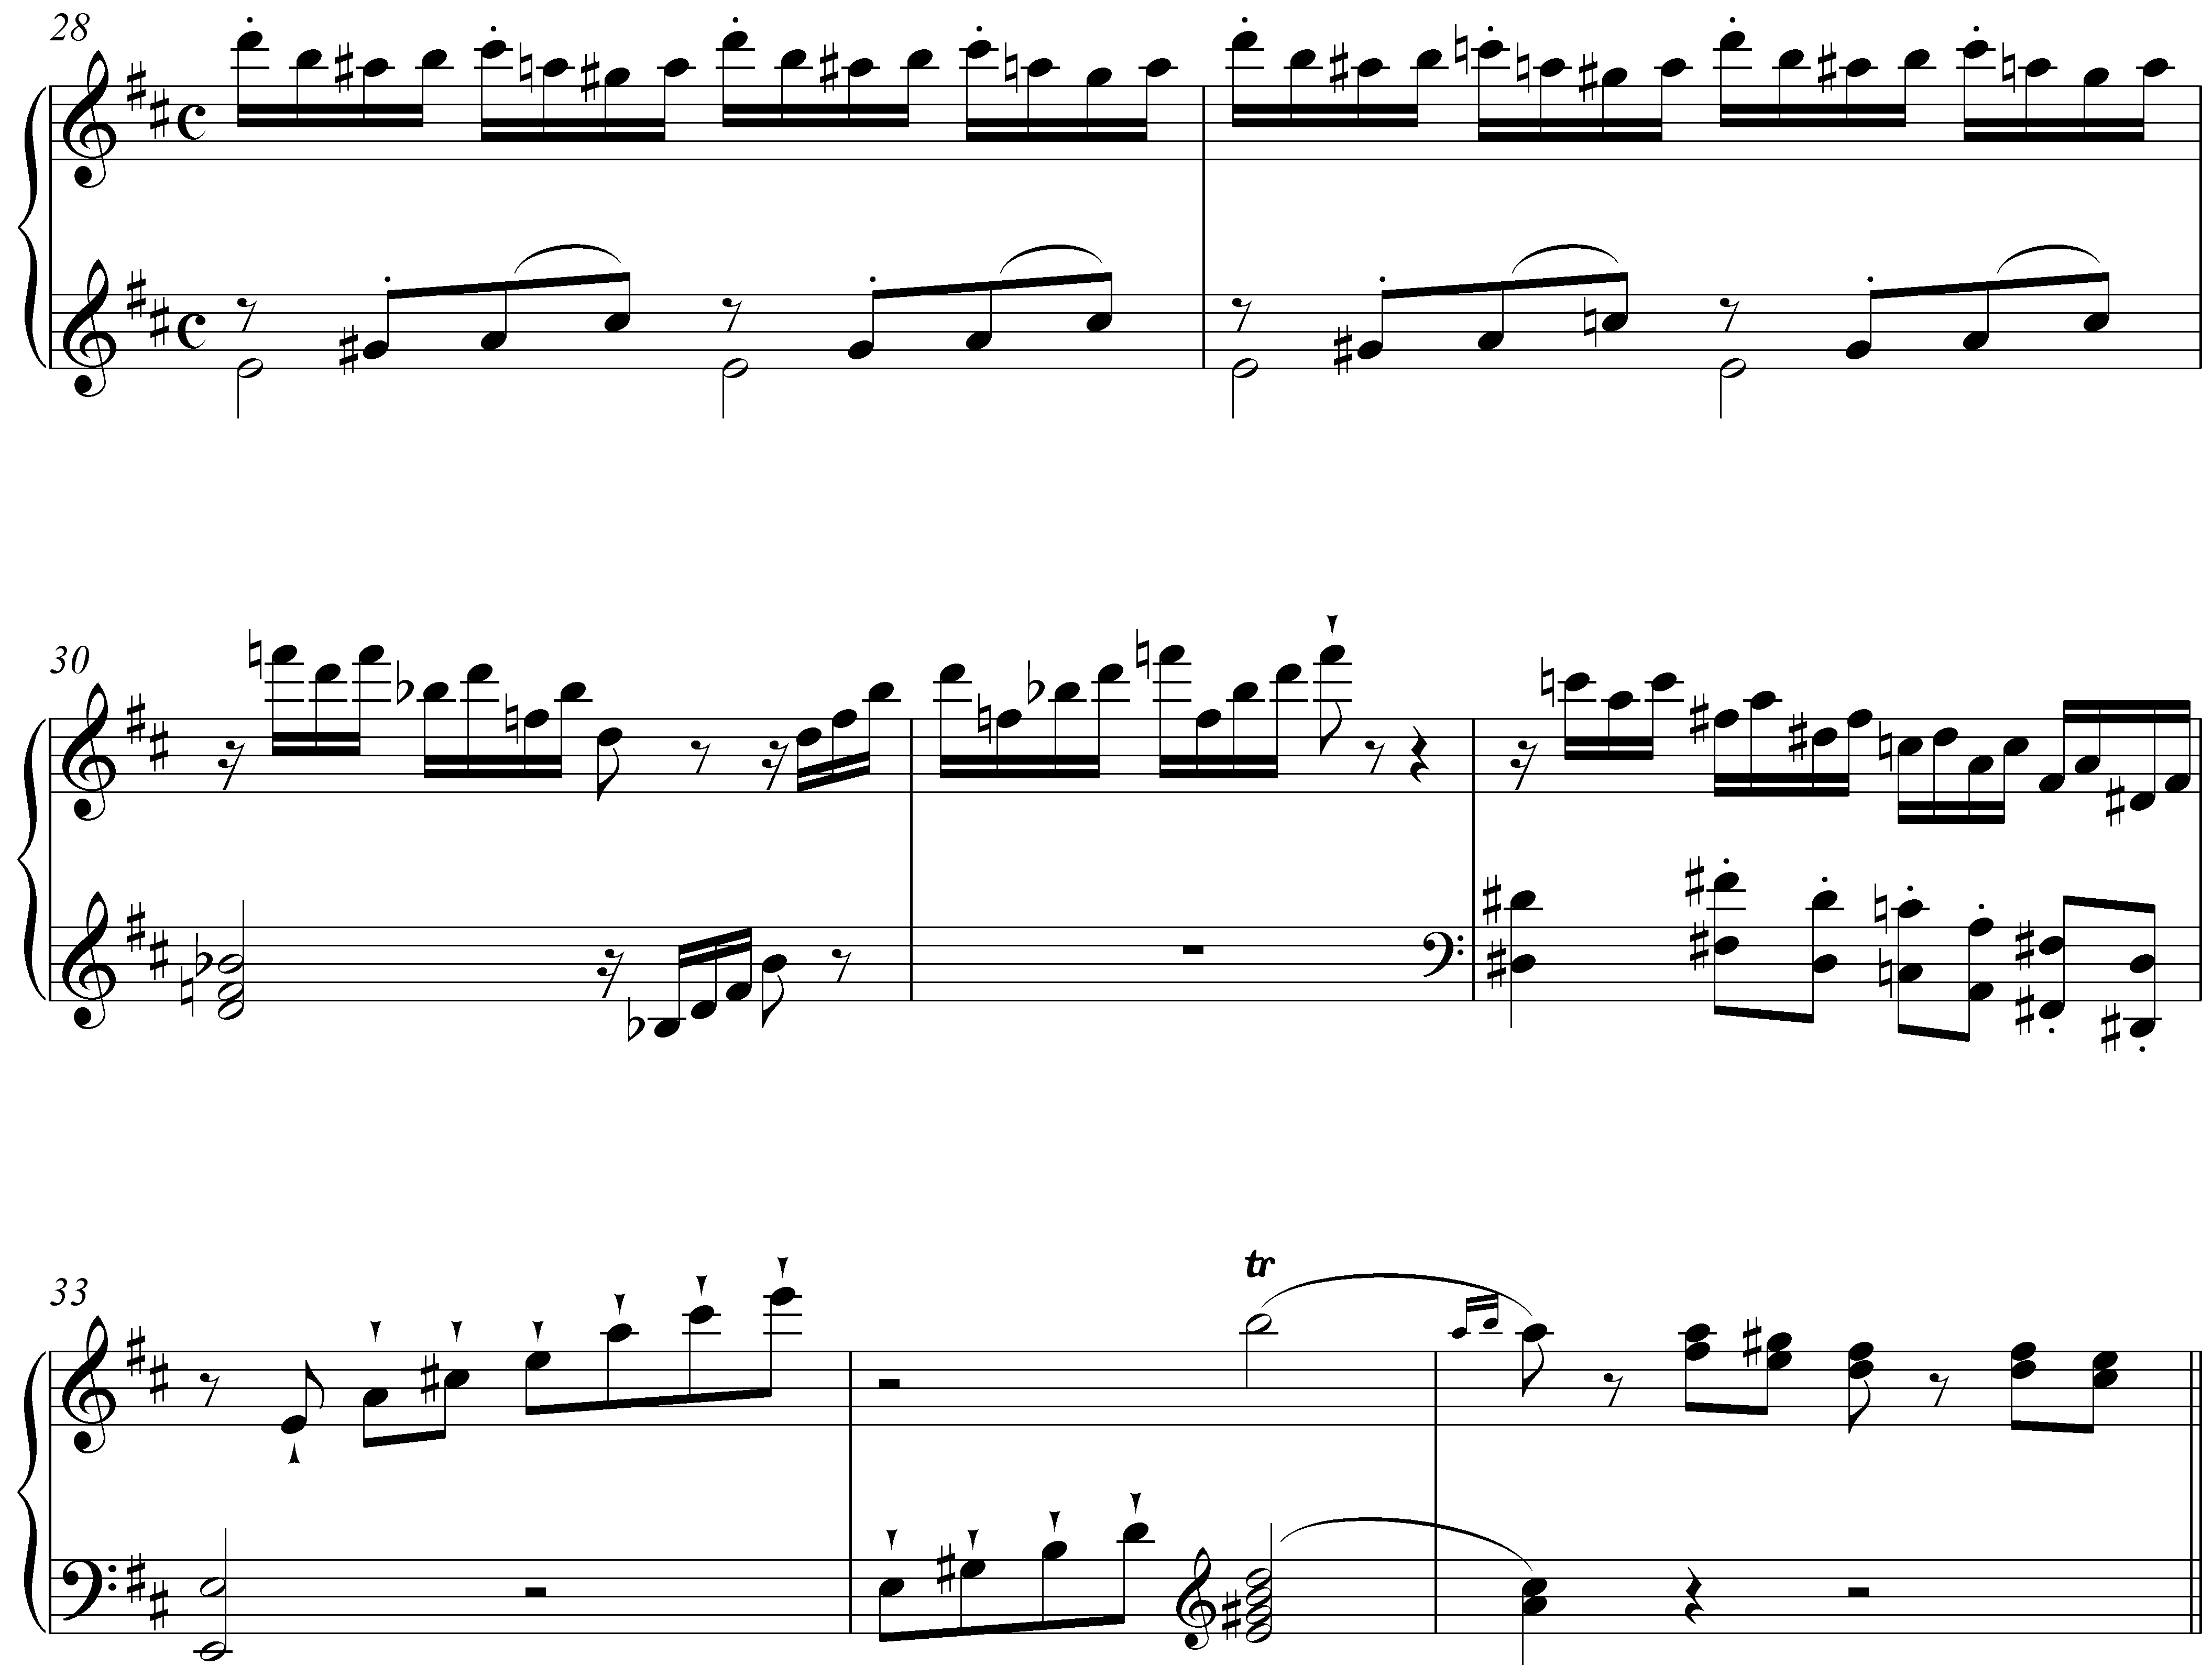
[Answer: students should click on m. 30 (specifically beat one). Response if correct: “Correct! The Neapolitan chord first appears on the downbeat of m. 30.” Response for m. 31: “Almost. M. 31 does contain Neapolitan harmony, but the chord appears earlier.” Response if incorrect: “Incorrect. (Hint: A good way to identify Neapolitan chords is to look for the expected chromatic alterations. In a major key, these are the lowered scale degrees 2 and 6.)”]

[Follow-up question:]
In this case, the Neapolitan does not move directly to the dominant. In what measure does the true dominant harmony arrive?
[Answer: m. 34. Response if correct: “Correct! M. 34 contains a dominant seventh chord.” Response for m. 33: “Almost. M. 33 does have the bass note of a dominant chord, but the upper voices are nonharmonic tones.” Response if incorrect: “Incorrect. (Hint: Look for a chord that measure whose pitches are that of a dominant seventh chord.)”]

[Two follow-up multiple-choice questions:]
The Neapolitan chord in mm. 30-31 eventually leads to a dominant seventh chord in m 34. What two other pre-dominant chords intervene?

Measure 32: [Choices: “vii^{o7}/V”, “iv”, “cadential ”, “ii⁶”]
[Answer: “vii^{o7}/V”. Response if correct: “Correct!” Response if incorrect: “Incorrect. Try again.”]

M. 33: [Choices: “iv⁶”, “V⁷/V”, “ii”, “cadential ”]
[Answer: “cadential ”. Response if correct: “Correct!” Response if incorrect: “Incorrect. Try again.”]

The same chords that are typically used to approach ii^{(o)6} are also used to approach the Neapolitan. Example 11 and Example 15 show Neapolitan chords following VI. Example 13 has a Neapolitan following iv—the Abs beginning in m. 143 act initially as chromatic upper neighbors to the fifth of the iv chord. Example 6 has a Neapolitan following ii. Example 1 and Example 3 approach the Neapolitan with tonic triads in first inversion, allowing for a stepwise ascent in the bass: 3 – 4 – 5.

Tonicizing the Neapolitan:

Composers frequently tonicize the Neapolitan. The structure of the minor scale makes this particularly convenient since the diatonic VI chord is enharmonically equivalent to the dominant of the Neapolitan. In other words, the progression VI – N⁶ can sound like a tonicization of the Neapolitan since the root motion is the same as V – I. Consider the following example:

Example 16 (F. Chopin, Mazurka, Op. 7, no. 2, mm. 12-16)
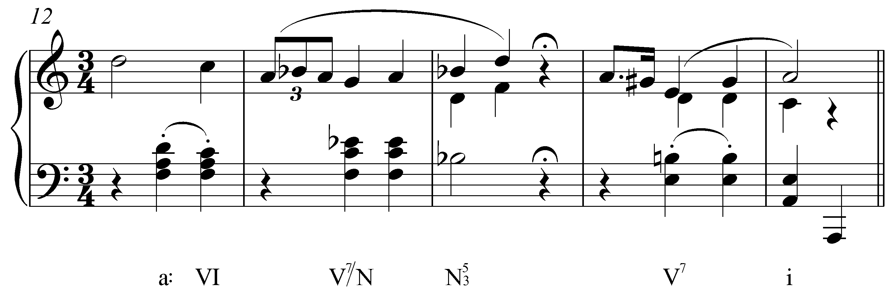

In this excerpt from a Chopin Mazurka, the Neapolitan is tonicized with an applied dominant seventh chord in m. 13. This applied chord is derived by adding a minor seventh above the root of the preceding VI chord (Eb). Composers will occasionally expand this sort of tonicization by modulating to the key of the Neapolitan for extended passages. Tonicizations of—and modulations to—the Neapolitan in a minor key are possible because, as pointed out earlier, chromatically altering 2 to become b2 stabilizes the unstable, diminished iiº triad into a major triad, bII.

The following excerpt provides another example of a tonicized Neapolitan

Example 17 (J.S. Bach, Trio Sonata for Organ no. 4 in E minor, Mvt. ii, mm. 1-3):
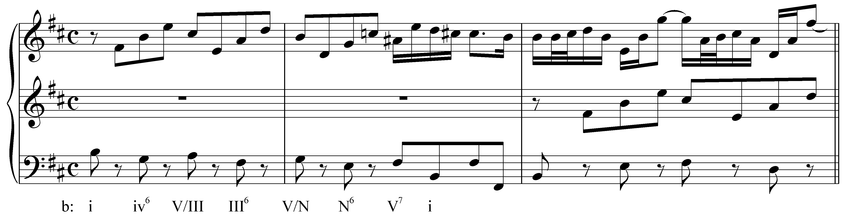

This passage from a Bach trio sonata for organ includes a Neapolitan chord in the opening phrase. On the second beat of m. 2, we see an E in the bass with G and C natural in the upper voice—a textbook example of a Neapolitan chord. Preceding this, we find a VI chord consisting of G in the bass with B and D in the upper voice. This chord can also be interpreted as an applied dominant to the Neapolitan. (It is labeled “V/N” in Example 17.) As an applied dominant, this tonicization of the Neapolitan continues a falling fifth progression begun in the previous measure. By moving to the Neapolitan, Bach avoids the tritone root motion that would have resulted from progression VI – iiº.

No matter what the length—single chords, tonicizations, modulations—appearances of the Neapolitan soon lead to the dominant. Emphasizing the Neapolitan in this manner dramatizes the arrival of the dominant.

Activity MMM.06:
For each of the following exercises, identify the pitches of an applied dominant seventh chord on the Neapolitan of the specified key.

Exercise MMM.06a
In the key of D minor, what would be the root of V⁷/N?
[Answer: Bb. Response if correct: “Correct!” Response if incorrect: “Incorrect. (Hint: The root of V⁷/N is the fifth of the Neapolitan chord.)”]
[Follow-up question:]
What are the three remaining pitches of the dominant seventh chord whose root is Bb?
[Answers: D, F, Ab. Response if correct: “Correct!” Response if partially correct: “That is partially correct.” Response if incorrect: “Incorrect. Try again.”]

Exercise MMM.06b
In the key of A minor, what would be the root of V⁷/N?
[Answer: F. Response if correct: “Correct!” Response if incorrect: “Incorrect. (Hint: The root of V⁷/N is the fifth of the Neapolitan chord.)”]
[Follow-up question:]
What are the three remaining pitches of the dominant seventh chord whose root is F?
[Answers: A, C, Eb. Response if correct: “Correct!” Response if partially correct: “That is partially correct.” Response if incorrect: “Incorrect. Try again.”]

Exercise MMM.06c
In the key of D major, what would be the root of V⁷/N?
[Answer: Bb. Response if correct: “Correct!” Response if incorrect: “Incorrect. (Hint: The root of V⁷/N is the fifth of the Neapolitan chord.)”]
[Follow-up question:]
What are the three remaining pitches of the dominant seventh chord whose root is Bb?
[Answers: D, F, Ab. Response if correct: “Correct!” Response if partially correct: “That is partially correct.” Response if incorrect: “Incorrect. Try again.”]

Exercise MMM.06d
In the key of F# minor, what would be the root of V⁷/N?
[Answer: D natural. Response if correct: “Correct!” Response if incorrect: “Incorrect. (Hint: The root of V⁷/N is the fifth of the Neapolitan chord.)”]
[Follow-up question:]
What are the three remaining pitches of the dominant seventh chord whose root is D natural?
[Answers: F#, A, C natural. Response if correct: “Correct!” Response if partially correct: “That is partially correct.” Response if incorrect: “Incorrect. Try again.”]

Conclusion:

The Neapolitan chord (sometimes referred to as Phrygian II) is notated as a major triad built on b2, but can be conceptualized in different ways. It can also be thought of as a melodically embellished subdominant chord whose fifth has been replaced by its chromatic upper neighbor—an explanation that accounts for the tendency of the Neapolitan to appear with 4 in the bass, and for the bass, as root, to be doubled. It can also be thought of as a chromatically altered ii^{(o)} chord, in which the root has been lowered by a semitone.

The respective Neapolitan chords of parallel keys contain the same tones, though two accidentals are required in major as opposed to the single accidental required in minor. Neapolitan chords appear far more frequently in minor keys, in part because they avoid the tritone between 2 and 6 in the iiº chord.

As a pre-dominant chord, the Neapolitan’s function is to lead to the dominant. It often does this directly—moving to V or V⁷ without delay—though frequently an applied chord or cadential intervenes. Any chord used to approach ii^{(o)6} can also precede a Neapolitan: i, i⁶, VI, or iv among others. Composers also tonicize it or modulate to that key. In any case, the Neapolitan eventually leads to some form of dominant harmony.

All in all, the Neapolitan is generally used as an expressive device. The chromatic alteration is striking in any context and is often used to heighten the dramatic tension of important passages.
Alternate examples:
Example 18 (L. Beethoven, Bagatelle, Op. 119, no. 5, mm. 13-16):
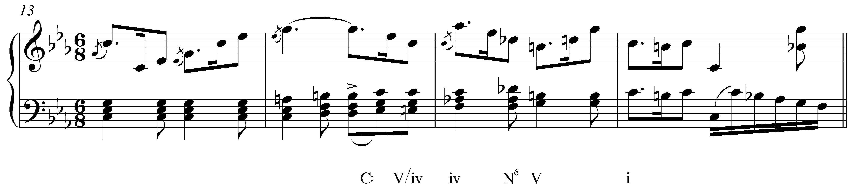
(Rothfarb: “Forte then shows in an example from Beethoven's Bagatelle, op. 119/5 9 (in C minor) a Neapolitan that clearly arises from iv, in m. 3, where a iv arrives following a V7/iv, and is immediately transformed into a Nepolitan sixth when the chord fifth is melodically inflected to a 6th.”)

Example 19 (J.S. Bach, Well Tempered Clavier book 2, Prelude in F# minor, mm. 30-36):
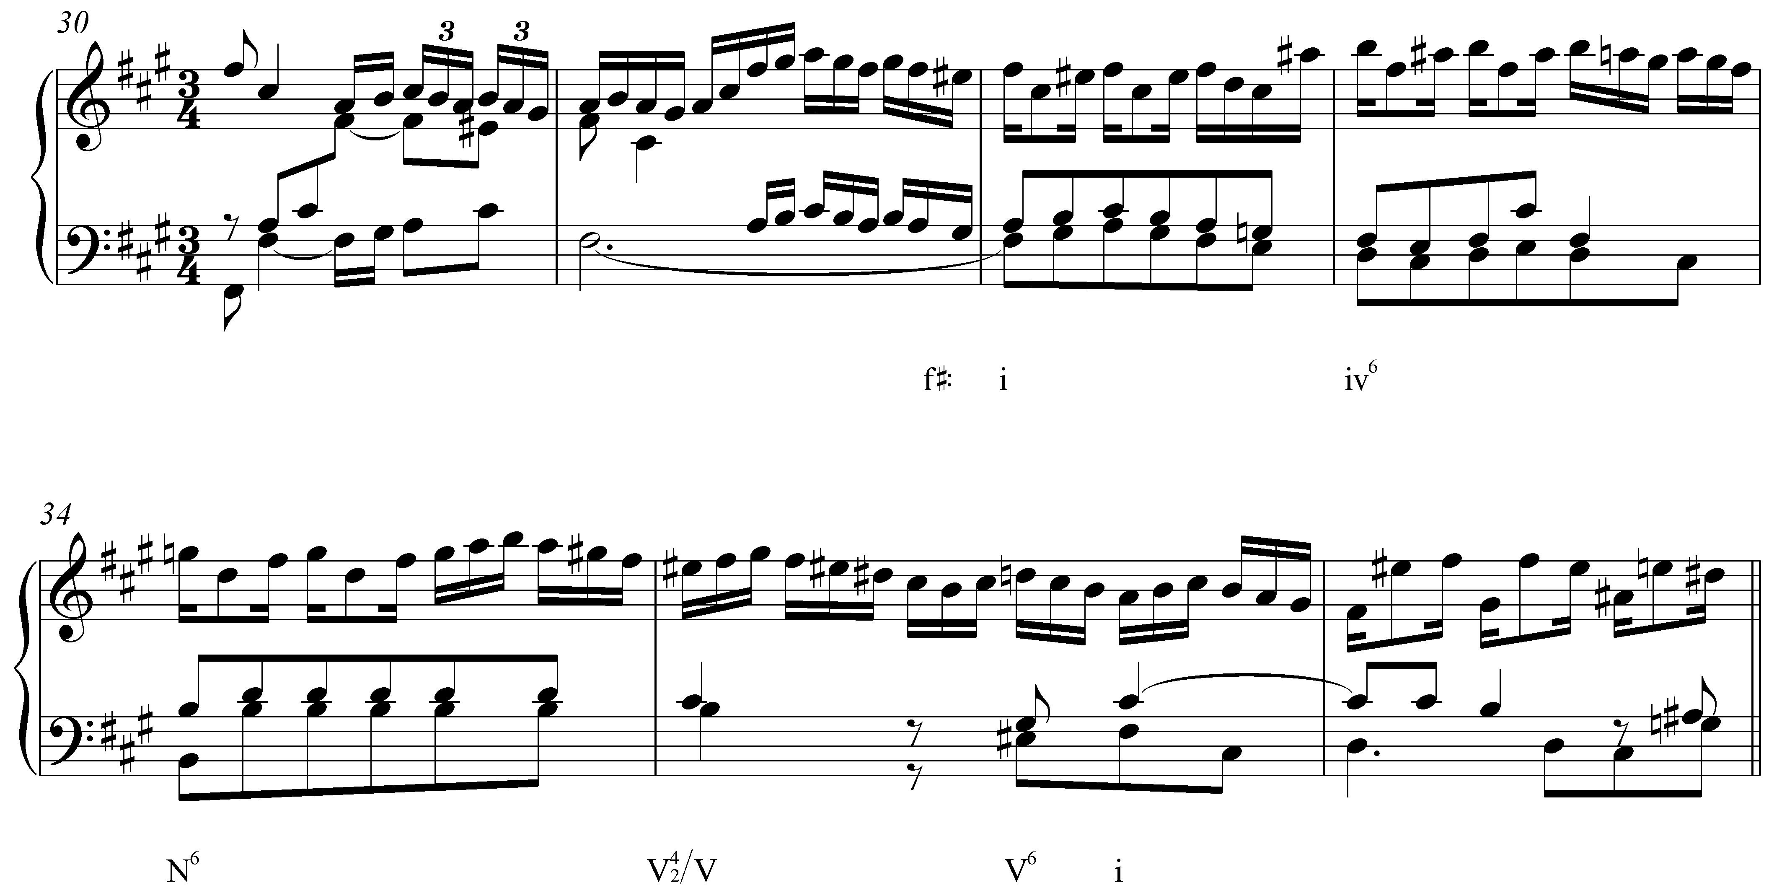
(Rothfarb: “There, you see a i moving to a iv6 (B minor chord) in m. 33. The fifth (F#) of the B-minor chord is stressed in the treble voice through syncopation and repetition throughout m. 33. At the end of m. 33, the bass, a D, descends through a PN (C#) to B, root of the iv, in m. 34, while the treble emphasizes G. So, when the bass D, third of a B-minor chord, iv) descends to a B, root of the iv, the treble slides up to G, creating a N6.”)

Example 20 (J.S. Bach, Orchestral Suite No. 2 (B minor), Badinerie, mm. 27-40):
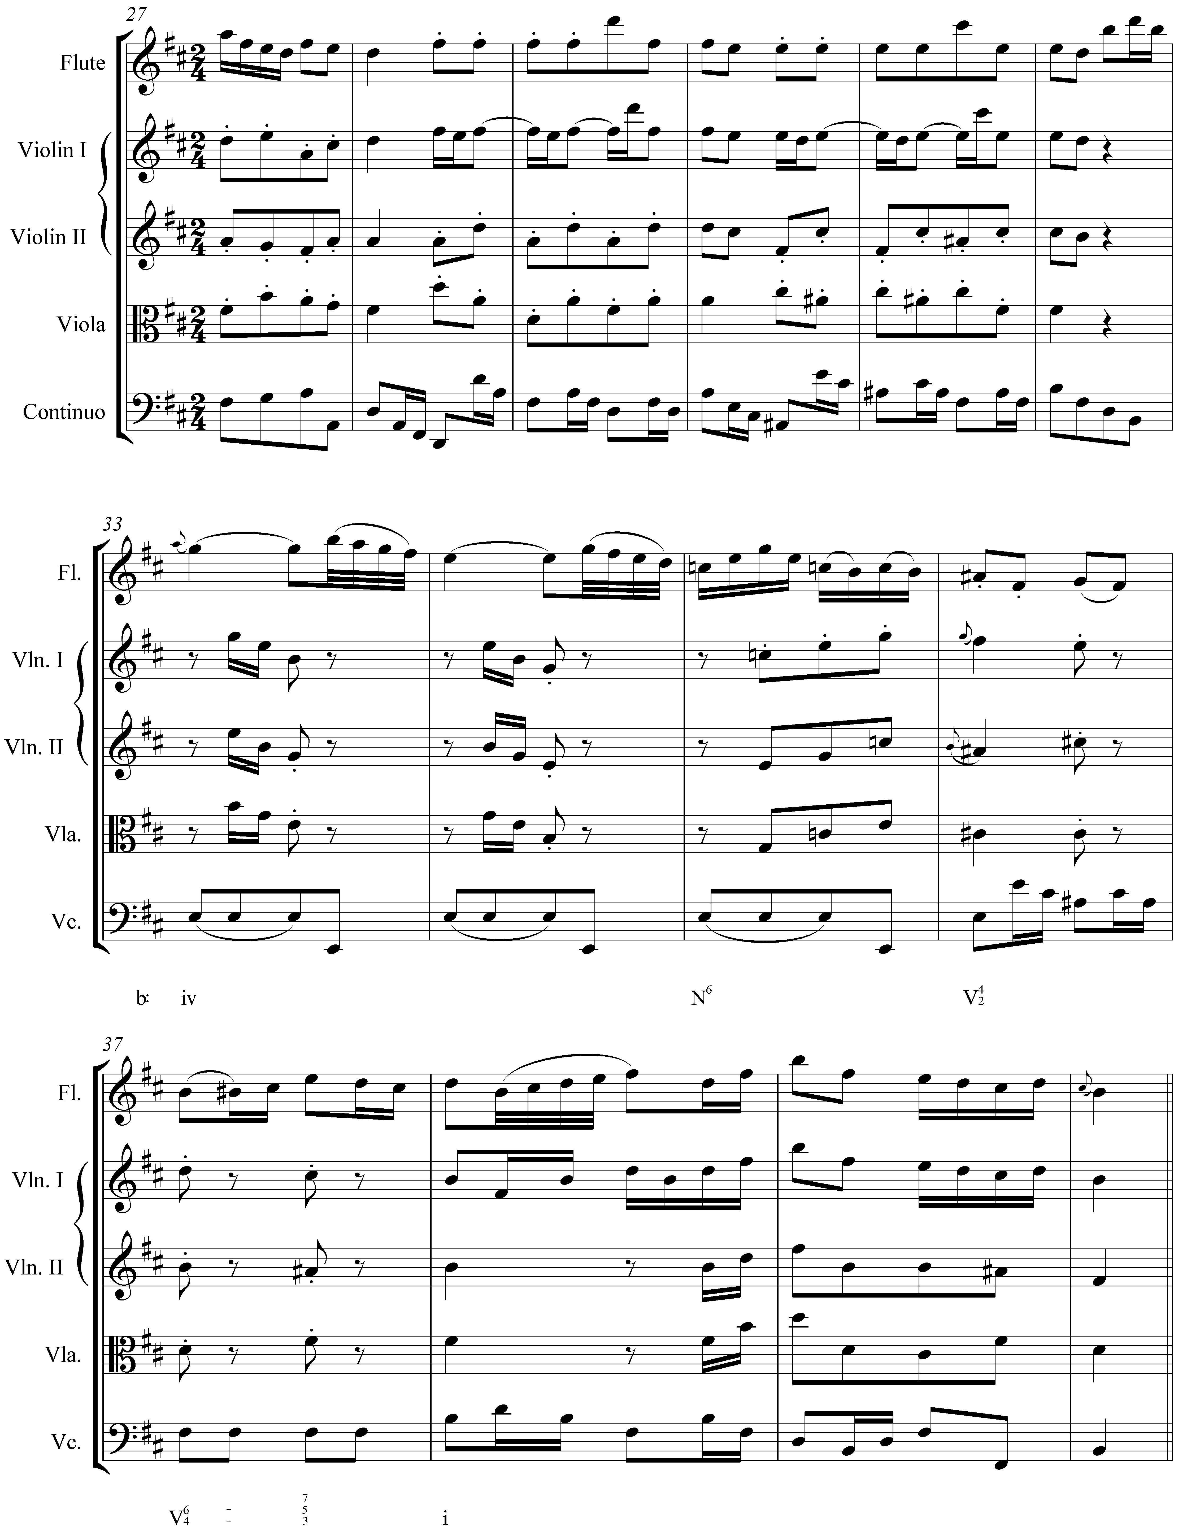
(Rothfarb: “In mm. 33-34, we have a root-position iv chord (E minor with E in the bass). In m. 35, while the bass (and bass pattern) remain the same, on E, the chordal fifth, B, slides up a half-step to C, a clear 5-6 that creates an N6. The next chord is a V4/2, retaining the E in the bass.”)

Example 21 (F. Mendelssohn, Songs Without Words, Op. 38, no. 2, mm. 56-59);
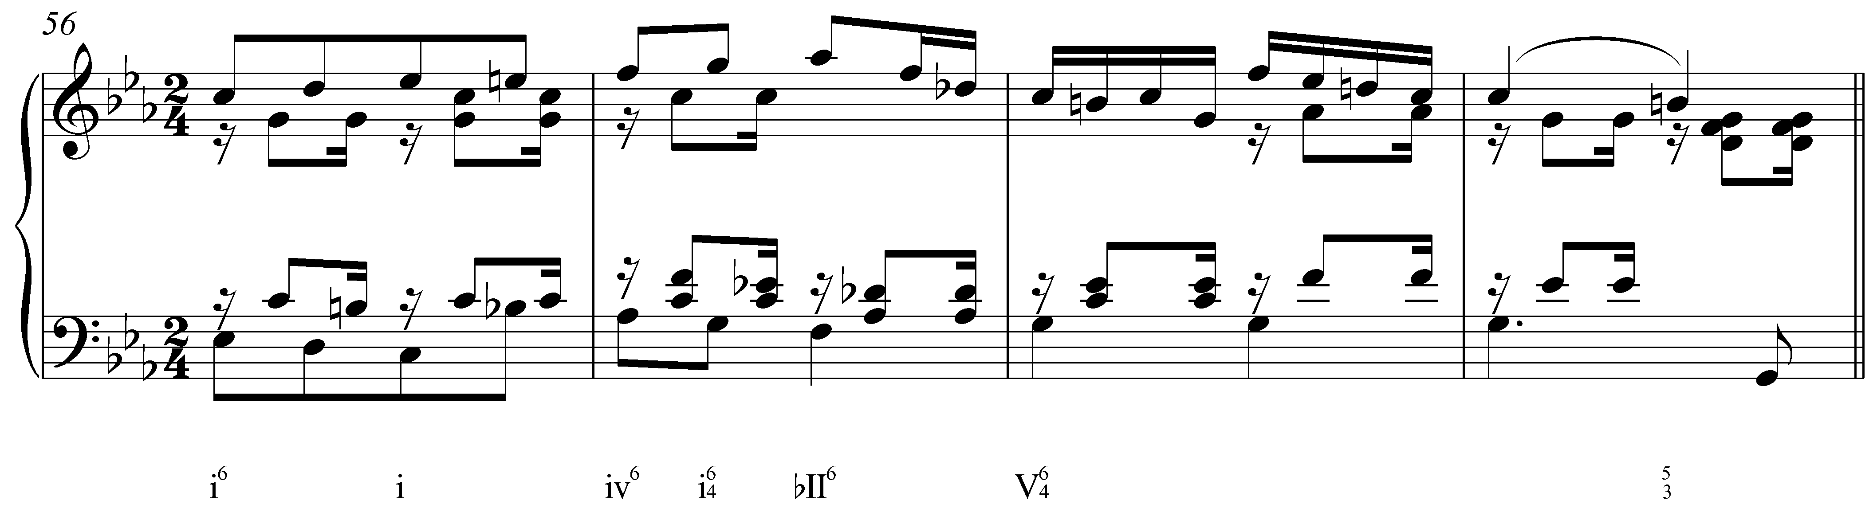

Example 22 (F. Schubert, Die Schöne Müllerin, “Die böse Farbe,” mm. 12-22):


