- Introduction
  - Viio triad
    - Example showing how the bass of viio6 is consonant with the upper voices

Example 1:
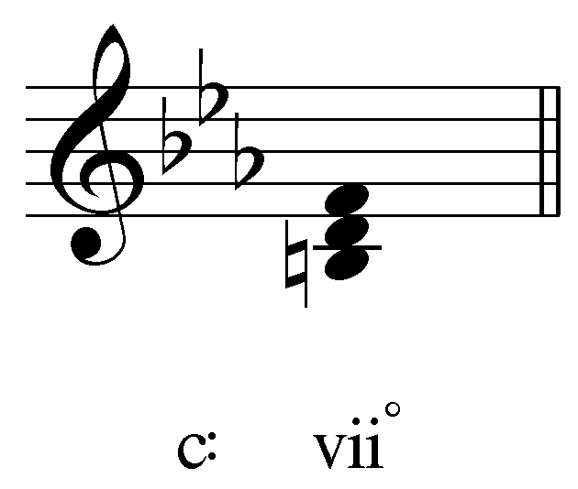

Example 2:
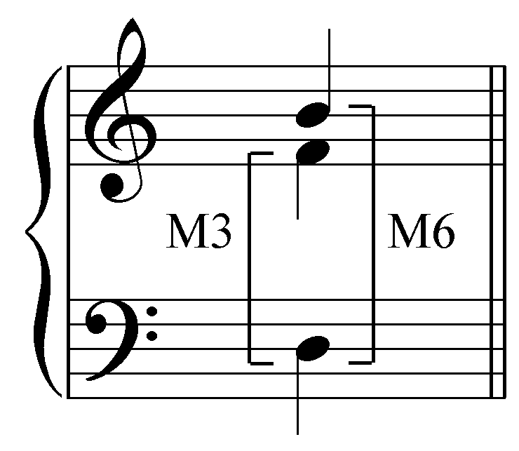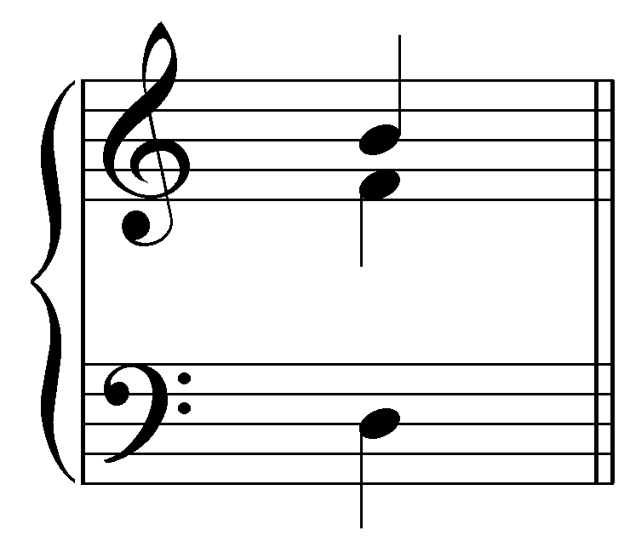

    - The diminished fifth is hidden in the inner voices between the tenor and alto: it is a resultant interval formed by the avoidance of dissonance with the bass.
  - Viio7 has a diminished seventh added on top

Example 3:
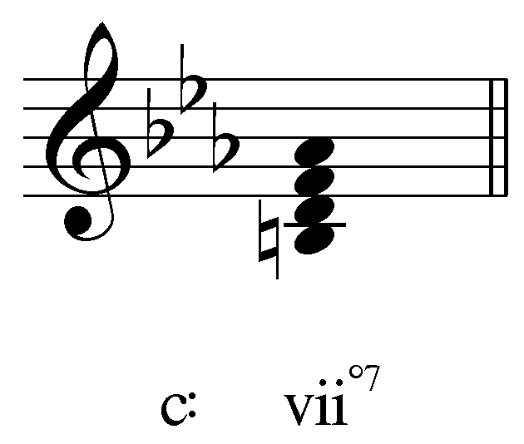

  - In this lesson:
    - Construction
    - Resolution
    - Function
    - Other uses:
      - common tone auxiliary sonority
      - modulation via enharmonic equivalence
- Construction/Function/Resolution:
  - Construction:

Example 4:
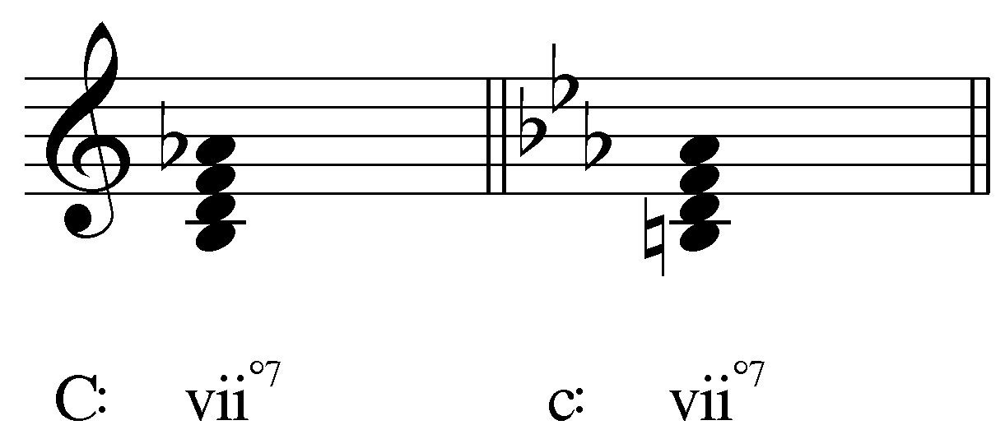

    - Viio7
      - Diminished triad + diminished seventh
      - Necessarily includes a non-diatonic tone
        - Doesn’t occur diatonically (LT seventh chord in minor)
      - Two interlocking tritones

Example 5:
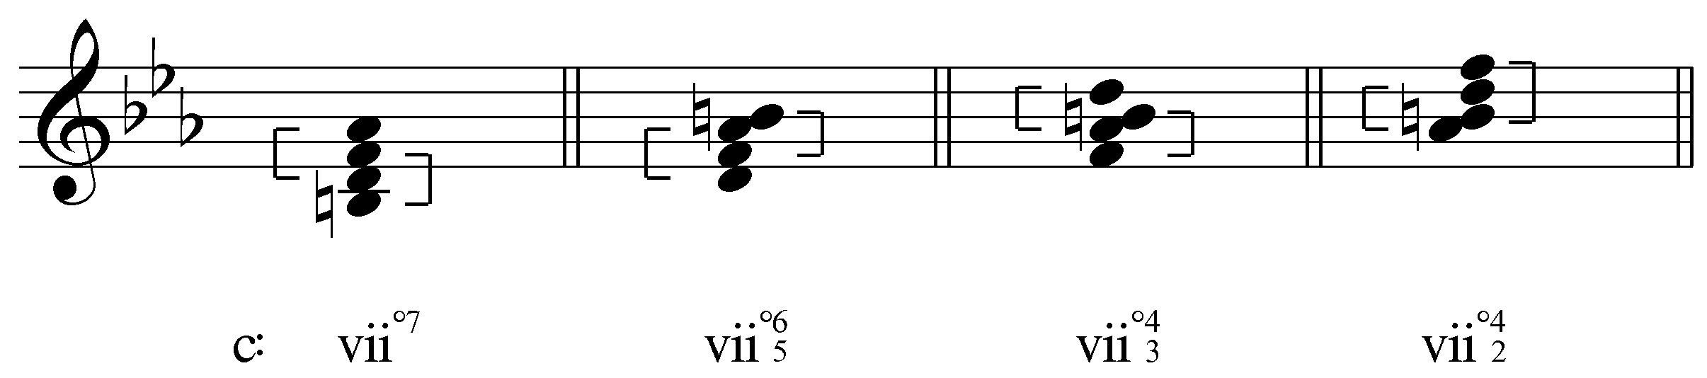

      - Unlike the triad, the bass inevitably forms a dissonant tritone with one of the upper voices
      - Unique sound that makes it very versatile in tonal music
    - Note on half-diminished seventh chords:

Example 6:
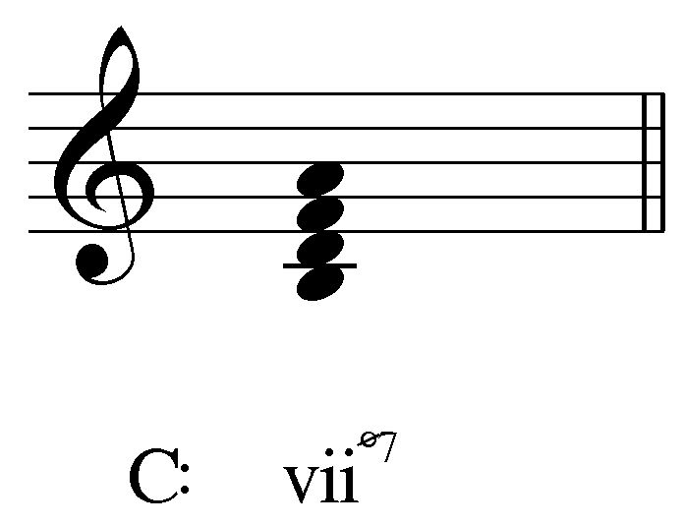

      - half diminished usually appears as a neighboring chord to I
        - only appears in major
        - risk of parallel fifths is even greater
  - Function:
    - Dominant function
      - Can substitute for V or V7
      - Shares 7 2 an 4 with V7

Example 7:
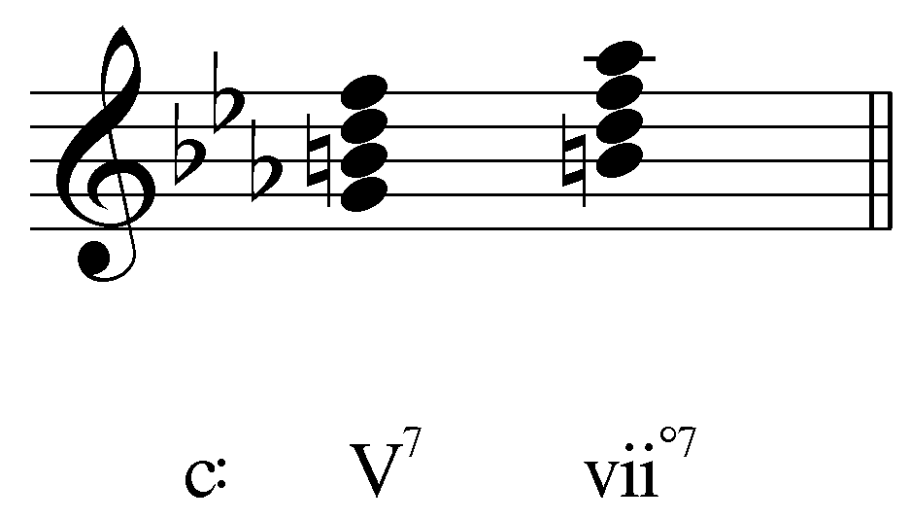

  - Resolution:

Example 8:
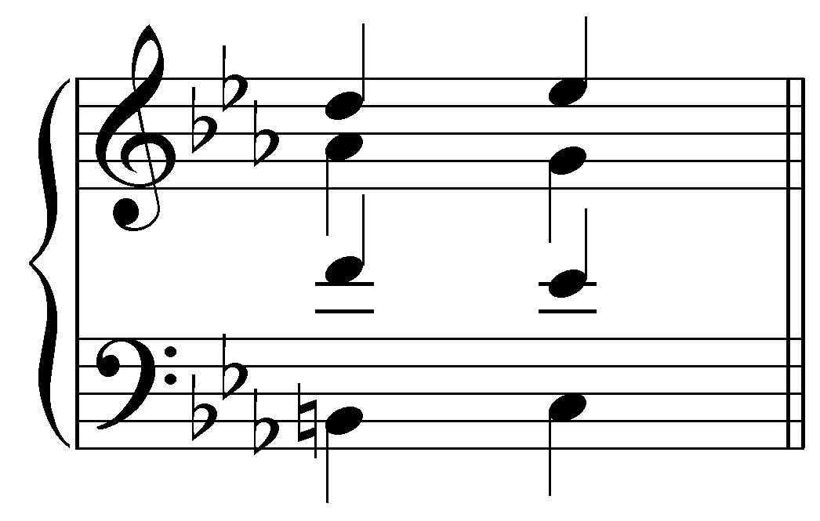

    - Treat the tritones with care
      - Unlike the triad, which typically conceals the tritone, the bass here always forms one
      - BIPs
      - contrary or similar motion
      - typically avoid similar motion
        - Similar motion to a P4 from an A4 is OK if restricted to the upper voices
    - 7th (6) goes down to 5 (See lesson 7 for more on seventh chords)
    - LT goes up to 1
    - 7 and 4 resolve typically to 1 and 3 respectively
    - chordal seventh (6) goes down (to 5)
    - 2 usually goes up to 3 or down to 1
    - can appear in any position
      - usually 42 is avoided since that would resolve to a i64 (cadential 64 is a possibility)

Example 9 (L. Beethoven, Sonata no. 8 (“Pathétique”), Op. 13, Mvt. I, mm. 1-8):
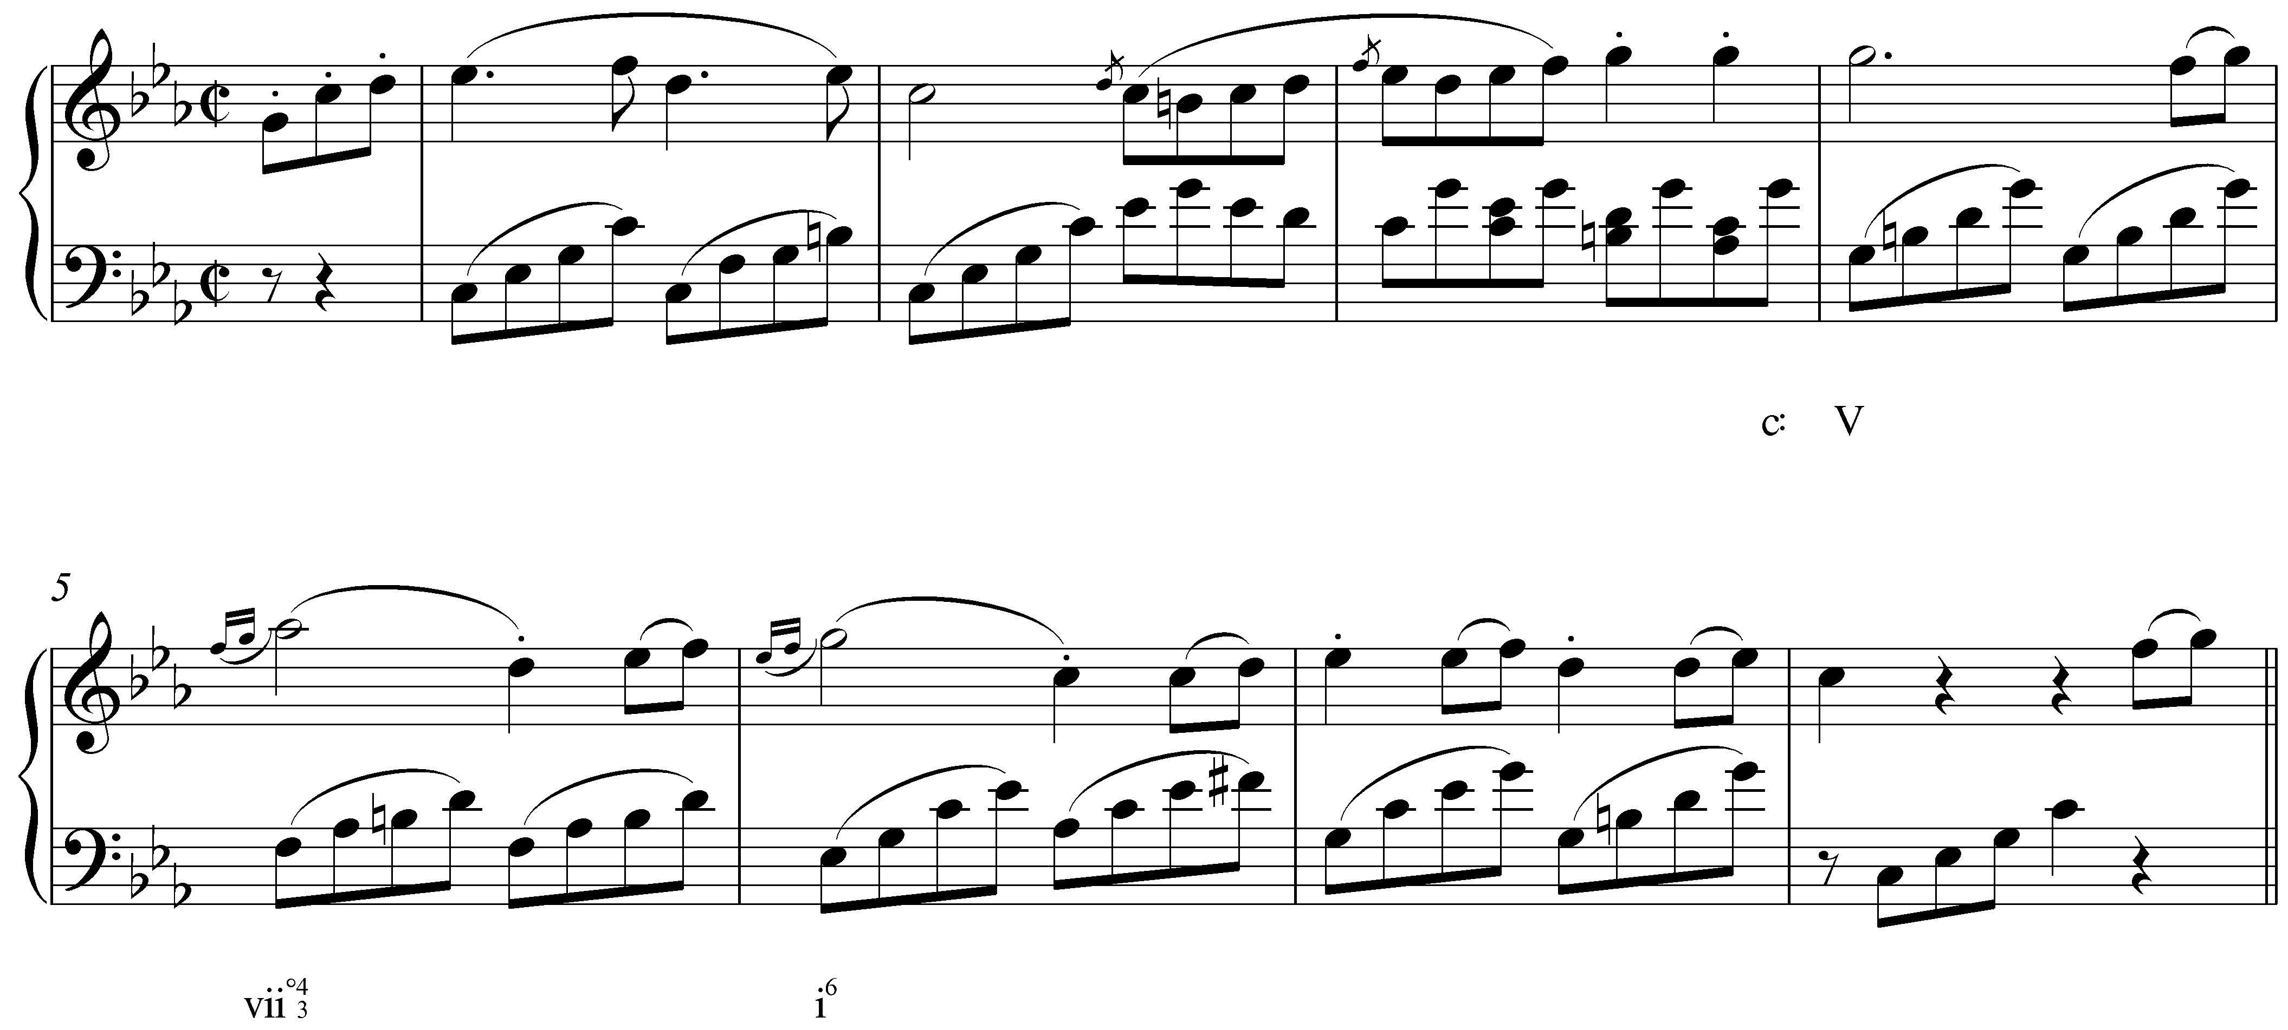

- As an applied chord
    - Can also be used as an applied chord
      - (applied vii chords can substitute for applied dominants)
      - all of the same rules apply

Example 10 (F. Schubert, “Erlkönig,” D 328, mm. 12-15):
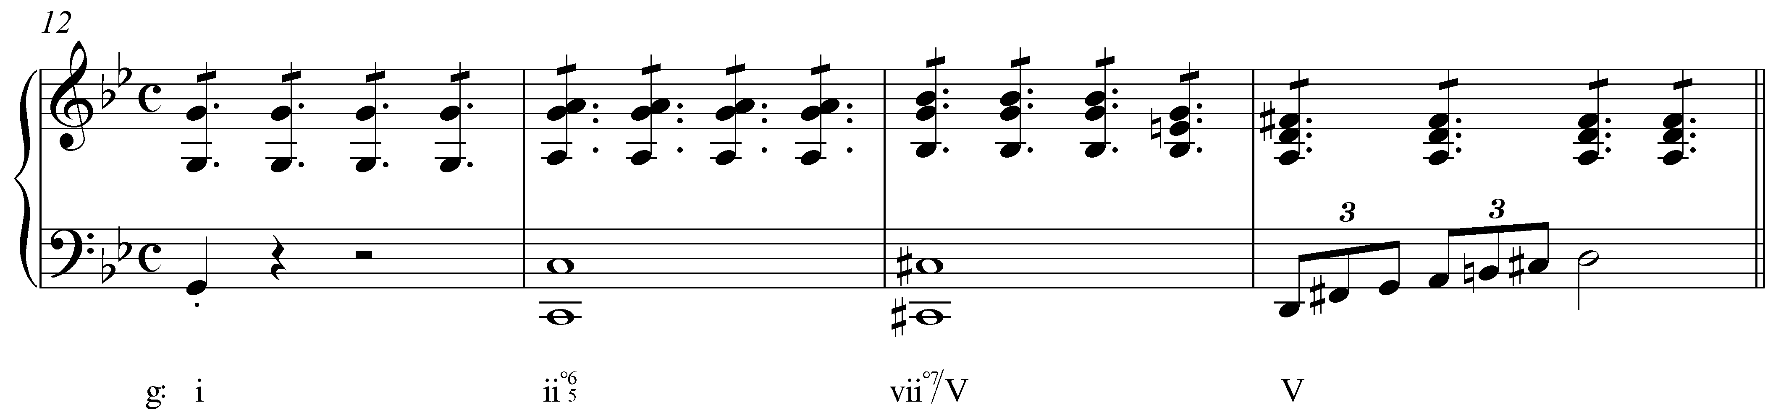
Example 11 (R. Schumann, Album for the Young, No. 14: “Kleine Studie,” mm. 8-15):
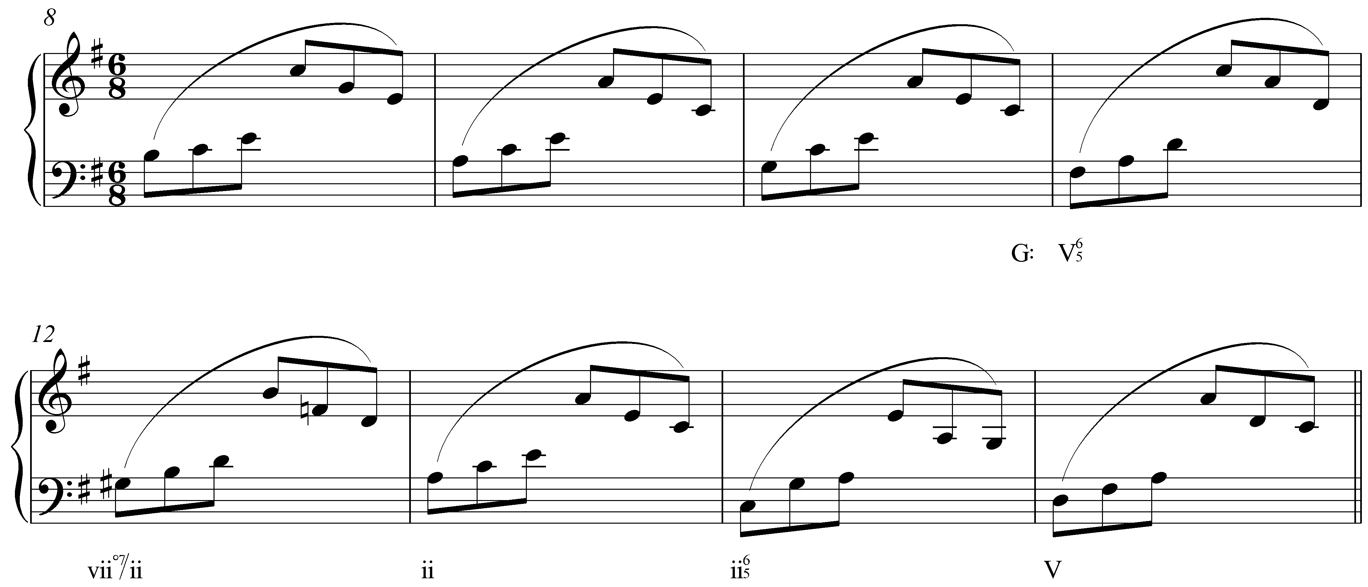

- As an auxiliary
  - common tone diminished seventh chords
    - neighboring function
    - chromatic embellishment of I in major
    - shares the root
    - #2 is chromatic neighbor to 3
    - #4 is a chromatic neighbor of 5
    - and 6 is a diatonic neighbor of 5
    - Examples:
      - Mendelssohn, Rondo Capriccioso, Op. 14 mm. 4-6
- Modulation
  - Very versatile for chromatic modulation (fully diminished)
    - Enharmonically, it can resolve in four different ways
    - You can modulate to any key “by using the diminished seventh chord as a secondary leading-tone chord.”

Example 12:
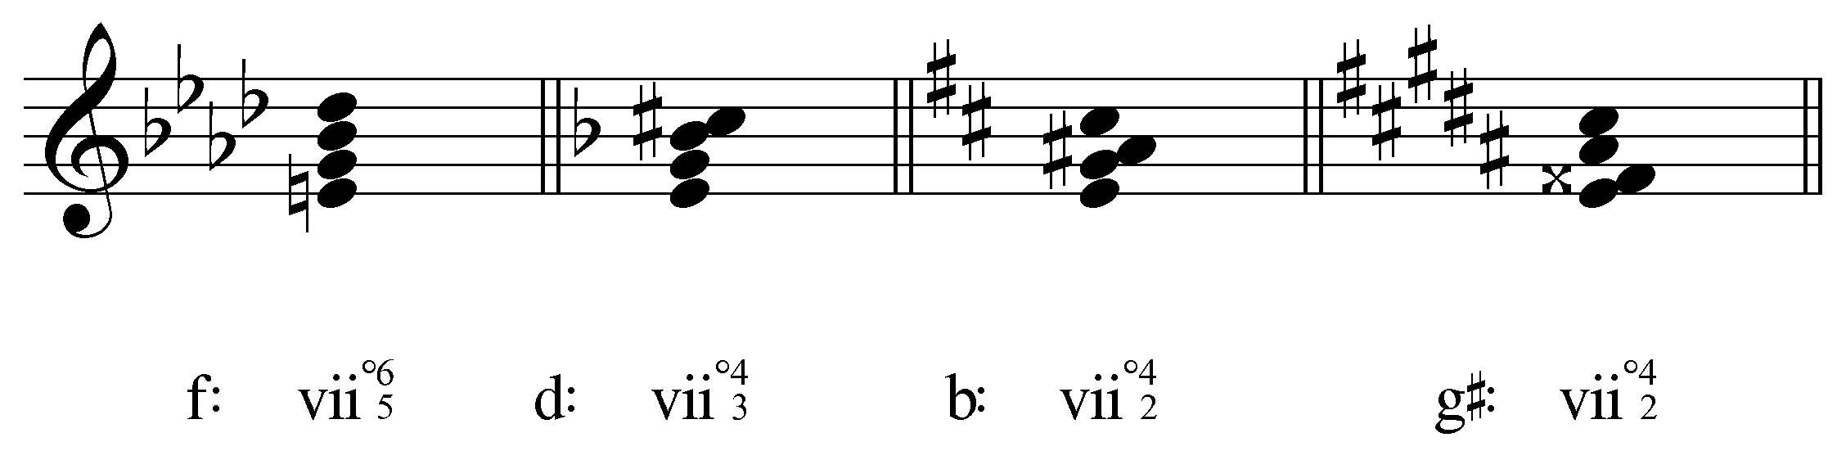

    - See Beethoven Pathetique, first mvt. 133-136

Example 13 (L. Beethoven, Sonata no. 8 (“Pathétique”), Op. 13, Mvt. I, mm. 133-137):
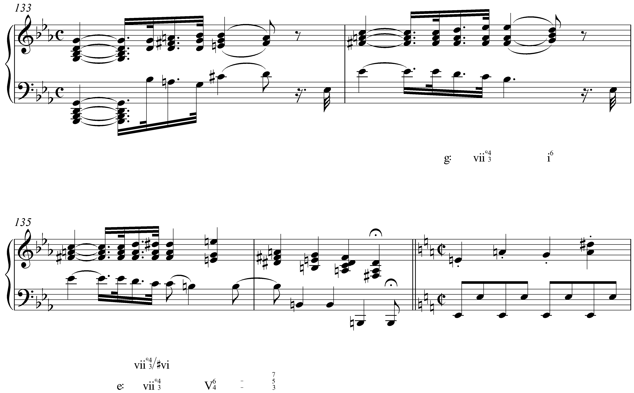

  - Viio7 can be notated so that it functions as viio7 in four different keys
  - For the Beethoven pathetique example:
    - “A diminished seventh chord belonging to G minor is reinterpreted so that it leads to E minor; the Eb is enharmonically transformed into a D#. In its new notation, and with its new orientation, the o7 embellishes the V7 that ushers in the E minor tonic.”

Dissonances are unstable and therefore require motion towards stability (resolution).

Lesson PPP: The Fully-Diminished Seventh Chord

Is it worth, then, adding a lesson on the fully diminished 7th chord? We
have one for leading tone diminished triad, first inversion. The
fully-dim 7th, given its dual tritones, is special...

Not a bad idea. It would not have to be lengthy. There are abundant, easily found examples. The lesson would explain the structure (two interlocking tritones), the routine inclusion of a non-diatonic tone (by mixture), and the forced resolution owing to the two tritones (BIPs being invoked here), and the exceptional, routinely doubled third in the resolution triad.

C&M:
127-28 252 255-60
582-85
300
469 516
602-6
631-32
361-63 401 483
- Consists of a diminished triad with a diminished seventh
- Can substitute for V or V7
- Can be half or fully diminished with a minor or diminished seventh
  - In major it’s half in minor its fully
- Fully diminished is found more often (sometimes in major with b6) because of the half-step voiceleading from 6 to 5
- They’re usually present with all four members
- They share 7 2 and 4 with V7
- 7 and 4 resolutions are typical (just as in a V7 chord)
- resolutions:
  - 7 to 1
  - 4 to 3
  - chordal seventh down (6 to 5)
  - 2 usually goes up to 3 or down to 1
- Two tritones:
  - 7 and 4
  - 2 and 6
- Resolving:
  - Resolve the d5 (2 and 6) inward to a third
  - When 2 is above 6, 2 can go to 1 (parallel “fourths” instead of “fifths”)
  - Avoid d5 to P5
- D5 to P5 is ok if there are parallel tenths (I vii65 i6)
- Can appear in any position, but usually not third inversion since that would lead to a second inversion tonic (unless it’s a cadential 64 chord)
- leading tone chords can sub for V
  - applied leading tone chords can sub for applied Vs
  - usually dim triad and fully dim seventh
  - usually not half dim
- For applied leading tone chords, all of the same rules/tendencies apply
- Very versatile for chromatic modulation (fully diminished)
  - Enharmonically, it can resolve in four different ways
  - You can modulate to any key “by using the diminished seventh chord as a secondary leading-tone chord.”
  - See Beethoven Pathetique, first mvt. 133-136

A&S
- Resolution:
  - 7th (6) goes down to 5 (See lesson 7 for more on seventh chords)
  - LT goes up to 1
  - D5 tends to go to a third and A4 tends to go to a sixth
    - (between upper voices, A4 sometimes goes to P4)
    - 42 is least frequent (usually goes to a 64)
- half diminished usually appears as a neighboring chord to I
  - only appears in major
  - risk of parallel fifths is even greater
- common tone diminished seventh chords
  - neighboring function
  - chromatic embellishment of I in major
  - shares the root
  - #2 is chromatic neighbor to 3
  - #4 is a chromatic neighbor of 5
  - and 6 is a diatonic neighbor of 5
  - Examples:
    - Mendelssohn, Rondo Capriccioso, Op. 14 mm. 4-6
- For the Beethoven pathetique example:
  - “A diminished seventh chord belonging to G minor is reinterpreted so that it leads to E minor; the Eb is enharmonically transformed into a D#. In its new notation, and with its new orientation, the o7 embellishes the V7 that ushers in the E minor tonic.”
- Viio7 can be notated so that it functions as viio7 in four different keys

