Lesson SSS: Diatonic Sequences

Introduction:

Very frequently in tonal music, you will encounter such passages as the following, where harmonic and melodic patterns are repeated at different pitch levels:

Example 1 (W.A. Mozart, Piano Sonata in C major, K. 545, Mvt. I, mm. 61-71):
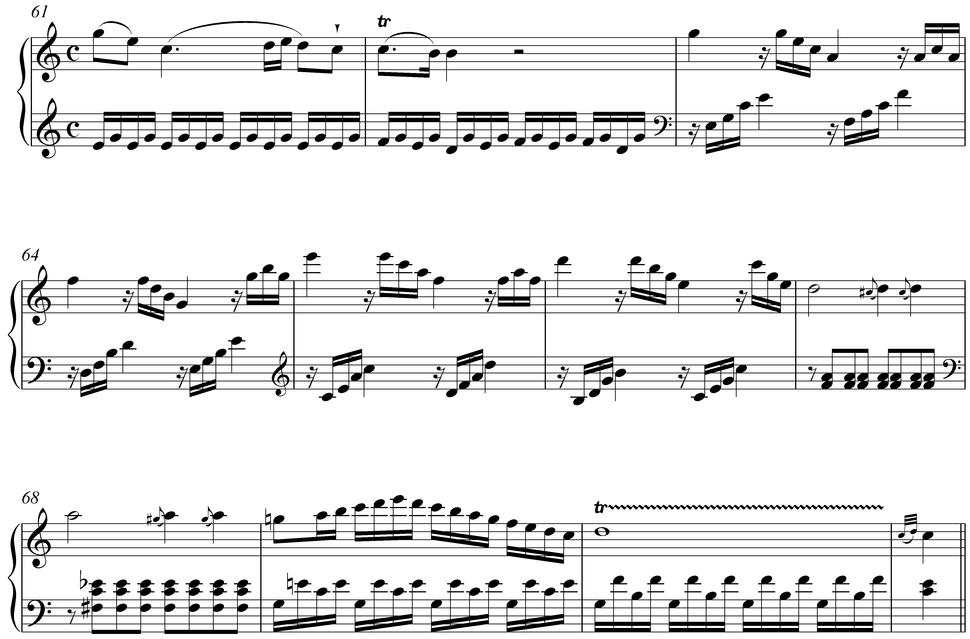

Following a half cadence in m. 62 of this excerpt from a Mozart sonata, we find a series of arpeggiated triads. Comparing m. 63 with mm. 64, 65, and 66, we find a similar pattern repeated in each successive measure, the only differences being the pitch levels at which each repetition occurs. The pattern begins on G in the right hand in m. 63, then repeats on F in m. 64, then on E in m. 65 (transferred up an octave), and finally on D in m. 66. Harmonically, the pattern ends right where it began—with a I chord. In this light, the entire passage from mm. 63-66 presents an expansion tonic harmony, bringing dramatic weight to the authentic cadence that follows in m. 71.

This sort of musical pattern, where successive repetitions occur at different but predictable pitch levels, is known as a sequence. Sequences appear with greatest frequency in music from the Baroque, but continued to be used by composers of every era of the common practice. As we will discuss in this lesson, they serve a number of functional purposes, but can always reduced to one of a handful of basic interval progressions. (See Lesson 1 for review of basic interval progressions.)

We will begin with a brief discussion of the general nature of sequences and will then proceed with an examination of some common variations on the basic principles.

The nature of sequences:

Composers generally employ sequences to either expand a single functional harmony—as we saw in Example 1—or as a transitional device from one harmonic area to another. In either case, the function of a sequence depends on the listener’s ability to recognize the repeated pattern. Upon hearing one, it is generally the contour of the repeated melody that we recognize first. But in every case, these repeated melodies or motives are supported by strong harmonic progressions, themselves derived from basic interval progressions.

Sequences are based on the same harmonic progressions that one finds in other contexts. Progressions in which the chord roots descend by fifth are by far the strongest and most frequently encountered, but ascending-fifth and descending- and ascending-third progressions are also quite common. In this sense, sequences are an extension of basic tonal practices expressed in a unique way.

Look again at the harmonic progression of the sequence i Mozart’s Piano Sonata, K. 545:

Example 2 (W.A. Mozart, Piano Sonata in C major, K. 545, Mvt. I, mm. 61-71):
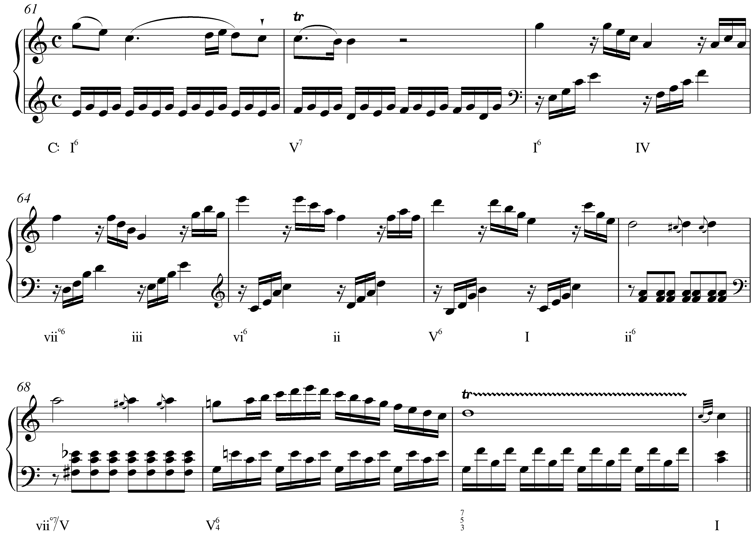

Each successive triad, starting with the tonic chord in m. 63, has it’s root a fifth lower than the one that comes before: I – IV – viiº – iii – vi – ii – V – I. (Note that some of these descending fifths are expressed as ascending fourths. This is done to avoid moving into too low of a register.) In this case, the sequence traverses an entire cycle of descending fifths from tonic to tonic. This is common—particularly with descending-fifth sequences—but most sequences consist of only three to five repetitions since completing an entire cycle can become tedious..

Note: This sequence and the others considered in this lesson are diatonic: all of the chords are native to a single key. Because the repetitions are not literal, you will find some variation in quality. The triads in m. 63 of Example 2 are both major, while those in m. 64 are diminished and minor. Regardless of the changes in quality, the similarity of the melodic contour is explicit enough for the listener to recognize the repeated pattern.

Another consequence of using only diatonic chords is the inevitable inclusion of diminished and augmented intervals. Composers negotiate these dissonances in several ways, as you’ll see from the various examples in this lesson. In Example 2, Mozart conceals the diminished-fifth root motion from F down to B as IV moves to viiº by alternating between root position and first inversion chords.

In addition to considering the repeated material—melodic and harmonic—it is essential that you be able to recognize the underlying interval patterns that form the basic structure of any sequence. In multi-voiced settings, you should look to the outer voices for these governing progressions. The following example provides a reduction of the sequence in Example 2, showing the successive intervals formed by the highest and lowest voices:

Example 3 (reduction of W.A. Mozart, Piano Sonata in C major, K. 545, Mvt. I, mm. 63-66):
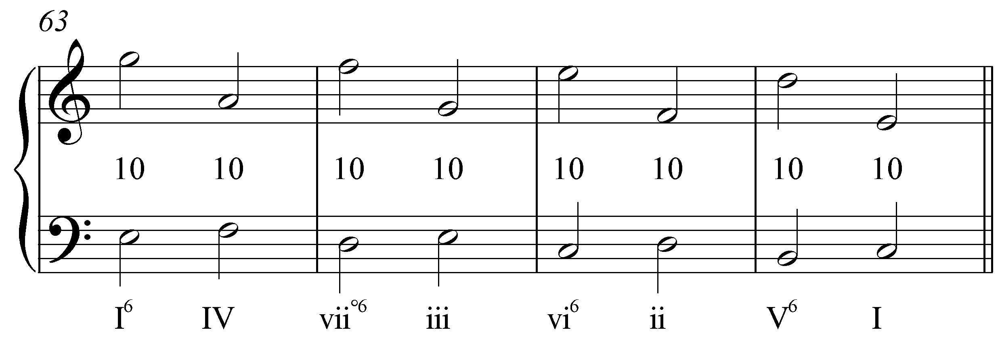

With each change in harmony, the outer voices form a series of tenths. Mozart embellished the t—leaping down by seventh to the second tenth of each measure and transferring the pattern to a higher register in m. 65—but the underlying principle is quite common. (These patterns are sometimes referred to as linear intervallic patterns, or, LIPs for short.) Each of the sequences discussed in this lesson can be similarly reduced.

Descending-fifth sequences:

Sequences in which the chord roots descend by fifth are common enough that they should be instantly recognizable by ear. Compare the following excerpt with the Mozart from above:

Example 4 (J. Brahms, Clarinet Sonata in E-flat Major, Op. 120, no. 2, Mvt. I, mm. 160-169):
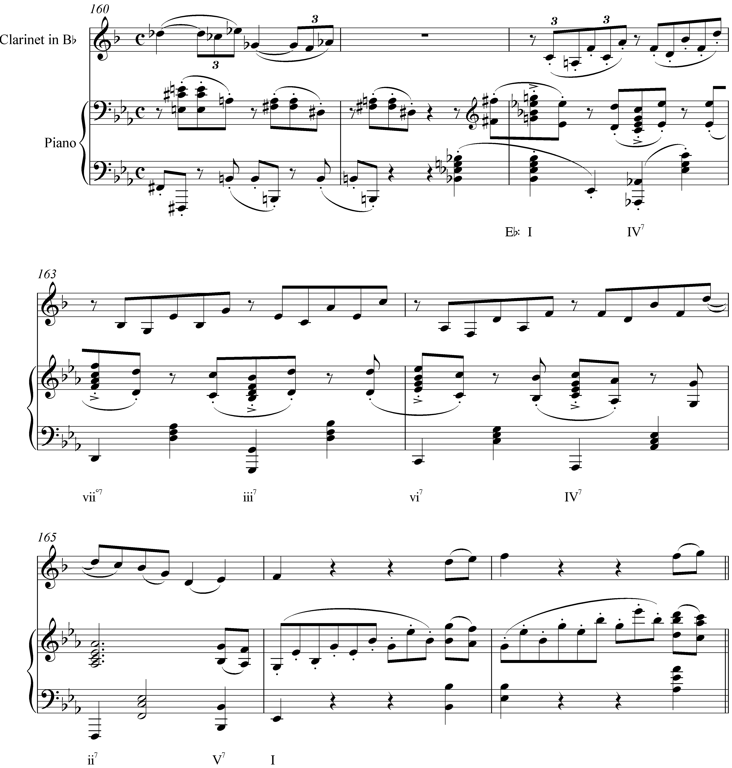

Despite some superficial differences, these two passages have a very similar sound. In this case, however, the sequence extends only from the initial tonic to the vi chord in m. 164. The pattern is then broken when the harmony moves to a IV⁷ chord (part of the pre-dominant area leading to an authentic cadence). Additionally, each harmony is adorned with a seventh above the root. Whereas sevenths appearing above I, iii, and vi chords would not typically be considered chord tones, in this case they are included by virtue of the sequence’s repetition.

Now consider the interval progression formed by the outer voices. Example 5 provides a reduction:

Example 5 (reduction of J. Brahms, Clarinet Sonata in E-flat Major, Op. 120, no. 2, Mvt. I, mm. 162-164):
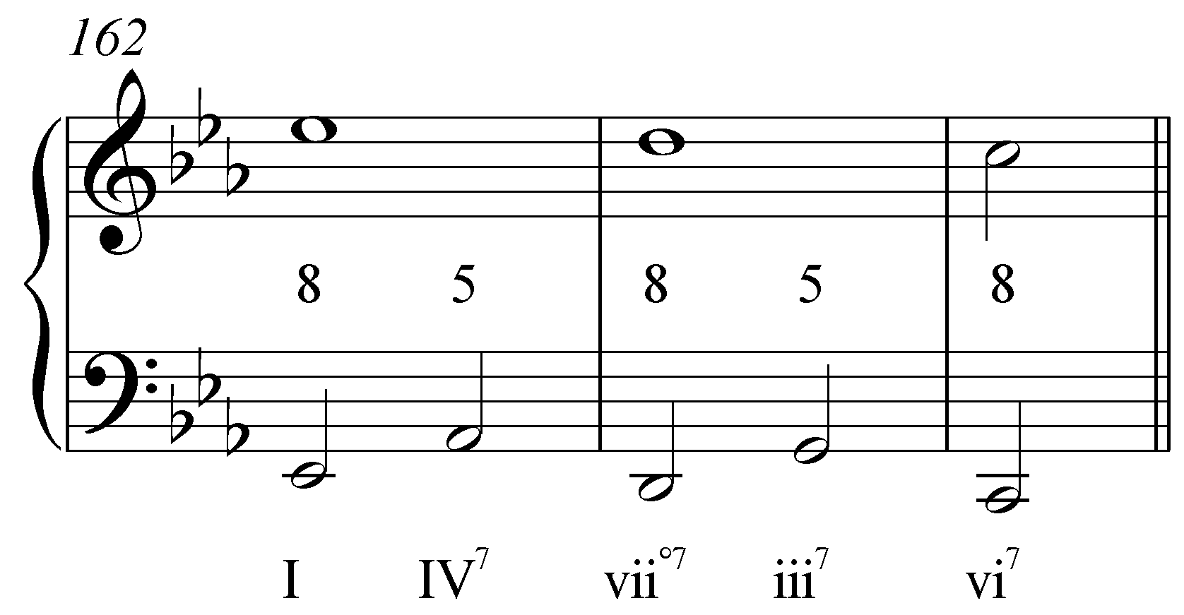

Whereas the sequence in Example 2 reduced to a series of tenths, here the outer voices alternate between octaves and fifths. Interval progressions “8 – 5” and “5 – 8,” as discussed in Lesson 1, are also very common in tonal music. Each successive chord appears in root position on a strong beat. The tritone between Ab and D that arises between the roots of the IV and viiº chords is obscured, however, by the intervening inversions that appear on the second and fourth beats of every measure.

Descending-fifth sequences are particularly prevalent in music of the Baroque era. The following excerpt from a harpsichord suite by Handel makes great use of this device:

Example 6 (G.F. Handel, Harpsichord Suite no. 12, Gigue, mm. 13-16):
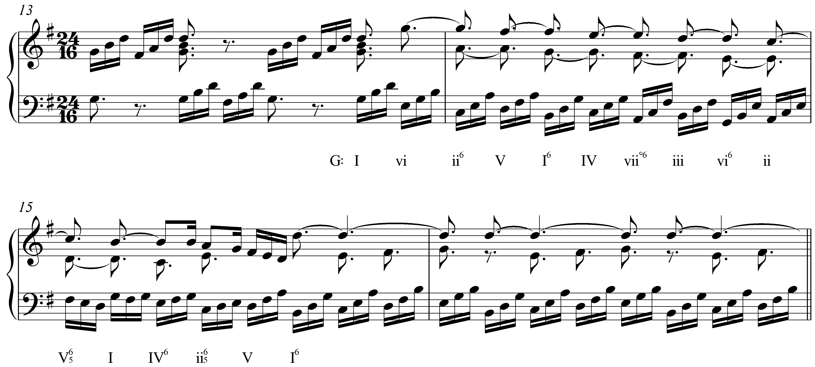

Beginning with the vi chord on the anacrusis to m. 14, a series of arpeggios in the left hand outline a descending fifth sequence through the remainder of that measure. In m. 15, the descending-fifth harmonic pattern set into motion by the sequence continues through V, I, and IV, despite the altered melodic pattern in the bass. At this point, the sequence is broken off, leading to an authentic cadence. Sequences such as this—which complete an entire lap around the circle of fifths and then some—are commonplace in Baroque music but were generally considered tedious or repetitive by later composers.

provides a reduction of the Handel:

Example 7 (reduction of G.F. Handel, Harpsichord Suite no. 12, Gigue, mm. 14-15):
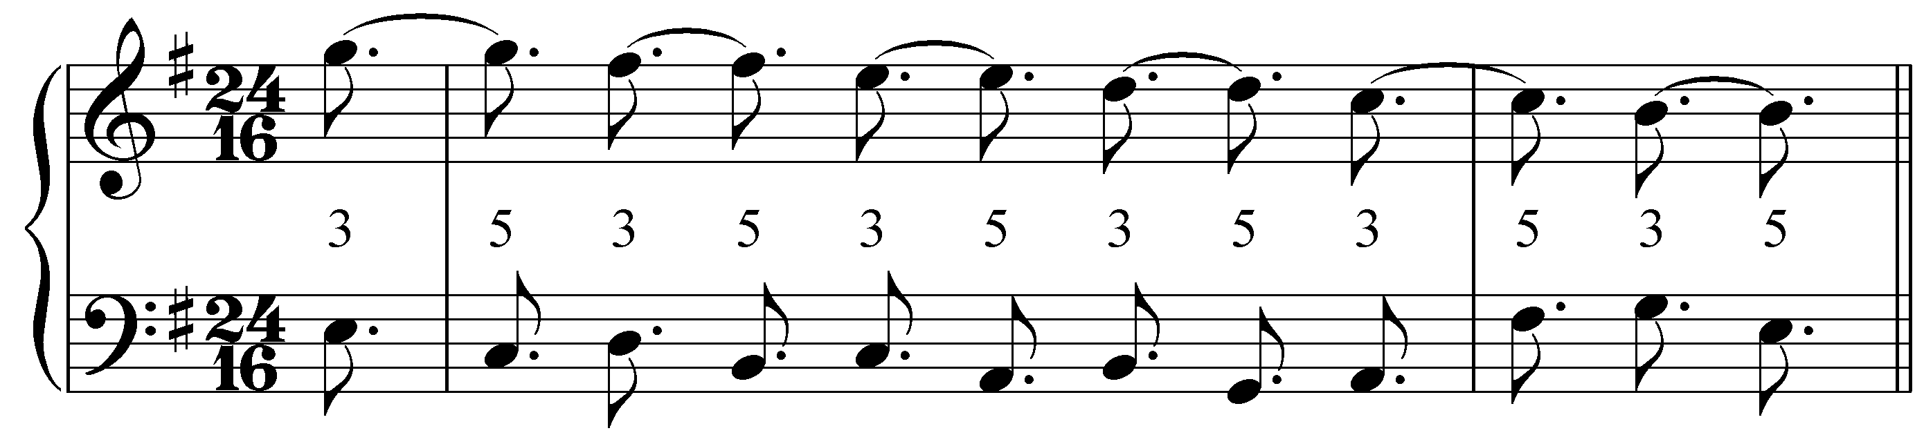

The outer-voice interval progression is particularly clear in this example. A series of suspensions in the upper voice create a pattern of alternating thirds and fifths with the bass.

The following excerpt from a Schubert impromptu also includes a complete cycle of descending fifths, this time in a minor key:

Example 8 (F. Schubert, Impromptu in E-flat, D. 899, No. 2, mm. 23-35):
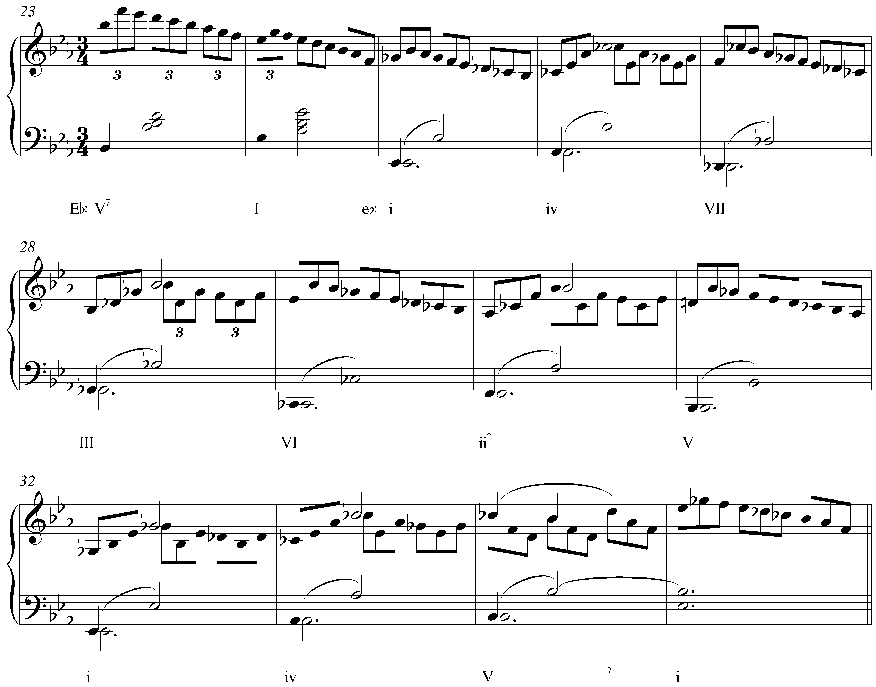

Following a cadence in m. 24, Eb major becomes Eb minor with the addition of Gb (and, subsequently, Db and Cb). The descending-fifth sequence that follows completes the cycle from the initial i chord to the tonic in m. 32. Harmonically, the iv chord in m. 33 continues the descending-fifth series, but the melodic pattern in the upper voice is broken.

Sequences in minor keys, in addition to the extra tritone between scale degrees 2 and 6, bear the added complication of the harmonic and melodic composites of the scale. (See Lesson 3 for more information on the harmonic and melodic minor composites.) Typically, in a minor-key sequence, scale degrees 6 and 7 are left in their diatonic form, appearing in their raised form only at sequence-ending cadences. Notice that in mm. 25-30, every instance of scale degrees 6 and 7 is diatonic (Cb and Db, respectively). Using diatonic 7 avoids the diminished triad built on the leading tone. It is only with the V chord towards the end of the sequence (m. 31) that we find the raised leading tone, effectively signaling the end of the sequence.

Now, let’s look at the outer-voice interval progression:

Example 9 (reduction of F. Schubert, Impromptu in E-flat, D. 899, No. 2, mm. 25-32):
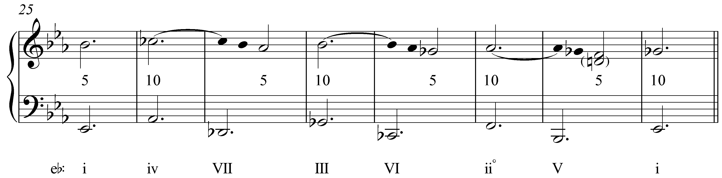

As Example 9 shows, this excerpt is based on a third type of interval progression: alternating between fifths and tenths. The repeated melodic pattern obscures the interval progression somewhat: the highest voice in mm. 27, 29, and 31 are actually suspended sevenths that resolve down to the consonant fifth on beat two of each measure. Since all of the triads appear in root position, this pattern of fifths and tenths helps conceal the tritone between the root and fifth of the iiº chord in m. 30.

Other outer-voice interval progressions are possible as well. The progression that defines a sequence depends, in large part, on which of the upper voices appears on top. Below is one example of a four-voice, descending-fifth sequence. Consider the interval progressions formed by each of the upper voices with the bass:

Example 10:
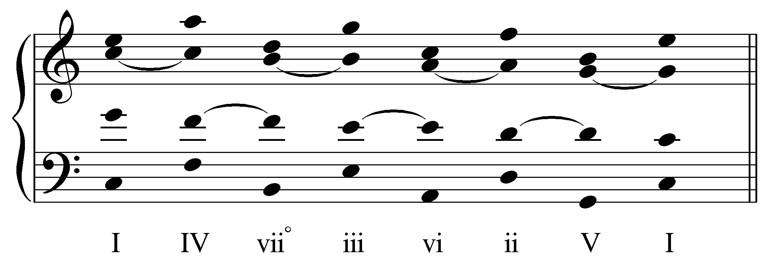

[Potential activity?]

Between the bass and soprano, we find the parallel tenths. Between the bass and alto we find the same upper-voice suspensions leading to alternating octaves and fifths as in Example 5. The tenor and bass also alternate between fifths and octaves, but begin with the fifth between 1 and 5. Any of these interval progressions could appear between the bass and soprano depending on the arrangement of the voices.

Alternating between root-position and first inversion chords in a descending-fifth sequence will create a different set of potential interval progressions:

Example 11:
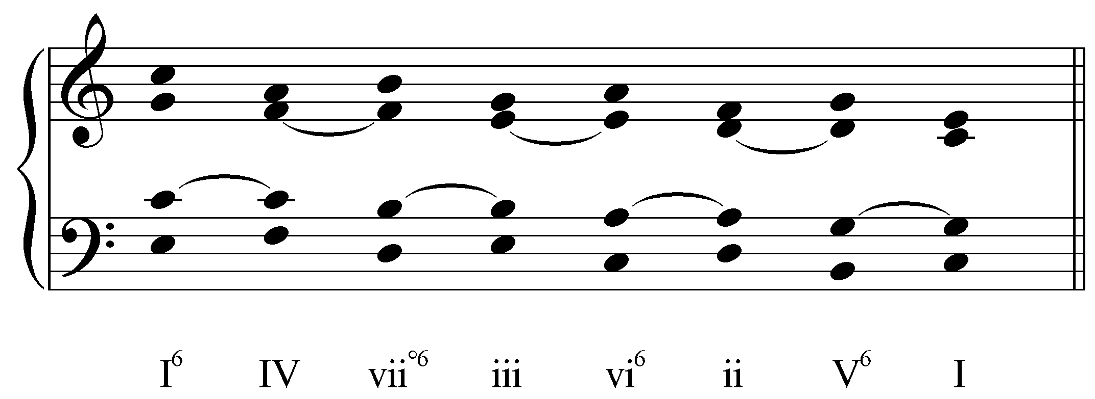

In Example 11, the soprano voice yields the same “10 – 10” pattern with the bass as in Example 3, while the alto and tenor yield “10 – 8” and “6 – 5” patterns respectively. Such a sequence could also begin with a root-position chord: I – IV⁶ – viiº – iii⁶ – etc.

Adding sevenths to the chords in either of the two examples above would lead to other possible outer-voice progressions.

Ascending-fifth sequences:

Like ascending-fifth root progressions in normal contexts, ascending-fifth sequences are far less common than their descending-motion counterparts. Nonetheless, they do appear with some frequency and have a decidedly different effect. Consider the following example:

Example 12 (A. Corelli, Sonata no. 11 from Sonate da Camera a Tre, Op. 4, Corrente, mm. 18-27):
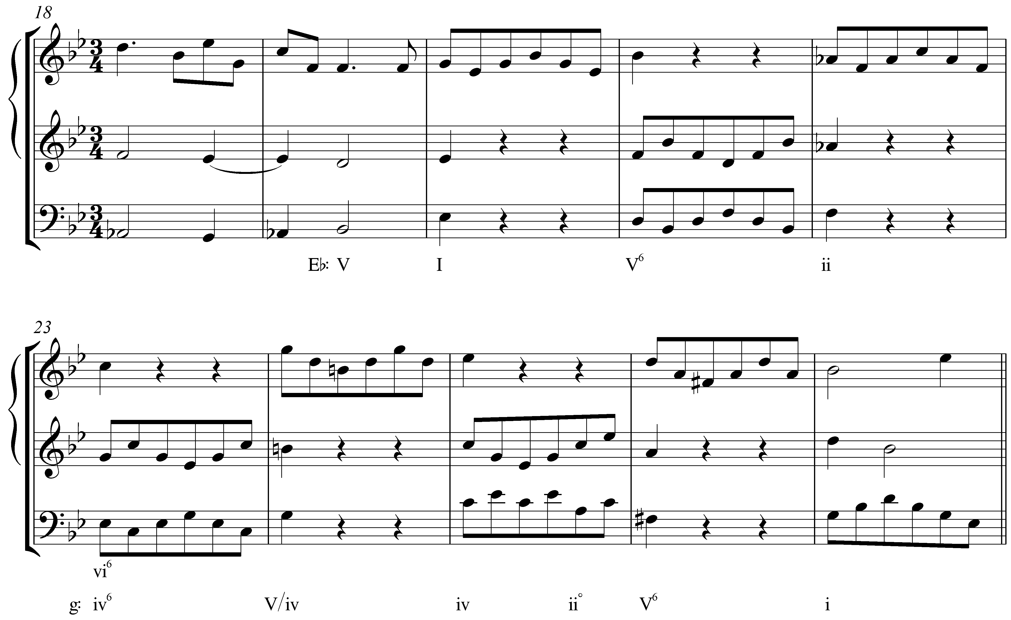

The melodic figure in m. 20 is passed back and forth between the bass and upper voice with every change in harmony. Starting with the tonic chord in m. 20, the harmonic progression ascends by fifth in each subsequent measure: I – V – ii – vi. In m. 24 though, the root of the chord is again a fifth higher. The pattern is broken by the altered melodic line in the upper voice.

Note as well that m. 24 introduces B natural. That chord, initially heard as V/vi in Eb major, turns out to be an auxiliary sonority prolonging the C-minor chord of m. 23, which in light of the ensuing cadence, is retroactively reinterpreted as iv in G minor.

Looking at the outer-voiceleading reduction, we again see familiar interval progressions:

Example 13 (reduction of A. Corelli, Sonata no. 11 from Sonate da Camera a Tre, Op. 4, Corrente, mm. 20-23):
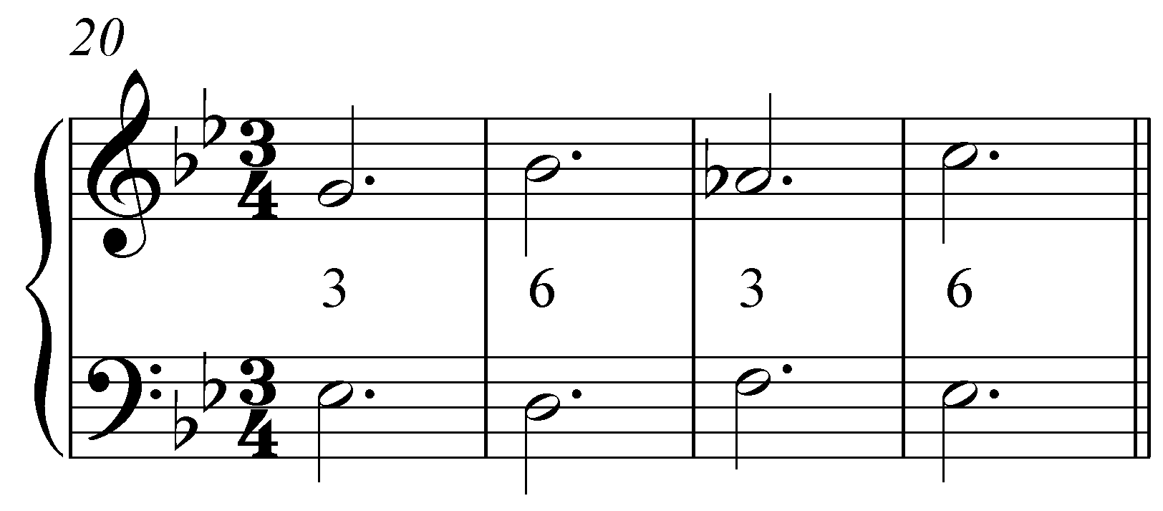

Here, the root-position chords have a third above the bass while the first-inversion chords have a sixth. “6 – 3” and “3 – 6” interval progressions are also very common. Note that in contrast to descending-fifth sequences, here the overall motion ascends.

The beginning of Bach’s Prelude in C Major (BWV 924) begins with an ascending fifth sequence (Example 15 provides a reduction):

Example 14 (J.S. Bach, Prelude in C Major, BWV 924, mm. 1-3):
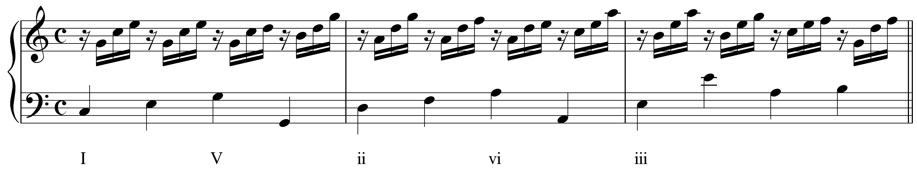

Example 15 (reduction of J.S. Bach, Prelude in C Major, BWV 924, mm. 1-3):
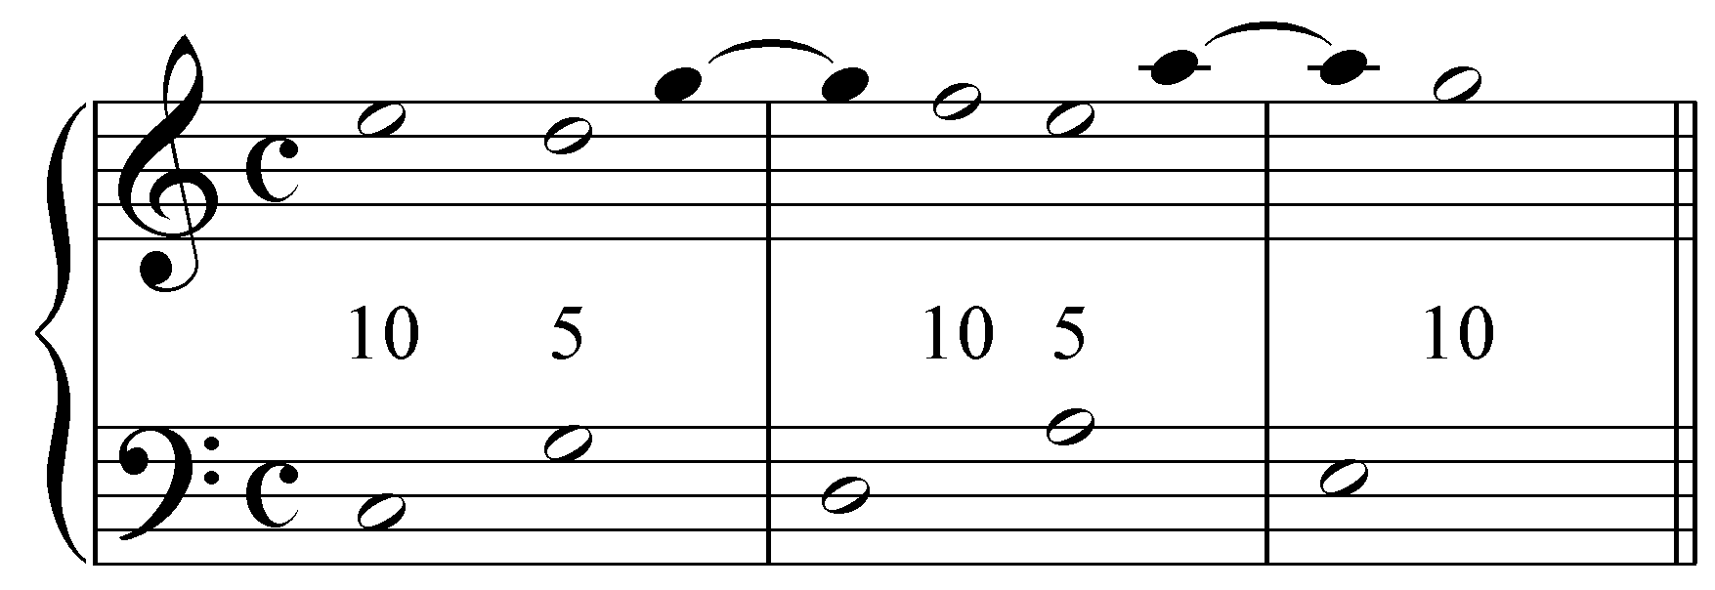

Throughout the passage, Bach uses suspensions and other techniques to smooth out the ascending-fifth progressions. In m. 1, the V chord is introduced as the continuation of a bass arpeggiation of I. The suspended fourth (1) resolves on the fourth beat as the upper voice makes a consonant skip up to the root of the triad. That voice is then suspended as a dissonant fourth into the next measure before resolving to the tenth above the bass and repeating the pattern. The basic framework of this sequence, then, is a series of alternating tenths and fifths.

Again, other interval patterns are possible with ascending-fifth sequences. Subsequent chords may alternate between root position and first inversion and “10 – 8” and “10 – 10” patterns appear quite frequently.

Descending- and ascending-third sequences:

Sequences in which the harmonic units move by thirds run a greater risk of creating parallel fifths and octaves than those that move by fifths. For this reason, composers often include an intervening chord to break up the parallel motion.

Example 16 (J.S. Bach, Fugue No. 16 in G minor, BWV 861, mm. 24-28):
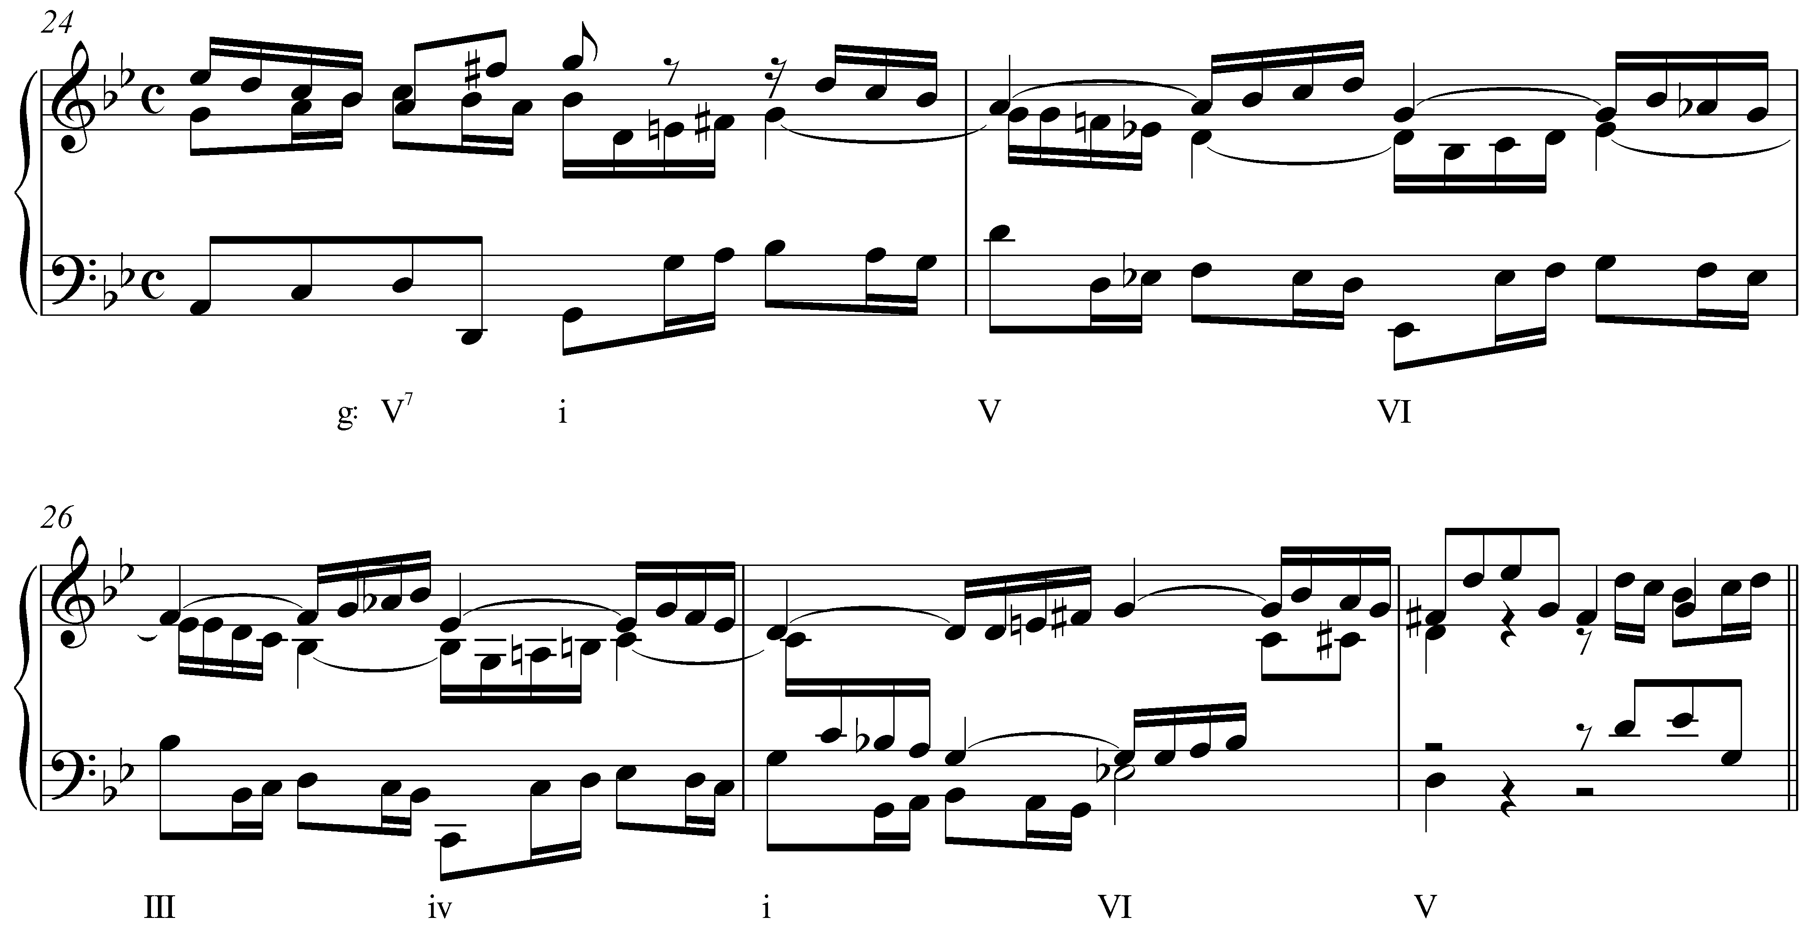

An authentic cadence in G minor initiates a descending-third sequence in m. 24 of this fugue by Bach. Each step in the chain of descending thirds appears on the second beat of its measure: i (m. 24) – VI (m. 25) – iv (m. 26). Between each step, however, the chord roots move down by fifth: V is inserted between i and VI, III between VI and iv. These secondary chords—along with the weak metric placement and melodic figuration—obscure the parallel octaves between each step in the sequence. The following reduction highlights the hidden parallel octaves in red:

Example 17 (reduction of J.S. Bach, Fugue No. 16 in G minor, BWV 861, mm. 25-27):
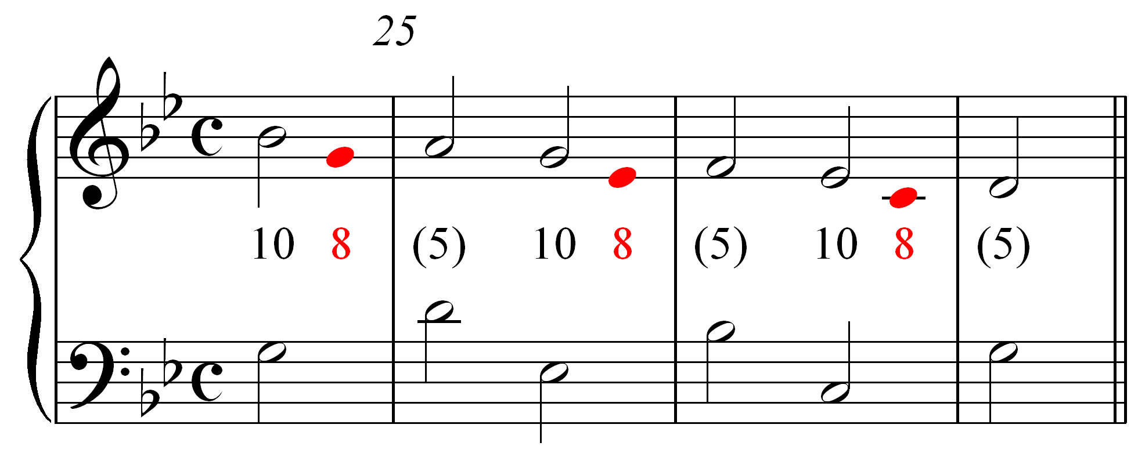

As Example 17 shows, the basic interval progression governing this sequence consists of parallel tenths. The intervening chords on the downbeats of mm. 25-26 break this motion up with fifths and help obscure the parallel octaves that appear on the last beat of each measure.

The following excerpt from Beethoven sonata shows a similar descending-third sequence, though here the chords alternate between root position and first inversion ( provides a reduction):

Example 18 (L. Beethoven, Piano Sonata in E Major, Op. 109, Mvt. I, mm. 1-3):
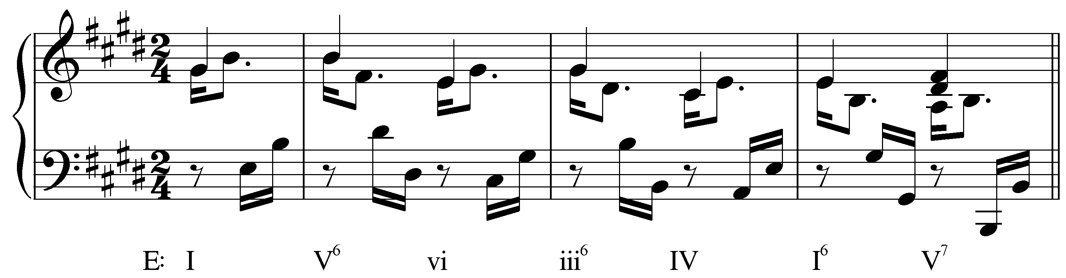

Example 19 (reduction of L. Beethoven, Piano Sonata in E Major, Op. 109, Mvt. I, mm. 1-3):
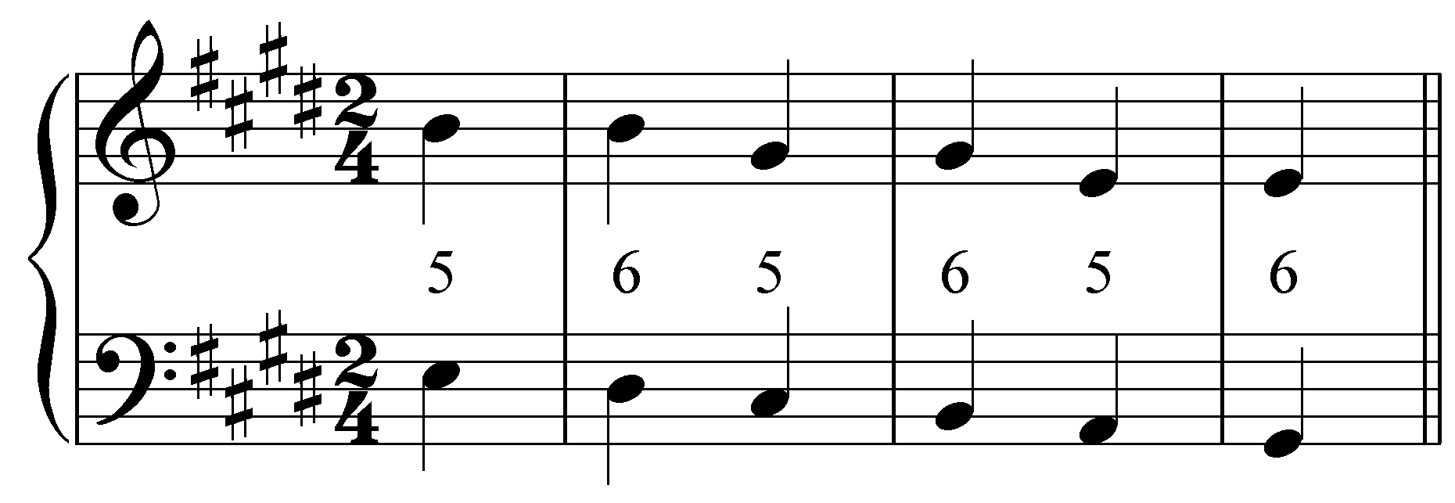

The order of harmonies (I – V⁶ – vi – iii⁶ – IV – I⁶) is virtually identical to Example 16, though here they are in a major key. As the reduction shows, alternating between root position and first inversion produces a desirable effect: a stepwise descending bassline. The intervening chords (V⁶ and iii⁶) break up the parallel fifths that would normally result from successive descending third root motions. (The parallel fifths are also obscured by the metrically staggered material in the bass.)

The result is a series of fifths suspended to become sixths as the bass steps down on the downbeat of each measure. This descending “5 – 6” technique was a popular contrapuntal strategy in the Renaissance and was continually used in later music.

In the following ascending-third sequence, we find a stepwise melodic line in the upper voice:

Example 20 (A. Corelli, Sonata no. 11 from Sonate da Camera a Tre, Op. 4, Allemanda, mm. 1-5):
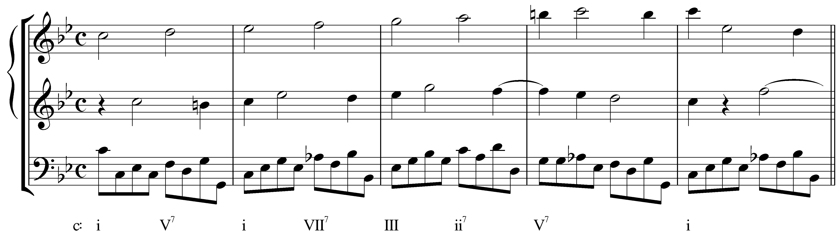

This movement from a Corelli trio sonata begins with an ascending-third sequence starting with the V⁷ chord in the first measure. Again, intervening chords break up the inevitable parallel fifths. Note that while parallel octaves do appear on the downbeats between the bass and the middle voice, they quickly skip up to tenths on the second beat of each measure.

Looking at the reduction, we can see how the mediating chords break up the parallel fifths:

Example 21 (reduction of A. Corelli, Sonata no. 11 from Sonate da Camera a Tre, Op. 4, Allemanda, mm. 2-4):
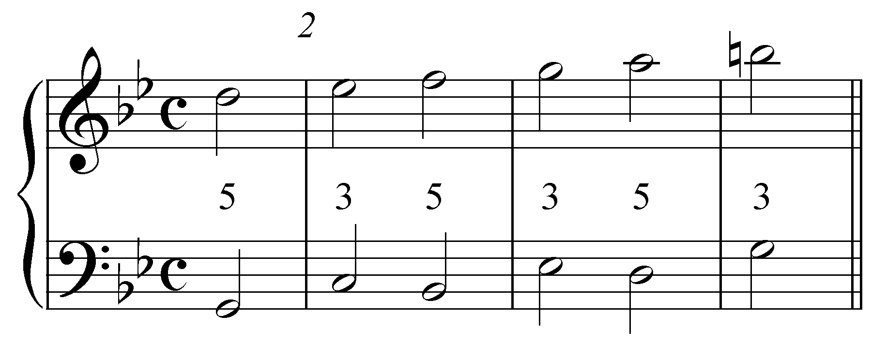

Instead of moving directly from one fifth to the next on the second beat of each measure, thirds intervene on the downbeats, changing the parallel motion to contrary motion. This results in the ascending stepwise motion of the entire upper line.

Ascending-second sequences:

You may encounter, from time to time, sequences in which the root motion ascends or descends by step. Consider the following example from a harpsichord piece by Handel:

Example 22 (G.F. Handel, Harpsichord Suite no. 3, Presto, mm. ??):
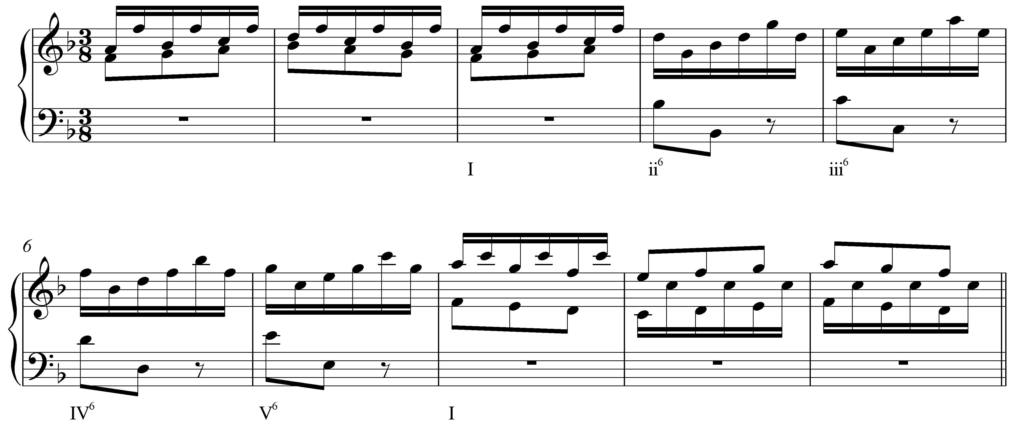

Starting with the ii⁶ chord in m. ?, the following three measures are practically identical, transposed up by a step each time. That the chords appear in first inversion helps to conceal the parallel octaves:

Example 23 (reduction of G.F. Handel, Harpsichord Suite no. 3, Presto, mm. ??):
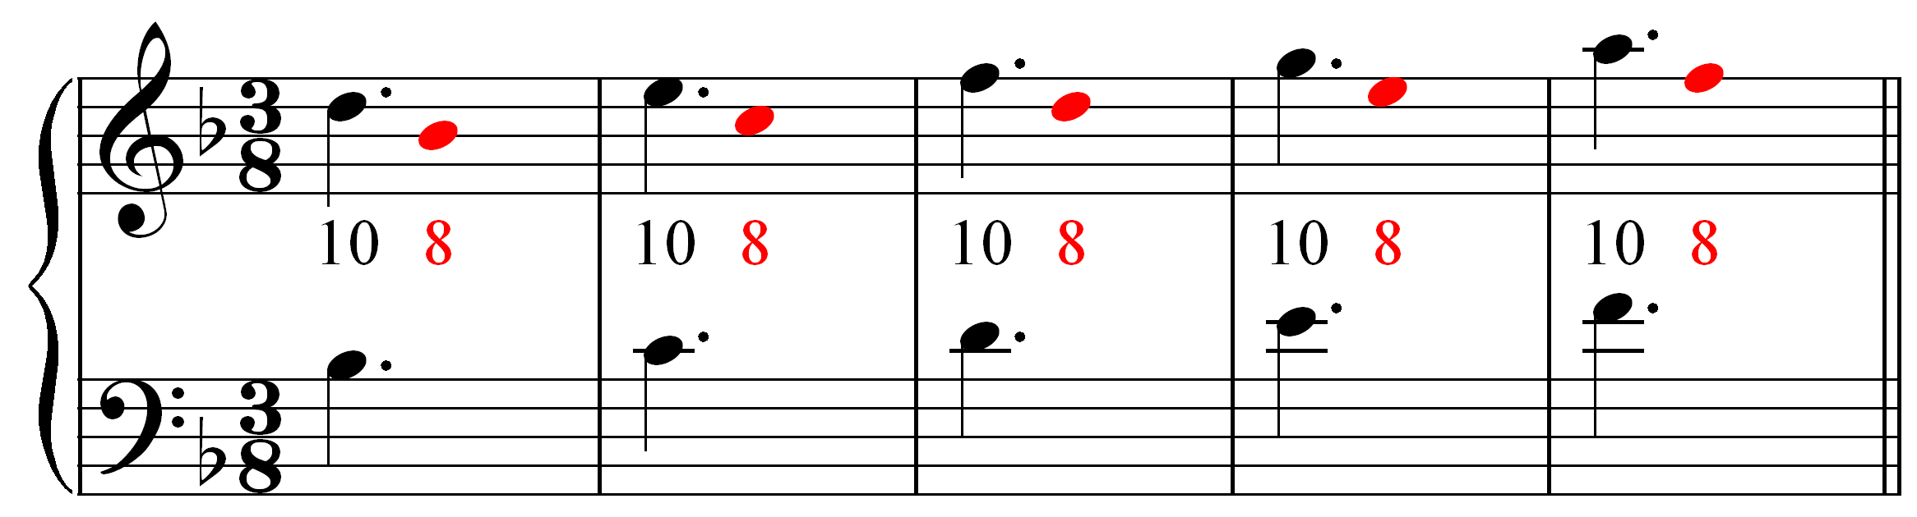

Like sequences based on thirds, ascending-second sequences often make use of intervening chords to break up parallel fifths and octaves. In the following excerpt from the fourth of Vivaldi’s Four Seasons concertos, first-inversion chords mediate between each step of an ascending-second sequence:

Example 24 (A. Vivaldi, Violin Concerto in F Minor, Op. 8, no. 4 (“Winter”), Mvt. II, mm 11-13):
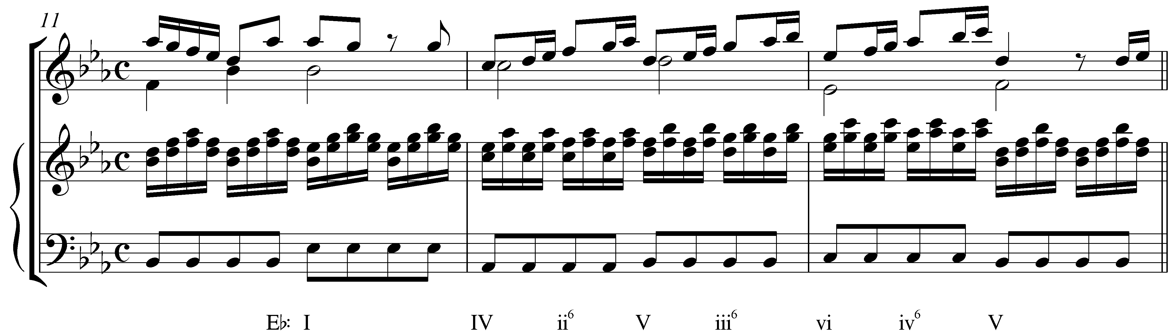

The IV chord on the downbeat of m. 12 initiates the sequence (IV – V – vi) with intervening chords on the weak beats. The intervening chords appear in first inversion, preserving the stepwise motion of the bass. The following reduction shows the interval progression between the bass and an inner voice to show how the intervening chords break up the parallel fifths:

Example 25 (reduction of A. Vivaldi, Violin Concerto in F Minor, Op. 8, no. 4 (“Winter”), Mvt. II, mm 11-13):
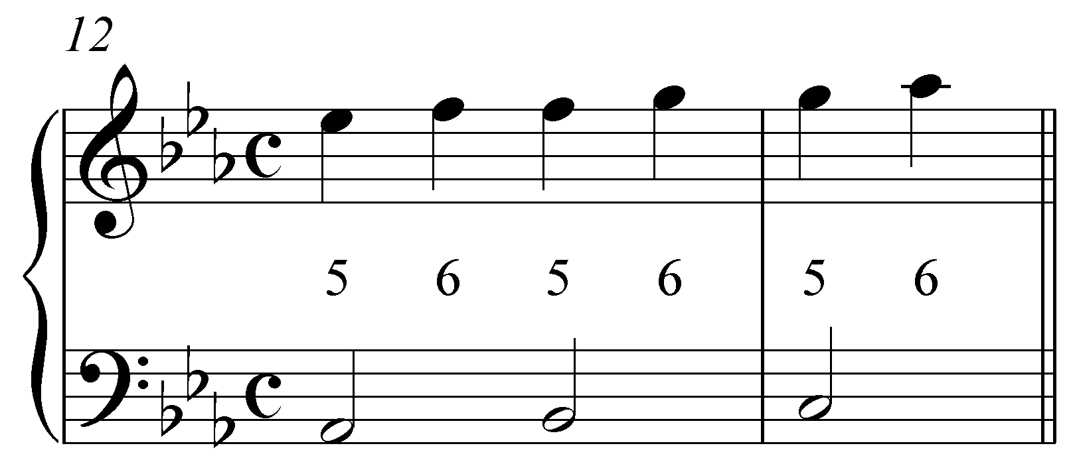

The ascending “5 – 6” motion seen in this reduction is remarkably similar to what we saw in Example 19. The only difference is that here the voices ascend instead of descend. The resultant sixths approach each subsequent fifth with oblique motion.

Conclusion:

Sequences consist of melodic and harmonic material repeated at different and predictable pitch levels. Diatonic sequences rely on the listener’s ability to recognize the basic contour of repeated patterns, since the qualities may change from step to step in conforming to the key. Composers use sequences in a number of ways, primarily to prolong a specific harmony or to move from one harmonic area to another. This lesson focused on diatonic sequences, but sequences can be useful tools for modulation as well.

Each step of a sequence—that is, each iteration of the pattern—is transposed at a regular interval. The majority of sequences move by descending fifths (or ascending fourths), due in large part to the prominence of descending-fifth root motion in harmonic progressions. Some sequences progress by ascending fifths, while others are based on ascending- or descending-thirds or seconds.

More importantly, the voiceleading of a sequence is based on the same basic interval progressions that govern all tonal music. Being able to recognize these patterns in a sequence is an important part of understanding how they work. (It is less important for you to memorize all of the possible interval patterns that form the outlines of various types of sequences.) These outer-voice intervallic structures are partly determined by which of the upper voices appears on top and by whether the chords all appear in root position or alternate between root-position and first-inversion.
Alternate examples:

Example 26 (W.A. Mozart, Piano Sonata in Bb major, K. 333, Mvt. III, mm. 188-193):
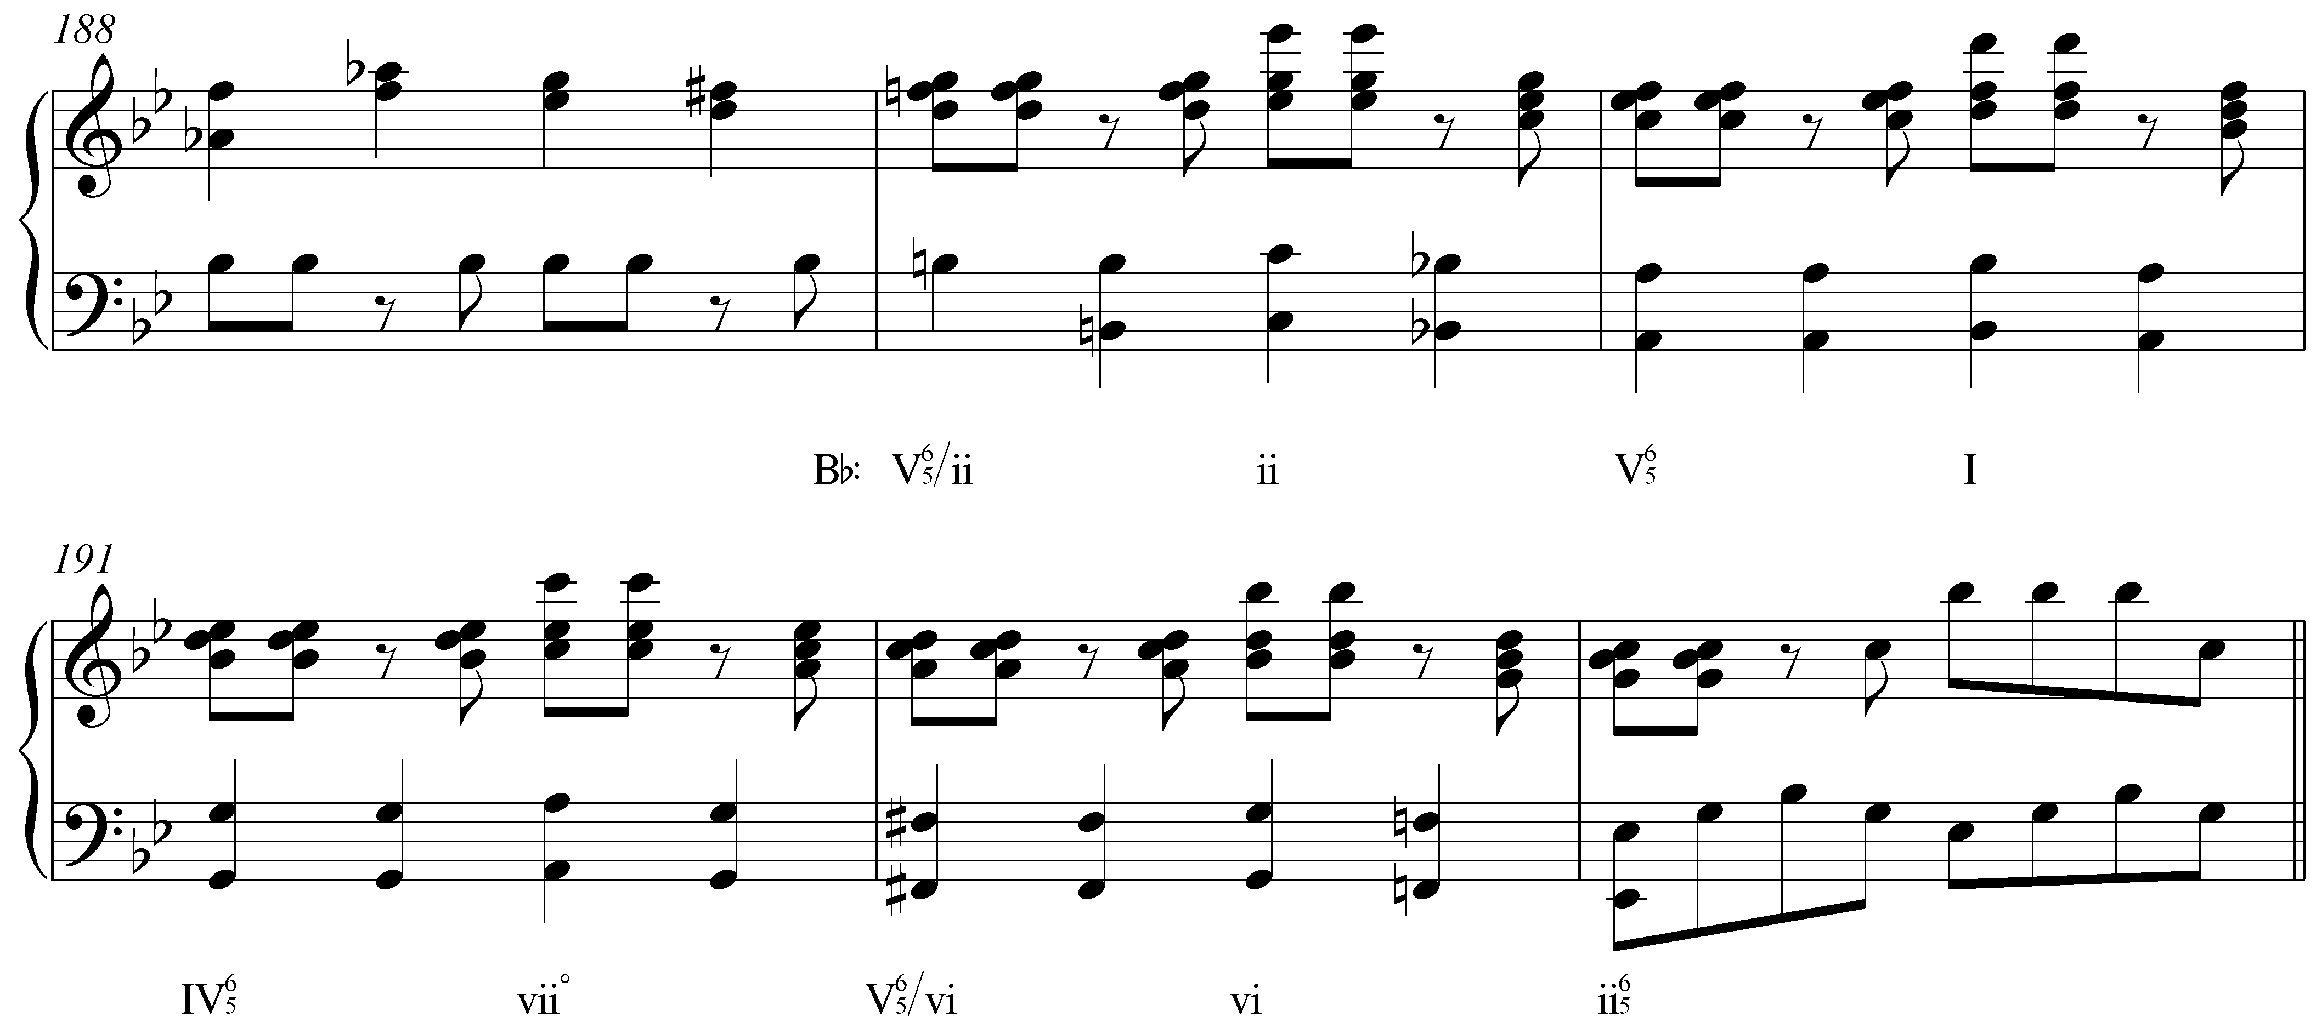
Example 27 (reduction of W.A. Mozart, Piano Sonata in Bb major, K. 333, Mvt. III, mm. 189-192):
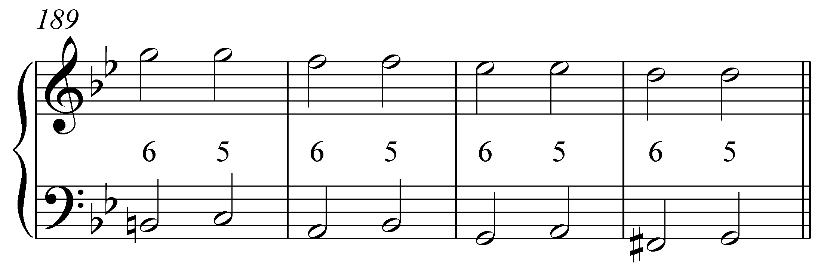

Example 28 (W.A. Mozart, Piano Sonata in D major, K. 284, Mvt. III, mm. 9-10):
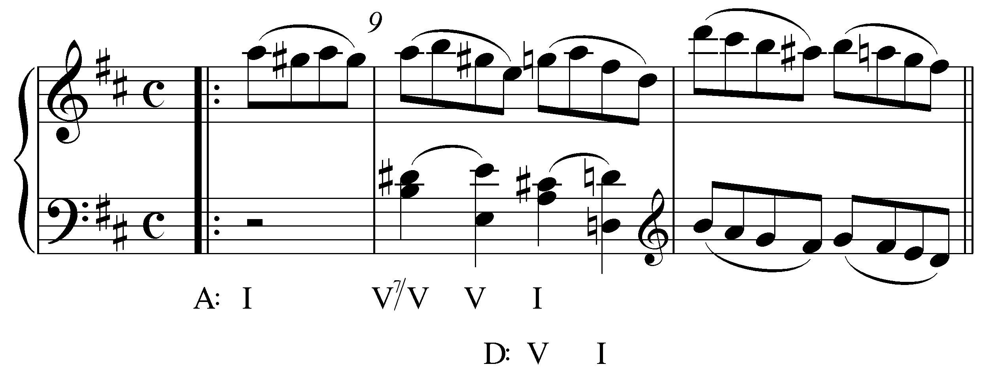
Example 29 (reduction of W.A. Mozart, Piano Sonata in D major, K. 284, Mvt. III, m. 9):
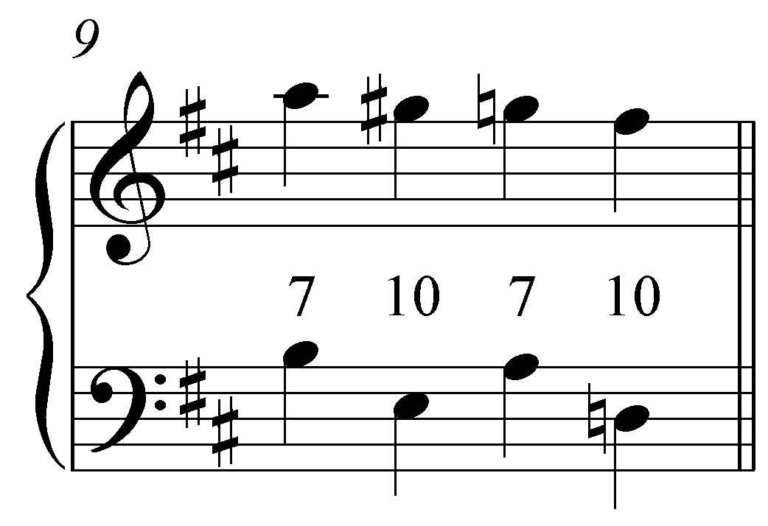

Example 30 (J.S. Bach, Sonata No. 1 in G Minor for Solo Violin, BWV 1001, Mvt. 4, mm. 11-17):
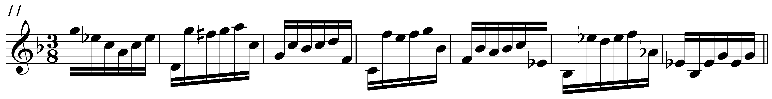

Example 31 (Bach Sinfonia No 8 mm 18-22):
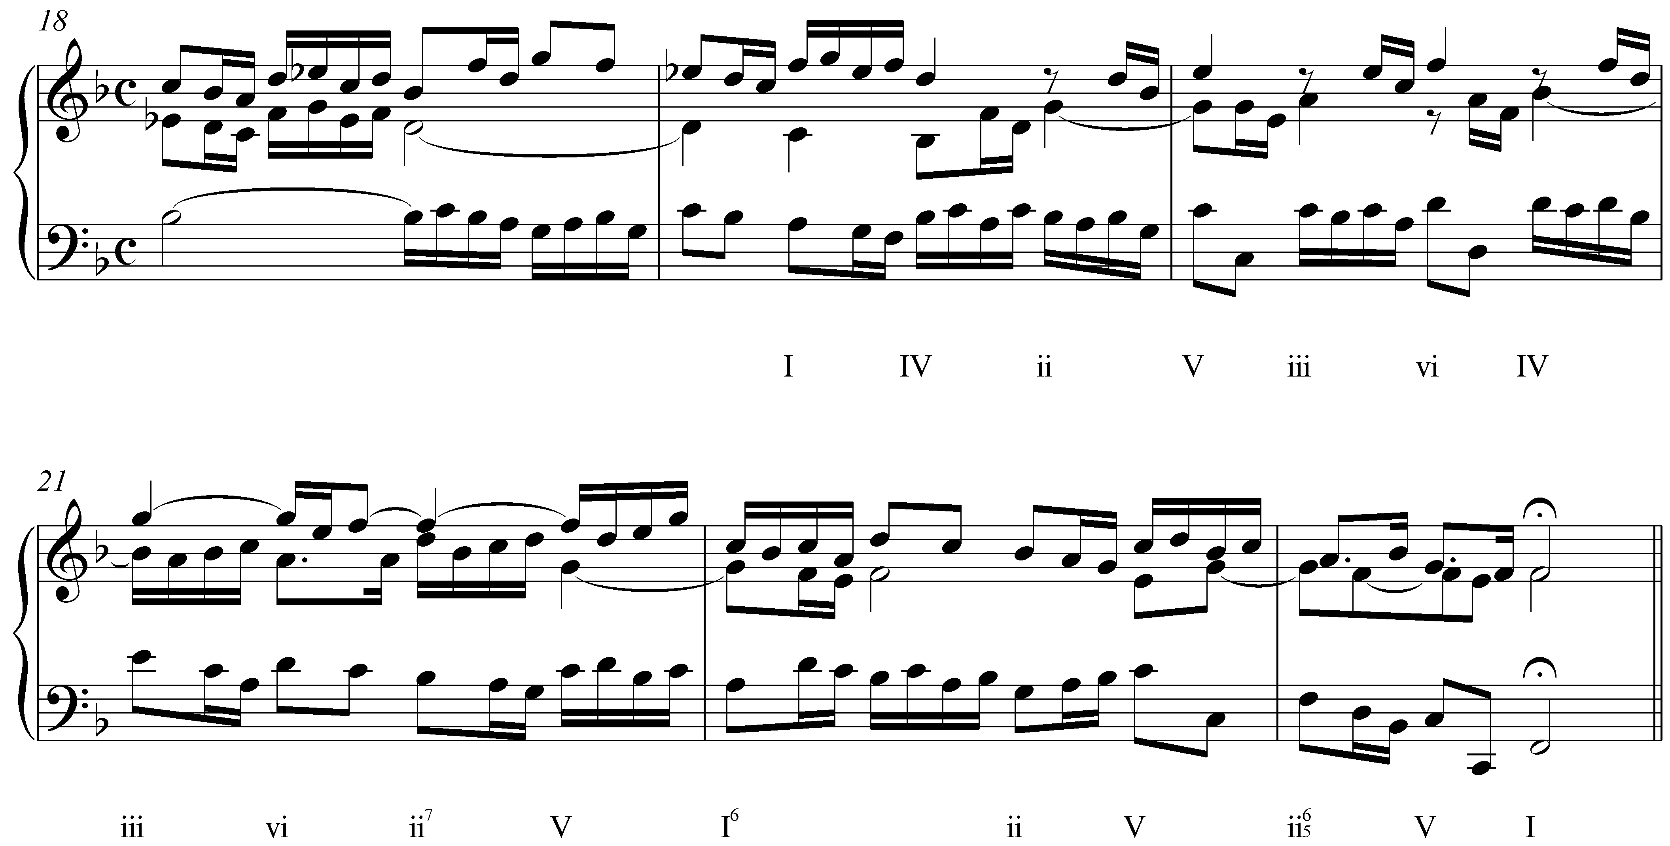

Example 32 (Bach Sinfonia No 12 mm 10-13):
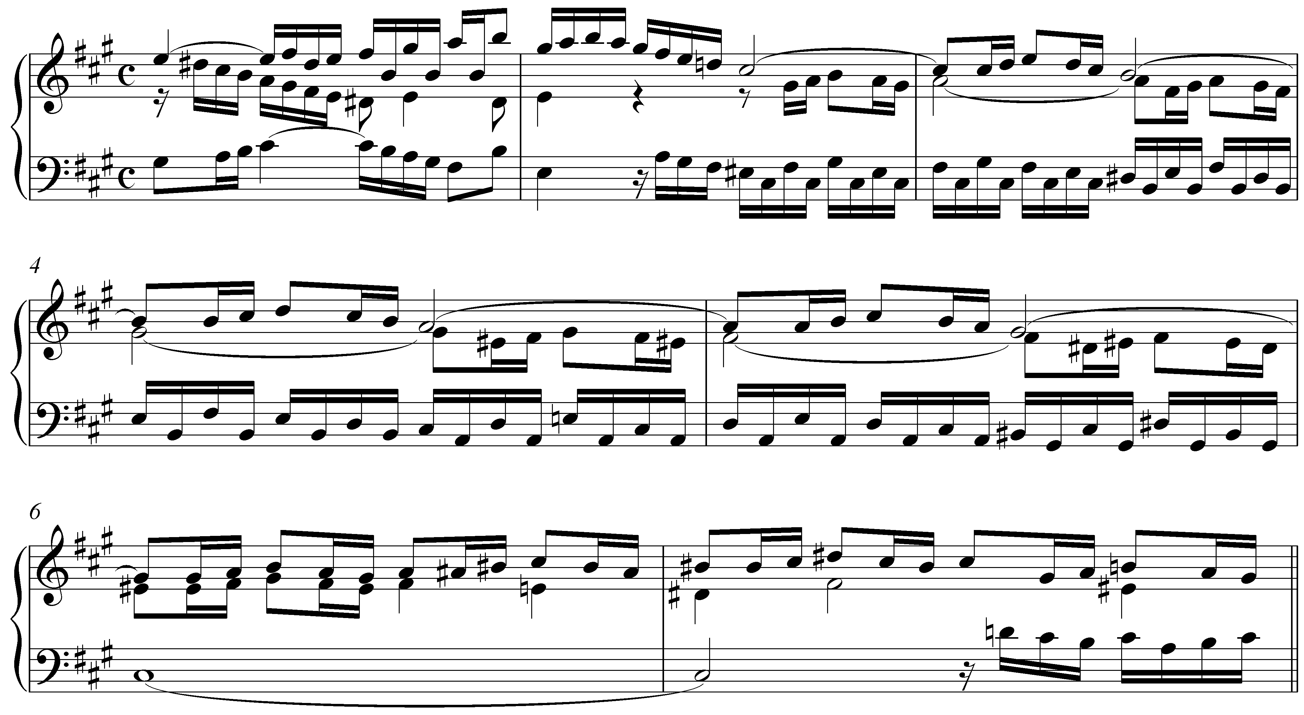

Example 33 (Mozart k 279 i mm 39-47)


