Lesson TTT – Other Diatonic Sequences

Introduction:

In Lesson SSS we discussed the fundamentals of diatonic sequences and examined the most common type: those in which the harmonies descend by root motion of a fifth. In this lesson, we will discuss several other varieties of diatonic sequences.

Descending- and ascending-“5 – 6” sequences (sequences based on thirds and seconds):

Sequences in which the harmonic units move by seconds or thirds run a greater risk of creating parallel fifths and octaves than those that move by fifths. For this reason, composers often include intervening chords to break up the parallel motion.

The following excerpt from Beethoven sonata shows a descending-third sequence in which intervening chords appear in first inversion:

Example 1 (L. Beethoven, Piano Sonata in E Major, Op. 109, Mvt. I, mm. 1-3):
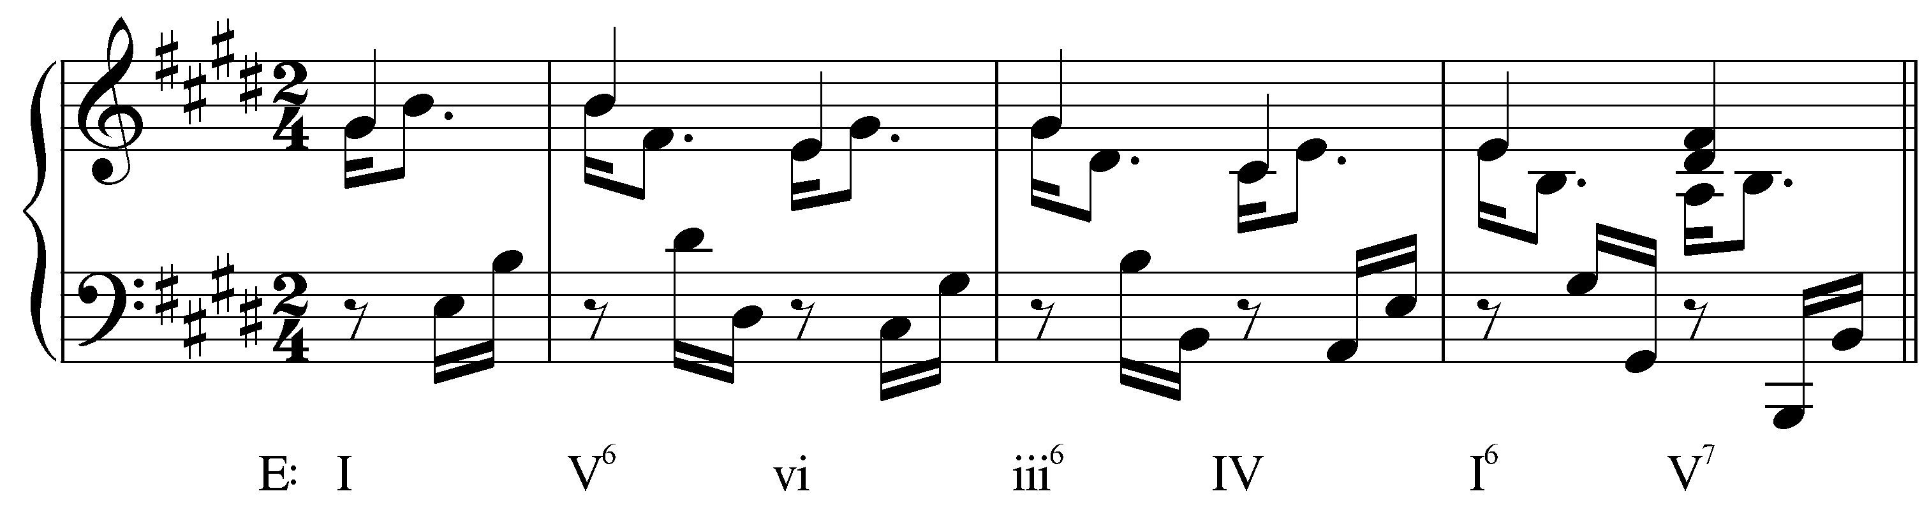

Each step in the chain of descending thirds appears on the second beat of its measure: I – vi – IV. Between each step, however, the chord roots move down by fifth: V⁶ is inserted between I and vi, iii⁶ between vi and IV. These secondary chords—along with the weak metric placement and melodic figuration—obscure the parallel fifths between each step in the sequence. We will refer to such sequences as “↓4th↑2nd” sequences to reflect the root motion from one chord to the next, but it is important to remember that bass will not reflect this if some chords appear in inversion.

Note: The labeling system used here shows the root motion from one chord in a sequence to the next. The arrows indicate the direction. That is, in a “↓4th↑2nd” sequence, the root motion first descends by a fourth (as in I to V or V⁶) and then ascends by a second (as in V to vi). Keep in mind that the overall root motion of a “↓4th↑2nd” sequence, for example, is by descending third. Each step simply contains an intervening chord. (This system, while not commonly used, does provide a common-sense way of describing the harmonic action of a sequence.)

Example 2 (reduction of L. Beethoven, Piano Sonata in E Major, Op. 109, Mvt. I, mm. 1-3):
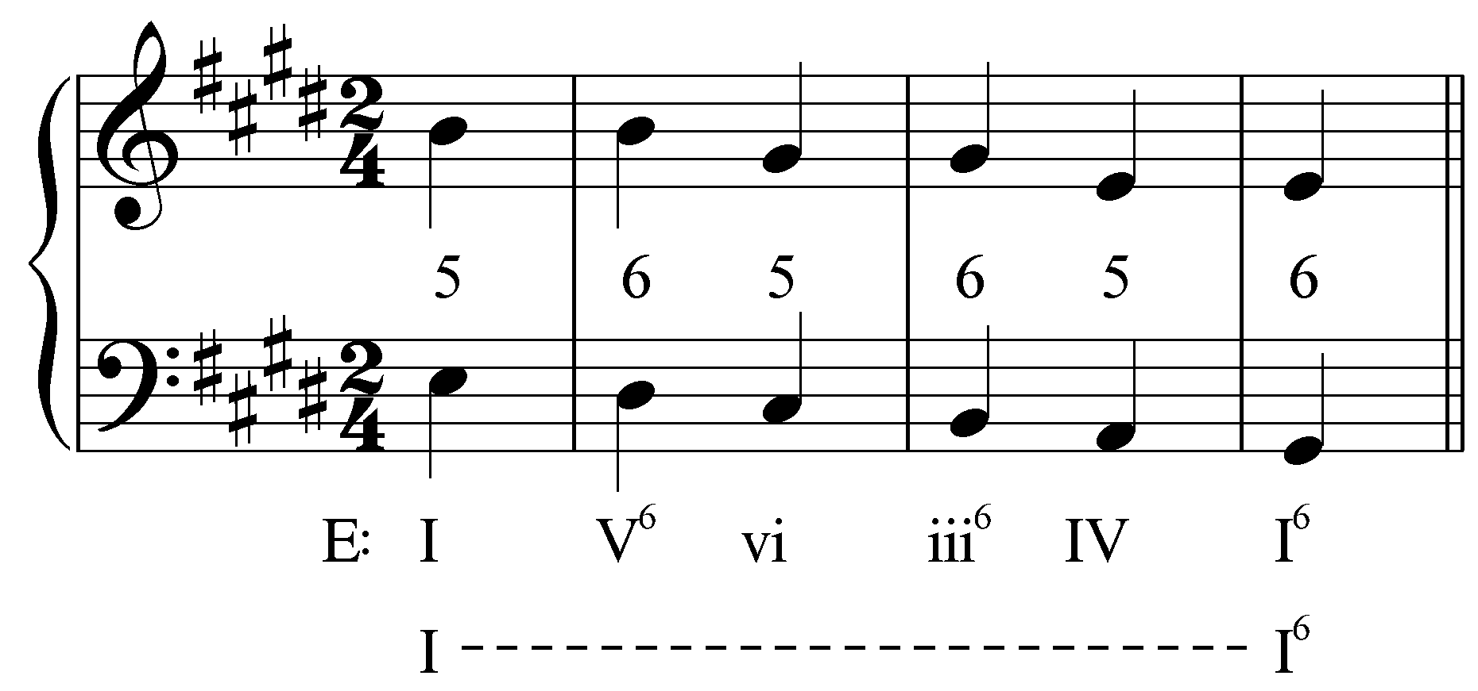

As this reduction shows, alternating between root position and first inversion produces a desirable effect: a stepwise descending bassline. The intervening chords (V⁶ and iii⁶) break up the parallel fifths that would normally result from successive descending third root motions. The result is a series of fifths suspended to become sixths as the bass steps down on the downbeat of each measure. As the second level of Roman numeral analysis shows, this sequence prolongs the initial tonic as I moves to I⁶. The descending “5 – 6” technique was a popular contrapuntal strategy in the Renaissance and was continually used in later music.

In the following excerpt, the order of harmonies (I – V – vi – iii – IV – I) is virtually identical to Example 1, though here they all appear in root position:

Example 3 (J. Pachelbel, Canon in D, mm. 1-2):
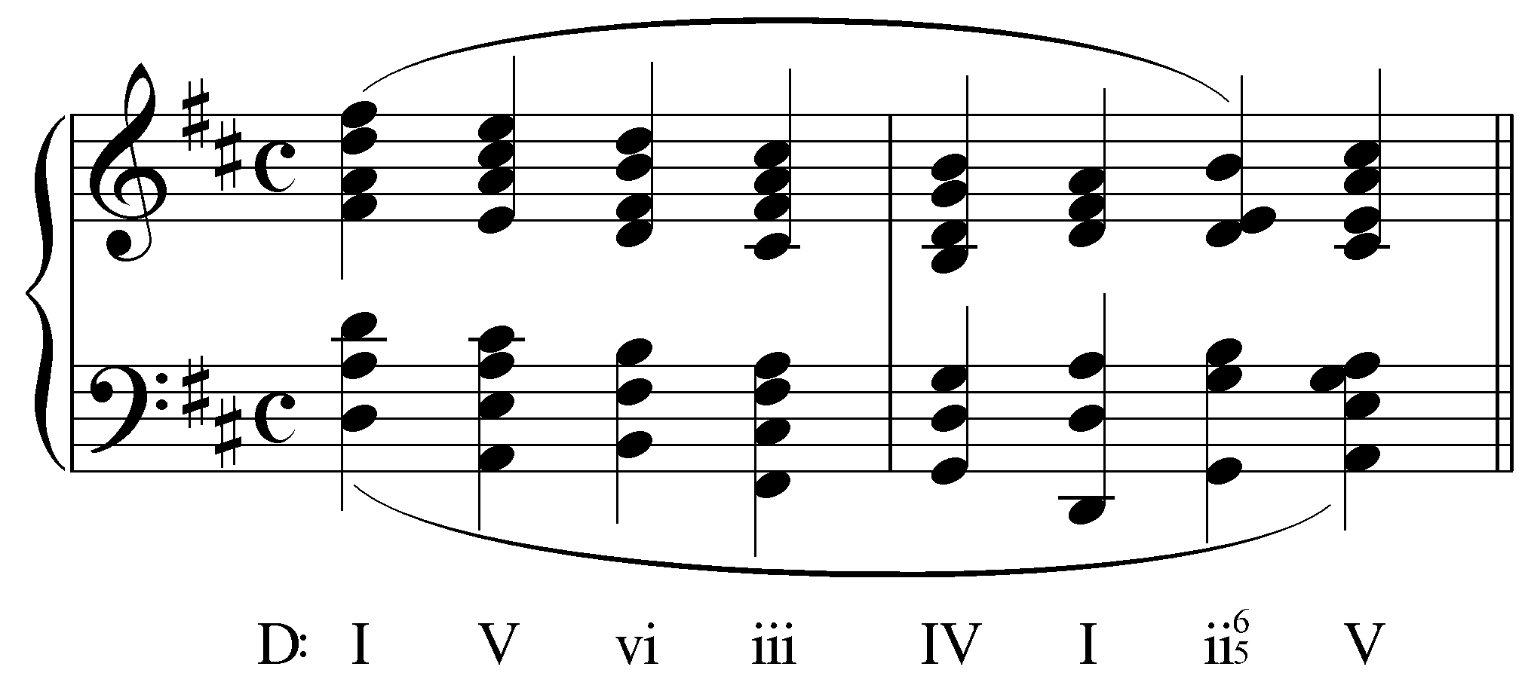

Johann Pachelbel’s famous Canon in D is built entirely around the sequence presented in the first two measures. Beginning with the initial tonic chord, this descending-third sequence continues until the next I chord on beat two of the second measure. Each step in the chain of descending thirds appears on a metrically strong beat (I – vi – IV), with intervening chords on the weak beats. Because each of the chords appears in root position, it is very easy to see the “↓4th↑2nd” root motion.

The following reduction removes the inner voices to clarify the voiceleading:

Example 4 (reduction of J. Pachelbel, Canon in D, mm. 1-2):
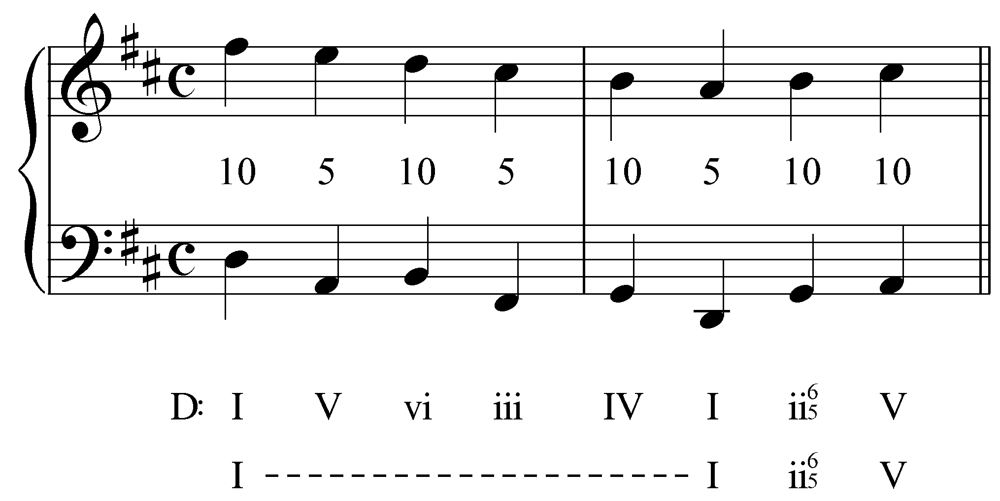

Between the outer voices we find tenths on the strong beats alternating with fifths on the weak beats. The intervening tenths obscure the parallel fifths. Like Example 1, this sequence prolongs the initial tonic harmony (as shown by the second level of Roman numeral analysis).

Activity TTT.01:
As we saw in Example 4, Pachelbel’s Canon in D finds the outer voices alternating between tenths and fifths. But take note of the inner voices reintroduced below (arranged in SATB for ease of reading). What LIP is formed by the “tenor” and “alto” of this reduction?

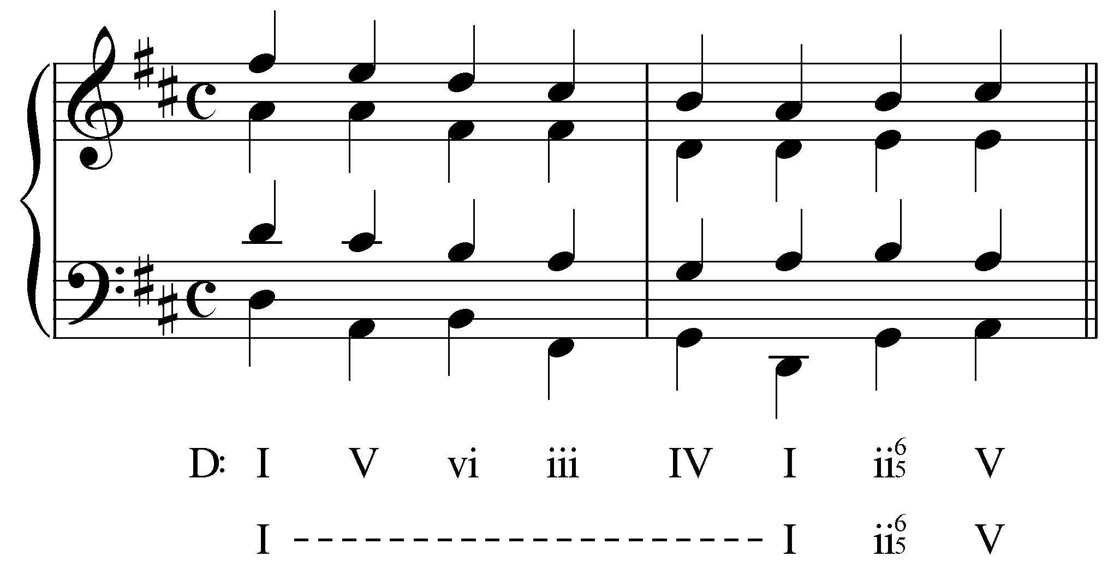

[Answer: 5-6. Response if correct: “Correct!” Response if incorrect: “Incorrect. Try again.”]

Example 5 (four-voice reduction of J. Pachelbel, Canon in D, mm. 1-2):

Note of the LIP appearing between the “tenor” and “alto.” On the first downbeat, the alto (A) forms a fifth above the tenor (D). The A is held as the tenor steps down to C, forming an oblique “5 – 6” interval progression. This pattern then repeats twice more. This inner-voice interval progression is the same one we saw in Example 2: a descending “5 – 6” pattern. Because this pattern is so recognizable, sequences such as the one found in Example 5 are often referred to as root-position variants of the descending “5 – 6” technique.

In the following excerpt from the fourth of Vivaldi’s Four Seasons concertos, first-inversion chords mediate between each step of an ascending-second sequence:

Example 6 (A. Vivaldi, Violin Concerto in F Minor, Op. 8, no. 4 (“Winter”), Mvt. II, mm 11-13):
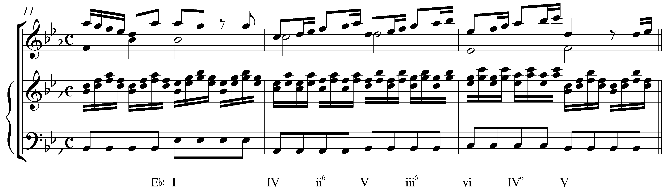

Like sequences based on thirds, ascending-second sequences often make use of intervening chords to break up parallel fifths and octaves. The IV chord on the downbeat of m. 12 initiates the sequence (IV – V – vi) with intervening chords on the weak beats. The intervening chords appear in first inversion, preserving the stepwise motion of the bass. Despite the stepwise bass line, we refer to sequences of this sort as “↓3rd↑4th” (read: down a third, up a fourth), summarizing the root motion from one chord to the next. The following reduction reveals the outer-voice interval progression and how the intervening chords obscure the parallel fifths:

Example 7 (reduction of A. Vivaldi, Violin Concerto in F Minor, Op. 8, no. 4 (“Winter”), Mvt. II, mm 11-13):
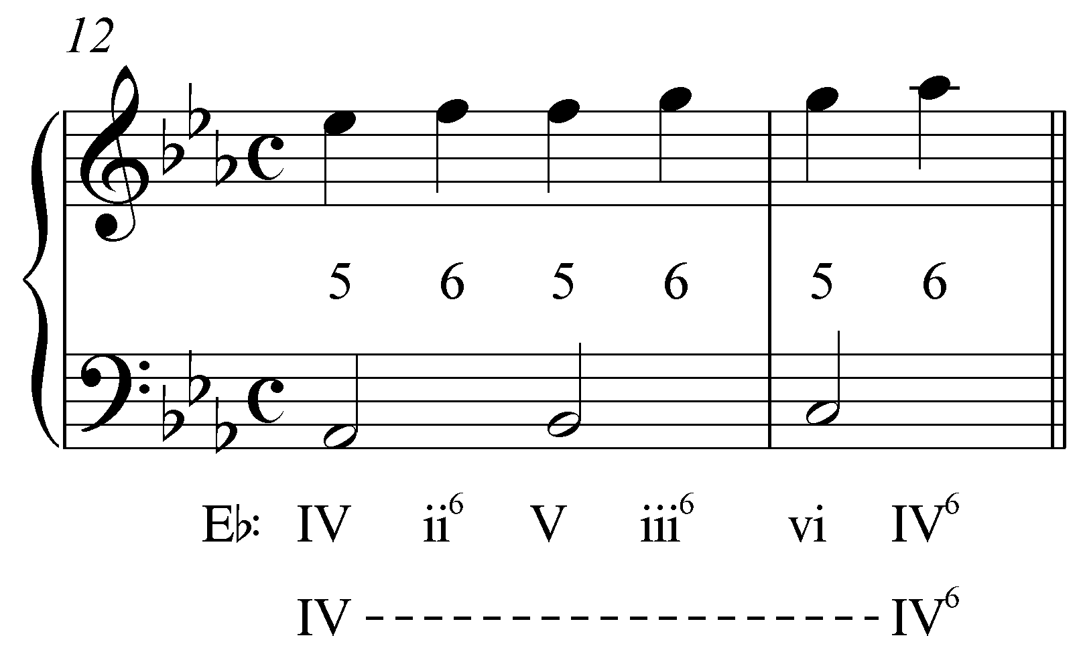

The ascending “5 – 6” motion seen in this reduction is remarkably similar to what we saw in Example 2. The only difference is that here the voices ascend instead of descend. (In this case, the sequence prolongs the predominant harmony.) Once again, the intervening sixths obscure the parallel fifths by approaching them through oblique motion. Such interval progressions are often referred to as ascending “5 – 6” LIPs.

The following excerpt begins with an ascending-third sequence starting with the V⁷ chord in the first measure:

Example 8 (A. Corelli, Sonata no. 11 from Sonate da Camera a Tre, Op. 4, Allemanda, mm. 1-5):
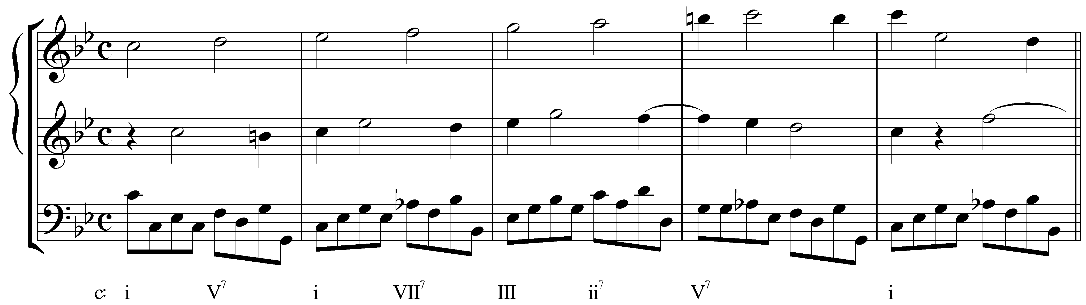

This ascending-third sequence features an ascending stepwise line in the uppermost voice. Again, intervening chords break up the inevitable parallel fifths. Note that while parallel octaves do appear on the downbeats between the bass and the middle voice, they quickly skip up to tenths on the second beat of each measure.

Looking at the reduction, we can see how the mediating chords break up the parallel fifths:

Example 9 (reduction of A. Corelli, Sonata no. 11 from Sonate da Camera a Tre, Op. 4, Allemanda, mm. 2-4):
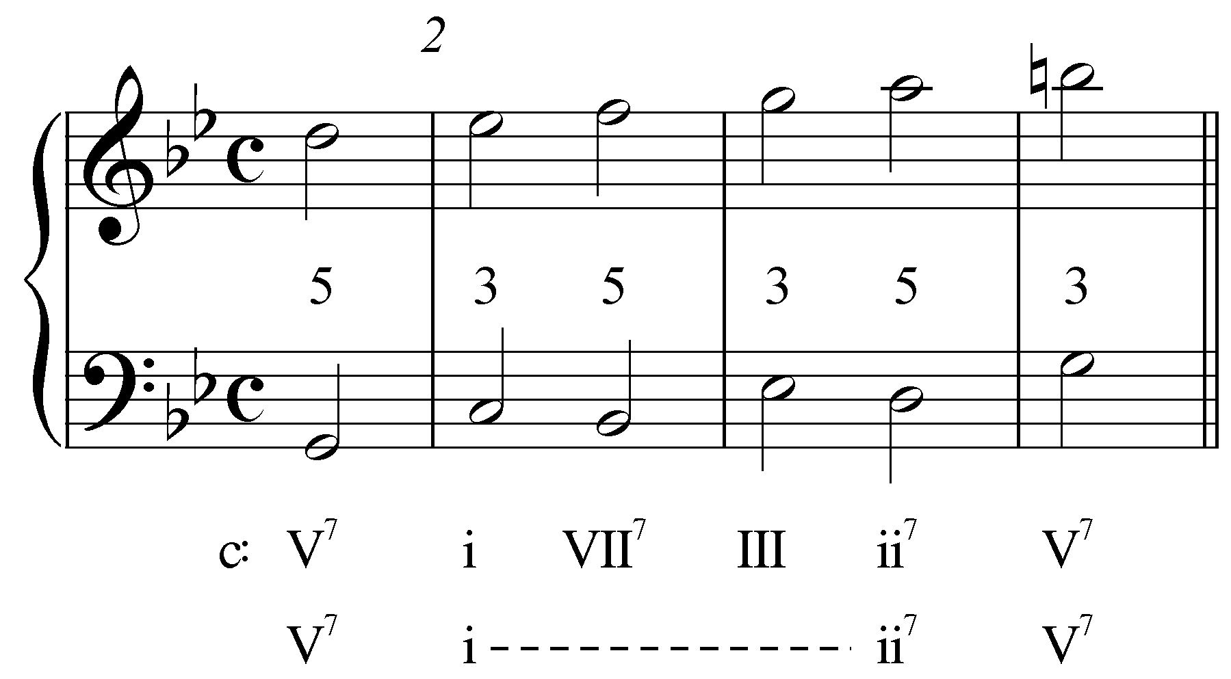

Instead of moving directly from one fifth to the next on the second beat of each measure, thirds intervene on the downbeats, changing the parallel motion to contrary motion. This results in the ascending stepwise motion of the entire upper line. If we consider the partially concealed inner voice, however, we find a familiar pattern:

Example 10 (reduction of A. Corelli, Sonata no. 11 from Sonate da Camera a Tre, Op. 4, Allemanda, mm. 2-4):
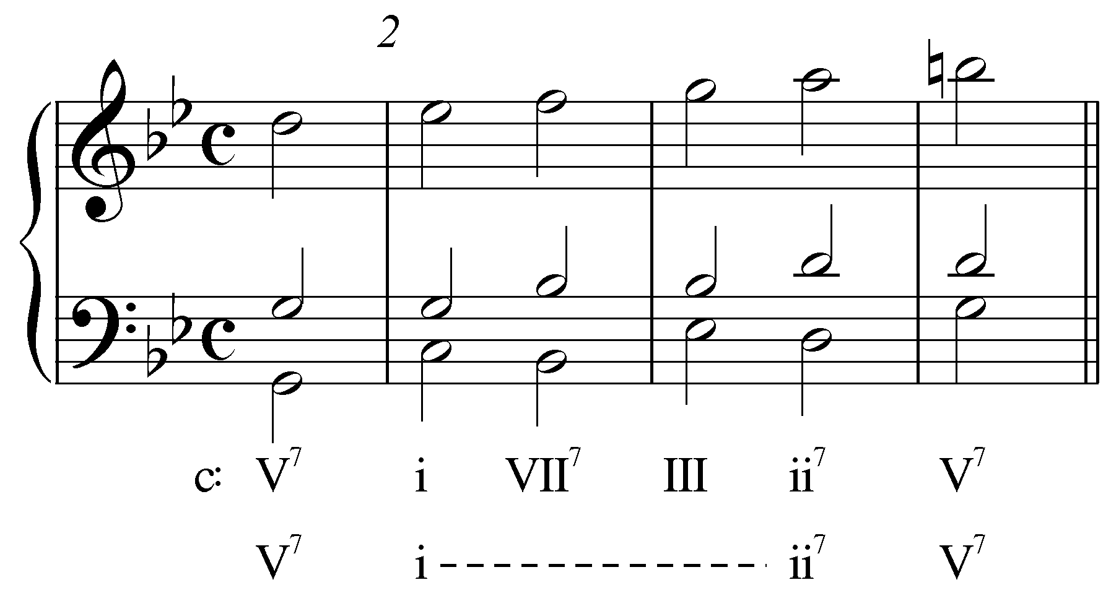

Consider the interval progression formed by the inner voice and the upper voice. On the anacrusis to m. 2, we find the upper voice (D) a fifth above the inner voice (G). The G is held into m. 2 while the upper voice steps up to Eb forming a sixth with the inner voice. The pattern then repeats. This is the same LIP we saw in Example 7! In this case, however, each of the harmonies appears in root position. You can think of this pattern as a root-position variant of the ascending “5 – 6” technique.

Note as well that in this case, instead of prolonging a single harmony, this sequence prolongs the progression from i to ii⁷.

Ascending-fifth sequences:

Ascending-fifth sequences are far less common than their descending-fifth counterparts. Nonetheless, they do appear with some frequency and have a decidedly different effect. Consider the following example:

Example 11 (A. Corelli, Sonata no. 11 from Sonate da Camera a Tre, Op. 4, Corrente, mm. 18-27):
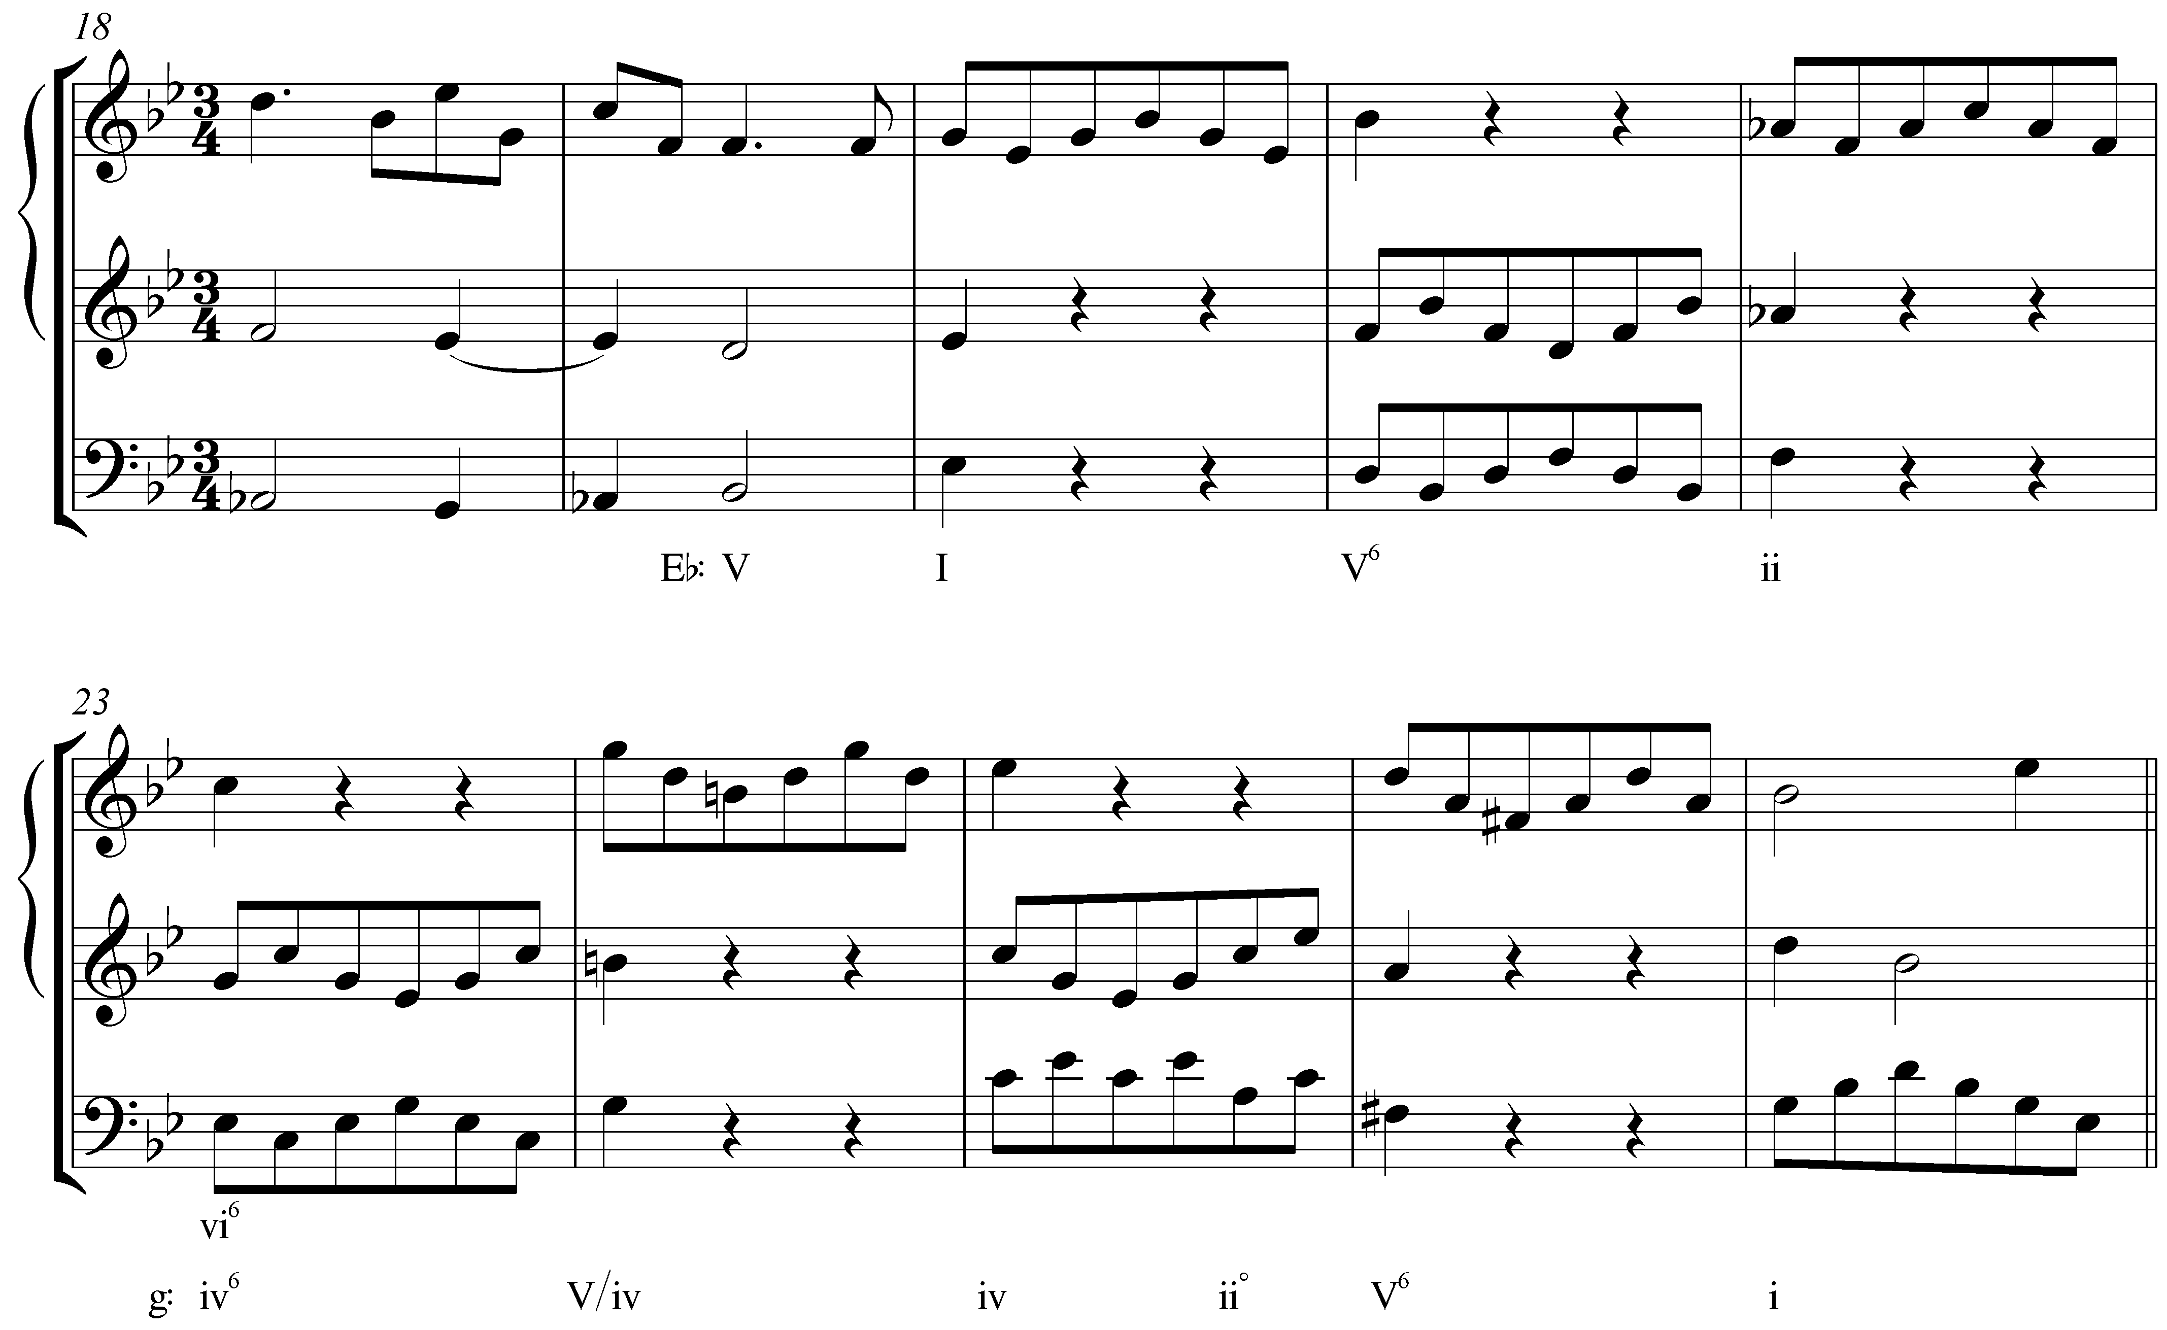

The melodic figure in m. 20 is passed back and forth between the bass and uppermost voice with every change in harmony. Starting with the tonic chord in m. 20, the harmonic progression ascends by fifth in each subsequent measure: I – V – ii – vi. In m. 24, the root of the chord is again a fifth higher, but the pattern is broken by the altered melodic line in the upper voice.

Note as well that m. 24 introduces B natural. That chord, initially heard as V/vi in Eb major, turns out to be an auxiliary sonority prolonging the C-minor chord of m. 23, which in light of the ensuing cadence in G minor is retroactively interpreted as iv in that key.

Activity TTT.02:
Beginning with the I chord in m. 20 and going through the vi⁶ chord in m. 23, what is the LIP between the outer voices? (Hint: Look at the notes on the downbeat of each measure, ignoring, for the moment, the decorations that appear above and below.)

[Answer: 3-6. Response if correct: “Correct!” Response if incorrect: “Incorrect. (Hint: The primary notes of this LIP are found on the downbeats of each measure. Don’t be distracted by the decorative eighth notes that appear above and below later on in each measure.)”]

Looking at the outer-voiceleading reduction, we again see a familiar interval progression:

Example 12 (reduction of A. Corelli, Sonata no. 11 from Sonate da Camera a Tre, Op. 4, Corrente, mm. 20-23):
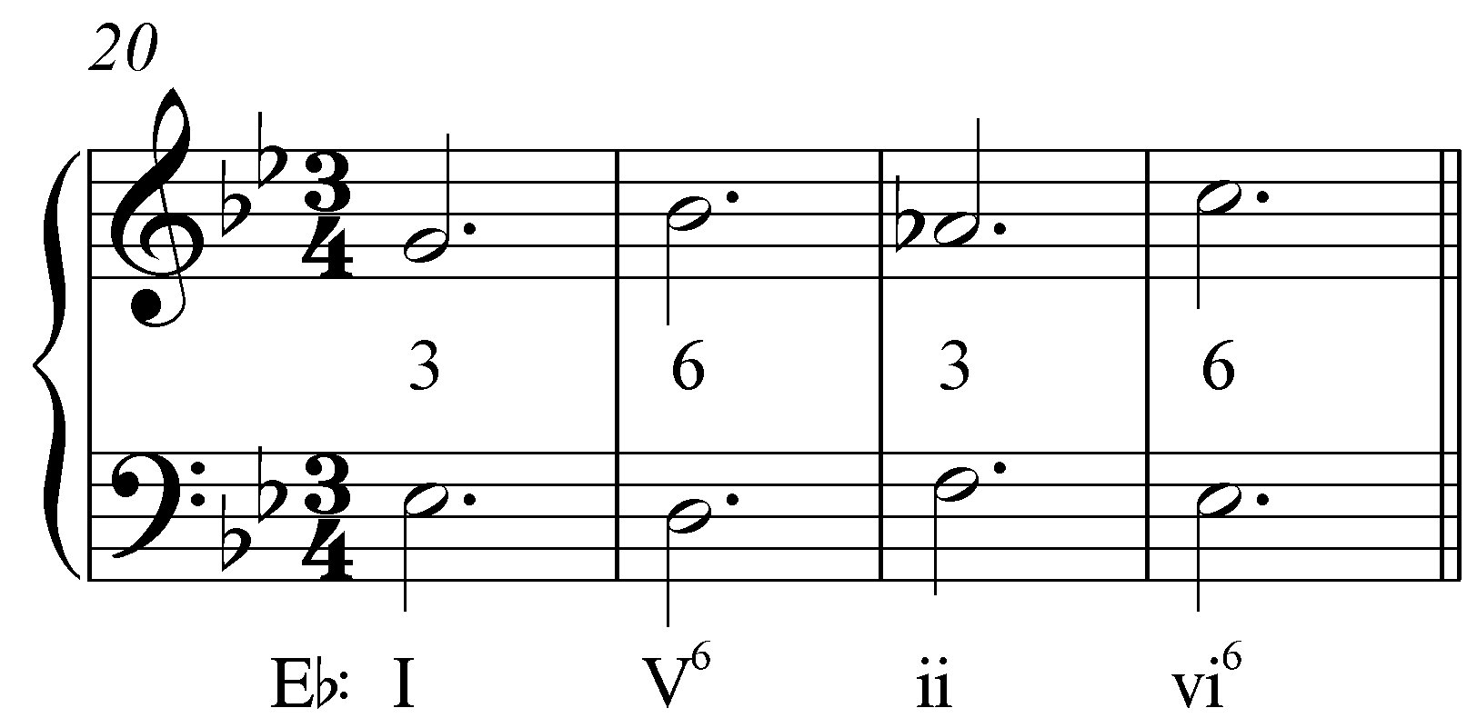

Here, the root-position chords have a third above the bass while the first-inversion chords have a sixth. “3 – 6” interval progressions are also very common. Note that in contrast to descending-fifth sequences, in which the overall motion descends, here the overall motion ascends.

The beginning of Bach’s Little Prelude in C Major, BWV 924, begins with a “↑5” sequence (Example 14 provides a reduction):

Example 13 (J.S. Bach, Little Prelude in C Major, BWV 924, mm. 1-3):
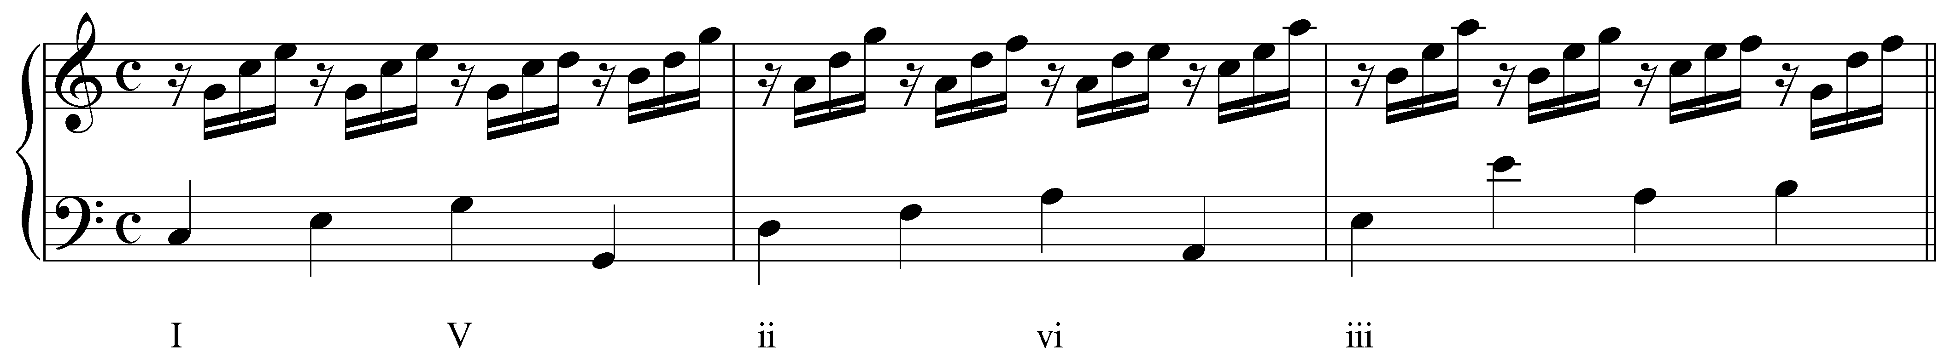

Example 14 (reduction of J.S. Bach, Little Prelude in C Major, BWV 924, mm. 1-3):
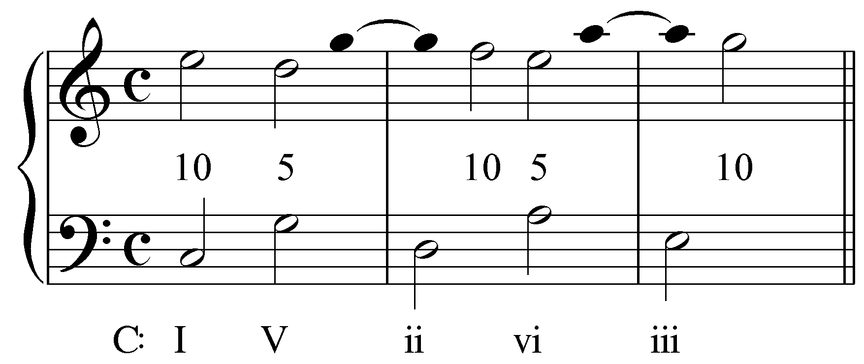

Throughout the passage, Bach uses suspensions and other techniques to smooth out the ascending-fifth progressions. In m. 1, the V chord is introduced as the continuation of a bass arpeggiation of I. The suspended fourth (C on beat 3) resolves on the fourth beat as the upper voice makes a consonant skip up to the root of the triad. That voice is then suspended as a dissonant fourth into the next measure before resolving to the tenth above the bass and repeating the pattern. The basic framework of this sequence, then, is a series of alternating tenths and fifths.

Note: Neither of the ascending-fifth sequences discussed above run past the fifth chord in the sequence—to do so would introduce a tritone in the bass as viiº moved to IV. Sometimes composers will skip entire steps of a sequence to avoid this situation. Consider the following example:

Example 15 (L. Beethoven, Piano Sonata No.21 (“Waldstein”), Op.53, mm. 446-450):
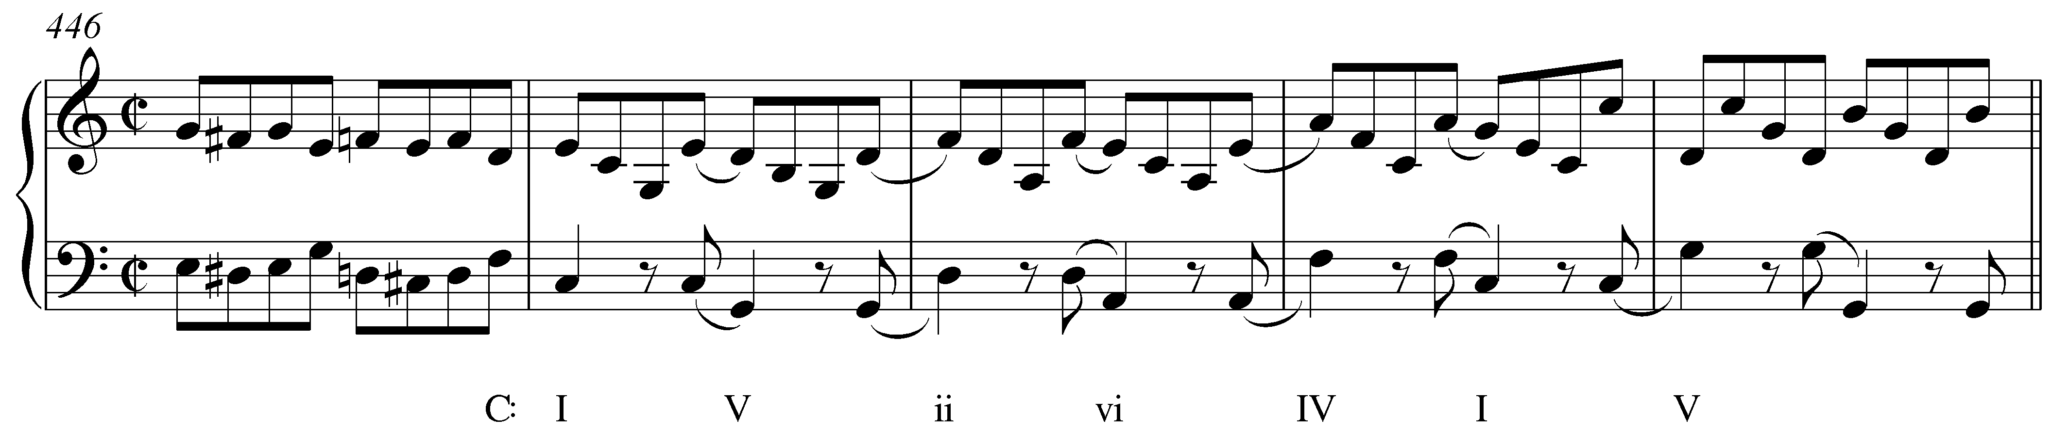

This ascending-fifth sequence begins normally, but breaks the pattern in mm. 449 to avoid the tritone bass motion: I – V – ii – vi – [missing: iii – viiº] – IV – I.

Other interval patterns are possible (e.g. “10 – 5” and “10 – 10”) with ascending-fifth sequences, depending on which chords are inverted, and on what chord member appears in the uppermost voice.

Conclusion:

While the majority of sequences move by descending-fifth root motion, you will also encounter sequences that move by seconds or thirds. Many of these are structured by a “5-6” interval pattern and include intervening chords that offset the parallel fifths that inevitably arise. In a descending “5-6” sequence, each repetition descends by a third but, typically, intervening chords lead to a “↓4th↑2nd” root motion within each step. Ascending “5-6” sequences, on the other hand, typically follow “↓3rd↑4th” root motion from one chord to the next. Ascending-fifth sequences have a unique effect, but occur much less frequently than their descending-fifth counterparts.

