Lesson YYY: Simple Meters

Introduction:

Although rhythm and meter are inextricably linked—two closely-related facets of how music unfolds over time—the words are used to describe different things. Both are related to the beat—a steady, underlying pulse found in the majority of Western music. Rhythm refers to the variety of note and rest durations that appear in the context of the beat. Meter, on the other hand, refers to how the beats are grouped and, as we will discuss shortly, divided. Lesson XXX describes three such groupings: meters that sort the beat into groups of twos (alternating strong and weak beats) are known as duple meters. Meters that sort the beat into groups of three or four are referred to respectively as triple and quadruple meters.

But describing a type of meter with regards to how it groups the beats provides only one part of the equation. We will now discuss the varying ways in which the beat can be divided. This lesson will consider meters in which the beat is regularly divided into groups of two and Lesson ZZZ will discuss those meters which regularly divide the beat into groups of three.

Beat division:

Listen to the following excerpt from a Mozart sonata. As you listen, tap along with your foot to find the beat. You should be able to hear two beats per measure—in other words, this excerpt is in a duple meter:

Example 1 (W.A. Mozart, Piano Sonata in Eb major, K. 282, Mvt. IV, mm. 1-16):
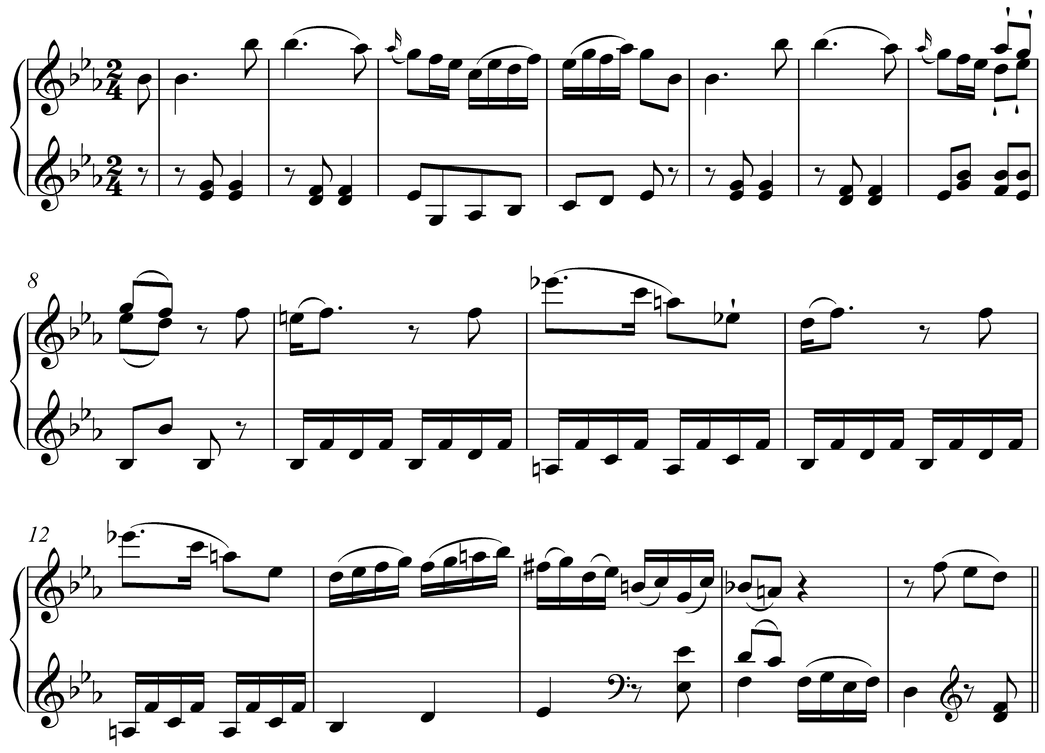

Were you able to hear that this excerpt is in a duple meter? The basic, underlying pulse has a duration equal to that of a quarter note. These quarter-note beats are organized into groups of two by the measure lines. Notice how the notation emphasizes the duple meter: shorter durations (eighth notes and sixteenth notes) are grouped in a way that does not obscure the duple meter. More on this momentarily.

As you may have noticed, the basic beat is not the only regular pulse. Listen to Example 1 again. This time, as you are tapping your foot to the beat tap your hand twice per beat. This faster pulse—twice as fast, in this case—is referred to as the beat division. The following example clarifies:

Example 2:
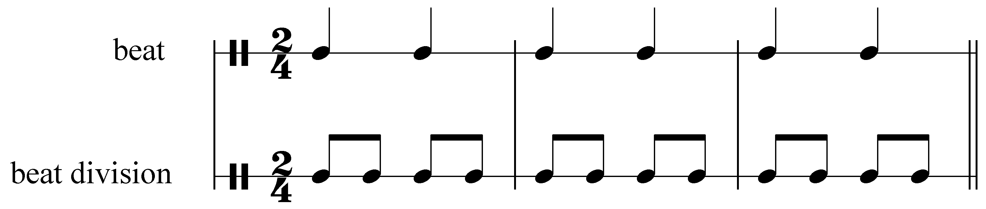

In this case, each quarter-note beat can be divided into two eighth notes. In other words, as your foot is tapping quarter notes along with the music, your hand should be tapping eighth notes. Meters like this, in which the beat is regularly divided into twos, are referred to as simple meters.

Activity YYY.1:
What would be the note value of the beat division for a simple meter in which the beat was equal to a half note?
[Answer: quarter note. Response if correct: “Correct!” Response if incorrect: “Incorrect. (Hint: Remember, the beat division for a simple meter is equal to half the duration of the beat itself.)”]

Now listen to the following excerpt. Again, you’ll find that the meter has two beats per measure.

Example 3 (W.A. Mozart, Piano Sonata in D major, K. 311, Mvt. III, mm. 1-16):
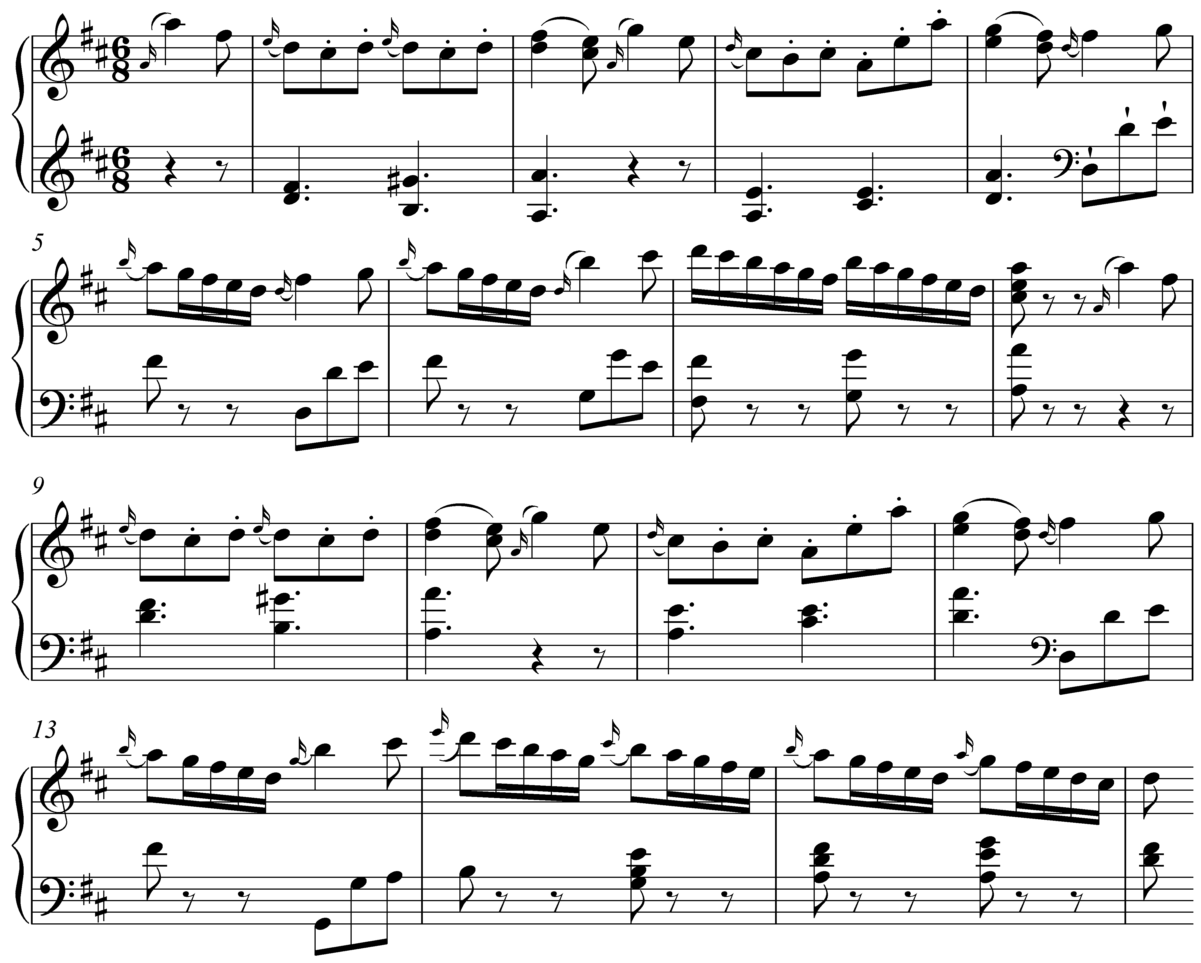

In this case, however, if you try tapping the beat division with your hand while tapping the beat with your foot, you’ll find it is difficult to divide the beat in two. Tapping your hand three times for every foot tap is much more natural. In this meter, the beat is divided into three notes. The following example clarifies:

Example 4:
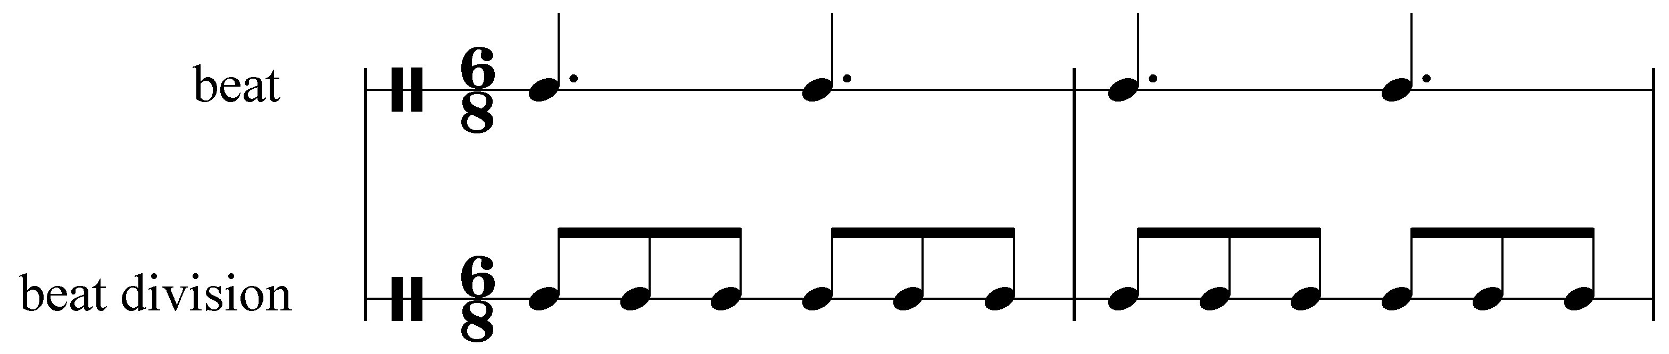

In this case, the beat is divided into threes. Each beat—the duration of which is equal to a dotted quarter note—is divided into three eighth notes. Meters such as this, in which the beat is divided into threes, are referred to as compound meters.

These two terms, simple and compound, indicate how the basic pulse is divided. They are usually used in conjunction with duple, triple, and quadruple to give a more or less complete description of any given meter. Both of the examples above have two beats per measure. In other words, they are both duple meters. They differ, however, in how those beats are divided. Example 1 divides the beat into twos and is therefore referred to as being in a simple duple meter. Example 3, on the other hand, divides the beat into threes and is therefore referred to as being in a compound duple meter.

Activity YYY.2:
Is the following piece (W.A. Mozart, Minuet No. 3 in D major (from 12 Minuets, K. 103), mm. 1-10) in a simple meter or compound meter?
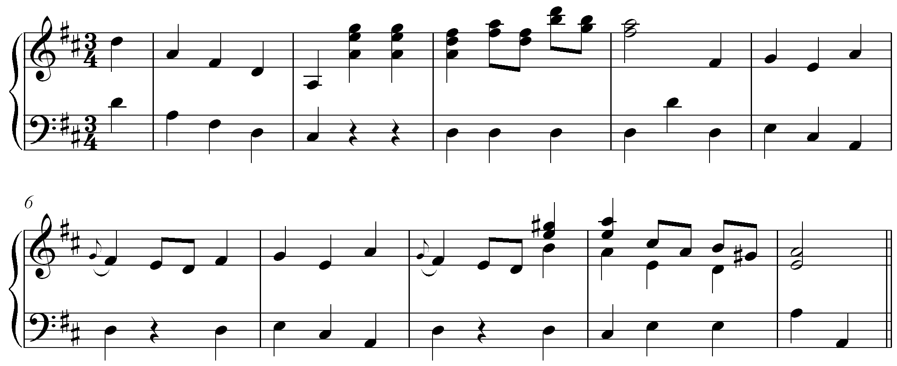
[Answer: simple. Response if correct: “Correct! This piece is in a simple triple meter.” Response if incorrect: “Incorrect. Try again. (Hint: Look for a division of the beat into shorter note values. Is the beat divided into two notes or three?)”]

The remainder of this lesson will focus on simple meters. A discussion of compound meters can be found in Lesson ZZZ.

Note: You may have noticed that each of the two excerpts above begin with an incomplete measure. Example 1 begins with an eighth note before the first measure line and Example 3 begins with a quarter note and an eighth note. An incomplete measure at the start of a piece of music is referred to as an anacrusis or pickup measure. Even though the music begins on a weak beat (or off beat) with regards to the meter, we have no trouble identifying the first downbeat.

The following example provides another example of an anacrusis. (Note that the first full measure is labeled as m. 1.)

Example 5 (B. Higley and D. Kelley, “Home on the Range,” mm. 1-7):
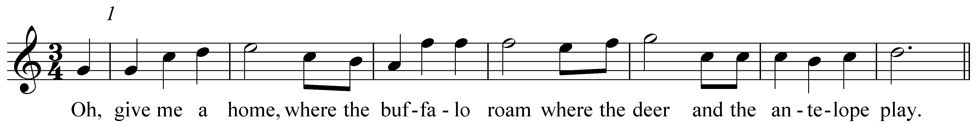

Anacruses can be used with any type of meter, simple or compound.

Simple meters and time signatures:

Any of the beat groupings mentioned above—duple, triple, or quadruple—can represent a simple meter. A simple triple meter, for example, would have three beats per measure, each of which would regularly divide into two.

Each of the examples above have some numbers just to the right of the key signature on the first line of music. These numbers are referred to as a time signature (or meter signature). They indicate to the performer the type of meter present in any given piece of music.

Each time signature consists of two numbers, one stacked on top of the other. For simple meters, the top number represents the number of beats and the bottom number the note value of a single beat. In Example 1, we saw the time signature “” and called that meter “simple duple.” The top number, in this case “2,” tells us there are two beats per measure (hence, “duple”). The bottom number, in this case “4,” tells us that each beat has a duration equivalent to a quarter note.

Consider the following short, familiar piece:

Example 6 (Minuet from the Notebook for Anna Magdalena Bach, mm. 1-16):
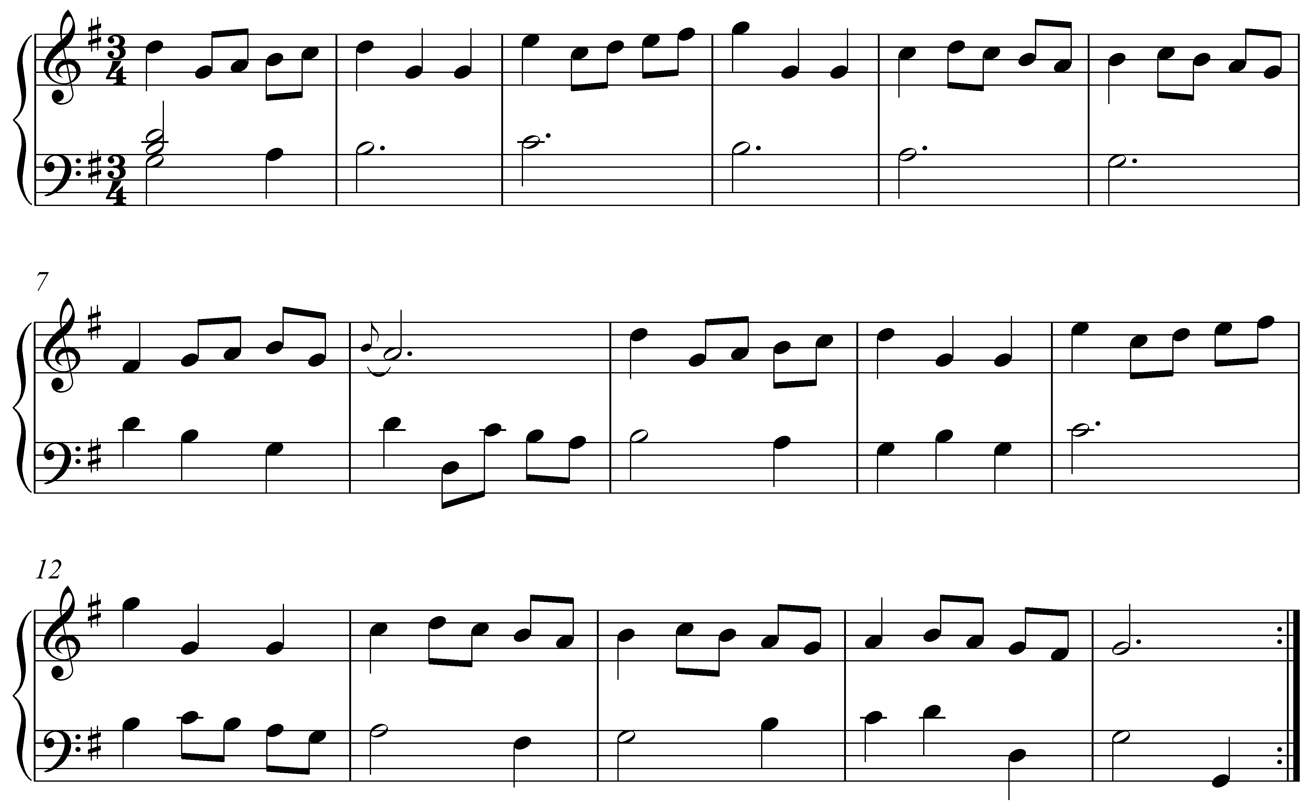

We see the time signature “” at the beginning of Example 6. Here, the “3” indicates that there are three beats per measure and the “4” that each beat is the length of a quarter note. As the shorter durations make clear, the meter is simple: each quarter note divides into two eighth notes.

Simple meters are generally very easy to recognize. Any time signature in which the top number is 2, 3, or 4 represents a simple meter.

Note: For simple meters, the general rule of thumb is that the top number of the time signature indicates the number of beats per measure (duple, triple, or quadruple) and the bottom number indicates the beat value. As discussed in Lesson ZZZ, however, this rule of thumb does not apply to compound meters.

The following examples show several common simple-meter time signatures:

Example 7 (common simple-meter key signatures):

a. simple quadruple: b. simple triple:
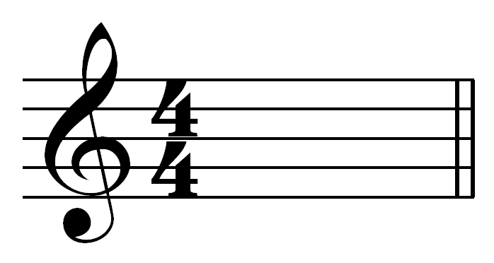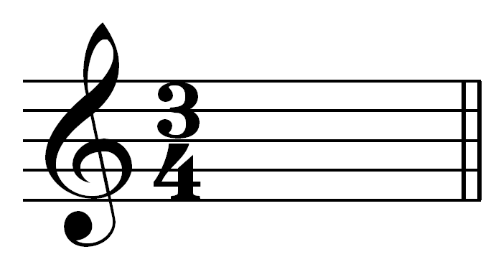

c. simple duple: d. simple duple:
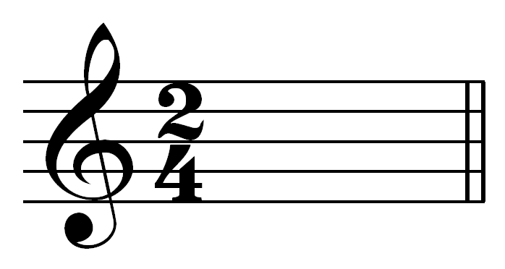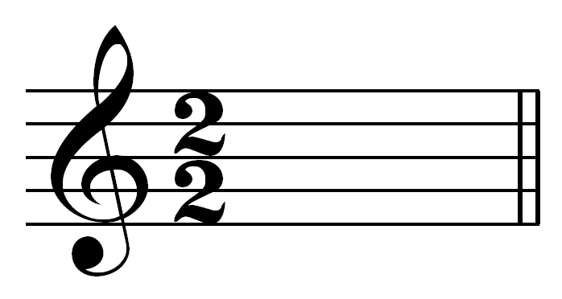

The difference between “” or “” is subtle. Both time signatures have measures whose durations are equal to a single whole note (four quarter notes or two half notes). The difference lies in how the music is performed or heard. The former will have four distinct beats per measure, while the latter will have only two.

Note as well that Examples Example 7c and Example 7d (“” and “”) are both simple duple meters. Both of them have two beats per measure. They differ only in the note value of the beat (a quarter note and a half note, respectively).

Frequently, you will encounter other, non-numeric symbols used as time signatures. These are shown in Example 8:

Example 8 (alternative time signatures):
a. “common time”:
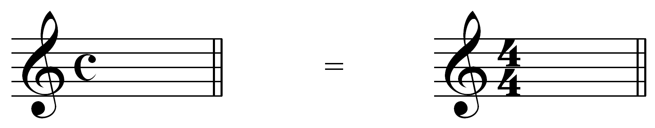

b. “cut time” (or, “alla breve”):
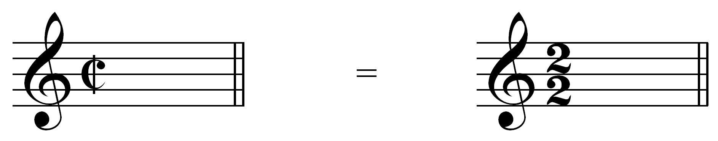

These time-signature symbols are often used as a shorthand way to write “” or “.”

Note: The symbol used for common time resembles the letter “C”—the first letter of the word “common.” The symbol used for cut time has a vertical line, cutting the “C” in half. These mnemonic devices, though useful, are not grounded by any historical accuracy.

Activity YYY.3:
For each of the following simple-meter time signatures, identify the number of beats per measure and the note value of a single beat.

Exercise YYY.3a
How many beats per measure are indicated by the following time signature?
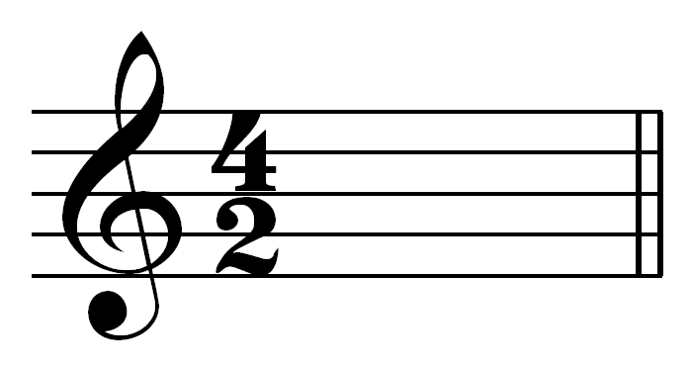
[Answer: 4. Response if correct: “Correct!” Response if incorrect: “Incorrect. Try again. (Remember that for simple meters, the top number of the time signature indicates the number of beats per measure.)”]
[Follow-up question:]
What is the note value of the beat, as indicated by this time signature?
[Anser: half note. Response if correct: “Correct!” Response if incorrect: “Incorrect. Try again. (Remember that for simple meters, the bottom number of the time signature indicates the note value of the beat.)”]

Exercise YYY.3b
How many beats per measure are indicated by the following time signature?
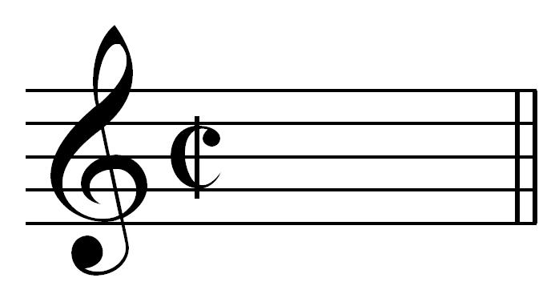
[Answer: 2. Response if correct: “Correct!” Response if incorrect: “Incorrect. Try again.”]
[Follow-up question:]
What is the note value of the beat, as indicated by this time signature?
[Anser: half note. Response if correct: “Correct!” Response if incorrect: “Incorrect. Try again.”]

Exercise YYY.3c
How many beats per measure are indicated by the following time signature?
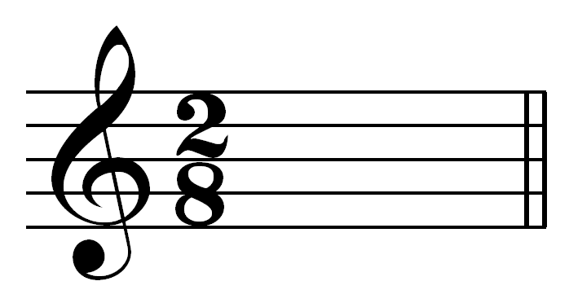
[Answer: 2. Response if correct: “Correct!” Response if incorrect: “Incorrect. Try again. (Remember that for simple meters, the top number of the time signature indicates the number of beats per measure.)”]
[Follow-up question:]
What is the note value of the beat, as indicated by this time signature?
[Anser: eighth note. Response if correct: “Correct!” Response if incorrect: “Incorrect. Try again. (Remember that for simple meters, the bottom number of the time signature indicates the note value of the beat.)”]

Exercise YYY.3d
How many beats per measure are indicated by the following time signature?
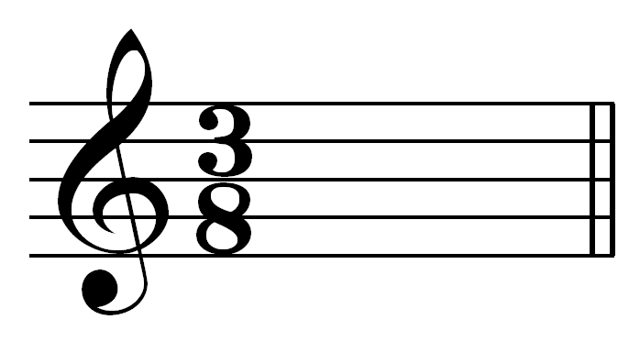
[Answer: 3. Response if correct: “Correct!” Response if incorrect: “Incorrect. Try again. (Remember that for simple meters, the top number of the time signature indicates the number of beats per measure.)”]
[Follow-up question:]
What is the note value of the beat, as indicated by this time signature?
[Anser: eighth note. Response if correct: “Correct!” Response if incorrect: “Incorrect. Try again. (Remember that for simple meters, the bottom number of the time signature indicates the note value of the beat.)”]

Beaming:

Note durations shorter than a quarter note—eighth notes, sixteenth notes, thirty-second notes, etc.—are written by adding flags to the stem. (Refer to Lesson XXX for more on rhythmic notation.) These flags can also be notated as beams: horizontal lines that connect two or more notes. Beams can be a helpful way to make a score appear less cluttered. They can also help emphasize the meter to the performer.

Beams are typically used to reflect the meter by grouping notes that occur within a single beat. Consider the following examples:

Example 9 (beaming in a simple meter):

a. incorrect:

b. correct:

Both of the rhythms in Example 9, if performed, would sound exactly the same. Although the corresponding note durations are identical, the beaming is quite different. Both rhythms are in simple duple meter, with two quarter notes per measure. The red dashed lines divide each measure in half, making clear which beats belong to the first beat and which to the second in each measure.

As you can see, in Example 9a some of the beams connect notes over the dashed line. This obscures the meter, making it difficult to recognize that there are two beats per measure. (The first measure, for example, looks as though it has three beats.) In Example 9b, on the other hand, none of the beams cross a dashed line. The durations of each group of beamed notes add up to that of the beat—a quarter note in this case. It is much easier to recognize the duple meter in Example 9b.

Activity YYY.4:
Several of the measures in the following rhythm have beaming that obscures the meter rather than support it. Click on the measures with incorrect beaming:

[Answers: m. 2 and m. 4. Response for each correct answer: “Correct!” Response for each incorrect answer: “Incorrect. The beaming in this measure does support the meter.”]

Conclusion:

Meter refers to the organization of basic underlying pulses in music. In Western music, we define a particular meter based on two parameters: how the beats themselves are grouped and how they are regularly divided. Beats are generally organized into groups of two, three, or four beats per measure. We refer to these as duple, triple, and quadruple meters respectively. Beats are generally divided into sets of two or three notes. Meters in which the beat is regularly divided into two notes are referred to as simple meters. (Those that divide the beat into three notes are referred to as compound meters, and are discussed in greater depth in Lesson ZZZ.)

The meter of a particular piece is generally indicated by the time signature—a stack of two numbers written on the first line of music, just to the right of the key signature. For simple meters, the top number indicates the number of beats per measure while the bottom indicates the note value of assigned the beat.

Beams, the horizontal lines that connect notes whose durations are shorter than a quarter note, can be used to help express the meter of a particular piece of music. Notes are typically grouped with beams within a single beat instead of across two or more beats. This makes the meter easier to recognize for both the performer and the analyst.

