Lesson ZZZ – Compound Meters

Introduction:

Lesson YYY outlines the different ways in which the underlying pulse of a piece of music (the beat) can be regularly divided. It also provides an introductory discussion of the nature of simple meters, those in which the beat is regularly divided into two equal notes. This lesson continues that discussion and looks at compound meters, those in which the beat is regularly divided into three equal notes.

This lesson will also provide a brief discussion of tuplets—a type of beat division that strays from the norm for a given meter.

Compound meters:

As discussed in Lesson YYY, compound meters are characterized by how the beat is regularly divided into three equal notes. Consider the following excerpt from a song by Schubert. This piece is in a compound duple meter. There are two beats per measure (each equal in length to a dotted quarter note) and each beat is divided into three eighth notes:

Example 1 (F. Schubert, “Des Müllers Blumen” (No. 9 from Die Schöne Müllerin, D. 795), mm. 7-14):
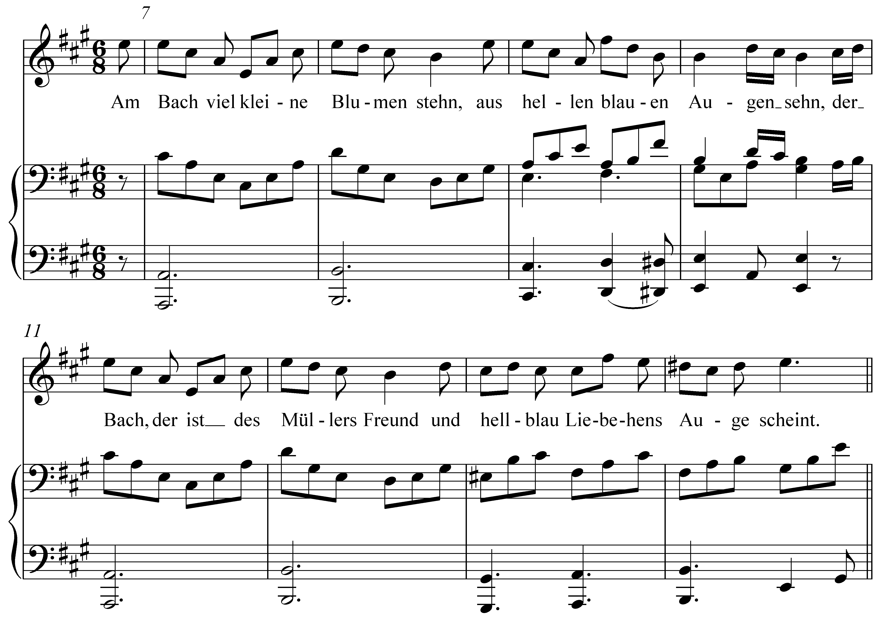

Compound meters, like simple meters, are indicated with time signatures. Understanding compound time signatures, however, is not quite as straightforward. For simple meters, the time signature conveys information about the beat: the top number indicates the number of beats per measure and the bottom number the note value of each beat. Compound meters, on the other hand, convey information about the beat division.

Note: Lesson YYY discusses how beams can be used to group notes in a way that clarifies the meter. While the right hand of the piano part in Example 1 does just this (organizing the eighth notes into groups of three), the notated vocal part does not. This is typical of vocal music, where beams are used primarily to group notes that belong to a single syllable of the text.

Take, for example, the time signature from the example above: “.” As we saw before, this is a compound duple meter. Each beat is equal to a dotted quarter note and each beat is regularly divided into three eighth notes:

Example 2 (compound beat division):
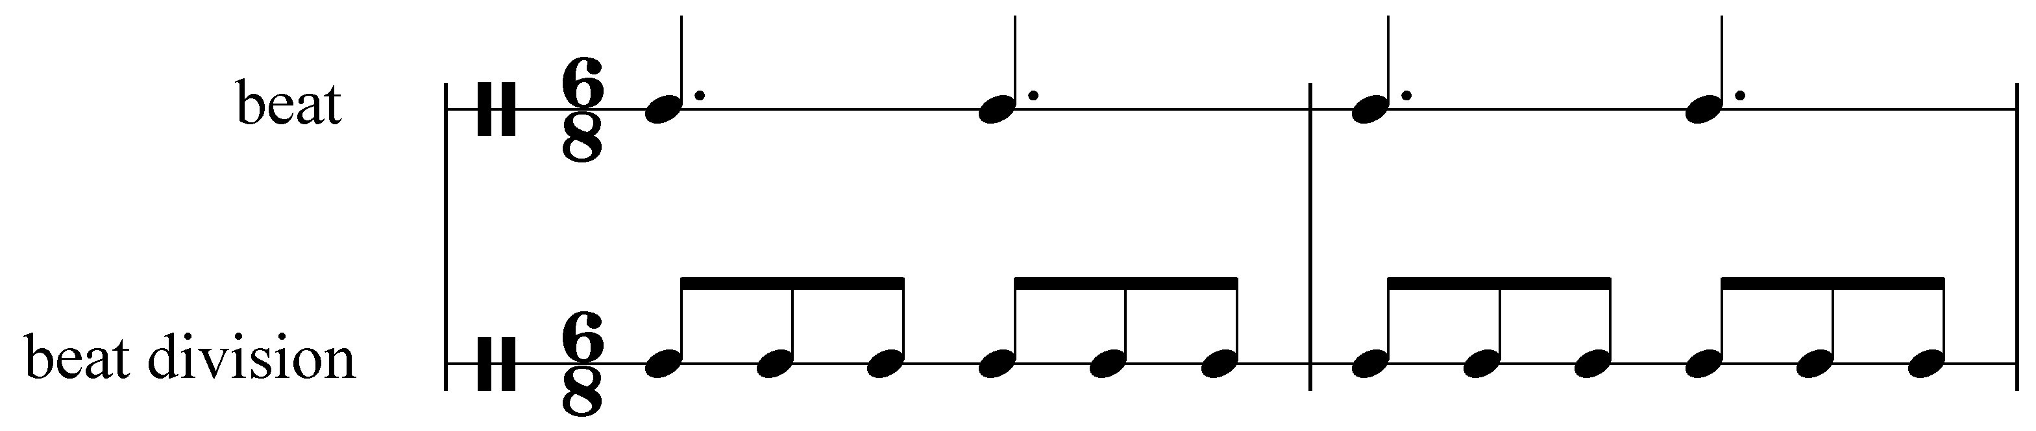

As you can see from Example 2, the numbers in the time signature refer to the beat division. Each measure of “” has six eighth notes. In other words, to find the number of beats per measure, one must divide the top number by three. If the top number is 6, the meter is duple. If the top number is 9 or 12, the meter is respectively triple or quadruple. These are the most common top numbers for compound-meter time signatures: 6, 9, and 12.

Since the bottom number indicates the duration of the beat division, one must add three of these note values together to get the beat unit. In the case of “,” the lower number indicates that the beat division is equal in duration to an eighth note. Three eighth notes add up to one dotted quarter note. The beat unit of a compound meter will always be a dotted note.

Note: A good rule of thumb to follow is that if the top number of a time signature is 2, 3, or 4, the meter is simple. If the top number is 6, 9, or 12 (any multiple of three, greater than three), the meter is compound.

Activity ZZZ.1:
Identify each of the following time signatures as simple or compound and as duple, triple, or quadruple. Then identify the note value of the beat.

Exercise ZZZ.1a
Does the following time signature represent a simple or compound meter?
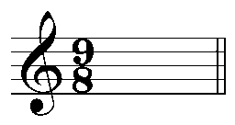
[Answer: compound. Response if correct: “Correct!” Response if incorrect: “Incorrect. Try again. (Remember, if the top number is 6, 9, or 12, the meter is compound.)”]
[Follow-up question:]
Is this meter duple, triple, or quadruple?
[Answer: triple. Response if correct: “Correct!” Response if incorrect: “Incorrect. Try again. (Hint: For compound meters, divide the top number by three to determine the number of beats per measure.)”]
[Follow-up question:]
What is note value of a single beat?
[Answer: dotted quarter note. “Response if correct: “Correct!” Response if incorrect: “Incorrect. Try again. (Hint: For compound meters, the beat unit is three times the length of the note value indicated by the bottom number of the time signature.)”]

Exercise ZZZ.1b
Does the following time signature represent a simple or compound meter?
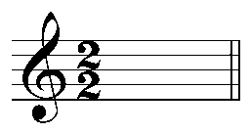
[Answer: simple. Response if correct: “Correct!” Response if incorrect: “Incorrect. Try again.”]
[Follow-up question:]
Is this meter duple, triple, or quadruple?
[Answer: duple. Response if correct: “Correct!” Response if incorrect: “Incorrect. Try again.”]
[Follow-up question:]
What is note value of a single beat?
[Answer: half note. “Response if correct: “Correct!” Response if incorrect: “Incorrect. Try again.”]

Exercise ZZZ.1c
Does the following time signature represent a simple or compound meter?
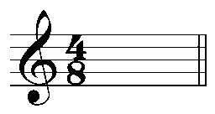
[Answer: simple. Response if correct: “Correct!” Response if incorrect: “Incorrect. Try again.”]
[Follow-up question:]
Is this meter duple, triple, or quadruple?
[Answer: quadruple. Response if correct: “Correct!” Response if incorrect: “Incorrect. Try again.”]
[Follow-up question:]
What is note value of a single beat?
[Answer: eighth note. “Response if correct: “Correct!” Response if incorrect: “Incorrect. Try again.”]

Exercise ZZZ.1d
Does the following time signature represent a simple or compound meter?
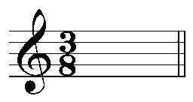
[Answer: simple. Response if correct: “Correct!” Response if incorrect: “Incorrect. Try again.”]
[Follow-up question:]
Is this meter duple, triple, or quadruple?
[Answer: triple. Response if correct: “Correct!” Response if incorrect: “Incorrect. Try again.”]
[Follow-up question:]
What is note value of a single beat?
[Answer: eighth note. “Response if correct: “Correct!” Response if incorrect: “Incorrect. Try again.”]

Exercise ZZZ.1e
Does the following time signature represent a simple or compound meter?
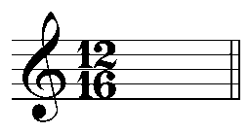
[Answer: compound. Response if correct: “Correct!” Response if incorrect: “Incorrect. Try again. (Remember, if the top number is 6, 9, or 12, the meter is compound.)”]
[Follow-up question:]
Is this meter duple, triple, or quadruple?
[Answer: quadruple. Response if correct: “Correct!” Response if incorrect: “Incorrect. Try again. (Hint: For compound meters, divide the top number by three to determine the number of beats per measure.)”]
[Follow-up question:]
What is note value of a single beat?
[Answer: dotted eighth note. “Response if correct: “Correct!” Response if incorrect: “Incorrect. Try again. (Hint: For compound meters, the beat unit is three times the length of the note value indicated by the bottom number of the time signature.)”]

Exercise ZZZ.1f
Does the following time signature represent a simple or compound meter?
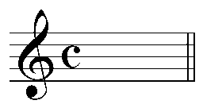
[Answer: simple. Response if correct: “Correct!” Response if incorrect: “Incorrect. Try again.”]
[Follow-up question:]
Is this meter duple, triple, or quadruple?
[Answer: quadruple. Response if correct: “Correct!” Response if incorrect: “Incorrect. Try again.”]
[Follow-up question:]
What is note value of a single beat?
[Answer: quarter note. “Response if correct: “Correct!” Response if incorrect: “Incorrect. Try again.”]

Tuplets:

You will quite frequently encounter beat divisions that defy your expectations based on your observations about the meter. Consider the following piece:

Example 3 (J. Haydn, Piano Sonata No. 3 in C major, Mvt. III, mm 1-8):
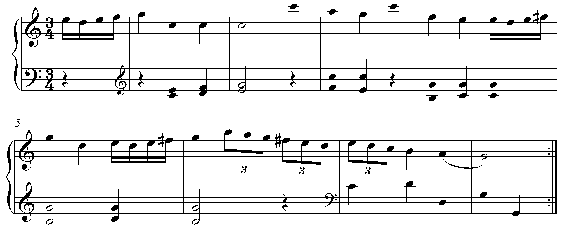
This excerpt from a piano sonata by Haydn is in “,” a simple triple meter. As the time signature indicates, one beat has a value equal to a quarter note. Since “” is a simple meter, the quarter note beat normally divides into two eighth notes. But, on the second and third beats of m. 6 (and the first beat of m. 7), three eighth notes are squeezed into each beat.

This rhythmic figuration is known as a triplet and is normally notated as it appears in Example 3: with a small “3” written alongside each group of beamed notes. Triplets such as these represent a temporary shift to the corresponding compound meter. If “” is a simple triple meter, “” would be the corresponding compound triple meter:

Example 4:

a. beat division in “”
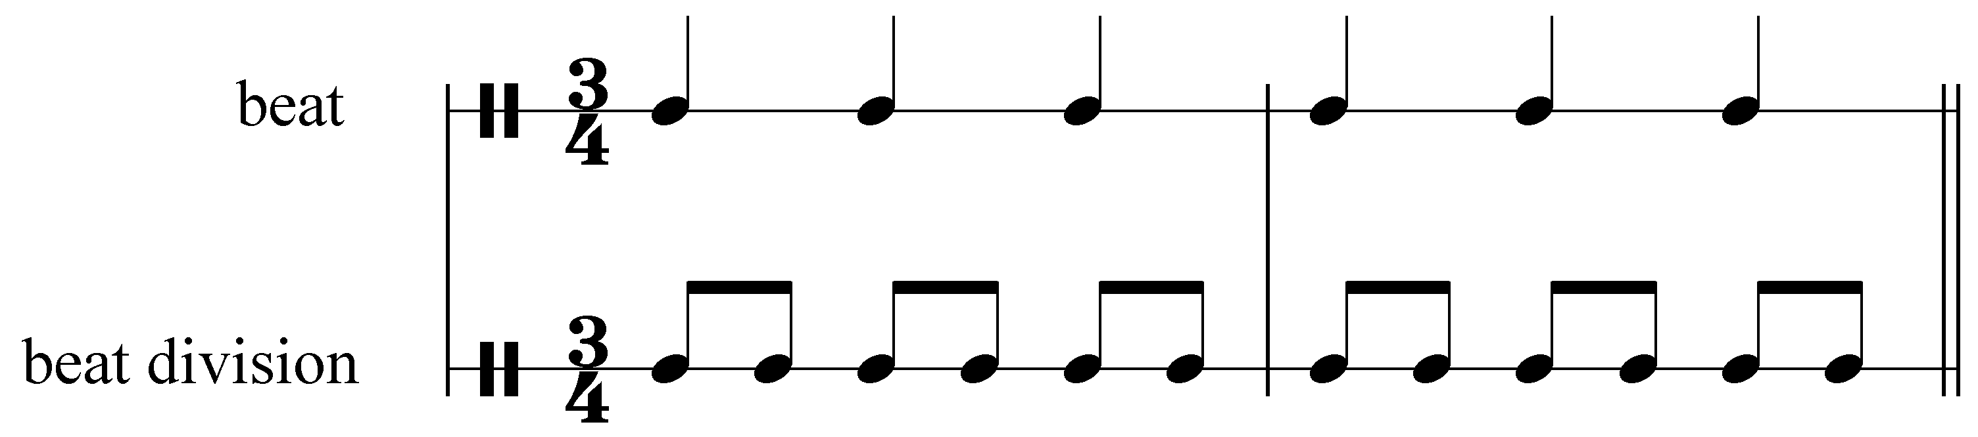

b. beat division in “”
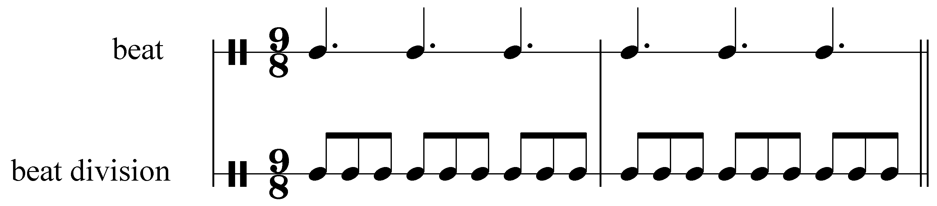

In “” each beat can be divided into two eighth notes. In “” each beat can be divided into three eighth notes. A triplet, therefore, represents a kind of rhythmic borrowing from the corresponding compound meter. In other words, when we hear the triplets in mm. 6-7 of Example 3, it sounds as though Haydn has temporarily switched to a compound triple meter, where each beat is divided into three even eighth notes.

The generic term for this type of rhythmic alteration is a tuplet. In addition to triplets, another type of tuplet is a duplet. Duplets typically appear in pieces in compound meters, like the following:

Example 5 (M. Ravel, “Noel des jouets,” mm. 29-34):
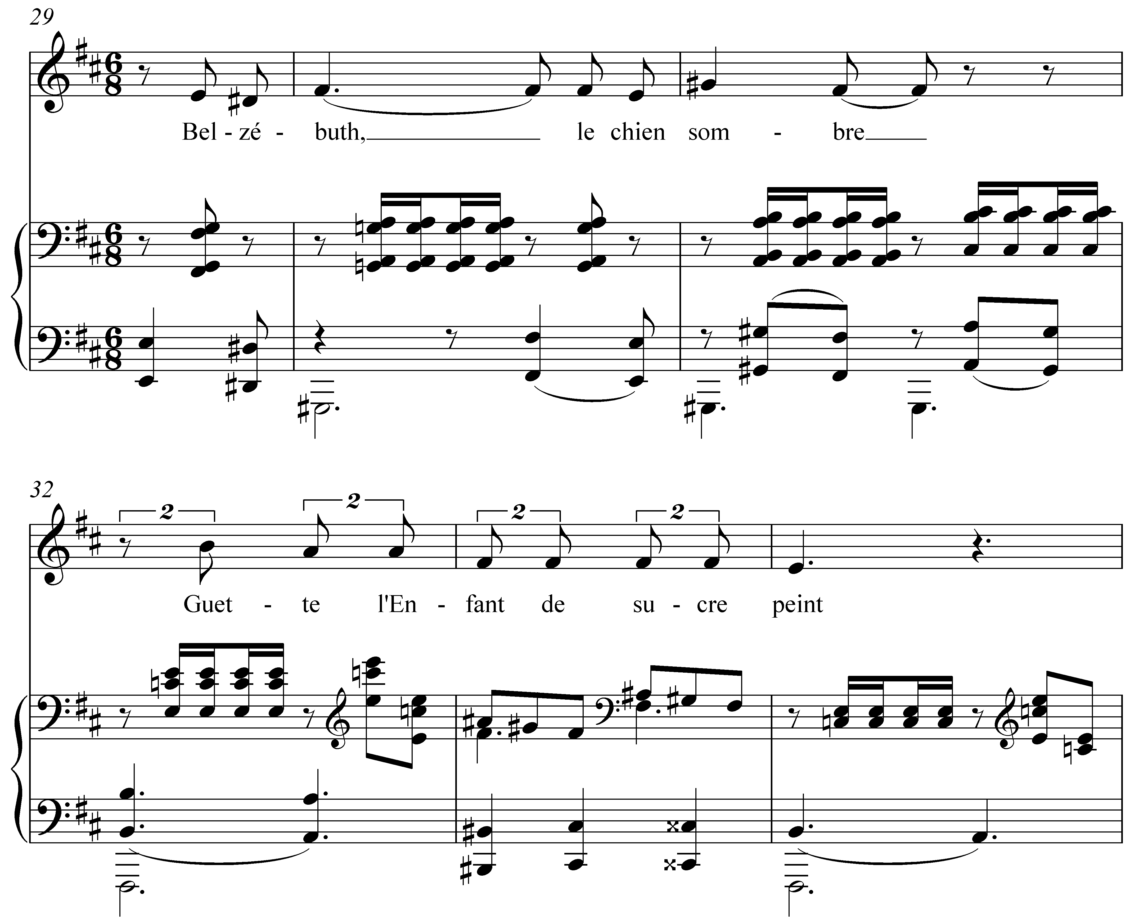

As the name implies, a duplet alters the rhythm so that two notes take up the space that would normally accommodate three. In this sense, a duplet can be thought of as the opposite of a triplet. The example above is in “,” a compound duple meter. Typically the beat (a dotted quarter note) would be divided into three eighth notes. In mm. 32-33, however, we see that each beat is divided into two eighth notes (indicated by the bracketed “2” above each group). Each of these duplets fills the space of an entire beat, or, three eighth notes.

Tuplets can be a very versatile tool with regards to the rhythmic expressiveness of a composition and many other types can be found. The two types discussed here, triplets and duplets, are by far the most common.

Activity ZZZ.2:
Triplets and duplets can be thought of as beat divisions borrowed from the corresponding simple or compound meter. The following example shows a rhythm in “,” a simple triple meter, that contains some triplets borrowed from “,” the corresponding compound meter. Convert the rhythm to “” by adjusting each rhythm accordingly. The first measure has been done for you. (As you can see, eighth notes become eighth note duplets and triplets become straight eighth notes.)

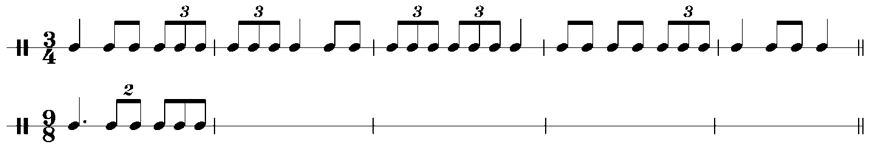

[Answer:
. Response if correct: “Correct!” Response if incorrect: “Incorrect. Try again.”]

Conclusion:

Compound meters are those in which the beat regularly divides into three even notes (as opposed to simple meters, which divide into two notes). Like any type of meter, compound meters are usually expressed with time signatures, though in such cases the numbers convey information about the beat division.

The bottom number of a compound-meter time signature indicates the note value of the beat division and the top number—usually 6, 9, or 12—indicates how many such notes make up one full measure. Since the top number refers to the beat division, one need simply divide it by three to determine how many beats appear in a single measure: 6 indicates a duple meter, 9 indicates a triple meter, and 12 indicates a quadruple meter. To determine the note value of the beat, one need simply add three beat division units together. The beat in a compound meter will therefore always be a dotted note.

Composers are not limited to the normal beat division of a given meter. They may—and often do—borrow the beat division from the corresponding simple or compound meter. These rhythmic figurations are known generically as tuplets. Triplets provide a compound-meter beat division in a simple-meter context (three notes in the space of two). Duplets do just the opposite: they provide a simple-meter beat division in a compound-meter context (two notes in the space of three).

